Reflection of air pollutants in component 2

Visualisations
My approach to visualisation was guided by the specific analytical goal of each task. The primary aim was to select a plot type that could represent the data and its underlying patterns in the most intuitive way.

For Tasks 3 and 4, which involved observing pollutant levels over time, the line chart was the most logical choice. As the requirement was to see trends—such as changes from one month to the next or across several years—a line plot provides an immediate and clear visual representation of this temporal flow. In Task 4, plotting multiple pollutants on a single graph allowed for direct comparison, effectively communicating their relative concentrations and shared patterns over the same period.

Example code for the single pollutant line chart (Task 3):
plot(df_draw$Date, df_draw[[pollutant]], type="l", xlab="Date", ylab=pollutant, main=paste("Date vs ", pollutant), col="blue", lwd=2)
Show as Fig 1.
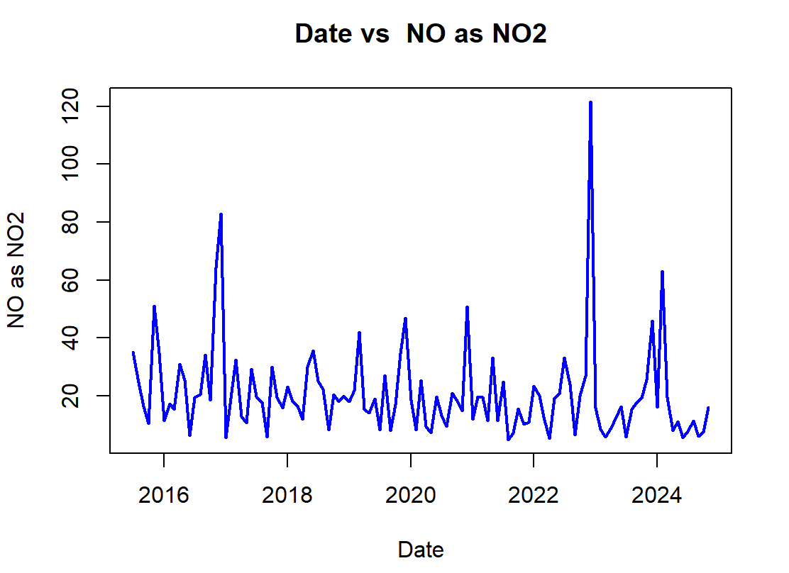
Fig 1. Date vs NO as NO2

For Task 5, the goal was to understand the relationship between two continuous variables, Ozone and NO2. A scatter plot is the standard and most effective tool for this purpose. By plotting one variable on the x-axis and the other on the y-axis, the plot immediately revealed the nature of their correlation—whether it was positive, negative, or non-existent—which visually prepared for the numerical correlation coefficient that followed.

Example code for the scatter plot (Task 5):
plot(PortTalbotAQ$Ozone, PortTalbotAQ$NO2, xlab = "O3", ylab = "NO2", col="blue", main = "Correlation between O3 and NO2")
Show as Fig 2.
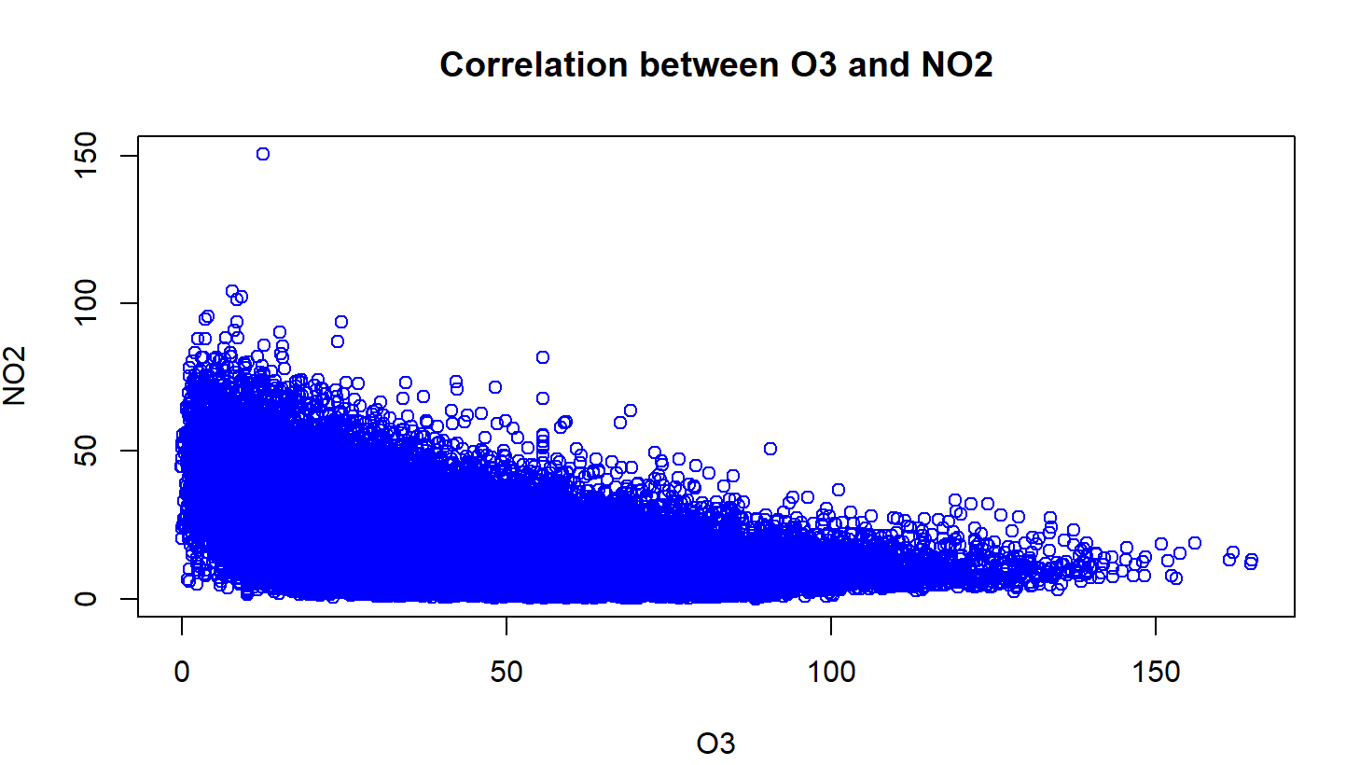
Fig 2. Correlation between O3 and NO2

Finally, for Task 7, a boxplot was used to visually support the ANOVA. After the ANOVA test suggested a significant difference between the groups (2016, 2018, and 2020), the boxplot served as a crucial communication tool. It clearly illustrated the differences in the distributions (median, interquartile range, and outliers) of NO2 levels for the three periods, making the results of the subsequent Tukey post-hoc test much easier to understand.

Example code for the boxplot (Task 7):
boxplot(NO2 ~ Year, data = group_all, main = "NO2 Levels at 17:00 (Nov-Dec: 2016, 2018, 2020)", xlab = "Year", ylab = "NO2 Concentration", col = c("blue", "green", "gray"))
See in Fig 3.
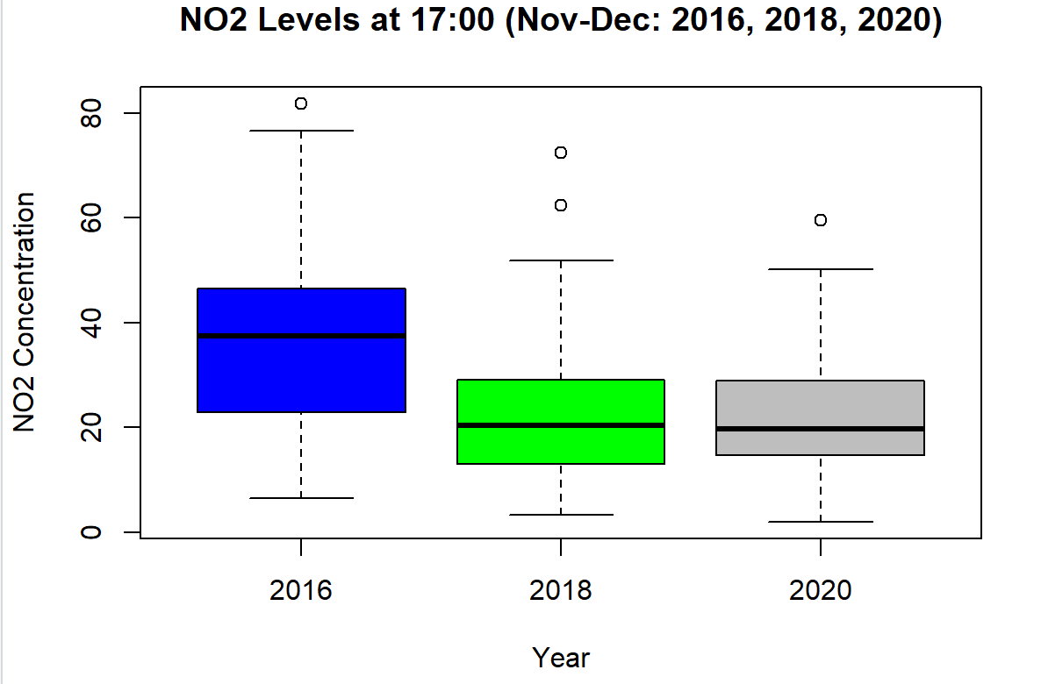
Fig 3. NO2 lavels at 17:00

Challenges and Things Learned
This project presented several key challenges. The most significant technical hurdle was time-based data subsetting (Task 3 & 7). My solution was to sort the data by date, then use the which() function to find the row indices for the start and end dates, allowing me to accurately slice the dataframe.
PortTalbotAQ <- PortTalbotAQ[order(PortTalbotAQ$DateTime), ]

start_index <- which(df_12$Date == start_date)
end_index <- which(df_12$Date == end_date)

A key conceptual challenge was selecting the correct statistical tests (Task 6 & 7). I was initially unsure whether to use independent or paired tests for this time-series data. I used a generative AI system to help clarify this; it confirmed that because my hypothesis compared independent groups (e.g., wind speed < 5 vs. >= 5), an independent t-test and one-way ANOVA were the appropriate choices. Additionally, I improved my foundational skills in dataframe manipulation by consulting textbooks and course materials.

Through this process, I solidified my understanding of the practical data analysis workflow—from cleaning "No data" (Task 2) to hypothesis testing. I also gained practical experience in defining custom R functions and implementing statistical tests like t.test and aov.

Improvements for Future Work
Based on this experience, I have identified key areas for improvement. My foremost change would be in data processing efficiency. Instead of converting data types as.numeric() ad-hoc, I would perform all conversions immediately after import. Furthermore, my method of creating df_12 and df_17 using for loops and rbind was computationally inefficient. In the future, I would use R's native vectorized operations or functions from the dplyr package (e.g., filter()) to subset the data directly.

Several alternative approaches could also enhance this analysis. For visualisation, I would adopt the ggplot2 package. While R's base plot() was functional, ggplot2 provides a more powerful system for creating layered, more aesthetically pleasing, and modern-looking graphics, which significantly improves data communication. For handling missing data (Task 2), I used "Last Observation Carried Forward." A more robust alternative would be to explore methods like linear interpolation (using zoo::na.approx) or mean imputation, and then compare if the chosen method impacts the statistical results.

Declaration on the Use of Generative AI
I used a generative AI system during this assignment for one specific purpose: statistical methodology validation.

For Task 6 (t-test) and Task 7 (ANOVA), I was uncertain whether to use independent or paired tests for the time-series data. I consulted an AI to clarify this concept. The AI helped confirm that because the groups being compared were independent (e.g., different wind speed conditions, different years), independent-sample tests were the correct approach. The AI's role was limited to this conceptual consultation; it was not used to write or debug any R code.

