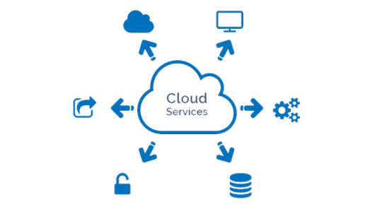

Assignment Title: Assignment 2
Module : Cloud Based Web Services
Module Code: ACCA6024
Student Name: Michelle Chalmers
Student Number: 1809316

Abstract
Cloud Services are a quickly expanding industry and companies are moving away from hosting and supporting their own infrastructure.
‘The global cloud computing market is projected to grow from $250.04 billion in 2021 to $791.48 billion in 2028…’ [1]
There are several Cloud Types and Cloud Services available, and no fixed rules as business needs differ greatly. This report breaks down the factors that need to be considered when selecting the correct service.

Table of Contents
Abstract 1
Table of Figures 3
Introduction 3
1. Cloud Computing 4
1.1 Cloud Computing Types 4
1.1.1 Public Cloud 4
1.1.2 Private Cloud 4
1.1.3 Hybrid Cloud 5
1.2 Cloud Computing Services 5
1.2.1 IaaS (Infrastructure-as-a-Service) 6
1.2.2 PaaS (Platform-as-a-Service) 6
1.2.3 SaaS (Software-as-a-Service) 6
1.2.4 Serverless Computing 6
1.2.5 Database Storage 6
2. Benefits 7
2.1 Speed of Implementation 7
2.2 Data Security 7
2.3 Accessibility 7
2.4 Reliability 7
2.5 Scalability 7
2.6 Performance 8
2.7 Productivity 8
3. Drawbacks 8
3.1 Downtime 8
3.2 Data Security 9
3.3 Data Loss 9
3.4 Internet Outages 9
4. Cost 11
5. Which is Best? 11
6. Virtualization and Docker 12
7. Developing a node.js Application 15
Stage 1 Install Application Dependencies 15
Stage 2 Create Application Files 16
Stage 3 The Dockerfile 16
Stage 4 Images in Repository 17
References 18
Useful Links 20

Table of Figures
Figure 1 Cloud Service Models 5
Figure 2 The spread of DDoS attacks by Mirai in 2016 9
Figure 3 Principle areas hit by Amazon.com outage 26th August 2021 10
Figure 4 VM Architecture vs. Container Architecture 12
Figure 5 Over 5000 images are available from Docker Hub 14

Introduction
From shopping, socializing, streaming media, and banking, the internet has become a huge part of modern life. The pandemic has seen a significant shift towards working from home, reducing the need for office capacity. Could moving services to the cloud reduce or negate the need for office space?
‘Home working set to more than double compared to pre-pandemic levels once crisis is over’ [2]
With increasing demands on IT services comes the challenge of creating an IT infrastructure that provides the right service at the right price. With the fast-growing business of cloud services it’s hard to know which, if any, is suitable.
Some questions that need to be addressed are:
- How do these solutions work?
- What are the benefits and drawbacks?
- What considerations are needed before a company decides if cloud services are suitable?

1. Cloud Computing
Traditionally a business’ data centre is hosted and supported by their IT department, in a secured area with environmental controls. Some businesses outsource this responsibility to a Managed Service Provider (MSP), who deal with the infrastructure, network connectivity, data security, backups, updates, disaster recovery etc.
Cloud computing is the step further on from outsourcing computer services. It is an on-demand access to software applications, resources, servers, data, and anything else required, all made available via the Internet.
‘Today, according to a rough estimate, nearly 90% of all businesses in the UK are using cloud services.’ [3]
Essential to any business considering cloud computing services is a suitable Internet service provider, and a cloud provider that has a guaranteed always-on Internet service.

1.1 Cloud Computing Types

1.1.1 Public Cloud
The cloud service provider makes resources available via the Internet, with pricing being subscription or usage based. Resources can be applications, virtual machines, development platforms etc. and responsibility for infrastructure, data centre, backups and hardware falls to the provider.
Public cloud clients share the data centre and infrastructure with other clients, as it is a multi-tenant environment.
Providers include Amazon Web Services [4], Google Cloud [5], and Microsoft Azure [6].

1.1.2 Private Cloud
Typically hosted within the customers own data centre but can be hosted by a private cloud provider. Infrastructure, services and data will be housed within a private data centre. This will be more costly as the provider has to dedicate a data centre to one client. Similar to an MSP but with access being via the internet, rather than the secure ‘pipe’ usually used with an MSP service.

A private cloud will suit companies that deal with confidential documents and data, this may be the only way that a company can meet some data privacy regulations.
Providers include Hewlett Packard Enterprise [7], Dell [8], Microsoft [9] and Oracle [10].

1.1.3 Hybrid Cloud
A combination of public and private cloud. This solution offers a company the facility to handle sensitive data in a private cloud environment (possibly their own data centre) whilst other data and facilities can be provided by the public cloud.
This can offer more flexibility but is also a midway solution when an organisation needs to transition from their own data centre to a public cloud solution. A first step may be to move away from Office installations and a mail server, and use O365 from the cloud.

1.2 Cloud Computing Services
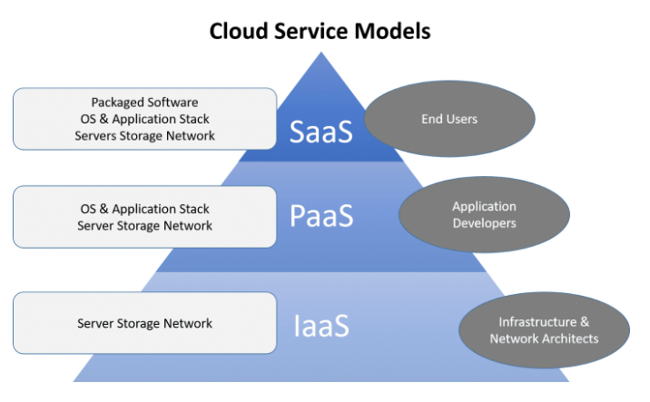 [11]
Figure 1 Cloud Service Models

1.2.1 IaaS (Infrastructure-as-a-Service)
First appeared in 2010, it is still widely used but its use is not growing as fast as other services.
‘IaaS was the most popular cloud computing model when it emerged in the early 2010s. While it remains the cloud model for many types of workloads, use of SaaS and PaaS is growing at a much faster rate.’ [12]
It is a pay-as-you-go service where the client rents services, storage, virtual machines etc. and in essence is a re-branding of managed services, but with a less rigid contractual tie in.
Resources can be expanded or contracted, reducing up-front set-up costs.

1.2.2 PaaS (Platform-as-a-Service)
Used by developers for developing, testing, and managing software applications. The provider will host everything required such as networking, database management, middleware, storage, operating systems etc. Developers can access this as an on-demand platform as and when required. Virtual machines may be in use, and it is common to use containers within these servers.

1.2.3 SaaS (Software-as-a-Service)
A software or suite of software that is accessed over the internet by the users. This frees the companies IT department up from setting up the infrastructure and software, and gives more flexibility should your business’ needs change. Because the software and facilities already exist, access to them can be almost instantaneous.

1.2.4 Serverless Computing
A platform for developers. The provider is responsible for scaling, managing, and provisioning the infrastructure. The service is charged on a usage basis and enables developers to focus on their task without having to consider the infrastructure

1.2.5 Database Storage
If you need a data depository there are services such as Dropbox, OneDrive and Google Drive. These are affordable to everyone, and as many people use tablets and phones instead of computers, they are becoming ‘the norm’ for personal use.

2. Benefits
Business is shifting to using cloud computing services more often and this can be for several reasons:

2.1 Speed of Implementation
A data centre requires time to implement. Most cloud services are provided on demand and will require very little time for initial set up. A new business could start with minimal facilities almost instantly and upgrade as they need to. Depending on the services they need and pay for there can be minimal need for IT involvement – such as using O365, rather than a mail server.

2.2 Data Security
With data security being critical it pays to make sure that the solution chosen can provide the best. Unless a company has cyber security specialists, and the means to monitor and control security, a cloud service provider may offer more security than managing it inhouse.

2.3 Accessibility
Because cloud services are provided globally, they are accessible from anywhere in the world. A global business will be able to have their staff online 24/7 without relying on IT support from a fixed location and time zone.
As services are accessible via a browser they are accessible on almost any device with internet access.

2.4 Reliability
A CSP can provide a solid business continuity solution. Disaster recovery can be fast as they can mirror your business to other sites, and in these days of real time backups (continuous data protection – CDP) there is little or no data loss.

2.5 Scalability
Clients can expand or contract the services as the business requires. Ideal if the business needs are seasonal or short term development is required, as clients only pay for what is used. If a business is supporting this themselves they need dedicated servers, which sit idle when not in use.

2.6 Performance
A large business with an established data centre will have a team of IT specialists. A small business is likely to employ a generalist to handle almost everything.
Major CSPs have a global network of data centres which are kept updated with the latest hardware, software, networking, and security. They employ specialists in every field, so they are providing the best solutions at all times.

2.7 Productivity
An IT department with a data centre is involved with building hardware, patching, server errors, monitoring etc. A cloud service negates the need for these tasks. The IT team can concentrate on other tasks such as planning, development, and research.

3. Drawbacks

3.1 Downtime
You may have a contract with an SLA (Service Level Agreement), but what happens when the provider fails to provide that service?
In 2017 Amazon Web Services had a major outage which cost companies using the service up to $150 million.
‘Amazon says a mistyped command caused a widespread outage in its cloud computing service…that disrupted websites across the Internet for hours.’ [13]
It seems that no matter how large, there is no CSP immune from the possibility of a major outage. In 2020 alone MS Azure, IBM Cloud, Cloudflare, AWS and Google Cloud all had outages [14]

3.2 Data Security
CSPs have security experts taking care of your data, but as soon as you allow it to be secured by another party, there is a risk. The General Data Protection Rule (GDPR) came into force in 2018 (in the EU) to try and force security via compliance.
‘Under GDPR, both customers (as controllers who define how and why personal data is collected) and cloud providers (as processors who manage, process, or store personal data on behalf of the controller) must be compliant.’ [15]
On 17th June 2014 Code Spaces suffered a DDoS attack, which became more sinister. The attacker had control of their AWS Control Panel and when they refused to pay the ransom, the attacker destroyed everything. In a matter of days, the company had to shut down as it could not recover.
‘The demise of Code Spaces at the hands of an attacker shows that, in the cloud, off-site backups and separation of services could be key to survival’ [16]
‘…DDoS product specialist at Neustar, reported that 55 percent of companies targeted by DDoS attacks are also victims of security breaches.’ [17]

3.3 Data Loss
Backup specialists will tell you that "If it's not in three places, it doesn't exist" [18] when talking about data. Code Spaces was relying on backups and recovery plans that were included in their cloud services, and their attacker destroyed almost all data including the backups.

3.4 Internet Outages
No matter how good the security, someone somewhere will attempt an attack. Almost all will fail, but the ones that do not, can be devastating. A simple Internet failure can be all it takes to cease access to your services.
In October 2016 the Mirai botnet successfully took down most of the American East Coast Internet with a major DDos (Distributed Denial of Service) attack. Here we see how the botnet attack snowballed over 14 days:
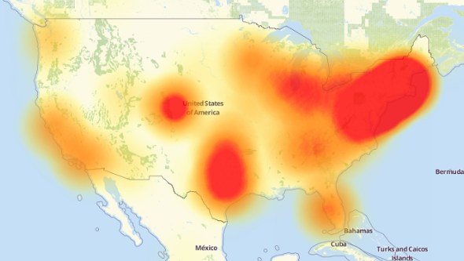 [19]
Figure 2 The spread of DDoS attacks by Mirai in 2016
‘The victim…a company that controls much of the internet’s DNS infrastructure … remained under sustained assault for most of the day, bringing down sites including Twitter, the Guardian, Netflix, Reddit, CNN and many others in Europe and the US.’ [20]
Your business is vulnerable unless both ends of the service, user and provider, have a guaranteed stable uninterruptible connection.
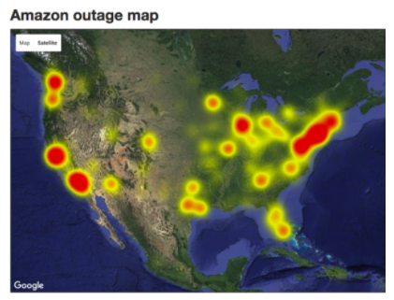 [21]
Figure 3 Principle areas hit by Amazon.com outage 26th August 2021
A data centre located in the office where all the staff work keeps you connected. A fully equipped company will also have a generator with Uninterruptible Power Supply (UPS) support in the event of a power failure.

4. Cost
There are so many areas to consider in regards to cost that there is no definitive guide, although Amazon Web Services and Google Cloud Platform do offer cost calculators. These do not consider all potential costs though.
Setting up a data centre involves significant costs and time (months or years). It has to be secure with environmental controls, and the on-site IT team will need to manage and maintain the data centre, usually 24/7. As more companies switch to working from home there will be less need for a centralised office, and possibly little reason to maintain a data centre.
Although cloud services are scalable, making changes may come with a price. Unless you are absolutely confident of the package you need it is possible that you may be tied in to a contract that is more expensive than needed. Note that ‘on demand’ and ‘pay-as-you-go’ does not mean there is no contract, it just means that within the contract you have some services that are charged only when used.
The cost of potential downtime may be significant. Can your business afford to have their CSP offline for any amount of time? An internet outage can happen at either end of the connection – the supplier or your business.
‘The Wall Street Journal reported that the [2017 AWS] outage cost companies in the S&P 500 index $150 million’ [13]

5. Which is Best?
In 2019 a price comparison was done for 1TB of data using comparable systems on-site and via the cloud, processing data at the same speed [22]. It approximated the infrastructure and data center costs, versus the CSP costs. AWS with Cloud Volume Services was calculated to be the winner. However, this was a specific comparison and does not represent what is best for all business.
A new business would probably find cloud services a cheaper option as they do not need to plan and implement their IT infrastructure solution. An established business with a data centre may find that migrating current services is not cost effective as they already have a solution running. Or they may need a private cloud and a large amount of bandwidth, both of which are costly.
Considerations:
- The size and age of the business – is there already a data centre in use?
- Accessibility – do you need a global 24/7 solution?
- Set up and ongoing costs.
- Home working or office-based staff.
- Privacy – if you need a private cloud solution you may benefit from having a data centre instead.
- Hidden costs – loss of business or reputation should there be an outage.
- Scalability.

6. Virtualization and Docker
Modern IT facilities and cloud services rely heavily on the different virtualization services.
Virtual machines (VMs)
Self-contained virtual servers installed on one physical server. The server resources are shared between the VMs, but some will be dedicated to each VM OS and will not be released if that VM is not in use.
In order to manage Windows VMs a hypervisor (software) acts as the interface between the physical and virtual machines. Linux already contains a hypervisor so does not need a separate one.
There are many types of virtualization including network, application, data and desktop. Cloud virtualization offers the services previously detailed, such as SaaS.
A container is a process or set of processes. The server has an OS installed, the applications are installed as containers, and the user starts the process(es) running when they use the application.
Each container releases server resources when not being used, therefore the resources are more available.
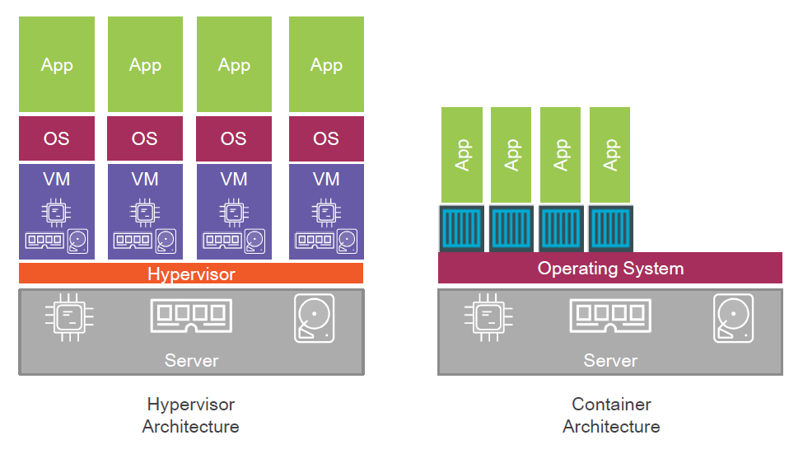 [23]
Figure 4 VM Architecture vs. Container Architecture
Virtual Machines:
- The server has an OS and each VM has an OS, all requiring licensing.
- Each VM requires administrating separately.
- A percentage of resources will be bound to each VM and cannot be utilised elsewhere.
- A Hypervisor is required, taking up more resources.
- Each VM may be running the same applications so there is a cross over, which adds to the cost if licences are required.
Containerization:
- One OS required.
- Applications run as processes, therefore when not in use the resources are released.
- The App can be changed within the container.
- No additional Hypervisor required.
Containerization has therefore allowed Cloud Services to become affordable as it has reduced the infrastructure, support and licence costs.

Containerisation is not a new technology and has been around since about 1979. When Docker, a containerization platform, was released in 2013 [24] it become the industry standard. It became popular with application developers and architecture designers as it was designed for the modern microservice architecture, providing:
- Portability. It can be installed anywhere that supports Docker.
- In-built version control. You can roll back to a previous version.
- Security. Containers need permission to access each other’s data.
- Fast deployment and quick runtimes as the Applications are installed on top of the OS.
Docker has allowed containerization to become a straightforward solution.
In addition to the development platform Docker also provides Docker Hub, a repository where a development team can store images. One image is created for an application or service, and if another instance of it is required the image is pulled from Docker Hub and a new container created with it.
Docker Hub offers many pre-designed images that can be used as a start point, covering Windows and Linux OS and several architecture styles.
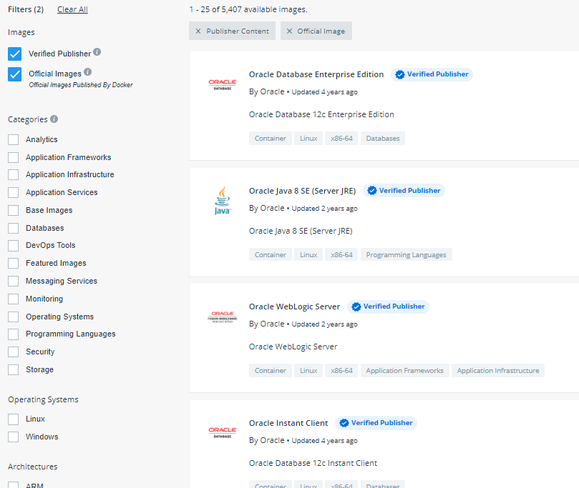 [25]
Figure 5 Over 5000 images are available from Docker Hub

7. Developing a node.js Application
This process makes the assumptions:
- A Linux server is being used
- Docker is installed on the server
- A Docker hub account is being used to store images.
- Node.js and npm are installed (node package manager (npm) is part of Node.js - npm packages are saved as package.json files)

Stage 1 Install Application Dependencies
These files contain the applications static content, dependencies, and code. These need to be created then copied to the container:
- Create a root directory. It is advisable to use terse naming conventions for simplicity, ie. node_test
- Within this new directory create a package.json file. This will contain information about the package and any dependencies. This may define scripts, development dependencies, browser lists (what browsers and versions are supported), version details etc.
Using a text editor add information required:
{
"name": "nodejs-test",
"version": "1.0.0",
"description": "nodejs test",
"author": "John Wick",
"main": "app.js", the app.js entrypoint
"keywords": [
"nodejs",
"express"
],
"dependencies": {
"express": "^4.0.1" requires this version or higher of Express
}
}

- If the application versions need to be tracked, add a repository to the package.json file.
- Run npm install to install the dependencies.

Stage 2 Create Application Files
Create the website or application as usual. It will have:
- app.js main entry point
- views directory contains static assets
- Landing page index.html located in views directory
- Information page information.html located in views directory
In app.js specify the module to load, router details, and the base directory.
Create page content for index.html and information.html, add a css styles page.
With the website or application created, start the application using command node app.js and browse to the webpage.

Stage 3 The Dockerfile
The Dockerfile details what is to be included in the container when the application is executed.
Use an image from Docker Hub is there is one suitable.
Create a new directory.
Create a file in that directory.
Issue a command to build the image:
docker build -t "NAMEofNEWimage:Dockerfile"
This builds the image.
If there are several development images to be built they can be built at once:
docker build -t "image1:Dockerfile"
docker build -t "image2:Dockerfile"
docker build -t "image3:Dockerfile"

Stage 4 Images in Repository
To push the image to Docker Hub:
docker push dockerhub_username/nodejs-test
To pull an image down from Docker Hub:
docker pull dockerhub_username/nodejs-anotherapplication
To build a container to run nodejs-anotherapplication:
docker run --name nodejs-anotherapplication -p 80:8080 -d dockerhub_username/ nodejs-anotherapplication

References

[1] | "Fortune Business Insights," May 2021. [Online]. Available: https://www.fortunebusinessinsights.com/cloud-computing-market-102697. [Accessed 31 08 2021].
[2] | "CIPD," 16 07 2020. [Online]. Available: https://www.cipd.co.uk/about/media/press/home-working-increases. [Accessed 31 08 2021].
[3] | H. Jones, "CARBONTEQ," 2019. [Online]. Available: https://blog.carbonteq.com/benefits-of-cloud-computing/. [Accessed 28 08 2021].
[4] | "AWS," Amazon, [Online]. Available: https://aws.amazon.com/. [Accessed 31 08 2021].
[5] | "Google Cloud," [Online]. Available: https://cloud.google.com/. [Accessed 31 08 2021].
[6] | "Azure," Microsoft, [Online]. Available: https://azure.microsoft.com/en-gb/. [Accessed 31 08 2021].
[7] | "Hewlett Packard Enterprise," [Online]. Available: https://www.hpe.com/uk/en/home.html. [Accessed 31 08 2021].
[8] | "Dell Technologies," [Online]. Available: https://www.delltechnologies.com/en-gb/solutions/cloud/storage-solutions.htm. [Accessed 31 08 2021].
[9] | "Microsoft," [Online]. Available: https://partner.microsoft.com/en-gb/solutions/cloud-os. [Accessed 31 08 2021].
[10] | "Oracle," [Online]. Available: https://www.oracle.com/cloud/. [Accessed 31 08 2021].
[11] | "IDM," 09 08 2018. [Online]. Available: https://medium.com/@IDMdatasecurity/types-of-cloud-services-b54e5b574f6. [Accessed 29 08 2021].
[12] | "IBM," [Online]. Available: https://www.ibm.com/cloud/learn/cloud-computing. [Accessed 31 08 2021].
[13] | R. Hersher, "NPR," 03 03 2017. [Online]. Available: https://www.npr.org/sections/thetwo-way/2017/03/03/518322734/amazon-and-the-150-million-typo?t=1529930367722. [Accessed 29 08 2021].
[14] | P. Jha, "Toolbox," 29 12 2020. [Online]. Available: https://www.toolbox.com/tech/cloud/articles/5-cloud-outages-that-shook-the-world-in-2020/. [Accessed 31 08 2021].
[15] | S. Scott, "cloud academy," 17 05 2018. [Online]. Available: https://cloudacademy.com/blog/4-best-practices-to-get-your-cloud-deployments-gdpr-ready/. [Accessed 29 08 2021].
[16] | P. Venezia, "InfoWorld," 23 06 2014. [Online]. Available: https://www.infoworld.com/article/2608076/murder-in-the-amazon-cloud.html. [Accessed 29 08 2021].
[17] | J. Goldman, "eSecurity Planet," 23 06 2014. [Online]. Available: https://www.esecurityplanet.com/networks/code-spaces-destroyed-by-cyber-attack/. [Accessed 29 08 2021].
[18] | Alison, "Ballyhoo," [Online]. Available: https://www.ballyhoo.co.uk/If-its-Not-in-Three-Places-it-Doesnt-Exist.html. [Accessed 31 08 2021].
[19] | "Shallow Learning Security," 26 10 2016. [Online]. Available: https://medium.com/@deeplearningsec/think-mirai-ddos-is-over-it-aint-96298a9ff896. [Accessed 29 08 2021].
[20] | N. Woolf, "The Guardian," 26 10 2016. [Online]. Available: https://www.theguardian.com/technology/2016/oct/26/ddos-attack-dyn-mirai-botnet. [Accessed 31 08 2021].
[21] | Abi Tyas Tungga, "UpGuard," 26 08 2021. [Online]. Available: https://www.upguard.com/blog/the-cost-of-downtime-at-the-worlds-biggest-online-retailer. [Accessed 28 08 2021].
[22] | Kristina Brand, "NetApp," 09 10 2019. [Online]. Available: https://cloud.netapp.com/blog/on-premises-vs-cloud-the-cost-comparison. [Accessed 29 08 2021].
[23] | scmGalaxy.com, "scmGalaxy.com," [Online]. Available: https://www.devopsschool.com/slides/docker/docker-containers-big-picture/index.html#/. [Accessed 29 08 2021].
[24] | "tutorialspoint," [Online]. Available: https://www.tutorialspoint.com/docker/docker_overview.htm. [Accessed 31 08 2021].
[25] | "dockerhub," [Online]. Available: https://hub.docker.com/search?type=image&image_filter=store%2Cofficial. [Accessed 31 08 2021].

Useful Links
Top 25 Cloud Computing Service Provider Companies (2021 Website Name List)

