
STUDENT NAME: GIFTY MARY OPOKU
STUDENT ID: 2416544
MODULE NAME: CHANGE MAKERS: CREATIVITY AND VALUE CREATION
LECTURE NAME: CAROLINE SALAMI

TASK1:

A significant gap in health and social care exists because many vulnerable people, particularly older adults, those living with dementia, and individuals with complex needs, find it difficult to access services. The Care Quality Commission reported that vulnerable groups often face gaps in care, especially when services are hard to reach or lack coordination.
The Care Link Companion aims to enhance access to health and social care for older adults living alone by offering a single point of contact, regular wellbeing checks, and support for digital inclusion.

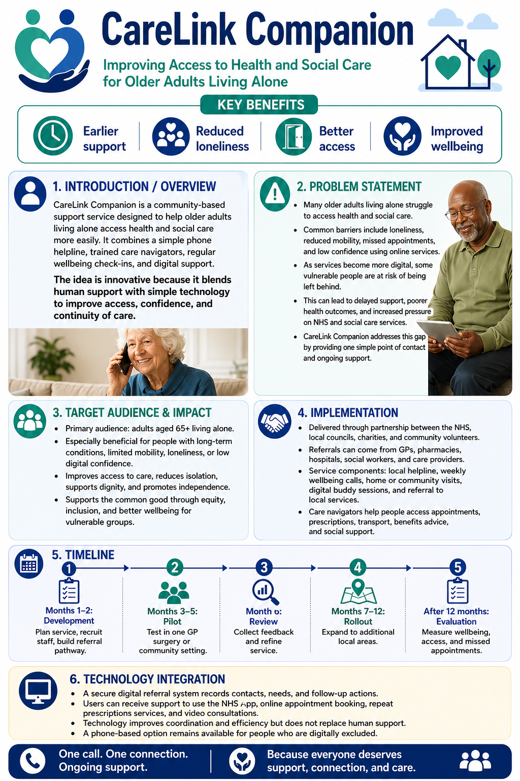
DISSEMINTATION
People will learn about Care Link Companion through GP surgeries, pharmacists, libraries, community centres, and local charities. Promotion could include posters, leaflets, local radio, social media, the NHS website, and community events. Health professionals will also receive brief training on how to refer people.

Task 2: The Pitch
Carelink Companion:
Improving Independence, Safety, and Connection For Older Adults Living Alone
Introduction:
The Innovation Care Link Companion is an advanced solution designed to support elderly individuals living alone, offering them a sense of security and connection. This technology typically integrates smart services, sensors, and communication tools to monitor the well-being of older adults and alert carers or family members if problems occur. It often features an emergency response system, health monitoring, medication reminders, and social interaction platforms. By bridging the gap between independence and safety, the Innovation Care Link Companion allows older adults to retain their independence while ensuring help is available when required.
This approach not only enhances the quality of life for older people but also reassures their loved ones worried about their well-being, and promotes person-centred care (NHS, England).
Background:
Older adults are more likely to need support from social care services due to long-term conditions, reduced mobility, bereavement, sensory impairments, or living alone. A key issue is loneliness and social isolation. Age UK reported that around 940,000 people aged 65 and over in the UK often feel lonely, and 270,000 older people in England go a week without speaking to a friend or family member. Loneliness can affect both mental and physical health, making it a significant public health and social concern (Age UK, 2024).
Another issue is that older adults may struggle to manage appointments, medication, and care information, especially when multiple professionals are involved. This can heighten anxiety for the individual and add pressure on families, unpaid carers, GPs, nurses, and social workers. NICE guidance emphasises the importance of supporting older people’s mental wellbeing and independence, particularly for those aged 65 and over who may be at risk of decline. Health and social care services are also moving towards more digital and personalised support. The Department of Health and Social Care states that digital transformation is a key priority for creating a more connected and personalised health and social care system.
Therefore, Care Link Companion will fill a genuine gap by integrating reminders, wellbeing support and communication into an accessible system.
Innovation description:
Care Link Companion will be specifically designed for older adults, especially those living alone, to manage long-term health and care needs. It won't be a complicated smartphone app. Instead, it will be accessible on a simple tablet or phone with a clear home screen, large icons, voice instructions, and options for family and professional support to assist with setup. This is important because digital support must be accessible and inclusive, particularly for those with sensory needs or limited digital confidence (NHS,2022).
The first key feature is medication reminders. The device will alert the user when it is time to take medication and allow them to press a button. If several reminders are missed, a nominated family member, carer, or professional could be notified. The second feature will be an appointment alert that reminds users about GP appointments, hospital visits, social care reviews, or community activities. This could reduce missed appointments and help adults feel more organised. The third feature will be a daily well-being check-in, where the user can answer simple questions, such as "How are you feeling today?" or "Do you need support?" using the smiley face button. If the person reports feeling unwell, lonely, or unsafe, Carelink Companion could suggest contacting a trusted person or local service. This links to the need to identify older people who may be at risk of reduced independence or declined mental well-being. The feature will include an emergency contact button that provides quick access to family members, carers, or emergency services if necessary. Finally, the innovation will incorporate a local support directory connecting older adults to services such as Age UK, community groups, transport schemes, lunch clubs, and social prescribing services. This makes the innovation more than just a reminder system; it becomes a companion that supports independence, safety, and social connection.
Impact on health and social care:
Carelink Companion could have a positive impact on older adults, families, carers, and professionals. For example, it might improve independence for older adults by helping them manage daily routines without constantly needing help from others. It supports dignity since the individual remains in control of their own care, which involves local authorities promoting personal wellbeing, including dignity, physical and mental health, protection from abuse and neglect, and control over daily life. It could also reduce loneliness by encouraging regular contact with family, carers, and community groups. This support recommends interventions that maintain independence and mental well-being among those aged 65 and over.
For families and unpaid carers, Care Link Companion could provide reassurance by easing the constant worry about whether their family members have taken medication or remembered appointments; they would receive updates only when support is needed. This could reduce carers' stress and enhance communication. For health and social care professionals, the innovation might enable earlier intervention; for example, repeated medication reminders, low-mood check-ins, or help requests could indicate that an older adult's needs are increasing. A GP, nurse, social worker, or occupational therapist could then intervene before the situation worsens. Care Link Companion could also support the broader goal of integrated care. Older adults might receive assistance from different individuals and services, but communication often becomes fragmented. By consolidating reminders, check-ins, contacts, and care information into a user-friendly system, this innovation could improve the quality of care and make services more responsive. This aligns with national aims for digital health and social care to deliver more connected, efficient, and personalised services.

Public and Stakeholder Involvement
Public stakeholders play a vital role in developing and implementing the Care Link Companion for older adults. These stakeholders include government agencies, healthcare providers, community organisations, and advocacy groups dedicated to promoting the well-being of older people. Family carers and unpaid carers should also be included because of their contributions to older adults. Healthcare professionals can help determine what information is useful and how alerts should be managed safely. Age UK links could support testing, training, and community connections. Advocacy groups could ensure the innovation safeguards choice, privacy, and independence. Public involvement would make the Care Link Companion more practical, as older adults may have concerns about technology, privacy, or feeling monitored (Department of Health and Social Care).

Policies, services and professional links
Care link companion links to the Care Act 2014, which requires local authorities to promote individual wellbeing and assess adults who may need care and support. This is important because elderly adults living alone might need help with daily tasks, safety, and social activities, such as contact or assessing services. It also aligns with the Equality Act 2010, as the service must be accessible to older adults and people with disabilities, sensory needs, language barriers, or low digital confidence.
The innovation also supports NHS and social care goals around prevention and early intervention; instead of waiting until an older adult reaches a crisis point, the Care Link Companion would help identify risks earlier. Professionals such as GPs, nurses, social workers, occupational therapists, pharmacists and social prescribers could all direct elderly adults to the service.
Existing services could also connect with Care Link Companion, including local authority adult social care, Age UK befriending services, community transport, falls prevention teams, mental health services, and voluntary organisations. This means the innovation would not replace professional care; instead, it will act as a bridge between elderly adults living alone and the support already available in the community (Care Act 2014).
Conclusion:
The Care Link Companion is essential because many elderly adults living alone face risks such as loneliness, falls, mixed medications, and delayed emergency support. The innovation will help older people stay safe, independent, and connected by providing daily check-ins, reminders, emergency information, and links to local services. It could improve well-being, support families, help professionals intervene earlier, and reduce pressure on health and social care services. With proper co-production and accessible design, the Care Link Companion will be practical and beneficial.

REFERENCES

Reference list
Age UK (2024). State of Health and Care of Older People in England 2024. [online] Age UK. Available at: https://www.ageuk.org.uk/discover/2024/september/state-of-health-and-care-of-older-people-in-england-2024/.
Care Quality Commission (2022). Innovation and Why It Is Important - Care Quality Commission. [online] www.cqc.org.uk. Available at: https://www.cqc.org.uk/publications/themes-care/innovation-why-it-important.
Department of Health and Social Care (2016). Care Act Factsheets. [online] GOV.UK. Available at: https://www.gov.uk/government/publications/care-act-2014-part-1-factsheets/care-act-factsheets.
Department of Health and Social Care (2025). Health and Care Act 2022. [online] GOV.UK. Available at: https://www.gov.uk/government/collections/health-and-care-act-2022.
GOV.UK (2010). Equality Act 2010. [online] Legislation.gov.uk. Available at: https://www.legislation.gov.uk/ukpga/2010/15/contents.
GOV.UK (2018). Data Protection Act 2018. [online] legislation.gov.uk. Available at: https://www.legislation.gov.uk/ukpga/2018/12/contents.
NHS (2022). Loneliness in Older People. [online] NHS. Available at: https://www.nhs.uk/mental-health/feelings-symptoms-behaviours/feelings-and-symptoms/loneliness-in-older-people/.
NHS England (2023). Digital transformation. [online] England.nhs.uk. Available at: https://www.england.nhs.uk/digitaltechnology/.
NICE (2012). 4 The role of stakeholders in the guidance development process | The NICE public health guidance development process (third edition) | Guidance | NICE. [online] www.nice.org.uk. Available at: https://www.nice.org.uk/process/pmg5/chapter/the-role-of-stakeholders-in-the-guidance-development-process.

