Dawid Trochim 1900457, Cyber Security & Networks
university of wales trinity saint david
Changemakers – E-Portfolio

Table of Contents
E-PORTFOLIO: 2
Mindmap: 2
Image-based presentation: 3
Video-based presentation: 4
Academic poster: 5
References 7

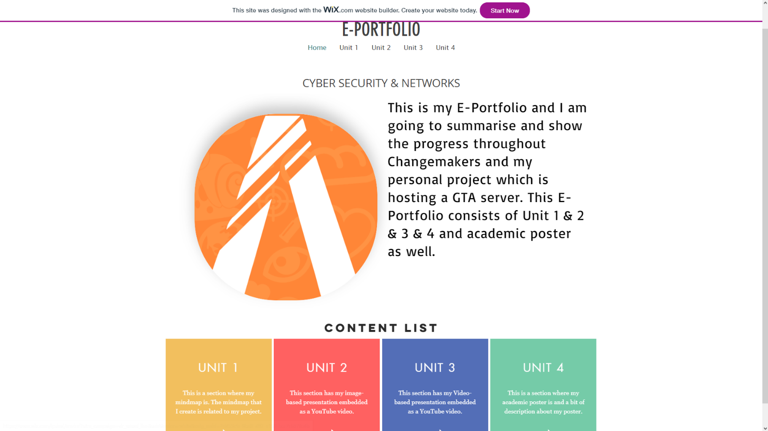
E-PORTFOLIO:
Link: https://emaildospamu19711.wixsite.com/dawidtrochim

Mindmap:
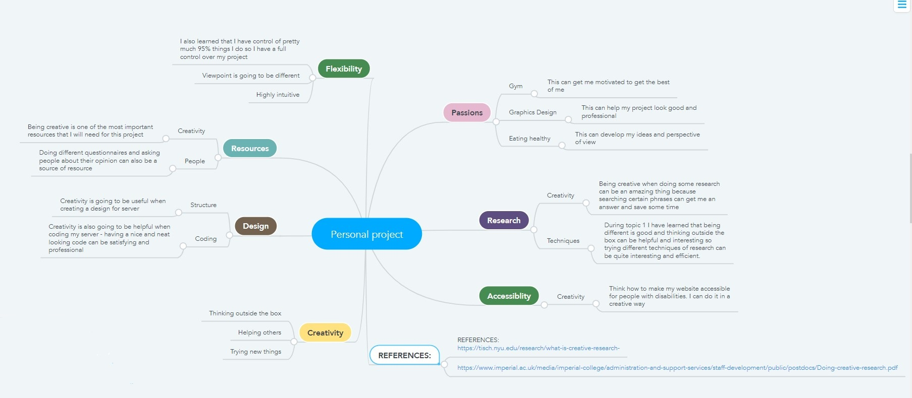
Link: https://www.mindmeister.com/1637488487?t=PbvqcaAGY8

MINDMAP REFERENCES: [1], [2]

Image-based presentation:
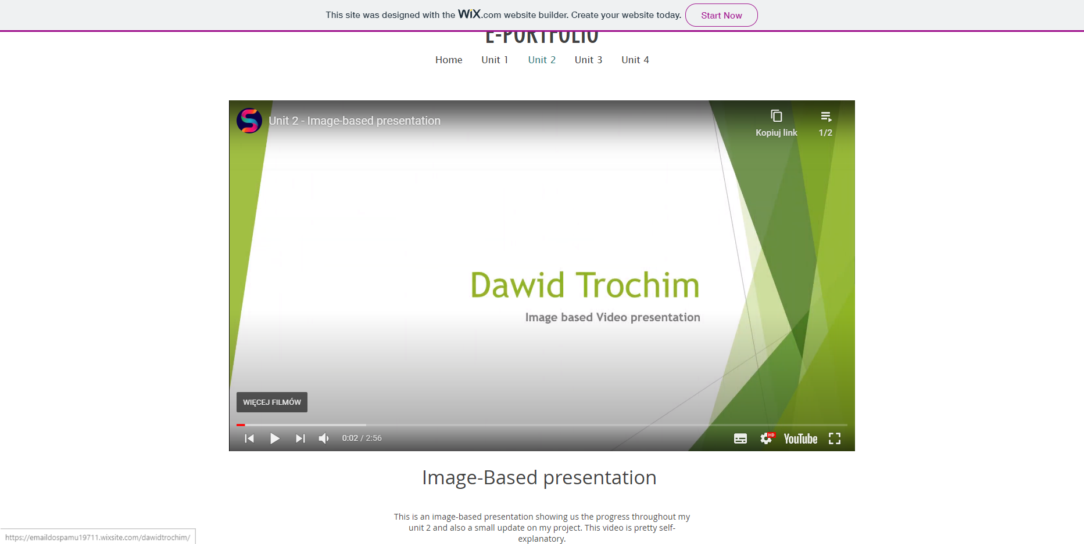
Link: https://emaildospamu19711.wixsite.com/dawidtrochim/unit-2

Video-based presentation:
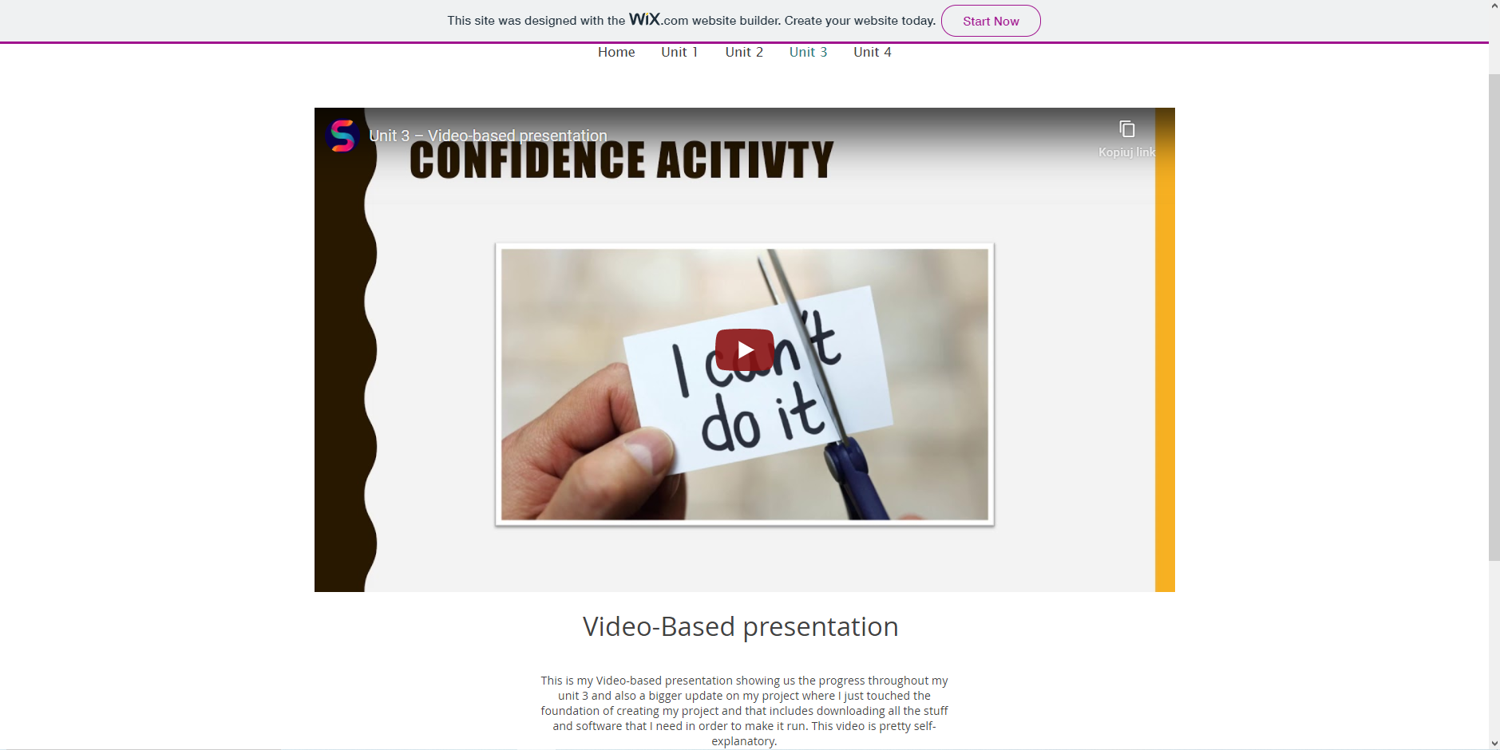
Link: https://emaildospamu19711.wixsite.com/dawidtrochim/unit-3

Academic poster:
Link (eportfolio): https://emaildospamu19711.wixsite.com/dawidtrochim/unit-4
Link (canva): https://www.canva.com/design/DAEM34Km8yA/uGMduFMFqT3XRZpupogvtQ/view?utm_content=DAEM34Km8yA&utm_campaign=designshare&utm_medium=link&utm_source=sharebutton
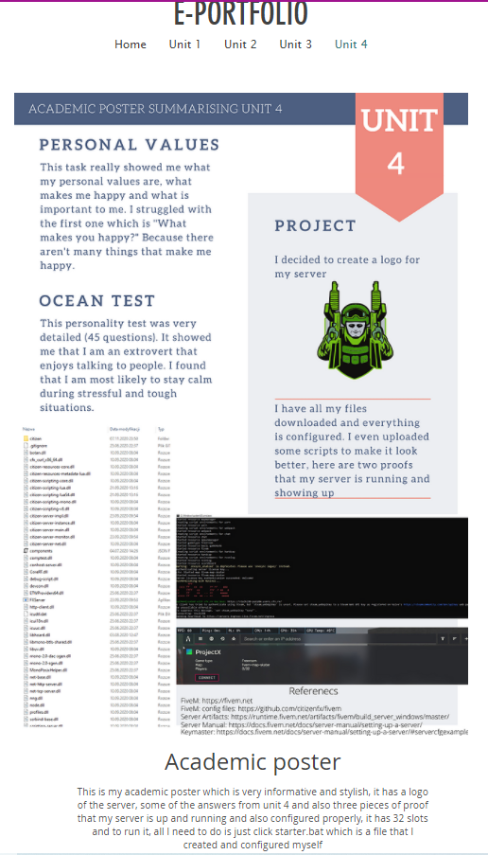

A3 Version:
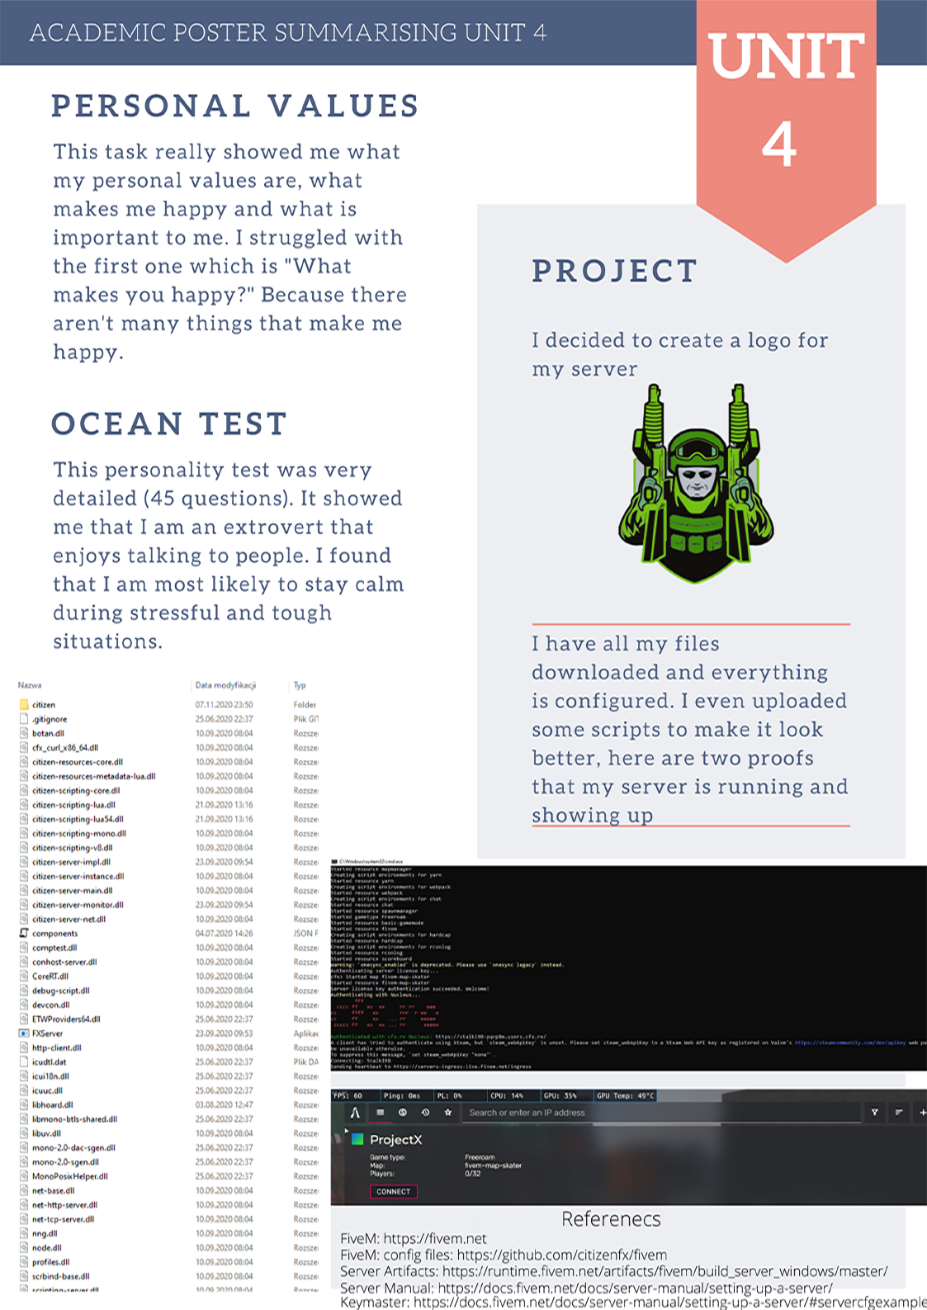

References

[1] | tisch.nyu, “what-is-creative-research-,” [Online]. Available: https://tisch.nyu.edu/research/what-is-creative-research-. [Accessed 25 11 2020].
[2] | Imperial College, [Online]. Available: https://www.imperial.ac.uk/media/imperial-college/administration-and-support-services/staff-development/public/postdocs/Doing-creative-research.pdf. [Accessed 25 11 2020].

