Phase 2 – Sustainability and Buildability Report
Construction Technology 2 – Assignment 2
Swansea bay sports park
Joseph Lewis
Introduction
I have been approached by a client with the intention of building a new hotel in the Swansea Bay area near the Swansea Bay Sports Park on Sketty Lane. As the client is inexperienced within the industry, he has asked me to provide a report on both the Construction Technology that would need to be included within the design of the building and a report on the Sustainability and Buildability of the project.
The client specified a medium to high rise hotel and previously tasked me with carrying out preliminary site investigations and surveys to gain knowledge on the site conditions, local environment and weather and environmental issues that could potentially impact the project. After this was carried out, I recommended that the best structural material for the project would be reinforced concrete due to the exposed nature of the site and the location that is close to the coast and has limited cover.
In this report, I will be discussing the sustainability and buildability of the proposed building based on my previous recommendations about building materials, climate and environment of the site and will provide further recommendations for the building. This report also aims to evaluate the environmental performance, sustainability strategies and buildability of the previously proposed design.
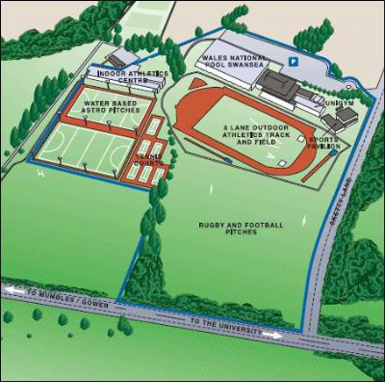
Figure 1 – Overview of the site with proposed building to be built on Rugby and Football Pitches area. (Google Images)

Environmental Impacts
In this section of my report, I will discuss the impact that the environment has on the construction of the building and how these impacts can be lessened or even incorporated into the design of the building.
Building Orientation
The orientation of the proposed hotel will significantly influence the environmental performance, internal comfort and operational efficiency of the hotel. It is one of the most important, early considerations when designing because it has a direct impact on natural lighting levels, solar heat gain and wind exposure which in turn affects ventilation considerations for the building.
Because of the exposed location of the proposed site, an orientation strategy would need to be developed and carefully balance the benefits and challenges of placing the building facing a certain direction.
Solar Gain and Daylighting
Correct orientation of the building can dramatically improve the buildings thermal performance. This means there could be a reduce reliance on both artificial lighting and heating systems. The most beneficial orientation for the hotel would be to have it south facing as it can benefit greatly passive solar heating during winter months and can reduce the energy needed to operate heating systems. However, if excessive glazing is placed on the south facing elevation, overheating can also take place during summer periods. As a control measure for this, shading devices may need to be installed or louvre systems to prevent excessive heat gain.
Below are solar path diagrams for the site during both the winter and summer months. There are vast differences in terms of daylight hours, potential solar gain and altitude of the sun that would need to be taken into consideration when in the design period for the hotel.
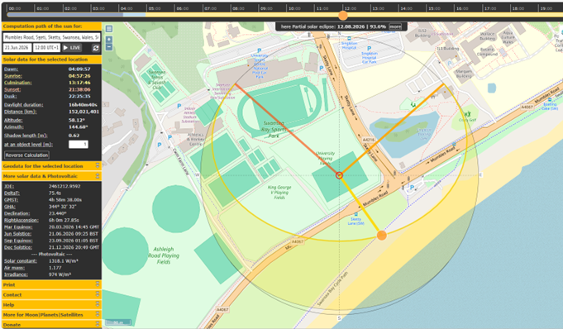
Figure 2 – Solar path diagram during the summer solstice (SunCalc)
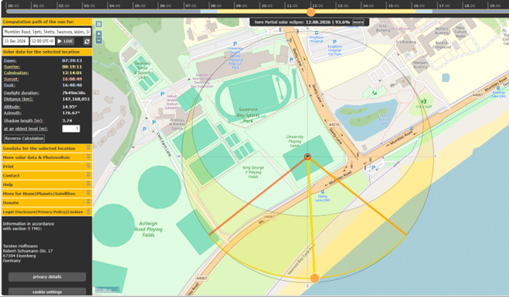
Figure 3 – Solar path diagram during the winter solstice (SunCalc)

Prevailing Wind Considerations
Wind is also a major factor to the orientation of a building. The prevailing winds within Swansea typically originate from the south-west, particularly during winter months where wind speeds can exceed 100 Kph during severe storms. For a medium to high-rise building, wind loading becomes a major structural and environmental consideration. As a result of this, the building should reduce excessive wind pressures on the south façade and should have minimal downdraught effects. If the building is poorly orientated, especially as a medium to high rise building, the base of the structure could suffer from accelerated wind conditions which would affect pedestrians and nearby public areas.
Natural Ventilation and Internal Comfort
Natural ventilation strategies can significantly improve occupant comfort and reduce operational energy consumption.
The coastal location provides opportunities to utilise prevailing breezes for passive cooling during warmer periods. Cross-ventilation can be achieved by strategically locating operable windows and ventilation openings across the building.
However, due to the height of the proposed hotel and the severity of coastal winds, unrestricted natural ventilation may create discomfort for occupants. Therefore, a mixed-mode ventilation strategy may be more appropriate.
This could include:
- Mechanical Ventilation with Heat Recovery (MVHR)
- Controlled natural ventilation systems
- Automated façade vents
- Pressure-controlled ventilation openings
Mechanical Ventilation with Heat Recovery systems are particularly beneficial because they:
- Improve indoor air quality
- Recover heat from extracted air
- Reduce heating demand
- Improve energy efficiency
- Reduce condensation risks
Careful orientation can also reduce the risk of overheating within guest rooms while maintaining thermal comfort throughout the year.
Views and Guest Experience
Orientation is also important from a commercial and architectural perspective.
Hotels rely heavily on the quality of guest experience, and maximising views towards Swansea Bay and the coastline would significantly improve the appeal and value of premium rooms.
Guest rooms facing the coastline would benefit from:
- Enhanced natural lighting
- Sea views
- Improved visual connection to the landscape
- Increased marketability
Communal spaces such as restaurants, lounges, and rooftop facilities should also be positioned to take advantage of views across the bay.
Relationship with the Surrounding Environment
The orientation and layout of the building should also respond sensitively to the surrounding urban environment.
Careful positioning of the building can minimise:
- Overshadowing of nearby areas
- Visual dominance over surrounding buildings
- Loss of daylight to adjacent spaces
Because the site is adjacent to recreational facilities and open green space, maintaining public visual access towards Swansea Bay is important.
A stepped building form or strategic orientation could help reduce the perceived scale of the hotel while integrating more successfully into the local environment.
Overall, building orientation will play a fundamental role in ensuring the proposed hotel achieves high environmental performance, occupant comfort, sustainability, and long-term operational efficiency while responding appropriately to the exposed coastal conditions of Swansea Bay.
Building Life Cycle and Material Durability.
In this section of my report, I will discuss the building materials that were mentioned in my previous report and how these could have an impact on the environment.
Structural Frame
As stated in my previous report, I recommended that the building would benefit greatly from a reinforced concrete frame due to the exposed and windy environment around the hotel. Reinforced concrete performs well under moist and windy conditions which is ideal for the coastal location. Also, it is very fire resistant and requires little long term maintenance compared to exposed structural steel in these conditions.
To improve the sustainability of the structure, low-carbon concrete mixes containing Ground Granulated Blast Furnace Slag (GGBS) or Pulverised Fuel Ash (PFA) could be used to reduce embodied carbon during construction. Recycled steel reinforcement could also be specified to improve environmental performance.
The external envelope materials should be selected based on long-term durability and resistance to coastal weathering. Marine-grade aluminium cladding and corrosion-resistant glazing systems are recommended due to their ability to withstand salty air and moisture exposure. Non-combustible cladding systems would also improve fire safety and compliance with modern building regulations.
The building should also be designed to allow future maintenance and replacement of external façade components without major disruption. This would improve the overall service life of the development and reduce long-term operational costs.
At the end of the building’s operational life, many of the materials used within the structure could be recycled or reused, particularly steel reinforcement, aluminium façade systems and glazing materials. Designing the building with adaptability and future refurbishment in mind would further improve the sustainability of the project.
Aesthetics and Local Environment
The proposed hotel should provide a modern architectural landmark while remaining sympathetic to the surrounding environment and existing buildings within the Swansea Bay area.
The surrounding area contains a mixture of university buildings, sports facilities, residential areas and healthcare buildings such as Singleton Hospital. Therefore, the hotel should avoid overpowering the local landscape or negatively affecting the character of the coastal environment.
A combination of glazed façades, durable cladding panels and carefully selected architectural features could help the building achieve a modern appearance while maintaining visual compatibility with surrounding developments. The use of lighter coloured façade materials could also reflect the coastal character of Swansea Bay and reduce heat absorption from solar radiation.
Landscaping around the site would play a major role in improving the visual appearance of the development. Green spaces, pedestrian routes and planted areas would soften the visual impact of the building while improving biodiversity and public amenity.
The inclusion of sustainable architectural features such as green façades and roof planting would further improve the visual appeal of the hotel and demonstrate environmental responsibility.
Façade Greening and Sustainable Urban Drainage Systems (SUDS)
Sustainable methods of creating a building are becoming more common within the construction industry. In this section I will discuss the possible methods and how they could benefit the hotel in the proposed area.
Façade Greening
Green façades and vertical planting systems could provide several environmental and aesthetic benefits for the proposed hotel development.
A green façade system involves vegetation growing across sections of the external building envelope either through climbing plants or modular planting systems attached to the façade. These systems can improve biodiversity, reduce urban heat island effects and improve air quality around the building.
One major benefit of façade greening is thermal performance improvement. Vegetation can provide additional solar shading to external walls, helping to reduce heat gain during summer months and lowering cooling energy demands within the hotel. Green façades can also improve insulation during colder periods by providing an additional protective layer against wind exposure.
Due to the exposed coastal environment, careful selection of plant species would be essential. Salt-tolerant and wind-resistant vegetation would need to be specified to ensure long-term survival and minimise maintenance requirements.
Green façades can also improve acoustic performance by helping to absorb external noise from nearby roads and public areas. This would benefit hotel occupants by improving comfort levels within rooms facing busy surrounding areas.
However, there are also challenges associated with façade greening systems. Regular maintenance, irrigation requirements and long-term management costs must be considered during the design process. Structural support systems would also need to be designed to accommodate additional loading from planting systems and retained moisture.
Despite these challenges, façade greening could significantly improve the environmental performance and appearance of the proposed hotel.
Sustainable Urban Drainage Systems (SUDS)
The implementation of Sustainable Urban Drainage Systems (SUDS) would be highly beneficial for the proposed development due to the risk of surface water flooding within parts of the Swansea Bay area.
Although the proposed site itself is considered relatively low risk, nearby areas such as Singleton Park and Oystermouth Road are susceptible to flooding during extreme weather events. Therefore, surface water runoff from the development should be carefully managed.
There are several systems that could be implemented into the design of the hotel. For example.
  - Permeable Paving Systems
  - Rain Gardens
  - Attenuation Tanks
  - Green Roofs
  - Underground Rainwater Storage Systems

Permeable paving within car parking and pedestrian areas would allow rainwater to infiltrate naturally into the ground, reducing pressure on local drainage systems. Swales and landscaped drainage channels could also direct and temporarily store surface water during periods of heavy rainfall.
Green roofs could provide additional benefits by slowing surface water runoff, improving biodiversity and increasing thermal insulation within the building. Rainwater harvesting systems could also collect roof drainage for reuse in irrigation or greywater systems within the hotel.
The implementation of SUDS would help reduce flood risks, improve water quality and support sustainable site management practices while complying with modern environmental planning guidance.

Buildability
The proposed reinforced concrete frame structure is considered practical and appropriate for the scale and location of the development. Reinforced concrete construction offers excellent durability, structural stability and fire resistance which are critical for a medium to high rise hotel located within an exposed coastal environment.
A reinforced concrete core combined with reinforced concrete floor slabs would provide strong lateral stability against wind loading while improving acoustic separation between hotel rooms.
The preferred construction method would likely involve an in-situ reinforced concrete frame with a combination of traditional and prefabricated construction elements. Slip-form or jump-form systems could be used for the construction of the central core to improve efficiency and speed during the structural phase.
Prefabricated bathroom pods could be manufactured off-site and installed once floor structures are complete. This approach would reduce on-site labour, improve quality control and shorten the construction programme.
Additional prefabricated elements such as façade panels, precast stairs and modular service risers could also improve efficiency and reduce waste generation during construction.
Site Logistics
The proposed site for the hotel produces numerous challenges for the logistics of the site. Firstly, the site is near busy public facilities that include Swansea University and Singleton Hospital. Construction traffic would need to be managed efficiently to prevent disruption to either of these or pedestrian routes. Dedicated delivery schedules and temporary access arrangements may need to be made with suppliers to reduce congestion around the site.
But, due to the relatively open nature of the site, sufficient storage space could be available close to the site and room for crane operations would be sufficient. Although, due to the coastal area, crane operations could get regularly delayed here due to coastal wind conditions.

Structural complexity, Sequence and Timeline
The proposed hotel would involve a number of moderate complex methods due to the building height, coastal exposure and façade requirements. As a result of this, I have created a proposed construction timeline based on this.

Stage | Construction Activity | Estimated Duration | Key Activities
1 | Site Preparation and Ground Investigation | 4–6 Weeks | Site clearance, fencing, welfare setup, temporary access roads, detailed geotechnical surveys, borehole investigations and environmental assessments
2 | Installation of Piled Foundations | 6–8 Weeks | Bored pile installation, pile testing, reinforcement installation and concrete pouring
3 | Construction of Pile Caps and Ground Floor Slab | 4–5 Weeks | Excavation for pile caps, reinforced concrete pile caps, ground beams and reinforced concrete slab construction
4 | Construction of Reinforced Concrete Core | 8–10 Weeks | Slip-form or jump-form construction of stairwells, lift shafts and central stability core
5 | Installation of Floor Slabs and Structural Frame | 12–16 Weeks | Construction of reinforced concrete columns, beams and upper floor slabs on a floor-by-floor sequence
6 | Façade Installation | 8–10 Weeks | Installation of cladding systems, curtain walling, glazing systems and weatherproof envelope
7 | Mechanical and Electrical Services Installation | 10–12 Weeks | Installation of HVAC systems, plumbing, electrical containment, fire protection systems and communications infrastructure
8 | Internal Fit-Out and Finishing Works | 12–14 Weeks | Partition walls, prefabricated bathroom pod installation, flooring, ceilings, decoration, furniture and hotel room finishing
9 | External Landscaping and SUDS Installation | 4–6 Weeks | Car parks, permeable paving, swales, drainage systems, green spaces, lighting and final external works
Any adverse weather conditions due to the coastal exposure could be a potential challenge but the project still remains feasible providing careful planning and sequencing takes place.
Safe and Sustainable Construction Methods
The proposed design supports safe and sustainable construction processes through both material selection and construction methodology.
The use of reinforced concrete provides excellent fire resistance and structural robustness during both construction and occupancy. Prefabricated elements reduce the amount of high-risk site activities and improve quality assurance.
Modern construction safety measures would need to include:
- Tower crane safety procedures
- Wind monitoring systems
- Safe lifting operations
- Temporary works coordination
- Strict site access controls
From a sustainability perspective, the project could reduce environmental impacts through:
- Use of recycled materials
- Reduced waste through prefabrication
- Low-carbon concrete mixes
- Sustainable drainage systems
The project could also aim to achieve a recognised environmental assessment standard such as BREEAM Excellent to demonstrate its commitment to sustainable construction and operational efficiency.
Conclusion
In conclusion, the proposed Swansea Bay hotel development presents a practical and sustainable opportunity to support tourism and economic growth within the local area. Due to the exposed coastal location and environmental conditions, careful consideration must be given to the building’s orientation, structural design, material selection and long-term durability.
Overall, the proposed hotel development has the potential to become a durable, sustainable and visually appealing landmark within the Swansea Bay area while supporting both the local environment and the wider tourism industry.
References
British Geological Survey (1999) Borehole investigation records for the Wales National Pool site, Swansea. Nottingham: British Geological Survey. Available at: https://www.bgs.ac.uk
(Accessed: 7th May 2026)
Natural Resources Wales (2024) Flood risk maps for Swansea Bay and surrounding areas. Available at: https://naturalresources.wales/evidence-and-data/maps/flood-risk-map/
(Accessed: 8th May 2026)
HM Government (2019) Approved Document B: Fire Safety. London: HM Government. Available at: https://www.gov.uk/government/publications/fire-safety-approved-document-b
(Accessed: 8th May 2026).
HM Government (2021) Approved Document L: Conservation of fuel and power. Available at: https://www.gov.uk/government/publications/conservation-of-fuel-and-power-approved-document-l
(Accessed: 8th May 2026).
Institution of Structural Engineers (2020) Structural use of concrete buildings. London: IStructE. Available at: https://www.istructe.org
(Accessed: 8th May 2026).
The Concrete Centre (2022) Sustainable Concrete and Low Carbon Construction. Available at: https://www.concretecentre.com
(Accessed: 9th May 2026).
Health and Safety Executive (2023) Construction Design and Management Regulations (CDM 2015). Available at: https://www.hse.gov.uk/construction/cdm/2015/index.htm
(Accessed: 9th May 2026).
BSI Group (2004) BS EN 1992-1-1: Eurocode 2 – Concrete structures. London: BSI. Available at: https://www.bsigroup.com
(Accessed: 9th May 2026).
BSI Group (2004) BS EN 1997-1: Eurocode 7 – Geotechnical design. London: BSI. Available at: https://www.bsigroup.com
(Accessed: 10th May 2026).
CIRIA (2015) The SUDS Manual (C753). London: CIRIA. Available at: https://www.ciria.org/Resources/Free_publications/The_SuDS_Manual_C753.aspx
(Accessed: 10th May 2026).
Institution of Civil Engineers (2019) Manual of Construction Materials. London: ICE Publishing. Available at: https://www.ice.org.uk
(Accessed: 10th May 2026).

