  Report  Individual Project Report | Krum Marinov ID_1922542  LECTURER Dr. Eric Osei GLOBAL BUSINESS ENVIRONMENT LCBB 4005_BIRM

Table of Contents

1. Introduction 3
2. Company Profile 3
3. PESTEL Analysis 4
4. Value Network 11
5. Porter 5 forces 13
6. Conclusion 14
References 16

Introduction
As global busnes environment we understand environment in a different independent countries with extrinsic factors to the organisation which could be different than the organisation home environment. The global business environment can be devided to external or internal environment The aim of this report is to discuss primarily external factors of a selected company that operates in multiple regions. External environment(PESTEL)include -Political,Economical,Social,Technological,Environmental and Legal factors affecting strategies and decisions of the organisation. Also Porter 5 forces aims to analyse the overall industry and further observe the changes in customer demand. In addition to that, the paper further focuses on the global environment for improving the weaknesses or overcoming the challenges. The selected company is BMW which is worldwide popular car company and is also known for their extensive marketing and branding strategies that further helped them to gain competitive advantages from the market thereby enhancing the rate of sales and popularity (Sovacool et al. 2019). BMW is also known as Bayerische Motoren Werke AG is marketed under the brand name of BMW, Rolls-Royce and Mini whereas the motorcycles are considered under the brand name of BMW Motorrad (Ershova and Kuznetsov 2019).

Company Profile
BMW is one of the popular German multinational organization that was founded in the year of 1916. Studies shows that the company manufactured range of aircraft engines in 1917 and continued till 1918 (Sovacool et al. 2019). It has been analysed that the automobiles of this brand are marketed as BMW and Rolls-Royce apart from Mini.Due to their effective business strategy the company is twelfth-largest producer of motor vehicles.
The growth rate of BMW is 5% in 2020, which is forecasted to grow less than the previous year. It has been analysed that pandemic outbreak has negatively affected the brand further resulting in potential economic loss. In addition to that, studies also show that the growth revenue of this brand is estimated to fall by 20% in the market (Belhadi et al. 2021). On the other hand, the brand is estimated to gain a 104 billion euros profit in 2019 (Belhadi et al. 2021). In the first quarter of 2020, the brand gained total revenue of 23.25 billion euros with the growth rate of 3.5% (Belhadi et al. 2021). On the other hand, it fell by 20.6% after the worldwide lockdown, which affected their brand image (Belhadi et al. 2021).

PESTLE Analysis
Political factors:
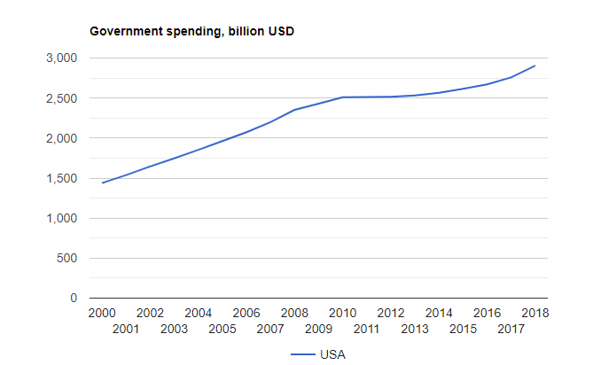
Figure 1: Government spending in billions from 2000 to 2018
Source: theglobaleconomy.com
Political factor plays an important role to a firm as that helps them to determine the benefits and risks of a brand. In this case, the brand is faced with higher political advantage in the market due to favourable external factors. It has been observed that the market of United States is comparatively higher than the other nations, which also helped them to expand their customer base in the US more than the other regions across the world (Lewin 2016).
In the study published by Shtal et al. (2018), the political factor operates in more than 15 nations and hence it has helped them to increase the range of funds and profits as well as the brand image. In addition to that, studies also show that the brand was faced with political instability that affected their consumer’s ability for buying or changing the buying patterns. On the other hand, this brand invested in multiple nations that was comprised of political instability where the investments might be faced with potential risks.
Economic factor:
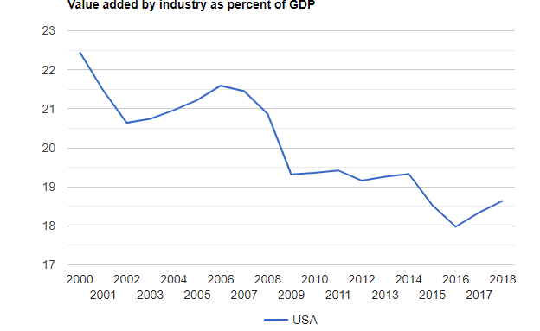
Figure 2: Value added by industry as percent of GDP
Source: theglobaleconomy.com
Previously, the concerned brand was considered as one of the most reputable companies in the entire world however, at present, it is faced with stiff competition in the market. One of the closest market competitors of this brand includes Toyota, Audi, Porsche and Ford among others. As a result, it has affected their revenue margin by 10% further reducing their valuation or profits (Xu 2019).
Analysing the above statistics, it can be observed that the firm is faced with unfavourable economic factors due to fall of share in the GDP. In addition to that, the brand is also faced with the changes in customer demand and rise of competition. It has been analysed that the growth rate has dropped by 20% in the year of 2020 due to fall of market share and customer demand (Belhadi et al. 2021). Studies shows that market competition provides a massive challenge to a firm or any business, which will also create a negative impact further resulting in economic loss (Ershova and Kuznetsov 2019).
Social factor:
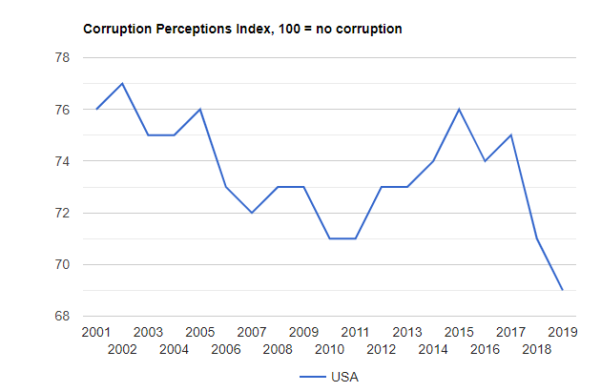
Figure 3: Corruption perceptions index
Source: theglobaleconomy.com
In the statistical data published, it can be analysed that BMW witnesses’ several advantages with their social factor in the US market. This is due to the fluctuations in global economy that created a negative impact over the performance of BMW as well as their overall valuation and also on the profits. Studies shows that fluctuations led to massive impact in company’s success and over the last few years, corruptions in US market has also reduced further enhancing the rate of organizational success (Jovanović et al. 2017).
Brand image is another important factor with the overall growth and development of a firm hence, most of the multinational firms are observed to focus on the development of marketing strategies in order to improve customer perception towards the brand. Other than that, it can be analysed that individual countries are comprised of different cultures and beliefs, which means the brand is assumed to adjust products and marketing with respect to the cultural differences. In case of BMW, the brand is observed to adapt with various changes according to each market with the help of one-size fit all approach that might help them to yield results (Jovanović et al. 2017).
Technological factor:
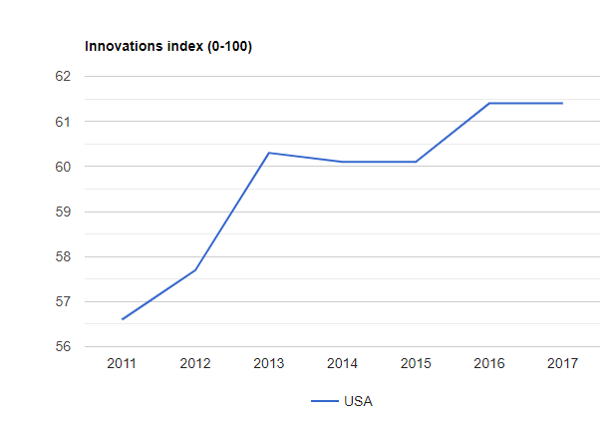
Figure 4: Innovations index
Source: theglobaleconomy.com
Technological factors include ability of a nation to promote artificial intelligence in the market, however, analysing the data it can be observed that the market of US and Europe is faced with favourable external factors. In addition to that, the rising competition of automotive industry has helped the brand to stand out or gain a competitive edge through various innovative and adaptative business strategies (Ershova and Kuznetsov 2019). With the innovation abilities of Tesla and Ford, the brand (BMW) witness major setbacks from the market.
Studies shows that BMW group is highly dependent on innovation as well as mobility which is reflected in automatic car parking, autonomous driving and hybrid vehicles (Jovanović et al. 2017). Autonomous driving plays an important role in the automobile industry hence, with the help of innovation facilities, BMW has been able to expand their market or entire customer base.
Environment factor:
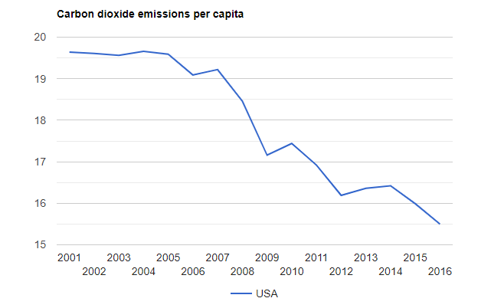
Figure 6: Carbon dioxide emissions per captia
Source: theglobaleconomy.com
Environmental sustainability is an essential component for a brand as that helps a brand to promote their brand image in the industry. In this case, it can be analysed that the emission of CO₂ has led to major setbacks to the automobile industry. Government implications and policies towards implementation of environmental sustainability has resulted many brands to change their equipment and machineries resulting in rise of business expenses.
Studying the provided statistical data, it can be observed that carbon dioxide emissions per captia has lowered due to governmental implications. In addition to that, it can be analysed that BMW has focussed on implementing effective measures for supporting various environmental causes (Jovanović et al. 2017).

Legal factor:
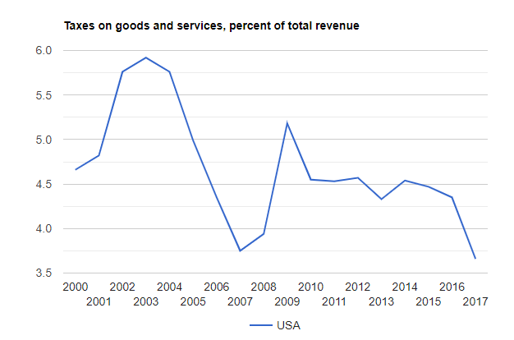
Figure 5: Taxes on goods and services, percent of the total revenue
Source: theglobaleconomy.com
Determination of tax for the brand is essential in order to identify potential risk or advantage for the firm. It has been analysed that taxes on goods and services in the external market of US and Europe is highly favourable which further enhanced the rate of organizational success. BMW Group is observed to abide copyright laws associated with their busines and also on the technology incorporated such as Bluetooth and WiFi (Jovanović et al. 2017).
Studies shows that automobile industry should focus on taxation rate due to the change of laws in each country. Analysing the data provided, it can be observed that the taxation rate of US market is observed to reduce at a huge rate that further enhanced the brand’s abilities to gain higher profit-margin or increase the sales of this brand in the external marketplace.

Value Network
- Primary activities of BMW
Value network plays an integral part for the business and hence, in this case, it has been observed that BMW aims to develop strong value network with the help of appropriate marketing strategies (Xu, Blankson and Prybutok 2017). Studies shows that the brand is comprised of more than 12,000 suppliers around the world due which, they have been able to reach maximum number of customers and improve their profit-margin (Jovanović et al. 2017). In addition to that, the largest supplier network of this brand is analysed to be located in Germany which helps the brand with accumulation of 38% raw materials alone in 2018 (Ershova and Kuznetsov 2019).
- Inbound logistics of BMW:
On the other hand, reports states that the brand gained 22.4% from various regions of Eastern Europe and 17% raw materials from Western Europe whereas gaining 14.9% of raw materials from the North America (Ershova and Kuznetsov 2019). Another study shows that DHL is one of the leading logistics partners of BMW that provides ample opportunities to this brand in the market. The logistics provider supports this brand with various business operations and further assists with outbound logistics (Xu, Blankson and Prybutok 2017).
- BMW operations
As the brand operates in multiple regions around the world hence, the global operations span is observed to be in more than 140 countries (Jovanović et al. 2017). Studies shows that the brand consists of 31 production location in more than 15 nations, which reflect their success in the market (Jovanović et al. 2017). Some of their business operations are also owned by BMW Brilliance Automotive joint venture of China.
- Marketing and sales in BMW
BMW is analysed to maintain a strong brand image in the international market with consistent focus over innovation as well as quality. Due to their high concern about customer loyalty, the brand uses extensive digital marketing. Studies shows that this brand is highly active in their social media accounts and hence, that has helped them to promote customer engagement.
Support Activities
- Technology
Competition is high in the automobile industry and hence, implementation of advanced technology will provide competitive benefits to a firm. In this case, BMW is observed to invest in various technological innovation. This is also reflected in the 16 research and development centre among which six are located in Germany (Jovanović et al. 2017). Studies shows that the investment increased by 12.8% from the previous year (2019) (Ershova and Kuznetsov 2019).
- Human resource management
Due to the rise in competition, businesses are observed to invest in recruiting talented or highly skilled employees. BMW is reported to hire a total 1,34,862 employees in 2018 which is higher than the previous year (2017) (Ershova and Kuznetsov 2019). In addition to that, the attrition segment for this year has remained at 2.78%, which showed higher employee satisfaction as well as employee retention (Ershova and Kuznetsov 2019).
- Infrastructure
Generally, the brand (BMW) is divided in two major business segments - automobile and motorcycle. BMW also comprises of finance segment apart from legal & procurement. With the focus on AI and innovative technologies, this firm has been able to develop their value chain or supplier network worldwide.

Porter 5 forces
Company’s competitive environment: Some of the notable rivals or competitors for BMW in the market includes Audi, Toyota, FCA as well as Ford apart from Mercedes. As the threat of new market entrants is low however, presence of various multinational automobile business resulted in an aggressive market (Kushwaha and Sharma 2016).
- Potential new market entrants: Studies shows that the threat for new market entrants in the overall automobile industry is considerably low due to higher entry as well as exit barriers (Geramian et al. 2017). Even though the entry barriers have been rising remarkably, the exit barriers are also observed to rise due to higher investment (Geramian et al. 2017).
- Bargaining power of suppliers: The negotiating power of a supplier is affected by various external factors such as supplier’s concentration, firm’s size and concentration of the buyers (Hashmi and Biesebroeck 2016). Analysing the value chain of BMW, it can be observed that the firm operates in more than 70 nations with approximately 12000 suppliers (Ershova and Kuznetsov 2019). However, several supply chain partners are involved with the auto firm and their aim is to manufacture wide range of BMW vehicles in the market.

- Bargaining power of customers: The bargaining power of customers for BMW is analysed to be low or weak force because, this firm focuses on sustaining product quality. In addition to that, the firm also focuses on promoting their brand image with the help of social media marketing, which provides various advantages. However, it is studied that the bargaining power of customers are observed to have grown extensively due to rise in competition and constant change in consumer needs (Guajardo, Cohen and Netessine 2016).
- Presence of substitute products: This is an important factor for this business as it reflects the demand and profitability ration of an automobile brand (Smys and Ranganathan 2019). The external factors for automobile industry support the growth of various small and medium automobile business however, BMW has established their position in the market (Gopal and Thakkar 2016). As a result, it can be assumed as a weak force for the brand in the automobile industry.

Conclusion
Lastly, the paper can be concluded by saying that BMW is one of the popular automobile manufacturers around the world due to their effective brand strategy and also due to their proper marketing planning. Studying the PESTEL analysis, it can be observed that BMW is faced with potential advantage in the US and several European market, which further increases their ability to expand their customer base. On the other hand, studies show that value chain or supply-chain network of BMW is based on mostly European market. Finally, the industrial analysis shows that BMW faces a strong force with threats to market entrants and bargaining power of customers due to their ability in marketing and customer engagement.

References
Belhadi, A., Kamble, S., Jabbour, C.J.C., Gunasekaran, A., Ndubisi, N.O. and Venkatesh, M., (2021). Manufacturing and service supply chain resilience to the COVID-19 outbreak: Lessons learned from the automobile and airline industries. Technological Forecasting and Social Change, 163, p.120447.
Ershova, A.E. and Kuznetsov, A.N., (2019). Strategy competitive development of the company BMW group. Business Strategies.
Geramian, A., Mehregan, M.R., Mokhtarzadeh, N.G. and Hemmati, M., (2017). Fuzzy inference system application for failure analyzing in automobile industry. International Journal of Quality & Reliability Management.
Gimmy, G., Kanbach, D., Stubner, S., Konig, A. and Enders, A.,( 2017). What BMW’s corporate VC offers that regular investors can’t. Harvard business review, pp.2-6.
Gopal, P.R.C. and Thakkar, J., (2016). Sustainable supply chain practices: an empirical investigation on Indian automobile industry. Production Planning & Control, 27(1), pp.49-64.
Guajardo, J.A., Cohen, M.A. and Netessine, S.,(2016). Service competition and product quality in the US automobile industry. Management Science, 62(7), pp.1860-1877.
Hashmi, A.R. and Biesebroeck, J.V., (2016). The relationship between market structure and innovation in industry equilibrium: a case study of the global automobile industry. Review of Economics and Statistics, 98(1), pp.192-208.
Jovanović, T.A.N.J.A., Bansemir, B.A.S.T.I.A.N., Kirchner, M.A.R.T.I.N. and Voigt, K.I., (2017). The crowdfunding idea contest of BMW. In Proceedings of the 26th international association for management of technology conference, Vienna, Austria.
Kushwaha, G.S. and Sharma, N.K., (2016). Green initiatives: a step towards sustainable development and firm's performance in the automobile industry. Journal of cleaner production, 121, pp.116-129.
Lewin, T., (2016). The BMW Century: The Ultimate Performance Machines. Motorbooks International.
Shtal, T., Buriak, M., Ukubassova, G., Amirbekuly, Y., Toiboldinova, Z. and Tlegen, T., (2018). Methods of analysis of the external environment of business activities.
Smys, S. and Ranganathan, G., (2019). Robot assisted sensing control and manufacture in automobile industry. Journal of ISMAC, 1(03), pp.180-187.
Sovacool, B.K., Rogge, J.C., Saleta, C. and Masterson-Cox, E., (2019). Transformative versus conservative automotive innovation styles: Contrasting the electric vehicle manufacturing strategies for the BMW i3 and Fiat 500e. Environmental innovation and societal transitions, 33, pp.45-60.
Xu, L.U., Blankson, C. and Prybutok, V., (2017). Relative contributions of product quality and service quality in the automobile industry. Quality Management Journal, 24(1), pp.21-36.
Xu, X., 2019. Assessment of Profitability of the Company BMW AG.

