Programme: Certificate in Higher Education Business Skills for the Workplace
Module: Enterprise and Entrepreneurship
Module code: LCLM4006

Title: GreenDesk Co-Working Café Ltd: A Hybrid Workspace Solution for Birmingham

Lecturer: Birmingham: Dr Chung Lai Johnny Wan
Student name: Elisa Macelaru
Student ID: 2437929

Executive Summary
GreenDesk Co-Working Café Ltd is a co-working hybrid workspace located in Birmingham that will benefit students, freelancers and remote employees. The business integrates low cost co-working to a cafe-family which enhances productivity and community. The increasing trends of hybrid working and the need to achieve flexibility in study areas provide the good market potential. GreenDesk is a Private Limited Company, which needs a starting capital of £28,000 to start operations. By offering competitive prices, partnering with universities and digital marketing, the business will gain sustainable growth and break even in the first year of operation.

Table of Contents
Executive Summary 2
1. Overview of the Business Idea 4
2. Market Research 5
2.1 Industry Overview 5
2.2 Target Market Analysis 5
2.3 PESTEL Analysis 5
2.4 Competitive Analysis 7
3. Marketing Communications 8
3.1 Marketing Objectives 8
3.2 Targeting and Positioning Strategy 8
3.3 Marketing Mix Strategy 9
4. Financial Plan 11
4.1 Funding Requirement 11
4.2 Sources of Funding 11
4.3 First Month Start-Up Costs 11
4.4 Revenue Projections 12
5. Conclusion 13
References 14

1. Overview of the Business Idea
GreenDesk Co-Working Café Ltd is a start-up of Birmingham that offers the experience of a professional co-working space with the atmosphere of a high-quality cafe. The company will target university students, people working in a remote area or freelancers and need to work in an inexpensive, flexible and productive workspace that is not within their homes (Greendesk, 2025). Most people find it hard to hard to concentrate, space or there is no networking opportunity when they have to work remotely. GreenDesk solves this issue by providing designed quiet spaces, group workstations, fast Wi-Fi and luxurious desk amenities with healthy food and drinks.
The company will be in the form of a Private Limited Company (Ltd) to reduce personal liability as well as improve the credibility in the eyes of the lenders and other potential investors. The revenue will be achieved by selling hourly passes, monthly member-ships and cafe sales. The first pricing strategy will be penetration pricing strategy to draw in students and create a loyal customer base (Barringer and Ireland, 2021).
GreenDesk also focuses on productivity and community instead of simply social interaction, which is the distinguishing feature of the existing cafes. Moreover, routine networking and competency workshops will enhance the customer interaction and retention (Kotler and Armstrong, 2018). The lean management framework will help control costs in the initial stages, which will help sustain it financially as well as allow it to grow in the long term in the developing student and freelance market in Birmingham.

2. Market Research

2.1 Industry Overview
The introduction of hybrid and remote working has developed the UK co-working industry massively. More freelancers and students are demanding flexible and affordable workspaces. At the same time, the desire to experience the environment in a cafe is increasingly on the rise, which is why business models of hybrid workspace-cafes like GreenDesk have high business prospects in the market.

2.2 Target Market Analysis
GreenDesk focuses on the students of the universities and the freelancers and the remote workers of the city of Birmingham. These groups look after inexpensive adaptable and efficient conditions out of the house. Some of the important customer requirements are high-speed internet connection which is reliable, quiet working spaces, networking and comfortable facilities (Mimoun and Gruen, 2021). The big customer pool is the high number of students in Birmingham hence offering an accessible and concentrated market.

2.3 PESTEL Analysis
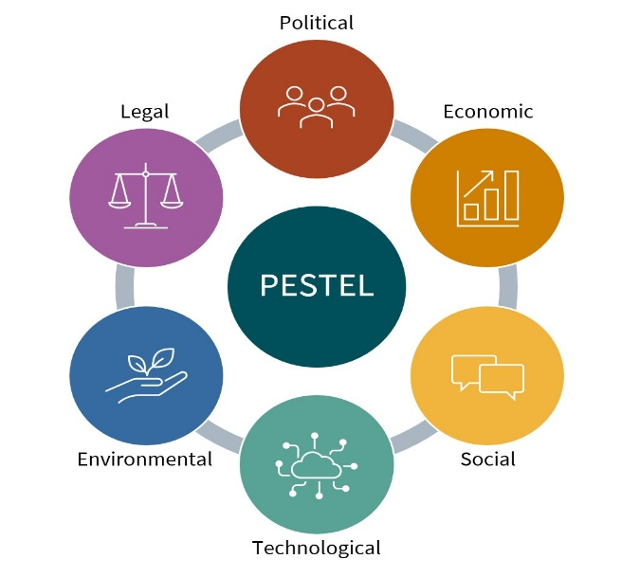
Figure 1: PESTEL Analysis (ModernAKIS, 2024)
Political Factors: The government of the UK is still promoting entrepreneurship with programs like Start Up Loans and small business support programs. This fosters the new businesses (Nováková, 2024). Nonetheless, GreenDesk will need to shoot or comply with business licensing requirement, food safety regulations, health and safety standard regulations. Failure to comply may lead to punishment or even negative publicity.
Economic Factors: Financial challenges include inflation and increase in commercial rent prices. The higher operating costs can be caused by increased energy prices. The hybrid work trend other hand offers stable demand (Aidar Vafin, 2022). A price model built on membership gives a consistent predictable recurring revenue, which decreases the financial uncertainties and enhances managing the cash flow.
Social Factors: The fact of hybrid working has become socially accepted and is a favorite among most professionals. Students are more demanding of study facilities that are more flexible outside the university libraries (Handke et al., 2024). Also, community-based workspaces that will lessen the effects of isolation and promote cooperation are in demand. These social trends are very favorable towards the GreenDesk concept.
Technological Factors: Dependable high-speed Internet, online booking applications and digital payment solutions allow the company to operate effectively. The social media channels offer cheap marketing options where GreenDesk can focus on the students and the freelancers directly. Technology minimises barriers of entry and improves convenience of customers.
Environmental Factors: Consumers are becoming more aware of the environment. Recyclable packaging, promotion of reusable cups and implementation of energy related lighting will reinforce brand image and meet sustainability requirements.
Legal Factors: GreenDesk will have to adhere to the employment law, food hygiene, health and safety laws, the laws on data protection (GDPR) and the requirements of the local authority as a licence holder (Information Commissioner's Office, 2023). The inability to comply with the legal requirements may lead to penalties or limitations to the operation, as well as tarnishing of the reputation.

2.4 Competitive Analysis
GreenDesk has a rivalry with traditional cafes, national coffee chains, co-working spaces and university libraries that are fully devoted. Old fashioned cafes have informal working segments but unorganised productiveness zones. The rate of co-working chains gives professional conditions and has high membership rates. Libraries are not expensive and prohibit food intake and cooperation. GreenDesk has the opportunity to fill a strategic midpoint between low-end informal environments and high-end co-working service providers because it provides low costs, flexible access, coffee houses, and a work-oriented design.

3. Marketing Communications

3.1 Marketing Objectives
Objective | Target | Time Frame
Build active membership base | 200 monthly members | Within 12 months
Increase daily workspace usage | Minimum 25 users per day | Within 6 months
Strengthen digital presence | 5,000 engaged social media followers | Within 6 months
Develop strategic partnerships | 3 university or freelance partnerships | Within 12 months
The main marketing goal of GreenDesk is the development of the good brand awareness and the attainment of sustainable customer growth within the first year of existing. The business targets to achieve 200 active monthly members and daily usage of workspace (Belch and Belch, 2024). Also, GreenDesk aims to reach 5,000 active followers on social media to enhance the digital presence and brand awareness. Forming cooperation with university associations and local freelance associations will contribute to the increase of visibility, customer trust and customer loyalty rates.

3.2 Targeting and Positioning Strategy
GreenDesk considers a segments approach using university students, freelancers and distance professionals in Birmingham. The selection of these segments is determined by the similarity of their needs on affordable, flexible and productivity-driven workspaces. The main audience demographics are between 18 and 40 years (Kotler and Armstrong, 2018). They appreciate convenience, convenience in terms of internet and social interaction.
The company brands itself as an efficient community workspace as opposed to a traditional cafe. GreenDesk unlike an informal coffee shop or a high end co-working chains provides an organised quiet area, community and affordable prices. Such a clear positioning reinforces the effects of competitive differentiation and passes over a powerful value proposition or focus, flexibility and belonging.

3.3 Marketing Mix Strategy
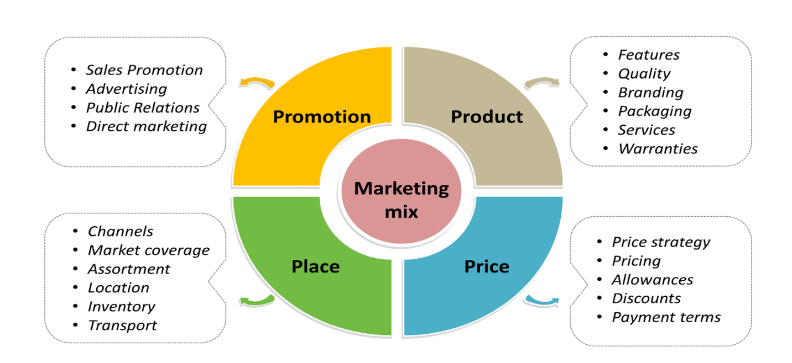
Figure 2: Marketing Mix Analysis (Sanjay Bandaru, 2024)
Product: GreenDesk offers the option of member workspaces, day use, fast wifi, designated quiet and work areas in a cafe environment. There are fresh drinks and snacks as well as regular networking and skills workshops that do not only provide a sense of community compared to workspace access.
Price: Penetration pricing strategy will be turned to secure group of price-sensitive students and early adopters. The monthly membership costs will be £60, and for hourly accessibility, it will be 50 cents a month (Kotler and Armstrong, 2018). This competitive price, especially makes it affordable and helps it to generate revenue, as well as long-term financial sustainability as well.
Place: GreenDesk will also be situated in strategic areas close to the universities in Birmingham to increase accessibility of students and professionals. Using a convenient web based system customers can book access to the workspace, and make reservations easily and with results enhancing the general customer experience.
Promotion: The targeted digital marketing strategies will be a means of promotion. YouTube videos will be used to attract the attention of Instagram and Tik Tok, whereas LinkedIn will be used towards attracting remote workers. The partnerships with local micro-influencers and student ambassadors will gain credibility (Belch and Belch, 2024). An incentive on referral and an introductive offer will boost trial, push word-of-mouth marketing and promote rapid early membership acquisition.

4. Financial Plan

4.1 Funding Requirement
GreenDesk needs an initial investment of a total of 28,000 in the form of property rent, interior set-up, furnishing, licensing cost, advertising and start-up cost. This capital will have adequate working capital at the time of the launch and decreases cash flow at the beginning (Burns, 2016). The estimated price represents the feasible costs in the local market and sustains the operations in the early stages.

4.2 Sources of Funding
Funding will be done by the personal savings and external debt funding of the business. The founder shall bring on board a personal capital of £12,000 which will show commitment and minimise the risk of borrowing. Also a UK Government Start Up Loan of £16,000 will be secured to meet the remaining costs. Debt financing allows the founder to maintain full ownership and control over decision making (Burns, 2018). Repayments of the loans will be arranged in form of manageable instalments, which will be backed by estimated monthly revenue.

4.3 First Month Start-Up Costs
Expense | Cost (£)
Rent deposit & first month | 8,000
Furniture & desks | 6,000
Coffee equipment | 4,000
Renovation & branding | 3,000
Licensing & registration | 1,000
Website & booking system | 1,500
Marketing launch | 2,000
Utilities & insurance | 1,500
Initial stock | 1,000
Total | 28,000

4.4 Revenue Projections
Revenue Source | Calculation | Monthly Revenue (£)
Membership Income | 150 × £60 | 9,000
Café Sales | Estimated | 4,000
Total Estimated Revenue |  | 13,000

5. Conclusion
The GreenDesk Co-Working Café Ltd has a viable and innovative business model in response to the increasing demand of flexible and affordable workspaces in Birmingham. The business has good competitive advantages though combining professional co-working facilities with a community-based cafe setting. The economic and financial forecast and the market analysis and the marketing strategy reveal sensible and real growth potential and sustainability. GreenDesk has a chance to succeed in the long term and realize value to its target market with proper implementation, strategic alliance, and customer-centric services.

References
Aidar Vafin (2022). The Impact of Remote Work on Firm’s Profitability: Optimizing Virtual Employee Productivity and Operational Costs. [online] Available at: https://www.researchgate.net/publication/360672212_The_Impact_of_Remote_Work_on_Firm [Accessed 18 Feb. 2026].
Barringer, B.R. and Ireland, R.D. (2021). Entrepreneurship : Successfully Launching New Ventures. 6th ed. New York, Ny: Pearson.
Belch, G.E. and Belch, M.A. (2024). Advertising and promotion: An integrated marketing communications perspective. 13th ed. New York, Ny: Mcgraw-Hill Education.
Burns, P. (2016). Entrepreneurship and small business start-up, growth and maturity. London Macmillan Education.
Burns, P. (2018). New Venture Creation : a Framework for Entrepreneurial start-ups. 2nd ed. London: Palgrave Macmillan.
Greendesk (2025). Greendesk — Offices and Co-Working Spaces for Rent in Brooklyn NY and LIC. [online] Green Desk. Available at: https://greendesk.com/ [Accessed 17 Feb. 2026].
Handke, L., Aldana, A., Costa, P.L. and O’Neill, T.A. (2024). Hybrid Teamwork: What We Know and Where We Can Go From Here. Small Group Research, 55(5). doi:https://doi.org/10.1177/10464964241279078.
Information Commissioner's Office (2023). Data protection and workers’ health information. [online] ico.org.uk. Available at: https://ico.org.uk/for-organisations/uk-gdpr-guidance-and-resources/employment/information-about-workers-health/data-protection-and-workers-health-information/ [Accessed 18 Feb. 2026].
Kotler, P. and Armstrong, G. (2018). Principles of marketing. Singapore: Pearson/Prentice-Hall.
Mimoun, L. and Gruen, A. (2021). Customer Work Practices and the Productive Third Place. Journal of Service Research, [online] 24(4). doi:https://doi.org/10.1177/10946705211014278.
ModernAKIS (2024). ISS Tools & Methods | Pestel Analysis. [online] Akisconnect.eu. Available at: https://akisconnect.eu/en/iss-tools-and-methods/tool-details?id=34&name=Pestel+Analysis [Accessed 18 Feb. 2026].
Nováková, M. (2024). The UK start-up ecosystem: Opportunities and Challenges. International Journal of Science and Research Archive, 12(2), pp.1445–1451. doi:https://doi.org/10.30574/ijsra.2024.12.2.1403.
Sanjay Bandaru (2024). Concept of Marketing Mix - College Hive. [online] Collegehive.in. Available at: https://collegehive.in/docs/2nd_sem/site/MM/Unit-1%20Introduction%20to%20Marketing%20Fundamentals/1.3.b%20Marketing%20Mix.html [Accessed 18 Feb. 2026].

