
Module: International Business Concepts
Module code: LCMB7034
Assignment Title: Report on the IT Industry of India
Student Name: Taranjot Randev
Student ID: 2436053
Word count: 5404

Table of Contents
Section 1: International Industry Report 3
1. Introduction to the report 3
2. Industry and Country Overview 3
2.1 Industry overview: IT sector India 3
2.2 Size, scope, and economic importance of IT sector_200 4
2.3 Major domestic and multinational firms operating 5
3. Global Competitiveness: Michael Porter’s Diamond Model of National Advantage 7
4. Identifying foreign MNCs/TNCs operating in India 10
4.1 One chosen MNC operating in the Indian IT sector 10
4.2 Evaluating internal & external factors on success of chosen MNC’s operations in India 11
4.2.1 PESTLE framework: External factors of market attractiveness of Indian IT industry 11
4.2.2 CAGE framework on cultural, administrative, Geographical & economic factors between host & home country of the chosen IT MNC 13
4.2.3 Porter’s five forces on the competitive IT landscape of India 15
4.2.4 SWOT on chosen IT MNC 17
4.2.5 BCG matrix on relative IT market share & growth for chosen MNC in India 18
4.2.6 Based on analysis, Identifying CSFs impacting success of operations of the MNC in Indian IT industry 20
4.2.7 Value chain framework on operational success for the MNC in IT sector of India 20
5. Conclusion to the report 21
Section 2: Reflective Account 23
Introducing reflective model: Gibbs reflective cycle 23
Gibbs' reflection on reflective process of my researching, analysing and preparing previous section of the assignment 23
Description: 23
Feelings: 24
Evaluation: 24
Analysis: 25
Conclusion: 26
Action plan 26
References 27

Section 1: International Industry Report

1. Introduction to the report
In the pursuit of relevant commercial transactions, the concept of international business is crucial in driving the aspects of globalisation and generating profits. In this context, the purpose of the concerned report is to critically evaluate the international business environment of a nation. The report has chosen the international marketplace of India and ensured a specific focus on the IT sector operating in this nation. In this regard, the study will offer a comprehensive overview of the Indian IT sector, considering its size, scope, and economic importance to the nation. It will further identify major domestic and multinational firms operating in the Indian IT landscape. Besides, the study will identify the global competitiveness of the industry with the application of Michael Porter’s Diamond Model of National Advantage. Also, the report will focus on foreign MNCs/TNCs operating in the IT domain of India, considering political, economic, legal and cultural factors.

2. Industry and Country Overview

2.1 Industry overview: IT sector India
The information technology (IT) industry of India is identified as a major industry of the nation. In the initial phase, the IT sector is highlighted to be the strongest pillar of the Indian economy and is significantly contributing towards the aspects of growth opportunities, employment and overall public welfare (IBEF 2025). As of 2025, the sector has recorded a growth of 16% in terms of hiring, which is further driven by understanding the evolving needs of artificial intelligence and cloud modernisation, in addition to the expansion of Global Capability Centres (GCCs) (IBEF, 2026). Besides, the growth of the Indian IT landscape is significantly driven by the development of new hubs across non-metro cities, including Udaipur, Vizag, Coimbatore, and Nagpur, which have enabled it to surpass hiring growth of over 50% (IBEF, 2026).
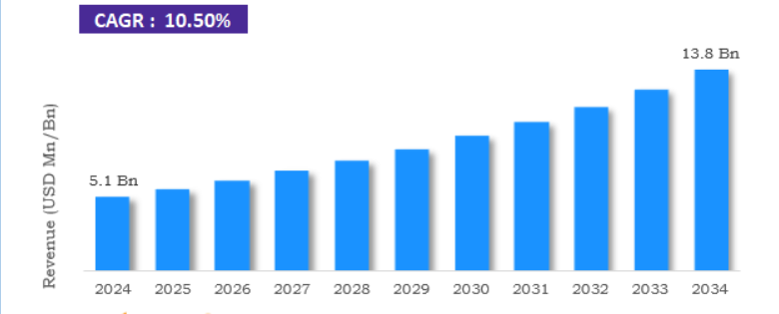
Figure 1: Growth of the Indian data centre market
(Source: Zion Market Research, 2025)
Besides, the computer software and hardware sector of India has attracted cumulative foreign direct investment (FDI) of $ 110.16 billion (Approximately INR 8,31,772 crore) over the specific period of 2025 (IBEF, 2026). The growth of the sector in these aspects is found to be driven by the focus of Indian IT organisations to set up the world's largest data centre in Jamnagar, Gujarat. This is enabling the industry to grow to 13.8 billion by 2034 at a growth rate of 10.5% between 2025 and 2034 (Zion Market Research, 2025).

2.2 Size, scope, and economic importance of IT sector_200
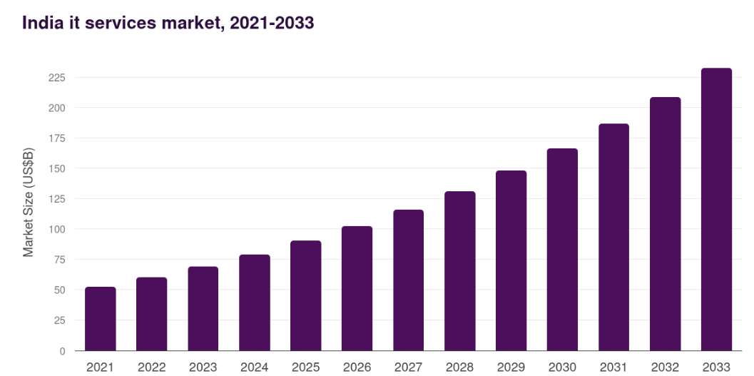
Figure 2: Indian IT industry market size
(Source: Grand View Research, 2025)
The above-provided statistical representation highlights the market outlook of the Indian IT service industry. In this regard, the Indian IT segment is expected to project a revenue of $232.2 billion by 2033 (Grandviewresearch.com. 2024). The growth will be driven by an annual growth rate of 12.4% between the specific period of 2026 and 2033 (Grand View Research, 2025). In 2025, the IT service of India at the global scale stood at $37.03 billion, supporting its credibility to expand at the growth rate of 9.06% (Mordor Intelligence, 2025). Such growth of the Indian IT segment is driven by the identification of scope, including Global Capability Centres, and the initiative of the government pertaining to digital infrastructure spending, amid global economic uncertainty (Mordor Intelligence, 2025).
The growth of the IT sector is determined to be perpetual in fostering the aspects of the Indian economy. The ability of the sector to witness a growth of $350 billion by 2026 significantly contribute towards the nation's gross domestic product (GDP) growth by approximately 10% (IBEF, 2026). India is highlighted to be the world's largest sourcing destination as the industry has supported economic transformation by employing about 10 million of the workforce and driving cost competitiveness (Darsana , 2019).

2.3 Major domestic and multinational firms operating
The Forbes 2025 market valuation report concerning Indian IT companies identified the top ten powerhouses within the IT segment. In terms of the market capitalisation and being a global leader in IT services and consulting, the first position is secured by TCS (Forbes India 2024). The company is constantly ranked in the top ten list, and it's supported by strong financial performance and its ability to gain massive global reach. Moreover, its ability to acknowledge and strive for continuous innovation in next-generation technologies, such as AI and cloud computing, has enabled it to maintain a healthy operating margin of $30 billion in 2025 (Forbes, 2025). On the other hand, the focus of Infosys on digital services has enabled it to secure a second market position. The company also showcases the ability to demonstrate deep trust and long-standing relationships. This has enabled Infosys to capture market cap and revenue of about $18 billion in 2025. In the top ten list, third position is secured by HCL Tech as it has ensured distinctiveness in engineering, R&D services, and innovative intellectual property partnerships. This has supported its market capitalisation of $13 billion in 2025 (Forbes, 2025). Additionally, with a global footprint in over 65 countries, Wipro captures the top ten position with the presence of a diverse and resilient revenue base. The company is known for aligning with modern business demands in response to cloud computing and cybersecurity, enabling it to witness a market cap of INR 2,57,019.09 crores (Forbes, 2025).
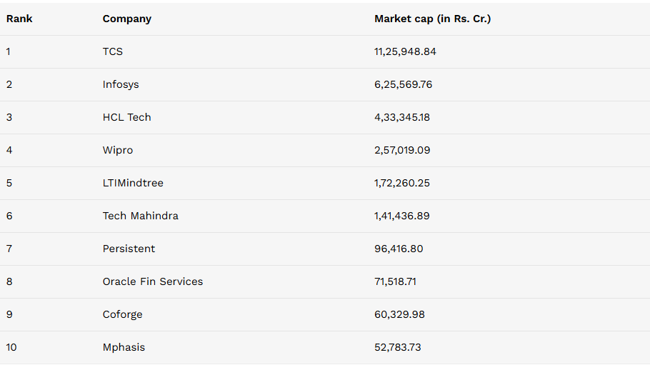
Figure 3: Top ten Indian IT companies
(Source: Forbes, 2025)
Simultaneously, multinational firms, such as Accenture and Cognizant leads in the Indian IT domain. In India, Accenture has recorded a market growth of 13% in FY25 and a net profit of 9% to INR 7,346 crore (Shilpa Phadnis 2026). The company focus on significant research & development, including Technology Labs and full-stack large language model (LLM) (Phadnis, 2026). Besides, Cognizant in India is earning market stability with the growth of $21.1 billion in 2025. The company is maintaining market stiffness in terms of AI-driven deals, with a focus on relevant resources for the design and development of technological products (Rao, 2026). This implies that the IT industry of India is highly competitive as it has the presence of potential and strong players, with both domestic and international recognition.

3. Global Competitiveness: Michael Porter’s Diamond Model of National Advantage
According to Bruin (2018), Porter’s Diamond Model, also referred to as the Theory of National Competitive Advantage are significant for determining the competitiveness of a global nation in relevance to specific industries (Bruin 2018). The theory argues about the ability of organisations to effectively compete in the international domain and is significantly driven through interrelated sets of aspects, including firm strategy, structure and rivalry; factor conditions; demand conditions; and related and supporting industries (Tan, 2025).
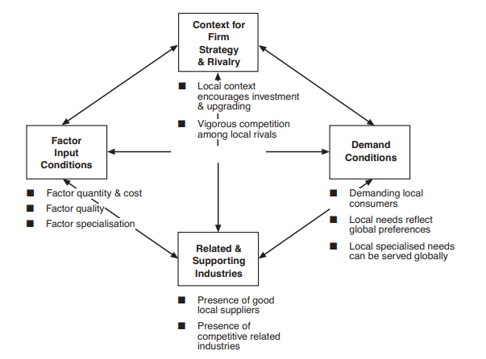
Figure 4: Porter’s Diamond Model of National Competitive Advantage
(Source: Yue and Lim, 2023)
In terms of determining the global competitiveness of the Indian IT industry, Porter’s diamond model of national competitive advantage highlights:
Factors conditions:
The IT sector of India illustrates competitiveness in terms of enhancing its strengths concerning tech talent. Globally, the industry has the largest supply of STEM (Science, Technology, Engineering and Mathematics) graduates, annually 2.5 million. In 2023, the sector has highlighted the enhancement of between 43 to 48% in response to having the largest female diversity ratio. Additionally, the tier 2/3 Indian cities are contributing to the engagement of about 60% graduates from a varied domain of engineering, arts, and science (Nasscom, 2023). In this regard, India has the largest pool of skilled IT professionals, approximately 5.4 million, which contributes to the enhancement of the industrial workforce by 39%. Based on this, the upcoming demand for digital talent is anticipated to cross 6 million (Nasscom, 2023). Simultaneously, the improvised digital infrastructure is also propelling the growth of the Indian IT sector. For example, the foundation of digital transformation across varied sectors, including IT, is driven through the Union Budget of INR 2,000 crore (approximately $232 million) during the financial year of 2026, focusing on AI, IT Hardware and its 2.0 version (IBEF, 2026).
Demand conditions:
The higher demand towards the adoption of core technologies, including artificial intelligence, cloud computing and automation, is driving the demand for IT services across the domestic marketplace. The evolving demand in this regard is expected to increase the market value of Indian IT services by $214.8 billion, at a growth rate of 12.3% between 2024 and 2029 (Technavio, 2025). Despite the constraints of stringent data privacy laws and cybersecurity regulations, the growing demand is making the domain an attractive destination to invest in IT hubs. Besides, on a global scale, the growth in the market value of digital transformation is $3,140.86 billion in 2026, with a growth rate of 21.40% highlights an opportunity to drive competitiveness in terms of meeting the requirements of evolving digital solutions (Fortune, 2026).
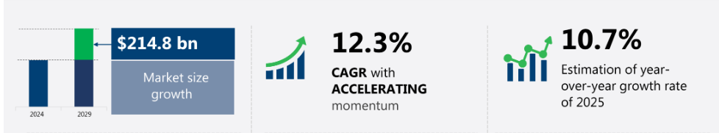
Figure 5: IT services growing demand
(Source: Technavio, 2025)
Related and supporting industries:
The position and competitiveness of the Indian IT sector are supported by the clusters of suppliers in the support of building an assembly plant. The long-term success of the sector is fostered by partnerships with global suppliers, such as General Electric and Areva, in the management of the energy portfolio (Chowdhry, 2024). Besides, the presence of improvised telecom infrastructure has been instrumental in enhancing the growth of Indian IT sector. The expansion of the telecom domain from $3 trillion in 2024 to $4 trillion by 2028 is found to be driven by the adoption of generative AI and IoT devices to align with the ongoing demand for higher internet (Pathak and Mahesh, 2024). This implies a growth opportunity for the IT sector in terms of designing and developing cloud-based infrastructure, thereby improving its supply chain and overall cost efficacy.
Besides, the evolving education domain of India also tends to offer significant opportunities for the IT sector in terms of gaining a competitive market share. For instance, educational institutions, such as IITs, IIMs, IIITs, NITs, government institutions and others are playing a significant role in shaping careers in relevance to engineering (Gov.in, 2025). This highlights an opportunity for the Indian IT sector to acquire the engagement of the talent pool and skilled workforce, in support of both domestic and global excellence.
Firm strategy, structure and rivalry:
The IT sector of the Indian nation is demonstrated to be highly competitive, since it has the presence of massive domestic and multinational firms competing for market share and position (Dhar and Amu, 2022). The presence of potential rivals, such as Infosys, TCS, Wipro, and Technocomet Solutions, highlights the focus of these firms in driving technological advancements. The rise in technological demands has been pivotal for the firms in terms of enhancing their footprint across the global technological landscape (Technocomet, 2025).
In this instance, firms, such as TCS, Infosys, HCL and Wipro demonstrate a fierce market competition for share, driving innovation and growth (Infotyke, 2025). In comparison to other IT organisations, TCS is constantly outperforming in terms of supporting clients with the transition to flexible and scalable IT environments. Regardless, in terms of striving into the competitive marketplace, each of these firms highlights capability and efforts towards fostering data-driven decisions, by comprehensively integrating multi-cloud management and cloud-native solutions as crucial for the contemporary business environment (Infotyke, 2025). Thus, the Indian IT sector showcase intention to rival in regard to driving innovation and securing long-term growth.

4. Identifying foreign MNCs/TNCs operating in India

4.1 One chosen MNC operating in the Indian IT sector
Accenture serves as an industry leader in the Indian IT market with a key hub for multinational operations with 784k employees globally and over 3 lakh in India, and over 9000 clients in 120 regions, over 350 partners (TNN, 2024). It has wider innovation hubs in cities including Bengaluru, Hyderabad, Pune, and Chennai. Integral offerings include improving the digital transition through cloud computing, data and AI, cybersecurity, and technology outsourcing. Accenture effectively enhanced its data and AI workforce to 69,000 with large part sourced from India (Rao,2025). The center for advanced AI and Gen AI studio in Bengaluru is a crucial part for customising innovative AI and GenAI solutions, tools and assets. In 2020, Accenture developed Project Spotlight, where start-ups collaborate with the company in its Innovation hubs, labs and liquid studios. Invested in Bengaluru-oriented “hyperspectral start-up Pixxel” in 2022(Rao,2025). In FY24, Accenture invested $1.1 billion for skilled development programs (Rao, 2025). Accenture's financial performance serves as an indicator for Indian IT organisations such as TCS and Infosys for the same revenue sources and client bases in banking and economic services. It maintains “360° VALUE” for encompassing transformation and generating value for all stakeholders globally (Accenture 2024).

4.2 Evaluating internal & external factors on success of chosen MNC’s operations in India

4.2.1 PESTLE framework: External factors of market attractiveness of Indian IT industry
Factor | Application | Opportunities/threats
Political | Standard GST rate is 18% for core IT services with IT design, consulting and others (Bansal, 2025). India-EU trade agreement reduces tariffs over 99% of Indian exports to EU. EU-India Free Trade Agreements (FTA) assist professional mobility, as EU removes 90% tariffs and 91% for value, and India mitigates 86% tariff and 93% value (Trade and Economic Security, 2024). | Threats
Economical | The “Indian IT market” increased at a “compound annual growth rate of 8.1% from FY22 to FY25 for reaching $264 billion”, and is anticipated to “enhance 8.7% yearly to FY25 to FY30 with $400 billion by FY30” (TNN, 2025). Inflation rate enhanced by 2.75% in 2026 with market demand of 2.4% (refer to Figure 6). | Opportunities
Social | Increasing social requirement for high-value skills of AI, ML and cloud computing in the IT sector, with this industry employing 5.8 million people in India, with the major cities of Bengaluru, Hyderabad and Pune (ET CONTRIBUTORS, 2025). | Opportunities
Technological | Infosys Topaz AI-platform, using Gen AI allows the IT sector to enhance operational efficacy and automate processes. TCS Crystallus™ harnesses the power of Salesforce to improve the digital transition-oriented decision-making process (Tcs.com, 2025). | Opportunities
Legal | “Information Technology Act, 2000 (ITA 2000)”, “National Policy on Information Technology (2012)” regulating “digital commerce, cybercrime, and data privacy” in India (India, 2026). | Threats.
Environmental | “Energy Conservation Act, 2001”, “Plastic Waste Management Rules, 2016” and “Solid Waste Management Rules, 2016” required IT firms to manage waste, disposal and energy efficiency (Indiacode.nic.in. 2016). | Threats.
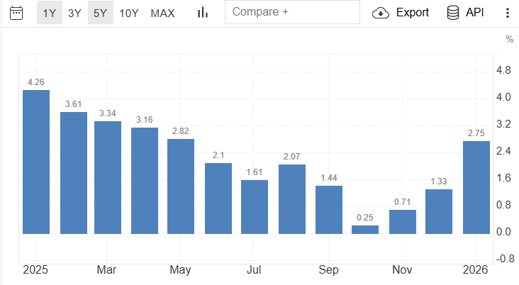
Figure 6: India’s inflation rate
Source: (Ferreira, 2024)

4.2.2 CAGE framework on cultural, administrative, Geographical & economic factors between host & home country of the chosen IT MNC
The cage framework indicates four distances between the home and host countries, which helps businesses to define the potential opportunities to expand their operations in the new market (Saville, Macleod and Onaji-Benson, 2021).
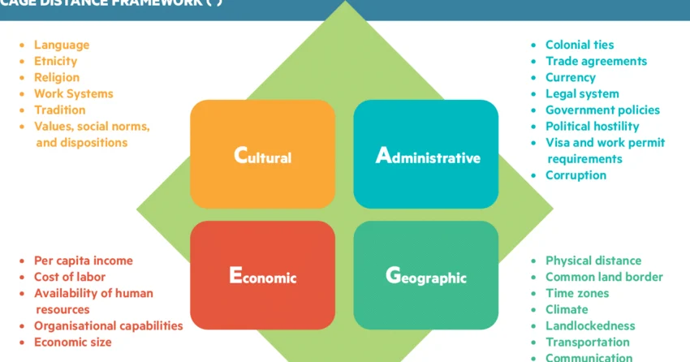
Figure 7: CAGE framework
Source: (Saville, Macleod and Onaji-Benson, 2021)
Cultural Distance: According to the report of DGFT (2026), it can be noticed that the official business language in India is Hindi or English. On the other hand, the official languages of Ireland are Irish and English (Ireland.com, 2022). Hence, it can be seen that both countries use English as a common language, which can help in addressing the communication barriers. However, a significant barrier in the context of business culture can be noticed in India (hierarchical) and Ireland (informal).
Administrative Distance: The legal system of Ireland is based on a common law system, which indicates that the Judge-made law in the country is a crucial source of regulation (Europa.eu, 2024). On the other hand, the legal system of India also includes a common law for legal regulations, whereas the civil law and the religious law are also considered (Minattur, 2026). Hence, the presence of a common law in both markets can address the administrative distances between these two countries.
Geographic Distance: The geographical ground-based distance between India and Ireland can be measured to 4,280 nautical miles or 7,926 kilometres (Travelmath, 2026). On the other hand, the time zone difference between these nations is very high. For example, the time in Ireland is 5.5 hours behind India (24 Time Zones, 2025). Hence, a gap in real-time collaboration and business operations can be noticed in companies operating in these countries.
Economic Distance: The average GDP (gross domestic product) per capita in India was around 2396.71 USD in 2024 (Trading Economics, 2025). On the other hand, in 2024, the Irish GDP per capita was approximately 34636.75 USD (Trading Economics, 2026). The labour costs in India were around INR 178 (US$2.13) in 2025 (Shira, 2025). Similarly, the hourly total labour costs in Ireland were nearly €37.19 in 2025 (CSO, 2025). Therefore, these economic distances between these regions can create financial disruptions in maintaining the operations of businesses.

4.2.3 Porter’s five forces on the competitive IT landscape of India
Forces | Description | Impact Level
Competitive Rivalry | - TCS (Tata Consultancy Services), Infosys, Deloitte, IBM (International Business Machines), and Wipro are existing popular IT brands in India (Forbes India, 2024).  - The intense market competition by businesses in the Indian IT sector can lead to issues regarding pricing pressure for businesses.  - The competitive rivalry in the IT market of India is high due to the leading IT firms in the country. | High
Threat of New Entrants | - The FDI (Foreign Direct Investment) in the Indian market has increased to 6.9 billion USD in 2025 from 4.7 billion USD in 2024 (Santander, 2026).  - The increased reputation and image of existing IT brands create issues for new businesses to enter the Indian IT sector.  - Thus, the new entry threats for Accenture are low in the Indian IT market. | Low
Bargaining Power of Suppliers | - The primary suppliers of the IT sector of India are the technology partners, workers, and training companies.  - The total number of employees in the IT industry of India has increased to 5.4 million in 2023, with the inclusion of 290000 new workers in the market (IBEF, 2025).  - The availability of a huge IT talent pool reduces the supplier's bargaining power in the Indian market. | Low
Bargaining Power of Buyers | - Customers in the Indian market are seeking new and effective IT solutions from firms.  - The increased demand by Indian customers for adequate technological solutions and easy switching options increases their bargaining power in India.  - Accenture can face issues due to the changing requirements of customers in India (Srivastava, Hallur, and Mukitm, 2023). | High
Threat of Substitutes | - The substitution threat for IT competition is low, as their high reputation and effective services can help in developing loyalty among customers.  - However, rapid digitalisation and the adoption of the latest digital tools and technologies, such as AI, in-house cloud-based solutions, and automation, can lead to product substitution (Yathiraju, 2022). | Moderate
Table 1: Porter’s five forces analysis of the IT sector of India
Source: (Self-created)

4.2.4 SWOT on chosen IT MNC
Strengths | Weaknesses
- Accenture has a high brand awareness level and reputation in the Indian market.  - Accenture has more than 3 lakh skilled workers in India and over 7.7 lakh globally in 2024 (The Times of India, 2024).  - The annual revenue of Accenture India has increased by 125% in 2025, reaching 74,667 crore INR in 2025 from 33,305 crore INR in 2024 (Phadnis, 2026). | - One of the most effective weaknesses associated with Accenture in the Indian market is its employee layoff practices (The Times of India, 2025).  - Accenture India has reduced its workforce to 779000 in 2025, which was 791000 three months (The Times of India, 2025).  - Accenture India faces issues in understanding the different views of its stakeholders (Accenture, 2026).
Opportunities | Threats
- Accenture can focus on adopting new technologies, such as AI and IoT, to improve its operations in India.  - The company can collaborate with technology partners in India in order to foster innovations within its workplaces.  - The company can focus on mergers & acquisitions in India to enhance its performance. | - Accenture can face intensive competition from existing IT organisations in India.  - The company can struggle in engaging its stakeholders with its business operations due to a poor understanding of stakeholders’ perspectives (Olawale, and Akinbola, 2024).  - An inconsistent workforce can reduce its productivity and performance in India.
Table 2: SWOT analysis of Accenture
Source: (Self-created)

4.2.5 BCG matrix on relative IT market share & growth for chosen MNC in India
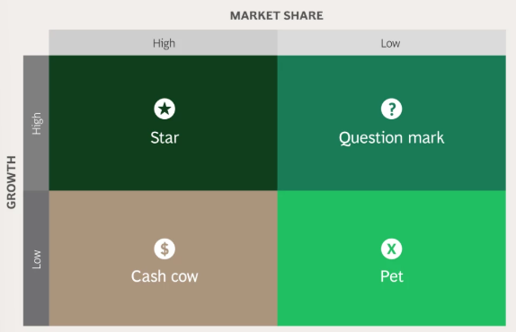
Figure 8: BCG Matrix
Source: (BCG, 2025)
The BCG matrix helps to analyse the product portfolio of businesses by considering the market growth rate and market share of products (BCG, 2025). It includes four quadrants, such as stars, question marks, cash cows, and dogs, which help to categorise the products of businesses. The BCG matrix of Accenture in the Indian IT market is illustrated below.
Cash cows: This quadrant of the framework highlights the products of firms with a low growth rate and a high market share. The IT outsourcing and application management services, along with the managed services of Accenture, have a low growth rate in the Indian market, with a high market share, which helps the company to gain the required cash flow to reinvest in its operations (Shreyash Mangale 2026).
Stars: Products in this category have high market shares and growth rates. Cloud Services and Generative AI are the primary products which are stars for Accenture in India. Based on the report of IDC (2025), it can be determined that the Cloud Service market of India increased to $10.9 billion in 2024, which is also projected to reach $30.4 billion by the end of 2029, with an annual growth rate of 22.6% between 2024 and 2029 (IDC 2025). On the other hand, it can also be specified that the Generative AI market of India was valued at 1,468.7 million USD in 2025, which is predicted to reach 23,003.5 million USD by 2033 with a 42% CAGR between 2026 and 2033 (Grand View Research, 2025). Therefore, these products are considered stars for the company in India.
Question marks: This category of products of businesses indicates a high market growth, along with a low share of the annual revenue of the companies. Specific digital solutions, specialised AI applications, and AgriTech services of Accenture are question marks for the business, as these have high market growth rates, whereas their contribution to the market share of the company is low (Rapberger, 2018).
Dogs: These products have both low growth rates and market shares. For example, the non-strategic IT management services of Accenture are dogs for the organisation in the Indian market.

4.2.6 Based on analysis, Identifying CSFs impacting success of operations of the MNC in Indian IT industry
Based on the above discussion, it can be concluded that the CSFs for Accenture that can impact its success in the Indian IT industry are its Generative AI solutions and Cloud Services. The demand for Cloud Services has increased over the years in the Indian IT market (Grand View Research, 2025). Similarly, customers in the IT sector of India are more focused on effective Generative AI solutions to improve their working performance and enhance efficiency (IDC, 2025). Moreover, it can also be detected that the growth of AgriTech services and technological AI applications has also increased over the years. Therefore, these services can ensure the success of Accenture in the IT industry of India.

4.2.7 Value chain framework on operational success for the MNC in IT sector of India

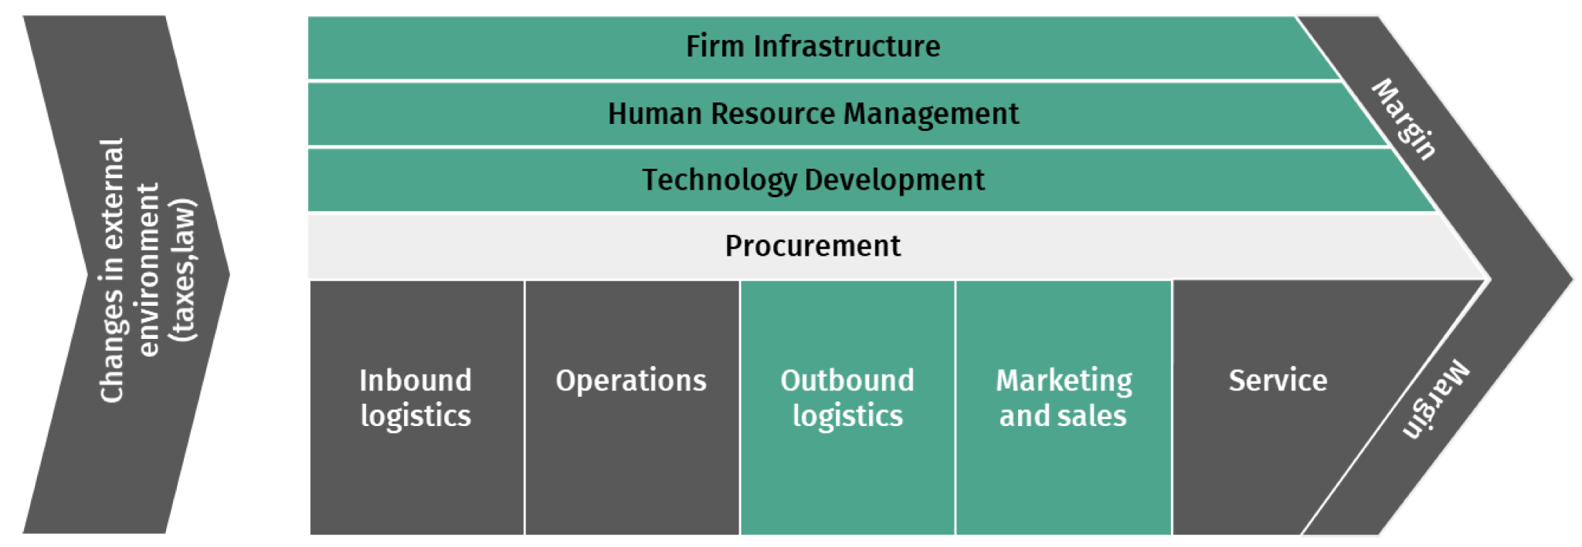
Figure 9: Value chain framework
Source: (Kohnová and Salajová, 2023)
The value chain framework highlights the primary & secondary activities of businesses that allow them to gain competitive advantages in the market (Kohnová and Salajová, 2023). The value chain analysis of Accenture in the Indian IT sector is explained below.
Primary activities:
Inbound Logistics: Accenture effectively manages its manufacturing and goods transportation to meet the demand and improve its inventory in the market (Accenture, 2024).
Operations: Accenture provides transformative corporate operations solutions with the aid of intelligent operations procedures, which sustain its growth in the Indian market (Accenture, 2025).
Outbound Logistics: Real-time coordination of Accenture across its transportation, global trade, order management, reverse logistics, and warehousing ensures the faster delivery of its services (Accenture, 2023).
Marketing and Sales: The global reputation of Accenture helps it in securing its large contracts in the IT market of India.
Service: Accenture offers 24/7 hours of customer, outsourcing, and maintenance services to its clients in the market, helping it to improve its performance.
Support Activities:
Firm Infrastructure: Accenture has a robust infrastructure enabling the corporation to maintain its operations effectively.
Human Resource Management: Accenture has around 3 lakh talented and skilled staff in India, who help to streamline its business operations in India (The Times of India, 2024)
Technology Development: Accenture facilitated its investment in technology adoption to implement new technologies to enhance iots operational efficiency.
Procurement: The procurement practices of Accenture are based on the production of software licenses and IT hardware to support the projects of its clients.

5. Conclusion to the report
The above analysis infers that the IT sector is a significant contributor to the enhancement of the nation's economy. The sector also highlights the engagement of skilled professionals, integration of improvised infrastructure, and the presence of supportive government policies and norms. It can be summarised that the sector is showcasing remarkable growth across both the domestic and global IT marketplace. The report has recognised the presence of robot competition between domestic and multinational firms, such as TCS, Infosys, HCL, Accenture, Cognizant and others. Moreover, the sector tends to offer a ripple effect on the Indian economy by enabling the nation to sustain feasible opportunities, appropriately fulfilling the needs and demands of businesses, entrepreneurs, and professionals in response to the attainment of digital infrastructure and services. In the holistic sense, the sector showcases a strong foundation and presence of favourable market conditions, in support of the upcoming growth trajectory in terms of becoming a global leader in the segment of digital innovation and the establishment of potential IT hubs.

Section 2: Reflective Account

Introducing reflective model: Gibbs reflective cycle
Adeani, Febriani and Syafryadin, (2020), presented Gibbs’ reflective cycle as an efficient framework while structuring literary insights about work and well-segmented reflection to examine in-depth evaluation. Gibbs serves as a six-stage model customized to structure reflection on experiences, assisting spontaneous learning and professional growth (Ocampo et al., 2025). Under the lens of description, feelings, evaluation, analysis, conclusion and action plan, allow us to understand the process, reason and improve future prospects.

Gibbs' reflection on reflective process of my researching, analysing and preparing previous section of the assignment
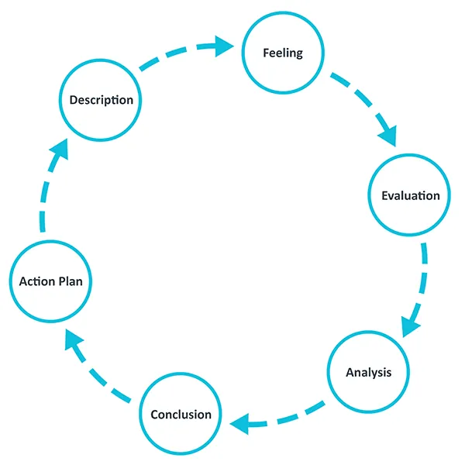
Figure 10: Gibbs' reflection cycle
Source :(The University of Edinburgh, 2024)

Description:
The above segment of the assignment has evaluated the information technology industry of India under the lens of a “multinational corporation”, projected to evaluate the structure, competitiveness and global incorporation within the Indian IT sector while addressing challenges and opportunities. This assignment initiated with an industry overview, including its size, revenue of $232.2 billion by 2033, along with scope and conducting Global competitiveness using Porter diamond model with the involvement of statistical data about market development, FDI and employment in India(Grandviewresearch.com. 2024). How about this report recognising the various domestic and MNCs navigating in the IT sector with a focus on TCS, Infosys, Accenture and Cognizant, with a focus on global footprint and potential, with a focus on the demand, factor and related and supportive organisations with organisational strategy and rivalry. Accenture has been selected as an MNC as the case organisation for evaluating IT operations in India (Aithal and Rao, 2024). External environment impact has been evaluated by using PESTLE, CAGE framework, Porter's five forces has been used for assessing the competitive market, SWOT analysis and value chain framework has been conducted to present MNCs consider India as a favourable destination for IT hub.

Feelings:
During this assignment procedure, primarily, I felt motivated as the Indian IT sector is highly relevant to the Global economy and technology revolution (Adebanjo et al., 2021). Following that I faced some challenges while researching credible and updated qualitative sources and industrial reports that can assist my explanation and reasoning regarding the points (Taherdoost, 2021). Addressing authentic statistical data and incorporating them with theoretical models such as Porter's Five Forces, diamond model, PESTLE, SWOT, and others requires a detailed appraisal of diverse articles and reports. After that, multiple sources and volumes of information have created confusion about the most relevant data supporting the argument. Instead of these barriers, I gained confidence as properly provided with information to support my opinion in the research result by incorporating theoretical frameworks (Passey, 2020).

Evaluation:
While conducting the assignment, I noticed various part was efficient as the main positive prospect of this assignment includes the utilisation of authentic data sources, news articles and industry reports such as “IBEF, Grand View Research, Times of India, Economic Times and credible articles from Google scholars” regarding the development in the Indian IT industry. These sources delivered relatable statistical information on the market size and employment, which improves the economic importance in industry (Hamzat, Abiodun and Joseph, 2023). Strength depends on the utilisation of the analytical framework of “Porter's diamond model, PESTLE, CAGE, SWOT, porter five forces” which enables research to transition beyond smooth description and deliver in death information. The barriers I faced was recognising the proper and recent market information regarding the IT sector. As various websites delivered inconsistent data about industry size and development functionality for these challenges, I cross-checked information over various reports and used the authentic ones (Markowitz et al., 2023). While incorporating theory, it was primarily challenging to connect theoretical ideas with the real-world insights and mitigate the issue through using data from India's large STEM graduate population and enhancing digital transitional requirements with solidified evaluation. By applying PESTLE, SWOT, BCG matrix, and CAGE needs particular policy, cultural and geographical functions and relevant strengths and weaknesses faced various difficulties through reaving government policies, including GST, tax, cultural practices, average GDP and recognising the accurate star, dog services, I became able to deliver a clear example of external factors impacting the IT hub of India.

Analysis:
The evaluation unit of this assignment used various strategic frameworks and models to examine the Indian IT sector and operational setting with the MNCs. The primary framework used was the Porter diamond model, which allowed me to examine the reasons India became a dominant competitive leader in the global information technology sector (Sengupta, Patel and Zaman, 2020). As the factor condition element presented about wider employees and accessibility of the STEM graduate community and IT experts. This delivers multinational organisations the credibility and resources to gain cost-effective and skilled employees (Tayali and Sakyi, 2020). PESTLE framework utilisation revealed about the IT sector for providing knowledge to Accenture as well as MNCs in India while operating with the lens of trade agreement, tax policies, inflation rate, environmental regulations and social requirements for tech-skilled people. The CAGE framework properly evaluates the distances segmenting with cultural, administrative geographic and economic factors, along with Porter's 5 forces, demonstrating the high impact from rivalry, buyer power and low threat from new entrants and supplier power, along with medium from substitutes (Ndzabukelwako et al., 2024). I have used the SWOT and BCG matrix as they help to deliver the actual strengths, opportunities and threat sources to improve understanding and the BCG matrix to address the comparison between IT market share and development. I could use the Ansoff matrix, the 7 Ps marketing model, to address the actual service-oriented competitors and allow Accenture to recognise the authentic market opportunities and mitigate threats.

Conclusion:
I have gained in-depth insight from this assignment regarding the Global competition of the Indian IT market and the pivotal role of multinational firms such as Accenture. The learning aspect relies on the significance of integrating credible and relevant theoretical frameworks with the practical and current industry information to deliver evidence-oriented outcomes.

Action plan
I have designed to expand my research and analytical skills through using a broader range of academic journals, peer-reviewed articles, rather than using mostly the industry and news websites for enhancing the reliability of any future assignment (Chertow, Kanaoka and Park, 2021). Creating a transparent research structure at the start of the assignment can help me to improve the research outcome through using critical thinking skills (Reynders et al., 2020). Additionally, I have intended to improve my potential in using and integrating theoretical models with industry data through using analytical skills in future. On the other hand, I will focus on improving my academic writing skills to improve the referencing accuracy and critical assessment prospect to improve the supporting data while presenting arguments (Zhang and Wu, 2024). Focusing on this perspective, I can create an in-depth exploration and a transparent argument while improving academic reliability in future work.

References
24 Time Zones (2025). Ireland time to India time conversion. [online] 24timezones.com. Available at: https://24timezones.com/difference/ireland/india.
Accenture (2023). Unlock Autonomous Fulfillment for Supply Chain | Accenture. [online] Accenture.com. Available at: https://www.accenture.com/us-en/services/supply-chain/autonomous-fulfillment.
Accenture (2024). Delivering value from every angle. [online] Available at: https://www.accenture.com/content/dam/accenture/final/corporate/company-information/document/Accenture-360-Value-Report-2024.pdf.
Accenture (2024). What is Supply Chain Management (SCM)? | Accenture. [online] www.accenture.com. Available at: https://www.accenture.com/in-en/insights/supply-chain-operations/supply-chain-management-operations-index.
Accenture (2025). Managed Services. [online] Accenture.com. Available at: https://www.accenture.com/pl-pl/about/operations-index.
Accenture (2026). Perception is reality: Closing stakeholder consensus gaps to shape sustainable organizations. [online] www.accenture.com. Available at: https://www.accenture.com/content/dam/accenture/final/a-com-migration/thought-leadership-assets/accenture-sustainability-consensus-gap-report2.pdf.
Adeani, I.S., Febriani, R.B. and Syafryadin, S., 2020. Using GIBBS’reflective cycle in making reflections of literary analysis. Indonesian EFL Journal, 6(2), pp.139-148.https://journal.uniku.ac.id/index.php/IEFLJ/article/download/3382/2034/0
Adebanjo, D., Laosirihongthong, T., Samaranayake, P. and Teh, P.L., 2021. Key enablers of industry 4.0 development at firm level: Findings from an emerging economy. IEEE Transactions on Engineering Management, 70(2), pp.400-416.https://gala.gre.ac.uk/id/eprint/30880/3/30880%20ADEBANJO_Key_Enablers_of_Industry_%28AAM%29_2021.pdf
Aithal, P.S. and Rao, A.S., 2024. Infosys: A Case Study of IT Service Evolution, Technology Adoption & Innovation Strategies. Poornaprajna International Journal of Teaching & Research Case Studies (PIJTRCS), 1(2), pp.77-129.https://papers.ssrn.com/sol3/Delivery.cfm?abstractid=5192367
Bansal, N. (2025). New GST Rate For It Services 2026 | Latest Rate, Price & Impact Guide. [online] BUSY Infotech Pvt. Ltd. Available at: https://busy.in/gst-rates/it-services/ [Accessed 5 Mar. 2026].
BCG (2025). What Is The Growth Share Matrix? [online] BCG Global. Available at: https://www.bcg.com/about/overview/our-history/growth-share-matrix.
Bruin, L. de (2018). Porter’s Diamond Model EXPLAINED with EXAMPLES | B2U. [online] B2U - Business-to-you.com. Available at: https://www.business-to-you.com/porter-diamond-model/.
Chertow, M.R., Kanaoka, K.S. and Park, J., 2021. Tracking the diffusion of industrial symbiosis scholarship using bibliometrics: Comparing across Web of Science, Scopus, and Google Scholar. Journal of Industrial Ecology, 25(4), pp.913-931.https://www.researchgate.net/profile/Marian-Chertow/publication/348546102_Tracking_the_diffusion_of_industrial_symbiosis_scholarship_using_bibliometrics_Comparing_across_Web_of_Science_Scopus_and_Google_Scholar/links/62bc61ac056dae24e8ed09fb/Tracking-the-diffusion-of-industrial-symbiosis-scholarship-using-bibliometrics-Comparing-across-Web-of-Science-Scopus-and-Google-Scholar.pdf?_sg%5B0%5D=started_experiment_milestone&_sg%5B1%5D=started_experiment_milestone&origin=journalDetail
Chowdhry, A. (2024). Report of Task Force to suggest measures to stimulate the growth of IT, ITES and Electronics Hardware manufacturing industry in India. [online] Available at: https://www.meity.gov.in/static/uploads/2024/02/24ab.pdf [Accessed 5 Mar. 2026].
CSO (2025). Earnings and Labour Costs Q4 2024 (Final) Q1 2025 (Preliminary Estimates) - Central Statistics Office. [online] Www.cso.ie. Available at: https://www.cso.ie/en/releasesandpublications/ep/p-elcq/earningsandlabourcostsq42024finalq12025preliminaryestimates/.
Darsana M (2019). AN OVERVIEW OF GROWTH OF IT SECTOR IN INDIA. [online] www.researchpublish.com. Available at: https://www.researchpublish.com/upload/book/AN%20OVERVIEW%20OF%20GROWTH-8228.pdf.
DGFT (2026). Official Language Activities. [online] Dgft.gov.in. Available at: https://www.dgft.gov.in/CP/?opt=official-language.
Dhar, S. and Amu, A. (2022). Competitive Advantageof Indian IT Industry. [online] Available at: https://apps.aima.in/ejournal_new/articlesPDF/Suparna-Dhar.pdf.
ET CONTRIBUTORS (2025). India’s IT workforce: A strategic asset in a fragmented world. [online] The Economic Times. Available at: https://economictimes.indiatimes.com/small-biz/security-tech/technology/indias-it-workforce-a-strategic-asset-in-a-fragmented-world/articleshow/124937558.cms?from=mdr.
Europa.eu (2024). National legislation | European e-Justice Portal. [online] Europa.eu. Available at: https://e-justice.europa.eu/topics/legislation-and-case-law/national-legislation/ie_en.
Ferreira, J. (2024). India Inflation Rate Below Forecasts. [online] Tradingeconomics.com. Available at: https://tradingeconomics.com/india/inflation-cpi.
Forbes (2025). Top 10 IT companies in India in 2023 by market capitalisation. [online] Forbes India. Available at: https://www.forbesindia.com/article/explainers/top-10-it-companies-in-india/87143/1.
Forbes India (2024). Top 10 IT companies in India in 2023 by market capitalisation. [online] Forbes India. Available at: https://www.forbesindia.com/article/explainers/top-10-it-companies-in-india/87143/1.
Forbes India (2024). Top 10 IT companies in India in 2023 by market capitalisation. [online] Forbes India. Available at: https://www.forbesindia.com/article/explainers/top-10-it-companies-in-india/87143/1.
Fortune (2026). Digital Transformation Market Size, Share, Growth | Report, 2028. [online] www.fortunebusinessinsights.com. Available at: https://www.fortunebusinessinsights.com/digital-transformation-market-104878.
Gov.in (2025). Year End Review 2025 : Ministry of Skill Development and Entrepreneurship. [online] Pib.gov.in. Available at: https://www.pib.gov.in/PressReleasePage.aspx?PRID=2217881®=3&lang=2.
Grand View Research (2025). India Generative AI Market Size & Outlook, 2030. [online] Grandviewresearch.com. Available at: https://www.grandviewresearch.com/horizon/outlook/generative-ai-market/india.
Grand View Research (2025). India IT Services Market Size & Outlook, 2030. [online] Grandviewresearch.com. Available at: https://www.grandviewresearch.com/horizon/outlook/it-services-market/india.
Grandviewresearch.com. (2024). India IT Services Market Size & Outlook, 2030. [online] Available at: https://www.grandviewresearch.com/horizon/outlook/it-services-market/india .[Accessed 5 Mar. 2026].
Hamzat, L., Abiodun, D. and Joseph, A., 2023. Empowering entrepreneurial growth through data-driven financial literacy, market research, and personalized education tool. World Journal of Advanced Research and Reviews, 19(2), pp.1692-1711.https://www.researchgate.net/profile/Lolade-Hamzat/publication/391666310_Empowering_entrepreneurial_growth_through_data-driven_financial_literacy_market_research_and_personalized_education_tool/links/6821fe13bd3f1930dd709dd1/Empowering-entrepreneurial-growth-through-data-driven-financial-literacy-market-research-and-personalized-education-tool.pdf
IBEF (2025). IT & BPM Industry in India: Market Size, Opportunities, Growth, Report | IBEF. [online] www.ibef.org. Available at: https://www.ibef.org/industry/information-technology-india.
IBEF (2025). IT & BPM Industry in India: Market Size, Opportunities, Growth, Report | IBEF. [online] www.ibef.org. Available at: https://www.ibef.org/industry/information-technology-india.
IBEF (2026). IT & BPM Industry in India: Market Size, Opportunities, Growth, Report | IBEF. [online] www.ibef.org. Available at: https://www.ibef.org/industry/information-technology-india.
IDC (2025). Indian Public Cloud Services Market to Reach $30.4 Billion by 2029, Growing at 22.6% CAGR: IDC. [online] IDC: The premier global market intelligence company. Available at: https://my.idc.com/getdoc.jsp?containerId=prAP53678525.
India.gov.in. (2026). India.gov.in | National Portal India: Where Government Information Converges. [online] Available at: https://www.india.gov.in/my-government/documents/details/national-policy-on-information-technology-2012 [Accessed 31 Mar. 2026].
Indiacode.nic.in. (2016). India Code: Already Registered. [online] Available at: https://www.indiacode.nic.in/handle/123456789/1362/simple-search?query=Plastic%20Waste%20Management%20Rules%202016&searchradio=rules [Accessed 5 Mar. 2026].
Infotyke (2025). Infosys vs TCS vs Tech Mahindra vs HCL vs Wipro. [online] Infotyke. Available at: https://infotyke.com/2025/03/26/infosys-vs-tcs-vs-tech-mahindra-vs-hcl-vs-wipro/.
Ireland.com (2022). Languages of Ireland. [online] Ireland.com. Available at: https://www.ireland.com/en-us/help-and-advice/practical-information/languages-of-ireland/.
Kohnová, L. and Salajová, N. (2023). Impact of industry 4.0 on companies: Value chain model analysis. Administrative Sciences, 13(2), p.35. doi:https://doi.org/10.3390/admsci13020035.
Markowitz, D.M., Levine, T.R., Serota, K.B. and Moore, A.D., 2023. Cross-checking journalistic fact-checkers: The role of sampling and scaling in interpreting false and misleading statements. Plos one, 18(7), p.e0289004.https://journals.plos.org/plosone/article/file?id=10.1371/journal.pone.0289004&type=printable
Minattur, J. (2026). Indian Legal System | Office of Justice Programs. [online] www.ojp.gov. Available at: https://www.ojp.gov/ncjrs/virtual-library/abstracts/indian-legal-system.
Mordor Intelligence (2025). India IT Services Market Size, Share & 2030 Trends Report. [online] Mordor Intelligence. Available at: https://www.mordorintelligence.com/industry-reports/india-it-services-market.
Nasscom (2023). India Tech Industry Digital Talent Demand and Supply 2023 | nasscom. [online] nasscom.in. Available at: https://nasscom.in/knowledge-center/publications/india-tech-industry-digital-talent-demand-and-supply-2023.
Ndzabukelwako, Z., Mereko, O., Sambo, T. and Thango, B., 2024. The impact of porter's five forces model on smes performance: A systematic review. Available at SSRN 4999059.https://papers.ssrn.com/sol3/Delivery.cfm?abstractid=4999059
Ocampo, F.A., McIntyre, B.G., Massey, D. and Saunders, R., 2025. Nursing student reflections on a research internship: A reflective discussion following the Gibbs' reflective cycle. Nurse education today, 145, p.106481.https://www.sciencedirect.com/science/article/pii/S0260691724003915
Olawale, A. and Akinbola, B., 2024. The relationship between financial performance, firm size, leverage, and corporate social responsibility: A case study of Accenture Plc.https://www.researchgate.net/profile/Olawale-Akinbola/publication/384968203_The_relationship_between_financial_performance_firm_size_leverage_and_corporate_social_responsibility_A_case_study_of_Accenture_Plc/links/670fd75109ba2d0c76051bd8/The-relationship-between-financial-performance-firm-size-leverage-and-corporate-social-responsibility-A-case-study-of-Accenture-Plc.pdf [Accessed 31 Mar. 2026].
Passey, D., 2020. Theories, theoretical and conceptual frameworks, models and constructs: Limiting research outcomes through misconceptions and misunderstandings. Studies in Technology Enhanced Learning, 1(1).https://stel.pubpub.org/pub/01-01-passey-2020
Pathak, M. and Mahesh, V. (2024). Telecom Industry Outlook 2024. [online] Infosys.com. Available at: https://www.infosys.com/iki/research/telecom-industry-outlook2024.html.
Phadnis, S. (2026). Accenture India revenue up 13% in FY25. [online] The Times of India. Available at: https://timesofindia.indiatimes.com/business/india-business/accenture-india-revenue-up-13-in-fy25/articleshow/126516467.cms.
Phadnis, S. (2026). Accenture India revenue up 13% in FY25. [online] The Times of India. Available at: https://timesofindia.indiatimes.com/business/india-business/accenture-india-revenue-up-13-in-fy25/articleshow/126516467.cms.
Rao, R. (2025). How India is powering Accenture’s big GenAI push globally. [online] Fortune India. Available at: https://www.fortuneindia.com/long-reads/how-india-is-powering-accentures-big-genai-push-globally/120521 [Accessed 5 Mar. 2026].
Rao, R. (2026). MNC 500: Cognizant is back in the winner’s circle. Here’s how it got there. [online] Fortune India. Available at: https://www.fortuneindia.com/long-reads/mnc-500-cognizant-is-back-in-the-winners-circle-heres-how-it-got-there/130290 [Accessed 5 Mar. 2026].
Rapberger, W. (2018). Agri-tech—the opportunities for insurers. [online] Insurance Blog | Accenture. Available at: https://insuranceblog.accenture.com/agri-tech-the-opportunities-for-insurers [Accessed 31 Mar. 2026].
Reynders, G., Lantz, J., Ruder, S.M., Stanford, C.L. and Cole, R.S., 2020. Rubrics to assess critical thinking and information processing in undergraduate STEM courses. International Journal of STEM Education, 7(1), p.9.https://link.springer.com/content/pdf/10.1186/s40594-020-00208-5.pdf
Santander (2026). Foreign investment in India - Santandertrade.com. [online] Santandertrade.com. Available at: https://santandertrade.com/en/portal/establish-overseas/india/foreign-investment.
Saville, A.D., Macleod, I. and Onaji-Benson, T. (2021). Platforms of Prosperity: The Africa Edition. [online] ResearchGate. Available at: https://www.researchgate.net/publication/354022814_Platforms_of_Prosperity_The_Africa_Edition.
Sengupta, S., Patel, P. and Zaman, S., 2020. Fostering business growth and innovation through internationalization: the interesting illustration of the Indian IT industry. In Technological Innovation and International Competitiveness for Business Growth: Challenges and Opportunities (pp. 361-387). Cham: Springer International Publishing.https://www.academia.edu/download/107060383/1B6D4EB4-3D5A-4C1B-A648-C4FA61C8916E.pdf
Shilpa Phadnis (2026). Accenture India revenue up 13% in FY25. [online] The Times of India. Available at: https://timesofindia.indiatimes.com/business/india-business/accenture-india-revenue-up-13-in-fy25/articleshow/126516467.cms.
Shira, D. (2025). A Guide to Minimum Wage in India. [online] India Briefing News. Available at: https://www.india-briefing.com/news/guide-minimum-wage-india-19406.html/.
Shreyash Mangale (2026). Indian IT sector is at a strategic crossroads. [online] LinkedIn. Available at: https://www.linkedin.com/posts/shreyash-mangale_indian-it-sector-is-at-a-strategic-crossroads-activity-7427886742923427840-dMn1 [Accessed 31 Mar. 2026].
Srivastava, S., Hallur, G.G. and Mukitm, A., 2023, September. Advanced-data analytics in telecommunications industry: A case study of accenture. In AIP Conference Proceedings (Vol. 2736, No. 1, p. 060036). AIP Publishing LLC.https://pubs.aip.org/aip/acp/article-pdf/doi/10.1063/5.0170732/18141743/060036_1_5.0170732.pdf [Accessed 31 Mar. 2026].
Taherdoost, H., 2021. Data collection methods and tools for research; a step-by-step guide to choose data collection technique for academic and business research projects. International journal of academic research in management (IJARM), 10(1), pp.10-38.https://hal.science/hal-03741847v1/file/Data%20Collection%20Methods%20and%20Tools%20for%20Research%20.pdf
Tan, K.H. (2025). Porter’s Diamond Model and Global Competitive Advantage Strategic Marketing. ResearchGate. [online] doi:https://doi.org/10.13140/RG.2.2.25399.64161.
Tayali, E.M. and Sakyi, K.A., 2020. Reputable relevant realistic reliable and rigorous human resource management strategic approaches and practices in the 21st century. Adv Soc Sci Res J, 7(6), pp.600-621.https://www.researchgate.net/profile/Esnart-Tayali/publication/342665954_Reputable_Relevant_Realistic_Reliable_and_Rigorous_Human_Resource_Management_Strategic_Approaches_and_Practices_in_the_21st_Century/links/5eff78a7a6fdcc4ca4481d65/Reputable-Relevant-Realistic-Reliable-and-Rigorous-Human-Resource-Management-Strategic-Approaches-and-Practices-in-the-21st-Century.pdf
Tcs.com. (2025). TCS CrystallusTM: Driving Seamless Enterprise Digital Transformation. [online] Available at: https://www.tcs.com/what-we-do/services/enterprise-solutions/solution/crystallus-enterprise-digital-transformation.
Technavio (2025). Business Process Outsourcing (BPO) Services Market Trends. [online] www.technavio.com. Available at: https://www.technavio.com/report/it-and-bpo-services-market-in-india-industry-analysis.
Technocomet (2025). Available at: https://technocometsolutions.com/top-ten-indian-it-companies-2025.
The Times of India (2024). Accenture to hire more in India: CEO. [online] The Times of India. Available at: https://timesofindia.indiatimes.com/business/india-business/accenture-to-hire-more-in-india-ceo/articleshow/113719885.cms.
The Times of India (2025). Accenture lays off more than 11,000 employees: 5 lessons for white-collar professionals from CEO Julie Sweet’s warning. [online] The Times of India. Available at: https://timesofindia.indiatimes.com/education/careers/news/accenture-lays-off-more-than-11000-employees-5-lessons-for-white-collar-professionals-from-ceo-julie-sweets-warning/articleshow/124179052.cms.
The University of Edinburgh (2024). Gibbs’ Reflective Cycle. [online] The University of Edinburgh. Available at: https://reflection.ed.ac.uk/reflectors-toolkit/reflecting-on-experience/gibbs-reflective-cycle.
TNN (2024). Accenture to hire more in India: CEO. [online] The Times of India. Available at: https://timesofindia.indiatimes.com/business/india-business/accenture-to-hire-more-in-india-ceo/articleshow/113719885.cms.
TNN (2025). Indian IT sector to cross $400bn by 2030: Report. [online] The Times of India. Available at: https://timesofindia.indiatimes.com/business/india-business/indian-it-sector-to-cross-400bn-by-2030-report/articleshow/124861026.cms.
Trade and Economic Security. (2024). MEMO: EU-INDIA Free Trade Agreement Chapter by Chapter Summary. [online] Available at: https://policy.trade.ec.europa.eu/eu-trade-relationships-country-and-region/countries-and-regions/india/eu-india-agreements/memo-eu-india-free-trade-agreement-chapter-chapter-summary_en.
Trading Economics (2025). India GDP per capita. [online] Tradingeconomics.com. Available at: https://tradingeconomics.com/india/gdp-per-capita.
Trading Economics (2026). Ireland GDP per capita | 1970-2018 Data | 2019-2020 Forecast | Calendar | Historical. [online] tradingeconomics.com. Available at: https://tradingeconomics.com/ireland/gdp-per-capita.
Travelmath (2026). Distance from India to Ireland. [online] Travelmath.com. Available at: https://www.travelmath.com/distance/from/India/to/Ireland.
Yathiraju, N., 2022. Investigating the use of an artificial intelligence model in an ERP cloud-based system. International Journal of Electrical, Electronics and Computers, 7(2), pp.1-26.https://www.academia.edu/download/85514837/IJEEC_01_march_april_2022.pdf [Accessed 31 Mar. 2026].
Yue, C.S. and Lim, J.J. (2023). 10. Singapore: A Regional Hub in ICT. ISEAS Publishing eBooks, pp.259–298. doi:https://doi.org/10.1355/9789812305848-015.
Zhang, L. and Wu, Z., 2024. Enhancing postgraduate academic writing skills through course reform: An action research study. Social Education Research, pp.217-233.https://ojs.wiserpub.com/index.php/SER/article/download/4202/2177
Zion Market Research (2025). India Data Center Market Size & Share, Forecast 2034. [online] Zion Market Research. Available at: https://www.zionmarketresearch.com/report/india-data-center-market [Accessed 5 Mar. 2026].

‌

‌

‌

‌

