University of Wales Trinity Saint David.
BSc Professional Policing
Dissertation BMPL6008

A Critical analysis of youth crime, the facts and figues of youth crime, and the rehabilitation services available to young people.

Name: Paige Marie Sandra Thomas
Student number: 2103005
Date: 6th May 2024
Word Count: 8,334

Table of Contents
Acknowledgements…………………………………………………………......2
Declarations………………………………………………………………………3
- Introduction……………………………………………………………….………4
1.1 Scope……………………………………………………………..…………....4
1.2 Objectives……………………..……………………………………………….7

- Literature Review……………………………………………………..……...….9
2.1 The root causes of youth crime……………………………………………..9
2.2 Facts and figures of youth crime……………………………………………12
2.3 Rehabilitation and early intervention…………………………………….....14

- Research methods…………………………………………………….....……..18
3.1 Research philosophy……………………………………………………...…18
3.2 Research approach………………………….……………………………….19
3.3 Research strategy…………………………………………………...……….20
3.4 Time horizon…………………………………………………………………..20
3.5 Ethnical consideration………………………………………………………..21
3.6 Research limitations………………………………………………………….21
3.7 Questions……………………………………………………………………...22

- Analysis………………………………………………………………………..….26

- Conclusion…………………………………………………………………..……36
5.1 Research Conclusion………………………………………………………...36
5.2 Further Research……………………………………………………………..38
- References…………………………………………………………………..….…40

Acknowledgements
I would like to thank the following people for all their support during this research project and my studies while I have been with the University of Wales Trinity Saint David.

Firstly, all of the lecturers that have supported me from the first year of my studies until the last. A special thank you to Mike Durke for getting me through this dissertation and encouraging me to trust myself and stop second guessing myself.

I would also like to thank my amazing family for being extremely supportive from the start of my studies and encouraging me to do my best in all that I do. A special thank you to my mum, grandad, and boyfriend who have supported me and believed in me throughout my studies.

Declarations
This work has not previously been accepted in substance for any degree and is not being concurrently submitted in candidature for any degree.
STATEMENT 1
This dissertation is being submitted in partial fulfilment of the requirements for the degree of BA/BSc.
STATEMENT 2
This dissertation is the result of my own independent work/investigation, except where otherwise stated.
Other sources are acknowledged in the Reference Section.
STATEMENT 3
I hereby give consent for my dissertation, if accepted, to be available for photocopying and for interlibrary loan, and for the title and summary to be made available to outside organisations.
STATEMENT 4
I hereby give consent for my dissertation, if accepted, to be available on the university’s IT system to those who have consent to use the system.

Student’s Name: Paige Marie Sandra Thomas

Signed: P. Thomas

Date: 6th May 2024

1. Introduction
1.1 Scope
As defined by Victim Support (2022) crime is the “deliberate act to cause physical or psychological harm, damage to or loss of property and is against the law”. Similar to Victim Support, the Oxford Dictionary (2024) describes crime as “an action or omission which constitutes an offence and is punishable by law”. While these definitions are similar, they are not entirely the same. Victim Support stresses that it is a deliberate action, whereas the Oxford Dictionary suggests that it doesn’t have to be deliberate.

In the year ending March 2023, statistics show that the total crime in England and Wales decreased by 10% since the previous year. While the overall crime rate has decreased, the amount of crime committed in the UK is still significantly high and demonstrates large impact on communities, businesses, and the police (Office for National Statistics, 2023). Statistics provided by the office for National Statistics (2023) demonstrates the biggest increase in computer misuse with a 30% rise since the previous year. Which is evolving as access to computers and technology is rapidly increasing, making it more likely for a person to misuse it. In contrast, they found the largest decrease in violent crime with a 21% decrease. While the number of incidents was still significant with 894,000, it demonstrates that the police interventions are somewhat successful, and the public safety is slowly increasing.

According to section 34 of the Crime and Disorder Act (1998), the age for criminal responsibility in England and Wales is 10, meaning that a child under the age of 10 cannot be arrested or charged with a crime. However, they can be subjected to a Child Safety Order which puts them under the supervision of a social worker (Uk Government, 2023). The Royal Society (2011) suggest that a ten-year-olds brain is still underdeveloped and very often still immature. The report discusses new insights provided by neuroscience and how they are concerned that the age for criminal responsibility is significantly low, suggesting that it should be at least twenty years of age. Supporting this, the Centre for Social Justice (2012) states that a child is not deemed responsible enough to buy a per until the age of twelve, drive until they are seventeen, vote in a general election until they are eighteen, or seek paid employment until they are thirteen, but can be criminally prosecuted in the court of law at an age as young as ten. However, they suggest that the age should be at least twelve, which differs from the findings provided by the Royal Society (2011).

While adolescents can be criminally prosecuted through custodial and life sentences, there are also many other alternatives for criminal punishments (Prisons and Probation, 2024). Depending on the severity of the offence, other methods of punishment could include local child curfews, where the police can ban specific children from being in a public place unless they are accompanied by an adult, between 9pm and 6am. This is more beneficial for offences such as vandalism and public order (Sentencing Council, 2024). Another example is secure children’s homes, where the Youth Justice Board can decide which children go to these homes that are run by the council. In this facility, the children follow a school day timetable, with thirty hours of education a week. There are many more alternatives for criminal prosecutions within young people, however these are the most used in the UK today (Police and Crime Commissioner for Leicestershire, 2024)

There is a wide range of types of crimes that young people commit, including theft, criminal damage, drug offences, violence against a person, public order, and many more. In the year ending March 2022, summary offences and possession of weapon offences were the two most common offences committed by a child (Youth Justice Board, 2023). The offence of possession of a weapon is most commonly found in gangs, which is becoming more and more popular within young people in the UK. Wolff (2019) suggests that young people with low self-esteem and a lack of support structures are more likely to join gangs as it provides a sense of belonging, protection, and identity. The vulnerability of children with low self-esteem is huge and feeling like a member of a group of people that look out for each other and create their own little community can create a purpose and routine in the individual’s lifestyle.

In the 1940’s, there was gangs of young people that were identified by the areas that they lived in. They would often fight using weapons such as bicycle chains, knives, cut-throat razors, and makeshift knuckle dusters which were coins wrapped in a handkerchief, wrapped around their wrists. The postcode gangs adopted named for themselves, some include the Elephant Mob, the Wild Boys, the Teddy Boys, the Bow-commoners, and the Millwallers (Mitchell, 2019). Differently, youth crime today is committed through different types of weapons, which are more evolved and dangerous. For example, Rambo knives, machetes, shotguns, air weapons, gas and pepper spray, and crowbars. While some of these weapons are similar, they are more advanced today as they are manufactured through companies as opposed to being created with different objects (Office for National Statistics, 2023). The House of Commons (2024) argue that the advance in weapons from the history of youth crime to now lies mainly with the ability to have access to weapons and how they are readily available to members of the public. They state that a google search takes no longer than 10 seconds and reveals many different types of weapons available to buy from online retailers that are commonly used, such as amazon and temu for less than £30. Thus, more children have access to these weapons which means that more children carry and use them, especially within the gang setting like the gangs earlier stated. This relates back to the statistics provided by the Youth Justice Board (2023) where they state that one of the most common offenses in youth crime is possession of a weapon.

1.2 Objectives
This research project will critically analyse and discuss three objectives, which are the root causes of youth crime, the facts and figures of youth crime, and the rehabilitation and early intervention services that are available to young people. Firstly, Adverse Childhood Experiences (ACEs) and the impact they have on children will be addressed and analysed, including how it causes crime within young people. Publications and records provided by the UK Parliament (2019) show that just under 50% of the UK’s population experience at least one ACE. While ACEs have a huge impact on youth crime in the UK, there are many other contributing factors which will be addressed in this dissertation. Including poor parenting and family relationships, the effects of having a parent in prison, unemployment and lack of education, and head injuries. These experiences are all part of the root causes of youth crime. The second objective is the facts and figures of the crimes, where the author will provide statistics from the Youth Endowment Fund (2022) on how youth crime is increasing or decreasing in recent years. The Home Office (2023) found that antisocial behaviour is a recurring problem within young people in the UK, which will be addressed in the second objective. Additionally, this dissertation will examine the effect that criminal child exploitation and county lines have on young people and their engagement in criminal activities. Finally, the third chapter will examine the rehabilitation services and early intervention that is available to young people, including Swansea’s Bureau Intervention that was set out in 2009, and the Child first Intervention (2022).

2. Literature review
2.1 The root causes of youth crime
Lester (2020) suggests that adverse childhood experiences play a massive negative impact on the physical and mental growth and development of a child. These experiences range from physical and sexual abuse, substance misuse, domestic violence, and many more. While these experiences can be really harmful to a child, not all young people are negatively affected by them. It was found that child abuse is closely linked with aggressive behaviour and demonstrates a negative impact on a child’s future because there are close links with children that are abused, sometimes grow up to be abusers (Ran, 2022).

Smith (2007) suggest that there are many factors that contribute to criminal activity within young people, however fractured families and poor parenting is the main factor that they draw upon. Indicators of youth criminal activity includes child abuse, family disruption, poor parental supervision, and unstable living conditions are all factors that contribute negatively towards the actions and life choices of a young person. However, Taylor (2016) suggests that a child’s background should not be an excuse for their behaviour, although the failure of education, health, and parental supervision have a direct impact on a child, it should not be used as an excuse for their behaviour in terms of engaging in criminal activity.

The HM Inspectorate of Probation (2023) offer evidence on the quality of family relationships and the impact each relationship has on offending in young people. They propose that lack of parenting such as supervision and healthcare allows children to associate with criminals and take part in criminal activity without their parents’ knowledge. This is a major risk factor within young people because they are still learning rights from wrong, and not being punished or told what is wrong will create a sense of normality and routine in criminal behaviour. Farrington (2011) has a very similar view on the impact parenting styles have on delinquency. He suggests that children who grow up in homes that lack support, parents that are apathetic and live a life characterized by conflict are most likely to be delinquent. However, families that are caring and have boundaries and offer child supervision are families that are less likely to experience delinquency.

In England and Wales, it is estimated that every year there are up to 310,000 children with a parent in prison. Although the population of children is a lot greater than this, 310,000 is still a significant amount and demonstrates a large impact on the children affected (Barnardo’s, 2023). Hampshire Safeguarding Children Partnership (2022) suggest that children whose parents are in prison or have a history of offending are more likely to engage in criminal activities such as antisocial behaviour. With the statistics of children with parents in prison being quite high in the UK, these findings insinuate that not only do the parents effect their lives, but it also creates a sense of normality for their children to be engaging in criminal activity.

Boys who experience two or more caregivers before the age of ten are more likely to be convicted with a violent crime in comparison to a child who has continuously lived with their parents (HM Inspectorates of Probation, 2023). In England alone, statistics show that 70 in every 10,000 children end up in care, which has significantly risen since 2001 where the statistics showed that the rate was 44 in every 10,000. This increase in children being put in care negatively impacts the amount of violent crime committed by young people (Become Charity, 2023). To support this, it was recorded in 2022 that since March 2021, there was an 18% increase in arrests of young people due to violence against a person (Youth Justice Board, 2023).

The Mayor of London, Sadiq Khan (2021) strongly believes that youth unemployment and lack of education demonstrates a significant effect on violent crime in the UK. He states that six of the 10 boroughs that are subjected to the largest increases in unemployment and education, are also in the top 10 boroughs for serious youth violence. Supporting Sadiq’s suggestion, the Young Londoners Fund (2019) provide evidence that London boroughs such as Lewisham and Croydon possess high rates in both unemployment and education, and serious youth violence.

While the concern for the root causes of youth crime is mainly focused on family backgrounds, it is suggested that head injuries from a young age can also cause a child to grow up with characteristics and traits of a criminal mindset. Schwartz and Jodis (2019) state that head injuries have previously been linked closely with problematic behavioural problems as well as mental health outcomes. Some outcomes include aggression, cognitive problems, and symptoms of anxiety and depression. Head injuries are strongly linked with aggression and violent offences from a child to a young adult, as well as antisocial behaviour as the cognitive problem doesn’t allow them to fully understand right and wrong, or the feelings of others (Laugalis, Connolly, 2023). This supports the findings provided by Lester (2022) where he suggests that physical abuse affects the mental development of a child. This relation stems from the head injury of a child caused by physical abuse, which then interrupts the mental development of the affected child as an adult.

2.2 Facts and figures of youth crime
According to the Youth Endowment Fund (2022), Since 2012 the number of first-time entrants to the youth justice system has been decreasing significantly, falling by 78% altogether. In more recent years it decreased by 20% in 2021, which within the last eight years was the largest decrease, falling by 28%. Following on to the year after that, 2022 saw a further 10% decrease in first time entrants. While this is a good reflection on young people, it doesn’t take away the fact that people are still offending and reoffending (Youth Justice Board, 2023).

Child criminal exploitations is often the start of a child engaging in criminal activity and results in a child developing a criminal mind-set that remains with them throughout their life, providing they don’t seek the support that they need. County lines is a major factor in child criminal exploitations, where vulnerable children are recruited by criminals through control and manipulation. The types of crimes that criminals recruit young people for include selling drugs, hiding or carrying weapons, money laundering, working on cannabis farms, and many more. Gangs or recruiters target vulnerable children such as children that have criminal family backgrounds, children that are growing up in poverty, or those who aren’t supervised by their parents (Harding, 2020 s.5 pp.143-145). While county lines are often hidden and unspoken about in communities, making it seem that it isn’t a problem in the UK, 90% of English police forces have reported county lines in their area, and four in five parents have concerns about county lines in their area (The Children’s Society, 2024). This relates back to the root causes of crime imposed by The HM Inspectorate of probation (2023) because they suggest that lack of parental supervision is a root cause of crime. The absence of parental supervision allows children to engage in criminal activity and associate with criminals without their parents’ knowledge. This allows child criminal exploitations to take place such as county lines because the parents are unaware of their children’s whereabouts, friendships or associates, and the types of things that they get up to when they are out of sight.

In the year ending March 2022, there was an 18% increase in arrests due to violence against a person since the previous year, while there was a 20% decrease of drug offences within young people. However, statistics show that the largest increase in arrests of an offence is sexual offences, which increased by 64%. This indicates that despite the decreases of some offences, there are aspects of youth crime, such as sexual offences, that are still increasing and are in dire need of attention to tackle these offences (Youth Justice Board, 2023, figure 1.3).

Antisocial behaviour within young people is a recurring problem in the UK. While it is often seen as ‘low-level crime’, it can amount to more serious crimes, causing the public perceptions to deteriorate, and feel unsafe. The impacts it has on the public include negative mental health, lack of social activity, decreased economic productivity, and major financial impacts (Home Office, 2023). After YouGov (2022) carried out a survey, it was found that more than 50% of people in the UK felt that the biggest anti-social behaviour issues in their local areas were caused by “youths/ teenagers/ groups of young people hanging out on the street” in 2022 (Resolve, 2023). Six teenagers aged between 13 and 15 were arrested following an anti-social behaviour incident in Swansea on August 16th, 2023. On the same day, a number of other youths were directed to leave Swansea city centre and were visited at their home address to be issued with anti-social behaviour warnings (Harries, 2023).

Relating back to the Home Offices statement and the survey findings, Swansea’s city centre is filled with shops and restaurants for people to go to and enjoy, however this type of behaviour will divert people to go somewhere else because they feel unsafe or disrupted by the negative presence of unwanted youth crime. This will contribute to lack of social activity and cause businesses lack of custom, resulting in closure of businesses. Examples of antisocial behaviour that affects businesses include, vandalism and graffiti, threatening behaviours towards customers, people in the street or staff members of the businesses, and environmental damage, such as littering and leaving rubbish (National Business Crime Centre, 2024).

2.3 Rehabilitation and early intervention
Youth offending teams in the England and Wales play a large part in rehabilitating young people who have previously been delinquent. They work together to plan and deliver interventions to young people aged between ten and seventeen and are under supervision within their community. Their main priority is to prevent young people from offending or further offending by coordinating youth justice services in local areas (Wilson, 2013).

In 2009, the Bureau intervention was created in Swansea with the hope to tackle youth crime in Wales. Their main aims were to reduce the number of fist time entrants to the Youth Justice System, to provide programmes to battle the root causes of criminal activity, and to treat young people as “Children first, Offenders second”. It is designed to divert young people from having criminal records or formal charges in order to avoid negative impacts on their employment opportunities in the future. With the engagement of parents or carers and offering a place for young people to attend and be heard about things going on in their lives were the main two strategies that the Bureau fixated on (Haines, Pp.5 2013). While this intervention was created over ten years ago and was used mainly in Swansea, in recent years it has extended to many other parts of Wales, and aspects of the intervention are still used today. Not only does the Bureau seek to divert young people away from the Youth Justice System, but it also aims to divert them into positive and successful outcomes, by offering them support in employment and education (Centre for Justice Innovation, 2018). This intervention will contribute to preventing crimes caused by unemployment and lack of education which was earlier established by Khan (2021) by hopefully decreasing the amount of young people that lack education and are unemployed in the UK. If this intervention is successful, statistics should show a decrease in youth crime.

“Why should a child of 14 have a criminal record which is going to affect them for the rest of their life, when steps can be taken and things can be done to prevent and put them on the right track, if they've gone off on the wrong track?” (Centre for Justice Innovation, 2018)

The statement above was made by a Bureau Police Officer which supports the intervention because it demonstrates a sense of hope and confidence that the work they are carrying out will create a positive impact on their desire to decrease the number of young people committing crimes and support them in their future life choices.

While the concept of “Children fist, Offenders second” is heavily supported by organisations, Case (2020) suggests that the term should be abolished and replaced with the term “Children first, Offenders nowhere”. He argues that the concept should promote positivity and faith in the fact that children will never be offenders, rather than emphasising on negative outcomes and criminalising children.

Similar to the Bureau intervention, early intervention splits into two main aims which are the prevention of crime, and the diversion of an existing offender. The activity to prevent crime focuses on preventing children from engaging in criminal activity by encouraging them to stay in school and ensuring that they possess a safe environment to live in at home. The activity to divert young people mainly focuses on children that have committed an offence, or have been linked with a crime, where services work closely with the children to make sure they are making positive choices and avoiding crime (Youth Justice Board for England and Wales, 2023).

While some people argue that the Early Intervention is only effective at the early stages of a child’s life. The Early Foundation (2023) argues that despite the age of the child, evidence shows that an effective intervention can significantly improve children’s life choices if carried out at any point during their childhood. Supporting their statement, Zeller (2017) states that after carrying out a survey, 90% of parents reported that the early intervention service improved their children’s behaviour and supported them as a family to develop and learn between the ages of three to seventeen.

The Child First (2022) intervention focuses on an ABCD approach to enhance the development of a child in a more positive way. The first objective ‘As children’ focuses on prioritising the best interests of a child and recognising their specific needs. The second objective is ‘Building pro-social identities’ which consists of promoting a child’s strengths and capacities in order to develop pro-social skills, leading to better community safety. The third objective being ‘Collaborating with children’ allows them to encourage children to participate in activities, engaging and supporting a wider social inclusion. Finally, the last objective is ‘Diverting children from stigma’ which consists of promoting a childhood removed from the criminal justice system, as well as using pre-emptive prevention techniques such as the rational choice theory which is increasing the amount of effort it takes to carry out the crime and reducing the rewards that the person may obtain from it (Youth Justice Board, 2022).

3. Methodology
During the literature review, there was different arguments made on the root causes of youth crime in the UK, while providing information on the facts and figures of the crimes and an analysis of the rehabilitation services available to children within the criminal justice system. It was highlighted in the previous chapter that family relationships and adverse childhood experiences have a huge negative impact on the mental development of a child and significantly increases the likelihood of that child growing up to engage in criminal activity. While this is not a definite outcome, the information was collected from many different research providers, including Lester (2020) and The HM Inspectorate of Probation (2023).

This chapter will provide information on the methods of research that are being undertaken during this research project. This will be done using the research onion which was established by Saunders Et Al. The research onion provides six layers of research methods and strategies, choices, and paradigms that researchers use throughout their research project (Alturki, 2021).

3.1 Research philosophy (positivism and interpretivism)
The research philosophy is critically important to any academic research project with the main focuses being split between two paradigms: positivism and interpretivism. These paradigms indicate how the researcher approaches and collects data surrounding their chosen topic (Phil, Pp. 2-3, 2023). Positivism is a research philosophy which focuses mainly on the generalisation and the basis of facts that are observable and measurable to gather a general overview of society (Junjie, Pp. 11, 2022). Rashid (2023) suggests that positivists assume that there is only one correct reality for our perceptions, following four key principles. The first objective stresses the importance of objectivity within research. This eradicates the idea of biasness and personal opinions when forming research. Determinism is the second objective, which suggests that external factors such as social order and economic circumstances can determine human behaviours. Reductionism being the third objective, which allows positivists to gather a better understanding of the subject by studying individual components of the chosen subject. Finally, positivists believe that quantitative methods such as surveys, statistics and experiments are a crucial part of research study as it allows them to collect and compare numerical data.

Unlike positivism, Interpretivists argue that it is essential to gather subjective and socially constructed information in order to gain a clear understanding of a person’s reality and reasons for particular behaviours. The historical and social perspectives differ from person to person, meaning every individual has a different definition of ‘reality’ which makes interpretivism subjective as opposed to objective (University of Nottingham, 2024). Interpretivists rely mainly on qualitative methods of research, including unconstructed interviews, focus groups, case laws and observation. An advantage of interpretivism is that it can collect and produce data in high validity as the main focus is based around personal meanings and motivations (UK Research and Innovation, 2022). However, a disadvantage of interpretivism is that because of its nature to the approach, it can cause the researcher to be bias, making findings less credible (Dudovskiy, 2022).

3.2 Research approach- Inductive v deductive
When dealing with research methods, there are two main approaches which are inductive and deductive. The inductive approach is a method that focuses on validating an existing theory or producing a new theory solely based on the researcher’s data collection and findings during the research activity (Bucher, 2021). In contrast, the deductive method focuses on developing a hypothesis using existing theories, and then takes it upon themselves to test the hypothesis through research, observations and collecting data, in order to determine the truth regarding the theory (Dudovskiy, 2022). Throughout the research project, lots of information and data will be collected and used to create a conclusion using an inductive research approach.

3.3 Research strategy
The Imperial College of London (2024) suggests that questionnaires can be used to gather both qualitative and quantitative information. They stress that the value that the questionnaire has to the research massively depends on the ability to provide relevant material and data that can be used in assistance to the research question. Thus, creating and distributing a questionnaire to people in the UK will contribute to better knowledge and a better understanding of family and public perceptions on youth crime in the UK. Furthermore, if the amount of rehabilitation services available to young people is significant enough, and if the quality of these rehabilitation services has a positive impact on the behaviours of young people.

3.4 Time horizon
The time horizon is part of the research onion, which is the period of time in which the researcher has most interest in studying, usually the timeframe which is at the most relevance to the research. There are two types of research depending on the time horizon, which are cross-sectional and longitudinal (Thesismind, 2019). Specifically, cross-section research is relevant if the researcher chooses to study things at a specific time. Whereas longitudinal research involves studying something over a period of time, which can be either long-term or short-term study (Alamgeer, 2023). However, in this research project a cross-sectional approach will be undertaken as the available timeframe is limited and there are deadlines to be met.

3.5 Ethical consideration
A research proposal and an ethics form were completed and submitted before carrying out this research project in order to provide approval that the researcher has complied with the ethical standards to make their research project genuine and legit. The ethics form is designed to ensure that any person taking part in the questionnaire, including the researcher will be protected and will experience no backlash or harm in their participation in the research project. In the course of respecting participants rights and dignity, any data collected during the questionnaire will remain confidential and only be used for the purpose of analysis of findings (UWE Bristol, 2024).

3.6 Research limitations
The limitations to a research project include failings and weaknesses of the research that could alter the data collected. While there are many advantages of carrying out a questionnaire, there are disadvantages that come with it (Sirisilla, 2023). (Andrade, 2020) suggests that online surveys that are distributed through social media platforms are only responded to by people that have access to the internet, which doesn’t allow everyone to participate and therefore limits the responses. Andrade also stresses that the people that are most likely to take the time to carry out the questionnaire are “sufficiently biased” as they are interested in the topic.

Aldhaen (2020) suggest that it can be difficult to obtain qualitive responses through questionnaires due to the inability to ask follow up questions to gain a more in-depth understanding of the perspective. However, face-to-face interviews offer the researcher more freedom in their research project.

3.7 Questions
Questions | References addressing issues raised in previous chapters
Q.1 The data collected from participants during this questionnaire will remain confidential and anonymous. Do you consent to use your responses in this BSc research project?  Q.2 Please select your age range  18+  21-25  26-35  36-40  41-50  51-55  56-65  66-75  76+  Q.3 Please select your ethical background  Q.4 What is your gender?  Male  Female  Other | Questions 1-4 are demographic questions that allow the researcher to gather the participants background information and to provide categories of age groups, ethnicities, and genders to contribute to the analysis when analysing findings.
Q. 5 What is the age of criminal responsibility?  7  10  15  18  Q. 6 Do you think it is too low?  Yes  No | This question is designed to gather the public's perception on the controversial question regarding the age for criminal responsibility. In the introduction, research shows that the Royal Society (2011) and the Centre for Social Justice (2012) believe that the age is too low and is in dire need of an increase.
Q.7 How strongly do you agree or disagree with the statement: youth crime is currently a problem in the UK?  (1 strongly agree – 5 strongly disagree) | This question is designed to gather the public's perceptions on the current severity of youth crime in the UK. The Youth Endowment Fund (2022) suggests that youth crime is currently decreasing and has been since 2012, but how do the public perceive that.
Q.8 Do you know what is meant by Adverse Childhood experiences?  Please explain. | This question is designed to gather information on the knowledge of the cause of youth crime that was imposed by the UK Parliament (2019) and Smith (2007) during the literature review.
Q.9 How strongly do you agree with the statement “Boys who experience two or more caregivers before the age of ten are more likely to be convicted with a violent crime.”  (1 Strongly agree – 5 Strongly disagree) | The HM Inspectorates of probation (2023) suggests that the given statement is a fact, associating frequent distributions to different caregivers with larger increases of offending within young people.
Q.10 What effect does criminal child exploitations and county lines have on the mental development and behaviour of a child? | The Children’s Society (2024) state that county lines and criminal recruitments within young people are hidden in communities, which doesn’t allow the public to see the problem that is going on behind the scenes.
Q. 11 Do you know what Swansea’s Bureau Intervention is?  If so, please explain. | The Bureau Intervention was created in Swansea and aims to tackle youth crime by adopting the attitude that children are “Children first, Offenders second”.

4. Analysis

A questionnaire was created and distributed to the public through social media which gathered their views and perspectives of youth crime in the UK. This chapter will analyse the data that was found in the questionnaire. Out of 84 responses, 100% of them consented for their responses to be used in this research project. 73% of respondents were female, and 23% were male, the majority of the respondents are white British, with some Greek individuals too. During this questionnaire, the most popular age ranges were people aged 18-20 and 21-25, and the least popular age range was 76+. This indicates that the majority of the responses were conducted by younger people, meaning the perspectives of youth crime will be mostly made of young people. This is a research limitation that was earlier established by Andrade (2020) where he suggests that questionnaires that are distributed through social media are only responded to by people that have access to the internet, which is generally the younger generation as opposed to individuals ages 76+.

Participants were asked what they think the criminal age for responsibility was in the UK through a multiple-choice question. 63% of respondents knew that the age was ten, however other respondents believed that the criminal age for responsibility was fourteen, eighteen, or ten as seen in the pie chart below.
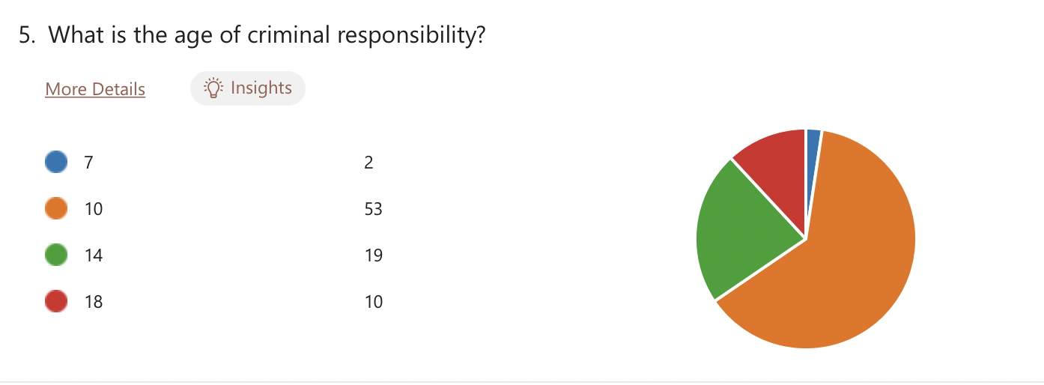
Figure 1- Question 5 responses
Additionally, the participants of this questionnaire were asked if they feel that the age for criminal responsibility was too low, and seventeen of them said that they feel it is. This question is designed to gather the public perception on section 34 of the Crime and Disorder Act (1998) where they outline the criminal age for responsibility. The majority of their reasons were because their brain is not fully developed. To assist this, Nguyen (2021) suggests that a human’s brain is not fully developed until around the age of twenty-five. Supporting this, the Royal Society (2011) suggests that a child’s brain is still underdeveloped and immature at the age of ten. Additionally, it was established in the introduction of this research project that children are not deemed responsible enough to buy their first pet, drive, vote in a general election, or seek paid employment until they are older than the age of ten, which leads to the question; how can they be criminally responsible for their actions before they can do all these things?

In contrast, the questionnaire reveals that the majority of respondents felt that the age for criminal responsibility is the right age, and it shouldn’t be changed. In 1993, two ten-year-old boys abducted and murdered two-year-old James Bulger. Because of the age of criminal responsibility being ten Bulgers family were able to receive the justice that they deserved when the ten-year-old boys, Thompson and Venables were criminally prosecuted. Bulger’s mum, Denise Fergus states that the murder was “coldblooded, planned, and premeditated” and people that suggest the age should be higher are “twisted and insensitive” (Morton 2023). While this case is extremely personal to her, a lot of the respondents stated that they feel children at the age of ten know right from wrong, regardless of if they consider the consequences on themselves and other families.

Question seven was designed to understand whether the public feel that youth crime is currently a problem in the UK. This research project earlier established by the Youth Endowment Fund (2022) that youth crime has been decreasing since 2012 in the UK. In the questionnaire, 61% of respondents strongly agreed that youth crime is one of the UK’s current issues, while only 5% strongly disagreed. This suggests that the public feel that youth crime is a problem that needs to be tackled. While this data is credible and interesting, it ultimately goes down to the areas that people live in or visit, where they may witness or be victims of youth crime. The Department for Environment Food & Rural Affairs (2022) states that police recorded crime rates are lower in rural areas than urban areas. This is purely because the population in urban areas is a lot greater, therefore more crime is being committed and more people are witnesses or victims of crime. Different to the Youth Endowment Fund (2022), the Youth Justice Board (2024) reveal that in 2023 the number of stop and searches against children has increased by 13% since the previous year, and the number of arrests made against children increased by 9%. While the statistics in 2022 may have demonstrated that youth crime has been on a downward spiral since 2012, more up to date legislation reveals that it is on an increase, and the public are noticing it. The average rating of the public perception on the current issue of youth crime was 4.29 as shown below.
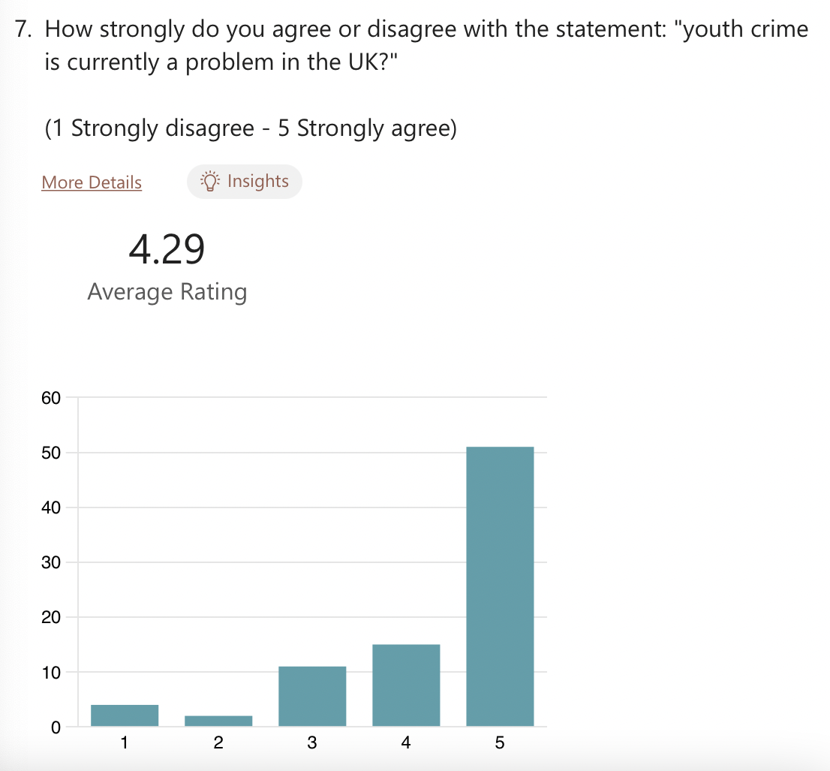
Figure 2- Question 7 responses
In the literature review, Lester (2020) suggested that Adverse Childhood Experiences are one of the biggest root causes of youth crime that has a huge impact on the mental development of a child and a negative impact on the child’s future. Participants were asked in the questionnaire if they know what is meant by the term ‘Adverse Childhood Experiences’ and 30 people said that they do not, while the rest said they do. Condit and Williams (2021) suggest that being aware of what Adverse Childhood Experiences are is crucial to helping individuals, noticing signs, and understanding why certain people act in a specific way. Statistics provided by the UK Parliament (2019) revealed that just under 50% of the UK’s population experience at least one Adverse Childhood Experience. Almost half of the participants from the questionnaire did not know what was meant by the term, which is quite high considering the UK Parliaments (2019) findings. This question limited the researcher as it should have been better constructed with a follow-up question for the people who did know what the term means, which is “Do Adverse Childhood Experiences have an impact on youth crime?’ to gain a better understanding of what the public feels is a root cause of youth crime.

The HM Inspectorates of probation (2023) states that “boys who experience two or more caregivers before the age of ten are more likely to be convicted with a violent crime”. In the questionnaire, participants were asked how strongly they agree with this statement on a scale of 1-5. The purpose of asking this question was to understand how the public perceive this statistic, and whether they feel that it is true or not. The average rating for this question was 3.17 with 43% of people rating it 3, meaning they are unsure. However, more people said that they agree rather than disagree with the statement. In support of this, the Children’s Commissioner (2022) feels that boys who experience two or more caregivers before the age of ten are twice more likely to be convicted with a violent crime. This is more specific than the HM Inspectorates of Probation, but the ratio of people who agreed and did not agree in the questionnaire suggests that the public are somewhat aware.
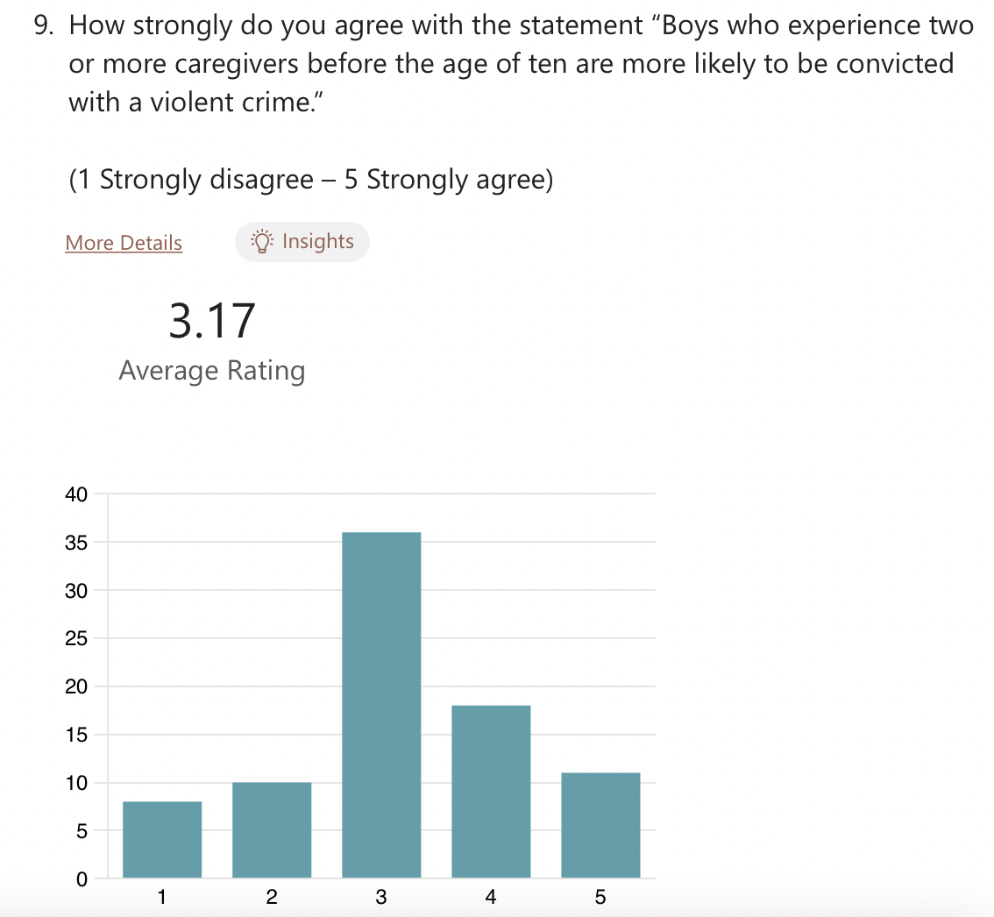
Figure 3- Question 9 responses
Question ten asked participants if they feel that criminal child exploitations and county lines have an effect on the mental development and behaviour of a child, and only seven respondents said that they are unsure. All the rest of respondents felt that it does impact children. Avon and Somerset Police (2023) suggest that young people that are exposed to the world of county lines suffer emotional, physical, and psychological trauma which can carry on throughout their life. A lot of respondents felt that it causes emotional and physical trauma that effects children in later life, as well as contributing to the cause of mental illnesses. Bonning and Cleaver (2020) suggest that county lines and criminal child exploitations impact children through creating a sense of normality within their criminal activities and encourages them to engage in criminal activities to make money, friends, or for accommodation. One participant stated that they are genuinely concerned about the future to come because they feel as if there is not enough support or boundaries for children these days and the effect of crimes like county lines can make it seem like the ‘norm’ in a child’s life.

Question eleven asked the participants if they know what Swansea’s Bureau Intervention is, where 81% of people said no. The intervention is designed to tackle youth crime in Wales and aims to promote positive outcomes through offering support in education and employment. While this intervention could be successful, the public do not know about the intervention which indicates that it is not well promoted, and it is not very successful yet. Swansea Council (2021) revealed a performance report that states that there were a lot of delays in supervision, the preparation of workshops, and the completion of reports during the year of 2020-2021 due to being short staffed, through annual leave, and a lot of staff members being on sick. Further statistics on the report show that the number of first-time entrants in the third quarter increased by six from the previous year, which could have been reduced if the intervention did not experience the delays through being short staffed. Additionally, the public’s lack of knowledge on this intervention may also be because of the issue that they had with the staff.

Swansea’s Bureau Intervention stated that they feel children should be treated as “Children First, Offenders Second” in order to prevent their actions having a negative impact on them, making them feel like they are not criminals and that they can still turn their life around. Having said that, it is a very controversial statement that some people feel should be demolished. Case (2020) suggests that the term should be abolished and replaced with “Children First, Offenders Nowhere” because he feels that the concept should promote positivity and faith in children rather than emphasising on potential negative outcomes. Question twelve of the questionnaire asked the participants which statement they most agree with out of the two. While it was quite close, 60% said “Children First, Offenders Second” and 40% said “Children First, Offenders Nowhere”. This means that out of the individuals that participated, the majority of them agree with the statement provided by Swansea’s Bureau Intervention, as seen below.
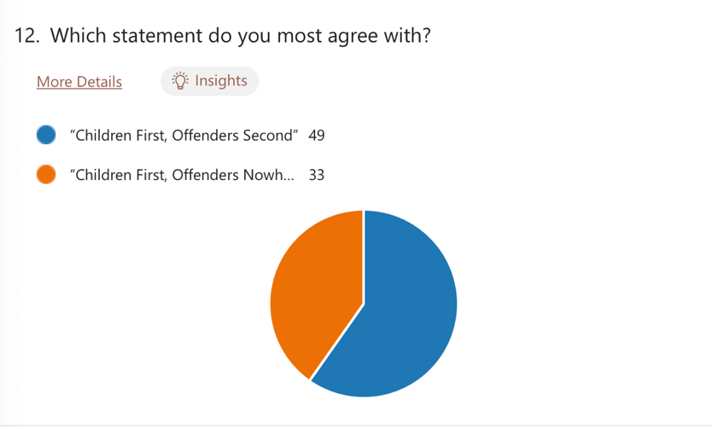
Figure 4- Question 12 responses
In the literature review the Early Foundation (2023) suggests that early intervention can significantly improve a child’s life and divert them from crime. Participants were asked if they feel that early intervention is effective in preventing youth crime only one person said no. They were then given a multiple choice of different types of early intervention and was asked to select the ones they feel are most effective. The intervention techniques with the most votes were education and family training, with the least being after school clubs, as seen in the bar graph below. The Early Intervention Foundation (2023) suggests that education is a fundamental tool for early intervention. Providing children with quality education can positively impact their cognitive, social, and emotional development and enhances their ability for success in their later life.
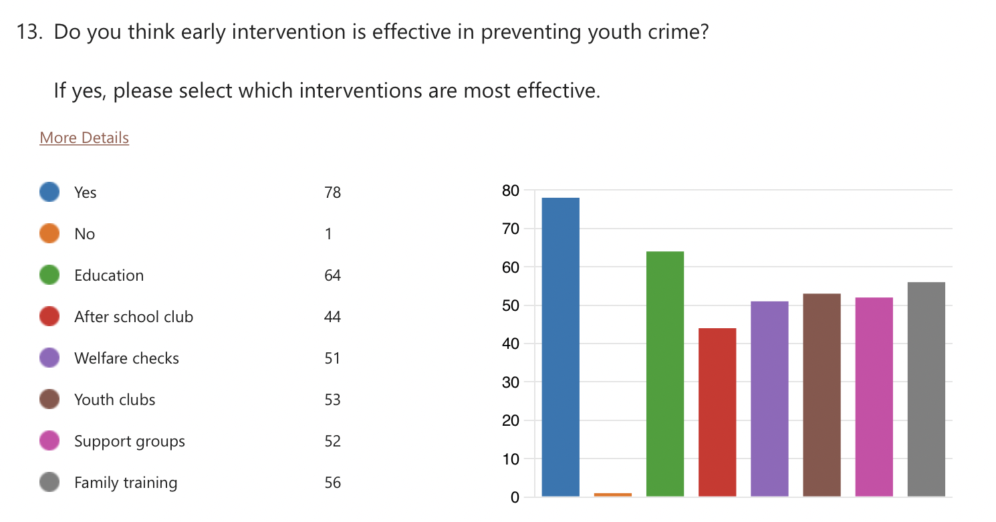
Figure 5- Question 13 responses
Question fourteen asked the participants what they think is the most common offence within young people in the UK. The Youth Justice Board (2023) revealed that the most common offences within young people are summary offences and possession of a weapon. However, the questionnaire results show that the public feel that the most common offence is theft, with 30% of people stating theft. The second most common offence according to the questionnaire is drug related crimes. Similar to question seven, this question ultimately goes down to the types of crimes that people are seeing or hearing about, which is dependent on where they live or visit most frequently. Some respondents did say that they feel knife crime is a common offence, which is supported by the Youth Justice Board (2023) because they say that possession of a weapon is the most common, which often amounts to the use of the weapon, whether it is a knife or a different weapon.

Finally, the last question asked the participants if they feel that unemployment and lack of education causes an increase in crime. Of all responses, only five people said that they do not think it has an impact on crime. Most respondents felt that the crime that is increased the most is theft because lack of income can cause an individual to be desperate and somethings they may need in life, they cannot afford to buy due to being unemployed. Unemployment comes hand in hand with lack of education because to be able to seek employment, most employers ask for qualifications which people will not have if they did not attend school or further education (Ha, 2019).

5. Conclusion

5.1 Research Conclusion

This research project aimed to critically analyse the root causes of youth crime, the facts and figures of youth crime in the UK, and the rehabilitation and early intervention services that are available to young people based on a qualitative and quantitative analysis. It can be concluded that there are many factors that contribute directly to youth crime, including Adverse Childhood Experiences, family relationships, children with parents in prison, children that go through the care system, and unemployment and lack of education. These findings impose that there are many challenges that children may experience throughout their life that causes them to behave and act in certain ways. Basto-Pereira (2022) stresses that not all children that face challenges through their childhood engage in criminal activities during their youth and adulthood. He imposes that it can increase the likelihood of children engaging in criminal activities because of factors like chronic stress, trauma, normality, a sense of belonging, and limited access to supportive resources. While some children may experience challenges throughout their childhood, there are many different factors that contribute to an individual’s outcomes, like resilience, access to support systems, employment, and opportunities for personal growth and development.

The researcher investigated the facts of the crimes that young people are currently committing in the UK and how the crimes are influenced by the root causes of crimes that were earlier established. The Youth Endowment Fund (2022) revealed that youth crime is currently decreasing in the UK and has been for the last eight years. While this is a positive reflection of police interventions, it does not mean that youth crime has completely stopped. In addition to this, the researcher’s questionnaire revealed that 61% of respondents felt that youth crime is currently a problem in the UK, meaning that although it has decreased, it is still evidently existent and the public notice it. A major concern for youth crime is gang involvement and county lines, where vulnerable children are exploited and used to sell drugs and engage in criminal activities through incentives like payment, friendship, and accommodation that they may be lacking through experiencing challenging times at home. Questionnaire participants all felt that county lines and criminal child exploitations have a huge impact on their involvement in criminal activity in their later life. Additionally, the Home Office (2023) suggest that antisocial behaviour is currently an issue in the UK, which does not only affect the children that are being prosecuted for the crimes, but it also deteriorates the public confidence and safety in their local areas or homes where they are supposed to feel safe. Thus, it causes businesses to be affected because they are experiencing lack of custom due to the lack of social activity because people are feeling unsafe and do not want to go out where they may feel vulnerable. Overall, it is clear that there are many different types of crimes that young people commit, which are all results of different experiences throughout their life. It is highly probable that most children that engage with criminal activity experience challenges throughout their life, however some children that commit crimes come from loving, functioning, and supportive families.

The last objective of this research study found that there are many different rehabilitation services available to young people which includes Swansea’s Bureau Intervention which aims to treat children as “children first, offenders second”. While Swansea’s Bureau Intervention is successful and sets out clear aims and objectives to decrease and support youth crime, the questionnaire revealed that 81% of participants had no idea what the intervention was. This suggests that int intervention is not well advertised, and they will struggle to thrive in their goals if nobody knows what it is. Other rehabilitation services include the Early Foundation and the Child First Intervention where they strive to improve children’s life choices, prioritise their needs, promote their strengths and capacities, encourage them to participate in activities, and divert them from stigma (Early Foundation, 2022). In contrast, Taylor (2016) suggests that children are not getting the help they need early enough which is one of the main reasons why youth crime escalates into crime throughout their adulthood. Based on the evidence, it is clear that there are working interventions and rehabilitation services available to young people, which are successful to a degree because the number of youth crime incidents is decreasing in the UK. However, it is highly probable that more can be done to support young people through extra funding for more early intervention opportunities and successful outcomes through rehabilitation services.

5.2. Further research
This research project would have been further enhanced if the time horizon period was longer for the researcher to conduct a further and more detailed understanding of the topic and the public’s perception of youth crime and the current issues that the UK are facing in relation to the root causes of youth crime, the facts and figures of the crimes and the rehabilitation services that are available to them. additionally, the researcher could have published the questionnaire further over more platforms and email so that people who do not use social media had the opportunity to participate in the questionnaire. This directly limited the quality of the questionnaire because it was solely targeted at people who use social media platforms like Facebook and WhatsApp. Further research could also be achieved by directing the questionnaire at people who work within the youth justice system and youth rehabilitation services to gain a deeper understanding and knowledge on their perception of youth crime.

References:

Alamgeer. Z (2023). Time horizon in Research Onion. Available at https://theinnovidea.com/time-horizon-in-research-onion/. Accessed on 26th January 2024.

Aldhaen. M (2020). International Journal of Education, Learning and Development. Interview versus questionnaire from the perspective of CBE members. Pp. 75-77. Available at https://www.eajournals.org/wp-content/uploads/Interview-versus-Questionnaire-from-the-Perspective-of-CBE-Members-1.pdf. Accessed on 6th February 2024.

Alturki. R (2021). Research Onion for Smart Lot-Enabled Mobile Applications. Available at https://www.hindawi.com/journals/sp/2021/4270998/. Accessed on 1st February 2024.

Andrade. C (2020). The Limitations of Online Surveys. Available at https://journals.sagepub.com/doi/10.1177/0253717620957496. Accessed on 6th February 2024.

Avon and Somerset Police (2023). The Realities of County Lines and Child Exploitation. Available at https://www.avonandsomerset.police.uk/news/2023/02/the-realities-of-county-lines-and-child-exploitation/#:~:text=Young%20people%20exposed%20to%20the,and%20deal%20Class%20A%20drugs.. Accessed on 24th April 2024.

Barnardo’s (2023). Children with a parent or relative in prison. Available at https://www.barnardos.org.uk/get-support/support-for-parents-and-carers/children-with-a-parent-in-prison. Accessed on 29th November 2023.

Basto-Pereira (2022). Child Abuse & Neglect. The global impact of adverse childhood experiences on criminal behaviour: A cross-continental study. Available at https://www.sciencedirect.com/science/article/abs/pii/S0145213421005287. Accessed on 6th May 2024.

Become Charity (2023). About the care system. Available at https://becomecharity.org.uk/about-the-care-system/#:~:text=There%20are%20more%20children%20in,to%2070%20in%20every%2010%2C000.. Accessed on 22nd November 2023.

Bonning. J., and Cleaver. K. (2020). ‘There is no “war on drugs”: An Investigation into county line drug networks from the perspective of a London Borough. Available at https://journals.sagepub.com/doi/full/10.1177/0032258X20956682. Accessed on 24th April 2024.

Bucher. J (2021). The Encyclopaedia of Research Methods in Criminology and Criminal Justice. Chapter 36. Accessed on 26th January 2024.

Case. S (2020). Abolishing Youth Justice Systems: Children First, Offenders Nowhere. Available at https://journals.sagepub.com/doi/full/10.1177/1473225419898754. Accessed on 8th December 2023.

Centre for Justice Innovation (2018). Expert Voice: Aaron Brown on youth diversion in Wales. Available at https://justiceinnovation.org/qa-aaron-brown. Accessed on 8th December 2023.

Condit. P., Williams. S. (2021). Adverse Childhood Experiences: Perceptions, Practices, and Possibilities. Available at https://wmjonline.org/wp-content/uploads/2021/120/3/209.pdf. Accessed on 23rd April 2024.

Crime and Disorder Act (1998). Available at https://www.legislation.gov.uk/ukpga/1998/37/section/34. Accessed on 6th November 2023.

Department for Environment Food & Rural Affairs (2022). Statistical Digest of Rural England: Crime. Available at https://assets.publishing.service.gov.uk/media/62bcb0628fa8f535b5ff0b14/Crime_Jun_22_final.pdf. Accessed on 23rd April 2024.

Dudovskiy. J (2022). Interpretivism Research Philosophy. Available at https://research-methodology.net/research-philosophy/interpretivism/#:~:text=Main%20disadvantages%20associated%20with%20interpretivism,by%20personal%20viewpoint%20and%20values.. Accessed on 26th January 2024.

Early Intervention Foundation (2023). Why is it good for children and families? Available at https://www.eif.org.uk/why-it-matters/why-is-it-good-for-children-and-families. Accessed on 25th April 2024.

Edith. W (2013). Ministry of Justice, Youth Justice Interventions – Findings from the Juvenile Cohort Study. Available at https://assets.publishing.service.gov.uk/media/5a7b7d00ed915d131105f922/juvenile-cohort-study.pdf. Accessed on 8th December 2023.

Farrington. D. P. (2011). Crime and public policy, Families and crime (chapter 5), pp. 130. Available at https://books.google.co.uk/books?hl=en&lr=&id=C3Gi1ob0W4oC&oi=fnd&pg=PA130&dq=does+lack+of+parenting+cause+youth+crime&ots=oXErwGel79&sig=nlwJitILen5tQjt15ijMp6Gh7TA#v=onepage&q&f=false. Accessed on 29th November 2023.

Ha. K. (2019). University of Essex. Analyse the relationship between unemployment and crime. Accessed on 25th April 2024.

Haines. K (2013). Pp.5, The Swansea Bureau: A model of diversion from the Youth Justice System. Available at https://yjresourcehub.uk/images/Partners/Swansea%20University/Swansea_Uni_Swansea_Bureau_Evaluation_2016.pdf. Accessed on 8th December 2023.

Hampshire Safeguarding Children Partnership (2022). Safeguarding Adolescents strategy guide. Available at https://www.hampshirescp.org.uk/wp-content/uploads/2022/06/16.-Parent-in-the-Criminal-Justice-System-FINAL.pdf. Accessed on 29th November 2023.

Harding. S (2020). County Lines: Exploitation and Drug Dealing amongst Urban Street Gangs. Chapter 5; Controlling the Line: Exploitation and Sanctions. Pp.143-145. Available at https://www-jstor-org.ezproxy.uwtsd.ac.uk/stable/pdf/j.ctv114c782.11.pdf?refreqid=fastly-default%3A5f758e46214899538ddc3da298cd9310&ab_segments=&origin=&initiator=&acceptTC=1. Accessed on 18th January 2024.

Harries. R (2023). Wales Online. Police arrests teenagers after disorder in city centre. Available at https://www.walesonline.co.uk/news/wales-news/police-arrest-teenagers-after-disorder-27557152. Accessed on 6th December 2023.

HM Inspectorate of Probation (2023). Family relationships. Available at https://www.justiceinspectorates.gov.uk/hmiprobation/research/the-evidence-base-youth-offending-services/specific-areas-of-delivery/family-relationships/. Accessed on 22nd November 2023.

Home Office (2023). Anti-social behaviour: impacts on individuals and local communities. Available at https://www.gov.uk/government/publications/impacts-of-anti-social-behaviour-on-individuals-and-communities/anti-social-behaviour-impacts-on-individuals-and-local-communities. Accessed on 6th December 2023.

Hose of Commons (2024). Offensive weapons. Volume 744. Available at https://hansard.parliament.uk/commons/2024-01-23/debates/14D87A52-2727-44AD-9ED4-7E44EEF68378/OffensiveWeapons. Accessed on 17th April 2024.

Youth Justice Board (2023). Pp.4, Youth offending teams: making the difference for young people, victims and communities. Available at
https://assets.publishing.service.gov.uk/media/5a7f8dcbed915d74e33f725e/Board_Visits_Final_Report.pdf. Accessed on 15th October 2023.

Junjie. M (2022). Pp. 11. Global Academic Journal of Humanities and Social Sciences. The Discussions of Positivism and Interpretivism. Available at https://www.gajrc.com/media/articles/GAJHSS_41_10-14.pdf. Accessed on 20th January 2024.

Khan. S (2021). Mayor reveals driving factors behind violence affecting young people. Available at https://www.london.gov.uk/press-releases/mayoral/driving-factors-behind-violence-affecting-young-pe. Accessed on 23rd November 2023.

Laugalis. V, Connolly. E.J (2023). Head Injury and Antisocial Personality Features in a Sample of Juvenile Detainees. Available at https://journals-sagepub-com.ezproxy.uwtsd.ac.uk/doi/10.1177%2F15412040231181349. Accessed on 23rd November 2023.

Lester. S (2020). Children and Youth Services Review. Service needs of young people affected by adverse childhood experiences (ACEs): A systematic review of UK qualitative evidence. Available at https://www.sciencedirect.com/science/article/pii/S0190740920310227, Accessed on 29th November 2023.

Mitchell. M (2019). A brief history of the Teddy Boys. Available at https://www.rs21.org.uk/2019/02/19/a-brief-history-of-the-teddy-boys/. Accessed on 29th November 2023.

Morton. S. (2023). Morton’s Solicitors. Should The Age Of Criminal Responsibility be Raised? Available at https://www.mortons-solicitors.co.uk/should-the-age-of-criminal-responsibility-be-raised/. Accessed on 23rd April 2024.

National Business Crime Centre (2024). Tackling Anti-Social Behaviour. Available at https://nbcc.police.uk/crime-prevention/anti-social-behaviour/tackling-asb#:~:text=It%20can%20also%20impact%20the,Nuisance%2C%20rowdy%20or%20inconsiderate%20neighbours. Accessed on 18th January 2024.

Nguyen. L. (2021). Paradigm Treatment. A Teen’s Brain Isn’t Fully Developed Until Age 25. Available at https://paradigmtreatment.com/teens-brain-fully-developed-age/. Accessed on 23rd April 2024.

Office for National Statistics (2023). Crime in England and Wales: year ending June 2023. Available at https://www.ons.gov.uk/peoplepopulationandcommunity/crimeandjustice/bulletins/crimeinenglandandwales/yearendingjune2023. Accessed on 22nd November 2023.

Oxford Dictionary (2024). Crime. Accessed on 6th February 2024.

Phil (2023). Research Philosophy: Getting your Business Research Philosophy clear. Chapter 1, Pp 2-3. Accessed on 20th January 2024.

Police and Crime Commissioner for Leicestershire (2024). Crime Recording in England and Wales – Age Classifications. Available at https://www.leics.pcc.police.uk/document-library/Planning-and-Money/Police-and-Crime-Plan/Refreshed-Plan/AppE.pdf. Accessed on 15th February 2024.

Prisons and Probation (2024). Types of Prison Sentence. Available at https://www.gov.uk/types-of-prison-sentence/sentences-children-young-people#:~:text=If%20you%27re%20aged%20between,the%20community%20%27under%20supervision%27.. Accessed on 15th February 2024.

Ran. G (2022). The association between child abuse and aggressive behaviour: A three-level meta-analysis. Available at https://journals.sagepub.com/doi/10.1177/15248380221129596#:~:text=Plenty%20of%20researches%20have%20investigated,likely%20to%20exhibit%20aggressive%20behavior.. Accessed on 29th November 2023.

Rashid. H (2023). Research Philosophy: Positivism, Interpretivism, and Pragmatism. Available at https://limbd.org/research-philosophy-positivism-interpretivism-and-pragmatism/. Accessed on 20th January 2024.

Resolve (2023). Young people and ASB. Available at https://www.resolveuk.org.uk/young-people. Accessed on 6th December 2023.

Schwartz J. A, Jodis C. A (2019). An evaluation of the directional relationship between head injuries and subsequent changes in impulse control and delinquency in a simple of previously adjudicated males. Available at https://www-sciencedirect-com.ezproxy.uwtsd.ac.uk/science/article/pii/S0047235217302398. Accessed on 23rd November 2023.

Sentencing Council (2024). Types of sentencing for children and young people. Available at https://www.sentencingcouncil.org.uk/sentencing-and-the-council/types-of-sentence/types-of-sentences-for-young-people/. Accessed 15th February 2024.

Sirisilla (2023). Writing Limitations of Research Study – 4 Reasons Why It Is Important! Available at https://www.enago.com/academy/limitations-of-research-study/#:~:text=Limitation%20in%20research%20is%20an,the%20outcome%20of%20the%20research.. Accessed on 6th February 2024.

Smith. I (2007). Being tough on the causes of crime: Tackling family breakdown to prevent youth crime. Available at https://www.centreforsocialjustice.org.uk/wp-content/uploads/2018/03/causes_of_crime.pdf. Accessed on 22nd November 2023.

Swansea Council (2021). Swansea Youth Justice Service. Performance Reporting 2020-21. Quarter 3. Available at https://democracy.swansea.gov.uk/documents/s73119/YJS%20Appendix%201%20-%20YJS%20Performance%20Report%20Q3.pdf. Accessed on 25th April 2024.

Taylor. C. (2016). Review of the Youth Justice System in England and Wales. Available at https://assets.publishing.service.gov.uk/media/5a7ffc81ed915d74e622bcdb/youth-justice-review-final-report-print.pdf. Accessed on 6th May 2024.

The Children’s Society (2024). What is county lines? Available at https://www.childrenssociety.org.uk/what-we-do/our-work/child-criminal-exploitation-and-county-lines/what-is-county-lines#:~:text=What%20does%20county%20lines%20mean,manipulate%20them%20into%20drug%20dealing.. Accessed on 18th January 2024.

The HM Inspectorate of Probation (2023). Family relationships. Available at https://www.justiceinspectorates.gov.uk/hmiprobation/research/the-evidence-base-youth-offending-services/specific-areas-of-delivery/family-relationships/#:~:text=divorce%20or%20separation%20of%20parents,convicted%20of%20a%20violent%20crime.. Accessed on 15th October 2023.

The Imperial College of London (2024). Educational development Unit; Questionnaires. Available at https://www.imperial.ac.uk/staff/educational-development/teaching-toolkit/educational-research-methods/methods/questionnaires/. Accessed on 26th January 2024.

The Royal Society (2011). Legal Applications of Neuroscience. Available at https://royalsociety.org/news/2011/legal-applications-of-neuroscience/. Accessed on 6th February 2024.

Thesismind (2019). Analysis of Saunders Research Onion. Available at https://thesismind.com/analysis-of-saunders-research-onion/. Accessed on 26th January 2024.

UK Government (2023). What happens if a child under 10 breaks the law? Available at https://www.gov.uk/child-under-10-breaks-law#:~:text=Child%20Safety%20Order.-,Child%20Safety%20Order,for%20up%20to%2012%20months. Accessed on 13th November 2023.

UK Parliament (2019). Publications and records. The evidence behind early intervention. Available at https://publications.parliament.uk/pa/cm201719/cmselect/cmsctech/506/50605.htm. Accessed on 19th December 2023.

UK Research and Innovation (2022). What is social science? Qualitative research. Available at https://www.ukri.org/who-we-are/esrc/what-is-social-science/qualitative-research/#:~:text=They%20use%20in%2Ddepth%20interviews,they%20thought%20it%20affected%20them.. Accessed on 26th January 2024.

University of Nottingham (2024). Two traditional research paradigms. Available at https://www.nottingham.ac.uk/helmopen/rlos/research-evidence-based-practice/designing-research/types-of-study/understanding-pragmatic-research/section02.html#:~:text=Interpretivism%20is%20based%20on%20the,individuals%27%20historical%20or%20social%20perspective.. Accessed on 26th January 2024.

UWE Bristol (2024). Why you need ethical approval. Available at https://www.uwe.ac.uk/research/policies-and-standards/research-ethics/why-you-need-ethical-approval#:~:text=Ethical%20review%20provides%20protection%20for,of%20a%20genuine%20research%20study.. Accessed on 5th February 2024.

Victim support (2022). What is Crime? Available at https://www.victimsupport.org.uk/crime-info/what-crime/#:~:text=A%20crime%20is%20a%20deliberate,and%20is%20against%20the%20law.. Accessed on 22nd November 2023.

Wolff. K (2019). Adverse Childhood Experiences (ACEs) and Gang Involvement Among Juvenile Offenders: Assessing the Mediation Effects of Substance Use and Temperament Deficits. Volume 18, Issue 1. Accessed on 17th April 2024.

Young Londoners Fund (2019). Helping children and young people make positive choices. Available at https://www.london.gov.uk/sites/default/files/ylf_round_2_data_resource_pack_31_may_2019.pdf. Accessed on 23rd November 2023.

Youth Endowment Fund (2022). Statistics update: The latest data on crime and violence affecting young people. Available at https://youthendowmentfund.org.uk/wp-content/uploads/2022/02/YEF-Statistics-update-February-2022-FINAL.pdf. Accessed on 30th November 2023.

Youth Justice Board (2022). A guide to Child First. Available at https://yjresourcehub.uk/images/YJB/Child_First_Overview_and_Guide_April_2022_YJB.pdf. Accessed on 19th December 2023.

Youth Justice Board (2023). Figure 1.3, Youth Justice Statistics: 2021 to 2022. Available at https://www.gov.uk/government/statistics/youth-justice-statistics-2021-to-2022/youth-justice-statistics-2021-to-2022-accessible-version#:~:text=Sexual%20offences%20saw%20the%20biggest,18%25%20and%2015%25%20respectively.. Accessed on 15th October 2023.

Youth Justice Board (2023). Figure 1.4, Youth Justice Statistics: 2021 to 2022.
Available at https://www.gov.uk/government/statistics/youth-justice-statistics-2021-to-2022/youth-justice-statistics-2021-to-2022-accessible-version#:~:text=Sexual%20offences%20saw%20the%20biggest,18%25%20and%2015%25%20respectively.. Accessed on 15th October 2023.

Youth Justice Board (2023). Youth justice statistics: 2021 to 2022. Available at https://www.gov.uk/government/statistics/youth-justice-statistics-2021-to-2022/youth-justice-statistics-2021-to-2022-accessible-version#:~:text=In%20the%20year%20ending%20March%202022%2C%20the%20two%20most%20common,offences%20committed%20by%20child%20FTEs. Accessed on 15th October 2023.

Youth Justice Board (2023). Youth Justice statistics: 2021 to 2022. Available at https://www.gov.uk/government/statistics/youth-justice-statistics-2021-to-2022/youth-justice-statistics-2021-to-2022-accessible-version. Accessed on 22nd November 2023.

Youth Justice Board (2024). Youth Justice Statistics: 2022 to 2023 (accessible version). Available at https://www.gov.uk/government/statistics/youth-justice-statistics-2022-to-2023/youth-justice-statistics-2022-to-2023-accessible-version. Accessed on 23rd April 2024.

Youth Justice Board for England and Wales (2023). Early intervention for lifelong benefits. Available at https://www.gov.uk/government/news/early-intervention-for-lifelong-benefits. Accessed on 8th December 2023.

Zeller. B (2017). Does early intervention actually help? Available at http://www.tinyfeetei.com/blog/2016/10/28/does-early-intervention-actually-help#:~:text=52%25%20%2D64%25%20of%20children,their%20children%20develop%20and%20learn. Accessed on 8th December 2023.

