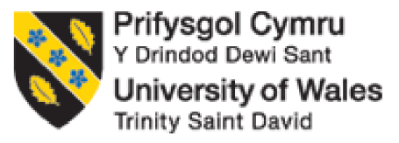

BA Business Management

LCBB4004 Marketing Fundamentals
Student Name: Daniela Mihaela Visan
Student ID: 2247387
Lecturer: Dr Piyumika Gamaze

Component 2: Coursework: Individual Report

Table of Contents

1. Introduction 3
2. External Business Environment Analysis 4
2.1 PESTLE Analysis 4
2.2 Global Market Trends 7
2.3 Competitive Landscape 7
3. Strategic Analysis of Unilever 8
3.1 Business Strategy Overview 8
3.2 Application of Porter’s Five Forces 10
3.3 Resource-Based View 11
4. STP (Segmentation, Targeting, Positioning) Analysis 12
4.1 Segmentation Strategy 12
4.2 Targeting Strategy 12
4.3 Positioning Strategy 13
5. Marketing Mix Analysis 13
6. Future Recommendations 14
7. Conclusion 15
8. References 16

1. Introduction
Unilever, a behemoth in the fast-moving consumer goods (FMCG) sector, operates on a scale that few can rival. With a reach extending to over 190 countries and a daily user base of 3.4 billion people, Unilever stands as a testament to the pervasive influence of global brands in our daily lives (Unilever PLC, 2023). This multinational corporation has successfully penetrated both developed and emerging markets, drawing nearly 59% of its turnover from the latter, showcasing its unparalleled ability to adapt and thrive in diverse economic landscapes (Unilever PLC, 2023). At the core of Unilever's operations are four primary categories that cater to everyday essentials: Beauty & well-being, Personal Care, Home Care, and Nutrition. Each category boasts a portfolio of renowned brands – Dove, Sunsilk, Lifebuoy, Axe, Rexona, Close-up, Cif, Domestos, Comfort, Knorr, Hellmann's, and Lipton – that have become household names across the globe (Unilever PLC, 2023). Unilever's dedication to innovation and consumer pleasure is shown by its varied assortment of goods that suit consumers' basic requirements and developing tastes. Unilever's strength goes beyond its products. Always researching and developing, the firm is an innovation powerhouse. Innovation includes sustainability as well as product enhancement and development. Unilever cares about being responsible to people and the world. Their top goals are taking action on climate change, cutting down on waste, and improving nutrition. This shows that the company cares about more than just making money.
The main point of this paper is to look at how Unilever has carefully dealt with outside forces. Unilever and other international companies have to keep coming up with new ideas and adapting to a global business environment that is always changing and often surprising. The goal of this study is to look into these changes by looking at how social trends, changes in politics and the law, scientific progress, economic upheavals, and new technologies have affected Unilever's strategy. Unilever has grown and thrived despite all the problems it has faced. This has improved its place in the market and set it up well for future success.

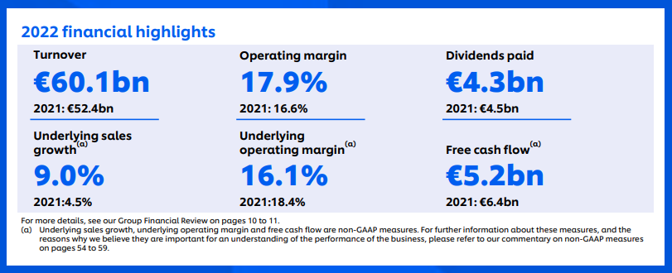
Figure 1: Unilever Financial Performance Highlights
(Source: Unilever, 2023)

2. External Business Environment Analysis

2.1 PESTLE Analysis

Political | Economical | Social
- The Brexit movement due to the exit of the UK from the EU raises new hurdles and challenges in trade impacting the supply chain of Unilever.  - Although the Free Trade Agreements may create a path to new market entry, Unilever still needs to deal with uncertainty.  - Even if adopting ethical practices has an impact on profits, Unilever may be pressured to do so by public scrutiny of corporate social responsibility. | - The Consumer Price Index has been up by 4.6% in the year 2023 (ONS, 2023)  - The current bank interest rate is 5.25% in the UK which can increase borrowing costs for consumers and businesses, affecting demand for Unilever products (Bank of England, 2023).  - The explosive growth of online buying has upended long-standing retail customs and given businesses like Unilever new difficulties. | - Unilever faces diverse social challenges and opportunities. The growing consumer awareness regarding health, wellness, and ethical consumption significantly influences Unilever's product development and marketing strategies.  - The company must adapt to changing demographics, lifestyle trends, and cultural nuances across different regions.
Technological | Legal | Environmental
- Technological advancements play a crucial role in shaping Unilever's operations. The company leverages cutting-edge technologies for product innovation, supply chain management, and customer engagement.  - Digital marketing, e-commerce, and AI-driven consumer analytics are pivotal in understanding and responding to consumer needs.  - Furthermore, Unilever invests in sustainable technologies for eco-friendly packaging and production processes, aligning with its commitment to environmental responsibility. | - Unilever operates in a complex legal landscape, facing varied regulations across different countries.  - Compliance with international trade laws, labour standards, and product safety regulations is paramount.  - The company must navigate changing policies on environmental protection, corporate governance, and consumer rights, adapting its operations accordingly.  - Intellectual property rights and anti-competitive practices also pose significant legal challenges, requiring diligent management to maintain Unilever's market position and reputation. | - Environmental sustainability is a key focus for Unilever, given increasing global concerns about climate change, resource depletion, and waste management.  - The company is committed to reducing its carbon footprint, minimizing waste, and sourcing ingredients sustainably. These environmental commitments influence product formulations, packaging decisions, and supply chain practices.  - Unilever's proactive stance on environmental issues also shapes its brand image and consumer perception, aligning with the growing eco-conscious consumer base.

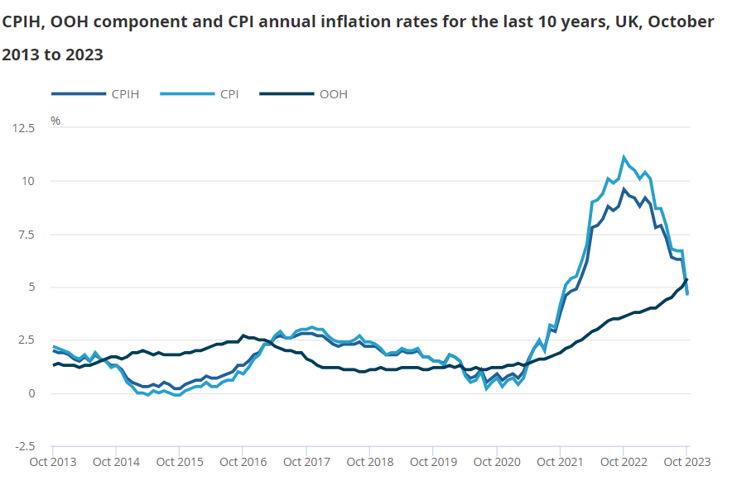
Figure: Consumer price inflation
(Source: ONS, 2023)

2.2 Global Market Trends
The huge changes in the consumer goods industry are having an effect on many of Unilever's plans and processes. Personalisation is becoming very popular very quickly because it lets businesses and customers make goods and services that are perfect for each person.
Unilever uses super techniques for marketing and interactive services which helps their customer in selecting the required product smoothly (Ailawadi and Farris, 2020). As the need for eco-friendly products grows, sustainability and fair sources become more and more important. So, Unilever (2023) is being open about its supply chain, using packaging that is good for the earth, and buying things in a legal way.
In answer to the rise of e-commerce and technology, Unilever has put money into an omnichannel strategy and online infrastructure to make sure that customers can have a smooth experience both online and offline. Health and fitness trends have an effect on Unilever's product development because people want products that are useful and made from natural ingredients. Last but not least, Unilever (2023) is focusing on making goods with added value and lowering costs to stay competitive in a market that is moving towards private labels and cheap stores. This is because consumers are becoming more price-aware and want to get more for their money because of inflation. These patterns help Unilever make smart changes in a global market that is always changing.

2.3 Competitive Landscape
There are many huge companies in the consumer goods business that Unilever has to compete with, such as Procter & Gamble, Nestlé, and L'Oréal (InsideIIM, 2019). These businesses are competitors of Unilever in a lot of different product areas, such as personal care and nutrition. Unilever is ahead of the competition in the market thanks to its wide range of products and strong position around the world. However, the company needs to keep growing and changing to stay ahead. Unilever focuses on ecology and customer-centered strategies to stand out in a market that is always changing and very competitive.
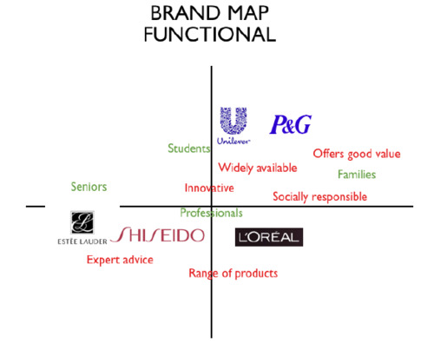
Figure: Brand positioning map of Unilever
(Source: Tumblr, 2023)

3. Strategic Analysis of Unilever

3.1 Business Strategy Overview
As a global leader in the FMCG segment, Unilever possesses a multi-faced structure for its business strategy. Five pillars of Unliver’s key strategies enable the company to operate and maintain the decision-making process.
1. Focused Diversification in Key Categories
Unilever’s strategy hinges on a diversified yet focused portfolio across five critical categories: Beauty & Wellbeing, Personal Care, Home Care, Nutrition, and Ice Cream. Each category features flagship brands like Dove, Sunsilk, Lifebuoy, Axe, Rexona, Close-up, Cif, Domestos, Comfort, Knorr, Hellmann's, Lipton, Magnum, Ben & Jerry's, and Cornetto (Unilever, 2023). These brands represent Unilever’s commitment to meeting the wide-ranging needs of consumers, from personal hygiene to indulgent treats, highlighting a balance between everyday essentials and luxury items.
2. Market Penetration and Growth
Unilever's goals for market entry and growth are to strengthen its place in existing markets and keep coming up with new products in its core categories. Iglesias et al. (2023) say that the company places a lot of value on coming up with new, unique products to meet changing customer wants. Unilever is also focused on growing in developing nations so they can take advantage of the fact that middle-class people there are getting richer and can buy more things.
3. Commitment to Sustainability and Social Responsibility
The company is solely committed to the sustainability and social responsibility. As per the opinion of Iglesias et al. (2023), the company is determined to launch some product that is not green friendly but also economical, here Unilever plays the role of both sustainability on the one hand and social responsibility on the hand. However, the growth of the company doesnt only refer to the success of the organisation but also the success of humanity.

4. Organizational Agility and Simplification
Iglesias et al. (2023) states that there are many other ways for a company to reach the goal of agility and simplification. Some of these are cutting down on red tape, giving employees more freedom over regular tasks, and using technology to improve marketing and operations. The main goal is to build a business that can quickly adapt to changing market conditions and customer tastes.
5. Brand Building and Creating Shared Value
Finally, Unilever spends a lot of money on marketing and ads to make its brand stick out and be loved. Our commitment to making cutting-edge, high-quality goods is at the heart of everything we do. Iglesias et al. (2023) say that Unilever focuses on sustainable practices and ethical sources to attract customers who care about social and environmental problems. As an example of ethical business practices that go beyond simple earnings, Unilever creates shared value that is good for both customers and society as a whole.

3.2 Application of Porter’s Five Forces

Porter’s Five Forces: Unilever Plc
Competitive Rivalry | A lot of small businesses sell big names in the same market as L'Oréal, Nestlé, and Procter & Gamble (InsideIIM, 2019). This makes it tough for consumer goods companies to stay ahead. Unilever faces tough competition in a number of its product lines, such as food and drink and personal care. There is a lot of competition in the market, so Unilever is always being pushed to make new goods, improve old ones, and come up with new ways to price and sell them. To get a bigger share of the market, businesses have to keep working to stand out from the rest and get customers to stick with their brand.
Threat of New Entrants | It is not too bad that new businesses are entering the market for consumer goods. The size and success of the market make it appealing, but getting into it is not easy. One of these problems is the large original investment that is needed to set up the manufacturing, research and development, marketing, and sales networks (InsideIIM, 2019). Unilever's well-known names and economies of scale also make possible rivals less likely to join the market. There may be new companies that try to take market share from Unilever in specialised areas or because more and more people want organic and eco-friendly goods, for example.
Threat of Substitute Products | Substitutes is a big problem for the consumer goods industry. In some types of products, customers have a lot of choices that aren't very different from one another. Customers don't have much trouble moving names because of this. This is especially true for personal care and home care products. For Unilever to stay ahead of the competition and keep customers coming back, they need to always be coming up with new ways to make their goods better.
Bargaining Power of Suppliers | Unilever has a lot of bargaining power with its suppliers because it has so many businesses and is known all over the world. Because the business is so big, it can negotiate better prices and terms. However, for some sustainable or specific raw materials, sellers may have more say over Unilever's supply chain choices and costs.
Bargaining Power of Consumers | Customers in this company have a lot of power when it comes to making deals. People are more price-conscious and picky because they can easily compare prices and quality across many brands and things. Because there are so many online groups and social media, customers have even more power over how people feel about brands and what they like (Jin et al., 2019). To keep customers coming back, Unilever has to keep going above and beyond what they expect and also be able to change to changing tastes.

3.3 Resource-Based View
The Resource-Based View (RBV) paradigm says that Unilever's ongoing competitive edge comes from the unique internal resources and skills that the company has. The company has a strong collection of well-known names, such as Knorr, Ben & Jerry's, and Dove, and its distribution network reaches both developed and growing areas (Unilever, 2023). Strong research and development skills allow for constant improvements in products and activities that help the environment, which in turn supports this wide reach. Unilever can acquire and invest wisely due to its solid finances. In China and India, where the firm is well-known, its cutting-edge technology and long-term supply chain ties set it apart. Long-standing brand heritage, complicated supply chain, and business culture that emphasises sustainability and ethical sources set Unilever (2022) apart. The company's strengths include creating innovative goods, developing strong brands, managing the supply chain, and implementing worldwide expansion plans while being ecologically sustainable. Unilever is a formidable competitor because of these factors.

4. STP (Segmentation, Targeting, Positioning) Analysis

4.1 Segmentation Strategy
Age: Unilever makes an effort to target specific age groups with its product ranges. When marketing to teens, Sunsilk highlights the latest styles and trends, whereas Dove reaches out to older women by highlighting the importance of nutrition and self-esteem. Products like CIF are marketed to families as necessities for cleaning the house (Unilever, 2023).
Income: Unilever's product offers are greatly impacted by income levels. Magnum is an opulent ice cream brand that targets affluent consumers looking for a little something more. On the other hand, Rexona Essentials is purpose-built to cater to budget-conscious shoppers by providing cheap quality (Unilever, 2023).
Lifestyle: Unilever formulates and promotes its products based on consumers' lifestyle choices. Ben & Jerry's enchants daring foodies with its inventive and robust flavours, while Lipton's eco-friendly tea varieties appeal to those who are concerned about the environment (Unilever, 2023).

4.2 Targeting Strategy
With its many targeting strategies, Unilever wants to reach a lot of different types of customers. Each of its products, like Dove for women and Axe for young men, is carefully made to reflect the views and goals of the people it wants to buy it. The company sells a lot of different brands, from more expensive ones like Ben & Jerry's to cheaper ones like CIF cleaners. This means that the business can serve people from all walks of life and income levels. Unilever (2023) localises its ads to reflect changes between regions so that they work in all of them. Omnichannel tactics, such as social media and in-store incentives, help the company build stronger relationships with its users. Unilever also uses data-driven personalisation strategies to make the customer experience better by interacting with them in a more personal way and tailoring marketing messages and product ideas to their needs.

4.3 Positioning Strategy
With its different ways of marketing, Unilever tries to meet the needs and goals of many customers. Some of the useful benefits that the company emphasises in its products are Cif, which is known for being very good at cleaning, and Knorr, which is known for making food taste better. One part of its approach is to appeal to people's emotions. For example, Dove encourages people to accept their bodies, and Ben & Jerry's makes people feel carefree and happy. Some of Unilever's goods, like Hellmann's, are seen as leaders in ethical and environmentally friendly sources by the business (Unilever, 2023). Premium products, like Magnum ice cream, charge more because they are more original or have a longer history as a brand. If you're on a tighter budget, Unilever has items like Rexona and Lifebuoy that are a good value without losing performance because they offer important quality at a price that most people can afford. Due to its multi-pronged positioning strategy, Unilever can meet the wants of a wide range of customers and maintain its prime marketplace.

5. Marketing Mix Analysis
Product Strategy:
Unilever's product plan is based on both a wide range of products and good quality. The company sells five main types of products: ice cream, nutrition, personal care, home care, and beauty and wellness. Because it has so many products, Unilever can meet the needs and wants of a wide range of customers. There are several options in each area, each with its price range and set of features to appeal to a different group of customers. It's clear how wide the range of products is. Unilever's product plan depends a lot on coming up with new ideas. The company is always coming up with new ideas and making its products better so it can keep up with changing customer tastes and industry trends. Buying names that are similar to Unilever's is a smart way for the company to grow and reach new markets.
Price Strategy:
Multi-tiered pricing is how Unilever sets its prices. Different budgets and ideas of value can be met by selling goods in each area at different price points. Prestige names like Magnum and Ben & Jerry's can charge more because they have been around for a long time and are always coming up with new ideas. However, important things like Lifebuoy soap and Cif products are set so that they are both cheap and good value for money (Beard, 2021). It also uses "dynamic pricing," which means that our prices change based on things like competition and interest in the market. Companies use deals, discounts, and bundles to get buyers on a budget and increase sales.
Place (Distribution Strategy):
The company's large distribution plan rests on a strong offline network of wholesalers, stores, and distributors to get its products to a lot of people. In the same way, Unilever believes in online shopping and selling directly to customers. Along with this plan, we are also working hard to expand our marketing in distant areas so that we can reach the growing number of customers who live there. When the company has good supply chain management and smart partnerships with nearby shops, it can cut costs, improve logistics, and have less of an impact on the environment.
Promotion Strategy
Unilever's marketing plan is both unified and has many different parts. For example, it uses TV, social media, celebrity marketing, and in-store sales, along with more traditional forms of marketing, to reach its wide range of customers. Emotional connections are made through stories and ads that are important to the audience (Unilever, 2023). These connections lead to brand loyalty. Data and analytics are very important for making marketing messages more relevant to each person. People who care about the environment and social problems are more likely to buy from companies that run marketing efforts that stress their commitment to sustainability and moral standards. Sponsorships and participation in the community can help build brand loyalty by getting to know customers better and showing their interests and views.

6. Future Recommendations
Navigating Future Challenges and Opportunities
- AI and data analytics can be used to make product deals, marketing messages, and prices more relevant to each customer.
- It is suggested that money be put into e-commerce platforms, online marketing, and digital supply chain management to stay ahead.
- To deal with changes and take advantage of new opportunities, it needs to build strong teams and adaptable business models.
- It should be more present and get a bigger part of the fast-growing markets in Africa and Southeast Asia.
- To get customers who are watching their pennies in these hard economic times to buy the goods, offer options that are based on value and be flexible with prices.
Innovation and Sustainability Ideas
Unilever should look into more environmentally friendly packing options like materials that break down naturally and can be used again and again. There needs to be a wider range of plant-based solutions to meet the growing demand for environmentally friendly and moral food choices. To stay ahead of the competition, customise meal plans and use AI to help it make goods that are better for each person. Working together with research centres is another way to make progress in healthy food production and resource management.

7. Conclusion
Unilever's diverse products, innovative marketing, and sustainability push solidify its global grip. Personalization, digital focus, and emerging market expansion fuel future growth, while robust sustainability and innovation ensure adaptability in a changing world. Short, sweet, and punchy!

8. References
Ailawadi, K.L. and Farris, P.W., (2020). Getting multi-channel distribution right. John Wiley & Sons.
Bank of England (2023). Interest rates and Bank Rate. [online] Bank of England. Available at: https://www.bankofengland.co.uk/monetary-policy/the-interest-rate-bank-rate (Accessed: 14 December 2023).
Beard, A. (2021). Why Ben & Jerry’s Speaks out. [online] Harvard Business Review. Available at: https://hbr.org/2021/01/why-ben-jerrys-speaks-out (Accessed: 14 December 2023).
Iglesias, O., Mingione, M., Ind, N., & Markovic, S. (2023). How to build a conscientious corporate brand together with business partners: A case study of Unilever. Industrial Marketing Management, 109, 1-13.
InsideIIM. (2019). Unilever, P&G And Nestle Top FMCG Rankings | InsideIIM Recruitment Survey 2018. [online] InsideIIM. Available at: https://insideiim.com/unilever-pg-and-nestle-top-fmcg-rankings-insideiim-recruitment-survey-2018 (Accessed: 14 December 2023).
Jin, S. V., Muqaddam, A., & Ryu, E. (2019). Instafamous and social media influencer marketing. Marketing Intelligence & Planning, 37(5), 567-579.
ONS (2023). Consumer price inflation, UK - Office for National Statistics. [online] www.ons.gov.uk. Available at: https://www.ons.gov.uk/economy/inflationandpriceindices/bulletins/consumerpriceinflation/october2023#:~:text=a%20year%20earlier.- (Accessed: 14 December 2023).
Tumblr, (2023). Amandeepgill-Journal Amandeep’s journal: La Roche-Posay on Tumblr, Tumblr. Available at: https://www.tumblr.com/amandeepgill-journal/23096352650/functionalemotional-maps-from-our-brand-sector (Accessed: 24 November 2023).
Unilever. (2023). Unilever Annual Report and Accounts 2022. [Onoine] Available at: https://www.unilever.com/files/92ui5egz/production/90573b23363da2a620606c0981b0bbd771940a0b.pdf (Accessed: 14 December 2023).
Unilever (2022). Sustainable and regenerative sourcing. [online] Unilever. Available at: https://www.unilever.com/planet-and-society/protect-and-regenerate-nature/sustainable-and-regenerative-sourcing/ (Accessed: 14 December 2023).
Unilever (2023). Rethinking plastic packaging. [online] Unilever. Available at: https://www.unilever.com/planet-and-society/waste-free-world/rethinking-plastic-packaging/.
Unilever PLC. (2023). At a glance, Unilever. Available at: https://www.unilever.com/our-company/at-a-glance/ (Accessed: 14 December 2023).

