Workplace Culture and Its Impact on Organizational Efficiency – Amazon
Student name : Mihaela Simona Chort 1910340
Lecturer name :Uju Ogochukwu

Table of Contents
Introduction 3
Workplace Culture and Organisational Efficiency 4
Features of Amazon’s Organisational Culture 5
Amazon’s Organisational Culture Advantages 5
PESTEL Analysis for Amazon 6
Political Factors 6
Economic Factors 7
Social Factors 7
Technological Factors 7
Environmental Factors 7
Legal Factors 8
Ethical Dilemma 8
Recommendations 11
Conclusion 11
References 12

Workplace Culture and Its Impact on Organisational Efficiency – Amazon

Introduction
On the basis of efficacy, some elements in organisational growth increase endurance. As conventions, goals, and purposes assist to strengthen an organisational performance, increased efficiency contributes to increased employee engagement (Nikpour, 2017). The organisational structure was founded on the successful creation of a mindset that fosters a positive training atmosphere. The creation of a robust organisational culture promotes employee productivity (Felipe, Roldán and Leal-Rodríguez, 2017).
In the current time with increasing challenging market, academics and practitioners are considerably more interested in achieving targeted organisational performance levels The elements that influence organisational performance are becoming increasingly important to study (Felipe, Roldán and Leal-Rodríguez, 2017). The impact of different forms of organisational culture on organisational performance is challenged when organisational culture is considered as one of the variables (Osborne and Hammoud, 2017). The impact of a dynamic work culture on the framework that enables organisational performance achievement can have a big impact on the link amongst organisational culture and organisational performance. The impact of individual organisational leaders on sustainable form is measured in terms of respective principles (Nikpour, 2017).
Amazon, the one of the leading e-commerce business practices an organisational culture in order to establish a better workplace for the working staff so that the organisational goals can be achieved. It helps to shape the ideology of the business (Schneider, 2017). The corporate culture at the Amazon encourages the employees to put forward the innovative ideas and to bring about the solutions to the challenges and issues faced by the company (Schneider, 2017). In order to do so, the Amazon also keep looking for the ways to establish the framework through which the effective system can be created and implemented. However, there are always some concerning areas which needs to be identified and solutions should be implemented (Schneider, 2017).

Workplace Culture and Organisational Efficiency
Organisational culture and its influence on numerous external factors inside the context of an organisation is a specific study topic in organisational behavior that has never waned in interest (Felipe, Roldán and Leal-Rodríguez, 2017). Organisational culture has indeed been identified as a key component to examine in corporate life, with findings into its influence on the achievement of organisational objectives growing with each day (Nikpour, 2017). In today's competitive environment, practitioners and academicians are more interested in achieving the desired organisational overall performance and examining the level of effect of the elements affecting this (Felipe, Roldán and Leal-Rodríguez, 2017).
The study on the relationship between corporate culture and organisational performance in the research is casting doubt on the relationships predicted with different conceptions of organisational performance in different organisational culture categories (Osborne and Hammoud, 2017). The discovery of novel environmental factors that strengthen the relationship of organisational culture and organisational efficiency might have a substantial impact on the evaluated relationships (Nikpour, 2017). There is no each culture framework that suits the demands of all companies since sectors and conditions differ greatly (Osborne and Hammoud, 2017).
The leaders of the successful firms and business always encourages and motivates the workforce for expressing brand characteristics to workers and potential new recruits (Chatterjee, Pereira and Bates, 2018). They are explicit regarding company beliefs and how certain beliefs shape and govern their companies' operations (Nikpour, 2017). By integrating and reframing traditions, and also to resolve the disparities, a shared foundation for the tomorrow can eb easily established (Chatterjee, Pereira and Bates, 2018). The swift speed of acquisitions and mergers has altered the framework through which various companies combines in the current history (Al-Ali et al., 2017). Mergers have changed their attention aside from mixing cultures and forward achieving particular corporate goals. Many analysts feel that a healthy organisational culture would emerge spontaneously if the proper business strategy and objectives are in existence throughout a combination (Nikpour, 2017).
If an organisation's culture is to increase global productivity, this should give a core competitiveness, with shared values and beliefs. Increased confidence and collaboration, reduced disputes, and much more effective decision are all advantages of a solid tradition (Felipe, Roldán and Leal-Rodríguez, 2017). A key role is assessed by the organisational culture in providing a strong sense of identification, informal control mechanism for the organisation and helps the employees to develop a sense of comprehension (Al-Ali et al., 2017). It has been seen that those organisations who practice strongly defined cultures are more likely to justify the behaviours of the employees (Pawirosumarto, Sarjana and Gunawan, 2017). Organisational culture is mainly shaped and sustained by the roles played by the leaders of the company (Brevini and Swiatek, 2020). For example, if the executives themselves do not practice such behaviours then they are more likely to fail in their designated tasks (Nikpour, 2017).

Features of Amazon’s Organisational Culture
Amazon is recognised for empowering staff to experiment with new concepts and think independently (Schneider, 2017). Amazon declares that “We're a firm of pioneers. It's our duty to take risks, and we derive our energy from creating new products for clients. Success is assessed in terms of what is feasible rather than what is likely. That is precisely why today's pioneers would prefer develop on Amazon than anywhere else on the planet.” (Desai, 2020). This statement demonstrates the following elements of Amazon's organisational culture: boldness, customer centricity, and uniqueness.

Amazon’s Organisational Culture Advantages
The founder of the Amazon, Jeff Bezos mentioned that the mission of this company sit work in a setting which is not only beneficial for the company but for its working staff as well (Desai, 2020). It has been found that the company has greatly benefit form the its cultural features whilst encouraging innovation by means of its various aspects. Though the concepts of uniqueness and boldness, the company encourages its employees to share great ideas which can be implemented for the betterment of the firm (Schein, 2020).
Moreover, the client-centricity ensures that the demands and needs of the customers and clients are considered and such products and services are provided which are the need of the time (Boewe and Schulten, 2017). However, there are several concerns in this regard which needs to be considered. For instance, the organisational culture of the Amazon puts excessive load on both types of resources, financial and human resources. It also demands the risk-taking capability which can lead to severe consequences (Desai, 2020).

PESTEL Analysis for Amazon
A PESTEL study is a model or technique that strategists adopt to assess and track microeconomic elements that affect an organisation, firm, or sector. It investigates various extrinsic factors which are discussed below. A SWOT analysis can be completed by analysing the factors and then evaluating the respective threats as well as the weaknesses of the company or organisation (Çitilci and Akbalık, 2020). The organisational culture of the Amazon is also assessed by means of the PESTEL analysis (Schneider, 2017).
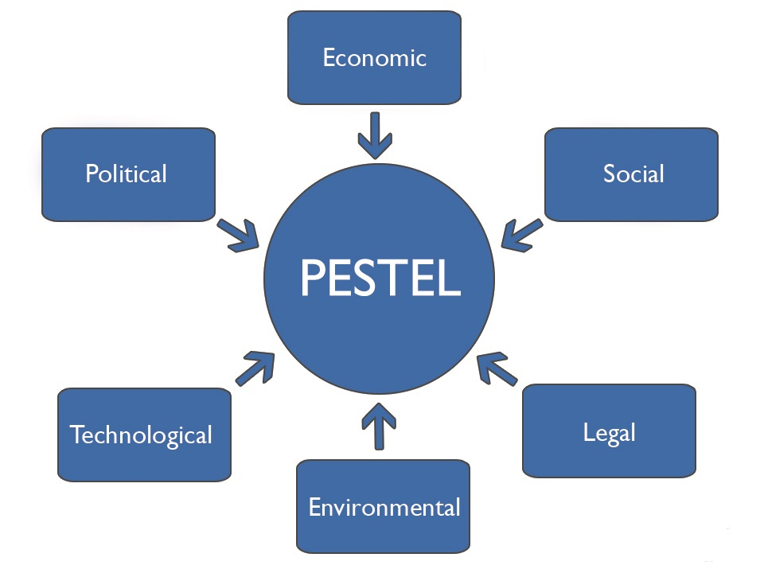

Figure 1. PESTEL Analysis

Political Factors
The political factors are the most important factors that should be analysed for the established of the company. There are several co-factors which come into existence whilst analysing the political factors. These co-factors include the involvement of the government, the restriction imposed by the government, the governmental policies related to the tax payment and many more. It has been evident that the political factors greatly affect the productivity of the organisation based on the factors that have been mentioned. In order to work effectively without getting affected by the political factors, the Amazon adapts the current government policies as well as the future regulations which might be implemented (Çitilci and Akbalık, 2020).

Economic Factors
The way an organisation performs its operation is also under the influence of various economic factors which can be divided into micro- and macro-economic factors. These are based on how the regulations are carried out for the overall marker sector and then analysing what is the current need of the specific company or an organisation. Moreover, the investment by the general population also comes under this category as they are a huge part of the country’s economy (Çitilci and Akbalık, 2020).

Social Factors
Socio-cultural elements are those in which the population greatly affects the behaviours and common beliefs of the company. Such elements include the growth rate, demography, health awareness, professional views and many more. By analysing these factors, the company is able to identify what are the trends that are currently being followed by the population and how these trends change depending upon the customer needs (Çitilci and Akbalık, 2020).

Technological Factors
It has been evident that the technology has shift the paradigm of development to a new extent. It has changed the market and products in the similar pattern. There are three different ways in which marketing and management of the Amazon has been affected by the technological factors. They include new ways of connecting with the targeted sector, producing services and goods and distribution of those services and goods (Çitilci and Akbalık, 2020).

Environmental Factors
Since last 15 years, the world has seen a great interference of environmental factors in the growth of the company. Due to the technological advancements, the prevalence of these factors is evident. The customers are now demanding the products and services which fulfills all the aspects of ethical norms and principles. Therefore, the manufactueres are foscuing on considering enviornemntal factors so that the customers requirements are met. However, this requires a lot of efforts by the organisation as a whole (Çitilci and Akbalık, 2020).

Legal Factors
Several legal factors such as practice of ethical principles and guidelines, security of both the working staff and the customer, campaigns used for the advertisements, equal opportunities for the development and enhancement, regulations related to the organisation safety and many more play a key role in establishment. It is important for the business to identify what is in favour of the company and what is not related to the laws and regulations. Only if the company is able to do so then the prosperity is highly acceptable. For an international organisation such as Amazon, it becomes extremely difficult to ensure the practice of legal factors as every government does have its defined code of conduct (Çitilci and Akbalık, 2020).

Ethical Dilemma
Ethical dilemmas are circumstances where a certain difficult decision must be taken amongst two or more choices, none of which addresses the issue according to recognised ethical norms (Diamantidis and Chatzoglou, 2019). Sustaining a committed workforce is important to an organisational progress. Employee productivity and workforce happiness have been regarded as significant boosters of organisational success and productivity in the world today (Brevini and Swiatek, 2020). As a result, Amazon needs adopt transformational methods to prevent negatively impacting the organisation’s comprehensive effectiveness Improving motivation of employees through managing performance criteria will have a beneficial influence on the business's flexibility in pursuing its aims and outcomes (Desai, 2020).
Unethical management who are responsible for running a business is a key element, because if a business is led by such a system, then there is a high probability that the business will operate in a harmful environment where the aggression is persistent in every mean (Osborne and Hammoud, 2017). A harmful culture may be compounded by continuously regenerating the firm with like-minded people and harmful attitudes, especially with the present concentration in several organisations in the process of recruitment for the "cultural fit." Furthermore, employing for "cultural fit" could be used as a cover for prejudice, leading to the onset of more ethical dilemmas in the future (Diamantidis and Chatzoglou, 2019).
To guarantee that perhaps the aims, strategic goals, and objectives established for workers are practical and attainable, the company's executive management must adopt realistic management (Brevini and Swiatek, 2020). The stated standards must push staff to succeed whilst without pushing them beyond respective capabilities, mostly since unattainable objectives can be stressful (D'Agostino, 2018). Furthermore, corporate practices must be established and enforced to address the long-abandoned work and individual life balance for workers by emphasising the health and life by providing appropriate sufficient rest (Meng and Berger, 2019).
On the basis of efficacy, some elements in organisational growth increase endurance. As conventions, goals, and purposes assist to strengthen an organisational performance, increased efficiency contributes to increased employee engagement (Nikpour, 2017). The organisational structure was founded on the successful creation of a mindset that fosters a positive training atmosphere. The creation of a robust organisational culture promotes employee productivity (Felipe, Roldán and Leal-Rodríguez, 2017).
Amazon has been condemned for its severely unequal and dangerous employment circumstances for its workers (Taplin, 2017). The company's facilities, where mishaps are prevalent, have indeed been criticised as having particularly severe workplace practices (Luo, 2020). Furthermore, Amazon's terrible working environment are linked to the business's disdain for its workers' work-life balance, that arises from the business's unreasonable and excessive demands of its staff (Osborne and Hammoud, 2017).
If an organisation's culture is to increase global productivity, this should give a core competitiveness, with shared values and beliefs. Increased confidence and collaboration, reduced disputes, and much more effective decision are all advantages of a solid tradition (Felipe, Roldán and Leal-Rodríguez, 2017). A key role is assessed by the organisational culture in providing a strong sense of identification, informal control mechanism for the organisation and helps the employees to develop a sense of comprehension (Al-Ali et al., 2017). It has been seen that those organisations who practice strongly defined cultures are more likely to justify the behaviours of the employees (Pawirosumarto, Sarjana and Gunawan, 2017). Organisational culture is mainly shaped and sustained by the roles played by the leaders of the company (Brevini and Swiatek, 2020). For example, if the executives themselves do not practice such behaviours then they are more likely to fail in their designated tasks (Nikpour, 2017).
Workers are forced to perform continually, both at work and at home, as well as on the workstations at night and on weekends, by the administration. For example, the firm may arrange work-related meetings on weekends and vacations depriving them of their vacation time (Brevini and Swiatek, 2020). Developing a positive work-life balance is a powerful strategy for increasing employee performance and efficiency at workplace (D'Agostino, 2018). Adverse consequences of an absence of work balance include higher absenteeism, family strife, and lack of performance (Diamantidis and Chatzoglou, 2019).
Workers are also overworked and dissatisfied as a result of the absence of appropriate working circumstances, and they are unable to achieve success in support of the objectives of the organisation People are the most significant corporate asset, thus they must be emphasised whilst also the operational setting is being planned (Pawirosumarto, Sarjana and Gunawan, 2017). As a result, an organisation which struggles to recognise the importance of optimal employment circumstances risks negative consequences, such as utter impossibility or higher expenses of retaining employees and recruiting (Meng and Berger, 2019).
Employees' working hours must be respected, and they should be allowed to relax following duty. Employees' efficiency and performance rise when they establish a decent work-life balance (Pawirosumarto, Sarjana and Gunawan, 2017). As a result, the firm must avoid situations when staff are invited to video call throughout the vacations or nights. Furthermore, Amazon must consider the health and safety of workers through putting in place adequate safety measures in their facilities soon before to prevent tragic incidents like the high-temperature disaster at its Pennsylvania facility (Taplin, 2017). Workers are motivated to perform the jobs efficiently when they don't have to worry about getting hurt (Meng and Berger, 2019).
In the current time with increasing challenging market, academics and practitioners are considerably more interested in achieving targeted organisational performance levels The elements that influence organisational performance are becoming increasingly important to study (Felipe, Roldán and Leal-Rodríguez, 2017). The impact of different forms of organisational culture on organisational performance is challenged when organisational culture is considered as one of the variables (Osborne and Hammoud, 2017). The impact of a dynamic work culture on the framework that enables organisational performance achievement can have a big impact on the link amongst organisational culture and organisational performance. The impact of individual organisational leaders on sustainable form is measured in terms of respective principles (Nikpour, 2017).

Recommendations
In order to sustain the organisational culture at the Amazon, the executives are recommended to analyse the overall performance of the company with respect to the employee productivity. It is also necessary to assess bottlenecks and identify the concerning problems so that immediate actions can be taken. Moreover, the areas which require improvements must be identified so that the company’s goals are accomplished. Amazon should also consider the fact that external procedures or policies and measures often prove to be efficient if they are evaluated carefully.
Since the establishment, Amazon has worked greatly in its raising concerns regarding the immediate issues. It knows how to implements the policies and measures for the company benefits and what are the ideas that can be beneficial in the future. This implies the importance of the organisational culture of the Amazon company. The employees feel encouraged for the fact that they shared their valuable ideas and thoughts for the betterment of the company. They are also encouraged to apply some of the best practices which are meant to solve the issues of the company. However, the Amazon should now focus mainly on the organisational culture for every single employee of the company.

Conclusion
Organisation analysis includes identifying numerous characteristics of a company by concentrating on its efficiency or incompetency in a particular domain and proposing potential improvements A company's organisational culture has a significant impact on its effectiveness outcome. As a result, poor organisational cultural practices are harmful since they influence employees, lowering the performance of the firm. Amazon is an online store based in the United States that sells a variety of items across the world. Nevertheless, the company has been accused of engaging in monopolistic methods that have harmed its workers. The online retail growth of the Amazon is considered to be the best in this regard. The associated cultural traits characterize. Amazon’s human resource management and, as a result, the e-commerce organisation's competencies.

References

Al-Ali, A.A., Singh, S.K., Al-Nahyan, M. and Sohal, A.S., 2017. Change management through leadership: the mediating role of organisational culture. International Journal of Organisational Analysis.
Boewe, J. and Schulten, J., 2017. The long struggle of the Amazon employees. Rosa Luxemburg.
Brevini, B. and Swiatek, L., 2020. Amazon: Understanding a Global Communication Giant. Routledge.
Chatterjee, A., Pereira, A. and Bates, R., 2018. Impact of individual perception of organisational culture on the learning transfer environment. International Journal of Training and Development, 22(1), pp.15-33.
Çitilci, T. and Akbalık, M., 2020. The Importance of PESTEL Analysis for Environmental Scanning Process. In Handbook of Research on Decision-Making Techniques in Financial Marketing (pp. 336-357). IGI Global.
D'Agostino, J.L., 2018. The Impact of E-commerce on Brands: An Analysis of Amazon and a Plan for the Future (Doctoral dissertation, University of Oregon).
Desai, A., 2020. Amazon’s Business Analysis, Amazon Go–Case Study, & Jeff Bezos’s Leadership.
Diamantidis, A.D. and Chatzoglou, P., 2019. Factors affecting employee performance: an empirical approach. International Journal of Productivity and Performance Management.
Felipe, C.M., Roldán, J.L. and Leal-Rodríguez, A.L., 2017. Impact of organisational culture values on organisational agility. Sustainability, 9(12), p.2354.
Luo, N., 2020. Amazon. com, Inc Strategic Audit.
Meng, J. and Berger, B.K., 2019. The impact of organisational culture and leadership performance on PR professionals’ job satisfaction: Testing the joint mediating effects of engagement and trust. Public Relations Review, 45(1), pp.64-75.
Nikpour, A., 2017. The impact of organisational culture on organisational performance: The mediating role of employee’s organisational commitment. International Journal of Organisational Leadership, 6, pp.65-72.
Osborne, S. and Hammoud, M.S., 2017. Effective employee engagement in the workplace. International Journal of Applied Management and Technology, 16(1), p.4.
Pawirosumarto, S., Sarjana, P.K. and Gunawan, R., 2017. The effect of work environment, leadership style, and organisational culture towards job satisfaction and its implication towards employee performance in Parador Hotels and Resorts, Indonesia. International Journal of Law and Management.
Schein, A., 2020. Organisational ambidexterity, hard power management and smart power management at Amazon, a case study. Global Business and Economics Review, 22(1- 2), pp.27-40.
Schneider, L., 2017. Overview of Amazon. com's history and workplace culture.
Taplin, J., 2017. Move fast and break things: How Facebook, Google, and Amazon have cornered culture and what it means for all of us. Pan Macmillan.

