

Programme: BA Leadership and Management
Module: Strategic Management for Business
Module Code: LCLM 6001

Individual Report
Innocent Drinks – A Mission-Driven Business

Lecturer`s Name: Md Ashikul Khan

Student ID: 2323448
Student Name: Cornel Andrei

Contents
Executive Summary 4
1. Introduction to Innocent Drinks 5
2. Evaluation of Current Market Situation 5
2.1 PESTEL analysis 6
2.2 Porter’s Five Forces 7
2.3 SWOT summary 8
3. Strategic Growth Options and Proposed Strategy 9
3.1 Strategic Growth Options (Ansoff Matrix) 9
3.1.1 Market Penetration (Existing products, existing markets) 10
3.1.2 Market Development (Existing products, new markets) 10
3.1.3 Product Development (New products, existing markets) 10
3.1.4 Diversification (New products, new markets) 10
3.2 Competitive Positioning (Porter’s Generic Strategies) 11
3.2.1. Recommended Strategy: Purpose-Led Differentiation for Sustainable Growth 11
3.2.2. Functional and Plant-Based Product Innovation 12
3.2.3. Channel and Market Expansion 12
3.2.4. Low-Carbon and Resilient Supply Chain 12
3.2.5. Strategic Rationale and Alignment with Organisational Values 13
4. Strategy Evaluation (SFA) 13
4.1. Suitability 14
4.2. Acceptability 14
4.3. Feasibility 15
4.4. Assumptions 15
4.5. Conclusion of Strategy Evaluation 16
5. Stakeholder Analysis 16
5.1 Stakeholder Impact 17
5.1.1. Customers 17
5.1.2. Employees 17
5.1.3. Retailers and Channel Partners 17
5.1.4. Suppliers and Farmers 17
5.1.5. Investors / Parent Company 17
5.1.6. Communities and Regulators 17
5.2 Stakeholder Engagement Plan (Mendelow’s Matrix) 18
6. Implementation and Monitoring 19
6.1 Strategic Objectives and Actions 19
6.2 Risk Assessment and Mitigation 20
7. Conclusion 20
8. References 22

Executive Summary
Innocent Drinks is a UK-based company operating in the growing but highly competitive health and wellness beverage market. The organisation has built a strong brand position through its focus on natural ingredients, ethical sourcing and a purpose-driven identity. Its mission is to make natural and healthy products that help people live well, supported by a commitment to environmental sustainability and social responsibility (Innocent Drinks, 2026a). However, the external business environment presents increasing challenges, including intense competition from multinational brands and private label products, rising cost pressures and growing consumer expectations regarding health and sustainability.
This report evaluates the current strategic position of Innocent Drinks and proposes growth strategies to support long-term performance. An analysis of the external environment indicates that the industry is characterised by highly competitive rivalry, strong bargaining power from major retailers and a high threat of substitutes, as consumers have a wide range of alternative beverage options (Porter, 1979). At the same time, macro-environmental trends such as increasing health awareness, stricter sugar regulations and climate-related supply risks are reshaping the market and influencing strategic decision-making (Scarborough et al., 2020).
Based on the analysis, the report recommends a growth strategy focused on purpose-led differentiation. Using Ansoff’s Matrix, the proposed approach combines product development and selective market expansion. Key strategic priorities include the introduction of functional and plant-based product innovations, expansion into health-focused channels and selected European markets, and the development of a low-carbon and resilient supply chain aligned with science-based environmental targets.
The proposed strategy is evaluated using the Suitability, Acceptability and Feasibility (SAF) framework and supported by a Balanced Scorecard to guide implementation and performance monitoring. The evaluation indicates that the strategy is aligned with market trends, consistent with stakeholder expectations and achievable using Innocent’s existing brand strength and operational capabilities. Effective implementation will enable the organisation to achieve sustainable revenue growth while reinforcing its competitive advantage and maintaining its mission to leave the world better than it found it (Barney, 1991).

Introduction to Innocent Drinks
Innocent Drinks is a UK-based company specialising in smoothies, juices and plant-based beverages. Founded in 1999, it has become one of the leading brands in the European healthy drinks market. The company’s mission is to “make natural, delicious food and drink that helps people live well and die old”, supported by a vision to “leave things better than we found them”, reflecting a strong commitment to combining commercial success with social and environmental responsibility (Innocent Drinks, 2026a). A central element of Innocent’s strategy is its ethical positioning. The company is certified as a B Corporation, demonstrating high standards of transparency, environmental performance and stakeholder accountability, alongside science-based carbon reduction targets and regular sustainability reporting (B Lab, 2024; Innocent Drinks, 2022). Since becoming fully owned by The Coca-Cola Company in 2013, Innocent has benefited from global distribution and financial support, although this increases scrutiny of its authenticity (Innocent Drinks, 2026b). Growing demand for healthy, sustainable products and increasing environmental risks require continuous innovation and strategic adaptation (Hart, 1995; Stubbs, 2017).
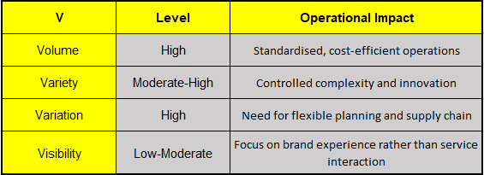
Figure 1 5Vs

Evaluation of Current Market Situation
This section assesses Innocent Drinks’ business environment using PESTEL, Porter’s Five Forces, and SWOT, focusing on evidence that is relevant to board-level decision making. Innocent’s strategy must work in a context where “better-for-you” beverages are growing in consumer interest, but where profitability is constrained by retailer power, intense rivalry, and input volatility.

2.1 PESTEL analysis
Political/Legal. UK and European regulation increasingly shape both health and sustainability outcomes. The Soft Drinks Industry Levy (SDIL) has driven reformulation and reductions in sugar content, demonstrating governments’ willingness to intervene to address diet-related risks (Scarborough et al., 2020). At the same time, tightening packaging, recycling and carbon disclosure requirements increase the strategic importance of recyclable materials and credible emissions reduction.
Economic. The economic environment is challenging for premium beverages. Rising costs for energy, transport and packaging reduce margins, while consumers facing cost-of-living pressures are more price sensitive. Powerful UK retailers further increase pressure by expanding private label ranges, which continue to retain customers even as economic conditions improve (Kumar and Steenkamp, 2007).
Social. Demand for healthier products remains strong, but consumers increasingly expect functional benefits alongside natural ingredients. Research indicates that health-conscious consumers are increasingly seeking products that combine nutrition, transparency and ethical sourcing (Euromonitor International, 2023). Trust and transparency are critical, and Innocent’s B Corp certification provides third-party validation of its social and environmental performance (B Lab, 2024).
Technological. Data analytics, rapid product testing and digital retail channels increase innovation speed and strengthen retailer control over customer access.
Environmental. Climate change threatens agricultural supply stability, making decarbonisation and sustainable sourcing essential for long-term resilience (Wheeler and von Braun, 2013).

2.2 Porter’s Five Forces
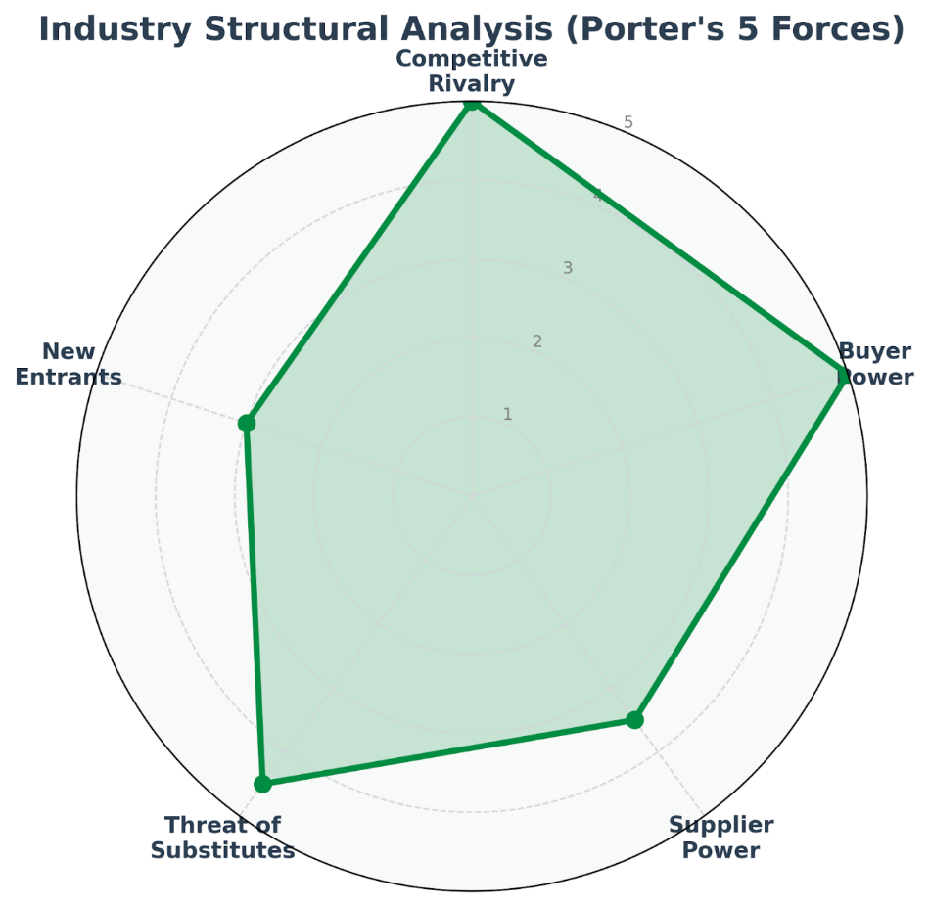
Figure 2 Porter`s 5 Forces
Industry rivalry is high, as the better-for-you beverage market includes multinational brands, niche health specialists and strong retailer private labels. In highly competitive consumer goods markets, firms must continuously innovate and differentiate their offerings to sustain competitive advantage (Porter, 1985). Frequent innovation, promotions and intense competition for shelf space limit the effectiveness of brand strength alone, requiring a coordinated strategy across product, sourcing and distribution (Porter, 1979).
Buyer power is also high because UK supermarkets control shelf space, pricing and consumer access, further strengthened by the growth of rapid-delivery services, which increases retailer influence over demand. This makes brand differentiation and channel diversification strategically important (Kumar and Steenkamp, 2007).
Supplier power is moderate but rising, as climate-related volatility affects fruit availability and the demand for sustainable packaging increases input costs (Wheeler and von Braun, 2013).
The threat of substitutes is high, with consumers able to switch to water, functional drinks or homemade options, especially during economic pressure.
The threat of new entrants is moderate, as niche brands can target functional segments, increasing the need for continuous innovation (Porter, 1980).

2.3 SWOT summary
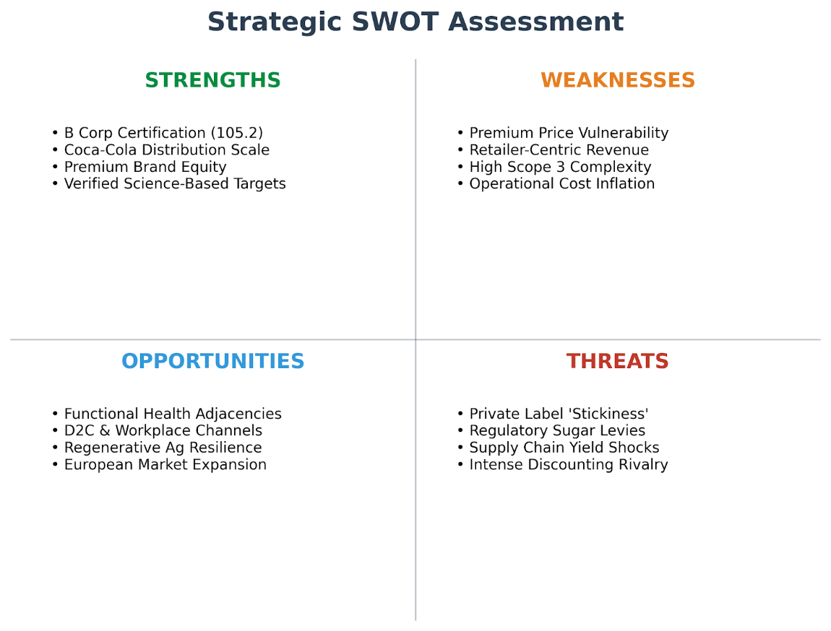
Figure 3 SWOT
Strengths: strong brand equity and tone-of-voice, B Corp credibility (score 105.2), and a clear climate pathway (50% per bottle by 2030; toward near-zero by 2040) that supports stakeholder trust and differentiation.
Weaknesses: premium price exposure during downtrading; heavy dependence on powerful grocery buyers; and large Scope 3 exposure across ingredients and packaging that is difficult and costly to reduce at speed.
Opportunities: functional/plant-based adjacency consistent with the brand; channel expansion into health contexts; and turning sustainability investment (e.g., farming innovation funding) into resilience and competitive advantage.
Threats: private label persistence, retailer power, regulatory tightening on sugar/claims, and climate-driven ingredient volatility.
Overall implication: Innocent’s environment is attractive for demand growth but structurally tough for margins. The business case for growth therefore rests on defending differentiation with credible sustainability and health leadership, while building resilience and reducing reliance on retailer-controlled value capture.

Strategic Growth Options and Proposed Strategy
To support sustainable growth while maintaining its mission-driven identity, Innocent Drinks must pursue strategic options that strengthen its competitive position in a market characterised by high rivalry, strong retailer power and increasing consumer expectations. This section evaluates potential growth paths using the Ansoff Matrix and Porter’s Generic Strategies, before recommending a strategy that aligns with Innocent’s values and long-term objectives.

3.1 Strategic Growth Options (Ansoff Matrix)
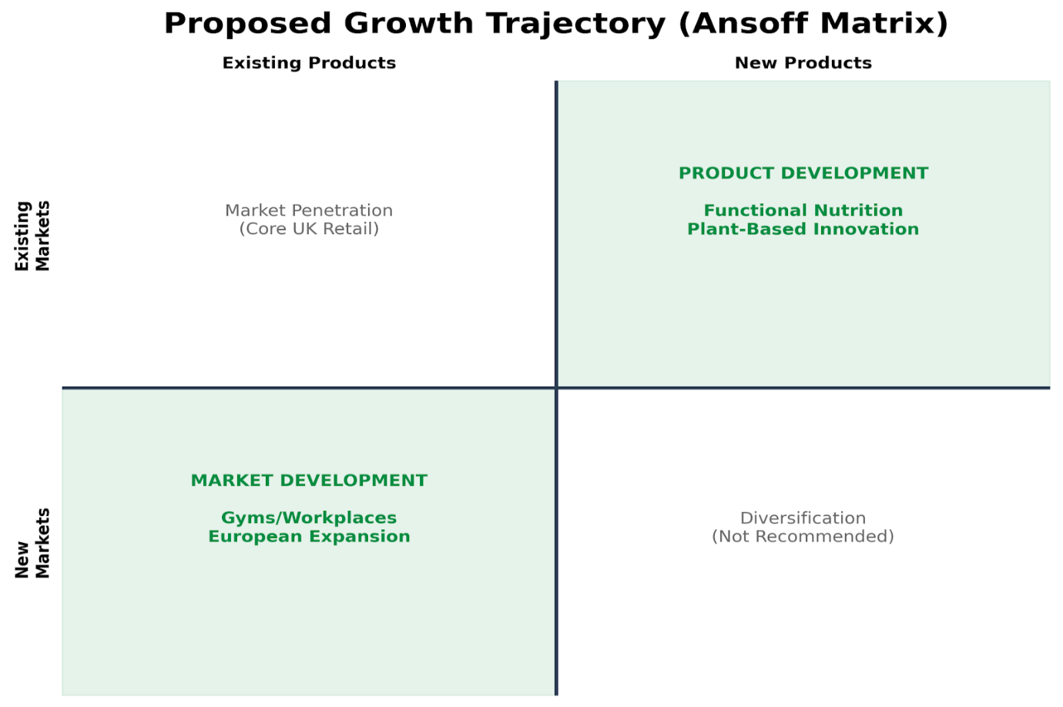
Figure 4 Ansoff Matrix
The Ansoff Matrix provides a structured framework for evaluating growth opportunities based on products and markets (Ansoff, 1957).
3.1.1 Market Penetration (Existing products, existing markets)
This option focuses on increasing sales of current smoothies and juices within existing markets through promotions, pricing strategies and improved distribution. While this approach carries relatively low risk, its growth potential is limited due to market maturity and intense competition. High retailer bargaining power also means that growth through promotions may reduce margins without delivering long-term competitive advantage.
3.1.2 Market Development (Existing products, new markets)
Expanding into new geographic markets, particularly within Europe, represents a moderate-risk growth opportunity. Innocent already operates in several European countries, and further expansion could leverage existing brand equity and Coca-Cola’s distribution network. In addition, expanding into alternative channels such as foodservice, workplaces, universities and gyms could reduce reliance on traditional supermarket retail and reach health-conscious consumers in targeted consumption contexts.
3.1.3 Product Development (New products, existing markets)
Developing new products for current customers offers significant growth potential. Consumer demand is shifting toward beverages that provide specific health benefits such as protein, fibre, hydration or immune support. Expanding the product portfolio into functional and plant-based categories would allow Innocent to respond to these trends while leveraging existing brand trust.
3.1.4 Diversification (New products, new markets)
Entering entirely new product categories or unrelated food segments would increase operational complexity and brand risk. Given the importance of authenticity to Innocent’s positioning, diversification beyond its core competence in healthy beverages is not recommended at this stage.
Overall, the most appropriate growth path is a combination of product development and selective market development, balancing growth potential with strategic fit and risk.

3.2 Competitive Positioning (Porter’s Generic Strategies)
Porter (1980) argues that firms must choose between cost leadership, differentiation or focus to achieve competitive advantage. Cost leadership is not appropriate for Innocent, as the company’s premium ingredients, sustainability commitments and ethical sourcing create a higher cost structure than mass-market competitors. Attempting to compete on price could undermine brand quality and credibility.
Instead, Innocent should continue to pursue a differentiation strategy, based on product quality, natural ingredients, strong brand personality and verified sustainability performance. Research suggests that intangible assets such as brand trust and reputation can provide sustained competitive advantage when they are valuable, rare and difficult to imitate (Barney, 1991). Innocent’s B Corp certification, science-based climate targets and transparent reporting support this form of strategic differentiation.

3.2.1. Recommended Strategy: Purpose-Led Differentiation for Sustainable Growth
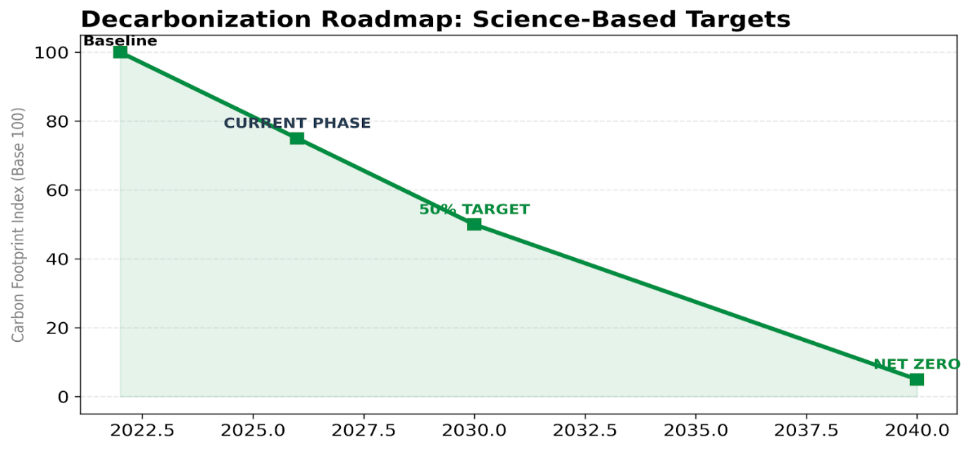
Figure 5 RoadMap
Based on the analysis, the recommended strategy is Purpose-Led Differentiation through Functional Innovation, Channel Expansion and Sustainable Operations.

Functional and Plant-Based Product Innovation
The primary growth driver should be the development of new products that deliver specific health benefits while maintaining natural ingredients and minimal processing. Potential areas include:
- High-protein smoothies for breakfast or post-exercise consumption
- Fibre or gut-health blends
- Immunity-focused products
- Plant-based nutrition drinks
This approach aligns with social trends toward personalised health and allows Innocent to capture value in higher-margin functional segments. Importantly, innovation must remain consistent with the brand’s natural and ethical positioning to avoid damaging authenticity.

Channel and Market Expansion
Innocent should expand distribution beyond traditional supermarkets into health-focused environments such as:
- Gyms and fitness centres
- Corporate workplaces
- Universities and hospitals
- Foodservice and travel locations
These channels target consumers who prioritise health and convenience and are less price sensitive. In addition, selective expansion into high-potential European markets will leverage existing brand awareness and Coca-Cola’s logistics capabilities while supporting revenue diversification.

Low-Carbon and Resilient Supply Chain
Environmental sustainability should be treated as a strategic capability rather than a compliance requirement. Innocent has already committed to science-based targets and reducing its carbon footprint (Innocent Drinks, 2022). Further investment in regenerative agriculture, supplier partnerships and recyclable packaging will:
- Reduce exposure to climate-related supply risks.
- Improve operational resilience.
- Strengthen brand credibility with consumers and stakeholders.
According to the natural-resource-based view, environmental capabilities can become a source of competitive advantage by improving efficiency and reducing risk over time (Hart, 1995).

Strategic Rationale and Alignment with Organisational Values
This strategy is recommended for three key reasons.
First, it responds directly to market trends, including growing demand for functional health products and sustainable brands. Second, it strengthens Innocent’s differentiation rather than competing on price in a highly competitive retail environment. Third, it aligns closely with the organisation’s mission and vision by promoting healthier lifestyles while reducing environmental impact (Innocent Drinks, 2026a).
Furthermore, combining product innovation with channel diversification reduces reliance on powerful supermarket retailers and creates more balanced revenue streams. The integration of sustainability into product design and supply chain decisions ensures that growth does not compromise the company’s ethical commitments.
Overall, the proposed strategy enables Innocent to achieve profitable growth while maintaining brand authenticity and long-term competitive advantage in a challenging industry environment (Porter, 1985; Barney, 1991; Hart, 1995).

Strategy Evaluation (SFA)
The proposed strategy for Innocent Drinks focuses on purpose-led differentiation through functional product innovation, channel expansion and the development of a low-carbon and resilient supply chain. To assess the effectiveness of this approach, the strategy is evaluated using the SAF framework (Suitability, Acceptability and Feasibility), which is widely used to support strategic decision-making at board level (Johnson et al., 2020).

4.1. Suitability
Suitability examines whether the strategy addresses the key opportunities and threats identified in the external environment. The proposed strategy is highly suitable for several reasons.
First, functional and plant-based innovation responds directly to changing consumer preferences for healthier and more personalised nutrition. Market trends indicate increasing demand for products that deliver specific benefits such as immunity, gut health and protein, reflecting the rapid growth of the functional beverage category (Euromonitor International, 2023). Second, channel expansion into gyms, workplaces and foodservice environments reduces dependence on large supermarket retailers, thereby addressing the high buyer power identified in the industry analysis (Porter, 1979).
Third, strengthening the supply chain through carbon reduction and regenerative sourcing directly addresses environmental risks associated with climate change and agricultural volatility. According to the natural-resource-based view, environmental capabilities can improve resilience and support long-term competitive advantage (Hart, 1995). Overall, the strategy aligns well with both market trends and the organisation’s mission to operate responsibly.

4.2. Acceptability
Acceptability considers the expectations of key stakeholders, including customers, employees, investors and partners.
For customers, the strategy enhances value by offering healthier products while maintaining the natural ingredients and ethical standards associated with the Innocent brand. Maintaining authenticity is critical, as brand trust is a key intangible asset that supports competitive advantage (Barney, 1991).
Employees are likely to respond positively to a strategy that reinforces the company’s purpose-driven culture and sustainability commitments. For investors, the focus on premium functional products and new growth channels provides opportunities for revenue growth and margin improvement.
From a risk perspective, the main concern is potential brand dilution if new products move too far away from Innocent’s core identity. This risk can be mitigated through strict product development guidelines that prioritise natural ingredients and transparency. Overall, the strategy is considered acceptable to stakeholders.

4.3. Feasibility
Feasibility assesses whether the organisation has the resources and capabilities required to implement the strategy successfully.
Innocent has several strengths that support implementation. The brand’s strong market recognition and customer loyalty provide a platform for launching new products. Ownership by The Coca-Cola Company provides access to extensive distribution networks, operational expertise and financial resources (Innocent Drinks, 2026b). These organisational capabilities support the firm’s ability to adapt to changing market conditions and sustain competitive advantage, consistent with the concept of dynamic capabilities (Teece et al., 1997). In addition, the company already has established sustainability programmes and science-based climate targets, which support the environmental elements of the strategy (Innocent Drinks, 2022).
However, successful implementation will require investment in product development, supplier partnerships and supply chain transformation. It is assumed that sufficient financial resources and organisational capabilities are available through the support of the parent company and existing operational infrastructure.

4.4. Assumptions
Where detailed operational data was not publicly available, the following assumptions have been made:
- Innocent has sufficient financial and operational support from The Coca-Cola Company to invest in innovation and expansion.
- Consumer demand for functional and plant-based beverages will continue to grow over the next three to five years.
- Existing sustainability initiatives can be scaled to support further carbon reduction and supply chain improvements.
These assumptions are consistent with industry trends and publicly available company information.

4.5. Conclusion of Strategy Evaluation
Based on the SAF analysis, the proposed strategy is suitable, acceptable and feasible. It addresses key external challenges, aligns with stakeholder expectations and can be implemented using existing organisational capabilities. By combining growth with sustainability and brand authenticity, the strategy provides a strong foundation for long-term competitive advantage (Johnson et al., 2020; Porter, 1985).

Stakeholder Analysis
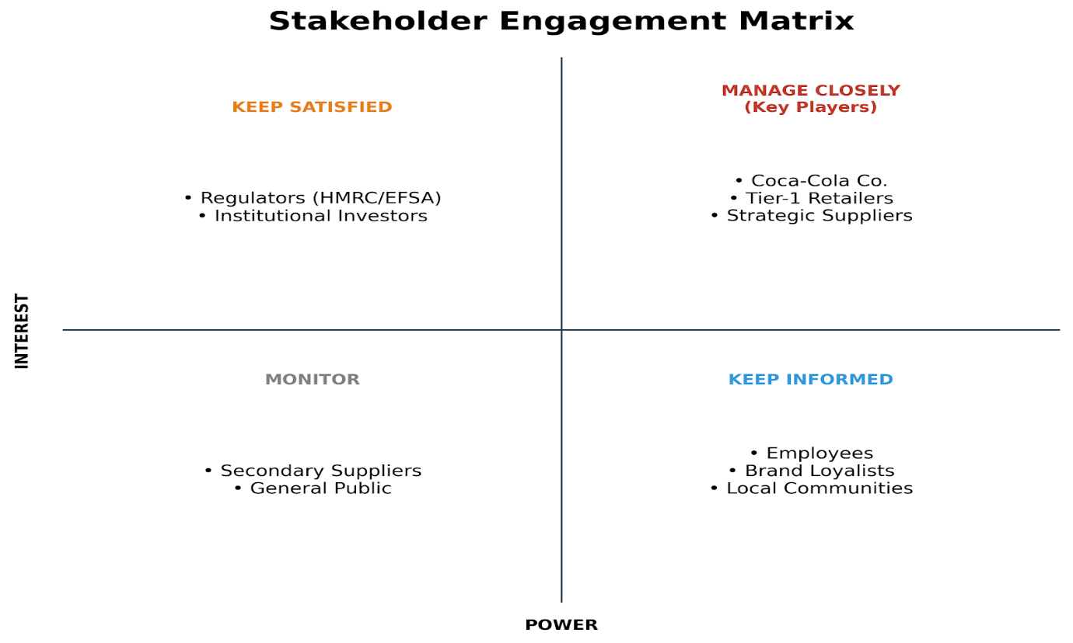
Figure 6 Stakeholders Matrix
The proposed strategy of purpose-led differentiation through functional innovation, channel expansion and supply chain sustainability will affect a range of stakeholders. Effective stakeholder management is essential to ensure successful implementation and long-term value creation. According to stakeholder theory, organisations must balance the interests of multiple groups rather than focusing solely on shareholders, as long-term performance depends on maintaining stakeholder support and trust (Freeman, 1984).

5.1 Stakeholder Impact
5.1.1. Customers
Customers will benefit from improved product offerings that provide functional health benefits while maintaining natural ingredients and ethical standards. The focus on sustainability and transparency is also likely to strengthen brand trust and loyalty. However, if innovation leads to higher prices, there is a risk of reduced accessibility for price-sensitive consumers.
5.1.2. Employees
The strategy reinforces Innocent’s purpose-driven culture and sustainability commitments, which can improve employee engagement, motivation and retention. At the same time, new product development and supply chain transformation may require additional training and organisational change.
5.1.3. Retailers and Channel Partners
Retailers may benefit from product innovation that drives category growth. Expansion into alternative channels such as foodservice and workplaces may reduce dependence on supermarkets, potentially altering power relationships. Strong collaboration and joint planning will be required to maintain positive partnerships.
5.1.4. Suppliers and Farmers
The move toward regenerative agriculture and low-carbon sourcing will require closer collaboration with suppliers. While this may increase short-term costs or operational complexity, it can improve long-term stability, productivity and environmental performance.
5.1.5. Investors / Parent Company
The strategy aims to deliver sustainable revenue growth and protect brand equity, supporting long-term financial returns. However, investment in innovation and sustainability initiatives may increase short-term costs.
5.1.6. Communities and Regulators
Reduced carbon emissions, responsible sourcing and improved packaging sustainability will generate positive environmental and social impacts, strengthening the company’s reputation and regulatory relationships.

5.2 Stakeholder Engagement Plan (Mendelow’s Matrix)
Using Mendelow’s Matrix, stakeholders can be prioritised based on their level of power and interest (Johnson et al., 2020).
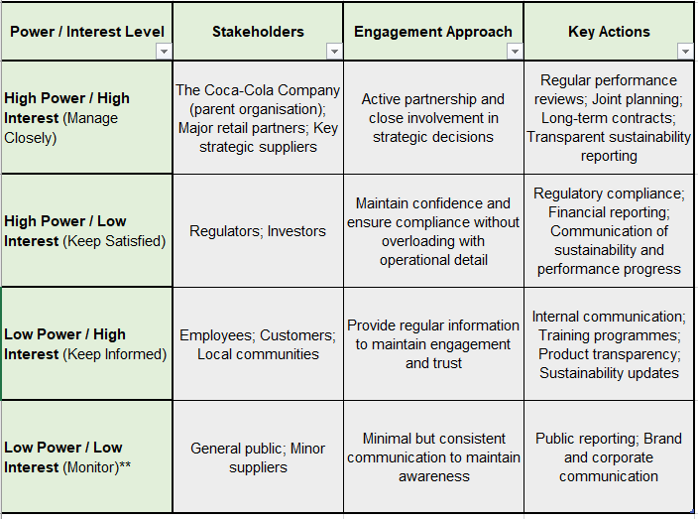
Figure 7 Source: Adapted from Johnson et al. (2020).
Conclusion
By applying stakeholder theory and Mendelow’s framework, Innocent can ensure that the proposed strategy is implemented in a way that maintains stakeholder support. Proactive engagement, transparency and collaboration will be essential to manage risks, build trust and support long-term sustainable growth (Freeman, 1984; Johnson et al., 2020).

Implementation and Monitoring
The successful execution of the proposed strategy requires a structured implementation plan supported by clear objectives, defined actions and measurable performance indicators. Effective implementation is critical, as research suggests that many strategies fail not because of poor design but due to weak execution and lack of alignment across the organisation (Kaplan and Norton, 1996). The following plan outlines the key priorities for Innocent Drinks over a three-year period.

6.1 Strategic Objectives and Actions
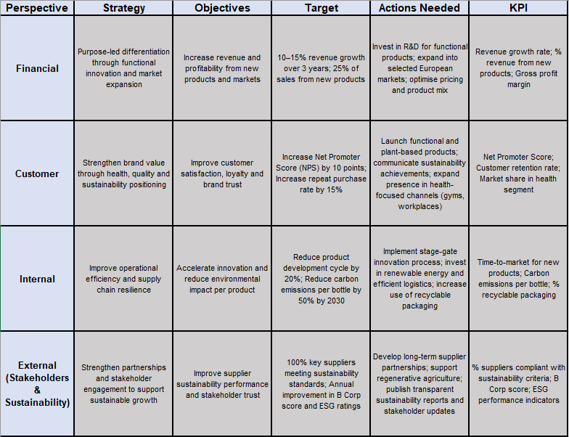
Figure 8 Strategic objectives and actions

6.2 Risk Assessment and Mitigation
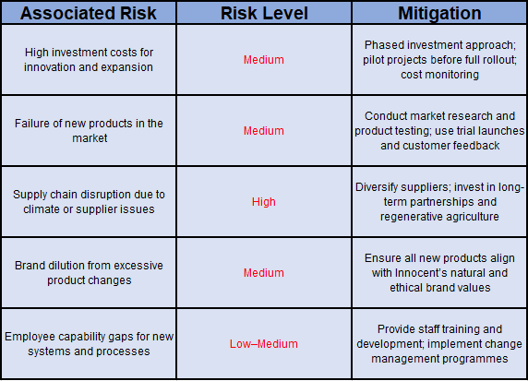
Figure 9 Risk assessment

Conclusion
Innocent Drinks operates in a highly competitive environment shaped by evolving consumer expectations, strong retailer bargaining power, and increasing environmental and regulatory pressures. External analysis using PESTEL, Porter’s Five Forces and SWOT suggests that although the company benefits from strong brand equity, sustainability leadership and the support of The Coca-Cola Company, it must address rising competition, price sensitivity and supply chain risks.
The recommended strategy of purpose-led differentiation supports sustainable growth by focusing on functional and plant-based innovation, expansion into health-oriented channels and selected European markets, and the development of a low-carbon, resilient supply chain. This approach aligns with Innocent’s mission to help people live well and its vision to leave the world better than it found it (Innocent Drinks, 2026a). It also leverages valuable and difficult-to-imitate capabilities in brand trust and sustainability (Barney, 1991). Overall, the strategy is suitable, acceptable and feasible, supporting long-term value creation (Johnson et al., 2020).

References
Ansoff, H.I. (1957) ‘Strategies for diversification’, Harvard Business Review, 35(5), pp. 113–124.
B Lab (2024) Certified B Corporation: Innocent Drinks. Available at: https://www.bcorporation.net (Accessed: [insert date]).
Baker, S.M., Thompson, K.E. and Engelken, J. (2004) ‘Mapping the values driving organic food choice’, European Journal of Marketing, 38(8), pp. 995–1012.
Barney, J.B. (1991) ‘Firm resources and sustained competitive advantage’, Journal of Management, 17(1), pp. 99–120.
Euromonitor International (2023) Health and wellness beverages: Global market trends. London: Euromonitor International.
Freeman, R.E. (1984) Strategic Management: A Stakeholder Approach. Boston: Pitman.
Hart, S.L. (1995) ‘A natural-resource-based view of the firm’, Academy of Management Review, 20(4), pp. 986–1014.
Innocent Drinks (2022) Doing Good Stuff Report. Available at: https://www.innocentdrinks.co.uk (Accessed: [insert date]).
Innocent Drinks (2026a) A bit about us. Available at: https://www.innocentdrinks.co.uk/a-bit-about-us (Accessed: [insert date]).
Innocent Drinks (2026b) Our owner. Available at: https://www.innocentdrinks.co.uk (Accessed: [insert date]).
Johnson, G., Scholes, K. and Whittington, R. (2020) Exploring Strategy: Text and Cases. 12th edn. Harlow: Pearson.
Kaplan, R.S. and Norton, D.P. (1996) The Balanced Scorecard: Translating Strategy into Action. Boston: Harvard Business School Press.
Kumar, N. and Steenkamp, J.B.E.M. (2007) Private Label Strategy: How to Meet the Store Brand Challenge. Boston: Harvard Business School Press.
Porter, M.E. (1979) ‘How competitive forces shape strategy’, Harvard Business Review, 57(2), pp. 137–145.
Porter, M.E. (1980) Competitive Strategy: Techniques for Analyzing Industries and Competitors. New York: Free Press.
Porter, M.E. (1985) Competitive Advantage: Creating and Sustaining Superior Performance. New York: Free Press.
Scarborough, P., Adhikari, V., Harrington, R.A., Elhussein, A., Briggs, A., Rayner, M. and Adams, J. (2020) ‘Impact of the announcement and implementation of the UK Soft Drinks Industry Levy on sugar content, price and product size of soft drinks’, PLoS Medicine, 17(2), e1003025.
Stubbs, W. (2017) ‘Characterising B Corps as a sustainable business model: An exploratory study of B Corps in Australia’, Business Strategy and the Environment, 26(3), pp. 331–344.
Teece, D.J., Pisano, G. and Shuen, A. (1997) ‘Dynamic capabilities and strategic management’, Strategic Management Journal, 18(7), pp. 509–533.
Wheeler, T. and von Braun, J. (2013) ‘Climate change impacts on global food security’, Science, 341(6145), pp. 508–513.

