Contemporary Issues
Poverty and crime
Design and Delivery: meeting needs and managing change
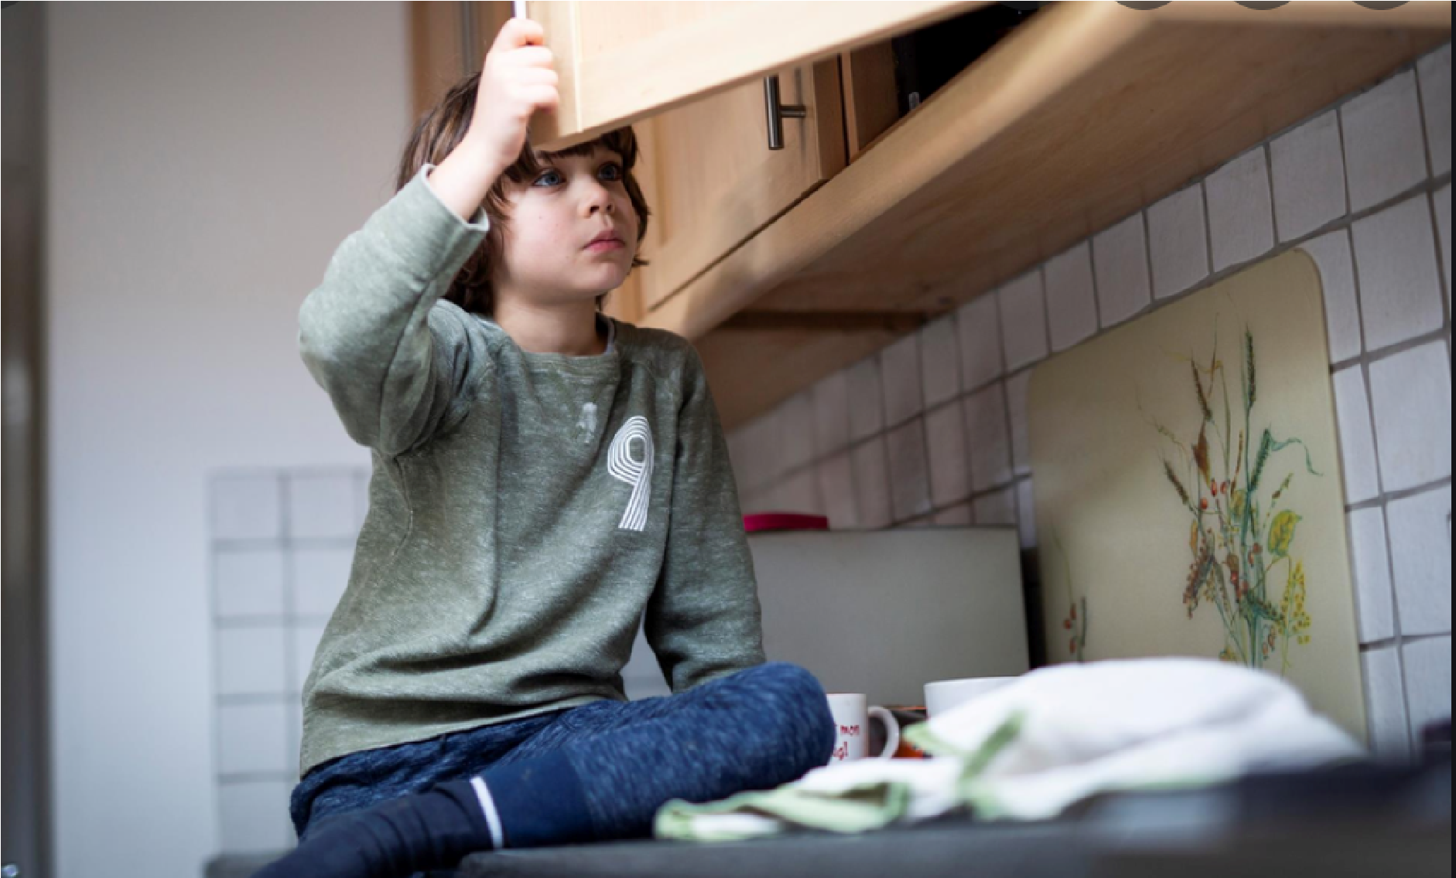

Tegan Sullivan – 2004525

Titled ‘Design and Delivery: meeting needs and managing change’. This essay highlights, and critically evaluates contemporary issues around poverty within the United Kingdom (UK) affects public services and how the design and delivery of services to tackle poverty can undertake changes that are challenging. Discussing poverty rates, roll on effects and what public services can do to tackle the on-going issue will result in recommendations for future practice to tackle issues. While looking at poverty and considering basic human rights and children’s rights (UN Convention on the Rights of the Child (UNCRC) - UNICEF UK, 2021), there is always a question of how poor is too poor? Standardised differently within different countries.
The dictionary defines poverty as “the state of being extremely poor” however extremely poor can be defined differently by individuals. Poverty is when a community or individual lack financial resources to be able to meet basic human needs for survival such as food and shelter.
Abraham Maslow designed the well known hierarchy of needs theory. The theory asserted that human needs come in levels, and that basic needs must be met before a person could gain motivation to pursue higher needs and desires. Basically if a person lives in poverty for a prolonged period they will loose the desire to thrive and become successful in life. Considering Maslow’s theory would suggest tackling poverty would create better outcomes for all (Maslow and Frager, 1987).
Child poverty is said to be the biggest human rights issue globally. The United Nations Convention on the Rights of a Child ((UN Convention on the Rights of the Child (UNCRC) - UNICEF UK, 2021) was developed in 1989 with an aim to give all children under the age of seventeen a comprehensive set of basic human rights. One hundred and ninety-six countries around the world entered into the treaty in agreement that all children would have these rights regardless of race, religion, ability or privilege. As poverty is still prevalent around the world and defined as a person having the lack of finances to be able to meet basic needs such as food and shelter (a human right), this would question the effectiveness of the UNCRC and suggest need for review.
Poverty has always been an ongoing issue globally including within the UK and can have a major effect on the physical and mental health of both children and families (The Health Foundation, 2020). Mental Disorders and Disabilities Among Low-Income Children, (2015) suggest children who have grown up in areas of poverty often begin to have mental health issues and disabilities which is also stated to have enduring impacts on children and their families.
In 2019 the worldwide Covid 19 pandemic which is still ongoing began bringing about unprecedented times on a global scale. COVID-19 is caused by infection to the severe acute respiratory syndrome coronavirus 2 (SARS-CoV-2) virus strain and very contagious. The pandemic put much of the world at a stand still with lockdowns and people being told to “stay home to save lives”. With business’ closed and people often home from work being unpaid the effect on people in poverty enhanced and many families already living on the breadline were additionally put into poverty. The pandemic created a global crisis (WHO Coronavirus (COVID-19) Dashboard, 2021). A few years prior to the pandemic a huge number of 4.3 million children were said to be already living a poor quality of life in poverty, these starching figures continued to rise. Due to the pandemic these figures raised even more by at least 700,000 suggests (Action for Children, 2021). These alarming figures show that poverty was becoming more of an issue generally and intervention from the public sector was needed along time prior because the numbers rose and continued rising at an alarming rate instead of decreasing (The Guardian, 2020).
There were many initiatives launched by the Government within the UK to try tackle the financial crisis that aided to poverty. To assist low earning individuals affected by the pandemic, the Welsh government publicised funding of a five-hundred-pound self-isolation support. This funding would cover loss of earnings if a person had to isolate with no pay. Swansea Council, (2021) suggested the funding would comfort various financial difficulties if people had been required to quarantine. The government also issued help to people who had lost jobs during the pandemic, some people were able to gain universal credit through a fast-track service instead of having to wait for the usual five weeks before the delivery of the beginning disbursement. Individuals who did not have the expenses to pay their mortgage or have disregarded payments, were able to submit an application to acquire around one hundred percent re-payable fee and banks offered ‘mortgage holidays’ on payments, which gave some relief. Certain individuals also had access to a discretionary assistance fund. GOV.WALES, (2020) claimed the fund would have a huge benefit on some people because it could indemnify household items to enable individuals to remain in their own home. Additionally, some people had access to have their council tax reduced or discounted and businesses were given grants. All of this support offered during the pandemic demonstrates how quick the government can respond therefore, if poverty was also classed as a pandemic and emergency support put in place continuously could this possibly tackle the ever-growing poverty crisis.
In 2015 the government introduced an act to discuss the longstanding power of decisions made by the public. The act is called the Well-being of Future Generations Act, the purpose of the act is to operate with individuals more efficiently and the society to avert relentless disputes, for instance, poverty and health inequalities. The act is considered to be “unique” to Wales and fascinates attentiveness from countries amongst many countries around the planet. Wellbeing of Future Generations Wales Act, (2015) state that there will be a progressive modification to existing and forthcoming cohorts as it places legal duties on public sectors to contribute and maximise efforts to make more inclusive and equal areas and opportunism for all. A review in 2018 suggests progress through multi agencies however, there seems little evidence to prove this. With the addition of the pandemic this is currently questionable.

Considering working together and multi agencies there is the Social services and well being act. The fourth principle in the social services and well-being act 2014 aims to provide enhanced support to people. This enables individuals to achieve positive outcomes through multi-agency collaboration and includes participation from the police, education, and emergency services. The social services and well-being act has provided legal framework for professionals for improving care and support to vulnerable people, for example people who are living in poverty. Although the social services and well-being act began in 2014, figures show that poverty has continued to rise within the UK, therefore these figures suggest need for a review. In November 2019 a review into the act began with the initial timescale for completion set to take three years, however due to the Covid-19 pandemic there has been delays. Since Covid-19 began, poverty within the UK has hit a record high, almost six in ten relatives alleged that they are finding it difficult to pay for key necessities, such as; child related costs, food, travel and house bills (Poverty in the Pandemic, 2020). It is proven that approximately half of families partake a new or worse poverty issue, suggesting critical importance for the review completion with an aim for better outcomes to tackle the ongoing issue. Additionally, considering that crime has also increased, a review and plan for interventions may help both areas of poverty and crime (Wallace, 2018). Parents and families who experience poverty often feel that they neglect their children because they do not have enough money to provide them and give children what they need.
Poverty stress can sometimes lead to domestic abuse within families. This is where police involvement is needed, social services involvement and often other services are involved, for example the ambulance services (Haugen and Boutros, 2015). A handful of women often get fall into sex labour through desperation and end up having children as a result. This brings on the responsibility of looking after children they sometimes did not necessarily want and they were forced putting strain on social services and the police (Biljon, Fatima and Arefin, 2021). Women who are forced to have children in an unhealthy relationship or who have been sexually assaulted sometimes not only feel that they must give up their children but are traumatised and have terrific mental health issues (Chandra, Herman, Fisher and Riecher-Rossler, 2020). Revealed: full links between poverty and violent crime in London, (2019) announced that a violence reduction unit has been formed to fund schools, young individuals and youth workers. Newfound facts show that at least three quarters of the districts in London experience extreme levels of violence and the majority are from a record of greatest deprived zones. The Metropolitan Police, the Mayor and community sectors arranged to investigate the intricate causes of intense violence. The Metropolitan Police argued that strong enforcement needs to be made to attempt tackling both economic problems and social issues which society faces. Strong enforcement is said to help report the violent crime issue. Data shows that occurrences by the younger generation are thought to happen at the end of a school day, so a new provision of expanding after school time in excessive crime areas is necessary. Children often find moving schools very hard to deal with, they often get extremely stressed and unhappy Schaverien, (2015), therefore moral support is given to children who are struggling (Fleetham, 2013).

School exclusions do not help as a punishment and can more than likely make children more angry and likely to commit a crime (Blair, Eden and Harris, 2022). Several numbers of children are affected by domestic abuse that has occurred at their homes, this can affect children’s learning at school and their attitude towards life. Children’s upbringing and surroundings have a huge effect on them because they think it is “normal” and may tend to pick up things from their family and copy (Parenting Matters, 2016). Support will not only be given to children but also the parents who are facing sexual offences or domestic violence. To assist in support, improved guidance for youth workers is undertaken and a formation of a Youth Action Group to implement the divisions work (Norman and Ryrie, 2013).
Inside young offender institutions and prisons, there is now a piloting programme, this helps offenders better themselves while they finish their sentence, currently probation officers have spoken up and raised that this idea is working well (Hansard, 2010).
Celebrity footballer Marcus Rashford, who plays for Manchester United is known as a kindhearted footballer who helps the community. In 2020, during the pandemic, Marcus Rashford teamed up with FareShare to help provide meals to the less fortunate (FareShare, 2020). Covid-19 was challenging, it began with no socialising with different households, face coverings, social distancing and constant hand washing, and all the factors developed into the new normal (Focus on Social Challenges, 2021). Football was forced to finish, so Marcus Rashford started to get the ball rolling and assist to modify the planet for the better by tackling the food crisis mainly for children. Rashford wanted no children in the UK to go hungry and without assistance he obliged a government U-turn two times (HitchingsHales, 2020). Rashford tweeted at the beginning of the pandemic saying there are over 32,000 schools across the UK which are closing. Since Rashford is in the public eye, he most definitely inspired others to help the community and to raise awareness (Rashford, 2021). He states that countless children present at school depend on free school meals, which is when he decided that he needed to help so he started speaking to many organisations to interoperate how this problem is going to be solved (Plant, 2020).

Public perceptions of public services helping tackling poverty is sometimes poor, some may say people are not doing enough to prevent it. Poverty is always briefly on the news; however, individuals claim that it is not shown enough as it should, it seems that the public think if people seen more about poverty people would develop a better understanding and help out (McKendrick et al., 2021). Poverty has continued to rise globally through the pandemic and although the government have given some assistance there still appears need to solve the crisis. Although people such as Rashford gave assistance this would need to continue to help some individuals.
Considering Crime is more prevalent in deprived areas tackling poverty could reduce figures of crime and improve outcomes for children into adulthood. Through multi agency and partnership working, adhering to the UNCRC equality for all could be achieved within the UK.

The three most vital features of community policing are described as partnerships, positive interaction and problem solving. The three P’s in policing corresponds how they arise and fix issues exclaims Engel, (2010), such as poverty, robbery and domestic violence, all of which occur when an individual is financially struggling (Handbook of Police Administration, 2017). Considering this, more should be done to tackle poverty which would clarify human rights and in time should lower domestic violence, child abuse and crime rates.

References
2015. Mental Disorders and Disabilities Among Low-Income Children. National Academies Press, p.15.
2016. Parenting matters. Washington, D.C.: National Academies Press.
2017. Handbook of Police Administration. Taylor & Francis.
Action For Children, 2021. Where is child poverty increasing in the UK?. Available at: <https://www.actionforchildren.org.uk/blog/where-is-child-poverty-increasing-in-the-uk/> [Accessed 10 October 2021].
Biljon, V., Fatima, M. and Arefin, Z., 2021. Reducing vulnerability to forced labor and trafficking of short-term, low-skilled women migrant workers in the South Asia to Middle East corridor. Intl Food Policy Res Inst.
Blair, A., Eden, K. and Harris, N., 2002. Challenges to School Exclusion. Taylor & Francis.
Chandra, P., Herrman, H., Fisher, J. and Riecher-Rössler, A., 2020. Mental Health and Illness of Women. 1st ed. Springer Singapore, p.1.
Cpag.org.uk. 2020. Poverty in the Pandemic. [online] Available at: <https://cpag.org.uk/sites/default/files/files/policypost/Poverty-in-the-pandemic_update.pdf> [Accessed 4 October 2021].
Engel, R., 2010. Race, Ethnicity, and Policing New and Essential Readings. NYU Press, p.76.
FareShare. 2020. Marcus Rashford’s work with FareShare. [online] Available at: <https://fareshare.org.uk/marcus-rashford/> [Accessed 2 October 2021].
Fleetham, M., 2013. How to support children moving school. 1st ed. Cambridge: Learning Development Aids.
Futuregenerations.wales. 2021. Well-being of Future Generations (Wales) Act 2015 – The Future Generations Commissioner for Wales. [online] Available at: <https://www.futuregenerations.wales/about-us/future-generations-act/> [Accessed 3 October 2021].
GOV.WALES. 2020. Get financial help to pay your bills during the coronavirus pandemic | GOV.WALES. [online] Available at: <https://gov.wales/get-financial-help-pay-your-bills-during-coronavirus-pandemic> [Accessed 1 October 2021].
Hansard, T., 2010. Parliamentary Debates (Hansard). H.M. Stationery Office, p.217.
Haugen, G. and Boutros, V., 2015. The locust effect. 4th ed. Oxford University Press, p.96.
Hitchings-Hales, J., 2020. Marcus Rashford Forces Second Sensational UK U-Turn Over Free School Meals at Christmas. [online] Global Citizen. Available at: <https://www.globalcitizen.org/en/content/marcus-rashford-free-school-meals-christmas-uk/> [Accessed 4 October 2021].
Houshyar, S., 2014. [Blog] Available at: <https://firstfocus.org/blog/poverty-and-child-neglect-what-we-know-and-what-we-need-to-do> [Accessed 4 October 2021].
London Assembly. 2019. Revealed: full links between poverty and violent crime in London. [online] Available at: <https://www.london.gov.uk/press-releases/mayoral/full-links-between-poverty-and-violent-crime> [Accessed 6 October 2021].
Maslow, A. and Frager, R., 1987. Motivation and personality. New Delhi: Pearson Education.
McKendrick, J., Sinclair, S., Irwin, A., O'Donnell, H., Scott, G. and Dobbie, L., 2021. This report analyses how the media reports UK poverty and its impact on public understanding and opinion. The media, poverty and public opinion in the UK. [online] Joseph Rowntree Foundation. Available at: <https://www.jrf.org.uk/report/media-poverty-and-public-opinion-uk> [Accessed 9 October 2021].
Norman, I. and Ryrie, I., 2013. The art and science of mental health nursing. 3rd ed. Open University Press, p.647.
OECD. 2021. Focus on social challenges. [online] Available at: <https://www.oecd.org/coronavirus/en/themes/social-challenges> [Accessed 4 October 2021].
Plant, M., 2020. Marcus Rashford’s inspirational 2020. [online] Manutd.com. Available at: <https://www.manutd.com/en/news/detail/timeline-of-marcus-rashfords-charity-work-and-awards-in-2020> [Accessed 2 October 2021].
Rashford, M., 2021. You Are a Champion How to Be the Best You Can Be. 2nd ed. Pan Macmillan.
Schaverien, J., 2015. Boarding school syndrome. 1st ed. Taylor & Francis.
Swansea. 2021. Coronavirus - benefits update - Swansea. [online] Available at: <https://www.swansea.gov.uk/coronavirusbenefitsupdate> [Accessed 2 October 2021].
The Guardian, 2020. Almost 700,000 driven into poverty by Covid crisis in UK, study finds. [online] p.1. Available at: <https://www.theguardian.com/society/2020/nov/30/almost-700000-driven-poverty-covid-crisis-uk-study> [Accessed 6 October 2021].
The Health Foundation. 2020. Living in poverty was bad for your health long before COVID-19 | The Health Foundation. [online] Available at: <https://www.health.org.uk/publications/long-reads/living-in-poverty-was-bad-for-your-health-long-before-COVID-19> [Accessed 8 October 2021].
Unicef UK. 2021. UN Convention on the Rights of the Child (UNCRC) - UNICEF UK. [online] Available at: <https://www.unicef.org.uk/what-we-do/un-convention-child-rights/> [Accessed 1 November 2021].
Wallace, J., 2018. Wellbeing and Devolution. 1st ed. Springer International Publishing.Covid19.who.int. 2021. WHO Coronavirus (COVID-19) Dashboard. [online] Available at: <https://covid19.who.int/> [Accessed 1 November 2021].

