

Individual Blog
Clarins Company

Student name: Ana Cojocari
Student ID: 2118833
Module title: Marketing Fundamentals
Module code: LCBB4004
Lecturer’s name: Piyumika Kithulgoda Gamage
Date of submission: 29.07.2023

Table of Contents
1. Introduction 3
2. Company Background 3
3. Segmentation Targeting and Positing strategies 3
Segmentation 3
Targeting 4
Positioning 5
4. Marketing mix 4PS 6
Conclusion 8
Reference 9

Introduction

Marketing, more than any other business operation, works with customers. Although we will soon look at more complex definitions of marketing, the simplest is this: “The first definition is Marketing is engaging customers and managing profitable customer relationships. The two-fold goal of marketing is to attract new customers by promising superior value and to keep and grow current customers by delivering value and satisfaction.” (Kotler, 2020).
The marketing process in the United Kingdom follows a strategic approach aimed at promoting products or services, building brand awareness, and ultimately driving sales. Here are the key steps typically involved: Market research, Target market identification, Marketing strategy development, Product development and pricing, Promotional activities, Distribution and sales, Monitoring and evolution, Customer relationship management.
In this blog, I will present the beauty company Clarins.
In the dynamic world of beauty and personal care, marketing plays a pivotal role in capturing the attention and loyalty of consumers. Among the industry's leading players stands Clarins, a renowned marketing company with rich skincare, cosmetics, and fragrance heritage. In this blog post, we will delve into the captivating journey of Clarins, exploring its innovative marketing strategies, commitment to sustainability, and enduring success.( (Clarins, n.d.))

Company Background

Clarins, a French luxury skincare company, was founded in 1954 by a masseur named Jacques Courtin created his treatment oils that firmed the skin and marketed them from his Paris salon. He amassed a sizable following base, including endorsements from some notable French celebrities. (Chesters, 2012)
He stole the name Clarins from a character he performed in a school play and considered it a lucky charm. He liked the name so much that he integrated it into his own in 1978, becoming Jacques Courtin-Clarins.
Clarins was the best-selling luxury skincare brand in France in 1980; in 1981, it extended to the United States; by 1990, it was the best-selling brand in Europe; and now, it is the best-selling brand in the world. (Chesters, 2012)

Segmentation Targeting and Positing strategies

Segmentation, targeting, and positioning (STP) strategies are crucial for a company like Clarins to effectively identify, reach, and cater to specific customer segments. Clarins, being a cosmetics and skincare company, can utilize the following STP strategies:

Segmentation
“Market segmentation divides a market into well-defined slices. A market segment consists of a group of customers who share a similar set of needs and wants.” (Kotler, 2016)

Clarins may restrict the vast, diversified target market by segmenting it into certain, closely defined groups. Market segmentation surveys are standard methods for acquiring customer-specific information that may be used to create groups with comparable characteristics. I am unaware of any specific examples of segmentation in the context of the Clarins Company beyond that date. However, I can provide you with a general understanding of segmentation and how it might be applied in a company like Clarins.
Clarins, a well-known skincare and beauty company, has proved its mastery of market segmentation by adapting its products and marketing methods to match the specific demands and preferences of diverse client groups. One remarkable example of their effective market segmentation can be seen in their product line targeting different age demographics.
For instance, Clarins developed a dedicated range of skincare products for mature consumers aged 50 and above seeking anti-ageing solutions. This product line included specialized creams infused with potent anti-wrinkle and firming ingredients and targeted serums to combat age-related skin concerns. By understanding the distinct needs of this age group, Clarins succeeded in creating a loyal customer base among mature individuals who appreciated their attention to age-specific concerns. (Clarins, n.d.)
Additionally, Clarins employed geographic segmentation to cater to diverse climates and environmental conditions. In regions with arid climates, they launched a line of moisturizers enriched with intensive hydration properties to combat dryness and promote skin nourishment. On the other hand, in humid and tropical regions, they emphasized lightweight, oil-free products designed to prevent excessive greasiness and clogged pores.
Furthermore, Clarins employed psychographic segmentation by recognizing the growing trend of eco-conscious consumers. Clarins introduced a collection of all-natural and organic skincare products to appeal to this environmentally aware segment. By aligning with the values of this target group and providing eco-friendly options, the brand attracted a devoted following of environmentally conscious customers. (Clarins, n.d.) Lastly, Clarins excelled in gender-based segmentation by offering distinct product lines for men and women. Their men's skincare range featured products specifically formulated to address male skincare concerns, such as post-shave irritation and oil control, thus catering to the unique needs of male consumers.
By effectively implementing market segmentation strategies, Clarins expanded its customer base and strengthened its brand loyalty. This approach allowed them to stay ahead of competitors and remain relevant in an ever-evolving beauty industry. Clarins' success is an inspiring example of how a thoughtful understanding of market segmentation can drive a company's growth and success. Clarins, a prominent player in the beauty industry, likely employs various forms of market research, customer surveys, and data analysis to identify and target different segments effectively. They may use this information to create tailored marketing messages, product formulations, and distribution strategies to serve their diverse customer base better.

Targeting
Targeting is also significant since it is necessary to determine which consumer category is the most appealing from a marketing standpoint. This consumer group, or segment, will be the focus of your marketing efforts. (Studysmarter, n.d.)

Traditionally, Clarins has been known to target specific demographic segments that align with its luxury positioning and product offerings. For some of the common demographic segments, Clarins may focus on different age groups with specific product lines tailored to the needs of younger or older consumers. For example, they might have products targeting youthful skin concerns for a younger demographic and anti-ageing solutions for an older demographic.
While many of their products are unisex, Clarins may have targeted marketing campaigns for specific gender groups, especially for products with distinct needs or preferences. As a luxury brand, Clarins' pricing may cater to consumers with higher disposable incomes, and their marketing efforts might reflect this by targeting affluent individuals. (Clarins, 2023)
Regarding geographic targeting, Clarins is an international brand with a global presence, so its products are likely available in various countries. They may focus their marketing efforts on regions where their products have a strong presence or where they see growth potential.
In terms of behavioural targeting, Clarins might employ strategies based on consumer behaviour and preferences. This could include targeting existing customers with personalized offers, retargeting website visitors, and leveraging data from customer interactions to create tailored marketing campaigns.
First example: young professionals are seeking quick skincare solutions for busy lifestyles. Clarins could also emphasize convenience and simplicity in their product packaging and marketing materials to cater to young professionals seeking quick skincare solutions. Providing clear instructions for use and highlighting the time-saving benefits of their products would resonate with this target audience.
It is important to note that these product ideas are speculative and based on the stated needs of young professionals seeking quick skincare solutions. Product development and offerings would require comprehensive market research, consumer feedback, and analysis to align with customer preferences and needs.
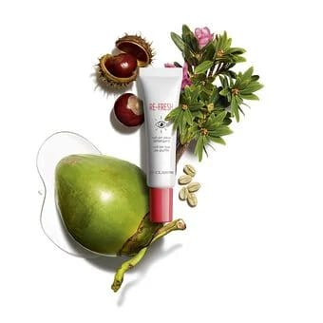
Roll-on eye treatment imbued with Natural coconut water to sustain, Snow capped rose concentrate to detoxify, and regular caffeine and pony chestnut to reduce dark circles and puffiness, the ideal equilibrium between foods grown from the ground removes.
The new watery gel invigorates the eye form while apparently decreasing indications of weakness around the eye. (Clarins, 2023)
Benefits: Saturates and invigorates the eye from region, re-establish brilliance noticeably reduces indications of exhaustion around the eye.
(Fig. 1Clarins)

Second example: an ageing population is looking for anti-ageing products.
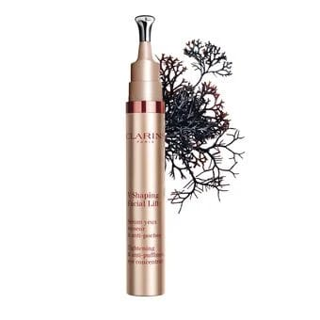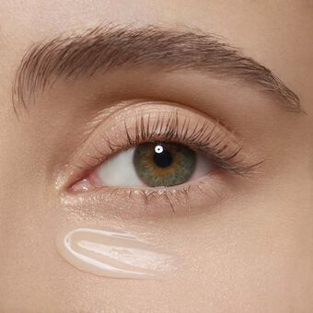
(Fig. 2 Clarins)

The Counter Puffiness Eye Concentrate diminish and forestall puffy eyes. Loaded with herbal concentrates, this is the best eye cream for lessening puffy and enlarged eyes in a moment. This eye cream will be planned with an interesting Angular tool to target eye shapes and forestall enlarging for the day. Benefits: Lifts weighty and hooded eyelids, diminishes puffiness, targets dark circles to light up the eye shapes, improves eyelashes, contains Clarins' Enemy of Contamination Complex. (Clarins, 2023)
In another example of targeting is it affluent customers are willing to invest in high-end skincare products. Affluent customers, often characterized by their higher income levels and greater spending power, are a valuable target market for high-end skincare products. These customers are typically willing to invest in premium skincare products that offer superior quality, advanced formulations, and desirable results. As a renowned beauty company, Clarins can leverage its reputation, research expertise, and innovative product development to cater to the preferences and demands of this affluent customer segment. Here are some key strategies Clarins might consider to attract and retain affluent customers looking for high-end skincare products: Luxurious Ingredients and Formulations, Customization and Personalization, Limited Edition and Exclusive Releases, High-End Packaging and Design. (Clarins, 2023)
Another point is it Community Engagement, creating a community or forum where customers with similar skin concerns can share their experiences, tips, and product recommendations can foster a sense of belonging and support.

Positioning
Clarins should position its brand and products uniquely and compellingly within the minds of its target customers. Some possible positioning strategies for Clarins include:
Natural and plant-based ingredients: Emphasize using botanical extracts and natural ingredients in product formulations.
Scientific innovation: Highlight the company's research and development efforts to create cutting-edge skincare solutions.
Luxury and indulgence: Position certain products as premium offerings for customers seeking a pampering experience.
Expertise and trust: Highlight Clarins' heritage, expertise, and reputation as a trusted skincare brand.
By positioning itself strategically, Clarins can differentiate its brand from competitors and create a robust and desirable image in the minds of its target customers.
It is essential for Clarins to regularly evaluate and refine its STP strategies based on market trends, customer feedback, and competitive dynamics to ensure continued success and growth.

Marketing mix 4PS
The 4Ps of marketing, also known as the marketing mix, are a set of fundamental elements that companies use to develop their marketing strategies. Let's apply the 4Ps to Clarins, a renowned cosmetics company. (Addison, 2019)
The first Ps to Clarins is it product, Clarins offers a wide range of skincare, makeup, and fragrance products. They use natural ingredients and scientific research to develop high-quality products that cater to different skin types and concerns. Clarins has implemented several strategies to differentiate its products from competitors in the beauty industry. These differentiating factors help Clarins stand out and attract customers who value unique features and benefits. Here are some ways Clarins has designed its products to differentiate:
For example Multi-Functional Products, Clarins designs multi-functional skincare products that address multiple concerns simultaneously. For example, a moisturiser may offer anti-ageing benefits, hydration, and environmental protection in a single formula. This approach provides value to customers seeking efficiency and convenience in their skincare routines.
Another example for product designed is Innovative Product Formats, Clarins occasionally introduces innovative product formats or application techniques. These unique offerings can create buzz and generate interest among consumers looking for novel beauty experiences.
By combining these elements in its product design, marketing, and company ethos, Clarins effectively sets itself apart from competitors, establishing a solid brand identity and loyal customer base. Differentiation is critical in a competitive market, and Clarins' strategic approach has contributed to its success as a prominent player in the beauty industry.
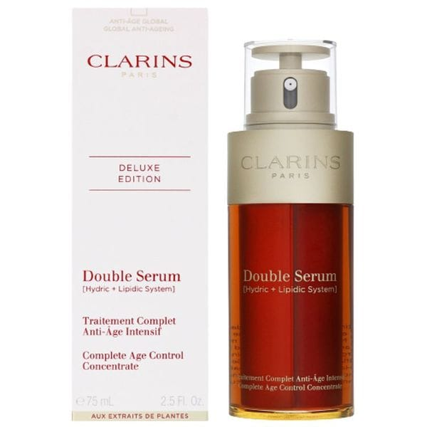
One example product for Clarins is the "Clarins Double Serum Complete Age Control Concentrate”. (Clarins, 2023)

This product is a popular anti-aging serum that combines two powerful formulas into one dual-chamber bottle. It contains a water-soluble formula that helps improve the skin's hydration and a lipid-soluble formula that targets signs of aging, including fine lines, wrinkles, and uneven skin tone.
The Double Serum is enriched with potent plant extracts, including turmeric, oat, and kiwi, which help to nourish and revitalize the skin. It also features Clarins' exclusive Anti-Pollution Complex to shield the skin from environmental stressors.
This product is designed to provide comprehensive age control benefits, promoting a more youthful and radiant complexion. The dual-chamber system allows for a customizable application, ensuring the right balance of both formulas for your specific skin needs.
(Figure 3,Clarins)
Clarins Double Serum is known for its lightweight and non-greasy texture, making it suitable for all skin types. It can be used both morning and evening as part of your skincare routine, alone or before applying moisturizer.
The second Ps to Clarins is Price, Clarins positions itself as a premium brand, and its pricing strategy reflects the perceived value of its products. They offer a range of price points to cater to different customer segments, but generally, their products are priced at a higher end of the market. The pricing considers product quality, research and development costs, and brand reputation.
Several key strategies can be employed regarding marketing for pricing in a company like Clarins. Clarins is a renowned beauty and skincare brand, and its marketing efforts should align with its positioning and target audience. Here are some marketing strategies for pricing in Clarins.
Value-based pricing: Emphasize the value and quality of Clarins products. Highlight the unique ingredients, research-backed formulations, and the effectiveness of the products. Communicate the long-term benefits and results customers can expect from using Clarins skincare.
Differentiation: Highlight what sets Clarins apart from competitors. Emphasize the brand's heritage, expertise, and commitment to using natural ingredients. Showcase any certifications or awards the brand has received, such as cruelty-free or organic certifications.
The third Ps to Clarins is Place, Clarins products are distributed through various channels. They have their retail stores and counters in department stores and beauty salons, allowing customers to experience the products first-hand and receive personalized recommendations. Additionally, Clarins products are available for purchase on their website and through authorized online retailers. This multi-channel approach ensures that customers can access Clarins products conveniently.
The fourth Ps to Clarins is Promotion, Clarins employs various promotional strategies to create brand awareness and drive sales. They use print media, television, and digital advertising campaigns to reach a wide audience. Clarins also uses public relations activities, such as celebrity endorsements and influencer collaborations, to enhance its brand image. They often offer samples, gifts with purchase, and exclusive promotions to incentivize customers. Additionally, Clarins invests in building customer loyalty through loyalty programs and personalized marketing communications. It's important to note that marketing strategies can evolve, so it's a good idea to refer to the most up-to-date information from Clarins to get an accurate understanding of their current 4Ps. (Clarins, 2023)

Conclusion

Clarins has etched its name as a marketing company that transcends the boundaries of the beauty industry. Through its innovative marketing strategies, commitment to sustainability, customer-centric approach, and dedication to corporate social responsibility, Clarins has positioned itself as a leader in the marketing landscape. As the company continues to evolve and adapt to changing consumer preferences, it is poised to shape the future of marketing in the beauty industry while maintaining its core values of enhancing natural beauty and promoting well-being.

Clarins is an established player in the luxury beauty market, known for its premium skincare, cosmetics, and fragrance offerings. The company's focus on natural ingredients, sustainability, and digital transformation positions it well to cater to evolving consumer preferences. While it faces competition from various brands, Clarins has a strong brand reputation and a global presence that enables it to navigate the dynamic beauty industry successfully.

Reference

Addison, 2019. Essay48. [Online] Available at: https://www.essay48.com/term-paper/13993-Clarins-Marketing-Mix[Accessed 17 July 2023].

Chesters, A., 2012. the guardian. [Online] Available at: https://www.theguardian.com/fashion/fashion-blog/2012/jan/03/brief-history-clarins
[Accessed 15 July 2023].
Chesters, A., 2012. the guardian. [Online] Available at:https://www.theguardian.com/fashion/fashion-blog/2012/jan/03/brief-history-clarins
[Accessed 15 July 2023].

Clarins, 2023. Clarin. [Online] Available at: https://www.clarins.co.uk/double-serum/C070400090.html [Accessed 17 July 2023].
Clarins, 2023. clarins. [Online] Available at: https://www.clarins.co.uk [Accessed 17 July 2023].

Clarins, 2023. clarins. [Online] Available at: https://www.clarins.co.uk/help-terms-conditions/terms.html [Accessed 17 July 2023].

Clarins, 2023. Clarins. [Online] Available at: https://www.clarins.co.uk/my-clarins-re-fresh-roll-on-eye-de-puffer/CS00243062.html [Accessed 17 July 2023].

Clarins, 2023. Clarins. [Online] Available at: https://www.clarins.co.uk/v-shaping-facial-lift-tightening-anti-puffiness-eye-concentrate/CS00243076.html [Accessed 17 July 2023].

Clarins, 2023. cosmeticsbusiness. [Online] Available at:https://cosmeticsbusiness.com/news/article_page/Clarins_targets_Millennial_market_with_natural_launch_My_Clarins/150191 [Accessed 20 July 2023].

Clarins, n.d. beautydaily.clarins. [Online]
Available at: https://beautydaily.clarins.co.uk/lifestyle-culture/sustainability/sustainable-beauty-now/ [Accessed 22 July 2023].

Clarins, n.d. Clarins. [Online]
Available at: https://www.clarins.ca/en/beauty-faq/face/mature-skin-cream/
[Accessed 24 July 2023].

Clarins, n.d. Clarins. [Online]
Available at: https://www.googleadservices.com/pagead/aclk?sa=L&ai=DChcSEwiLp97b8q6AAxXJ2-0KHVi4BXIYABAEGgJkZw&ohost=www.google.co.uk&cid=CAESauD2Dqj5I0ipPVYu4sBCA0yJms_fERLIzLTA9ffvLPEna-Pc0idN40hxTQhZsRKBQn2xlSUaAy51WlzSZoHMTK6dBNS4wfX_qFGi2J0MFgZua0TDlIIdQDoBnDiS8U7 [Accessed 22 July 2023].

company, C., n.d. cosmeticsbusiness.com. [Online]
Available at: https://cosmeticsbusiness.com/news/article_page/Clarins_targets_Millennial_market_with_natural_launch_My_Clarins/150191 [Accessed 26 July 2023].

Kotler, 2016. Marketing Management. 15 ed. Harlow, Eangland: Pearson Education Limited.

Kotler, P., 2020. In: E. E. edition, ed. Priciples of marketing. Harlow, England: Pearson, p. 5.

Studysmarter, n.d. studysmarter. [Online]
Available at: https://www.studysmarter.co.uk/explanations/marketing/customer-driven-marketing-strategy/market-segmentation-targeting-and-positioning/
[Accessed 20 July 2023].

