Introduction of certificate of higher education.
Kersha may davies student no; ….
Introduction.
In this assignment I will be showing my self-awareness by explaining the different learning techniques, to build and sustain a business, the following I will be talking about are; smart analysis, swot analysis, tows analysis, A go mad diagram and two learning styles, then a personal development plan (PDP) and the conclusion, these will help me recognize my personality more and how I learn effectively. I will be explaining how each one is used and what they stand for, I will then explain what my goals are and how I have used them so far in my first year of university.
My Main employability goal is to complete this first year in university, then in the future I want to, open my own business in cleaning. By working hard in this course and listening, and understanding the strategies, and how they work, I may have an 80% chance of passing this assignment at the end of the year. Also, by going to study skills and by going to IT skills classes within the university, this may increase my employability skills and ability understand how a business is run efficiently. If I work hard in the business for the work -place course in the next year I could closer to opening my new business with my business degree at the end of the year.
SMART ANALYSIS.
I will now explain what a smart analysis is;
- specific - Get healthy, lose weight, lose ten pounds. Being specific with your goal is crucial in building a business because you need to know what your main goal is to achieve success in your life (Academy, 2019).
- measurable - Is the goal measurable example losing ten pounds in a specific time bound. Not just thinking you can do it but giving yourself a measurable time limit to accomplish you goal (Academy, 2019).
- Achievable – is our goal achievable and have do we have the resources to pursue our goal. Do we have the skills to achieve our goal? Can we work on them and make ourselves achieve them? (Academy, 2019).
- Realistic - Is the goal realistic? douse it meets our personal skills. By saying you will be a millionaire, over night if you pursue your goal isn’t realistic, by thinking you will work hard towards this goal then you may become successful, most successful businesspeople, don’t become successful overnight. (Academy, 2019)
- Timebound- instead of saying you are going to lose ten pounds you will say I will lose ten pounds in ten weeks, which makes this one pound a week. And more realistic to your goal (Academy, 2019). Smart was developed in 1960 into the year 1970 SMART is a business strategy, applying, (The Balance Careers, 2019).
implementing “SMART” into our goal, for our career is widely known in the business industries. It can help us be specific, measure our goal, achieve, and create our goal in a realistic and time bound time frame. SMART goals target good management, and business skills (Core.ac.uk, 2019).

My SMART DIAGRAM. 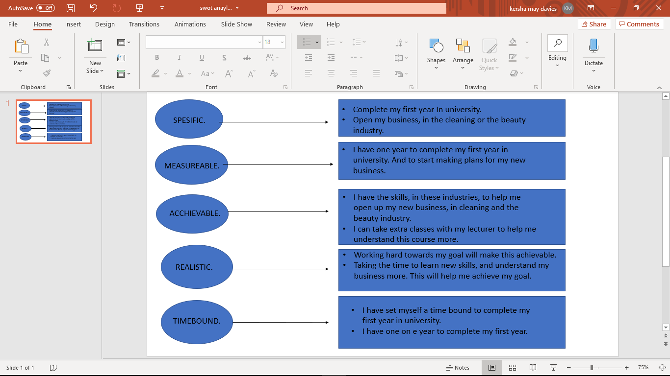

My smart analysis.
I want to complete my first year in university. Then open my own business in the cleaning or beauty industry. I will have a year to complete this course, I can pay attention more in my lectures, and research companies to help me with the funds to set up my business in the future. I will know I have completed this goal if I receive my degree in this first year at university. I have worked in the cleaning industry and passed many coursers in the beauty industry. I believe I understand the roles in these industries and have been complimented by many customers in both industries. I understand the basics for theses job roles. If I listen in class and get help from my lecture, I may complete my first year in university. Believing in myself and being motivated to push myself to work harder may help me achieve my goals. The time scale I have set for myself is one year to pass the university course and three months to build my first business, I believe this is achievable, if I pay more attention in my lecture’s classes, go to the study skills help classes in the university, Research my business, and research how to get the resources from different companies, to help me build and set up my business. I hope to have completed my university course in the next year. I receive much support from my family and partner, so I believe I will have the time to complete the task given to me by my lecturer, I believe if I can complete these tasks so that I am one step closer to achieving goal.

SWOT analysis.
A swot analysis is another business strategy, to help us build and maintain a successful business. SWOT stands for strengths weaknesses opportunities, and treats. SWOT is slightly different to SMART analysis as it uses internal and external facts. The Internal factor evaluation is known as (IFE) it is a management tool helping us understand, our strengths and weaknesses in our business and our life goals (CVA, 2017).Opportunities and threats are external things that may affect us and our business mindset, such as larger business with a good reputation, Low prices, and high customer satisfaction (Parsons, 2019).

TOWS ANALYSIS.
Tows was created by Heinz Weirich. It stands for Threats, opportunities, weaknesses and strengths. Tows matches internal factors to external factors. This can help an organisation to take advantage of opportunities, reduce threats, overcome weaknesses and see their strengths (Oxford College of Marketing Blog, 2019).

MY SWAT ANALYSIS DIAGRAM.
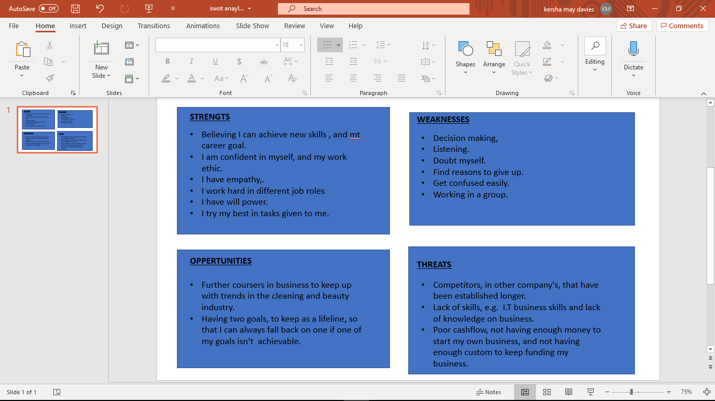

My swot and Tows analysis.
I believe I can achieve my first year in university, because I have the will power and mind set to do so. I have worked in many different job roles, and understand many basic, roles within them. I have the skills and understanding of these industries. After completing my first year in university, I will have already investigated how I can build my business. And over this year I will research what help I will need to get started in either one of my goals. I will research the new trends in these industries, and my competitors which will assist in converting my threat and help me to gain competitive advantage. I will try and cut my bad habits out such as smoking and put some money aside to start my business which will help me to convert my threat of low cash flow and start saving money towards my business. I am going to try and make more decisions for my self and push myself to listen more and understand the subjects in depth by participating more in class and taking lead in group discussions will help me to convert this weakness into a strength. I have commitment to these job roles and are passionate about each one. I will be more flexible in my work and adapt to different tasks given to me. I will be more focused on having good time management and meet specific deadlines. I will take further coursers in the future if I do not pass this first year in university to get where I want to see myself in my working life. I am very confident in my self on times and know I have more to give. This keeps me wanting more for myself and my family. Having these goals and completing this goal by using these business strategies is helping me in my working life right now and I believe it will do so in my future.

Go Mad Thinking framework.
The go mad framework and thinking, which stands for “Go Make a difference” makes people and teams to think more easily, solve their problems and improve their productivity (Gomadthinking.com, 2019).
Andy Gilbert was the developer of the go mad frame work and thinking system he helped many companies worldwide with the companies using this framework he has over 20 years of experience and sold 200 audio and video programs he was the entrepreneur off the year 2009 (Anon, 2019).

My go mad goal.
Is to finish and complete this first year at university, so that I can then further my education in business by taken the next years degree level doing business studies. This could help me gain new skills and understand for my business career. I want to create a team of five and help them create teams for them selves in my own business. I will attend university and attend more coursers to further my education in the business industry, by completing this year, I will be able to go on to the degree level once I have completed my first year.

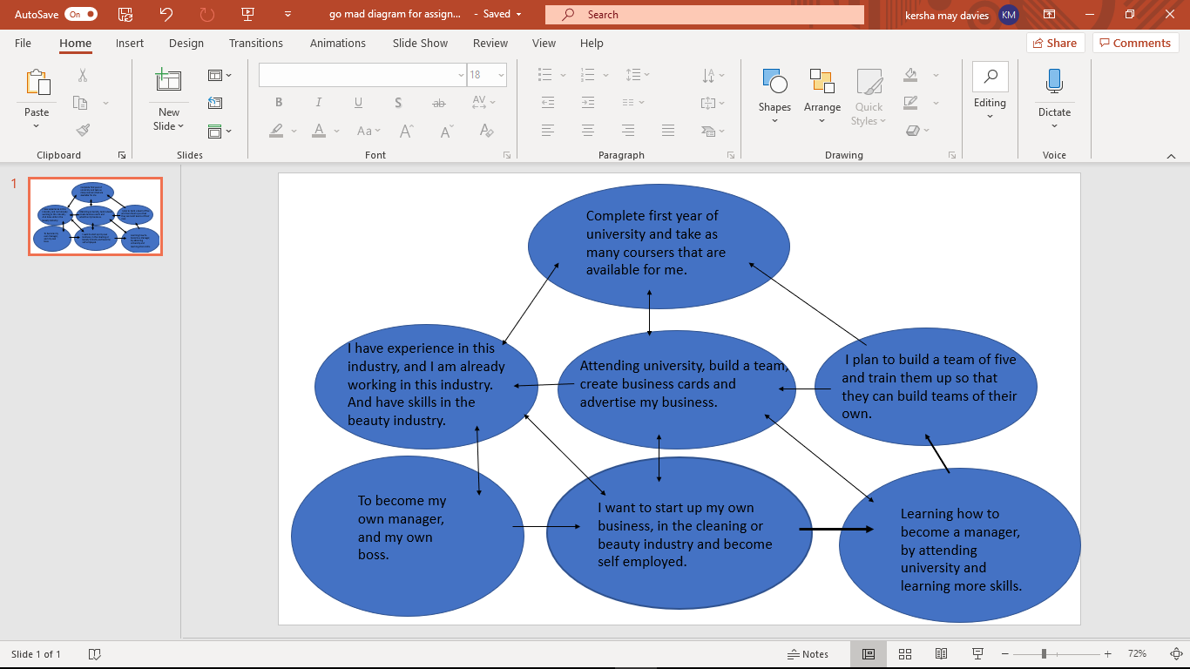

VARK LEARNING STYLE.
Fernald, Keller, Orton, Gillingham, Stillman and Montessori are the creators of VARK. VARK stands for Visual, Aural, Read/write and kinaesthetic. This tell us whether we are either one of these by taking a learning style questionnaire this helps us understand just how we learn and our inner personalities (Answersdrive.com, 2019).

My VARK learning style questionnaire.
According to the VARK questionnaire I am a, Aural and a Read/Write learner. This says I learn through audio/sound. Believe this is true. it also says I learn through reading and writing I believe this is also true. I learn a lot from watching educational videos, also through you tube. VARK has helped me understand that this is how I learn and how it helps me so well. And recognize that learning through Aural and Read/Write is why I learn so well when I am doing these rather than the visual and kinaesthetic ways of learning.
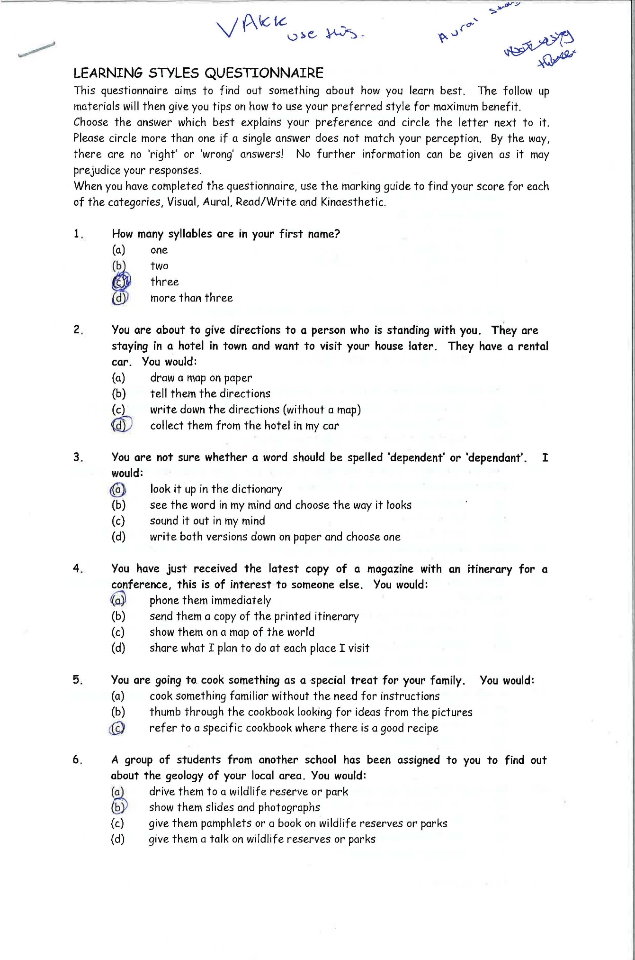

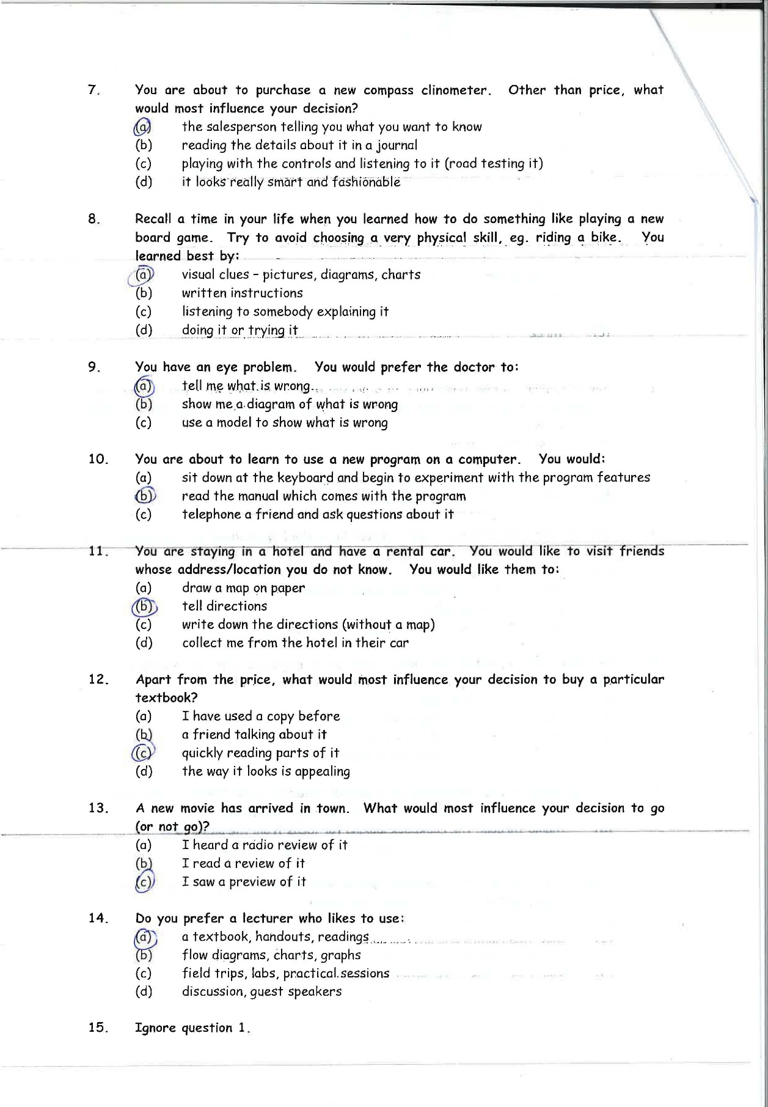

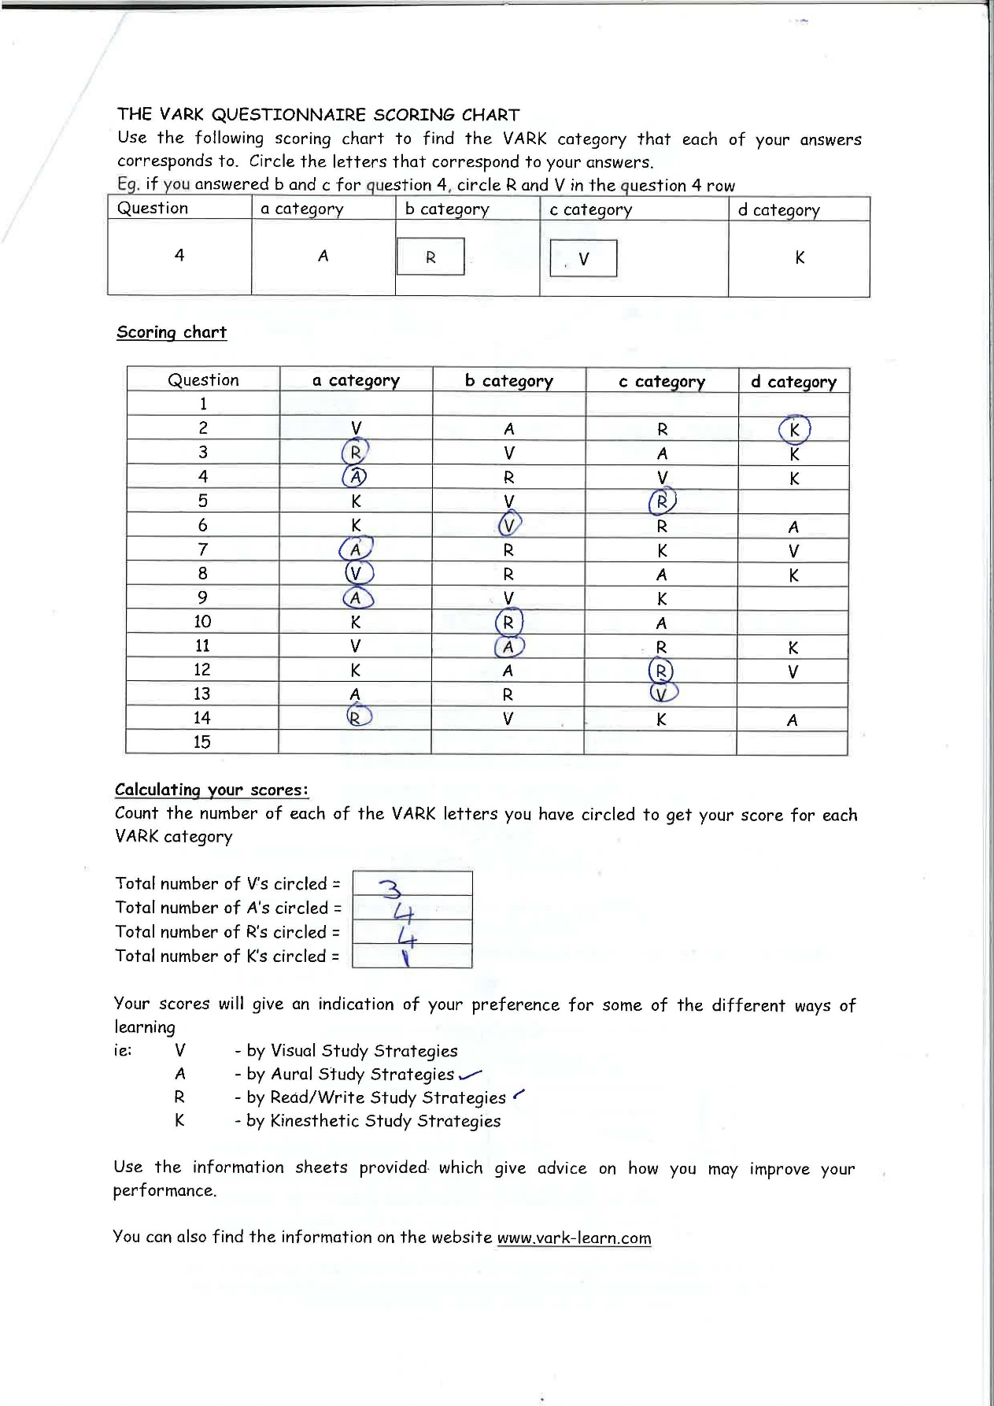

PETER HONEY AND ALAN MUMFORD LEARNING STYLES.
This Learning styles were developed by Peter Honey and Alan Mumford, based on the work of Kolb, they identified four learning styles Activist, Theorist; Pragmatist and Reflector. These are learning styles that most people prefer to use in this order to maximise their understanding of the learning techniques (Www2.le.ac.uk, 2019).

My Peter Honey and Alan Mumford learning style.

This learning style says that I am a REFLRCTOR.
This states that I learn by observing and thinking about what happened. I prefer to stay on the side lines rather than get involved with certain activities. I prefer to look back on my experience, collect data and work towards a better conclusion (Www2.le.ac.uk, 2019).

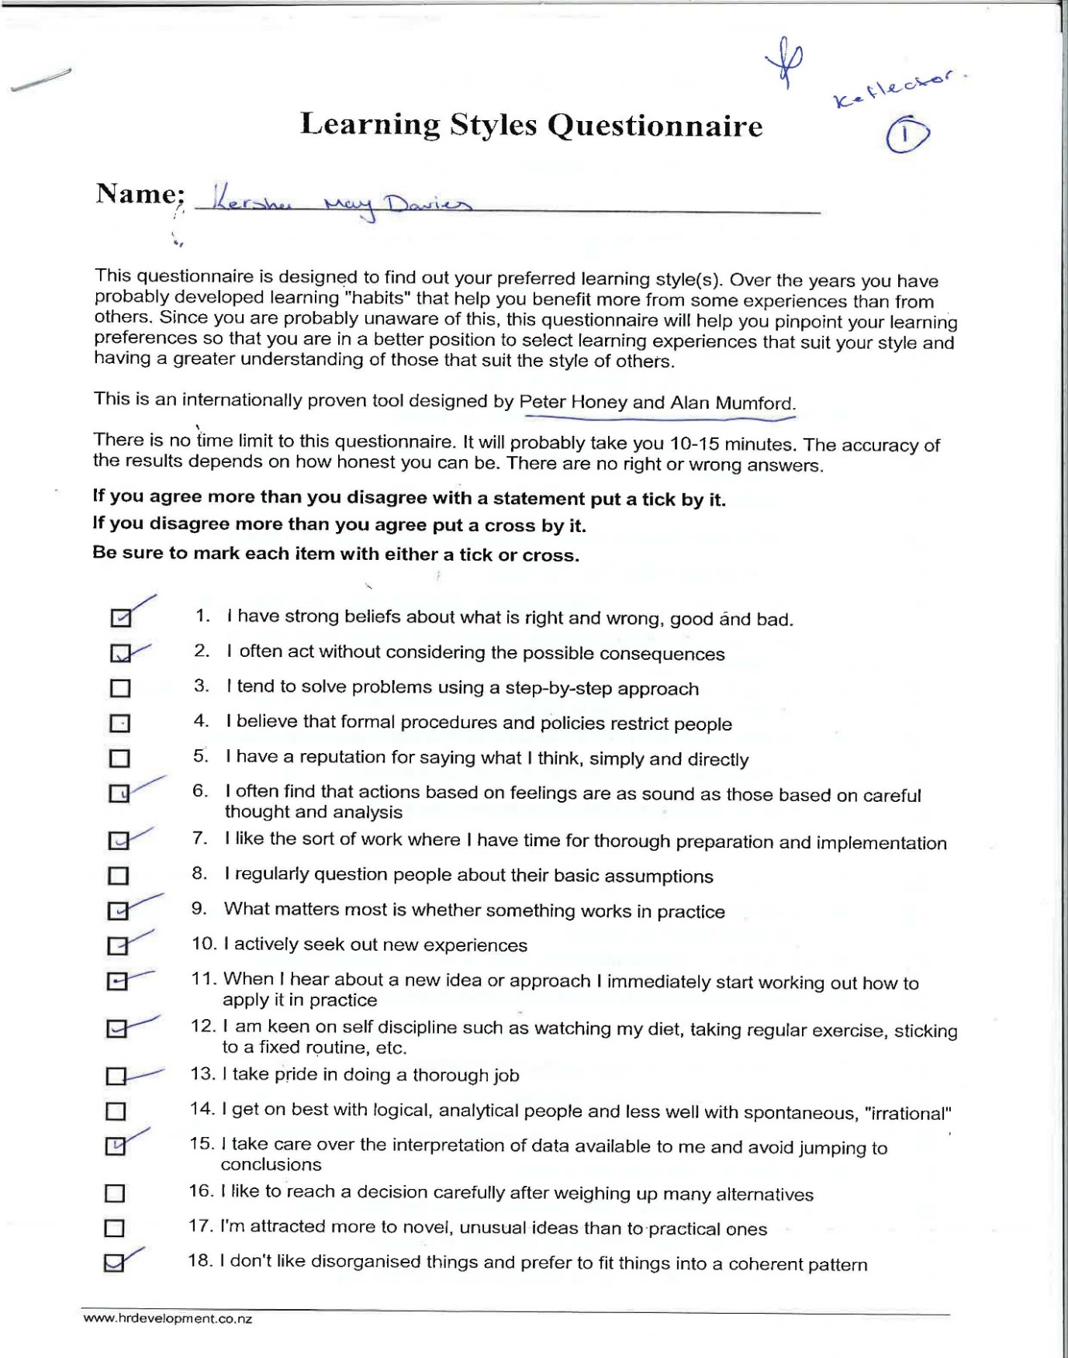

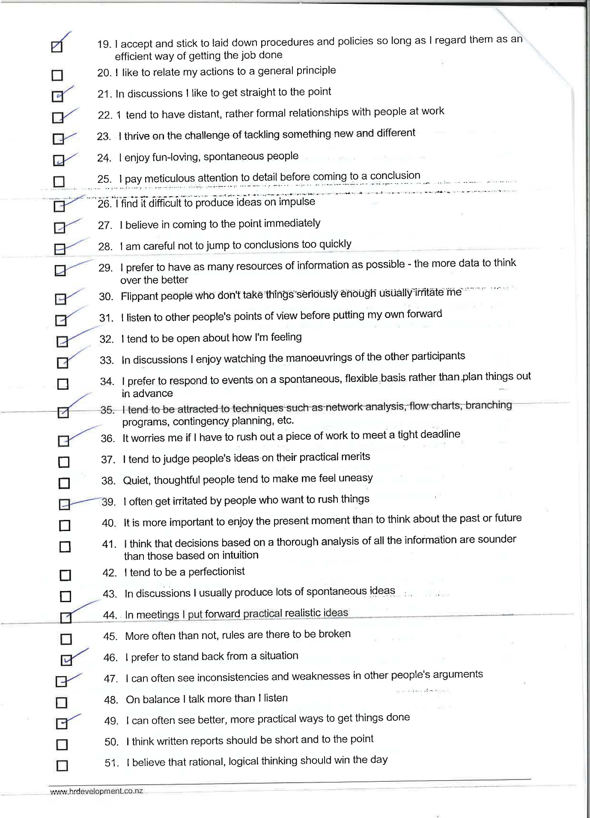

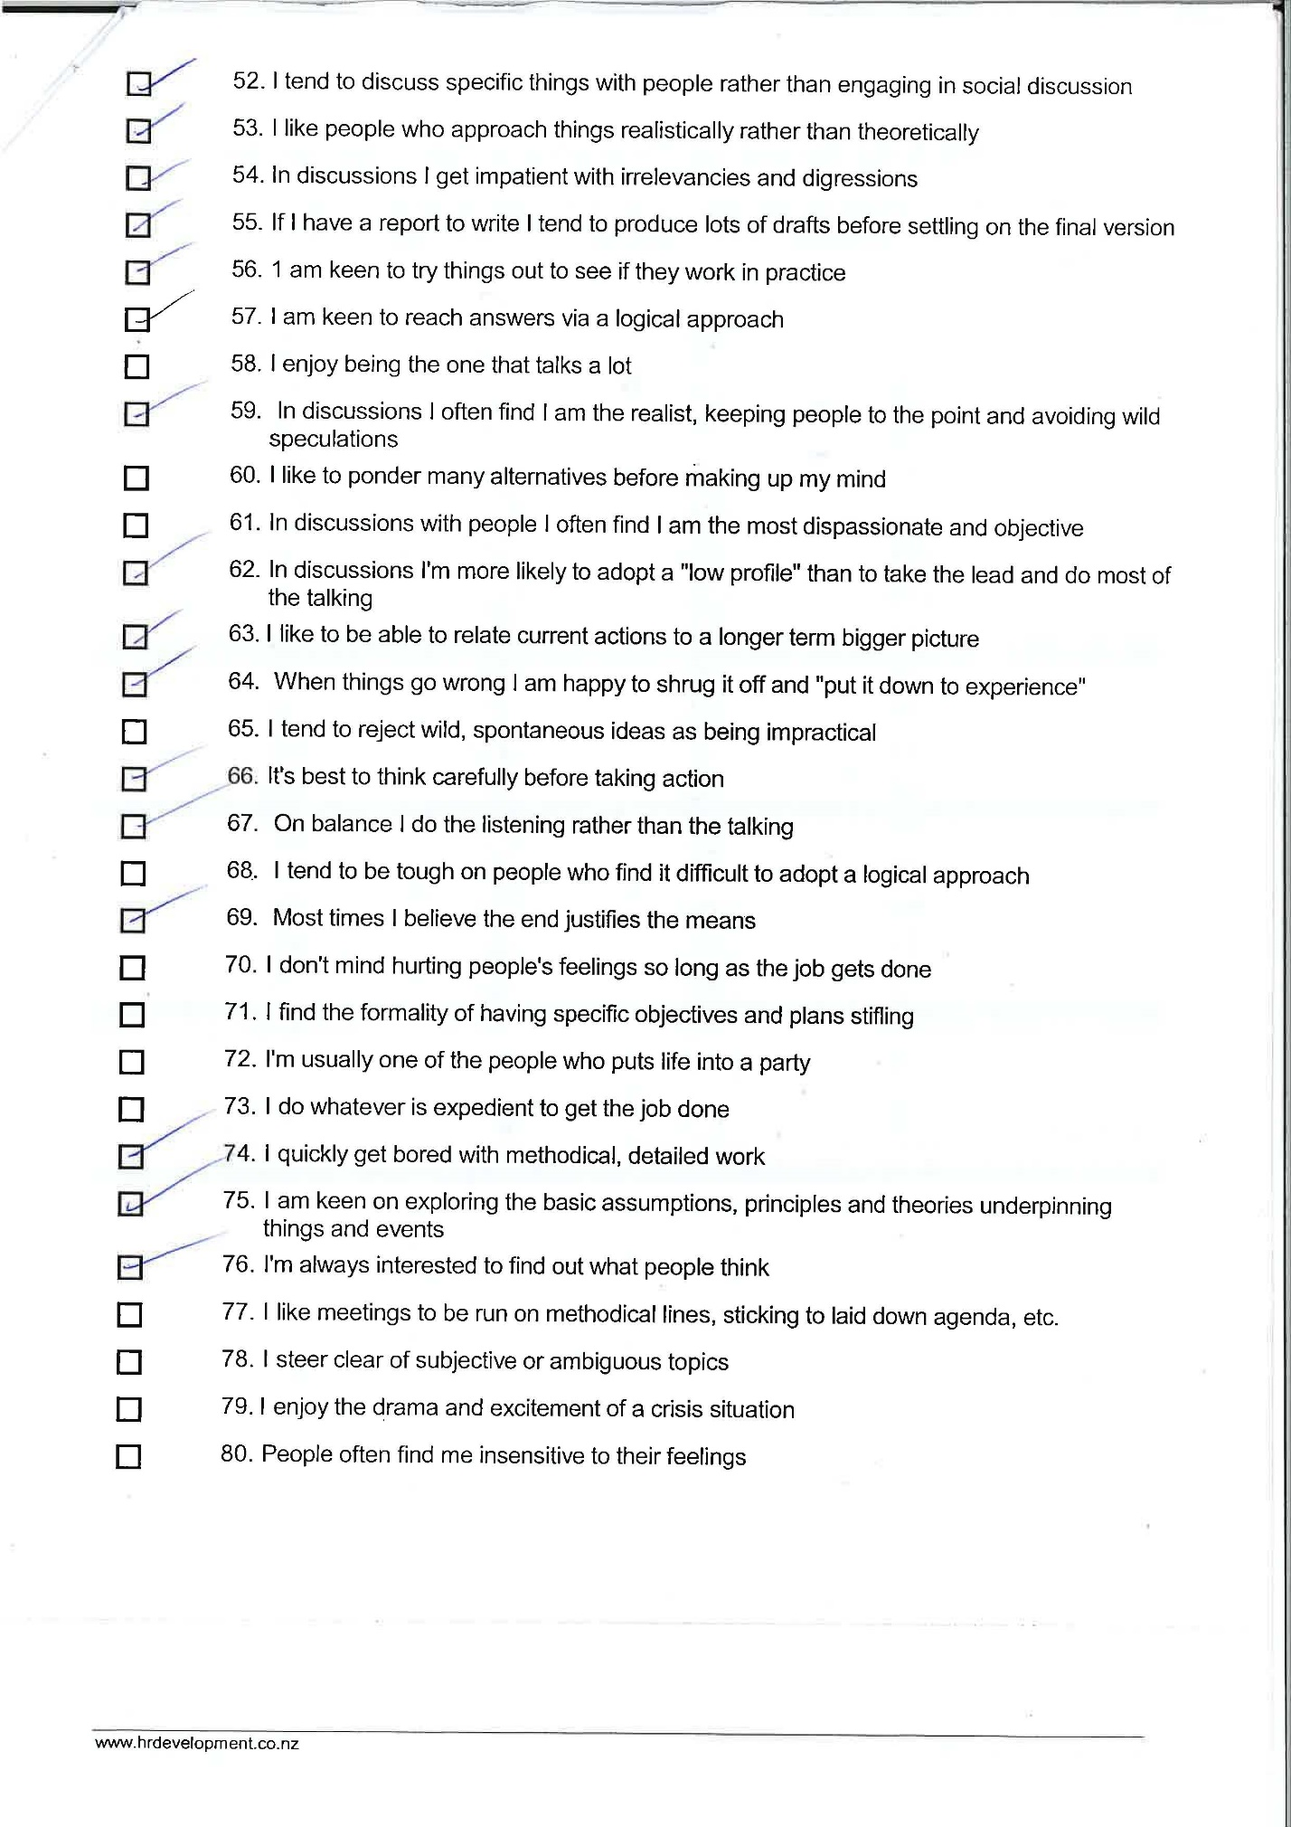

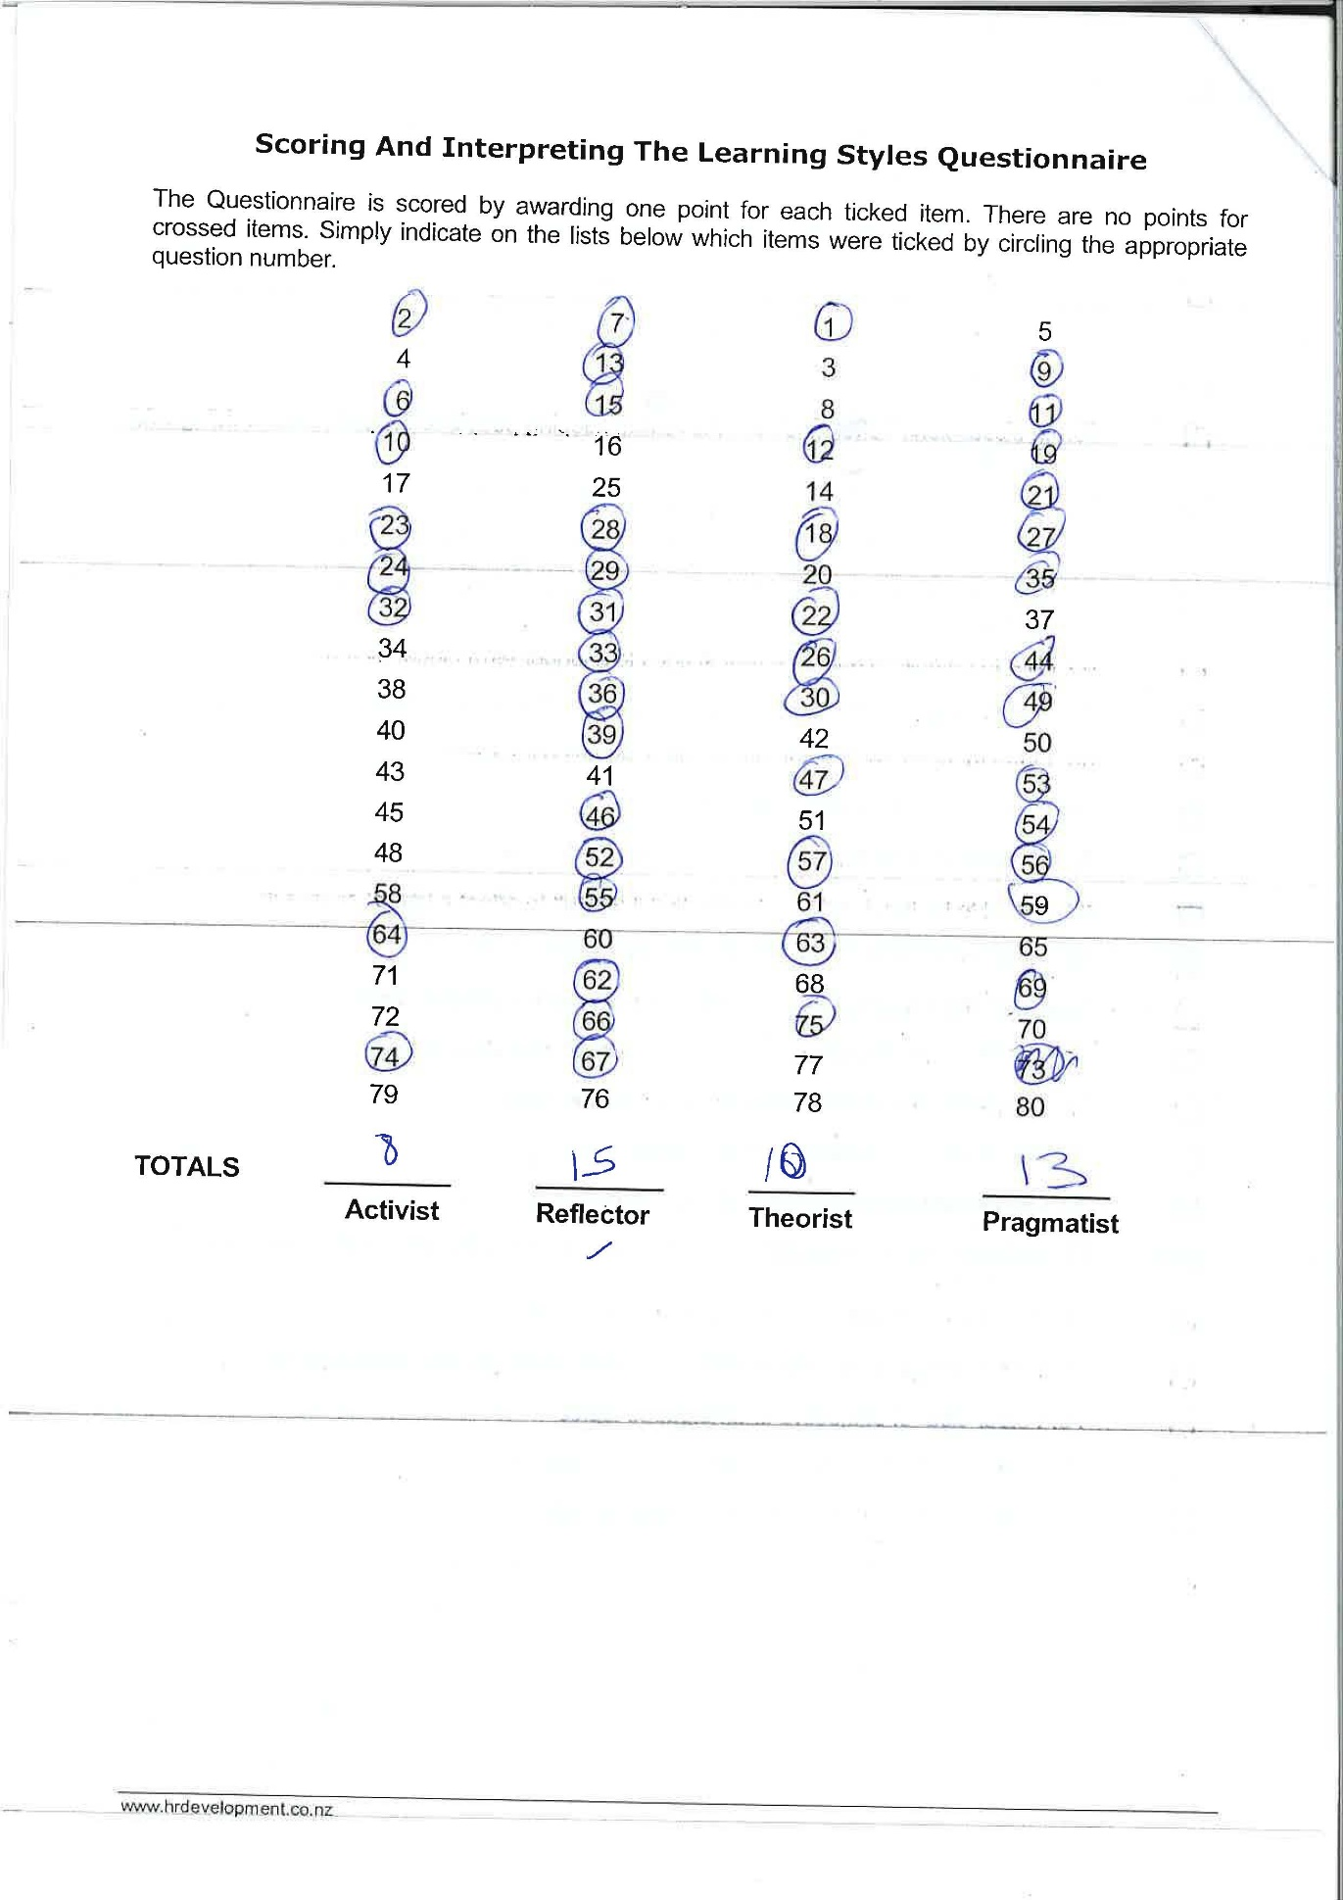

PDP.

Development objective. | Specific actions. | Blockers and how they will be removed. | Support required. | How I will know when I have achieved the objective.
- Improve my maths skills. | I will go to maths skills class/study skills classes.  I am aural and read/write learner according to VARK so I will study more using, these learning styles. | Time and money.  I am going to save money from quitting smoking this month so that I can save to put towards my business. | Family and friends. Lectures to explain. | When I can understand this skill more.
- Improve my communication skills E.G presentation skills. | Practice rehearsing in the mirror. Plan my presentation notes in advance. Present in front of family and if I’m in a group rehears with them before the presentation. To get feedback. | Time is a barrier because of my homelife commitments. | Will ask my partner to help me more around the house so that some of my home lifework load is taken off me, could ask my sisters who attended university to help me understand the assignments. | When I deliver my next presentation I will be more confident in public speaking.
- Improve my time management. | Plan and prioritise, my work and myself. Id like to develop new ideas with my piers to help me organise my work. VARK says I learn more from reading and writing I will read on the topic and rewrite my own notes to help me understand things better. | I don’t have access to books because I can’t make time to come to the library to research and read the books there, so I will go online to get the books on there and use the websites. | I will use the support of my classmates to help me with ideas and check understanding. | Getting assignments done on time being organised and planning my study’s.

Conclusion.
To achieve my goals, I will reflect on my mistakes and I will try to pay more attention to my lecture in class. I am going to focus more on my goals and how to start and maintain my business. I will study more using the books from the library by making time to get them I will ask my family for help to look after my daughter to do so. I will attend study skills before class by leaving home earlier. I will believe in myself more and keep going over my learning styles so I can refresh my mind of who I am and what I can achieve. According to the VARK questionnaire I am an Aural and a Read/Write learner. I will use this to my advantage to help me increase my skills. By joining these two learning styles together I believe I will use my skills to my advantage. Using the Honey and Mumford learning style which says I am a reflector I will use this to reflect on my past experiences write them and try to understand them using these learning styles.

Academy, P. (2019). What are SMART objectives and how do I apply them? [online] Professionalacademy.com. Available at: https://www.professionalacademy.com/blogs-and-advice/what-are-smart-objectives-and-how-do-i-apply-them [Accessed 5 Nov. 2019].
Answersdrive.com. (2019). Who created the VARK learning style? | AnswersDrive. [online] Available at: https://answersdrive.com/who-created-the-vark-learning-style-96122 [Accessed 13 Nov. 2019].

The Balance Careers. (2019). Important Employability Skills for Workplace Success. [online] Available at: https://www.thebalancecareers.com/employability-skills-list-and-examples-4143571 [Accessed 8 Oct. 2019].

CVA, K. (2017). https://www.medwinpublishers.com/JOBD/JOBD16000139.pdf. Journal of Orthopedics & Bone Disorders, 1(7).

Core.ac.uk. (2019). [online] Available at: https://core.ac.uk/download/pdf/9426096.pdf [Accessed 11 Nov. 2019].
Encyclopaedia Britannica. (2019). International Labour Organization | United Nations. [online] Available at: https://www.britannica.com/topic/International-Labour-Organization [Accessed 8 Oct. 2019].

Parsons, N. (2019). What Is a SWOT Analysis, and How to Do It Right (With Examples) | LivePlan Blog. [online] LivePlan Blog. Available at: https://www.liveplan.com/blog/what-is-a-swot-analysis-and-how-to-do-it-right-with-examples/ [Accessed 7 Nov. 2019].

Wade, D. (2009). Goal setting in rehabilitation: an overview of what, why and how. Clinical Rehabilitation, 23(4), pp.291-295.
Gomadthinking.com. (2019). Go MAD Thinking. [online] Available at: https://www.gomadthinking.com/ [Accessed 13 Nov. 2019].

Gomadthinking.com. (2019). Go MAD Thinking. [online] Available at: https://www.gomadthinking.com/ [Accessed 13 Nov. 2019].

Oxford College of Marketing Blog. (2019). TOWS Analysis: A Step by Step Guide - Oxford College of Marketing Blog. [online] Available at: https://blog.oxfordcollegeofmarketing.com/2016/06/07/tows-analysis-guide/ [Accessed 13 Nov. 2019].

Www2.le.ac.uk. (2019). Honey and Mumford — University of Leicester. [online] Available at: https://www2.le.ac.uk/departments/doctoralcollege/training/eresources/teaching/theories/honey-mumford [Accessed 13 Nov. 2019].

