

Certificate of Higher Education in Skills for the Workplace

Task 2
Professional career development report

Student name:
Student ID:

Module name: Professional Career Development
Module code: (BMSW4005_LON)
Lecturer name:
Word count:
Submission date:

Table of Contents

Type chapter title (level 1) 1
Type chapter title (level 2) 2
Type chapter title (level 3) 3
Type chapter title (level 1) 4
Type chapter title (level 2) 5
Type chapter title (level 3) 6

Introduction

In this report I discuss my own career development plan…. I provide a reflective account of the role play by using Gibb’s reflective cycle. In the report I analyse the skills and knowledge required to work effectively as travel agent which is my career ambition. An evaluation of my current strengths and areas for development is provided, including a personal development plan with SMART targets.

• Personal reflection on the role play: Recruitment and Selection - Applying Gibb’s learning cycle.

In week 9 I took part in a role play as part of my assessment of the module Professional Career Development. Here/in this section/Below I provide a reflective account of the role play using
Gibb’s learning cycle.
Gibb’s learning cycle is composed by 6 reflective steps/stages
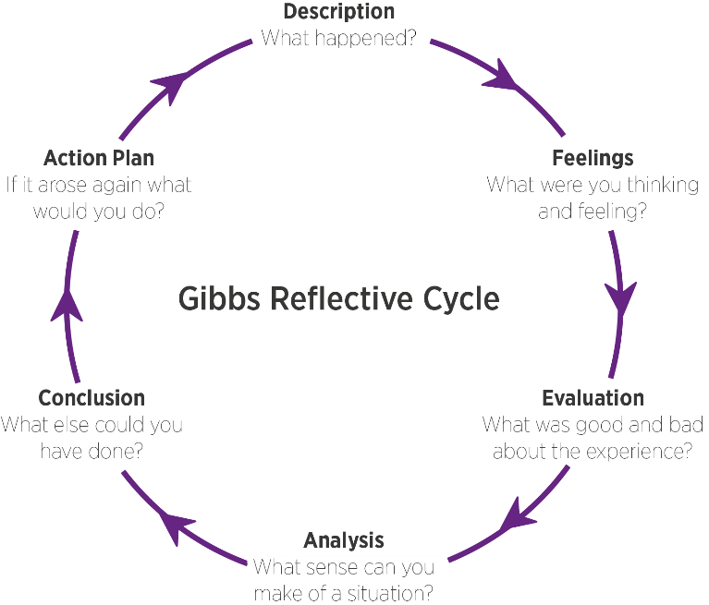

1 step: description. What is the event? What happened?

2 step: Feelings in the event

3 step: evaluation positive and negative

4 step: analysis: make sense of the situation/ most relevant things

5 Conclusion: What else could I have done? What could I have done differently?

6 step: Action plan: behaviour/action I will take in a similar situation in the future.

1 step: description: The event is the role play that I have done in week 10 as part of my assignment

• Skills and knowledge which contribute toward working effectively

• My personal strengths and areas for further development
Write paragraph/s about strengths and areas for further development

- SWOT ANALYSIS

SWOT ANALYSIS

STRENGHTS | WEAKNESSES
OPPORTUNITIES | THREATS

PERSONAL DEVELOPMENT PLAN

NAME |  | Target Job/career  Example: Teacher, Manager, Business Person

TIME PERIOD | From: | To:

What Skills do I need to achieve my goal?
SKILLS | How Will I get them | What resources or support will I need? | What can prevent me from achieving my goals: (unemployment, illness | How long should it take

- My short - medium – long term targets for the development of my own professional career plan (using Specific, Measurable, Agreed, Realistic, Time-bound –SMART targets)

Short-term plan (3 -6 months)
Specific

Measurable

Agreed

Realistic

Time-Bound | 15/10/2022
Medium-term plan (1-2 years)
Specific

Measurable

Agreed

Realistic

Time-Bound | 10/10/2024
Long-term plan (2-5 years)
Specific

Agreed

Realistic

Time-Bound | 10/10/2025

Conclusion

References:
Gibbs, G. (1988) Learning by Doing: A guide to teaching and learning methods. Further Education Unit. Oxford Polytechnic: Oxford.

Appendix A :
Job application form

Application for [job title] -

Your details

Name:

Education and training
Please give details:

Qualifications
Please give details:

Employment history

Your current or most recent employer

Name of employer:

Job title:

Length of time with employer:

Reason for leaving: Career progression

Duties:

Previous employers
Please tell us about other jobs you have done and about the skills you used or learned in those jobs.

Supporting statement
Please tell us why you applied for this job and why you think you are the best person for the job.

Right to work in the UK
Do you need a work permit to work in the UK? Yes / No

References
Please give the names and contact details of 2 people who we can ask to give you a reference. We may ask them before an employment offer is made. We will not ask your current employer until we get your permission.

Declaration
I confirm that to the best of my knowledge the information I have provided on this form is correct and I accept that providing deliberately false information could result in my dismissal.

Name:

Signature:

Date:

Appendix B

The questions asked as interviewer in the role play (A1)
1.
2.
3.
4.
5.
The question/s asked as interviewee in the role play (A1)
1.

