University of Wales Trinity Saint David
Wales Institute of Science & Art



Testing Electrical Circuits and Applications
Electrical Control Systems (ACHA4010)

Ben Slade
2104137
May 2023
Table of Contents
1. Task 1 2
1.1 A 2
1.2 B 2
1.3 C 2
1.3.1 I 2
1.3.2 II 2
1.3.2 III 2
1.3.4 IV 2
1.4 D 2
1.5 E 2
1.6 F 2
1.7 G 2
2. Task 2 2
2.1 Scope Time Division Calculations 2
2.2 Function Generator Output Sine Wave 2
2.3 Unsmoothed Rectifier Wave 2
2.4 Smoothed Rectifier Wave 2
2.5 Drop In Voltage Question 2
2.6 Rectifiers Use in Automotive Application Question 2
2.7 Probing Question 2
3. Task 3 2
3.1 Scope Time Division Calculations 2
3.2 Function Generator Output Sine Wave 2
3.3 Capacitor charge and Discharge Wave Marked at Correct Points 2
3.4 Basic Capacitor Calculations 2
3.5 Capacitor Discharge Table 2
3.6 Gradient Plot and Calculations 2
3.7 Inaccuracies Question 2
4 . Reference List 2

Task 1

1.1 A
$V=IR$ Therefore $R= \frac{V}{I}$
$R= \frac{12}{0.5}$ $R=24Ω$

1.2 B

$$0.5A -A=B+C$$
$$0.5A-0.3A=0.2A$$
$\frac{0.2}{2}=0.1A per resistor$

1.3 C

1.3.1 I
$P= I^{2}R$ Therefore $R= \frac{P}{I^{2}}$
$R= \frac{0.9}{{0.3}^{2}}$ $R=10Ω$

1.3.2 II
$P=VI$
$P=12×0.1$ Therefore $P=1.2W$
$R= \frac{P}{I^{2}}=\frac{1.2}{{0.1}^{2}}=$ 120 $Ω$

1.3.2 III
$R_{Total}= \frac{1}{\frac{1}{R_{1}}+ \frac{1}{R_{2}}+ \frac{1}{R_{3}}}$ Therefore $R_{Total}= \frac{1}{\frac{1}{10}+ \frac{1}{60}+ \frac{1}{60}}=7.5Ω$
$V=IR=0.5×7.5=3.75V$

1.3.4 IV
$R= \frac{V}{I}= \frac{5}{0.1}=50 Ω$

1.4 D
$12V-2V=10V$
$R= \frac{V}{I}= \frac{10}{0.5}= 20Ω$

1.5 E
$V=IR= 0.5 ×6=3v$
$12v-3v=9v$ drop

1.6 F

$R_{Total}= \frac{1}{\frac{1}{R_{1}}+ \frac{1}{R_{2}}+ \frac{1}{R_{3}}}=\frac{1}{\frac{1}{20}+ \frac{1}{6}+ \frac{1}{50}+\frac{1}{8.57}}=2.83$ $Ω$

1.7 G

Emf =

2. Task 2

2.1 Scope Time Division Calculations
$$Period= \frac{1}{f}$$
$$f=10Hz$$
$$Period= \frac{1}{10}=0.1s$$

2.2 Function Generator Output Sine Wave

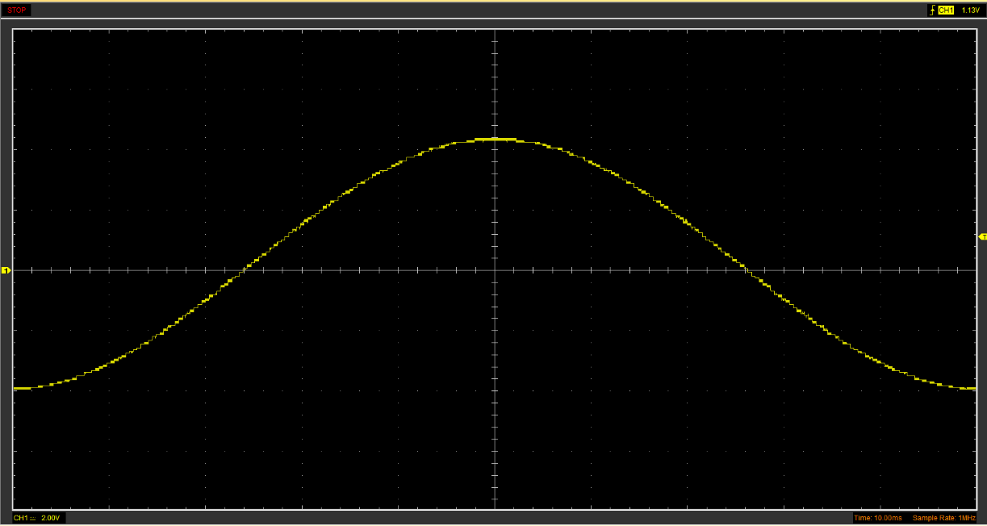
Figure 1 - Function Generator output sine wave

2.3 Unsmoothed Rectifier Wave

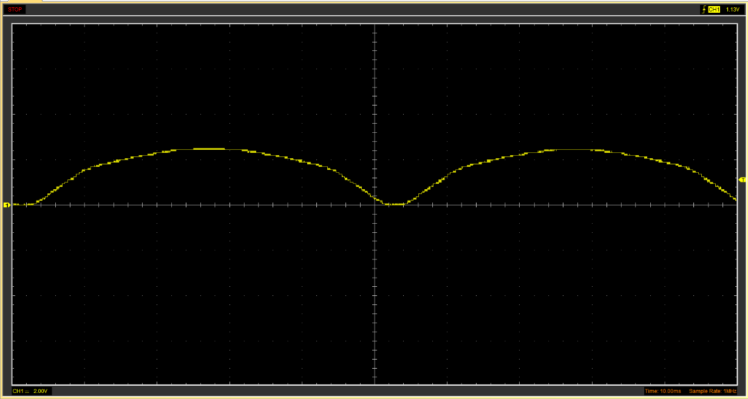
Figure 2 – Unsmoothed Rectifier Wave

2.4 Smoothed Rectifier Wave

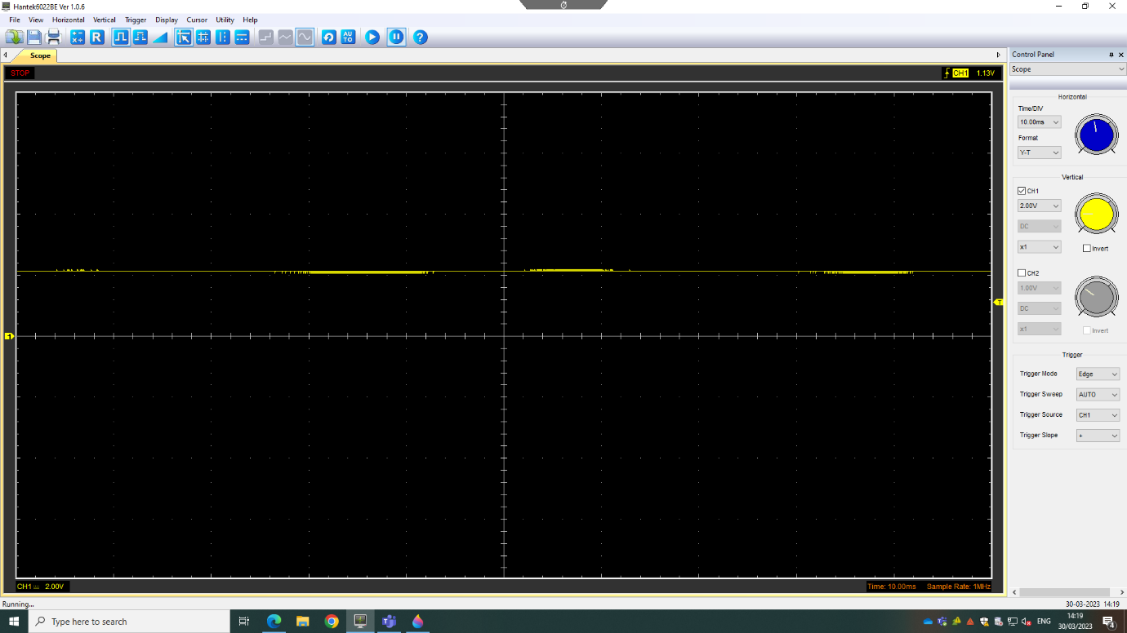
Figure 3 – Smoothed Rectifier Wave

2.5 Drop In Voltage Question

Voltage drops through the rectifier as it uses diodes, and diodes have to have a suitable voltage forwards to push the electric charge through it. Almost as if you were to push a liquid through a one way valve, it still requires some force to push the fluid through the valve in the correct direction, which adds resistance. In a diode, this small amount of resistance will result in a voltage drop.
(Banerjee, 2023)

2.6 Rectifiers Use in Automotive Application Question

Rectifiers have many uses in automotive applications, some being in the EMS, Ignition, radio, alternator and many more. When being used with an alternator, it is used as the electricity generated by the alternator is AC when all car batteries are DC, so the AC needs to be converted to be compatible.
Rectifiers can also be used as detectors of radio signals in early radios. It would rectify the AC radio signal directly and convert it into usable signals to be extracted for sound. (Arrow Electronics, 2018)

2.7 Probing Question

3. Task 3

3.1 Scope Time Division Calculations

$R=1000Ω$
$C=1×{10}^{-6}$
$t= ΩC=1000×{10}^{-6}=0.001$
$20t=0.02$
$p= \frac{1}{0.02}=50hz$

3.2 Function Generator Output Sine Wave

Figure 4 -Function Generator output sine wave

3.3 Capacitor charge and Discharge Wave Marked at Correct Points
Charge
Discharge
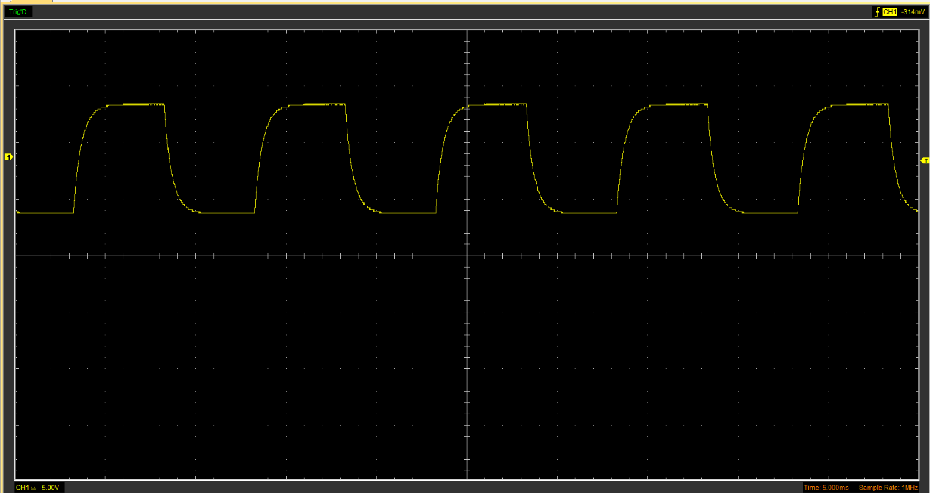
Figure 5 – Capacitor Charge and discharge wave marked at correct points.

3.4 Basic Capacitor Calculations

$$t= ΩC=1000 × {10}^{-6}=0.001$$

3.5 Capacitor Discharge Table

3.6 Gradient Plot and Calculations

3.7 Inaccuracies Question

4 . Reference List
Banerjee, K. (2023). Diode Voltage Drop: What, Why, How And Detailed Fact. Lambdageeks.com. Available at: https://lambdageeks.com/diode-voltage-drop/#:~:text=The%20diode%2C%20in%20forward%20bias%2C%20selects%20a%20suitable,across%20the%20PN%20junction%20causes%20the%20voltage%20drop
Arrow Electronics (2018). How Rectifiers Work – Types of Rectifiers & Their Uses. Arrow.com. Available at: https://www.arrow.com/en/research-and-events/articles/how-rectifiers-work-types-of-rectifiers-and-their-uses

