The definition of the term “monster” originates from the Latin word, “monstrum”, which translates to an uncanny (strange, mysterious or unsettling) person, thing or creature. Paul Murgatroyd defines the term as ‘mythical/fabulous creatures which are extraordinary, alien or abnormal’; he explains how the idea of a monster is often associated with the idea that something is physically malformed, has a savage or malevolent nature and brings in the association with special powers and abilities, such as breathing fire. My own views, on the definition of a monster, are that monsters are the physical representations of the common fears, which are made physically malformed and ill natured to increase the level of fear and legend around them, and subsequently the fear they are based around. When ascribing something the title of a monster, in Graeco-Roman eras, it served as a category for creatures such as Gorgons, Harpies and Chimeras; however in more modern times it can be applied to a person or thing whose morals do not align with those of wider society. The use of the term monster has been used when talking about people; people whose morals and actions are well outside of what is classed to be socially acceptable (e.g. globally condemned monstrous people such as Adolf Hitler and prolific murderers such as Ted Bundy). The quality that most commonly leads to the ascribing of the term monster onto a human being is the lack of the basic human emotions, such as empathy and sympathy; the lack of these qualities and the actions and moral direction it creates is deviated from the rest of society and viewed in more sceptical ways.
Monsters can be used in media and art as a form of metaphor for societal fears; in modern ideas of monsters, such as werewolves, have been called a metaphorical example of a man’s primitive bloodlust and the “desire to violate another human”. There are arguments made that the monsters of the Graeco-Roman times also served as metaphorical representations for societal fears; for example, there is the idea that Medusa serves as representation of the “feminization of monsters served to demonize women” in a patriarchal society, because of the beauty she is said to have possessed, which, in some iterations of Medusa’s story, she is said to have been boastful of, which angered the Goddess Athena, who then turned her into the Gorgon creature she is depicted as in art.

Monsters serve many different purposes in a societal sense; they can be a source of information into the common societal fears, such as how in modern media the use of zombies can be seen as a societal fear of mass contagion or primitive subcultures and the stories of the Sirens in Homer’s Odyssey representing the sea and female flattery. In the Graeco-Roman times there was also the desire for aetiological explanations of the world around them, such as how baboons were thought to be men with the heads of dog. An aetiological myth is the explanation of why something is the way it is and has three different categories of aetiological myth: natural aetiological myth (explaining the unknowns from nature, such as Zeus being angry causing thunder and lightning storms), etymological aetiological myth (explaining word origins, e.g. ‘aphrois’ is the Greek word for sea foam, which is used to explain that because she was born from sea-foam, Aphrodite is named after it) and religious aetiological myth (explaining religious ritual, i.e. the Greek Goddess Demeter travelling to the city of, Eleusis, and being worshipped is the reason for the ritual of the Eleusian Mysteries). This idea sees the creation of monsters as ways of explaining things which were not fully understood in the era, such as how the explanation for volcanic activity was that the Hephaestus, God of Metalworking, was at work on his forge under the volcano. The idea of Hephaestus under the volcano is also an example of natural aetiological myth because it is a representation of nature and the ‘terrifying’ aspects of it. There are many different mythological monsters dating from the Graeco-Roman era; among these include the three-headed guard dog of the Underworld, Cerberus; the venomous water serpentine, the Hydra. There were also a large number of monsters in the Graeco-Roman mythology which are hybrid monsters (a mix of a number of humans or animals); notable examples of the different hybrid monsters featured in the mythology include: the Chimera, a creature with the body and head of a lion, as well as an additional head of a goat and a tail in the form of a snake, with the head at the end; the Minotaur, a creature with the body of a man and the head of a bull (these creatures are popular in modern media); the Echidna, a creature with half the form of a woman and the other of a snake (the Echidna is thought to be the mother of a large majority of the monsters found in Graeco-Roman mythology).
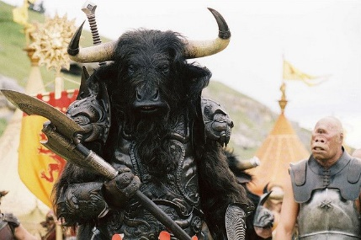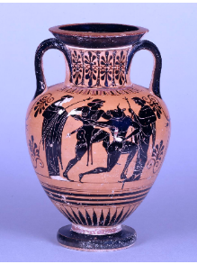
Depiction of a Minotaur featured in A black figure neck-amphora
Disney’s, ‘The Chronicles of Narnia: with a depiction of Theseus
The Lion, The Witch and the killing the Minotaur
Wardrobe’ film (2005) (c.510.BC – 500.BC)

The ideas of monsters have changed from those found in the classical mythology of the Graeco-Roman era. Siren’s, for example, are considered to be, by Murgatroyd, an enigma among the other more well-known Graeco-Roman monsters, there was not a solid version of what a Siren was, rather having various adaptions in both antiquity and modern times, with both being different. While not changing in sense that they were creatures who would lure sailors to them with their singing, were depicted, in antiquity, as a hybrid of a woman and a bird; however, onwards from the Medieval period to the modern one, Sirens have been depicted as more fish-like, similar to the idea of a mermaid. One of the earliest depictions of Sirens comes in the form of an oil flask from the archaic period, depicting sirens as a black bird of prey, this differs from the modern view of the mermaid-like figure that has been popularised by modern times, so much so that the 1891 painting, Ulysses and the Sirens’, caused stirs because of the portrayal of the Sirens as birds. Associations that are made with the depictions of the Sirens has changed over time. The original depictions of Sirens are not always associated with the water (something which was made popular belief by the changing of appearance from bird to fish) or with music. The modern depiction of Sirens come with the associations of seduction and death (this association was first seen in the Classical period). A change in ideas from the Graeco-Roman depictions are that the Sirens were not exclusively female creatures, this differs from the commonly seen modern portrayal of Sirens as beautiful, seductive women (a sexualisation of the creatures which was seen more in the Roman depictions as opposed to the earlier ones); when linking this with the association of Sirens and death, this idea of them being beautiful women could be argued as being linked to the societal fears surrounding overt female sexuality.

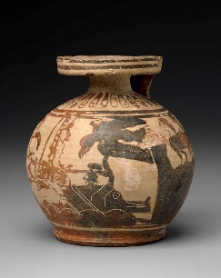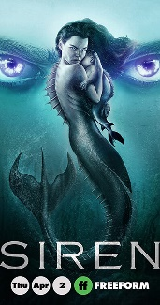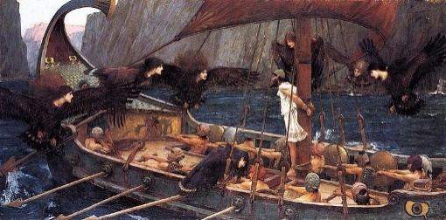
A limestone statue of a A cover poster of the ‘Ulysses and the Sirens’, by
bird-like Siren Freeform television John William Waterhouse (1891)
(c.350. BC – 300.BC) programme, Siren (2018) ‘
There are artistic challenges when depicting creatures from Graeco-Roman mythology. While there is opportunities for artistic individuality when creating any form of art work, or media for the modern era, when creating a piece based off of the likeness and mythos of a creature from Graeco-Roman times, there needs to be a certain level of similarity with the creature. The art piece created and intended to represent a certain creature from mythology needs to be recognisable as what it is intended to be.
Looking at depictions of Medusa as an example, it can be seen that the representations of her have been changed and altered depending on the different periods and societal views surrounding her at that time. The image of a woman with a mass of venomous snakes in place of her hair is instantly recognisable as Medusa and she is one of the most popular and represented monsters from Graeco-Roman mythology. Statues remain dating back to the Graeco-Roman era depict Medusa and her demise at the hands of Perseus and paintings from the 17th Century show depictions of the Gorgon. Modern cinematic works have altered the image of Medusa by often incorporating the addition of a snake’s body as opposed to only her hair being serpentine; this change fits the societal view of Medusa only as a monstrous being, contrasting to the idea of Medusa as a beautiful figure from around the time 450. BC, or of the idea that Medusa was a victim, because of the iteration of her story where she was assaulted by Poseidon and punished for it by Athena. The changing view on Medusa impact upon the representations of her which are produced during that period.

It can be seen that the appearance and representations that are seen of Medusa have altered since her first depiction in antiquity; there is a more anthropomorphic view of Medusa that is being seen and there is a feminisation of her character. This feminisation can serve a dual purpose in Medusa’s representation; one purpose of the feminisation of Medusa is to alter her appearance from the original idea of the hideous Gorgon, which can be seen depicted onto a statue of her (c. 570.BC) which is described as “comically hideous”, to a more beautiful and alluring figure, playing on the sexuality and seduction which the change from monster to maiden, one of the first examples of which is a red-figure pelike (c. 450-400.BC), which coincided with the increased use and popularity of the story of Medusa being a maiden who was punished by the Goddess Athena for an assault by the God Poseidon (a change from the earlier story of Medusa always being one of the three Gorgon sisters). The Classical period in which the change in Medusa was first seen also saw the feminisation of other Graeco-Roman monsters, such as the Siren and the Scylla, with creatures commonly “losing some scales and wings as their bodies were more and more humanized”.

Representations of Medusa offer two different scenarios into both Graeco-Roman and modern views into the beauty and power of women and the destructiveness.
The artistic decision to depict Medusa as a beautiful being, even after the transformation into the Gorgon creature by Athena, shows how beauty can be deadly. In the myth of how Medusa became the Gorgon creature, her beauty is something which is mentioned throughout the myth, from how her hair was said to rival that of Athena and her beauty brought people to the Temple of Athena, including the God Poseidon. After her transformation into the Gorgon, there are still examples of Medusa being beautiful, even while being a ‘monstrous’ creature. The continuation of the depiction of Medusa being beautiful are meant to demonize the feminine beauty; beauty that draws people in and destroy them for it. It is a well known fact that to look upon Medusa’s face would cause anyone to turn to stone; with this fact in mind, by making Medusa a beautiful maiden, it could be argued that there is an underlying symbolism of beauty being deadly and destructive. Medusa’s appearance is used to show how there is a need or curiosity towards the aesthetically pleasing, even with the knowledge of how deadly it is. This form of depiction of Medusa is a demonisation of the beauty and femininity which she possesses, possibly due to a Graeco-Roman societal fear of women and any power they may have over men; she has become a well known ‘femme fatale’ figure in art and media, “a conflation of femininity, erotic desire, violence and death” and an “allegorical figure of fatal beauty, or a ready image for superimposing the face of a detested woman in power”

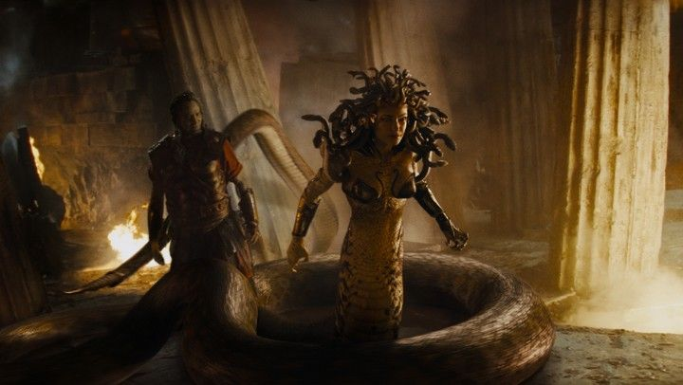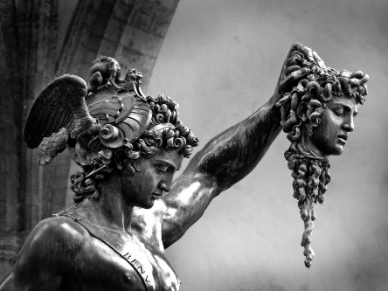
Medusa depicted in the Warner Bros. ‘Perseus and the Head of Medusa’
Pictures film, ‘Clash of the Titans’ (2010) by Benvenuto Cellini
(c.1545 – 1554)

A monster is defined by Paul Murgatroyd as a mythical or fabulous creature which has different abilities and a malevolent or evil nature. This definition is a generalisation that can be ascribed to all types of monsters from the Graeco-Roman and other civilisations mythologies. My own definition is that a monster is something which is created through the fears of society and made to seem as frightening as physically possible, symbolically enhancing the fear surrounding of what the creature was based on. This can be seen across the Graeco-Roman period, with Medusa serving to represent the fear of beauty and power in a woman. The artistic challenges regarding these mythical monsters is being able to ensure that they are accurate to the original mythos but also being able to enhance the story, possibly adding the fears of the current society onto that monster (possibly a hint to why Medusa is still such a popular figure from Graeco-Roman mythos, because of modern societies own fears of women). Monsters serve their purpose as a myth and the depictions of them which can be seen in media and art from both antiquity and modern day show the fears represented by the monster and change them to fit better.

Bibliography
- Artsy, (2018) What depictions of Medusa say about the way society views powerful women. Accessed: 24.05.2020 (Available at: https://www.artsy.net/article/artsy-editorial-depictions-medusa-way-society-views-powerful-women)
- Hyperallergic, (2018) The Beauty and Horror of Medusa, and Enduring Symbol of Women’s Power. Accessed: 03.06.2020 (Available at: https://hyperallergic.com/432102/dangerous-beauty-medusa-in-classical-art-metropolitan-museum/)
- Murgatroyd, P. (2013) Mythical monsters in Classical literature. London: Bloomsbury
- Bell, C. (2012) Mythology: The complete guide to our Imagined world. Thames & Hudson
- Performing Humanity, (2012) The Metaphorical Werewolf. Accessed: 24.05.2020 (Available at: https://performinghumanity.wordpress.com/2012/06/16/the-metaphorical-werewolf/)
- Mellenthin, J. and Shapiro. S.O, (2017) Mythology Unbound: An Online Textbook for Classical Mythology, Rebus Community. Accessed: 04.06.2020 (Available at: https://press.rebus.community/mythologyunbound/chapter/three-types-of-myth/)
- The Metropolitan Museum of Art, (2018) Dangerous Beauty: Medusa in Classical Art. Accessed: 03.06.2020 (Available at: https://www.metmuseum.org/exhibitions/listings/2018/dangerous-beauty)
- Vice, (2019) Sirens are actually Bird-Bodied Messengers of Death, Not Sexy Mermaids. Accessed: 05.06.2020 (Available at: https://www.vice.com/en_us/article/43zaxd/sirens-greek-mythology-women-death)
- Vox, (2016) How the zombie represents America’s deepest fears. Accessed: 25.05.2020 (Available at: https://www.vox.com/policy-and-politics/2016/10/31/13440402/zombie-political-history)

Illustrations
- Depiction of Theseus killing the Minotaur, The British Museum. [online] Accessed: 25.05.2020 (Available at: https://www.britishmuseum.org/collection/object/G_1843-1103-21)
- Medusa featured in The Clash of the Titans, Pinterest. [online] Accessed: 24.05.2020 (Available at: https://www.pinterest.com/pin/235242780514231833/)
- Minotaur featured in The Chronicles of Narnia, Pinterest. [online] Accessed: 25.05.2020 (Available at: https://www.pinterest.com/pin/593701163350899901/)
- ‘Perseus and the Head of Medusa’, Daily Art Magazine. [online] accessed: 24.05.2020 (Available at: https://www.dailyartmagazine.com/perseus-and-the-head-of-medusa/)
- Siren Oil Flask, Museum of Fine Arts Boston. [online] Accessed: 05.06.2020 (Available at: https://collections.mfa.org/objects/180727)
- ‘Siren’ promotional poster, IMDB. [online] Accessed: 05.06.2020 (Available at: https://www.imdb.com/title/tt5615700/mediaviewer/rm2607921409)
- ‘Ulysses and the Sirens’, Wikipedia Commons. [online] Accessed: 05.06.2020 (Available at: https://commons.wikimedia.org/wiki/File:John_William_Waterhouse_-_Ulysses_and_the_Sirens_(1891).jpg)

Murgatroyd, P. (2013) Mythical monsters in Classical literature. London: Bloomsbury, pg1
https://performinghumanity.wordpress.com/2012/06/16/the-metaphorical-werewolf/)
https://www.artsy.net/article/artsy-editorial-depictions-medusa-way-society-views-powerful-women
https://www.vox.com/policy-and-politics/2016/10/31/13440402/zombie-political-history
Murgatroyd, P. (2013) Mythical monsters in Classical literature. London: Bloomsbury, pg45
https://press.rebus.community/mythologyunbound/chapter/three-types-of-myth/
Murgatroyd, P. (2013) Mythical monsters in Classical literature. London: Bloomsbury, pg.44
https://www.vice.com/en_us/article/43zaxd/sirens-greek-mythology-women-death
https://hyperallergic.com/432102/dangerous-beauty-medusa-in-classical-art-metropolitan-museum/
https://hyperallergic.com/432102/dangerous-beauty-medusa-in-classical-art-metropolitan-museum/
https://www.metmuseum.org/exhibitions/listings/2018/dangerous-beauty
https://hyperallergic.com/432102/dangerous-beauty-medusa-in-classical-art-metropolitan-museum/

