Sample business plan
RESTAURANT BUSINESS PLAN (The Traditional Home-Style Restaurant)

Executive Summary or Statement of Purpose
The Traditional Home-Style Restaurant (“THR”) will be a moderately priced 86 seat restaurant offering family style food and service. Breasted chicken, pot roast, steaks and pork chops along with classic hamburgers, wraps and generous salads are all on the menu. We will offer specialty selections including a lighter options and smaller portions for a children’s menu.
The restaurant will be family owned and operated by Jeff and Betty Wright. Together they have over 25+ collective years experience in the restaurant and catering industry.
The Wrights will be leasing a 3,400 square foot space located at West Roads Shopping Centre, an existing retail centre located in Benbrook, a suburb in Fort Worth, Texas. The site was previously leased as an Italian Restaurant. Although the location was previously utilized as a restaurant, the former tenant removed the majority of the furniture, fixtures and equipment which will need to be replaced. The location will also require some additional renovation to update the lavatories and increase table space in the dining area.
The décor will feature wood accented chairs with blue and white checked table cloths. Dinner style tables will be surrounded by wooden chairs with comfortable seating cushions.
Sales projections assume 1700 customers per week resulting in weekly sales of just over $19,777, or $1,028,000 annually. This equates to around $302 per square foot in sales annually which positions THR as a highly desirable concept for ownership in a table service market where $200 to $325 per square foot is considered moderately profitable and therefore a good investment. Total start up costs will be $363,000, $174,000 of which will be contributed by the owners and the remainder will be secured by a proposed bank loan.

Section One: The Business
- Description of Business and Aims/Objectives

Aims/Objectives

Business Objectives
The primary objectives of the business plan for Restaurant are below:
• To be the premier home-style restaurant in western Fort Worth, Texas
• To provide quality meals at reasonable prices with exemplary service
• Achieve Cover ratios of 1.00X at each lunch and dinner serving

We would like to provide a unique and relaxing dining experience – similar to dining at home. We will strive to achieve this goal by: 1) by providing menu items incorporating quality ingredients at reasonable prices, and 2) we will be mindful of the well being of our customers and staff– treating each and everyone with dignity and respect – just like we would at our own home!

Description of Business

The restaurant will be wholly owned and operated by Jeff and Betty Wright. The restaurant will serve a variety of classic home-style favourites from pot roast and mashed potatoes to patty melts and vanilla ice cream.

THR will be open 7 days a week for lunch and dinner requiring multiple shifts. Jeff will write the schedules.

Monday 11:00 am – 9:00 pm
Tuesday 11:00 am – 9:00 pm
Wednesday 11:00 am – 9:00 pm
Thursday 11:00 am – 9:00 pm
Friday 11:00 am – 10:00 pm
Saturday 11:00 am – 10:00 pm
Sunday 12:00 pm– 5:00 pm

Proper labeling and rotation techniques, accompanied by ample storage facilities will ensure that high quality prepared product will be sufficiently available to meet the demands during peak business hours.

Ownership

The restaurant will be owned by Jeff Wright. Jeff began his restaurant career at the age of 15 working in a quick-service foodservice operation and earned his way through college as a server and bartender. After earning his degree, he worked for a regional restaurant chain and an independent fine dining restaurant. In these organizations he held the positions of Assistant Manager and then General Manager.

Betty Wright received her Culinary Degree from the Art Institute in Dallas. After graduation she was employed by a local chain restaurant and then at a Five Star Hotel in Dallas. Betty will be employed as the Kitchen Manager.

Legal Form

THR will be organized as a sole proprietorship, wholly owned and operated by Jeff Wright d/b/a Traditional Home-Style Restaurant. THR is registered in the state of Texas a community property state.

Start-Up Summary

The cost to open the restaurant is £363,000. The majority of the expenses are in furniture fixtures and equipment totally £110,000. The location requires some build-out and renovation totally £50,000 and will require approximately 30 days to complete. The Wrights will sub-contract the work themselves.

£175,000 of the start-up costs will be funded by the owners. The owner’s source of funds is a combination of liquid assets and marketable securities, primarily from their existing catering business.

B.Products/Services
Jeff Wright will be responsible for ordering, receiving and maintaining sufficient inventory to meet production demands. Ordering schedules will be staggered with perishable products being ordered multiple times per week to preserve freshness. Standard grocery and supply orders will be ordered less often, according to a predetermined schedule and storage capacity.
Upon arrival, guests will be greeted immediately by either the assistant manager or a server and asked for the seating preference. Drink orders will be taken and guests can munch on our complimentary rolls. Once the customer’s order is taken, the order will automatically be printed to a requisition printer located in the grill area. The grill cook will use the printed ticket to keep track of orders and place the meal under the heating lamps until the order is complete. The kitchen preparation line has been designed to be operated by a minimum staff of 1 line cook and a maximum of 4 cooks. This design allows line staffing to be adjusted to the business volume. Shift changes for all staff will involve cleanup, restocking and preparation. All monies will be settled at the end of each shift. The closing shift will involve designated closing duties that will leave the restaurant clean and fully prepared for the next day.
Because of their years of experience combined with their existing catering business, Jeff and Betty Wright have established relationships with qualified suppliers. These suppliers can provide reasonably priced products, delivered according to the schedule.

C.Market Analysis
The restaurant industry is a large and diverse business: Restaurant-industry sales are forecast to reach $580.1 billion in 2010 – an increase of 2.5 percent over 2009. Restaurant-industry sales are projected to total $604 billion in 2011 and equal 4 percent of the U.S. gross domestic product. The overall economic impact of the restaurant industry is expected to exceed $1.7 trillion in 2011.

Market segments
THR will appeal to a broad base of consumers in both the residential and business community. The location selected for THR was chosen primarily to appeal to the growing number of households in the area.
Target Market Segment Strategy
Jeff and Betty Wright selected the subject area for its restaurant primarily because of its location to the very busy intersection of Cherry Street and Camp Bowie. The restaurant located in a retail strip center is located on “going home” side of Camp Bowie. This will encourage families tired from a day of work to stop in for a home cooked meal they can enjoy – without the cleanup!

Market Needs
The Benbrook area is in great need of a family style restaurant. This section of Camp Bowie is commonly referred to as “fast food alley” The selection of fast food is vast however; the area is limited on its family restaurant choices. THR’s nearest competitor, The Hedary Restaurant is located over 5 miles away from the location.

Marketing Strategy and Implementation
THR will position itself as the premier home-style restaurant in the Benbrook suburb of Fort Worth, Texas. We will do this by providing quality home style meals, prepared with quality ingredients at a reasonable prices. Customers will enjoy the quaint surroundings inside with the wood tables and checkered table cloths. Our restaurant will provide a relaxed atmosphere and when customers walk in they will be greeted by warm smiles and greeted just as they were arriving home.
THR will also remain current with current industry marketing tends. In addition to a website with our menu, map and driving directions, we will also have a Facebook page and utilize other social media such as Twitter.
Word of Mouth We already have a database of existing catering customers and will rely heavily on this method to attract and grow new business.
In the future we may consider fax or email orders as well a phone application.

Marketing Programs
Our initial marketing campaign will consist of contacting our databases clients and notifying them of our grand opening. We will seek the use of a local mailing service program to assist us in the implementation of the campaign
Ongoing- we will meticulously keep our database current and use the Constant Contact program
Loyalty and Birthday Club members will notified of upcoming special menu items and to alert them of our catering service.

SWOT
Strengths
- Prime location with easy access from Interstate 30
- Exceptional staff with the can do attitude. Combined 25 years in the restaurant industry
- Because owner has catering industry experience, he already has established a customer market and approved vendors
- Due to our small size, we believe we can provide exceptional quality by hand selecting our market specials when compared to our larger corporate competitors

Weaknesses
• Recruiting and retaining quality employees
• Tight margins will allow little wiggle room for error

Opportunities
• Little barriers to entry allows for immediate business opportunities
• Offer additional catering services

Threats
- Government mandates (restaurant operation, food safety, and worker protection at the federal level and health, sanitation, safety, fire at the local level)
- Rising operating costs
- Building/maintaining sales volume
- Supermarkets and convenience stores
- Consumers that believe that meals at home are healthier than those prepared in restaurants.
Marketing Strategy and Positioning
- We realize the success of THR will have to be achieved by doing more that serving great food, and providing friendly service. We will utilize a marketing plan to build customer traffic. At THR we will continually strive to win more customers by being proactive rather than reactive in our marketing efforts and stay current with popular industry trends. We will achieve these goals by using the following:

- Database: We will begin our campaign by marketing to our existing database of customers. We will email fliers announcing our grand opening. We will continually update our database by providing a fishbowl for business cards in the lobby and offer a weekly or monthly drawing.
- Loyalty Program/Birthday Program. THR will offer a birthday/loyalty club proving a complimentary hamburger or chicken sandwich or wrap to the for the birthday person. A recent report from the National Restaurant Association explained how this simple technique can increase revenues as much as 15% due to repeat business. Our restaurant team will also be active in the local community and we plan to take an active role by participating, sponsoring, and donating to local churches, sports clubs or teams in the market area.
- We will also strive to develop rapport with local business as a quick, comfortable lunch choice. In the future, we plan on establishing a marketing campaign to call on the local business in the market area, deliver samples, and encourage them to consider our restaurant as the restaurant of choice for their next business luncheon

Pricing Strategy
At THR, cost accounting is important, since the profitability of individual dishes can vary significantly and will initially determine the cost of the menu items. We will take advantage of our excellent credit terms with our suppliers and will also update our menu to take advantage of seasonality for example in local produce items. We will also closely monitor the Prime Cost Report which focuses on the controllable expenses of Cost of Goods Sold and Labor. As a new start-up we can currently control employee cost by hiring family members who will work for low and reduced wages.

Sales Strategy
Customer service is of the utmost importance. Customer surveys estimate that only 1 in 20 customers that have a problem in a restaurant will tell management about it. It will be our goal to provide a wonderful home-style meal combined with superior customer service. Training programs will include teaching materials to train our employees about service attitudes, customer perception and how to handle guest complaints. Jeff and Betty will conduct periodic staff meetings intended to review policy, increase guest satisfaction and to keep a general line of communication between staff and management. All guest complaints will be acknowledged by the staff and referred to management. Programs will be in place for all types of guest complaints. More serious complaints will be documented and kept on file. Customer feedback will be accomplished by customer surveys or the use of mystery shoppers.

E. Location
The Traditional Home-Style Restaurant will be located 7950 Camp Bowie West Blvd, Fort Worth, Texas.
OR
The 3,400 square foot restaurant will be located in a West Roads Shopping Centre, a retail strip centre located in the Benbrook suburb of Fort Worth, Texas. The restaurant is located in a major traffic area, at the intersection of Camp Bowie and Cherry Road.

F. Competition
Local competitors within a five mile radius are as follows.
- Hedarys Restaurant - This is a full service family restaurant established in 1977. The 5,000 SF restaurant run as a sole proprietorship, has 17 employees and generates £1.7 million in revenue annually. Prices are higher than THR and range from £8.00-£20 per entrée.
- Applebee’s - this is a chain restaurant offering standard fare. The food quality is average. Entrées range from £6.99 - £20.
- Chili’s – this is a chain restaurant also offering standard fare. Food choices are varied and prices range for £8-£21.
- Barbeque Ben’s – This is sole proprietorship offering primarily barbeque item. Although the food offering does not compete directly with the subject, the restaurant targets the same neighborhood families and has been operating at the single location since 1978. Entrée range from £8.99-£12.
- Cracker Barrel – located along Interstate 30, the restaurant is not located within the target market area. However due to its menu offering of home comfort food, the restaurant attracts a similar market, although Cracker Barrel’s attract the tourist business as well. Entrées range in price from £7.99-£14.

G. Management and Operations
The Wrights will practice sound management procedures in order to control costs, insure quality of product and provide friendly customer service. The following systems will be used by management:
Order Guide: The restaurant will use an item specific order guide to track order history and maintain designated levels of product in inventory.
Weekly Inventory: Management will conduct a weekly inventory to determine valuation for use in the preparation of weekly profit and loss reports.
Daily Inventory Tracking: Daily inventory will be taken on specific items. Movement will be compared to sales data to ensure designated products have been properly accounted for.

Organizational Structure
THR expects to hire 19 employees. Together, Jeff and Betty Wright will personally select each candidate. They’ve adopted an effective interview process designed to staff the restaurant with highly qualified people for each position. Each applicant will be rated and evaluated according to a pre-defined set of standards designed for each position. Background checks will be utilized for designated positions. Recruiting efforts will always center on referrals.

Management Team
The restaurant will be owned by Jeff Wright. Jeff began his restaurant career at the age of 15 working in a quick-service foodservice operation and earned his way through college as a server and bartender. Betty Wright received her Culinary Degree from the Art Institute in Dallas. After graduation she was employed by a local chain restaurant and then at a Five Star Hotel in Dallas.

H. Personnel
Hire top notch chefs and offer training to keep the chef on top of his/her game, and pay top wages to ensure they stay with us.
A part-time bookkeeper will process and record invoices and credits daily. Reports detailing cash expenditures, payments by check, and accounts payable transactions will be readily available. Check disbursements will be prepared by the bookkeeper. Check signing authority for the general operating account will be given to the general manager.
We will be proactive with our employees by scheduling regular performance reviews, and provide bonuses and other incentives to motivate our staff.
We will also provide our employees with the most current training programs regarding safe food handling, and worker protection.

Section Two: Financial Data

Sales Forecast
We are expecting a conservative 5% increase in sales revenues annually over the next 3 years. The growth is adjusted for inflation. With the addition of catering revenues, sales will increase by 12.93% in Year 2 and 6.02% in Year 3.
The following table shows expected Sales Forecast for the next 3 years:
Table 5.6.1 Annual Sales Forecast
(table)

Sales Progams

We will encourage our employees to grow our customer base and provide incentives and regular bonuses to employees for referrals and repeat customers. These initiatives are still in the planning stages as we gear up to hire and staff. They will play an active role in our employee culture.

Important Assumptions
Meal Price range from £8.00 - £15.00
Average lunch price: £8.79
Average dinner price: £13.74
- The dining room will be comprised of 20 tables with a seating capacity of 86 seats and 40 available parking spaces to meet the needs of the customers.
- The restaurant will employ 19 employees
- £860,000 -£1,200,000 revenue target
Start-Up Costs
- Total start up costs will be £363,000, £174,000 of which will be contributed by the owners and the remainder will be secured through a proposed bank loan.
(table)

Breakeven Analysis
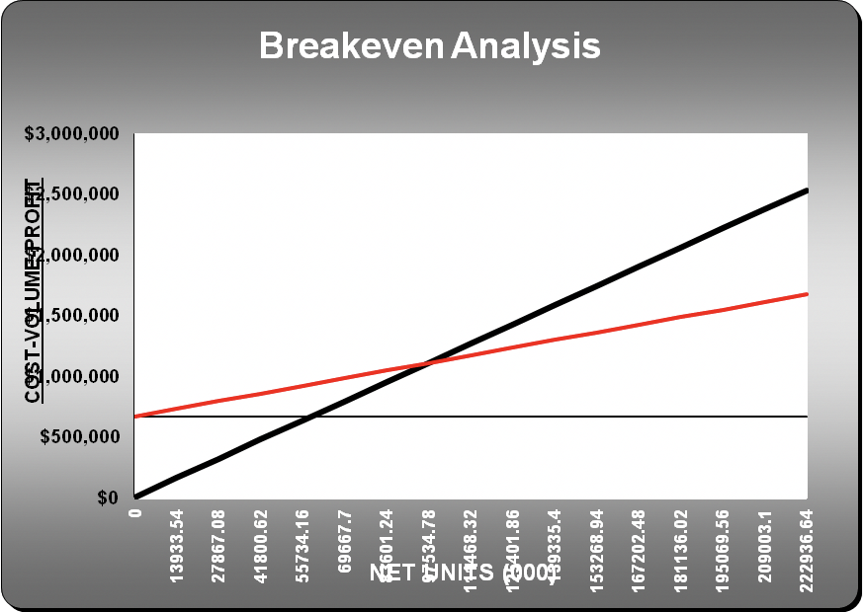

Projected Profit and Loss
The profit and loss demonstrates modest increases in revenues over the three expected years with adjustments for inflation.
(table)

Projected-cash flow
The statement of cash flow shows the incoming and outgoing cash of the business.
(table)

