The Optimisation of a Shower Through Systems Engineering Principles
11/12/2022
Charlotte Knight (1907828)
2022
Contents
Table of Figures 1
Abstract 2
Introduction 2
Context Diagram 3
Requirements analysis 5
Operational requirements 5
Functional requirements 5
Non-functional requirements 5
Quality Function Deployment 6
Function Means Analysis 7
Potential failure modes 8
Critical design features 9
The manufacturing processes 11
Critical process steps 11
Process control measures 13
Conclusion 14
References 15

Table of Figures
Figure 1- The author’s current shower 2
Figure 2- The context diagram for the shower within the flat 3
Figure 3- Stakeholder influence map 3
Figure 4- List of stakeholder requirements 4
Figure 5- QFD-1 for the shower 6
Figure 6- The FMA for the shower 7
Figure 7-Pugh diagram for the proposed shower designs 8
Figure 8-FMEA for the shower filter sub-system 9
Figure 9- QFD-2 for the shower system 10
Figure 10- the sequence diagram for the shower filter sub-system 11
Figure 11-QFD-3 for the manufacture of the shower filter sub-system 12
Figure 12- P-diagram for the manufacture of the shower filter sub-system 12
Figure 13- A what why table for the manufacture of the shower filter sub-system 13
Figure 14- QFD-4 for the manufacture of the shower filter sub-system 14

Abstract
The following report intends to optimize the design, manufacture and implementation of a shower using systems engineering principles.

Introduction
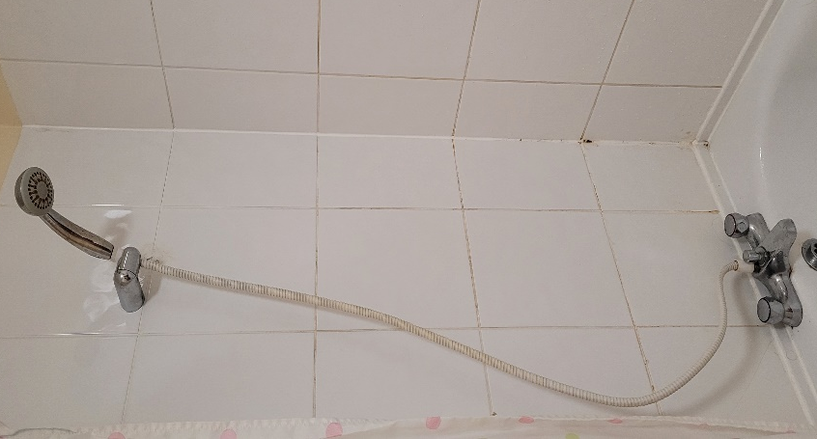
Showers are an essential part of the modern hygiene routine. From the first blast of hot water that wakes you up in the morning, to the icy refreshing shower that cools you down after a tiring workout, they are crucial in our everyday lives. Unfortunately, not all showers are created equal. The shower installed in the author’s Salisbury flat is at the bottom of that scale. As demonstrated in figure 1, a precise awareness of angular geometry is required to get both taps to achieve an acceptable water temperature. Consequently, a lengthy balancing act must ensue, to get the temperature within this goldilocks flow rate. Additionally, the shower head displays severe deposits of limescale as a result of the hard local water. This further reduces the flow rate of the water droplets leaving the shower head. This reduced flow rate in turn leads to longer showering times leading to a sub optimal end user experience. Therefore, it is vital a new system is proposed that combats these issues effectively.
Using a variety of systems engineering principles, the author aims to methodically design and manufacture a new shower system, ensuring it fulfils both their and fellow stakeholders full set of requirements.
Figure 1- The author’s current shower

Context Diagram
Firstly, a context diagram is created to outline how external entities interact with any new system. This allows potential issues such as clashes with existing systems to be identified and amended [1]. The context diagram for the shower can be seen in figure 2. As shown, it has great dependencies on the boiler and water system for the flat. Therefore any solution must bear that in mind.
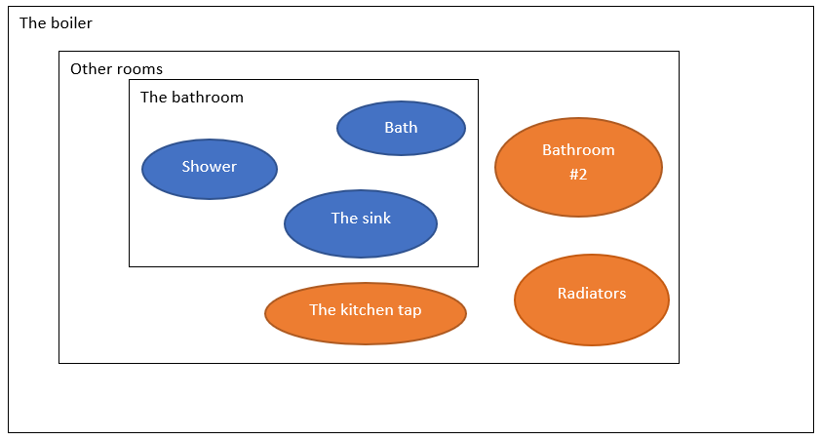
Figure 2- The context diagram for the shower within the flat

Requirements
Requirements are the basis of all development tasks within a project. To understand the system requirements, the key stakeholders must first be identified. A stakeholder map is a visual way of mapping out the influences and relationships between the stakeholders of a project. They are useful as they encourage the user to think about the range of stakeholders and ensure their views are heard if required. Additionally, they show which stakeholder has the most influence, so their requirements may be prioritized. A stakeholder influence map for the shower can be seen in figure 3.
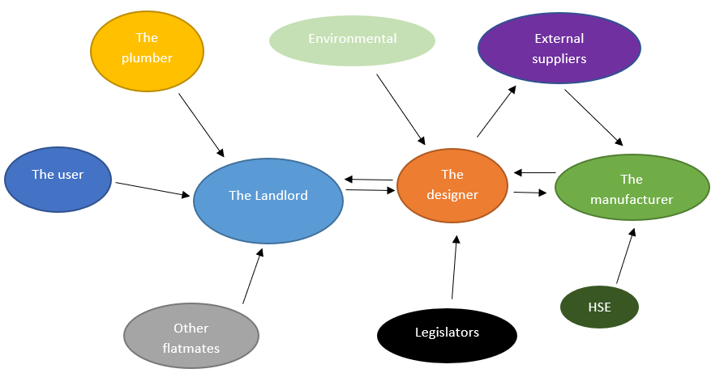
Figure 3- Stakeholder influence map

The diagram above assumes the landlord is considerate of their clients needs and is purchasing a bespoke system to suit their own unique requirements. As shown, the designers show a reliance on three key stakeholders: the landlord, manufacturer and any external suppliers, as these have either a direct or indirect effect upon them. Consequently, their requirements will be prioritised upon the product design.
Next, their needs and expectations need to be captured and organised. It is vital these requirements are as detailed and targeted as possible. The SMART (Specific Measurable Achievable Realistic and Time-related) acronym has been used throughout the shaping of these requirements to ensure the requirements themselves are attainable for this task [2]. As shown in figure 4, this has been completed through researching the showering options currently available and their relevant price points.
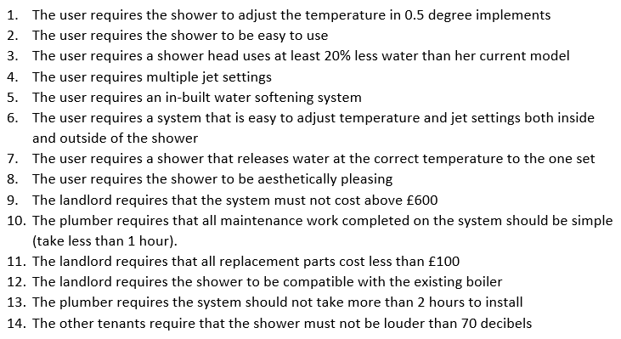

Figure 4- List of stakeholder requirements

These requirements are essential in shaping any future design work that occurs. If these requirements are not achieved, the consequences are a dissatisfied customer.

Requirements analysis
The requirements above need to be broken down further to gain a further understanding of the functionality required from the system. They can be broken into three categories:

Operational requirements
These define the main purpose of a system together with the key overarching constraints. For a shower it would be : a device capable of releasing filtered temperature controlled water upon demand.

Functional requirements
The functional requirements specify the function of the system- how a system will achieve its operational requirement. Requirement 1 from figure 4 is a good example of this. It requires a high degree of accuracy to execute, which limits the designers component choices for performing this function.

Non-functional requirements
The non-functional requirements are the constraints on the system. They do not specify what a system has to do, just how it does it. These requirements fall into three categories:
- Non-functional performance- these define how well a particular has to perform, such as requirement 3 from figure 4. This example is beneficial to the manufacturers, as it provides figures which they can test against.
- Non-functional system- these define constraints that effect the whole system. Requirement 9 impacts all stakeholders, so must be fed into both the design and manufacturing options.
- Non-functional implementation- These requirements specify how a system has to be built in terms of a specific technology, such as requirement 12. This justifiable requirement assists the designers with the fittings and fixtures the shower requires.

Once all the requirements have been realized, the next stage of the process can occur. It is essential that throughout every future stage, these requirements must be regularly considered, to ensure that every action in the design and manufacture enables their completion.

Quality Function Deployment
Quality functionality deployment (QFD) is a focussed way of capturing the requirements of the customer and mapping them against product characteristics. QFD-1 enables the products functions to be built with the customers requirements at the forefront. Each of the showers functions is ranked by importance (on a 0-9 scale) against the customers’ requirements. This is beneficial as it highlights any functions not required by the customer, as well as functions that are crucial to the product design. Additionally, it can display functions that the customer has not even considered, which demonstrates the importance of the requirements capture [3].

The initial QFD-1 can be seen for the shower in figure 5. As demonstrated, the function “pre-set the shower pressure and temperature” is significant across the majority of requirements. Consequently this function is critical to the product design and is therefore is crucial to completing the customer requirements. The water filtration is the least significant feature. Therefore, less energy can be spent in ensuring an optimum design and manufacture.

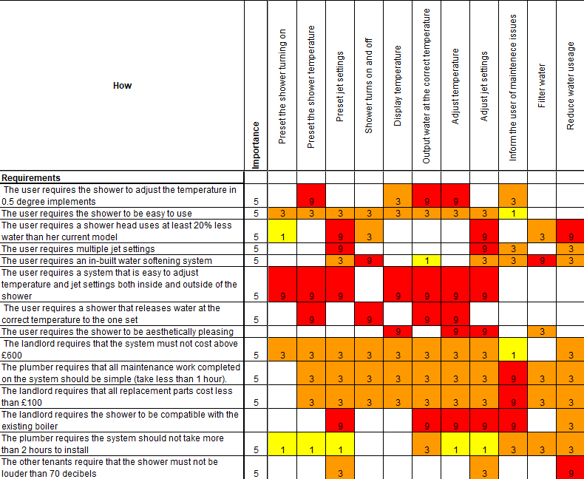
Figure 5- QFD-1 for the shower

Function Means Analysis
Function means analysis (FMA) is a tool that assists with generating, capturing, selecting and documenting system design concepts. It can be used to identify complete solutions, through producing a systematic, transparent and traceable diagram [4]. Creativity is the key, as there are always multiple solutions to solving each function. This diagram enables the user to broaden their design ideas and not necessarily go for the “status quo” in solutions.
The FMA for the shower is in figure 6. As shown, there are many similarities between the means of achieving the required functions. This is advantageous, as it means the same methodology can be used for each function, making the system itself simple in the design, manufacture, usability and maintenance.
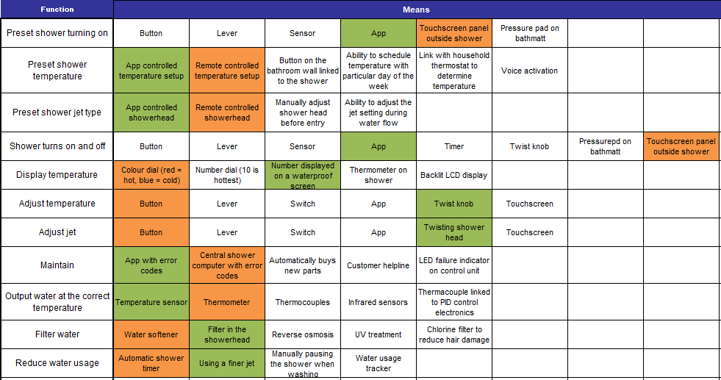
Figure 6- The FMA for the shower
After the FMA has been filled in, all the design choices must be compared against each other, and the optimal solutions found. Each control measure must be compared against a selection criteria, based upon the original customer requirements. These included: cost, ease of use, reliability, ease of installation and manufacturability. Each design choice was then ranked from 1-5 for each criteria, to allow the user to establish the optimal choice for each function.
Next, the solutions for each function are analysed as a complete working system to determine if there are any issues with the sub-system interactions. The ideal solution is shown in green, and the secondary in orange.
Pugh diagrams allow these two optimum designed solutions to be compared against the original design. They are essential in ensuring any designed options are an improvement upon the existing system, and fulfil the original design requirements. The Pugh diagram for the shower can be seen in figure 7. As demonstrated, the both proposed systems perform better than the current shower, and design 1 is the most effective.

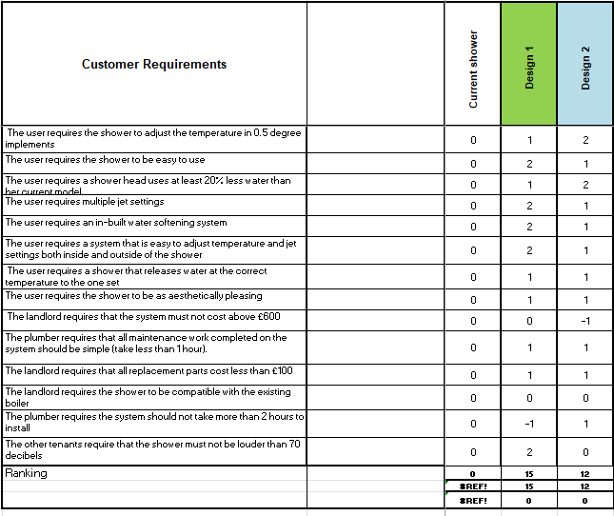
Figure 7-Pugh diagram for the proposed shower designs

Potential failure modes
Before going too far into the design of the product, the failure modes must be considered. Failure Modes and Effects Analysis (FMEA) is a systematic method for evaluating the failure modes of a process, their causes, and their effects on the rest of the system. In doing so, it identifies the parts of the process that require change [5]. They often utilise the 5 failure modes: too much function, too little function, intermittent function, no function and unintended function [6].
Figure 8 describes the failure modes of the filtration sub-system. As shown, it only displays 3 of the 5 failure modes. This is because there are no drawbacks to showering in soft water, therefore having too much function isn’t plausible. Additionally, no water is filtered when the shower is off, so there should be no unintended function.
This information should then be fed back into the FMA to ensure the optimal design options have been decided, or whether they should be amended based upon the predicted severity and occurrence of their failures. Ideally, this FMEA diagram should be completed for each proposed design solution within the FMA, as it highlights any flaws early on, however it can become repetitive and time intensive. By completing it for the chosen design solutions it ensures risk management is built into the component design. The process controls for these failure modes will be fed into the manufacturing processes later on.

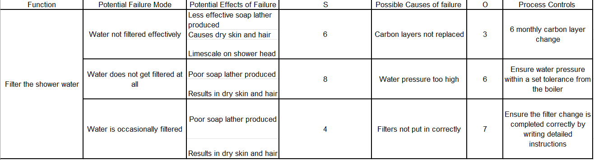
Unfortunately, by looking at each function individually within FMEA, it is difficult to understand any knock on effect a function failure has on a different function. To combat this, other systems engineers use connection circles to see a systems cause and effects through the relationships between functions. This technique involves placing the design solutions around a circle, and drawing arrows across it to symbolise their relationships. Through this, it can identify any feedback loops that arise. In failure analysis, it can also allow the designer to assume the “worst case scenario” for faulty systems [7]. For example, the temperature displayed on the screen is affected by both the app and the temperature sensor. If the app sends an incorrect temperature, and the sensor also records an incorrect temperature then the temperature displayed may be wildly different to that inputted by the customer (e.g. far too hot). Understanding the effects of this sub-systems failure is just as significant as the individual ones.
Figure 8-FMEA for the shower filter sub-system

Critical design features
QFD-2 checks the chosen concept design from the Pugh diagram will meet its requirements by verifying the design concept. It outputs the critical design features required for the whole system to work effectively. Additionally, it helps define the lower-level sub-system requirements. In the example below in figure 9, the app is essential in executing a majority of the systems required functions. Consequently, the app is a critical design feature and should be prioritised in the later stages of manufacture/ software development as without it the customers requirements will not be met.
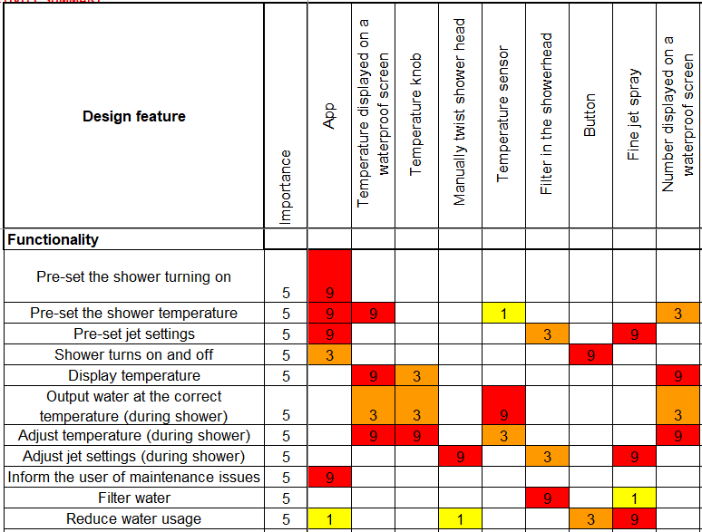
Figure 9- QFD-2 for the shower system

Next, in order to understand what design parameters are sensitive to which noise factors, a parameter (P) diagram is used. This notifies, captures and documents all parameters that have an effect on system performance. The control factors are elements that can be altered within the system, to optimize its performance. Unwanted behaviours (noise) are also considered. There are three types of noise:
•External: the system experiences external factors which reduces the likelihood of optimal performance.
•Unit to unit: natural variation between manufactured components cause system failures.
•Deterioration: usage of the system causes parts to deteriorate away from their assigned tolerances.
The noise factors are then numerically compared to the control factors. This allows the critical design features to be realised, as these are the highest ranking control factors.
Next, a what-why table is created from the noise and control factors created within the P-diagram. This allows the user to numerically assess which factors are most likely to influence the robustness of the process or design. Any issues with the intended functions are fed back into QFD-2.

The manufacturing processes
The manufacturing process for the system is complex, and thus requires repetition of the activities above. Firstly, stakeholders requirements are captured. Examples of such requirements are: having repeatable performance, a low rate of defects and a low set up cost. Once again, QFD-1 is used, to compare this with known manufacturing functions such as fitting the CPU, and putting a casing over the shower motor.
Next, manufacturing solutions must be found for each function. An FMA was completed to determine the best solutions. For example, extruding was chosen over machining to produce the basic shape due to the reduction in cost and time. An additional QFD-2 is created to determine the criticality of each solution when compared to the required functions.
Sequence diagrams put the chosen functions from QFD-2 in chronological order so the full manufacturing process can be realised. These allow the interaction between objects and processes to be understood. This allows for potential emergent behaviour to be assessed and potentially reduced further down the process [8]. The sequence diagram for the manufacture of the showerhead filter can be seen below in figure 10.

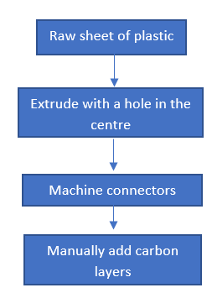
Figure 10- the sequence diagram for the shower filter sub-system

Critical process steps
QFD-3 involves choosing the product assembly process which helps the user translate solution requirements into manufacturing requirements by addressing the proposed manufacturing processes stated within QFD-2 . The operational guidelines, elements and levels of variation in manufacture must be fully defined and understood for this to be successful.

Shown in figure 11, QFD-3 utilises the critical process parameters from QFD-2, the what why table and the P-diagram from the original product design. These diagrams help identify the features sensitive to variation, and thus are critical to the overall system.

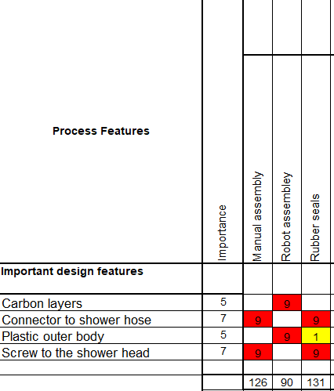
Figure 11-QFD-3 for the manufacture of the shower filter sub-system

An additional P-diagram then identifies the process parameters of the critical process steps from QFD-3. An example of this can be seen in figure 12, for the shower filter sub-system. There are a many noise factors that require addressing in the later stages of manufacture.
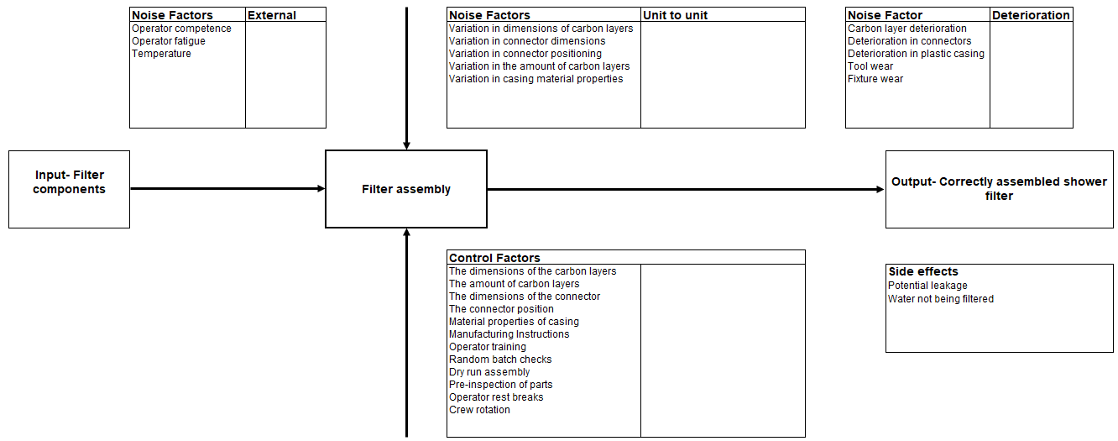
Figure 12- P-diagram for the manufacture of the shower filter sub-system

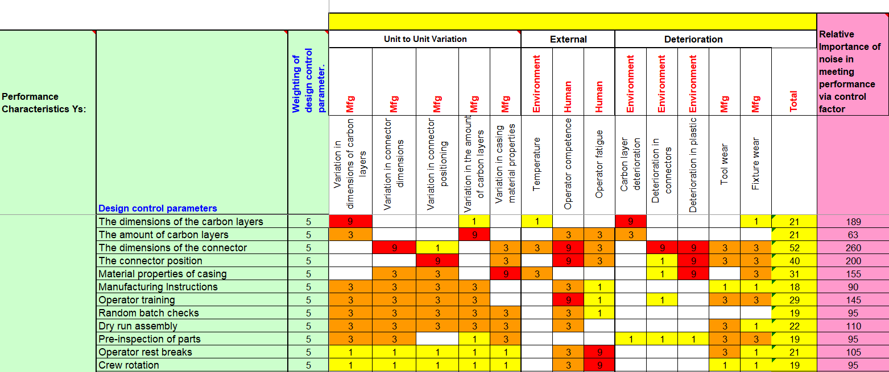
Next, a what why table is created to determine the critical process parameters. Figure 13 shows how the control parameters from the P diagram are compared against the noise factors. The dimensions of the connector are susceptible to the most amount of noise so therefore it is essential that the proposed control measures in QFD-4 reduces this to ensure a fully functioning product is created.
Figure 13- A what why table for the manufacture of the shower filter sub-system

The process parameters and targets from this are fed into QFD-4.

Process control measures
Process capability diagrams compare the variation in manufacture to the original customer requirements. They map a standard deviation curve of the process variation against the specification decided by the designer. If the degree of variation lays outside the these upper and lower limits, it is deemed uncapable. If the centre of the curve does not match the target specified by the designer, it can also be off target. Completing these curves helps the designer understand how good the process can be in both the long and short term. This can help the manufacturer foresee any upcoming issues, and then implement changes to reduce it. This could include changing the manufacturing process, relying on inspection to remove any defected products and altering the design to be less sensitive to variation. This was completed for the shower filter, and no issues were discovered.

QFD-4 plans how the manufacturing/production and quality control intend to keep the promises of QFD-3. It allows the relationships between manufacturing system process requirements and production/quality control requirements to be assessed. This ensures the end product is repeatedly within specification during manufacture. Consequently, the impact of the manufactures component selection can be compared with the original customer requirements.

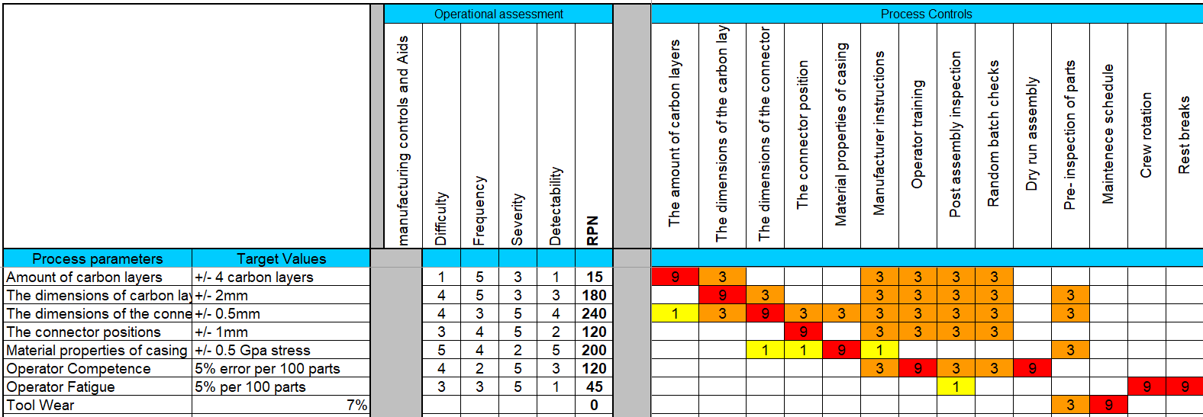
As shown in figure 14, the control measures from the P-diagram have been used. Emphasis must be placed upon operator training, manufacturer instructions and pre/post assembly checks to ensure quality products are produced.
Figure 14- QFD-4 for the manufacture of the shower filter sub-system

QFD 4 should be repeated for each critical process step to ensure there are enough process controls in place to limit the variance and errors within each step. This will create a consistently reproducible product to a high manufacturing standard.

Conclusion
The shower has successfully been upgraded into a design which matches the original stakeholder requirements. Any potential failure modes in the filtration sub-system has been left shifted through an emphasis in operator training, clear manufacturing instructions and having pre and post assembly inspections.

References

[1] | Micro, Micro, [Online]. Available: https://miro.com/blog/context-diagram/. [Accessed 9 12 2022].
[2] | G. Doran, “There's a S.M.A.R.T. way to write management's goals and objectives,” Management Review, vol. 70, no. 11, p. 35–36, 1981.
[3] | P. Guevara, “Safety Culture,” 29 11 2022. [Online]. Available: https://safetyculture.com/topics/qfd/. [Accessed 12 10 2022].
[4] | D. S. Burge, “Function Means Analysis (FMA) Alias Morphological Analysis,” in The Systems Engineering Tool Box, Warwickshire, Burge Hughes Walsh, 2006, pp. 1-13.
[5] | Institute for Healthcare Improvement, “ QI Essentials Toolkit: Failure Modes and Effects Analysis (FMEA) Tool,” Institute for Healthcare Improvement, 2017. [Online]. Available: https://www.ihi.org/resources/Pages/Tools/FailureModesandEffectsAnalysisTool.aspx#:~:text=Failure%20Modes%20and%20Effects%20Analysis%20(FMEA)%20is%20a%20systematic%2C,most%20in%20need%20of%20change. [Accessed 22 11 2022].
[6] | D. S. Burge, “A Systems Approach to Failure Modes, Mechanisms,Effects and Causes,” Systems Engineering Company, 2018.
[7] | L. Acaroglu, “Tools for Systems Thinkers: Systems Mapping,” Disruptive design, 2017.
[8] | Lucid Chart, “Lucid Chart,” [Online]. Available: https://www.lucidchart.com/pages/uml-sequence-diagram. [Accessed 10 12 2022].

