
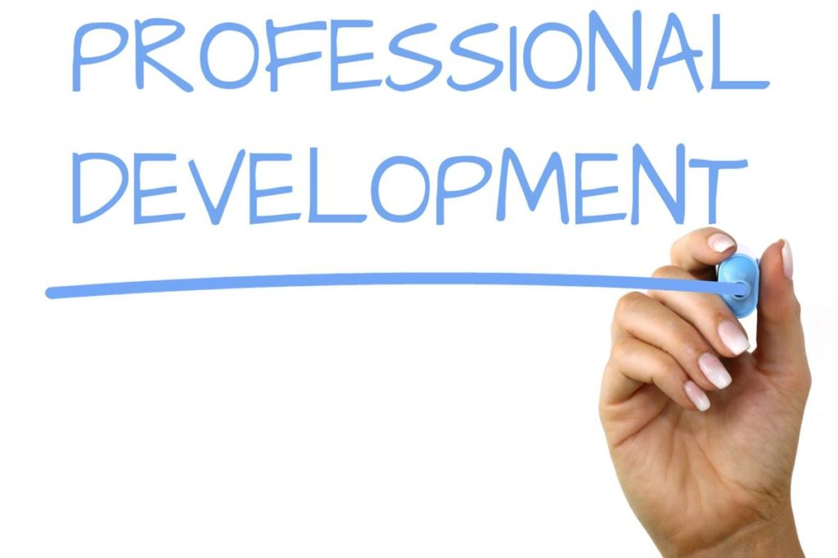
This Photo by Unknown Author is licensed under CC BY
Student Name: Diana Abreu
Lecture Name: Nishi M Ramsurrun
Module name: Developing Relationships and Workplace Achievement BMSW 5102

Table of Contents
1
1
INTRODUCTION 3
360 DEGREE FEEDBACK 4
Management by Objectives (MBO) in viagogo 6
Professional Development Plan at viagogo 9
CONCLUSION 10
RECOMENDATION 11
REFERENCE 12

INTRODUCTION | 
viagogo was created in England in 2006 by Eric Baker, a co-founder of StubHub, a ticket based in Switzerland operating around the world. Customers may buy and sell tickets for sports, music, theatre, comedy, and other events using the site operating in a worldwide online marketplace for tickets to live sporting events, musical performances, and other shows with many custoer service offices around the world such as Taiwan Irland, London, New York and Switzerland with hundreds of thousans of employees. viagogo’s aim to provide ticket purchasers the greatest possible selection of events, viagogo works with ticket sellers of all sizes to enable them connect with a worldwide audience, including individuals with a spare ticket and huge multi-national event organisers.

viagogo has worked with many of the world's major sports and entertainment businesses, allowing consumers from all around the globe to buy tickets to their favourite events in their own language, currency, and on the device of their choosing.

360 DEGREE FEEDBACK
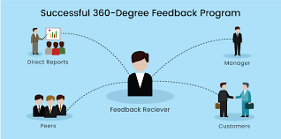
After researching about the 360 degree Feedback model, it was understood that, It is an evaluation method that collects input about a person from a variety of sources that are familiar with him or her. Generally, this would include coworkers, direct reports, and viagogo’s customers, among others. Individuals gain from using it as a training and development tool because it provides them with more accurate information about their abilities, performance, and working relationships than more typical evaluation systems that rely only on line managers' evaluations.

A self-perception survey is normally completed by the person seeking input (the appraisee), after which invites between 6 and 10 additional people (the responses) to provide comments using an identical questionnaire.

History
The German army is credited with the first recorded application of 360° feedback throughout World War II, when they started collecting input from a variety of sources in order to assess the performance of their leaders.

One of the first commercial applications of the technology happened in the 1950s at Esso Research and Engineering Company, which was based in Houston. When Jack Welch began reorganising General Electric in the 1980s, he notably introduced the phrase "streamlining."

In subsequent years, the notion of 360-degree feedback gained some traction, to such an extent that most Human Resources and quality management experts were familiar with it by the late 1990s.

But since paper-based approaches were time-consuming and costly, many professionals avoided utilising this method because it was inconvenient and time-consuming. The introduction of online solutions, on the other hand, revolutionised everything, making 360° feedback a simple, cost-effective, and time-saving process to deploy. Internet-based 360-degree feedback systems are now almost universally accepted in commercial learning and development circles, with some estimates stating that about 90 percent of Fortune 500 organisations now frequently employ them (source).

Purpose
The 360-degree feedback is designed to help each person identify their advantages and weaknesses and identify areas of professional growth that need to be addressed. The business world is rife with discussions on how to:

- Choose a feedback method and begin the process.
- appoint the judges
- Use the feedback to your advantage.
- Check out the comments.
- A bigger performance appraisal system should be used to coordinate and develop the process

Structure

In order to get 360° feedback, you need to obtain the views of a lot of individuals utilising competency-based surveys. In addition to the outcome answers, there are also open-ended questions that are meant to allow users to provide input that is not constrained by the limits of the scored questions.

For the surveys, we supply either a generic collection of managerial skills, or we may develop a customised structure to meet the client or an unique use case.

The benefits of a 360-degree evaluation at viagogo
- Enhance your understanding of the individual performance by providing a more complete picture.

- This increases the credibility of the performance evaluation.

- The comments of trusted colleagues will aid in the development of one's own abilities.

- Professionals' obligations to their consumers are increased.

- The combination of concepts may result in a more effective assessment.

- Suggestions acquired from a large number of employees are almost certain to be more compelling.

- Not only should managers evaluate the performance of their employees, but so should their subordinates and coworkers.

- Individuals who are self-deprecating are often driven by positive comments from others.

- If a greater number of employees participate in the process of performance review, the organisational culture of the firm will be more trustworthy.

The limitations of a 360-degree evaluation at viagogo
- Taking a significant amount of time and being difficult to administer

- The extension of exchanging feedback might cause problems and conflicts among a number of employees.

- In order to acquire efficient functioning, extensive training and significant effort are required.

- It will be quite difficult to predict the outcomes.

- If feedback is not handled properly and easily, it might be rendered ineffective.

- If information is not handled clearly and honestly, it has the potential to create an atmosphere of distrust.

After the information found, overall we can state that 360-degree feedback is essential to help and records all member of viagogo.

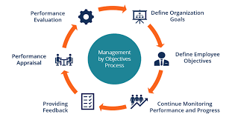
Management by Objectives (MBO) in viagogo

Learning about MBO it was stablished that is another strategic management model MBO strives to enhance viagogo effectiveness by defining clear goals that are agreed upon both by management and people. Strategic planning and action plans should be open to all employees, according to the notion, in order to foster a sense of ownership and responsibility among workers. (A. Hayes, A. Drury, P. Rathbrun, 2021)

Standard operating procedures for the MBO

Every employee in viagogo, from the lone employee to the head of department, is given specific objectives to work toward since everyone understands exactly what they are expected to accomplish and how their work fits into the bigger picture.

In order to ensure that everyone is working towards the same goal, it is crucial to have a clear set of objectives. There is also a lesson to be learned about one's own capacity to achieve in a certain length of time. During the quarterly review process, quarterly objectives might be changed if they are too simple or too difficult. Inspiring objectives should be created so that workers face a true challenge.

It advocates a maximum of one to three goals. Employees are forced to identify their most important objectives as a result of this. "Do first things first, and second things afterwards," said Peter Drucker. The MBO procedure is broken down into the following five steps:

Determine viagogo’s goals.

- Involve workers in setting and achieving goals.

- Monitoring

- Assets The results

- Incentivize good work

You should also measure your goals so that you can measure your progress, which will be critical during the review process. It's helpful to have regulations like this, but they don't have to be followed strictly. Non-quantifiable organisation goals are often at the top of the list. It's impossible to estimate the value of company culture, but it's a significant asset that should be prioritised.

In addition to MBOs, you may also be interested in OKRs (objectives and key outcomes), a comparable management framework for creating and monitoring goals.

The measuring performance procedure in the identification of faults and missteps. An open discussion regarding the company's long-term goals might also take place at this meeting (Workfront.com, 2021)

MBO is designed to concentrate on objectives and targets, MBO typically overlooks other aspects of a business such as the company structure, worker behaviour and a healthy work ethos, surroundings concerns, and opportunities for engagement and contribution to the society and collective benefit.

Is all this effort worth it? Without hesitation, the response is A study in the Journal of Applied Psychology looked at organisations before, during and after they adopted MBO. More than a 10 percent gain in efficiency was obtained by the typical organisation, according to the researchers. (Powell, 2021)

MBO Benefits at viagogo

- A result-oriented strategy like MBO, which focuses on creating and managing goals, pushes managers to plan out their work in great detail.

- There is no job ambiguity or uncertainty since both the management and the subordinates know exactly what is expected of them.

- Managers must set quantifiable goals, performance criteria, and strategies for achieving these goals. As a result, the roles and duties of each employee are clearly defined.

- It helps employees better understand the organisational objectives. Employees are usually focused on their own goals and the environment in which they operate. Staffs are happy to be a part of an MBO team since they feel that they're contributing to viagogo overall success. Their devotion and morale are boosted by this.

- When it comes to career advancement, management by objectives (MBO) frequently identifies areas where workers might benefit from further training.

- Using a system of periodic assessment, managers may keep tabs on their employees' progress. A focus on definable goals in MBO makes it easier to monitor performance and ensure that it is fair and objective.

- Allows for better communication between managers and employees.

MB0 Limitations at viagogo

- Only with the full backing of the company's senior executives can MBO be successful.

- It is possible that employees may have a negative reaction to MBO. Desired results may be set unreasonably high because they are under pressure from management to get along. There is a risk that their morale will be lowered, and they may grow distrustful of the MBO idea.

- For all they know it may be another managerial trick to have their employees working more and being more committed and invested. The MBO approach places a heavy focus on defining and measuring goals and objectives. It leaves no room for subjective aspirations. Hard to measure and much harder to assess places exist.

- There is a constant requirement to deal with, and the manager's time is already stretched thin. More discussions and reporting put the director under more pressure and stress. It's possible that some managers may object to the programme due to the obvious paperwork it requires.

- Short-term aims take precedence over long-term objectives. To plan long-term, it is impossible to precisely foresee all the elements impacting the strategic plan because of the continuously changing socio-economic and technical environment directly influences stability of objectives.

- Many managers lack social skills, such as coaching and counselling, which are essential in today's workplace.

- MBO's interaction with other programs, such as budgetary planning, is abysmal. This has a negative impact on the overall performance of all components.

Iimprovements to the MBO's Effectiveness at viagogo
The following issues impede the full potential of MBO:

- Pressure-oriented
- Constantly draining
- Documentation increases
- Making goals might be a challenge.
- Issues in the workplace

Recommendations for Enhancing MBO

- Company responsibility
- Education and preparation
- Access to sufficient resources
- Appropriate reviews within realistic time frame

If a business wants to succeed, it must have clearly defined goals. Managers and employees, however, have a significant impact on this. Individuals' goals and contributions are linked to viagogo overall goals and performance via management by objectives. To be effective, MBO initiatives must have the support and involvement of everyone in the organisation, from the top management to the lowest-level employees.

Professional Development Plan at viagogo
Development  Objectives | Priority | Activities to be Undertaken | Resources | Target Start Date | Target End Date | Criteria for Success
Customer Approach | High | Staff will have to take a quiz after training | House training  Training material  Computer  Coach | 6 Dec 2021 | 28 Feb 2022 | CS teams will have better understanding of customer approach
Time Management | High | Staff will need to provide examples of time management a quiz of some scenarios | House training  Training material  Computer  Coach | 3 Jan 2022 | 21 March 2022 | All CS Department will be able to improve time management at work
Brazilian Market | Medium | Staff need to provide feedback | House training  Training material  Computer  Coach | 3 Jan 2022 | 21 March 2022 | Customer service Brazilian team understand how Brazilian market operates and will improve customer service quality
Data Protection  Sensitive Info Handling | High | Staff will do an online quiz at the end of the training | House training  Training material  Computer  Coach | 1 Dec 2022 | 4 April 2033 | All CS department will understand the importance of data protection

CONCLUSION
A company's and an employee's success depends on regular performance evaluations. Using this methods such as 360 or 540 degree feedback or Management by Objectives, viagogo may determine whether or not an individual is a productive member of the team. It aids the worker in determining the direction in which his or her career is headed. It is an integral aspect of human resources management.

RECOMENDATION

Content marketing strategies and other online digital tools such as the effectiveness

In this section I would like to recommend or the company to conduct a performance analysis on the content marketing which is useful technique to engage with existent or potential customers.

This strategy creates knowledge, raises brand recognition, and keeps your company at the front of think about when it comes time to purchase what you offer. Content marketing does more than simply start a dialogue with your potential customers. It also maintains the discourse relevant, useful, and interesting over time. Excellent content advertising promotes the participation and interaction rather than being transient and commercial. As importantly, digital advertising does not detract from the user's engagement; rather, it is a welcome addition of it.

REFERENCE

Appraisal 360 (2020). What is 360 degree feedback and appraisal? - Appraisal 360. [online] Appraisal360. Available at: https://www.appraisal360.co.uk/about/what-is-360-degree-feedback/ [Accessed 15 Nov. 2021].
Creative, E. (2021). Does Management by Objectives Work? [online] Scontrino-Powell. Available at: https://scontrino-powell.com/blog/does-management-by-objectives-work [Accessed 15 Nov. 2021].
workfront (2021). What is MBO? Management By Objectives with Examples | Workfront. [online] www.workfront.com. Available at: https://www.workfront.com/strategic-planning/goals/mbo [Accessed 10 Nov. 2021].
Zigu (2020). 540 Degree Feedback Definition, Importance, Advantages, Example & Overview | Human Resources (HR) Dictionary. [online] MBA Skool-Study.Learn.Share. Available at: https://www.mbaskool.com/business-concepts/human-resources-hr-terms/17835-540-degree-feedback.html [Accessed 17 Nov. 2021].

