BUSINESS SUSTAINABILITY
NIKE Inc.

Stefan Gheorghe-2024473

The Global Business Environment – LCBB 4005
Dr. Rexon Nting
University of Wales Trinity Saint David
07.05.2021

Table of Contents
1. Introduction 3
2. Labour Exploitation and Environmental Sustainability 3
3. Nike Inc. Response 4
4. Benefits of Change and Recommendations 8
5. Conclusion 9
6. References 10
7. Appendix 11

Business Sustainability Nike Inc.

1. Introduction
Founded in 1964 by Bill Bowerman and Phil Knight under the name of Blue-Ribbon Sports, Nike Inc. has become a multinational company that designs, manufactures, and sells high quality footwear, apparel, and sports equipment. The company headquarter is in Beaverton, Oregon and since its foundation it has extended its office locations to 43 countries, with products being manufactured in over 486 factories, in 39 countries (Appendix 1). It has the biggest global market share in the sports footwear segment with 27.4%, well ahead of its main rival Adidas AG and other fashion competitors. In 2020, the first two competitors of Nike Inc., had reported approximatively 29.8 billion of dollars in revenue, with 107.500 employees, while Nike Inc. had 37.4 billion of dollars, with 75.400 employees (Craft.co, 2021). From this we can see that the company has a strong market position, and its business strategies are working effectively.
The business growth of Nike Inc. though has been criticised in the past for its unethical practices in terms of labour exploitation and environmental sustainability. We will try to explain these problems that the company faced, and analyse the changes taken to self-regulate. We will also explain if these changes have provided some form of competitive advantage and provide some relevant recommendations.

2. Labour Exploitation and Environmental Sustainability
Nike Inc. has been accused of unethical practices since 1970, for using sweatshops to produce its goods, while offering poor working conditions and low wages in undeveloped countries. In 1991, the activist Jeff Ballinger published a report that detailed the labour exploitation that was happening in Indonesia based factories, which led to an aggressive and sustained campaign against the company policies (Sankey, 2018). Nike Inc. has failed to provide a proper response and a decade later there were still reports of underpaid workers and poor working conditions. This was possible because the company, who wanted to make greater profits, took advantage of their factories that were build in less developed countries to exploit workers due to the poor regulations in the labour markets there. This problem and the lack of proper response had affected the brands image and sales, as some stakeholders became outraged by the ignorance the company proved.
Another problem that the company faced was the increased environmental sustainability awareness. The fashion industry is the second most polluting industry, after the oil and gas. It accounts for 10% of global carbon emissions and 25% of the world chemical usage (Imran, 2017). This has been possible due to the overproduction of fashion goods as well as the unsustainable use of its raw materials. As one of the largest fashion industry company, Nike Inc. plays a significant role in shaping the climate change controversy. And with the latest trend of fast fashion, the problem with this industry negative effects on the environment have increased. Nike Inc. value chain is comprised of nine stages (Appendix 2) and its footprint is one of the polluting factors that affect the environment, so the company has taken measures to minimize the footprint effects (Nike Inc., 2021).

3. Nike Inc. Response
The response of Nike Inc. to the growing concerns regarding the environmental sustainability and labour exploitation came in the form of an Impact Report, a Code of Conduct and a Code of Leadership Standards that resumes everything the company does to self-regulate. They address certain areas of impact and propose targets and indicate measures taken by the company. In figure 1 below, we can see a summary of the expectations that each supplier facility is required to meet.
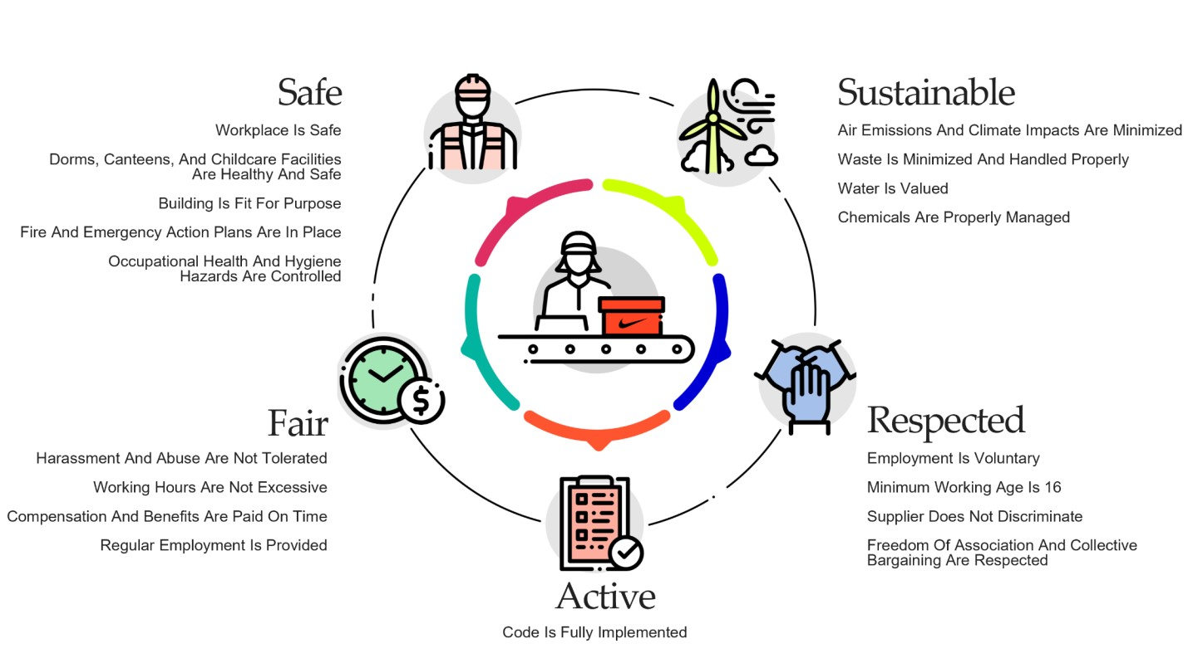
Fig.1 Source: (Nike Inc., 2021)
In 2012 Nike Inc. has launched a Sourcing and Manufacturing Sustainability Index (SMSI), that rates factories from gold to red and reflects the sustainability performance by combining ratings for lean manufacturing, labour and health, safety, and environment. At the end of 2020, 94.4% of Nike Inc. 518 contract factories were rated bronze or better based on the SMSI (Appendix 3).
The company has taken some measures to reduce its impact on the environment starting with the materials used in the manufacturing of its products and continuing with the supply chain. The materials used before were accounted for more than 70% of any product footprint. By introducing Nike Flyknit, in 2012, the company consumed on average 60% less water than in traditional footwear, and it uses six to seven recycled plastic bottles. Since 2008, all Nike Air are composed of at least 50% recycled manufacturing waste and as of 2020, all Nike Air Manufacturing Innovation facilities in North America are powered by 100% renewable wind energy. The company also recycles polyester which is made from plastic bottles and turned into a high-quality yarn. Each year they divert an average of one billion plastic bottles from landfills and waterways. As of 2020, the cotton used in the product line is 100% organic, recycled, or outsourced under the Better Cotton Initiative (Nike Inc., 2021). There are still improvements to be made in Nike Inc. operations as they have not met some targets in 2020, from their baseline set in 2015, regarding the energy use or carbon emissions per unit, as showed in figure 2 below.
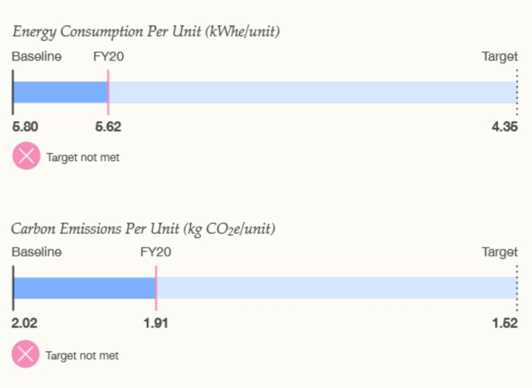
Fig.2 Source: (Nike Inc., 2021)
When we talk about Nike Inc. supply chain, the key principles behind it are outsourcing, to save costs, diversification, to minimize risk, and corporate social responsibility, to manage its impact on the environment where it operates. The company has set targets, for the next five years, to maintain or reduce the carbon footprint of its supply chain by switching to renewable energy, alternative fuels or by efficiently using its energy. With the business growth expected over the next years, so are the investments required to reduce the impact on the environment.
Water is a valued asset and Nike Inc. has adopted several strategies to reduce its use by innovative low-water materials and technologies, by scaling through industry collaboration, or by efficiently use and re-use it. They have developed an internal Water Minimum Program that encouraged material vendors to adopt wastewater recycling and to create water balances for every site with the scope of monitoring where and how much water is being used. The freshwater use per kg in 2020 has been lower that anticipated, as we can see in figure 3, and lower than all the past years (Appendix 4).
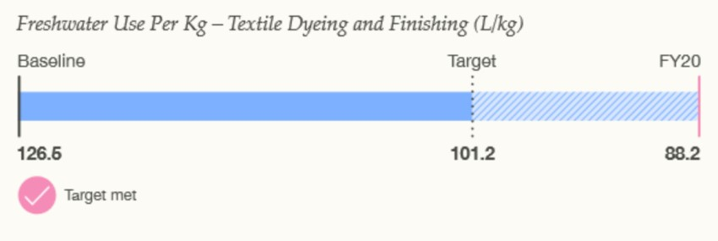
Fig.3 Source: (Nike Inc., 2021)
Regarding the labour exploitation, Nike Inc. has put in place a Code of Leadership Standards, by which they ensure that each supplier facility meets a minimum standard to the work regulations of the country and the expectations of the Nike Inc. The code ensures the supplier provides a safe working place and takes necessary actions to limit the risk of accidents. Training is given to the personal for the operation of machinery, with safety procedures being in place on each machine. The Code of Leadership Standards also prohibits forced, bonded, or indentured labour. It has some specific requirements that addresses some risk factors of forced labour, like prohibiting workers to pay fees for employment, terms and conditions explained before departure, for international workers, and proving contract in both workers language and employer language. To enforce the code and ensure its application the company conduct internal and third-party audits. To preserve the global supply chains Nike Inc. has engaged with multi stakeholder group that try to assess and convene on solutions.

4. Benefits of Change and Recommendations
With the company Move to Zero campaign, which seeks to eliminate the carbon emissions and waste to protect the future of sport and humanity, they seek to find a solution to the more pressing matter of what customers want and expects from them. All the changes that the company has adopted over the last few years have been to counter the negative image they received in the past. The environmental sustainability problems and labour exploitation have affected many fashion industry companies, and those that addressed these problems have been able to attract a better stakeholder image and reputation. Because all organisations must consider the business environment in which they operate and must interact with customers to ensure its success, the stakeholders’ opinions and perceptions are of great importance. It has become more imperative for our stakeholders that the environment and worker exploitation will not be accepted as before, and the companies will have to change the way they do business. Nike Inc. has invested time and money to change their old business model and started to think more on the sustainability of their business for future generations.
Nike Inc. build a brand image that gained the customers trust in different markets and that high level of trust has put them ahead of their competitors. They have focused on customers wants, taste and changing preferences, and through research and innovation they have been able to bring the products to the market before its competition, while adapting to the required environmental sustainability.
Innovation has always been a source of competitive advantage for Nike Inc., as customers preferences changed faster, the company had to adapt and invested more capital in Research and Development to gain more market share and grow. Through innovation the company has been able to create more sustainable materials to produce their goods and to lower their impact on the environment. In 2017, the company introduced Nike Flyleather, a new material that was made with 50% recyclable leather fibers, using 90% less water, and with an 80% lower carbon footprint. This new material was created for performance and its five times more durable and 40% lighter than normal leather (Nike Inc., 2021).
Nike Inc. was among the first companies in the fashion industry to use sustainability as a competitive driving force, and their initiatives have created a solid foundation to adapt to the climate change pressures. With the company intensifying its efforts to grow the ecommerce business so will the number of packages shipped per day increase, and that will create more waste and more delivery channels used. It would be preferable if customers realise the extent of some orders compliance and the environmental implications and would accept a wider timeframe for delivery. It would be also advised if the company would find a smaller packaging solution to their products, as some of them are too wasteful when it comes to the package size.

5. Conclusion
As a conclusion we can state that Nike Inc. has modelled itself as a company that values the most its customer needs and priorities. Unwilling to repeat past mistakes, the company has constantly found new methods and solutions to problems that will benefit the stakeholders. Through innovation and commitment, they managed to change the consumer perception about their unsustainable and unfair practices and adopted measures that impacted how they are seen in the business environment. Leadership has played an important role in creating a vision of a future company that has as priorities fairness and sustainable practices.

6. References
Craft.co, 2021. Nike Profile. [Online]
Available at: https://craft.co/nike/competitors
[Accessed 06 05 2021].
Imran, A., 2017. Susteinability Transformation. [Online]
Available at: https://digital.hbs.edu/platform-rctom/submission/nike-is-it-the-sustainability-transformation-of-the-decade/
[Accessed 06 05 2021].
Nike Inc., 2020. Manufacturing Map. [Online]
Available at: http://manufacturingmap.nikeinc.com/
[Accessed 06 05 2021].
Nike Inc., 2021. Code of Conduct. [Online]
Available at: https://purpose.nike.com/code-of-conduct
[Accessed 06 05 2021].
Nike Inc., 2021. Impact Report. [Online]
Available at: https://purpose.nike.com/fy20-nike-impact-report
[Accessed 06 05 2021].
Nike Inc., 2021. Nike Flyleather. [Online]
Available at: https://www.nike.com/gb/flyleather
[Accessed 07 05 2021].
Nike Inc., 2021. Sustainable Materials and Innovation. [Online]
Available at: https://www.nike.com/gb/sustainability/materials
[Accessed 06 05 2021].
Nike Inc., 2021. Value Chain Stages. [Online]
Available at: https://purpose.nike.com/value-chain-stages
[Accessed 06 05 2021].
Sankey, A., 2018. Glass Clothing. [Online]
Available at: https://glassclothing.com/a-history-of-nikes-changing-attitude-to-sweatshops/
[Accessed 06 05 2021].

7. Appendix
Appendix 1
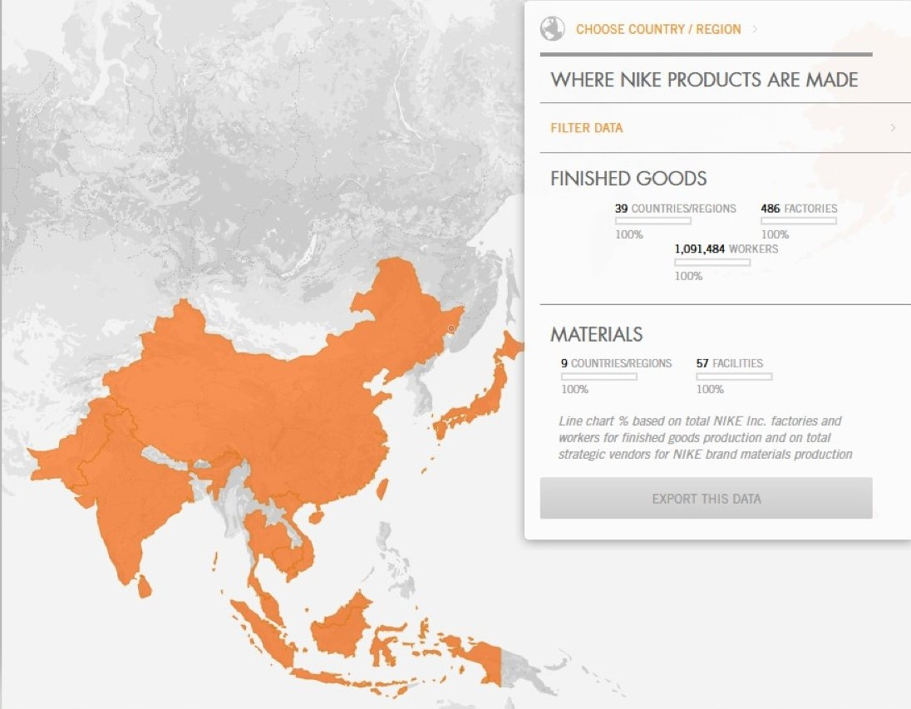
Source: (Nike Inc., 2020)

Appendix 2
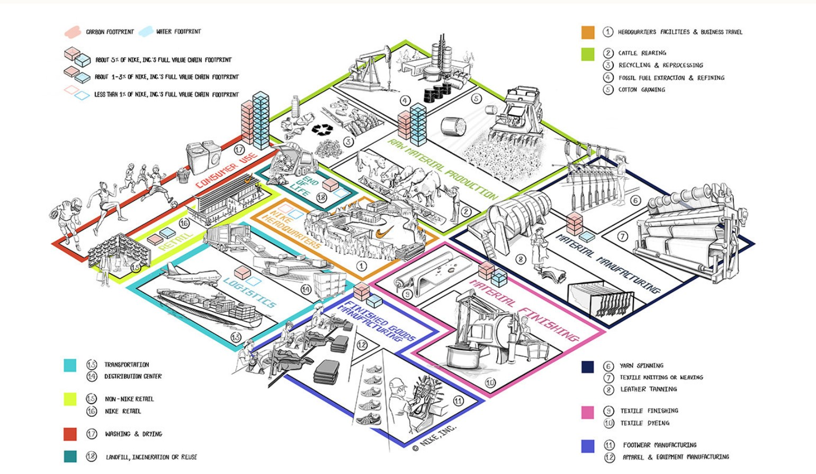
Source: (Nike Inc., 2021)
Appendix 3
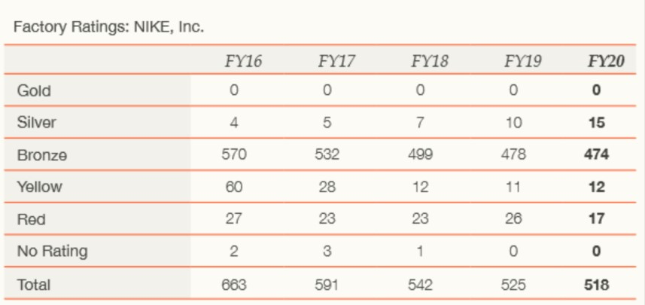
Source: (Nike Inc., 2021)
Appendix 4
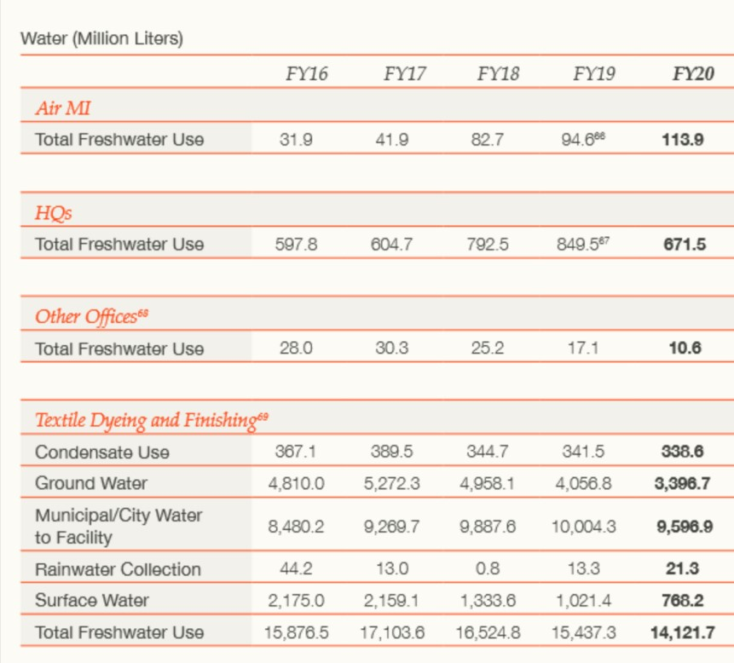
Source: (Nike Inc., 2021)

