Ways of Perceiving, Curation
Essay
‘Fast Fashion’

Student Name: Lauren Gooch
Student Number: 1900686
Word Count: 1502
Character Count: 8547
BA Product Design Student – Julia Lockheart

Fast Fashion Essay – Lauren Gooch

My plan is to create an exhibition where fashion designers that both impact the world of fashion positively and negatively will gather on the New York fashion stage during New York fashion week to observe a mass bonfire of clothes that the designers have produced which have led to the fast fashion issue increasing. This reflecting Socrates’ teachings on how philosophy should achieve practical results for the greater wellbeing within society. I feel as though using a stage in such a high profile event will help the point come across clearly and produce practical results for society as we know it.
Fig.1 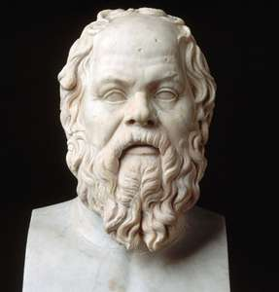
One of the biggest statement places within New York fashion week is Spring studios, 50 Varick street, this is the current venue for NYFW this year and would have the most impact upon the designers I choose to gather. This would be where the live exhibition would take place, the bonfire is symbolic of the unused clothes that reach landfills every year that get wasted and remain unused by anyone. However, the bonfire would include the newer designs from the most and least popular designers again worldwide. During New York fashion week would be the best time to set this event at, as it would be very influential to all of the people attending and it would bring positive attention to the issue we face as an industry. This would leave the designers no choice but to amend their products to working with the sustainable fashion fight instead of against it.
Fig.2 
In the past several decades, ‘97% of climate scientists agree that global warming is the result of human activities’ and one of the biggest issues that face humanity today is but global warming. However, ‘fast fashion’ is not only a contributor to this but it passes masses and masses of waste into an industry that is already in the mentality that society is now of purchasing new items instead of fixing or upcycling older fashions.
Fast fashion impacts the environment we live in today, and as a designer myself, I have decided to teach others into how we are helping the world worsen in terms of health and strength. Fast fashion as a problem contributes to up the 10% of the worldwide carbon emission, this itself is enough reason for the industry to rethink its methods. Another large issue being that fast fashion is the second biggest polluter of clean water again this being worldwide. This showing that as a world we need to make a change and make it fast. Fast fashion is a term that describes literally what its purpose is, this either being down to the manufacturing push or the customer pull. At the end of it, if the designers did not allow the customers wants to develop faster and faster then there would not be as bad of a demand for; Spring, Summer, Fall and Winter seasoned clothing that changes annually within the trends of society today. The demands of customers with fashion ‘trend’ are what needs to have a practical change to them.
Socrates stated,
‘I know you won’t believe me, but the highest form of human excellence is to question oneself or others’
This itself is the founding statement to my exhibition. This is where my idea stemmed from that we must question ourselves and others to make a community and society change that impacts our wellbeing for the better. The people that I plan to attend this bonfire will be the following designers; Oscar Perez Marcote (CEO of Zara), Karl-Johan Persson (CEO of H&M), Paul Marchand (CEO of Primark), Megan McSherry (@acteevism Tik Tok account), Jordan Nodarse (CEO of Boysih jeans), David Greenblo (CEO of BOODY) and finally my colleagues in studying design at UWTSD. These people are all required for me to enhance the new ways that society should uphold, all of these designers either are following the ways of being sustainable or fast fashion. This exhibit will take place in front of all of these people.
There will be seven signs that have seats next to each station, each station will have the name of the person or group that I have invited to the exhibition on. They will be in a circle around the bonfire on the stage inside spring studios. The reasons I have chosen each designer is for a different reason and some being positive and some being negative, some of the brands I have mentioned are big contributors to the world of fast fashion and others are fighting the battle against it.

Fig.3 
The first sign will be for Oscar Perez Marcote, him being the CEO of Zara, which is a very popular clothing store that does not actively support the fight of fast fashion in the world. The branding as a company is cheap so it encourages customers to keep purchasing more and more, this adding onto the tonnes of unused clothing that ends up in landfill every year. Even when the product ends up it landfill it makes it hard to decompose because of the fibres used in the production lines. Marcote does not follow Socrates’ teaching that to reach greater well being in society and to reach human excellence you must question yourself. This is why Marcote should attend the exhibition of the fast fashion bonfire.
Fig.4 
The next sign in the circle being the placement for Megan McSherry, McSherry takes the platform of using TikTok to both show her upcycling methods and also to promote the fight against fast fashion and how to do it. She is the youngest of all the people I plan to invite, however she follows the teaching of Socrates better than all of the designers I have invited. She combines trends of today with the fashion of yesterday and focuses on making the world a better place by looking at what she wears and creates. She as a designer has reached,’ Human Excellence’ and spreads it with her 20k followers weekly. She is teaching the adults of tomorrow how to improve the world we live in and how to fight the battle of fast fashion one step at a time.
Fig.5 
The following signs in the circle surrounding the bonfire belong to Paul Marchant the CEO of Primark and Karl-Johan Persson the CEO of H&M. Both of these designers negatively reflect the fashion industry and therefore themselves by not supporting the fight against fast fashion, they are some of the biggest contributors to the problems we face today, they create products with lifespans that is getting close to non-existent, because the quality of the products reflect them as being not meant to last. They also use social media in a negative way, unlike McSherry as they use it to promote their new fashion trends. They again do not clearly support the teachings of Socrates and they remain unable to reach, ‘Human Excellence’ as they do not criticise what they have done wrong.
Fig.6 
The next signs are in place for both David Greenblo the CEO of BOODY and Jordan Nodarse the CEO of Boyish Jeans. Both of these companies use sustainable materials which start the fight against fast fashion. They are also both eco ethical companies that respect the eco guidelines put in place, adding on to that they would be accepted into Socrates’ guiding principle of achieve practical results for the well-being of society. They both have the goal of becoming a zero waste company which is a huge inspiration to other companies.
Fig.7 
The final sign in the circle would be for the designers of tomorrow, these being my fellow students at UWTSD, they will have a chance to view a symbolic bonfire for the destruction that fast fashion is doing to our world. This is to open up the minds of the students and to teach them of Socrates’ teaching of teaching ‘human excellence,’ you must question yourself first. This is really important as we as designers are designing tomorrow’s future and therefore the impact we have on the world.
Fig.8 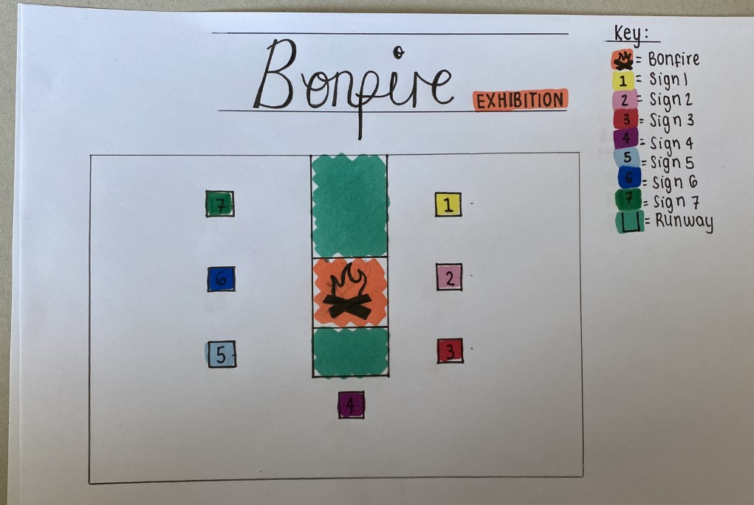
I hope that instead of just following the mainstream in society, these designers will start to see the World from mine and many other peoples points of view and it will also remind the designers of tomorrow that instead of following fashion trends of season we should avoid them, and ship second hand where possible and if not possible support ethical brands that promote a world of sustainable fashion. However there is a possibility that I would not be helping as I would be burning or wasting clothes of new trends trying to explain my point for the designers, I would be contributing to the waste of clothing adding up yearly. Yet again, I choose to make this statement to the designers in the room and plan to shock them with the facts behind fast fashion and what it is doing to our world as we know it. Bit by but we can all follower Socrates’ guiding principle of ‘ achieving practical results for the greater well being of society.’

Figures:
Fig. One : https://cdn.britannica.com/s:300x300/69/75569-004-3B260631.jpg
Fig. Two : https://fashionista.com/.image/t_share/MTUyNzQxMTQ0NTU4NTc3MTkw/spring-bfa_8474_1000361.jpg
Fig. Three : https://upload.wikimedia.org/wikipedia/commons/thumb/f/fd/Zara_Logo.svg/1280px-Zara_Logo.svg.png
Fig. Four : https://upload.wikimedia.org/wikipedia/id/thumb/1/1c/Tiktok_logo.svg/1200px-Tiktok_logo.svg.png
Fig. Five : https://orange.handelsblatt.com/wp-content/uploads/2018/03/primark-hm-1-760x428.jpg
Fig. Six : https://thegreenhubonline.com/wp-content/uploads/2019/04/Boody-logo-300x300.jpg
Fig. Seven : https://www.designinsiderlive.com/wp-content/uploads/2014/02/Image-1.jpg
Fig. Eight : Exhibition key and plan

Bibliography:
https://www.invaluable.com/blog/famous-philosophers/ ‘philosophy should achieve practical results for the greater wellbeing within society’
Megan McSherry (2020) ‘97% of climate scientists agree that global warming is the result of human activities’
‘fast fashion’
Socrates, (399 BC), ‘I know you won’t believe me, but the highest form of human excellence is to question oneself or others’
Socrates, (399 BC), ‘Human Excellence’
Socrates, (399 BC), ‘achieving practical results for the greater wellbeing of society.’

