An Analysis of the Various Approaches Towards Islamic Dress-Codes in UK Context.
This essay will analyse the various approaches towards Islamic dress codes in the UK context, it will also illustrate these different approaches. 68% of all Muslims in the UK are Asian, Deobandi Islam is the largest and most dominate branch of Islam within UK context. Some Deobandi scholars, but not all, regard the face veil as obligatory. The Niqab is popular among some Deobandi Muslims. The niqab is a piece of clothing that covers the face just leaving the eyes exposed. The hijab is a head covering of head scarf which is considered modest and Islamic. There are no official guidelines for wearing the hijab and other religious dress in school. The National Union of Teachers decided to publish their own guidelines with the intention of working towards equality in school, when a pupil was unlawfully excluded for wearing a jilbab to school. The jilbab is a long and loose-fitting coat or outer garment. This essay will analyse dress codes within the NHS which has a Bare Below the Elbows policy. Finally, this essay will analyse modern Muslim fashion looking at how young Muslim women blend high street fashion with South Asian fashion.
The earliest Muslim communities in the UK were in the eighteenth century, when men from the Indian Sub-Continent were recruited to work for the Merchant Navy. The first mosque to be built in the UK was in 1889 in Woking. It was not until the late 1950’s that the first mass migration of Muslim men entered the UK to join the manual labour force. In the 1960’s and 1970’s these Muslim men were joined by their wives and children. There is approximately 3.4 million Muslims living in private households in the UK. The areas of the UK with the highest proportion of Muslims are Birmingham, Blackburn, Bradford, London, Luton and Slough. According to the Muslim Council of Britain, in the UK in 2011, 68% of all Muslims are Asian, this includes Muslim that are of Asian British decent which include (Indian, Pakistani and Bangladeshi).
Deobandi Islam is the largest and most dominant branch of Islam in the UK. It originated in the nineteenth century in Colonial India. They have a conservative interpretation of Islamic Law; they follow the Hanafi School of Islamic teaching and 44% of British mosques follow the Deobandi teachings. Some Deobandi Scholars regard the wearing of the face veil a religious obligation. A Deobandi run girls’ school in Leicester named ‘The Jameah Girls’ Academy insist that all pupils aged eleven and above are to wear the niqab when they are travelling too and from school. Mufti Muhammad Ibn Adam a conservative Deobandi scholar advices woman on his website that it is necessary for them to wear a veil and cover their faces unless the wearer feels this would cause physical or verbal abuse to herself when in a crowded area. He also encourages women to remain within home unless there is a need for them to be outside. Also, in most circumstances’ woman must not travel more then 48 miles if they are not accompanied by a male relative. Some Deobandi scholars believe that because women are under no obligation to pray in a congregation, 40% of the Deobandi mosques within the UK do not allow women in them. Not all Muslims with a Deobandi connection follow the guidelines 100%.
Veiling was practised in Mesopotamian cultures long before Islam. High status and married women wore them to distinguish themselves from slaves and prostitutes, it became a sign of a respectable women.
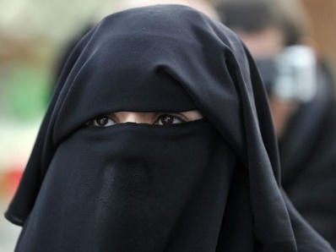
The Niqab
The niqab is a piece of clothing that covers the face leaving only the wearers eyes exposed, it is worn alongside a headscarf.
Fig 1
Shaykh Haitham Al-Haddad an imam from a mosque and Islamic school in West London gave a lecture on the niqab at a Sisters’ Event at the Brady Centre in Whitechapel in May 2007. He argued that all Scholars agree that the niqab is highly recommended or compulsory and all Muslim women should cover their faces in front of non-family members. He believed that in Britain, Muslims were struggling to preserve their identity. He stated that if more people wore the niqab in public then the public would get use to seeing it and would be more likely to accept it as normal practice. The Imams lecture on the niqab inspired Muslim women and they were encouraged to advice others to follow the practice. In 2006, Jack Straw who was a Labour MP and cabinet minister published a story in a leading newspaper where he stated that he had difficulty communicating with women who wore the niqab. He felt that the niqab promoted separation and difference and that it made the possibility of inter-community relations more difficult because facial expressions were important for communication. The Muslim community were outraged and felt that Jack Straws comments were insensitive. The demand and sales for the niqab was said to have rapidly increased in the days following the incident. The niqab appeals to some women as it gives them a feeling of security, they feel protected from western society.
The Hijab
Fig 2
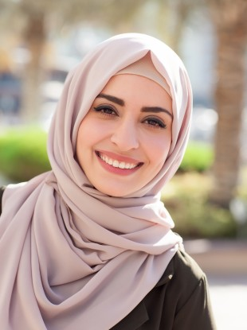
The hijab is a head covering or headscarf, which is a style of dress considered to be modest and Islamic. After September 11th, 2001, the bombing of the twin towers in America, the wearing of the hijab increased and became a sign of religious identity and Muslim solidarity. When Muslim women are asked why they wear the hijab their response is they are complying with a qur’anic injunction. In the Qur’an it states:
“Tell believing men to lower their eyes and guard their private parts: that is purer for them. God is aware of everything they do. And tell believing women that they should lower their eyes, guard their private parts, and not display their charms beyond what [it is acceptable] to reveal, they should drape their coverings over their necklines.” (The Qur’an: 24:30-31).
For many the hijab is just a piece of cloth, but for many Muslim women when adopting the hijab, they transition from being Muslim to becoming visibly Muslim. Women may wear the hijab for different reasons, they may wear it for religious reasons, or they may feel by covering up they are changing how men see and behave towards them. Instead of being a sexual object for men to gaze at, the men become more respectful of them, they see them foremost as a Muslim and not as a potential sexual conquest. Covering up the body goes against mainstream British Culture. British non-Muslims may show anger towards hijab wearers as they feel the wearer is betraying the struggle foe women’s rights, as the non-Muslim can feel that hijab wearers are a ‘sign’ of oppression. Wearing the hijab can often be seen as taking a stand against western culture which places an emphasis on physical beauty. If someone is wealthy, thin and beautiful they are more likely to be accepted by society. Wearing the hijab can make women feel more at ease as they are no longer in competition with other women regarding, the way they look.
Islamic Dress Codes Within Education.
Fig 3
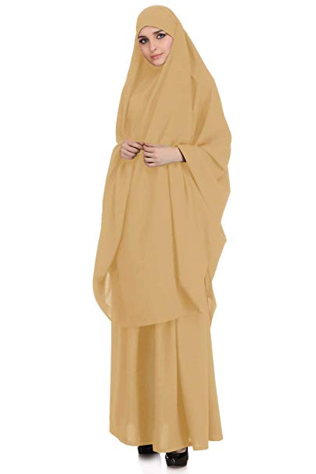
There are no official national guidelines on the wearing of the hijab and other religious dress in school. The National Union of Teachers decides after widespread consultation that they would publish their own guidelines. The NUT states that they are working towards equality in schools and their guidelines should be considered when interpreting the right to religious freedom within schools and schools developing their own school uniform policy.
In March 2005 a Luton High School was found by Court of Appeal to have unlawfully excluded a pupil for wearing a jilbab. Previously the pupil had worn a shalwar kameez, which is tunic and trousers to school. Yet the pupil felt that only piece of clothing that conformed to her faith was the jilbab. The jilbab is a long and loose- fitting coat or outer garment. The Luton High School argued that it had a right to impose a reasonable and balanced school uniform policy. The school stated that school their school uniform policy was agreed on after numerous consultations with Department of Education, pupils, parents and Muslim Organisations. 79% of the pupils at the Luton High School were Muslim and the school said it maintained the ban on the jilbab because they felt other Muslim girls would feel pressured within the Muslim community to start wearing the Jilbab. The Court of Appeal decided that the school should have taken into consideration that the student had a right to manifest her religious beliefs.
There is no legislation in Britain for school uniforms. The Department for Education and Skills states that it is the responsibility of the schools governing bodies to decide their own uniform policy and it is the job of the headteacher to ensure the pupils follow it. School governors are obligated under the Sex Discrimination Act 1975, the Race Relations Act 1976 and the Human Rights Act 1998, when deciding on a school uniform policy to make sure that they are considering the needs of all pupils regarding cultural, racial and religious groups. The DFES advised that there are four main principles to consider when drawing up a school uniform policy, Avoid making assumptions on how Muslims should express their modesty, allow individual choice to be expressed within a broad dress code framework, avoid allowing different interpretations of modesty of dress between different sets of parents, consider carefully how best to avoid overriding the beliefs of some Muslims while allowing other Muslims to have different dress codes of their choice.
Research has suggested that Muslim girls and women have experienced problems with physical education lessons regarding dress codes, mixed-sex groupings, privacy and modesty. The British P.E kit requirements for shorts and tee-shirts, short skirts, public changing rooms and showering in public are not acceptable to Islamic requirements. It is custom for Muslim pupils to be sex-segregated after reaching puberty which in many state secondary schools is not possible. Swimming lessons are also an issue because of mixed-sex public swimming baths. Much has improved and most PE departments allow girls to wear tracksuit bottoms instead of shorts and skirts, and showering has become optional instead of it been compulsory. It was noted that there was a lack of awareness with teachers on the Muslim girls needs, more teachers need to be knowledgeable on the issues surrounding Islam and Muslims.
Dress Codes Within the National Health Service.
Fig 4
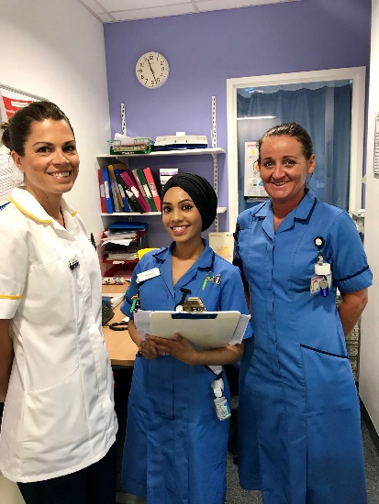
Muslim women are torn between their religious beliefs and the NHS dress code policies when pursuing a career in surgery. The NHS also have a Bare Below the Elbows policy which negatively impacts on Islamic modesty dress codes. The Bare Below the Elbow policy was authorised in February 2018 by the Infection Prevention Committee. It is a supplementary policy for hand hygiene1.0. Infections can be transmitted directly through hands and indirectly through environmental sources. The policy states that evidence indicates hands are a contributing factor in the control and spread of infection in healthcare. It states all staff have a responsibility to comply with the policy and any member of staff not complying with the policy, would be reported to the Governance Department and closely monitored through accountability meetings and reported to the Infection Prevention Committee. The requirements of the BBE policy are short clean nails- no nail polish or nail extensions, no wrist watches are to be worn, no jewellery is allowed to be worn around the wrists and no rings with stones are allowed to be worn, only one plain ring/band is permitted. Sleeves must be short and if long sleeves are worn, they must be rolled securely up to the elbow. Recommendations are that Muslims and other faith groups should be able to wear full length sleeves when they are not engaged in direct patient care activity.
A research survey was distributed to participants at a conference aimed at Muslim women in healthcare. The survey hoped to collect data on the experiences of wearing the headscarf in operating theatres. The criteria to take part in the study was they had to be a Muslim women and work in the NHS as a medical health professional. 93% of the participants wore a headscarf outside of work and 94.1% agreed that wearing the headscarf was important to them and for their religious beliefs. 20% of the participants reported that they had to remove their headscarf completely and exchange it for a theatre cap. These participants felt that their religious requirements were not been met. Only 57.6% felt accepted when wearing a headscarf in theatre, 23.4% felt embarrassed and 37.1% felt anxious when wearing a headscarf in theatre. The participants were shown an image of a disposable headscarf that could be worn in theatre and 98.7% stated that they would wear it if it was made available. Recent research has shown that in the past twenty years very little progress has been made with regards to discrimination against black, Asian and ethnic staff in the NHS.
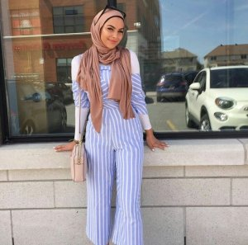
Modern Fashion
Fig 5
In Britain much of the Muslim population is South Asian, South Asian fashion and high street fashions are often blended, where Muslims choose to shop depends on their age, occupation and their income. Muslim women can often be found shopping for clothes in Topshop, Primark and H&M. Young Muslim women are now choosing their own clothes as in the early 2000s older siblings or relatives would choose their clothing for them. Layering is a good way to stay modest and still be fashionable.
Muslim model Mariah Idrissi was the first Muslim woman to feature in a fashion campaign for H&M wearing a hijab in 2015. The campaign that she did for H&M was broadcast all over the world and was viewed over 50 million people online. In one day, she went from 20 followers to 20,000 on Instagram. When some people see Mariah, they can assume that she is oppressed with the wearing of a hijab, but she feels completely free. Mariah was born in London to a Moroccan dad and her mum was from Pakistan. From the age of four to sixteen she attended an Islamic school on Sundays. She did GCSE in Islamic studies and went to college to study art, which is when she started to properly wear the hijab. Mariah has since travelled the world modelling for magazines and designers, such as Vogue and Gucci. Mariah says she loves coming back to Britain because:
“we have one of the most accepting societies in the world, maybe that is why we were the first to have a hijab wearing model on a mainstream brand.” Some Muslim women can be seen as being frumpy, but you can still be Muslim, Trendy and Fashionable Mariah hope s to inspire people from ethnically diverse backgrounds to join the fashion industry.
Modest Fashion search on google produces nearly 149 million results. Pinterest UK reports that searches for the term Modest Fashion are up by 500% since 2019 began. The State of the Global Islamic Economy predicts that the market for Modern Fashion could be worth more than 226 billion by 2020. The term Modest Fashion can be interpreted in many ways however the clothing can include tops, trousers, jackets and dresses that feature a modest cut this can also include hijabs and burqas. Modest Fashion has risen in popularity due to the need for more Fashionable clothing options, specifically in the case of young religious women. Muslims have a growing number of designer’s and social media stars due to the gap that they have spotted in the market and they have set up online stores.
Conclusion.
This essay has analysed the various approaches towards Islamic dress codes in the UK. The niqab is highly recommended by the Imam Shaykh Haitham Al-Haddad as he feels British Muslims are struggling to preserve their identity. Niqab wearing Muslim women are encouraged to advice other Muslim women to take up the practice. The women feel secure and protected from western society when they wear the niqab.
The hijab can be worn for different reasons although many Muslim women wear it for religious reasons. It can be worn to show that the wearer is taking a stand against western culture which can put too much emphasis on physical beauty.
There are no official guidelines on the wearing of the hijab and other religious dress in schools. The DFES states that it is up to the governing bodies in all schools to decide their own uniform policy. The NHS BBE policy negatively impacts on Islamic modesty dress codes. Many Muslims felt that their religious requirements were not been met in regard to the removal of the headscarf in surgical theatres. Some women felt embarrassed and others felt anxious when wearing a hijab in theatre. 98.7% of the participants in the survey stated that would wear a disposable headscarf in theatre if they were made available.
The interest in modern fashion has risen dramatically as there is a gap in the market for more fashionable clothes options, especially for young religious women. The market for modern fashion could be worth more than 226 billion by 2020.
Bibliography.
, The Qur'an, trans. by A new translation by M.A.S. Abdel Haleem (Oxford: Oxford University Press, 2004).
Bowen Innes, Medina in Birmingham, Najaf in Brent: Inside British Islam (London: Hurst & Company, 2014), p.11-34.

Dagkas Symeon: benn Tansin, 'Young Muslim women's experiences of Islam and physical education in Greece and Britain: a comparative study', Sport, Education and Society, 11.1, (2006), 1-31.

Griffiths Ben, Modest Model: British Muslim model Mariah Idrissi on owning 100 hijabs, changing the fashion industry and inspiring others (2019) <https://www.thesun.co.uk/fabulous/9978164/muslim-model-mariah-idrissi-hijab/> [accessed 19 December 2019].
Guindi Fadwa El, Zuhur sherifa , Hijab (2019) <http://www.oxfordislamicstudies.com.ezproxy.uwtsd.ac.uk/article/opr/t236/e0306?_hi=1&_pos=4> [accessed 18 December 2019].
Independent, what is Modest Fashion and Why is It Becoming Mainstream? (2019) <https://www.independent.co.uk/life-style/fashion/modest-fashion-asos-hijab-range-design-islam-religion-a8875636.html> [accessed 19 December 2019].

Lewis Philip, Islamic Britain: Religion, Politics and Identity among British Muslims (London: I.B. Tauris, 2002), p.11.

Lewis Reina, Muslim Fashion: Contemporary style cultures (London: Duke University Press, 2015).

Malik A, ''I decided not to go into surgery due to dress code': s cross-sectional study within the UK investigating experiences of female Muslim medical health professionals on bare below the elbows (BBE) policy and wearing headscarves (hijabs) in theatre', BMJ Open, 19.3, (2019), 1-10.
National Union of Teachers, The Muslim Faith and School Uniform: wearing the Hijab and other Islamic Dress in Schools ([n.p.]: National Union of Teachers, 2006), p. 1-12.

NHS Tameside and Glossop Integrated Care, 'Bare Below the Elbow': Supplementary Policy for Hand Hygiene 2.1 (2019) <tamesidehospital.nhs.uk/documents/BareBelowtheElbowsupplementpolicy.pdf> [accessed 19 December 2019].
Office for National Statistics, Religion in England and Wales 2011 () <https://www.ons.gov.uk/peoplepopulationandcommunity/culturalidentity/religion/articles/religioninenglandandwales2011/2012-12-11> [accessed 14 December 2019].
Tarlo Emma, Visibly Muslim: Fashion, Politics, Faith (Oxford: Berg, 2010), p.141-143.
The Muslim Council of Britain, Muslims are highly ethnically diverse and not one ethnic 'block' (2019) <https://mcb.org.uk/wp-content/uploads/2016/05/BMINBriefing9_May16.pdf> [accessed 14 December 2019].

Zebiri Kate, British Muslim Converts: Choosing Alternative Lives (Oxford: Oneworld Publications,2008), p.20.
Fig 1: Frank Perry, Niqab (2019) <https://nationalpost.com/news/canada/court-to-decide-if-muslim-woman-can-wear-niqab-on-the-stand-in-assault-case> [accessed 18 December 2019].
Fig 2: Shutterstock/Taraskin, Gardai not reviewing uniform policy about Hijabs (2019) <https://www.thejournal.ie/gardai-hijab-turban-2947661-Aug2016/> [accessed 18 December 2019].
Fig 3: Amazon, Jilbab (2019) <https://www.amazon.com/MyBatua-Jilbab-Breathable-Batwing-Sleeves/dp/B07H3431T8> [accessed 19 December 2019].
Fig 4: Twitter, NhsUniform (2019) <https://twitter.com/wxmatron/status/1014817847539896320> [accessed 19 December 2019].
Fig 5: fashionbytouma, Humour & Style (2019) <https://www.humourandstyle.com/modern-hijab-fashion-for-stylish-muslim-ladies/> [accessed 19 December 2019].

Philip Lewis, Islamic Britain: Religion, Politics and Identity among British Muslims (London: I.B. Tauris, 2002), p.11.
Kate Zebiri, British Muslim Converts: Choosing Alternative Lives (Oxford: Oneworld Publications,2008), p.20.
Office for National Statistics, Religion in England and Wales 2011 () <https://www.ons.gov.uk/peoplepopulationandcommunity/culturalidentity/religion/articles/religioninenglandandwales2011/2012-12-11> [accessed 14 December 2019].
The Muslim Council of Britain, Muslims are highly ethnically diverse and not one ethnic 'block' (2019) <https://mcb.org.uk/wp-content/uploads/2016/05/BMINBriefing9_May16.pdf> [accessed 14 December 2019].
Innes Bowen, Medina in Birmingham, Najaf in Brent: Inside British Islam (London: Hurst & Company, 2014), p.11-34.
Fadwa El Guindi, Sherifa Zuhur, Hijab (2019) <http://www.oxfordislamicstudies.com.ezproxy.uwtsd.ac.uk/article/opr/t236/e0306?_hi=1&_pos=4> [accessed 18 December 2019].
Emma Tarlo, Visibly Muslim: Fashion, Politics, Faith (Oxford: Berg, 2010), p.141-143.
Emma Tarlo, Visibly Muslim: Fashion, Politics, Faith (Oxford: Berg, 2010), p.144.
Emma Tarlo, Visibly Muslim: Fashion, Politics, Faith (Oxford: Berg, 2010), p.75.
Kate Zebiri, British Muslim Converts: Choosing Alternative Lives (Oxford: Oneworld Publications, 2008), p.204-211.
National Union of Teachers, The Muslim Faith and School Uniform: wearing the Hijab and other Islamic Dress in Schools ([n.p.]: National Union of Teachers, 2006), p. 1-12.
National Union of Teachers, The Muslim Faith and School Uniform: wearing the Hijab and other Islamic Dress in Schools ([n.p.]: National Union of Teachers, 2006), p. 1-12.
National Union of Teachers, The Muslim Faith and School Uniform: wearing the Hijab and other Islamic Dress in Schools ([n.p.]: National Union of Teachers, 2006), p.1-12.
Symeon Dagkas: Tansin Benn, 'Young Muslim women's experiences of Islam and physical education in Greece and Britain: a comparative study', Sport, Education and Society, 11.1, (2006), 1-31.
NHS Tameside and Glossop Integrated Care, 'Bare Below the Elbow': Supplementary Policy for Hand Hygiene 2.1 (2019) <tamesidehospital.nhs.uk/documents/BareBelowtheElbowsupplementpolicy.pdf> [accessed 19 December 2019].
A Malik , ''I decided not to go into surgery due to dress code': s cross-sectional study within the UK investigating experiences of female Muslim medical health professionals on bare below the elbows (BBE) policy and wearing headscarves (hijabs) in theatre', BMJ Open, 19.3, (2019), 1-10.
Reina Lewis, Muslim Fashion: Contemporary style cultures (London: Duke University Press, 2015).
Ben Griffiths, Modest Model: British Muslim model Mariah Idrissi on owning 100 hijabs, changing the fashion industry and inspiring others (2019) <https://www.thesun.co.uk/fabulous/9978164/muslim-model-mariah-idrissi-hijab/> [accessed 19 December 2019].
Independent, what is Modest Fashion and Why is It Becoming Mainstream? (2019) <https://www.independent.co.uk/life-style/fashion/modest-fashion-asos-hijab-range-design-islam-religion-a8875636.html> [accessed 19 December 2019].

