Living with Care: The Older Person
mODULE CODe: BMHP6009
Assessment 2: debate & supporting paper
Enkeleda Tafa (2020203)
lECTURER NAME: Laila surani

Supporting Paper

Table of contents:
1. Introduction
2. Standpoint of the debate - Statistics on the ageing UK population
3. Other views on the debate
4. Reflection of the main points discussed during the debate
5. Impact of Population ageing on the Healthcare system and the impact of the Covid-19 pandemic on the older person and relevant services
6. Current government support or services in place to support the UK elderly population
7. Conclusion
8. References

Introduction

Due to its effects on the UK's health and social care system, the problem of population ageing has received a lot of focus recently. My group position in the group discussion was that the health and social care system faces significant challenges as a result of the ageing population. This essay will examine my point of view, the opposing viewpoints raised during the discussion, data on the ageing UK population, how population ageing affects the healthcare system, current government assistance programmes or services for the UK's elderly, the effects of the Covid-19 pandemic on the elderly and pertinent services, and more.

Standpoint of the debate - Statistics on the ageing UK population
Rebuttal:

We continue to comply with what we have stated:
“Population Ageing Pose Challenges for Health and Social Care System.”

In the course of our group debate, I put forward the point that the UK's health and social care system faces serious problems as a result of population ageing. In the UK, the number of individuals 65 and older has been rising, and this pattern is expected to continue in the years to come. In the UK, one in six individuals - one in four by 2050 (Catherine Thompson, 2015) - are 65 or older. The UK's ageing population will place pressure on the health and social care systems, increasing medical diseases and the need for healthcare services like hospital stays and doctor appointments. It can be said that as the population ages, the demand for healthcare services and social care increases, while the number of people available to provide these services may decrease (The Guardian, 2023). This creates a strain on the healthcare workforce and on the funding available for these services.

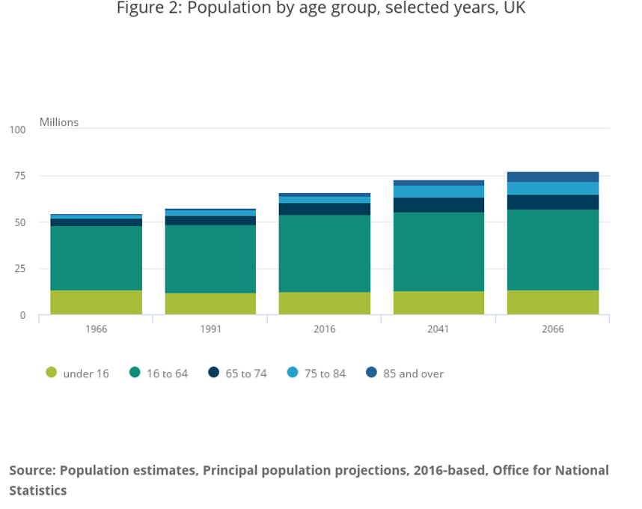

Other views on the debate

However, diverse groups in the discussion expressed the opinion that the UK's health and social care system is not significantly threatened by the ageing of the population. They contended that improvements in science and medicine would lessen the negative effects of an elderly populace on the healthcare system. With the retirement age increasing in many countries – Retiring age in the UK: 66 years old- the opposing groups also thought that elderly people would keep working, which would relieve some of the strain on the healthcare system and will contribute to the economy.
While it is true that some elderly people might wish to spend more time at work, it is equally critical to understand that not everyone can. There might not be enough acceptable employment possibilities available for elderly people who want to stay in the workforce if they have health problems or disabilities that prevent them from working. As a result, while working longer hours may assist the economy and reduce some of the pressure on the healthcare system, it may not be an option for all elderly people.

Reflection of the main points discussed during the debate

The debate placed significant understanding on the challenges that the UK's healthcare system faces as its population ages. The number of older individuals is growing, according to data on the ageing UK population, which will place a strain on the healthcare system. An increase in medical conditions, a rise in the need for healthcare services, and a lack of healthcare employees are some effects of population ageing on the healthcare system. To guarantee that the health and social care system can satisfy the requirements of the ageing population, these issues must be resolved.
Although other groups had different opinions, our points of view stand out within the presentations. The debate was strong and straightforward; however, some areas should have been presented differently and supported by more convincing evidence.

Impact of Population ageing on the Healthcare System and the Impact of the Covid-19 pandemic on the older person and relevant services

Healthcare systems have to adapt so that they provide proper care and assistance as the elderly population rises. Increased use of technology, integrated care models, and an emphasis on chronic illness management are all necessary for this shift to happen. Healthcare systems also need to handle the growing need for long-term care services, a lack of qualified workers, and rising healthcare expenditures. If these issues are not resolved, healthcare access and quality might be limited. Moreover, the outbreak of Covid-19 has significantly affected older people and pertinent services. Older individuals are more susceptible to the virus, and many have been forced to separate themselves or shelter others, which can cause loneliness and social isolation. Hospitals and care facilities have become the virus's hotspots, putting a major pressure on health and social care systems. The lack of healthcare workers has worsened because of several staff members contracting Covid-19 or being forced to isolate after exposure.

Current government support or services in place to support the UK elderly population

The UK government has put in place a number of programmes to help the ageing population. The NHS Long Term Plan is one of these programs, which seeks to expand financing for health and social care services and enhance patient access (NHS, 2019). The plan also outlines improvements to the care provided to those with dementia and other chronic diseases. The government has also put in place a number of programmes to help persons who have been affected by the Covid-19 outbreak, including financial aid and the distribution of vaccines.
The ageing population of the UK is also supported by several government supports and initiatives additional to the NHS Long Term Plan. For instance, under the State Pension system, the government offers financial assistance to persons who are retired or have attained the state pension age. For people who have disabilities or need further financial support, there are also additional benefits available. The Social Care Act of 2012, issued by the government, establishes the foundation for social care services offered to elderly people as well as people with disabilities.

Conclusion

In conclusion, as we observed in our group debate and as we stand for, population ageing presents significant challenges for the UK's health and social care system. The healthcare system must adapt in order to give adequate care and support to the ageing population due to an increase in medical diseases, an increase in the need for healthcare services, and a shortage of healthcare workers. In addition, the Covid-19 epidemic has increased healthcare costs and contributed to a rise in elderly people's social isolation and loneliness. The NHS Long Term Plan and Covid-19 alleviation projects are only two of the ageing population assistance initiatives the UK government has currently put in place.

References

Catherine Thompson (2015). NHS England» Meeting the challenges of an ageing population. [online] England.nhs.uk. Available at: https://www.england.nhs.uk/blog/catherine-thompson/.
NHS (2019). NHS Long Term Plan. [online] NHS Long Term Plan. Available at: https://www.longtermplan.nhs.uk.

“Living Longer - Office for National Statistics.” Ons.gov.uk, 13 Aug. 2018.Availeble at: www.ons.gov.uk/peoplepopulationandcommunity/birthsdeathsandmarriages/ageing/articles/livi 2018-08-13. Accessed 10 Mar. 2023

Partington, Richard, and Richard Partington Economics correspondent. “Healthcare Staff Shortage Main Factor in Near-Record Job Vacancies.” The Guardian, 13 Feb. 2023,www.theguardian.com/business/2023/feb/13/healthcare-staff-shortages-fuelling-near-record-job-vacancies-across-uk-economy#:~:text=Job%20vacancies%20in%20the%20UK. Accessed 12 Mar. 2023

University of Bolton. (n.d.). How Does the Ageing Population Affect Social Care. [online] Available at: https://www.bolton.ac.uk/blogs/how-does-the-ageing-population-affect-social-care/.

World Health Organization (2010). Ageing: Global population. [online] www.who.int. Available at: https://www.who.int/news-room/questions-and-answers/item/population-ageing. Accessed 13 Mar. 2023

WHO. WHO European Health for All Database, January 2009 edition. Copenhagen, WHO Regional Office for Europe, 2015
State Pension. (n.d.). Available at: https://www.ageuk.org.uk/globalassets/age-uk/documents/information-guides/ageukig53_state_pension_inf.pdf.

Sury, L., Burns, K. and Brodaty, H. (2013). Moving in adjustment of people living with dementia going into a nursing home and their families. International Psychogeriatrics, [online] 25(6), pp.867–876. Available at: https://www.cambridge.org/core/journals/international-psychogeriatrics/article/moving-in-adjustment-of-people-living-with-dementia-going-into-a-nursing-home-and-their-families/1EBA7D1F02FCDE56959E5A96B9AF3D23.
‌

