Advanced Stress Analysis & FEA
Module Code: M6X00420

November 2019
Nia Rossiter (P151615)
Ortho Clinical Diagnostics

Table of Contents
1. What is Non-Destructive Testing? 3
3. Three Examples of NDT Techniques. 4
3.1. Visual Inspection (Abbreviation - VI) 5
3.2. Ultrasonic Testing (UST) 8
3.3. Infrared Thermography (IRT) 11
4. Effects of each NDT method on stress analysis. 14
5. Conclusion. 16
6. References 17

What is Non-Destructive Testing?
Non-Destructive Testing (NDT) is used amongst varying industries such as aerospace, oil and gas, nuclear, medical, rail and many more. Testing a product is a critical representative of the quality control and ultimately health and safety (TWI, 2019). The American Society for Testing and Material (ASTM) defines (NDT) as the following;
“NDT is the development and application of technical methods to examine materials or components in ways that do not impair the usefulness or serviceability in order to detect, locate, measure and evaluate discontinuities, defects and other imperfections; assess integrity, properties and composition; and measure geometrical characteristics.”
(American Society Material Testing (ASMT), 2019)

Unlike destructive testing methods that can damage or destroy the object being tested, the very nature of NDT is its biggest advantage. Materials, structures and components can be evaluated quickly and accurately without being damaged and without their future usefulness being impaired (Nexxis Press Releases, 2017). See Table 1 for the comparison of non-destructive with the alternative destructive testing methodology.
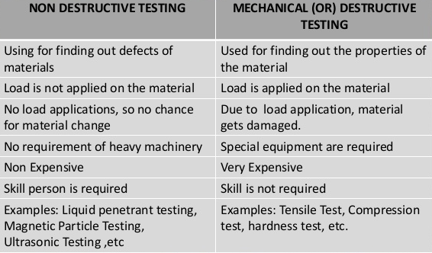
Table 1 – Comparison of Destructive and Non-Destructive Testing (Halmshaw, 1987).
NDT plays an important role in the quality control of a product. NDT is used during all the stages of manufacturing of a product. It is used to monitor the quality of raw materials which are used during manufacturing and finished product before it is released to customers (IAEA, 2012). If inappropriate NDT is applied or NDT is not applied correctly, then the results are likely to give a false impression of the integrity and safety (HSE.gov, 2019).

All NDT methods use energy to obtain information about the test object. Energy can be provided by light, heat, radiation, electromagnetism, mechanical force, acoustic waves and many more according to (Fahr, 2013). NDT testing can be categorised into two groups; conventional and non-conventional as shown in Table 2.
Conventional NDT | Non-Conventional NDT
- Visual Testing  - Penetrant Testing  - Hardness Testing  - Magnetic Particle Testing  - Vacuum Testing  - Eddy Current Testing  - Radiographic Testing  - Ultrasonic Testing  - Ultrasonic Thickness Testing | - Phased Array Ultrasonic Testing Time  - Of Flight Diffraction  - Computerised Radiography  - Positive Material Identifications  - Infrared Thermography Inspection  - Eddy Current Testing  - Magnetic Flux Leakage Pipework
Table 2 - Examples of Conventional and Non-Conventional NDT Methods (Fahr, 2013).

Three Examples of NDT Techniques.
This report will describe and analysis three different NDT techniques; Visual Inspection, Ultrasonic Testing and Infrared Thermography – see Table 3;
Visual Inspection | Ultrasonic Testing | Infrared Thermography
  Figure 1 (Alter, 2019) | 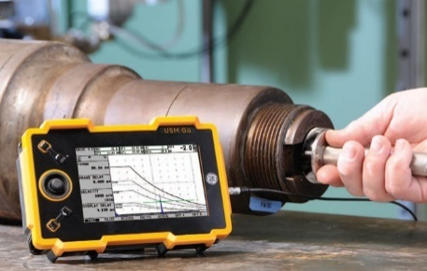  Figure 2 (Code Compliant Inspection, 2019) | 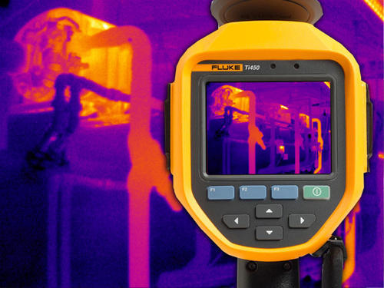  Figure 3 (Business Market, 2019)
Table 3 – Three Examples of NDT Techniques.

Visual Inspection (Abbreviation - VI)

The scientific principles behind the technique.
Often overlooked in listings of NDT methods, visual inspection (VI) is one of the most common and powerful means of non-destructive testing (IAEA, 2012). Visual and optical testing is a method of NDT used to examine items for an array of characterises and features. Often even without realising it, manufacturing industries conduct VI every day (HSE.gov, 2019).
At the simplest, visual testing typically requires a component to be inspected by an operator in adequate light with no equipment however, the inspection process can be improved by introducing optical equipment to aid the inspection (HSE.gov, 2019). Optical equipment which can aid inspection are magnifying glasses, endoscopes, computerised video systems and more (Judi, 2015).

Advantages and disadvantages of the technique.
Comparably to all other NDT techniques, VI comes with both advantages and disadvantages depending on the individual product and the level of quality required by the organisation. The evaluation has been summarised in Table 4.
Advantages | Disadvantages
Non destructive | Can detect only surface flaws
Testing is simple and effective | Eye resolution is weak
Expensive equipment is not a necessity | Eye fatigue
Fast process | Manual inspection relies on human factor
Experienced operators and/or advanced equipment make it possible for visual inspection to be very sensitive | Automated vision systems can often be very technical and require validation.
Portable inspection method
Ability to automate vision systems.
Training and experience times can be short.
Table 4 - Advantages and Disadvantages of Visual Inspection (IAEA, 2012).

    - Potential sources of error and assumptions.
Visual inspection errors typically take one of two forms; missing an existing defect or incorrectly identifying a defect that does not exist resulting in a false positive. For most inspection tasks, missed defects typically range from 20% to 30% (Dury, 2019). The most frequent and consistent observation is the imperfection of human inspectors. Imperfections attributed due to human error can be reduced through training and practice but cannot be completely removed (Khan, 2019). There are many factors that can influence the success of the test, see Figure 4.

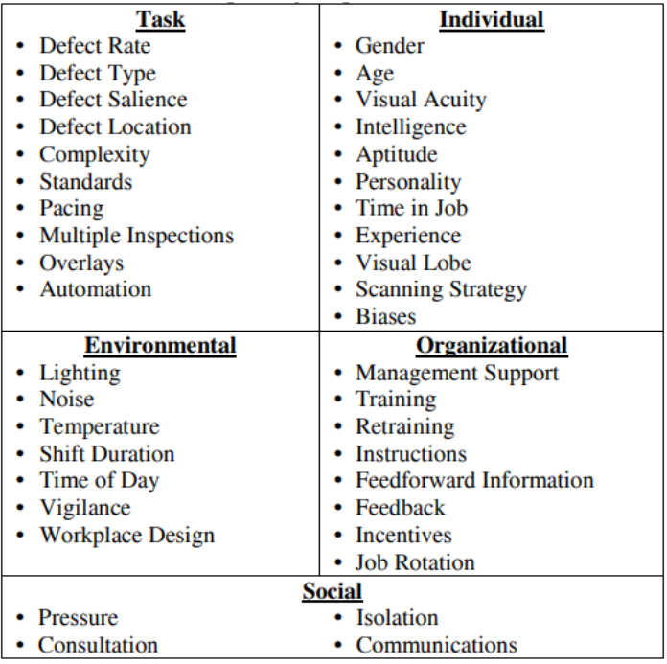
Figure 4 - Factors That Can Affect Success of Visual Inspection (Khan, 2019).

Many are sceptical that VI is an effective quality check however, an experienced operator working under optimum conditions can detect even the small tight cracks. Repeatability is, however, a problem (Dury, 2019). If conditions are not optimised, the same operator may miss the same crack on the same component on a repeat inspection. Therefore, optical aids are often used to give the operator the best chance of finding the fault condition as often as possible (Judi, 2015).
Moreover, differences in inspection efficiency during different work shifts result not only from the organization of work itself, but also from the psychophysical abilities of the operator (Kujawińska, 2015). Human based visual inspection errors at the end of a shift can be up to 15 per cent higher as a result of loss of operator concentration due to fatigue (Timings, 1993). It is recommended that companies consider introducing automated visual inspection process where possible to improve repeatability of inspection data.

    - Typical applications that use Visual Inspection.
VI is often referred to as the most basic, yet the most common inspection method due to the huge array of suitable applications (Anon., 2019). Visual inspection has encompassed a wide variety of products, including piston rings, acoustical tiles, aircraft components, pipelines, highway bridges, television panels, contact lenses, printed circuit board assemblies, airport baggage, pharmaceuticals, and food products (Judi, 2015).
Examples of applications which use Visual Inspection are listed in Table 5;
Application | Explanation
Dimensions | Shape, width, length, height, weight or alignment of mating parts.
Material | Incorrect colour, surface finish or unwanted foreign material.
Quality | Burrs, scratches, cracks, dents, dirt, pattern, erosion or corrosion.
Table 5 - Application Examples of VI (GE, 2012) (Gramopadhye, 1997) (Tetteh, 2008).

Figure 5 (Dury, 2019) outlines the inspection sequence that most processes will undergo to achieve a inspection result. It is the “Decide” stage which is where the sample undergoes judgement, poor judgment can result in inaccurate results.
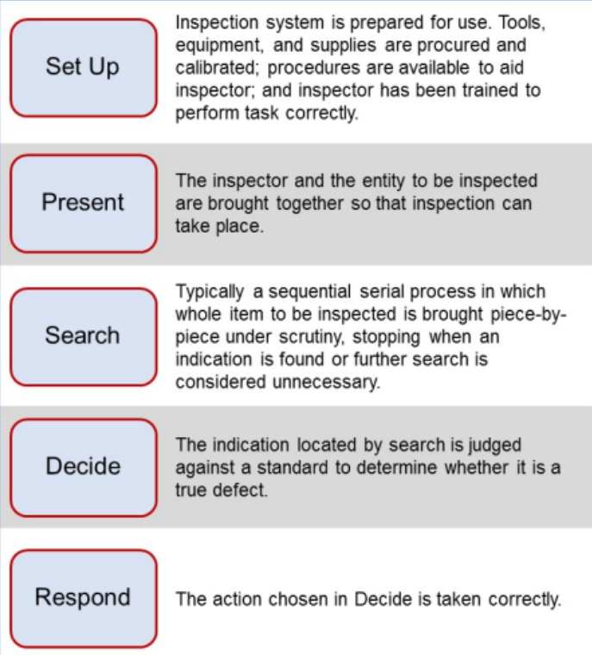
Figure 5 - Inspection Sequence (Dury, 2019)

Ultrasonic Testing (UST)

The scientific principles behind the technique.
Ultrasound is the name given to describe a pitch too high to be detected by the human ear, often at a frequency greater than 18kHz. Ultrasonic waves have a wide variety of applications over an extended range of intensity, including cutting, cleaning, and NDT (J. Blitz, 1995). The use of ultrasonic waves for NDT has enormous benefits within manufacturing, if used correctly. UST can evaluate and detect flaws by relying on the excitation, propagation and scattering of energy waves (Karl-Jörg Langenberg, 2012). The principle of UST is illustrated schematically in Figure 6.
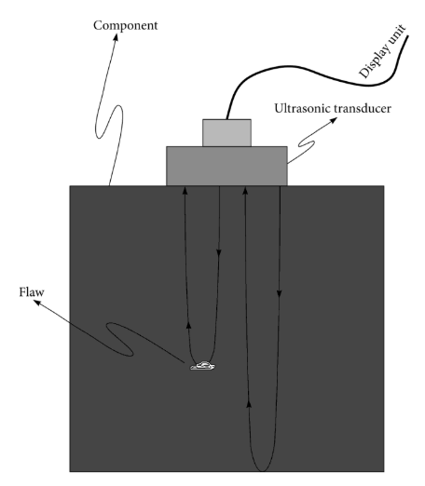
Figure 6 – Principles of Ultrasonic Testing (Md Nazoor Khan, 2017).

To further explain the process of UST, the Cambridge Press described the process of ultrasonic as;
“Sound energy propagates through a test material in the form of waves. When there is a discontinuity (such as a crack) in the wave path, part of the energy will be reflected from the flawed surface. The reflected wave signal is transformed into an electrical signal by the transducer and is displayed on a screen.”
(Principles of Engineering (Md Nazoor Khan), 2017).

Advantages and disadvantages of the technique.
Advantages
UST can accurately test for seams, voids, cracks, blow holes and many other defect modes (Code Compliant Inspection, 2019). Other advantages include real time availability of results, higher penetrating power of the waves, higher sensitivity for planar defects, independence of sensitivity over depths, low cost for inspection, higher portability of equipment and compatibility for automation (Baldev Raj, 2002). UST is a versatile NDT method which is applicable to most materials, metallic and non-metallic (Baldev Raj, 2002).
Disadvantages
Comparably, there are many factors which limit the application of UST, among the most important are sensitivity, resolution and noise discrimination (TWI, 2019). Sensitivity is the ability of the instrument to detect the small amount of energy reflected from a discontinuity. Resolution is the ability of the instrumentation to detect flaws lying close to the test surface or to separate and distinguish the indications from several defect occurring close together in the specimen. Noise discrimination is the capacity of the instrumentation for differentiating between the signals from defects and the unwanted noise of either electrical or acoustical nature (U.S. Government Printing Office, 1967). Despite the ability of the UST instruments to be very accurate, results can be subjectively doubted due to the operators training and skill is a stumbling block for its wider acceptance (Baldev Raj, 2002).
To summarise, the advantages and disadvantages are listed in Table 6;
Advantages | Disadvantages
Non destructive | Surfaces must be smooth and free of all spatter and arc strikes.
Capability to produce very accurate | Initially costly due to capital expense for equipment
Capability to produce repeatable results | Non automated process relies on human input
Real time availability of results | Timely process to set up process
Long term low inspection costs | Poor resolution can affect results negativity
Portable equipment | Noise discrimination can affect results negativity
Testing is automation compatible | Incorrect sensitivity settings can affect results negativity
Adjustment to sensitivity of equipment will alter the scanning depth | Difficulty for instrumentation to differentiate from multiple defects close together
Test can be completed on a wide range of materials | Instrumentation requires maintenance and calibration.
Table 6 - Advantages and Disadvantages of UST

Potential sources of error and assumptions.
According to the journal titled ‘Ultrasonic Non-destructive Testing’ released by the USA Government (U.S. Government Printing Office, 1967), UST will only be successfully if the following is achieved;
- Equipment suitable for the specific application
- Capable operators
- Clearly defined test problem
- Adequate reference standards
- Practical test specifications
- Realistic acceptance criteria
- Detailed test record
- Frequent inspection of the equipment
UST carries many opportunities for error and poor assumptions, however operator training, accurate equipment, and adequate test standards improve the reliability of results.

Typical applications that use this technique.
Ultrasonic testing is used across all manufacturing industries, for a range of applications however, primarily UST is chosen by the manufacturer to ensure the repeatability of high-quality product without being destructive. Examples of applications at within Table 7;
Application | Explanation
Material Thickness | Gauge material thickness at high precision even on large, complex parts.
Hardness | Ultrasonic vibrations to calculate a hardness value.
Bond Inspection | Analyse welding, brazing, soldering and adhesive bonds.
Growth Rate of Potential Defect | Capability to determine rate of growth of fatigue cracks, reduced elastic moduli, material grain size and other material properties.
Internal Flaws | Detection of internal material flaws without mechanical interventions.
Table 7 - Application Examples of UST (U.S. Government Printing Office, 1967), (Md Nazoor Khan, 2017) and (GE, 2012).

Infrared Thermography (IRT)

The scientific principles behind IRT.
Whether equipment failures are electrical or mechanical, most failures result in a significant rise in operating temperature (Business Market, 2019). Changes in temperature can help indicate deteriorating components before they fail.
Fluke (Fluke, 2019), a leading manufacturer manufacturing instrumentation, states that infrared thermography can detect heat patterns in the infrared wave-length spectrum that are not visible to the unaided eye – see figure 7 for Electromagnetic spectrum. Infrared thermography is the science of detecting infrared energy emitted from an object, converting it to apparent temperature, and displaying the result as an infrared image.
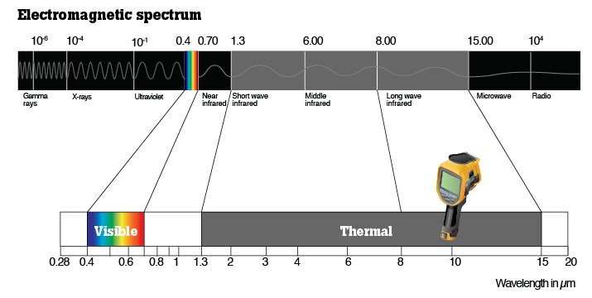
Figure 7 - Electromagnetic Spectrum Displaying Infrared Wavelengths (Fluke, 2019)

Advantages and disadvantages of IRT.
IRT is a powerful tool that can identify areas that are abnormally hot or cool. If changes in heat are detected in good time, the condition can be corrected before the area is subjected to high stress which can result in failure. There are both benefits and draw backs with using IRT for testing, to summarise, the advantages and disadvantages are listed in Table 8;
Advantages | Disadvantages
Non-Contact | Costly
Portable | Reliance on skillset of user
Wide temperature measurement range  with expensive cameras | Limited working temperature  range of the instrument
High thermal sensitivity | Emissivity of the surface can be an issue
Wide applications in the industry | Surface temperature measurements only
Immune to electromagnetic noise | Atmospheric influences / attenuations cause significant error in measurements
Table 8 - Advantages and Disadvantages of Infrared Thermography (Addepalli, 2017).

Potential sources of error and assumptions.
The accuracy of thermography measurement is associated varying parameters such as the quality of calibration of the array detector, the size of the object undergoing the scan, external temperatures and many more (Waldemar Minkina, 2009). All affecting characteristics have been listed in Figure 8.
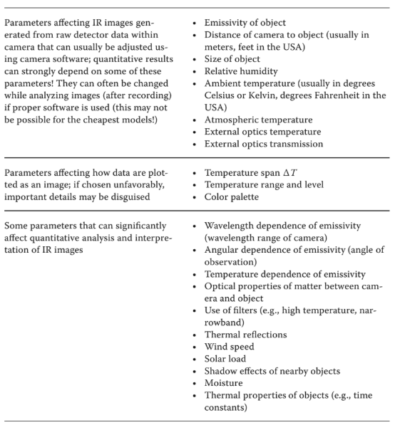
Figure 8 - Parameters and Factors Affecting Image Recording Accuracy (Michael Vollmer, 2018)

Additionally, extensive research has highlighted how important it is to achieve an accurate emissivity value otherwise the test results achieved will be inaccurate and therefore invalid. Refer to Figure 9 for more details regarding factors which affect emissivity.
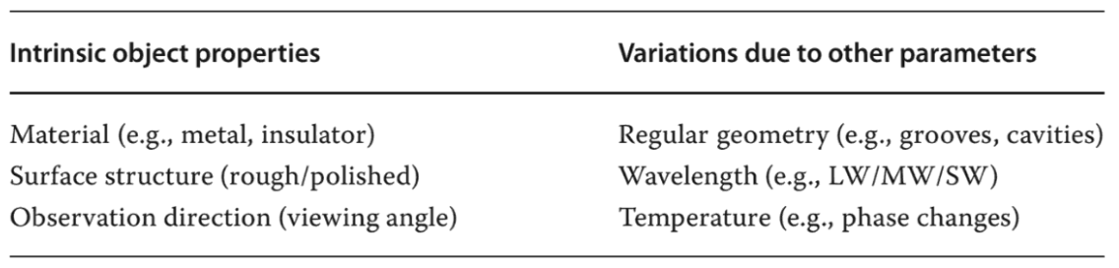
Figure 9 - Factors Which Affect Emissivity of Infrared Thermal Imaging (Michael Vollmer, 2018)

Typical applications that use IRT technique.
IRT is so widely used in industry it is impossible to list all the applications, however a few fundamental examples have been identified in Figure 10;
Example 1 –
Photo of drain valve arrangement, and photo of IRT display of hot pipes to show drain leakage.
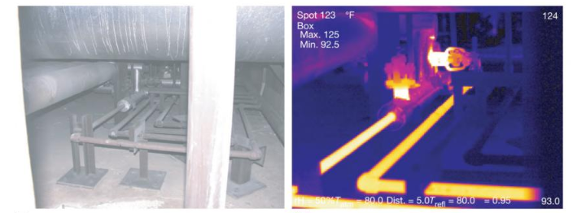
Example 2 –
The use of IRT to show liquid levels.
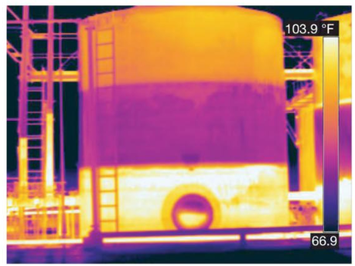
Example 3 –
Microelectronic board with a fan which maps the heat distribution.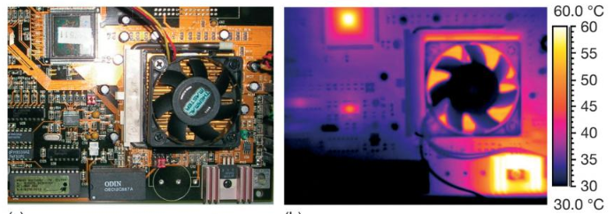
Figure 10 - Applications of Infrared Thermography (Waldemar Minkina, 2009).

Effects of each NDT method on stress analysis.
    - Explain how the results of VI NDT can be used to improve stress analysis
The majority of VI methods do not require applying any stress to the part undergoing inspection, however there are occasions where the parts that require visual inspection are in areas that cannot be seen due to blind spots. To complete inspection in such blind spots would require a destructive mechanical intervention such as a cut or even a complete cross-section (Drury, 1985). Alternatively, the introduction of an aided visual inspection device such as endoscope with a light source removes the need to put stress on the test subject to complete inspection.
Alternatively, stress analysis can be improved from visual inspection by introducing Finite Element Analysis (FEA). FEA is the simulation of any given physical phenomenon using the numerical technique called Finite Element Method (FEM) (SolidWorks, 2019). Engineers use FEA to conduct stress analysis on an electronic modelled part to replicate reality – see Figure 11 for an example of a part undergoing stress analysis. FEA provides information about the stresses on a part which cannot be seen visually alone.
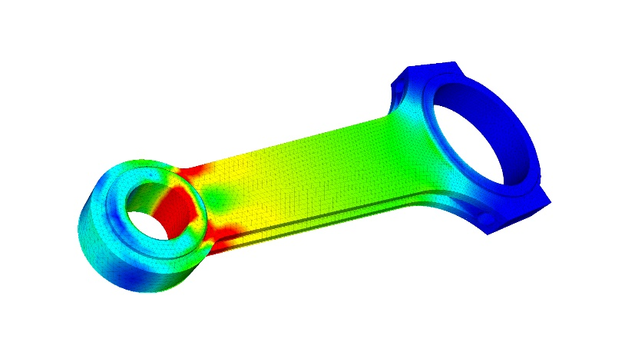
Figure 11 - FEA Example

Explain how the results of UST NDT can be used to improve stress analysis
The ultrasonic method of stress measurement is based on the acoustic elasticity effect, according to which the velocity of elastic wave propagation in solids is dependent on the mechanical stresses (O. Gushcha, V. Smilenko and V. Brodovy, 2017). The acoustic relationships are the theoretical grounds for the development of acoustic methods of stress measurement and in investigations of physical-mechanical properties of materials by means of the ultrasound. For the measurement of residual stresses in a material with known mechanical properties, the propagation velocities of the longitudinal ultrasonic wave and shear waves of orthogonal polarization are determined. The use of UST can remove the need to subject test material to high stress conditions which will weaken the part or even cause it to be scrap entirely.
Software packages like SolidWorks, AutoCAD, MATLAB and more can provide stress analysis results however, results provided off such packages are only as good as the information inputted. If the wrong information has been entered, then the results will also be wrong.

Explain how the results of IRT for NDT can be used to improve stress analysis.
With infrared thermography inspections, there is no guesswork in whether there are defects within test samples. Thermography inspections have already saved businesses billions of pounds since their advent in the 1970’s (Addepalli, 2017). Infrared Thermography has improved how stresses are analysed by using a non-destructive alternative.
Typically, problems are addressed reactively after mechanical breakdown, however by using IRT disruption to the work can be avoided by monitoring equipment conditions periodically to determine deuteriation rate, if any (Michael Vollmer, 2018). Another example where IRT is beneficial is the use of the technology to reduce fires caused by electrical failure, fires can cost the business a great deal of investment and people get injured in the process. Companies can potentially save lives and safeguard their assets by scheduling regular infrared thermography inspections (EPowerPlus, 2019).
Thermography inspection is mostly used for thin parts because when defects moved deeper under the surface of a part, they tend to produce less heat fluctuation than defects seen closer to the surface of the part. As a generally rule, defects that have a diameter smaller than their depth in the part, cannot be picked up by this type of inspection. A flaw, such as a delamination or impact damage causes a change in the thermal radiation of the area (Meyendorf et al, 2013).

Conclusion.
This report has provided a top-level overview of NDT and three techniques; visual, ultrasonic and infrared thermography. The literature search was particularly focused on these three techniques, but companies considering introducing a NDT inspection process should consider the wider options too to ensure the most appropriate option is chosen in order to establish the highest reward. Each NDT method has certain capabilities and limitations, so much so that often more than one method is required to obtain the necessary information about the test target.
Visual inspection can often be a cheap replacement for other more expensive exotic NDT methods, For example, a dye penetration test is cost effective and typically easy to perform however, it can only identify defects on the exposed surface. Alternatively, ultrasonic methods are sensitive to both internal and surface connected defects, but they are often time consuming and more difficult to perform. Furthermore, infrared thermography is easy to introduce, cost effective but unfortunately is very reliant on unpredictable environmental conditions. The choice of which NDT technique is best is dependent on many factors including inspection requirements and condition of the object as well as the capabilities and limitations of the NDT methods, access to test target, ease of application, and price dependent too.
The NDT market size has been estimated to be $4.5 billion pounds by Business Global Forecast (Reuters, 2019), and it is continuously growing due to the huge array of associated benefits – most importantly the lack of need to put stress onto a product, item of equipment or material. Ultrasonic inspection services accounted for over 30% revenue in the NDT market in 2018 (Reuters, 2019).
As a result of labour prices increasing annually as shown in Figure 12, more companies are looking at cost saving exercises to reduce overhead costs and increase profit. Figure 12 displays that if a labour-intensive inspection process can be replaced by an automated non-destructive inspection process using equipment such as vision systems, ultra-sonics or other NDT methods alongside the use of robots then there is a huge cost saving to be made; due to the reduced scrap from non-contact stress analysis and reduced labour too.

Figure 12 - Cost of Automation vs Labour for Inspection (Unit, 2012).
To further improve this report, NDT methods should be compared against Finite Element Analysis (FEA) as alternative physically conducting inspection. More work is required to explore the usage, robustness, adaptability and application of FEA techniques for Stress Analysis.

References
Addepalli, S. N. P., 2017. A critical investigation of the use of infrared thermography, Swansea: University of Wales Trinity Saint David.
Alter, 2019. Alter Technology. [Online]
Available at: https://wpo-altertechnology.com/external-visual-inspection/
American Society Material Testing (ASMT), 2019. Non-Destructive Testing Guidelines. s.l.:s.n.
Anon., 2019. Visual Inspection. [Online]
Available at: https://inspectioneering.com/tag/visual+inspection
Baldev Raj, T. J. M. T., 2002. Practical Non-destructive Testing. s.l.:Woodhead Publishing.
Business Market, 2019. Infrared Thermography. [Online]
Available at: https://www.indiamart.com/proddetail/infrared-thermography-service-16862057573.html
[Accessed November 2019].
Code Compliant Inspection, 2019. Ultrasonic Testing. [Online]
Available at: http://www.ccindt.com/ultrasonic-testing-services.php
Drury, C. G. &. F., 1985. Stress and quality control inspection. Job stress and blue collar work, p. 113–129.
Dury, S. &., 2019. The Role of Visual Inspection in the 21st Century. Visual Inspection, Volume 61, pp. 262-266.
EPowerPlus, 2019. EPower Facts About Infrared. [Online]
Available at: https://www.epowerplus.com/blog/3-Facts-About-Infrared-Thermography-Inspections_AE16.html
[Accessed November 2019].
Fahr, A., 2013. Applications of Non-destructive Testing. Pennsylvania : DEStech Publications.
Fluke, 2019. Thermography fundamentals. [Online]
Available at: https://www.fluke.com/en/learn/best-practices/measurement-basics/thermography/what-is-infrared-thermography
[Accessed November 2019].
GE, 2012. Measurement and Control. [Online].
Gramopadhye, A. K. D. C. G. a. P. P. V., 1997. Training strategies for visual inspection.. Human Factors and Ergonomics in Manufacturing, pp. 171-196..
Halmshaw, R., 1987. Non-Destructive Testing. s.l.:Edward Arnold.
HSE.gov, 2019. Inspection/Non Destructive Testing. [Online]
Available at: http://www.hse.gov.uk/comah/sragtech/techmeasndt.htm
IAEA, 2012. Training Guidelines in Non-Destructive Testing Techniques. Vienna: TERNATIONAL ATOMIC ENERGY AGENCY .
J. Blitz, G. S., 1995. Ultrasonic Methods of Non-destructive Testing. s.l.:Springer Science & Business Media.
Judi, S., 2015. Visual Inspection Reliability for Precision. Journal Sandia National Laboratories, pp. 1428-1442.
Karl-Jörg Langenberg, R. M. K. M., 2012. Ultrasonic Nondestructive Testing of Materials: Theoretical Foundations. New York: CRC Press.
Khan, J., 2019. Everything you need to know about Visual Inspection. [Online]
Available at: https://nanonets.com/blog/ai-visual-inspection/
Kujawińska, A., 2015. HUMAN FACTORS IN VISUAL QUALITY CONTROL. Management and Production Engineering Review.
Md Nazoor Khan, S. P., 2017. Principles of Engineering Physics 1. s.l.:Cambridge University Press.
Michael Vollmer, K.-P. M., 2018. Infrared Thermal Imaging: Fundamentals, Research and Applications. Germany: John Wiley & Sons.
Nexxis Press Releases, 2017. Mining Technology. [Online]
Available at: https://www.mining-technology.com/contractors/exploration/nexxis-mining/pressreleases/eight-benefits-ndt/
O. Gushcha, V. Smilenko and V. Brodovy, 2017. Jornual - Residual Stress. [Online]
Available at: http://citeseerx.ist.psu.edu/viewdoc/download?doi=10.1.1.517.8741&rep=rep1&type=pdf
[Accessed October 2019].
Reuters, 2019. $4.5bn Non-Destructive Testing (NDT) Market Size by Technology, Method, Application, Region, Industry Players – Global Forecast to 2025. [Online]
Available at: https://www.reuters.com/brandfeatures/venture-capital/article?id=107116
[Accessed October 2019].
SolidWorks, 2019. FEA. [Online]
Available at: https://www.simscale.com/docs/content/simwiki/fea/whatisfea.html
[Accessed November 2019].
Tetteh, E. J. X. M. D. S. Y. M. M., 2008. Evaluation of a jobaiding tool in inspection systems.. Human Factors and Ergonomics in Manufacturing, 18(1), pp. 30-48..
Timings, 1993. Non-Destructive Testing. Visual Inspection Statistical Sampling.
TWI, 2019. Non-Destructive Testing. [Online]
Available at: http://www.twitraining.com/home/programmes-and-courses/non-destructive-testing
U.S. Government Printing Office, 1967. Ultrasonic Nondestructive Testing. s.l.:United States. Federal Aviation Administration.
Unit, E. I., 2012. Internal Robot Federation, s.l.: Economist Engineering.
Waldemar Minkina, S. D., 2009. Infrared Thermography: Errors and Uncertainties. Wiltshire : Wiley.

