Gethin Purton (2406302)

Apprenticeship in Computing (Data and Information Systems
Networks and Cyber Security Essentials
Synthesize a solution to a potential real-life scenario

Table of Contents
Introduction 3
Identification of Modern Threats 4
Ransomware 4
Phishing 4
Vishing 4
Cloud Risks 4
Supply chain risks 5
Insider threats 6
Modern Security Policies 7
Zero trust 7
Access Control 7
MFA 7
Continuous verification 8
CIA TRIAD 8
NIST 8
Technical Mitigation Measures 9
MFA 9
Encryption 10
Firewalls 10
Patches 10
Backups 10
Proactive Monitoring and Incident Response 11
SIEM (Security Information and Event Management) 11
24/7 Monitoring 12
Incident response steps: 13
Continuous Training and Awareness 14
Phishing simulations 14
Vishing training 14
Regular employee training 14
Awareness campaigns 14
Conclusion 15
References 16

Introduction
As the IT Security Manager of Vigilant Trust & Asset Management which is a medium-sized financial services organisation, the role is responsible for overseeing the organisation’s cybersecurity posture.
The company in recent months has been encountering multiple security incidents. The company has launched an advanced phishing campaign that was successful in evading conventional email filtering mechanisms, as well as an attempted ransomware attack.
In response to these events, the board of directors has commissioned the development of a comprehensive and contemporary cybersecurity framework to document these attacks and to bolster their security in a grounded in the principles of a Zero Trust architecture.

Identification of Modern Threats

Ransomware
Ransomware is a malicious piece of software (known as malware) that can prevent end users from accessing their files. Systems and sometimes the network by demanding that a ransom is paid to unlock the files.
“Ransomware is a type of malware that holds a victim’s sensitive data or device hostage, threatening to keep it locked—or worse—unless the victim pays a ransom to the attacker.” [1]
For VTAM, ransomware infection could prevent employees from accessing critical files such as financial records and portfolios, potentially causing disruption and financial loss along with damage to the company’s image.

Phishing
As explained by the NCSC, phishing is when an end user receives scam emails, text messages or even phone calls to trick them into visiting a website via a link to which they download a virus onto their device or taken personal information such as bank details. [2]
For VTAM, phishing attacks could result in attackers stealing employee login credentials and gaining unauthorised access to sensitive data such as customer data and financial systems.

Vishing
As described by CISCO, vishing is like phishing by using fraudulent phone calls or voicemails designed to trick their victims into providing sensitive information such as bank details or login details. The details can then be used for criminal activities such as indemnity theft and fraud.[3]
Vishing attacks that are AI-powered present a growing threat to VTAM because attackers can impersonate anyone such as chief executives or IT staff to manipulate employees into revealing confidential information or approving transactions.

Cloud Risks
According to DarkTrace, the most popular cloud-based risks are data breaches, account hijacking and insecure APIs (Application Programming Interfaces). Data breaches often occur when there are misconfigurations or weak access controls implemented. Account hijacking is when an unauthorised user gains access to the authorised accounts and using the account privileges to go to restricted areas. APIs allow different software systems to interact, but they are not often secured and can become vulnerable in cyber-attacks.[4]
As VTAM relies on cloud platforms and SaaS applications support hybrid working, misconfigured cloud storage could expose sensitive information, or compromised accounts could result into attackers getting customer information.

Supply chain risks
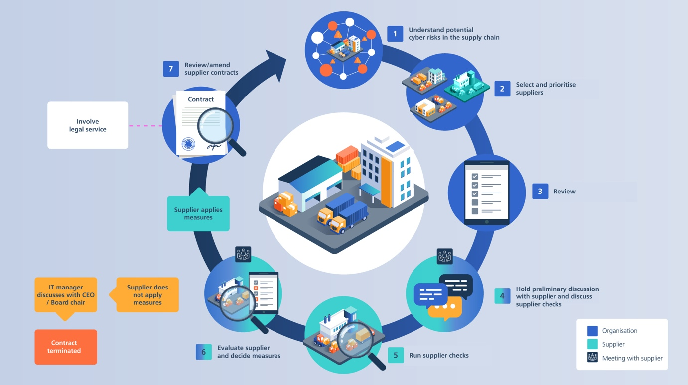
[5] Figure 5 shows how Supply Chain risks happen and how they can affect VTAM.

Insider threats
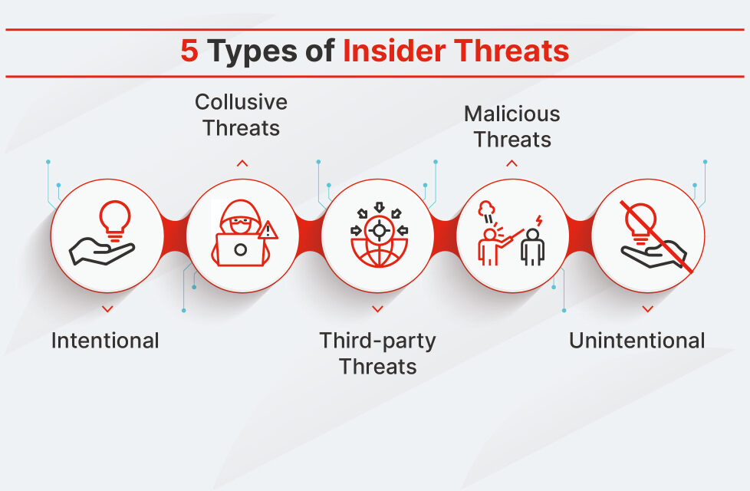
[6] Figure 6 shows the most common insider threats that common in the workplace.

Modern Security Policies

Zero trust
Zero trust is a strategy used within Cyber Security to reduce breaches and cyber-attacks. The strategy is based on a principle of “never trust, always verify” and to limit or remove trust for users and devices.
According to Microsoft, zero trust is a strategy that follows the following principles, Verify explicitly, Use least privilege access, Assume breach. [7]

Access Control
Access control is fundamental to VTAMs staff as the process manages who is authorized to access company files and applications while keeping unauthorised users out.
According to NSCC, Access control is a way of ensuring authorised users or systems can access data or services. [8]

MFA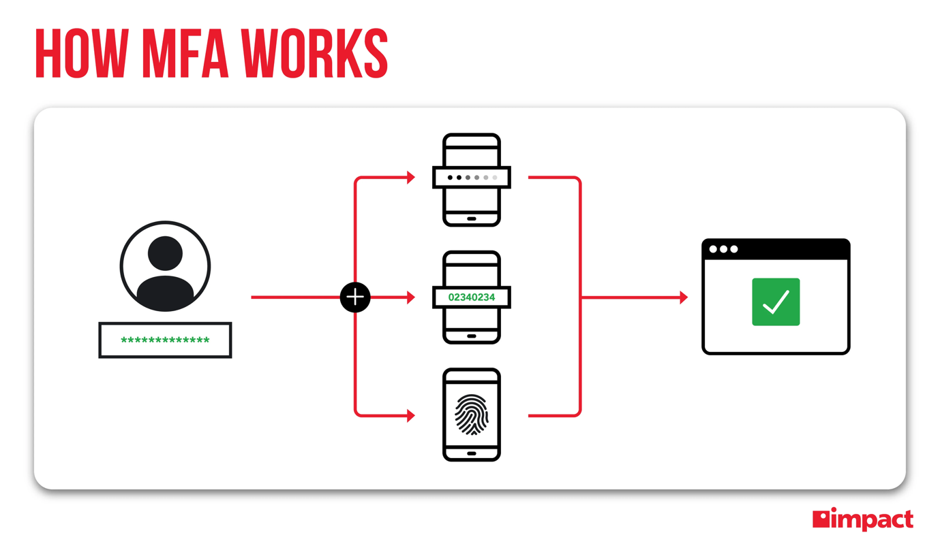
[9] Figure 7 illustrates how MFA works by showing the end user supplying their password for the Multi Factor Authenticator to generate a key to allow them access.

Continuous verification
Continuous authentication
According to the NCSC, device health checks are critical to evaluate compliance of laptops, servers and other connected devices to prevent breaches. [10]
Behaviour monitoring
CIA TRIAD
Confidentiality – Ensures that sensitive data can only be accessed by authorised users.
Integrity – Ensures that data remains accurate and has not mutated.
Availability – Ensures that systems and services are operational.

NIST CSF 2.0
Govern – Establish the risk
Identify – Develop and understand the risk to the company
Protect – Implement safeguards
Detect – Identify the attack
Respond – Take appropriate action
Recover – Restore services
Above is the NIST Cyber Security Framework 2.0 core functions that VTAM has implemented due to the recent attack.

Technical Mitigation Measures

MFA
[9]
Figure 7 illustrates how MFA works by showing the end user supplying their password for the Multi Factor Authenticator to generate a key to allow them access. VTAM uses MFA for hybrid working.

Encryption
Encryption is the process of turning readable data e.g. plaintext into an unreadable text using algorithms so only authorised staff can understand the information.
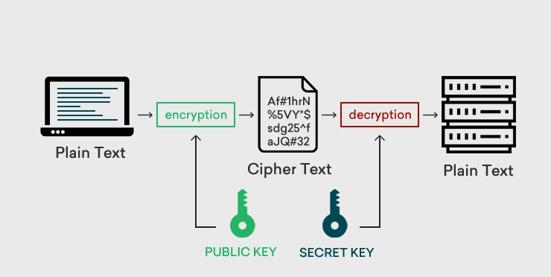
[11] Figure 8 shows the process of how encryption is done. In VTAM customer information is encrypted and backed up to protect the information.

Firewalls
A firewall is a network security system that monitors and filters incoming and outcoming traffic between internal and external networks. It acts as a security officer based on rules, allowing safe traffic in and blocking out threats. [12] VTAM’s Firewall is configured to monitor inbound and outbound traffic to reduce the risk of unauthorised access.

Patches
Verifying that all operating systems and applications are up to date to the latest version. In VTAM, software that is used is regularly checked for updates along with the software that is in use within the company.
According to CISA, patches are software and operating system updates that address any vulnerability within the programme or product. [13]

Backups
Backups are the last line of defence when it comes to data loss, backups are regularly done within VTAM to ensure that any data that is lost can be restored after any hardware failures or cyber-attacks.
According to Open Text, “Data backup and recovery serves as the last line of defence against data loss, corruption, and cyber threats. This critical cybersecurity measure ensures that organizations can recover their valuable information even when other security layers fail.”[14]

Proactive Monitoring and Incident Response

SIEM (Security Information and Event Management)
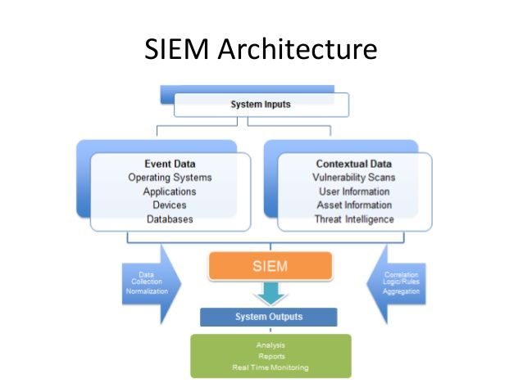
[15]
Figure 8 illustrates how SIEM centralises a log collection from multiple systems that support real-time threat detection.

24/7 Monitoring
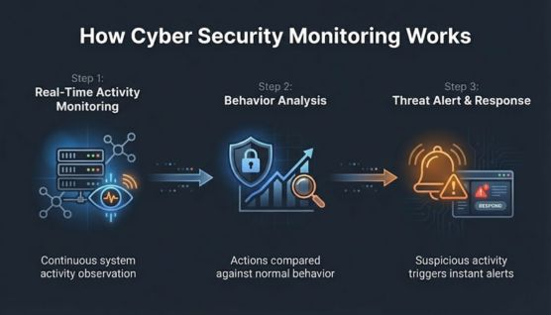
[16] Figure 16 shows how 24/7 monitoring works.

Incident response steps:

- Detect Attack – Incident gets reported
- Threat is evaluated e.g. isolated to one machine or spreading
- Contain the attack so it does not spread
- Deploy measures to stop the threat
- Services are back up and lessons learned

Continuous Training and Awareness

Phishing simulations
Phishing Simulations will be carried out by a third-party contractor to test employee’s awareness with their emails. Any employee that fails the simulation will then be put onto an awareness course.

Vishing training
Vishing Simulations will be carried out by a third-party contractor to test employee’s awareness when answering the calls. Any employee that fails the simulation will then be put onto an awareness course.

Regular employee training
Regular employee training will be mandated by the Cyber Security department; training will be offered yearly but subject to change if there is a new threat.

Awareness campaigns
Awareness campaigns will be published through the global email that is sent out daily along with posters in the hallways and being advertised at VTAM’s intranet homepage.

Conclusion
In conclusion, modern cyber threats such as ransomware, phishing and cloud-based attacks continue to post risks to companies and organisations such as Vigilant Trust & Asset Management (VTAM). As cyber-attacks are evolving and becoming more sophisticated, traditional approaches are no longer sufficient to protect information.
To address these challenges, TAM has implemented a Zero Trust security framework supported by the NIST Cyber Security Framework 2.0 core functions. Due to this more measures have been put into place such as MFA for hybrid workers, updated firewalls, encryption, patch management, SIEM monitoring, backups and continuous verification to help strengthen the organisations security.
Overall, the implementation of these policies improves VTAM’s security and resilience against evolving threats and protects the confidentiality and integrity of the business’s data and services.

References
[1] M. Kosinski. "What Is Ransomware? | IBM." Accessed: Apr 28 2026. [Online]. Available: https://www.ibm.com/think/topics/ransomware
[2] "Phishing: Spot and report scam emails, texts, websites and calls | National Cyber Security Centre." Accessed: Apr 28 2026. [Online]. Available: https://www.ncsc.gov.uk/collection/phishing-scams
[3] "What Is Vishing?" Accessed: Apr 28 2026. [Online]. Available: https://www.cisco.com/site/us/en/learn/topics/security/what-is-vishing.html
[4] "Cloud Security | The 10 Most Common Threats | Darktrace." Accessed: Apr 28 2026. [Online]. Available: https://www.darktrace.com/cyber-ai-glossary/the-most-common-cloud-security-threats
[5] DDPS, Federal Department of Defence, Civil Protection and Sport. "Cybersecurity in the supply chain." Accessed: May 11 2026. [Online]. Available: https://www.ncsc.admin.ch/ncsc/en/home/infos-fuer/infos-unternehmen/aktuelle-themen/lieferkette.html
[6] "What Is an Insider Threat? Definition, Types, and Prevention." Accessed: May 11 2026. [Online]. Available: https://www.fortinet.com/resources/cyberglossary/insider-threats
[7] "What is Zero Trust." https://learn.microsoft.com. Accessed: 13/05 2026. [Online]. Available: https://learn.microsoft.com/en-us/security/zero-trust/zero-trust-overview
[8] "Access control | National Cyber Security Centre." Accessed: May 13 2026. [Online]. Available: https://www.ncsc.gov.uk/section/advice-guidance/all-topics/access-control
[9] "Ranking the Different Types of Multi-Factor Authentication." Accessed: May 11 2026. [Online]. Available: https://www.impactmybiz.com/blog/ranking-mfa-types/
[10] "3. Assess user behaviour, service and device health | National Cyber Security Centre." Accessed: May 13 2026. [Online]. Available: https://www.ncsc.gov.uk/collection/zero-trust/architecture-design-principles/assess-user-behaviour-service-and-device-health
[11] "What is Encryption? – A Detailed Guide About Encryption" ClickSSL. (-04-302024). Accessed: May 13, 20262026, [Blog]. Available at: https://www.clickssl.net/blog/what-is-encryption
[12] "What Is a Firewall? Definition and Types of Firewall." Accessed: May 13 2026. [Online]. Available: https://www.fortinet.com/uk/resources/cyberglossary/firewall.html
[13] "Understanding Patches and Software Updates | CISA." Accessed: May 13 2026. [Online]. Available: https://www.cisa.gov/news-events/news/understanding-patches-and-software-updates
[14] "Data Backup & Recovery: Ultimate Defense Against Cyber Threats." Accessed: May 13 2026. [Online]. Available: https://www.opentext.com/what-is/data-backup-and-recovery
[15] "Security Information and Event Management (SIEM) Architecture." Accessed: May 11 2026. [Online]. Available: https://www.logsign.com/case-studies/blog/security-information-and-event-management-architecture//
[16] "What Is Cyber Security Monitoring? | CloudSEK." Accessed: May 13 2026. [Online]. Available: https://www.cloudsek.com/knowledge-base/what-is-cyber-security-monitoring

