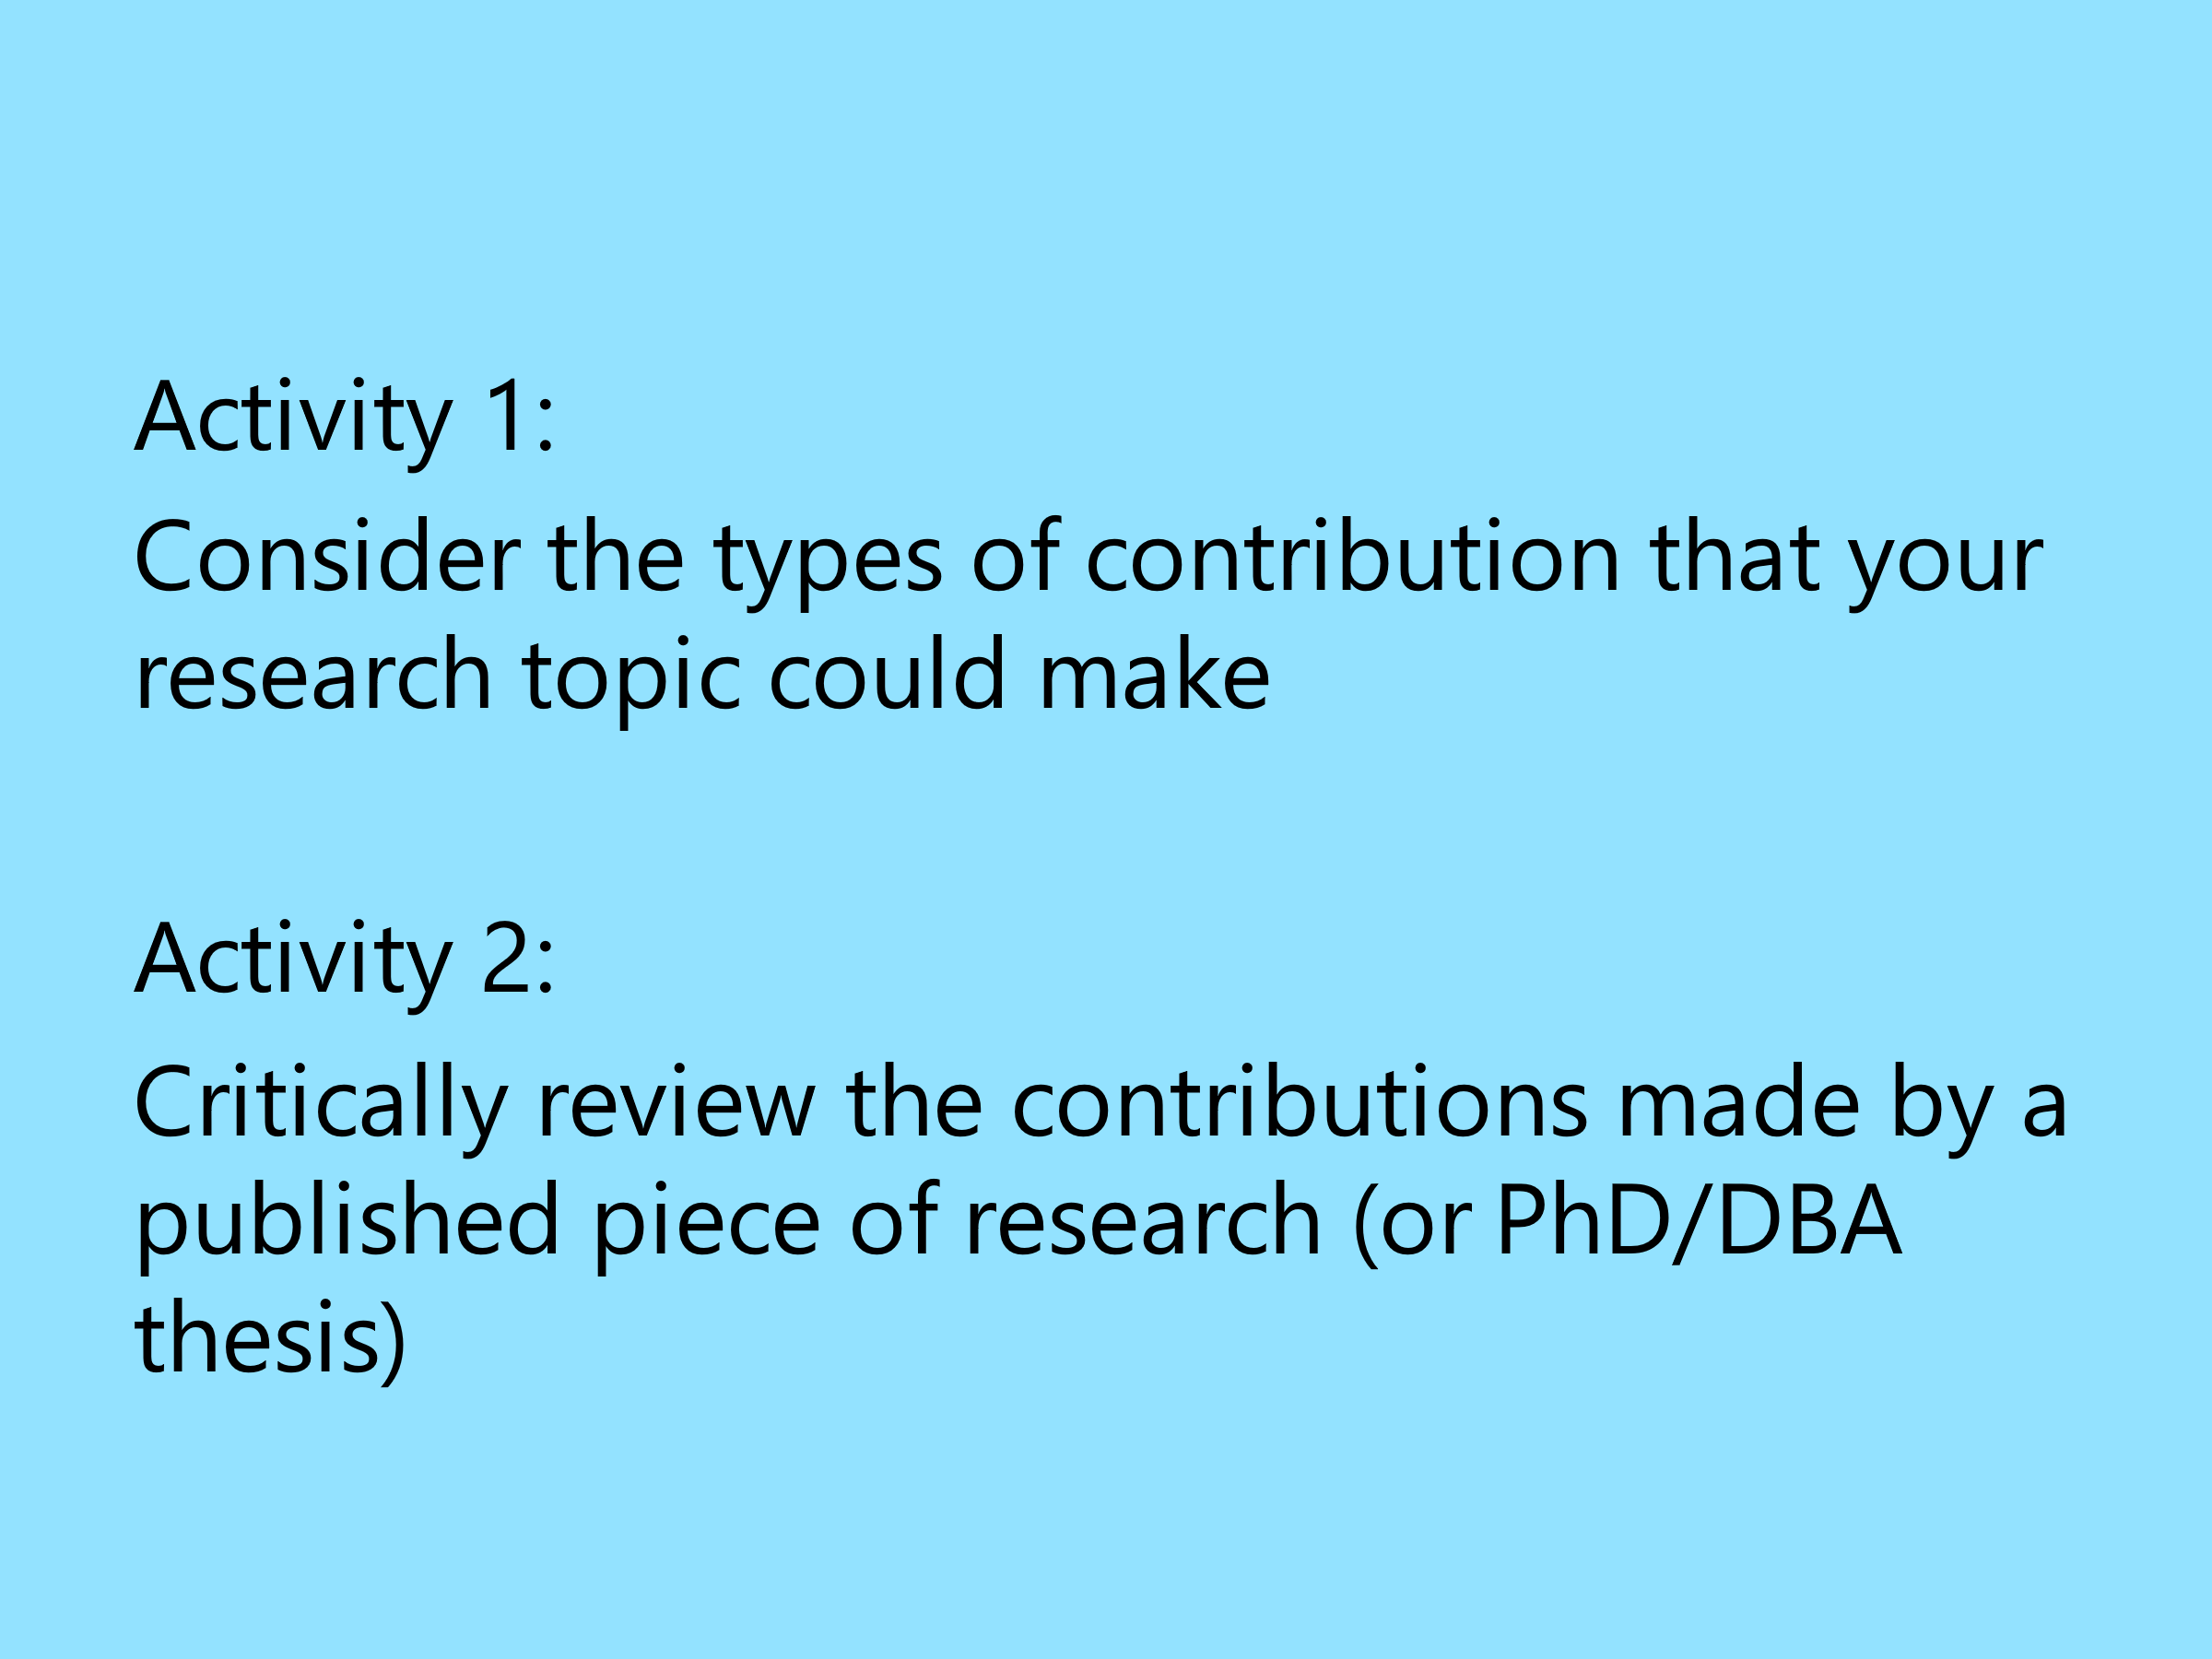

CREATING YOUR PUBLICATION STRATEGY

RESEARCH TOPIC

Key messages you want to be known for | Potential audiences | Types of publication (include format book, article, review, blog, conference or other) | Prioritisation (for your career) | Action plan (include objectives, time frame, success measures)

