Is the external challenge a good or a bad?
Analyse the impacts of
external environment on employee recruitment and retention
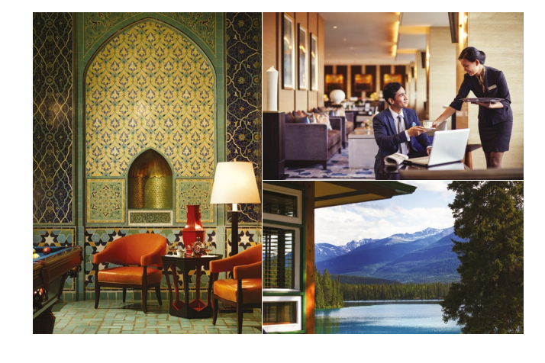
BMIH5005
Personnel Resourcing and Development
Deborah Lloyd

Valentina Stoian
2209627

Executive Summary

This report evaluates the recruitment and retention challenges faced by the Accor Hotel chain. It considers external factors such as advancements in Artificial Intelligence, demographic shifts in the workforce, the repercussions of Brexit, and the ongoing recovery from the COVID-19 pandemic. Accor's approach to addressing these challenges is assessed through a PESTLE analysis, which examines the macro-environmental factors, and a SWOT analysis, which evaluates internal capabilities and market positioning.
Our research suggests that technological innovation has the potential to improve operational efficiency, but also poses a challenge in terms of workforce skills. The retirement wave and Brexit have led to a shortage of skilled professionals, while the pandemic has expedited shifts in employee expectations and work structures. Accor Hotels can utilise its global brand presence and dedication to corporate social responsibility to attract and retain a diverse and skilled workforce, despite the obstacles it faces.
Recommendations prioritise strategic investment in employee development, improving work flexibility, and utilising technology to complement, rather than substitute, the essential human element in the hospitality sector. The Accor Hotel chain should adopt these strategies to sustain its competitive advantage and achieve long-term growth.

Table of Contents
1. Introduction
2. Background of Accor Hotels
3. PESTLE Analysis
4. Industry Retention Rates
5. SWOT Analysis
6. Discussion and Literature Review
7. Evaluation
8. Conclusion

Introduction
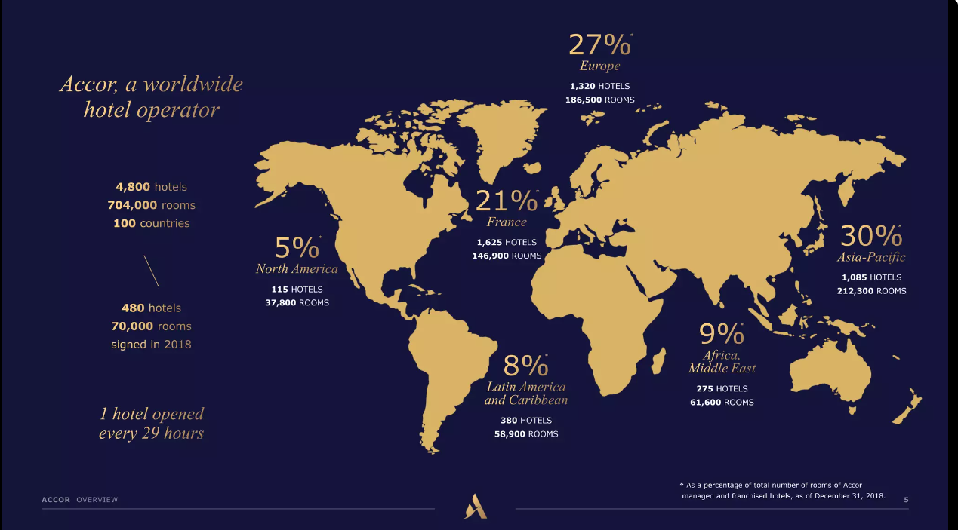
The hospitality industry is currently facing significant challenges due to various external factors, such as technological advancements and geopolitical changes. This report analyses the Accor Hotel chain's management of complex challenges as a prominent player in the global hospitality sector. Accor's ability to adapt to the changing dynamics of the modern workforce, specifically in terms of recruitment and retention, is crucial for its ongoing success (Holston-Okae, 2017).
This report examines key issues in the current landscape, including the integration of Artificial Intelligence (AI) in hotel operations, demographic changes caused by retirement, economic and workforce implications of Brexit, and the overall impact of the pandemic. These elements contribute to the difficulties of maintaining a strong employee base (Abellanet Miranda, 2021).
This introduction seeks to provide a foundation for a thorough examination of Accor Hotels' strategic position in response to these challenges. This analysis will discuss the historical background and current market position of Accor, focusing on the importance of its recruitment and retention strategies in response to the changing external environment of the industry. This report intends to present a concise overview of Accor's current status and advantages (Garavan, et al., 2021).

Background of Accor Hotels

Accor Hotels, established in 1967, has emerged as a prominent international hospitality industry leader, with its headquarters located in Paris, France. Accor, a globally recognised hospitality company, operates in 110 countries, offering a wide range of properties and food and beverage venues. Accor, in 2023, possesses a range of prominent brands, such as the high-end Sofitel and Pullman, the mid-range Novotel and Mercure, and the cost-effective Ibis.
The company's market position reflects its innovation and commitment to excellence, driving growth in mature and emerging markets. Accor's expansion strategy involves a combination of organic growth, acquisitions, and partnerships, which allows the chain to provide a distinct array of experiences to its guests (IvyPanda, 2020).
Nicoules (2020) highlights the importance of recruitment and retention in Accor. The group depends on its extensive workforce to provide outstanding guest experiences, as it is a service-oriented industry. Accor prioritizes effective employee engagement and retention strategies to combat frequent turnover in the hospitality sector. These strategies are crucial for Accor's operational scale and significantly influence its reputation, service quality, and financial performance.

PESTLE Analysis
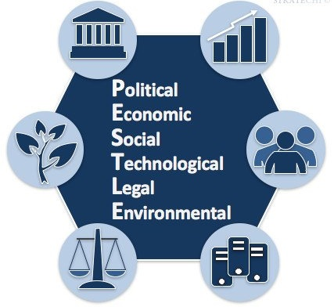
Political: Accor's global operations are influenced by the political landscapes of more than 110 countries, including policies related to tourism, international travel, and trade agreements. Brexit has led to visa complexities and labour restrictions, which have affected Accor's staffing and operational efficiency (George, 2021).
Economic: The hotel industry is influenced by economic fluctuations. Accor encounters challenges due to exchange rate fluctuations, inflation disparities, and divergent economic growth rates across regions, impacting travel patterns and purchasing capacity (Ye, 2022).
Sociocultural: Accor is adjusting to sociocultural shifts by catering to the rising demand for sustainable and localised experiences in the travel industry. Bagdadi (2023) argues that Accor's service offerings and marketing strategies are influenced by demographic changes, particularly the increasing presence of millennial travellers and job prospects.
Technological: Technological advancements offer Accor opportunities to improve guest and employee experiences with digital check-ins and smart room technologies. The need for ongoing investment is driven by the fast rate of innovation (Narang & Jaiswal, 2021).
Legal: Accor places great importance on adhering to international, regional, and local laws, particularly those about labour, health and safety, and data protection. Accor's HR policies and cybersecurity measures are influenced by legal frameworks (Accor, 2022).
Environmental: Accor recognises the growing significance of environmental sustainability due to the increasing awareness among travellers. Accor's dedication to reducing carbon emissions and adopting sustainable practices is both ethically significant and a source of competitive advantage (Accor, 2022).

Industry Retention Rates 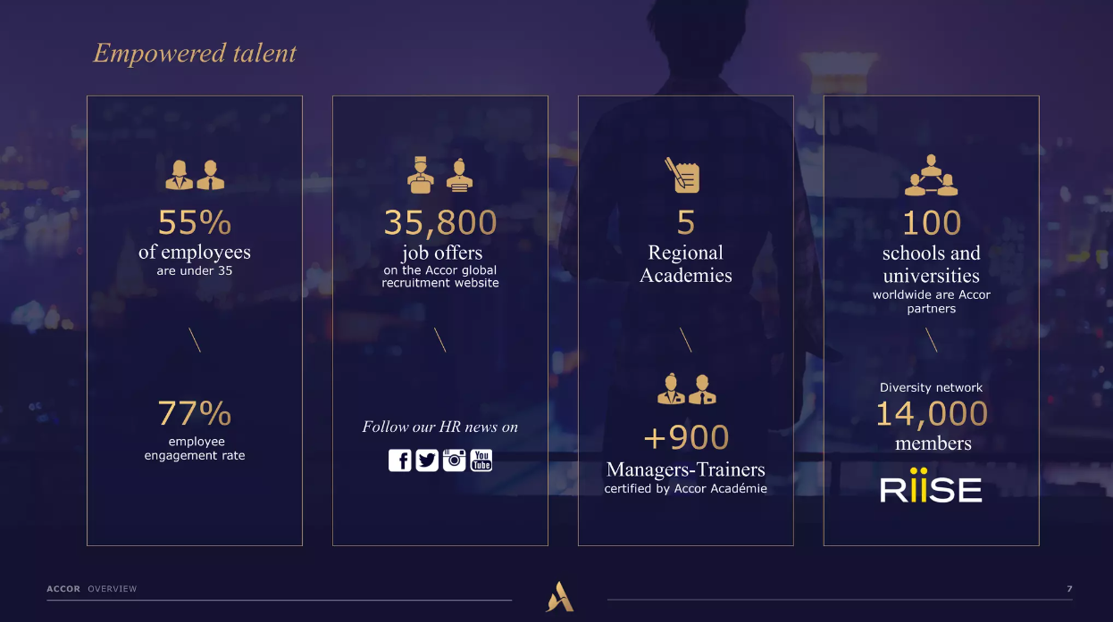
Holston-Okae (2017) states that the hospitality industry experiences significant employee turnover, often exceeding 70% per year. This challenge is caused by various factors, including lower wages, long working hours, and the seasonal nature of tourism jobs. Employee retention is crucial for Accor Hotels, a multinational chain with various brands and properties, to maintain service excellence and operational efficiency.
Kumar (2021) states that Accor has employed various effective strategies to address turnover, such as offering competitive compensation, comprehensive benefits, and personal growth prospects. Accor's employee-focused policies have consistently achieved a higher retention rate than the industry standard, indicating their effectiveness.
Accor's employee retention is influenced by its focus on internal promotion and global mobility initiatives, which cultivate a sense of loyalty and facilitate career advancement. This approach promotes both long-term tenure and the retention of experienced and motivated employees at Accor.
According to Ye (2022), the chain's progress should not overshadow the fact that it is still susceptible to the industry's overall trend of temporary employment, particularly for part-time and hourly workers. Front-line employees, including housekeeping and service staff, experience high turnover rates due to their pursuit of improved work-life balance and better compensation in other sectors.
Accor's turnover analysis highlights the necessity of continuous innovation in HR strategy. The emergence of the gig economy, changing millennial workforce expectations, and the growing emphasis on work-life balance. Technological advancements are altering the employment landscape. Accor has implemented various measures to improve employee well-being, such as wellness programmes, flexible scheduling, and creating more engaging work environments (Garavan, et al., 2021).
Kumar (2021) suggests that Accor should refine its offerings to enhance retention by catering to the diverse needs of its workforce. Utilising digital tools, acknowledging and incentivizing employee contributions, and cultivating inclusivity are supplementary strategies that can enhance employee dedication. Accor's HR strategies are crucial for talent retention and maintaining competitiveness during economic and socio-political challenges.

SWOT Analysis

Strengths: Accor Hotels has a diverse portfolio of internationally recognised brands, which contributes to its strong market presence (Kilson, 2022). The company's loyalty programmes and strategic partnerships have been widely recognised for their ability to improve guest retention and increase brand value. Accor demonstrates its dedication to innovation through its digital platforms and service offerings, enhancing operational efficiency and customer experience.
Weaknesses: Accor encounters brand consistency challenges across various regions despite its global presence. Addressing gaps in the integration of sustainability into the business model is crucial due to its growing significance for both consumers and employees (Jones & Comfort, 2019). Managing a diverse workforce across different jurisdictions can create challenges in maintaining consistent service standards and employee satisfaction (Zheleznyak, 2017).
Opportunities: Accor has the potential to expand its boutique and lifestyle segments due to the increasing demand for personalised and unique lodging experiences. Bharwani and Mathews (2021) suggest that emerging technologies can be utilised to improve guest services, streamline operations, decrease expenses, and enhance employee productivity. Accor can leverage its global reach to attract a diverse workforce, promoting innovation and inclusivity (Kilson, 2022).
Threats: Abellanet Miranda (2021) states that the hospitality industry is vulnerable to economic downturns, geopolitical tensions, and pandemics, leading to travel disruptions and decreased demand for hotel accommodations. According to Dumoulinstateiacomel (2020), the presence of Airbnb and the gig economy as alternative lodging options also pose a competitive threat to traditional hoteliers. Additionally, the swift rate of technological advancements necessitates ongoing financial commitment, which presents a potential threat of becoming outdated.

Discussion and Literature Review
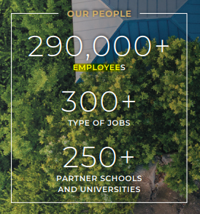
The hospitality industry is dynamic, and Accor Hotels faces challenges in recruiting and retaining employees. The existing literature examines various external factors that impact these challenges, such as technological advancements, socio-economic changes, and evolving workforce demographics (Narang and Jaiswal, 2021).
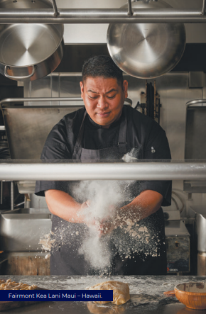
Research has shown that recruitment and retention play a crucial role in maintaining operations and ensuring guest satisfaction in the industry. Scholars claim that a hotel's workforce plays a crucial role in the service delivery process, impacting both customer loyalty and business profitability. Accor Hotels has implemented strategies to cultivate a robust employer brand that effectively attracts and develops talent (Kumar, 2021).
Scholars have highlighted the conflicting views of incorporating Artificial Intelligence (AI) and automation in hotel operations in the existing literature on technological impacts. Although these innovations improve efficiency, there is a potential risk of devaluing the human element in the hospitality experience, which is a fundamental aspect of Accor's service philosophy. Accor utilises technology to improve guest experience and invests in its workforce to effectively operate and support these technological systems (Hassanien and Dale, 2019).
Collinson et al. (2020) argue that socio-political factors, including Brexit, have disrupted traditional labour markets, impacting Accor's talent pool in European regions. The literature shows concerns regarding labour shortages and emphasises the need for Accor to adjust its recruitment strategies to address these risks. Additionally, Stewart (2018) argues that the retirement of experienced employees, referred to as the 'retirement tide', and the ambitions of an expanding millennial workforce require a reconsideration of career development initiatives to meet the varied expectations of employees.
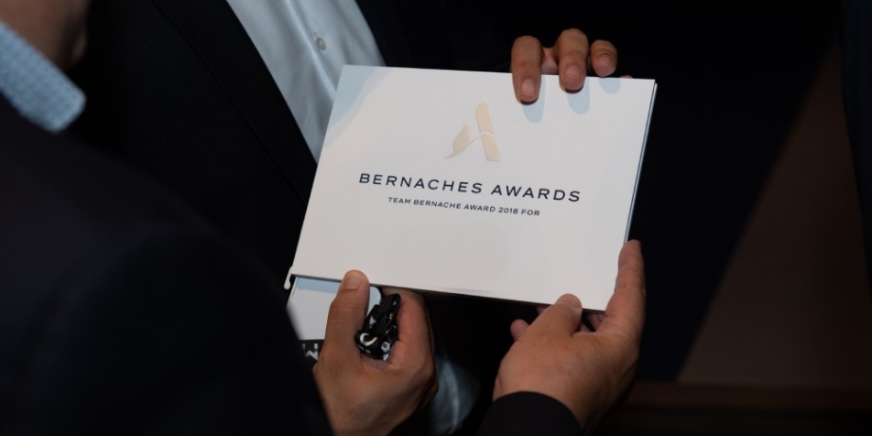
The COVID-19 pandemic has been extensively studied due to its significant impact, particularly in terms of disrupting employment models, leading to a need for swift reassessment. Accor has demonstrated a focus on employee well-being and adaptability, as indicated by industry analyses. Responsive strategies such as flexible work arrangements, mental health support, and enhanced health and safety measures have been implemented. (Abellanet Miranda, 2021).
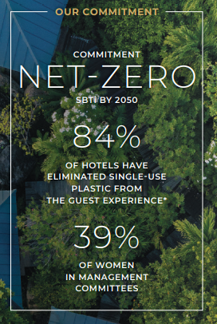
The literature emphasises the significance of corporate social responsibility (CSR) and sustainable practices in attracting and retaining value-conscious employees. Le Bot et al. (2022) state that Accor has made progress in this domain. However, further efforts are necessary to ensure that CSR initiatives are in line with employee values.
The literature focuses on the importance of comprehensive and adaptable HR strategies to address the changing challenges in the hospitality industry. Accor aims to achieve a harmonious integration of human and technological aspects, cultivate a forward-thinking work environment, and adhere to wider societal principles, while also upholding operational efficiency.

Evaluation

This study evaluates Accor Hotels' recruitment and retention strategies in light of the highly competitive and dynamic hospitality industry. The evaluation indicates that Accor has made notable progress in establishing a desirable work environment by offering competitive compensation, comprehensive training programmes, and a clear career advancement trajectory, in line with HR management best practices. Accor's initiatives exemplify their recognition of the inherent connection between employee satisfaction and superior guest service (Sabourin, 2021).
The industry standards comparison indicates that Accor needs to enhance its employee value proposition to stand out from rivals. Accor must consistently invest in employee training to keep up with rapid technological advancements in the industry and meet the high service expectations of modern travellers (Kumar, 2021).
Accor has demonstrated adaptability in addressing external challenges identified in the PESTLE analysis, such as economic fluctuations and sociopolitical changes. However, some areas can be improved, such as work-life balance and the integration of sustainable practices, which are gaining significance in the workforce (Accor, 2022).
The evaluation suggests that Accor has a strong recruitment and retention framework. However, the company needs to update its strategies to proactively respond to the dynamic nature of the hospitality industry. This will help Accor maintain its reputation as a preferred employer (Sabourin, 2021).

Conclusion

The examination of Accor Hotels using a PESTLE analysis, industry retention rates, and a SWOT analysis has offered a comprehensive perspective on the recruitment and retention challenges and opportunities faced by the company. Accor has successfully established a strong framework for attracting and retaining a skilled workforce, which is crucial for its service-oriented business model. The company's proactive approach to employee development and satisfaction demonstrates its acknowledgement of human resources as a valuable asset (Erguido, 2019).
In the fast-paced and ever-changing hospitality industry, it is essential to constantly innovate HR strategies due to technological advancements and evolving sociocultural factors. Accor should utilise its global presence and brand recognition to attract a diverse pool of talent and foster a work environment that emphasises adaptability and individual development, in line with the changing demands of today's workforce (Bratton, et al. 2021).

The report suggests that Accor should prioritise technological integration to improve employee roles, adapt its work-life balance strategy for the post-pandemic era, and reinforce its commitment to sustainable practises, which have a growing impact on employee retention (Even, and Christiansen, eds., 2023).
Accor Hotels can strengthen its leadership position by adopting these strategies, ensuring its durability and significance in a dynamic global hospitality industry.

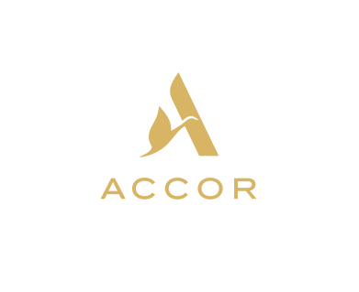

References

1. Abellanet Miranda, C., Multinational firms in the tourism sector: Accor Hotels. Available at: https://dspace.uib.es/xmlui/bitstream/handle/11201/158933/Abellanet_Miranda_Coloma.pdf?sequence=1&isAllowed=y
2. Accor Group, 2023. Our history. Available at: https://group.accor.com/en/group/who-we-are/about-us
3. Accor, 2022. UNIVERSAL REGISTRATION DOCUMENT 2022. Online Available at: https://group.accor.com/-/media/Corporate/Investors/Documents-de-reference/ACCOR_DEU_2022_US_PDF_UA.pdf
4. Bagdadi, A., 2023. Corporate social responsibility practices within the scope of sustainable tourism: A research at Accor Hotels. Prosperitas, 10(1).
5. Bharwani, S. and Mathews, D., 2021. Techno-business strategies for enhancing guest experience in luxury hotels: a managerial perspective. Worldwide Hospitality and Tourism Themes, 13(2), pp.168-185.
6. Bratton, J., Gold, J., Bratton, A. and Steele, L., 2021. Human resource management. Bloomsbury Publishing.
7. Collinson, S., Narula, R., Qamar, A. and Rugman, A.M., 2020. International business. Pearson UK.
8. Dumoulin, R. and Giacomel, A., 2020. Disruption and the strategy of hotel groups. Shapes of Tourism Employment: HRM in the Worlds of Hotels and Air Transport, 4, pp.9-21.
9. Erguido, A., 2019. A management framework for enhancing asset management decisions in service-oriented business models.
10. Even, A.M. and Christiansen, B. eds., 2023. Enhancing Employee Engagement and Productivity in the Post-Pandemic Multigenerational Workforce. IGI Global.
11. Garavan, T., Matthews-Smith, G., Gill, A.M. and O’Brien, F., 2021. Strategic talent management in the hospitality industry. In Talent management innovations in the international hospitality industry (pp. 9-30). Emerald Publishing Limited.
12. George, R., 2021. The Tourism and Hospitality Marketing Environment. In Marketing Tourism and Hospitality: Concepts and Cases (pp. 183-219). Cham: Springer International Publishing.
13. Hassanien, A. and Dale, C., 2019. Hospitality business development. Routledge.
14. Holston-Okae, B., 2017. Employee turnover intentions in the hospitality industry (Doctoral dissertation, Walden University). Available at: https://www.proquest.com/openview/bea0edb3e7de297ad0c2b92d36bfa2fc/1?pq- origsite=gscholar&cbl=18750
15. IvyPanda. (2020). Accor Hotel Group's Strategic Analysis. https://ivypanda.com/essays/accor-hotel-groups-strategic-analysis/
16. Jones, P. and Comfort, D., 2019. Sustainable development goals and the world’s leading hotel groups. Athens Journal of Tourism, 6(1), pp.1-14.
17. Kilson, G.A., 2022. The Use of Digital Media for the Employer Brand Management in Hotels (Doctoral dissertation). Available at: https://comum.rcaap.pt/bitstream/10400.26/43989/1/2022.04.002.pdf
18. Kumar, S.V., 2021. A study on adept soft skill & knowledge accompanying hospitality employee retention behavior during Covid-19 lockdown phase.
19. Le Bot, C., Perrigot, R., Déjean, F. and Oxibar, B., 2022. Corporate Social Responsibility in franchise chains: Specificities, insights from French franchise chains’ CSD, and avenues for future research. Journal of Retailing and Consumer Services, 66, p.102945.
20. Narang, R. and Jaiswal, A., 2021. Crea-ng Experien-al Value through Technology Enabled Service Encounters in the Hotel Industry. Youth Voice Journal.
21. Nicoules, L., 2020. The deployment of the talent and culture strategy: a human resources and managerial challenge to conquer a new generation of workers. Online Available at: https://archive.cm.mahidol.ac.th/bitstream/123456789/3385/1/TP%20GM.023%202017.pdf
22. Sabourin, V., 2021. Strategic Management for the Hospitality and Tourism Industry: Developing a Competitive Advantage. CRC Press.
23. Stewart, S.W., 2018. The Relationship between African American Millennials' Participation in Employee Resource Groups and their Experiences in the Workplace (Doctoral dissertation, Union Institute and University).
24. Ye, C.W., 2022. Equity research-Accor SA (Doctoral dissertation, Instituto Superior de Economia e Gestão). Online Available at: https://www.repository.utl.pt/bitstream/10400.5/26911/1/DM-CWY-2022.pdf
25. Zheleznyak, K., 2017. Contemporary labour migration and talent management in the global hotel industry (Doctoral dissertation, Sheffield Hallam University).

