

Core Network Services as a Service (CNSaaS) Cloud Service Model Experiment

by
Mr Paul M Lawrence

Supervisor: Dr Tim Bashford
Second Marker: Dr Kapilan Radhakrishnan

Project submitted as part of the requirements for the award of BSc (Hons)

Computer Networks and Cybersecurity

May 1st 2019

Abstract
This paper is the experimental first stage of the creation of a new Cloud Service Model (CSM) called Core Network Services as a Service (CNSaaS). This experiment was carried conducted, to identify the most efficient technologies and configurations to utilise within the final CNSaaS CSM along with the research and framework of the new CSM.
The experimental stage of the project was conducted within a computer laboratory that consisted of three Operating Systems (OS); Unix-FreeBSD v12, Linux – Ubuntu v18 and Windows server 2019 – Datacentre Edition that were installed as Virtual Machines (VM) within a Tier-1 hypervisor (Hyper-V) to provide core networking services to three separate Small-Medium-Business (SMB) client Local Area Networks (LAN) from a centralised LAN via an emulated Wide Area Network (WAN) that was implemented using; 7 Cisco routers that were a mixture of 1900 and 2900 series LAN based routers that were configured within a ‘Hub and Spoke’ WAN topology. The 1900 routers installed within the emulated WAN were connected using serial WIC 2.8Mb/s interfaces.
The Hub and Spokes were configured by utilising a Site-to-Site Generic Routing Encapsulation (GRE) Virtual Private Network (VPN) that were configured with Advanced Encryption Standard-256 (AES-256), to secure the communications between the ‘Hub’ and each of the ‘Spokes’. Two WAN protocols were also experimented upon which were; Border Gateway Protocol (BGP) and Multiple Protocol Label Switching (MPLS).
The benchmarking metrics that were measured were; Latency, Packet loss and Throughput, along with VM OS hardware utilisation benchmark metrics generated by the hypervisor using the Windows PowerShell VM-measure module from the hypervisor parent OS.
The Latency and Packet loss data was collected using 1000 Internet Control Message Protocol (ICMP) packets across 3 tests, that were conducted 30 minutes apart, 3 permutations in relation to hop count of this experiment were performed on each OS as a controlled measure.
The throughput metrics were collected using each of the OS file servers mapped drives from the individual clients they were servicing, that tested the Upload and Download throughput speeds between each of the clients and their corresponding servers using a 100MB file. The results for the throughput test were inconclusive because they produced a false positive of 100% throughput, this was theorised to be caused by the low throughput serial WIC interfaces that were utilised within the experiment, that created a 2.8Mb/s bottleneck at the emulated WAN segment of the experimental network.
Packet Loss was recorded as 0% across all benchmarking tests, which was also theorised to be a possible false positive because of the minimal amount of traffic and data types that was being generated within the experiment network within the computer laboratory because of the lack of end users.
The final conclusions that were drawn from the experiment was that; FreeBSD v12 was the most efficient VM OS that recorded a ‘Mean’ average latency of 0.89ms ±0.09ms within the ‘Hub’ LAN, which was calculated to be 93.26% more efficient than the Linux-Ubuntu v18 OS and 187.64% more efficient than the ‘Windows Server 2019 Datacentre Edition’ OS within the experimental network. The one standard deviation σ error from the WAN latency calculations was calculated to be ±0.09ms, this value was transferred to each of the VM OS’s when the WAN latency was subtracted from the initial mean average OS latency.
MPLS was calculated to be the most efficient WAN routing protocol, although high hardware utilisation was observed within MPLS with packets traversing more than 3 routers, the latency was dramatically increased when each OS spoke was positioned at the furthest location within the network, which was 4 hops.
BGP was more efficient within the 4-hop permutation of the experiment. This anomaly was theorised to be caused by the additional added 32-bit overhead of the MPLS labels within the IP header of each packet being processed along with the Label Switching Protocol (LSP) adding high hardware utilisation to each of the routers within the topology, within the low-grade LAN based 1900 and 2900 series Cisco routers. The results from the experiment were backed up by the initial MPLS research conducted.
The network was observed to be very stable as each of the 3 individual tests performed on each OS client spoke from each experiment were performed 30 minutes apart and reported identical data across all three tests.

Declaration

I, Mr Paul M Lawrence declare that I am the sole author of this Project; that all references cited have been consulted; that I have conducted all work of which this is a record, and that the finished work lies within the prescribed word limits.

This work has not previously been accepted as part of any other degree submission.

Signed: 

Date: 21/04/2019

FORM OF CONSENT

I Mr Paul M Lawrence hereby consent that my Project, submitted in candidature for the B.Sc.(Hons) Computing Network and Cybersecurity degree, if successful, may be made available for inter-library loan or photocopying (subject to the law of copyright), and that the title and abstract may be made available to outside organisations.

Signed:

Date: 21/04/2019

Table of Contents
Abstract 2
Declaration 4
Table of Contents 5
Table of Figures 6
Table of Tables 7
Acknowledgements 8
1.0 Introduction 9
1.1 Aims and Objectives 12
1.2 Content included within this CNSaaS Project Document 13
2.0 Research and Development Methodology 13
2.1 Cloud Services Review 14
2.2 Document Review 14
2.3 CNSaaS Network and Systems Development 14
3.0 Research Literature and CNSaaS Implementation 14
3.1 Cloud Services and Centralisation 14
3.2 Local Area Network (LAN) Components and Functionality 19
3.3 Network Operations Centre (NOC) 22
3.4 Wide Area Network (WAN) 23
3.5 Network Cable Media Types 28
3.6 Server OS Architectures 29
3.7 Core Network services 33
3.8 Virtualisation 37
3.9 Network Security 39
3.10 Network Metrics and Benchmark Analysis 41
3.12 SMB IT Overhead Cost Analysis 42
3.13 Review of Research Literature 42
4.0 Implementation and Configuration of the CNSaaS Experiment 43
4.1 Objective 1: CSP NOC LAN Hub Design and Implementation 43
4.2 Objective 2: SMB LAN Spoke Design and Implementation 44
4.3 Objective 3: Hypervisor and Server VM OS’s Configuration 44
4.4 Objective 4: Wide Area Network (WAN) 45
4.5 Objective 5: Network Convergence 45
5.0 Network Benchmarking Metric Collection of the Raw Data 46
5.1 LAN OS Client Spoke Placement in the WAN in Relation to Hop Count as a Controlled Measure 46
5.2 Tabulated Raw Data Output Collected from the Network Metric Benchmark Experiments 47
6.0 CNSaaS Raw Data Visualisation and Analysis 54
6.1 BGP and MPLS Experiment Data Visualisation Analysis 54
6.2 Calculated Mean WAN Latency Variance between BGP and MPLS ≤ 3 Hops Analysis 63
6.3 OS VM Hardware Utilisation Benchmark Analysis 64
6.4 BGP and MPLS Throughput Analysis of Mean Data 65
7.0 Evaluation of Data Analysis 65
7.1 BGP vs MPLS ICMP Experiments 65
7.2 OS File Server Throughput Experiment 67
8.0 Conclusions 67
9.0 CNSaaS Project Reflection 68
10.0 Future Considerations for CNSaaS 69
11.0 References 69
12.0 Bibliography 78
13.0 Appendix – CNSaaS Experiment Evidence 79

Table of Figures
Figure 1: CNSaaS Geographical Physical WAN Topology [6] 9
Figure 2: CNSaaS CSM Network Topology 11
Figure 3: Three main CSM categories comparison illustration [68] 15
Figure 4: Example basic SMB LAN Topology AP,WLAN Controller and Layer-3 Switch not shown here) [95] 19
Figure 5: Example Network Operation Control (NOC) [115] 22
Figure 6: MPLS 32-bit Header (Layer-2.5) [133] 25
Figure 7: Traditional Hub and Spoke WAN Topology [140] 27
Figure 8: OS 3 Ringed Architecture [156] 30
Figure 9: DHCP configuration process between client and server [185] 34
Figure 10: Hypervisor Comparison [200] 38
Figure 11: CNSaaS CSP NOC LAN Topology [6] 43
Figure 12: CNSaaS SMB's LAN Topology [6] 44
Figure 13: Hyper-V Server Manager VM Installation and Configuration [219] 44
Figure 14: CNSaaS Emulated WAN Topology [6] 45
Figure 15: CNSaaS Converged Logical Topology [6] 46
Figure 16: Standard Deviation Formula σ 51
Figure 17: SMB LAN Location in Relation to Hop Count (First Permutation) BGP Data Analysis 54
Figure 18: SMB LAN Location in Relation to Hop Count (First Permutation) MPLS Data Analysis 55
Figure 19: BGP vs MPLS Hop Count and Latency Correlation Analysis Permutation 1 56
Figure 20: SMB LAN Location in Relation to Hop Count Second Permutation BGP Data Analysis 57
Figure 21: SMB LAN Location in Relation to Hop Count Second Permutation MPLS Data Analysis 58
Figure 22: BGP vs MPLS Hop Count and Latency Correlation Analysis Permutation 2 58
Figure 23: SMB LAN Location in Relation to Hop Count Third Permutation BGP Data Analysis 59
Figure 24: SMB LAN Location in Relation to Hop Count Third Permutation MPLS Data Analysis 60
Figure 25: BGP vs MPLS Hop Count and Latency Correlation Analysis Permutation 3 61
Figure 26: Virtual Machine Operating System Latency Mean Average Analysis with one standard deviation σ 62
Figure 27: Emulated WAN Hop Count to Latency Ratio (BGP and MPLS) Midrange Calculation Analysis 63
Figure 28: Calculated Mean WAN Latency Variance between BGP and MPLS ≤ 3 Hops Analysis 63
Figure 29: VM Hardware Utilisation Benchmark Analysis 64
Figure 30: BGP and MPLS Throughput Analysis of Mean Data 65
Figure 31: BGP Controlled Permutation ICMP Experiment 79
Figure 32: MPLS Controlled Permutation ICMP Experiment 79
Figure 33: Throughput Experiment Unix 80
Figure 34: Domain Join to Samba from Windows Client Belfast 80
Figure 35: Belfast FQDN Webserver Index Page, Mapped File Server Drive and Domain Information i.e. DHCP,DNS 81
Figure 36:BGP Controlled Permutation ICMP Experiment 81
Figure 37:MPLS Controlled Permutation ICMP Experiment 82
Figure 38: Linux Edinburgh Samba Domain Join Confirmation and DHCP, DNS Domain Information 82
Figure 39: Edinburgh Linux Ubuntu Mapped Drive to SAMBA48 from Windows 10 CLient 83
Figure 40: Edinburgh Linux Ubuntu HTTP Server Index Page Accessed Via FQDN From Windows 10 Client 83
Figure 41: London Windows Server BGP ICMP Experiment First Controlled Permutation 84
Figure 42:London Windows Server MPLS ICMP Experiment First Controlled Permutation 84
Figure 43: London Windows Server Client Domain Join and DHCP, DNS, Domain Information 85
Figure 44:London Windows Server Client File Server Mapped Drive 85
Figure 45: London Windows HTTP Server Index Page Accessed Via FQDN From Windows 10 Client 86
Figure 46: Physical Routers and Switches for SMB Client Gateways 86
Figure 47: Physical Routers for Emulated WAN with Serial WIC Connection 87
Figure 48:Physical Routers for Emulated WAN with Serial WIC Connection and Router Gateway for emulated CSP NOC LAN 87
Figure 49: Left Network Rack Containing Emulated WAN Routers and CSP LAN NOC Gateway Router 88
Figure 50: Right Rack Containing the SMB LAN Router Gateways and Layer-2 Switches Along With CSP NOC LAN Layer-3 Switch 89

Table of Tables
Table 1: CNSaaS IP Address Scheme 35
Table 2: BGP ICMP and Throughput Experiment First Permutation (Control) 48
Table 3: MPLS ICMP and Throughput Experiment First Permutation (Control) 48
Table 4: BGP ICMP and Throughput Experiment Second Permutation 49
Table 5:MPLS ICMP and Throughput Experiment Second Permutation 49
Table 6: BGP ICMP and Throughput Experiment Third Permutation 50
Table 7: MPLS ICMP and Throughput Experiment Third Permutation 50
Table 8: Latency to Hop Count Ratio – Midrange of Ranges Calculation 51
Table 9: Calculated VM OS Latency within a Tolerance of ± 0.09ms 52
Table 10: Calculated Mean WAN Latency Difference between BGP and MPLS ≤ 3 Hops 53
Table 11: VM Hardware Utilisation Benchmark Experiment 54

Acknowledgements
During this project I have received a lot of specialist support from not only my lecturers Dr Tim Bashford and Dr Kapilan Radhakrishnan but also the support staff that work at the university; the systems engineer Mr Lee Cobley and also the desktop hardware technician within the university Mr Ray Halls who was instrumental in locating and gathering the server hardware that was required to complete this project, so I would like to say a big thank you to all of the aforementioned people, because without your help this project may not have been a success.

1.0 Introduction
Within modern day computing, the ‘Cloud’ services sector [1] of the Information Technology (IT) industry is highly lucrative, because IT networking hardware and knowledgeable staff within this specialised field are expensive overheads for Small-to-Medium Business’s (SMB) [2], especially if the focus of the SMB does not include specialised IT engineering as its core business services i.e. Law firms, Dental practices, Doctors surgery’s, Accounting firms, Photography studios etc. IT expenditures within these companies are viewed as non-profitable overheads, so outsourcing core networking IT services and the maintenance of these services along with the hardware for a fraction of the current cost would be very attractive to SMB’s around the globe.
X as a service (XaaS) [3] is a marketing business model developed by the IT industry to describe remote IT services that end users i.e. company’s, individuals etc can purchase. There are many forms of XaaS available within todays cloud services market that all offer bespoke network, software, virtualisation and hardware features that will be researched and analysed in further detail within the research literature section of this report.
Core Network Services as a Service (CNSaaS) is unique in the fact that it will aim to encompass and remotely deliver all facets of Local Area Network (LAN) [4] engineering services to SMB’s from; bespoke core administrative services within a LAN architecture to; configuration and maintenance of internetworking hardware i.e. Routers and Switches delivered across a large geographical area i.e. internally within a country and/or internationally via a public Wide Area Network (WAN) [5] i.e the Internet. To visualise the far-reaching implications of the CNSaaS Cloud Service Model (CSM) a geographical physical WAN network topology can be found in figure 1.
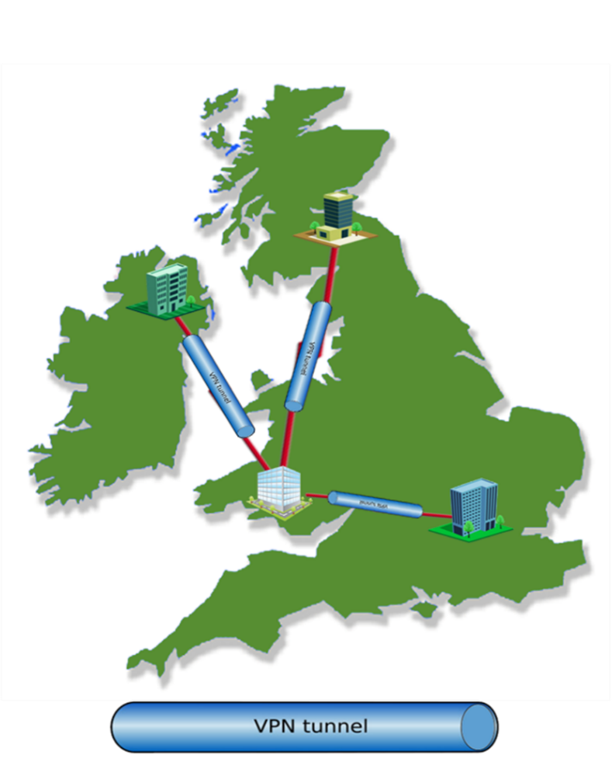
Figure 1: CNSaaS Geographical Physical WAN Topology [6]
For the purpose of the first experimental stage of CNSaaS CSM, a sample selection of core network services will be implemented and then remotely delivered from an emulated Cloud Service Provider (CSP) [7] [8] Network Operations Centre (NOC) [9] LAN segment; to three emulated SMB LAN segments across an emulated WAN as a way of experimentation within a computer laboratory and test the efficiency of CNSaaS core functionality and how it would function within a production environment, which is the first stage of the creation of the CNSaaS CSM along with the business framework and related market research.
The main purpose of the CNSaaS experimental project is to identify the most efficient Operating System (OS) [10] and WAN Exterior Gateway Routing Protocol (EGRP) [11] [12] to utilise within the final CNSaaS deployment model.
Each of the emulated SMB’s within the experiment will be each serviced by a different server OS architecture i.e. Linux – Ubuntu v18 [13], Unix-FreeBSD v12 [14] and Windows Server 2019 Datacentre Edition [15] from a Tier-1 hypervisor [16]–[18] (Hyper-V [19], [20]) virtualised environment located within the emulated CSP LAN NOC, with the objective of collecting ,measuring and analysing network metrics; Latency [21] [22], [23], Packet loss [23], [24], [25] and Throughput [23], [26], [27] by utilising 1000 Internet Control Message Protocol (ICMP) [28], [29] packets being sent simultaneously from each SMB LAN end client Windows 10 [30] end client terminal to each of their servers located within the emulated CSP LAN NOC, in order to identify the most efficient server OS to be utilised within the final CNSaaS deployment model.
Two separate WAN routing protocols; Border Gateway Protocol (BGP) [31], [32] and Multiple Protocol Label Switching (MPLS) [33]–[35] will also be beta tested in two iterations of the CNSaaS experiment, that will each comprise of three permutations of SMB LAN to CSP LAN NOC router hop count location within the CNSaaS network, this action will be taken as a controlled measure to further observe and then objectively identify from the network metrics generated from experiments the most efficient WAN routing protocol to be utilised within the final CNSaaS deployment model. The collected benchmark metric data will then be calculated using various mathematical statistical data analysis methods to isolate the latency to within two decimal places of a millisecond that is being generated within the WAN from both routing protocols and the CSP NOC LAN OS’s.
The ‘Halo Cloud Services’ CSP CNSaaS logical network topology can be found in figure 2.
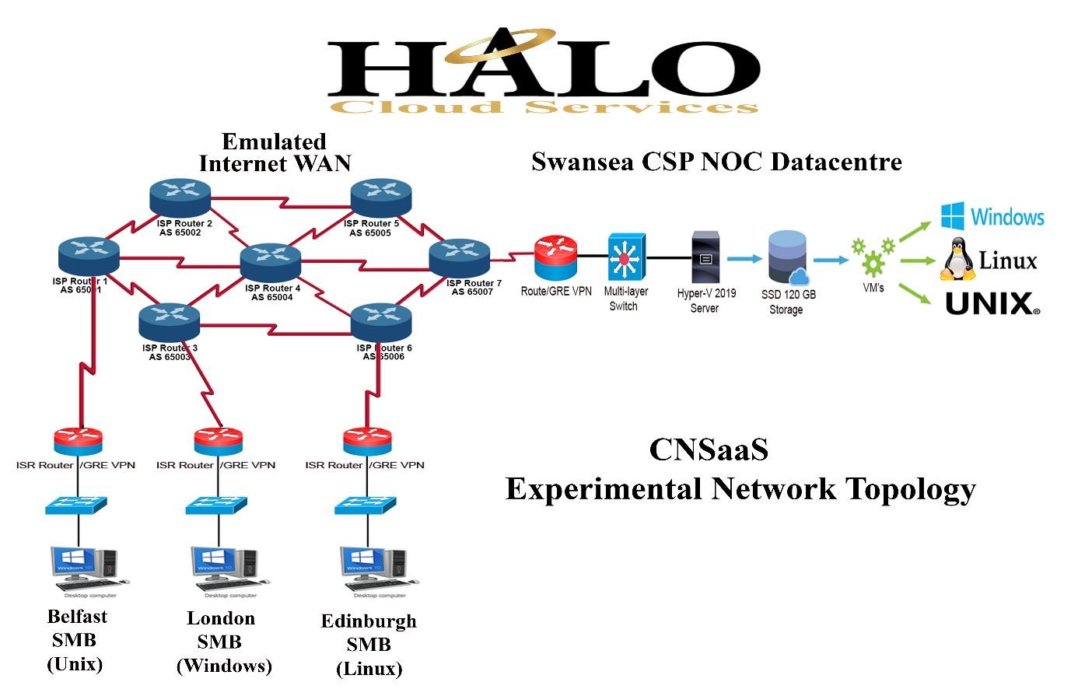
Figure 2: CNSaaS CSM Network Topology
The core network services that will be delivered to each of the LAN’s will include; Dynamic Host Configuration Protocol (DHCP) [36], [37], File Services , Domain Name Services (DNS) [38], [39] , Active Directory (AD) [40] and Hyper Text Transport Protocol (HTTP) [41]Web Services.
These services will be provided by a ‘Tier-1’ hypervisor server to provide a virtualised environment to host each of the OS’s as Virtual Machines (VM) [42], [43] that will be used for experimentation. The ‘Tier-1’ hypervisor will deliver the services remotely and securely from the emulated CSP NOC LAN datacentre [44] across an emulated public Internet as previously discussed.
The connection between the emulated CSP LAN NOC and each of the emulated SMB clients will be secured with an encrypted end-to-end tunnel by utilising a suite of network protocols to create a Site-to-Site Internet Protocol version 4 (IPv4) Virtual Private Network (VPN) to each of the business client’s LAN’s. [45], [46]
The real-world CSP LAN NOC datacentre that will deliver the final most efficient CNSaaS model will be an external IT CSP company that specialises in delivering network services remotely to businesses within a ‘Hub and Spoke’ Wide Area Network (WAN) network topology [47]–[49]. Each SMB’s server OS (the identified most efficient OS from this experiment) will be stored at the CSP NOC LAN as a Virtual Machine (VM) for the tier-1 hypervisor to utilise.
The proposed bespoke CNSaaS CSM framework is not currently available within todays cloud services market and is estimated to outsource a large majority of all IT services hardware and staff within a non-IT services SMB that are currently being provided internally within a SMB. The CNSaaS model would negate the need for; core network infrastructure hardware and highly skilled specialised IT networking staff whom monitor/maintain these devices, which are very large overheads for a non-IT services company, thus providing large economic savings within the IT networking realm of each SMB that utilise CNSaaS.

1.1 Aims and Objectives
The aim of this project is to further research, develop, experiment, implement and then benchmark (analyse) core network services delivered across an emulated public Internet, configured within a ‘Hub and Spoke’ WAN topology via a Site-to-Site Generic Routing Encapsulation (GRE) [50], [51] over IPv4 tunnel secured by IP security (IPsec) [52], [53] suite of protocols to form a VPN in order to create a logically extended secure LAN, to offer the CNSaaS cloud services model to SMB clients whom are not knowledgeable within the IT Industry from a computer network/systems engineering perspective.
The end goal of this project will be for SMB clients to outsource and centralise a large majority of their internal IT LAN operations to an external CSP company that will deliver, monitor and maintain these services remotely, securely and efficiently from a NOC datacentre location as previously discussed.
The first stage of the CNSaaS project is the previously discussed experiment to identify the most efficient configuration of the final CNSaaS CSM as previously discussed. The CNSaaS experiment has been broken down into five manageable objectives so that the project can be completed to a high standard that will produce meaningful raw data.
All of the objectives identified below will need to be obtained to achieve the overarching aim of identifying if the CNSaaS CSM is a practical and efficient solution to an ever-growing SMB client consumer IT problem and if so what technologies to utilise within the CNSaaS CSM moving forward.
These objectives are as follows:
Objective 1: Research, design and implement a NOC LAN that comprises of a; Tier-1 hypervisor (Hyper-V), Cisco Layer-2 2900 series Switches, Cisco 1900 and 2900 Router with network security and efficiency as the focus.
Objective 2: Research, design and implement three small client LAN’s that comprise of; Cisco Layer-2 2900 series Switch, Cisco 2900 Routers with Windows 10 end clients.
Objective 3: Research and implement a Unix - ‘Free BSD v12’ Server, Linux – ‘Ubuntu v18.04’ Server and Windows 2019 datacentre server that will all be stored within a centralised location CSP LAN NOC housed within a Tier-1 hypervisor (Hyper-V) as VM’s that will utilise the physical server hardware resources to provide; DHCP, File services, DNS, HTTP Web services, AD and/or Samba (Unix/Linux equivalent of AD) services for three separate SMB LAN’s located in various Autonomous Systems (AS) within an emulated WAN.
Objective 4: Research and implement an ISP WAN within a computer laboratory with emphasis on BGP and MPLS for connectivity, efficiency and throughput. Also, secure the emulated WAN connection between the hub (NOC) datacentre LAN and spokes (SMB LAN’s), by utilising a Site-to-Site GRE over IPv4 VPN tunnel to provide end-to-end encryption of network traffic between each of the Customer Edge (CE) routers configured at the proposed spoke sites.
Objective 5: Converge the network segments from objectives 1-4, test and/or troubleshoot connectivity and then benchmark the CNSaaS with two separate experiments with each experiment containing three permutations of SMB spoke to CSP LAN NOC placement within the experimental topology, by utilising 1000 ICMP packets and a file server from each of the OS’s to measure throughput (Upload and Download), and then utilise data analysis mathematics to separate each OS LAN latency from the WAN latency to identify the latency within each OS and WAN protocol to within two decimal places in order to identify and then provide the most efficient server OS and WAN communication protocol configuration of the final CNSaaS cloud model to business clients.

1.2 Content included within this CNSaaS Project Document
This paper includes comprehensive background research of all the technological and business components that make up the overall aim of the CNSaaS experimental CSM, along with the design, development and analyses stages of the project, thorough data analysis and evaluation, accompanied by final conclusions drawn from the outcome of the CNSaaS experiment. A personal reflection of the network/systems engineer’s journey throughout the project and future CNSaaS implementation considerations will also be discussed.

2.0 Research and Development Methodology
This project has been identified as a network/systems experimental development project as there are many similar CSM’s available, that encompass a large majority of the technologies that will be utilised for the CNSaaS solution proposed but none that provide the overarching aims and objectives of the CNSaaS CSM mission statement. [54]
The philosophical research methodology chosen for this project will be positivistic because a real-world working solution to an IT business problem is the final goal of this research experimental project based on the quantitative data generated from the CNSaaS network. [55], [56]
The research will include academic white papers on all facets of computer networking that encompass the CNSaaS CSM along with vendor specific documentation and published networking theory books by reputable authors within the networking industry.
The research into each of the individual segments of the proposed CNSaaS CSM experiment will also include the development and implementation syntax, protocols, technologies, hardware and network architecture topology designs that will need to be fully researched and understood in order to implement each of the technologies successfully to complete the experimental project with the desired successful outcome.
The approach that will be utilised is ‘deductive’ since logical decisions will be made after analysing the data from three OS experiments (3 permutations each) and the data produced from the WAN routing experiments to identify the most efficient configuration for the final CNSaaS deployment to verify the reliability and validity of the system. [57]
The ‘Spiral’ Methodology [58] has been chosen as the development strategy for this project. It’s a combination of the agile waterfall [59] and iterative models [60]as it can be adapted for the CNSaaS network/systems development project as opposed to other development methodology’s that are aimed at developing a prototype (build) software products in one linear cycle, that requires end user testing.
These methodologies do not map across easily within an experimental computer network architecture project that aims to deliver transparent services to end devices comprising of many separate entities, that relies on performance metrics as its testing bed without end user testing and feedback during the initial experiment, as opposed to the spiral model that allows for flexibility within these areas.
By utilising the ‘Spiral’ methodology, the project can be separated into manageable segments called ‘Spirals’ each representing the first four objectives of the CNSaaS project that can be individually iterated using the spiral cycle invariants; research/planning, design, implementation and then troubleshooting/risk analysis. The last spiral; ‘objective 5’ within the project will be the integration of all the completed network segments (Spirals); to create and further troubleshoot the entire network. Benchmark analysis of the entire system will also take place at the final spiral. [58]
The secondary research strategy processes that will be followed for this project are as follows:

2.1 Cloud Services Review
A technical review of traditional CSM’s that utilise similar cloud technologies as the proposed CNSaaS CSM, will be researched and further analysed to identify any problems with; protocol compatibility or specific hardware requirements that may arise during the development of the CNSaaS model.
This research process will be conducted to save time within the development stage of the project by negating the need to solve problems that may have already been previously identified and solved by other researchers/vendors.
Research within the field of business management and economics will also be conducted with focus on; SMB IT costs and IT services that are delivered to end clients internally within SMB’s will be analysed at this stage to identify the validity of CNSaaS within the real world, to evaluate the economic savings and the internal IT services that could be outsourced if SMB’s were to adopt the CNSaaS solution.

2.2 Document Review
CNSaaS has been identified as an experimental development project, therefore there will be a lot of emphasis within research of vendor documentation/academic white paper reviews due to the masses of technologies that are available within this field and the vendor specific products that will be utilised during the project.
This stage of the research will identify the correct hardware/software technologies that will be utilised within the design of CNSaaS i.e. routers, servers, OS’s, LAN/WAN protocols etc and the network/systems engineering theory that will need to be applied successfully to complete this experimental project to avoid design/configuration issues later within the project.

2.3 CNSaaS Network and Systems Development
This stage of the research process will identify the correct configuration command syntax, OS versions and installation industry best practices for each of the identified technologies, and the vendor specific hardware that will be utilised i.e. Cisco, Microsoft, Linux, Unix within the designing and development of the proposed network.

3.0 Research Literature and CNSaaS Implementation
This section includes comprehensive background research that was conducted to fully understand all the technological barriers and problems that encompass the CNSaaS cloud model in order to realise a working solution to the problem.

3.1 Cloud Services and Centralisation
The ethos behind cloud computing is to aggregate expensive server hardware and the computational power that they possess within one location i.e. datacentres that can then be delivered remotely to end clients. Portions of these server’s hardware resources i.e. Central Processing Unit (CPU) and memory (non-volatile and volatile) housed within the datacentres are then remotely leased to end clients using various virtualisation platforms i.e. Virtual Machines (VM’s), containerisation etc to perform various computational tasks and/or to store large amounts of data for a fee. [61], [62]
This modern cloud computing model is only practical within the Internet ‘Information Age’ we live in today because of the infrastructure that has been put in place over the last decade to deliver ultra-high-speed data throughput to residential homes and businesses around the world, making centralised computing a viable alternative to expensive modern in-house services. [63]

3.1.1 X as a Service (XaaS)
X as a Service (XaaS) [3] is a generic marketing term used within the IT industry to describe a network infrastructure services model that can be delivered remotely to end clients across a public WAN i.e. the Internet. Companies whom provide these services are referred to as Cloud Service Providers (CSP). The CSP leaders in this industry are; Amazon Web Services (AWS) [64], Microsoft Azure [65] and Google Cloud [66] .
There are many versions of ‘X as a Service’ (XaaS) currently available within today’s market that are all offered by the CSP market leaders. XaaS can be broken down into three CSM categories that are utilised by SMB’s and Corporations around the world for services tailored to their business needs.
For the purpose of the CNSaaS model, the three foremost CSP models will be the main focus of this research because they are not only similar in architecture, but they also utilise the same infrastructure hardware/core CSP technologies as the proposed CNSaaS model. [67]
The three primary CSM can be found in figure 3.
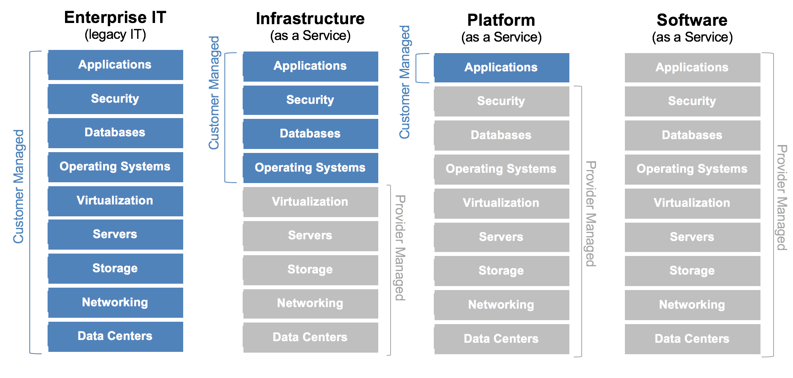
Figure 3: Three main CSM categories comparison illustration [68]

3.1.1.1 Infrastructure as a Service (IaaS)
This CSM offers clients the rental of a CSP’s underlying data centre infrastructure that contain many servers that would typically be located at the client’s premises. This infrastructure is very expensive to purchase and maintain for non-IT services SMB. [69]
The CSP IaaS model leases a small portion of their datacentre server’s computational power and Storage Area Network (SAN) [70]. The client is responsible for installing the server OS’s VM’s, configuring/maintaining the; E-Mail services, database services, web services, web applications and file services that end IT engineering staff within a company can access through a web browser portal via the public Internet. [71]
IaaS provides a client with a leased portion of a datacentre’s underlying network infrastructure i.e. Servers, SAN etc that is managed by the CSP and configured by the client as opposed to the infrastructure being located internally within an SMB.
This model allows the client to implement, configure and manage their own; VM’s, business applications, web applications, storage etc to run a range of customised services for their business through a secure Hyper Text Transport Protocol Security (HTTPS) [72] web browser interface that utilises Secure Socket Layer (SSL) [73] and Transport Layer Security (TLS) [74] for encrypted communications, that can be accessed by the client via an Internet browser as previously discussed.[67][75]
After researching IaaS cloud services model, an understanding of its inherent advantages and disadvantages was established to identify potential single points of failure within the CNSaaS model and also the proven benefits of this model that would also complement the CNSaaS project, these advantages/disadvantages are as follows; [76][77][78]
Advantages:
- An economically viable solution for non-IT companies who can’t afford an expensive networking infrastructure and large specialised networking IT team.

- Clients have full control of their VM’s and can either use pre-configured versions or configure their own instances and run whatever OS they prefer.

- IaaS is considered the most secure cloud model currently available because of the granular control over data, VM’s etc with an option for a virtual firewall instance to be installed within each VM.

Disadvantages:
- Advanced network administration knowledge is needed to maintain and configure these services, also the clients are responsible for backing up all of their data.

- Relies heavily on a stable Internet connection with high throughput. Without WAN connectivity, access to services would not be possible.

- Can be very expensive if services aren’t monitored correctly that are being paid for when they are not being used, as the CSP subscription implements an itemised billing system that can confuse most non-IT companies i.e. per CPU cycles used, RAM used, Storage used, services used, VM instances etc.

- This CSM utilises HTTPS SSL/TLS (port 443) for secure delivery of services which are accessed via a client’s web browser as previously discussed. This method of WAN connectivity does not logically extend a LAN such as a site-to-site GRE VPN tunnel provides, which does not allow for core internal LAN network services to be delivered via the WAN using this method. HTTPS is also vulnerable to attacks by malicious actors (hackers) using exploits such as; POODLE [79], Heartbleed [80], [81] and BREACH [82]. Forged SSL/TLS certificates are also a vulnerability that can be exploited by malicious actors [83]. [84] [82] [83][85]

Whereas a site-to-site GRE VPN utilises military grade Advanced Encryption Standard (AES) 256-bit encryption [86]. AES-256 has not been successfully exploited/cracked that is why it utilised by the military for secure communication of sensitive information. [87]

3.1.1.2 Platform as a Service (PaaS)
PaaS provides clients with the underlying datacentre network infrastructure equally to IaaS. In this model everything including the database, middleware etc is managed by the CSP, apart from the applications and the user data generated by the applications, allowing web application developers to use the infrastructure as a testing platform (test bed) for web application development/management and then to publish their applications for end users to utilise. Vendor specific applications can also be run in this model by the client. Configuration and WAN delivery of this service is identical to IaaS. [67][88][89]
After researching PaaS cloud services model, an understanding of its inherent advantages and disadvantages was established to identify potential single points of failure within the CNSaaS model and also the proven benefits of this model that would also complement the CNSaaS project, these advantages/disadvantages are as follows;[76] [77], [78]
Advantages:
- Minimum networking knowledge is required and no large overheads of infrastructure costs.

- Granular control over applications/user data for user analytics and performance metrics of software.

- System integration support between cross platforms for software applications.

Disadvantages:
- No control of VM’s and the underlying infrastructure processing the data that could potentially pose a security risk.

- Patching and updating of software applications is the client’s responsibility, this will not only cost money and time but would also require knowledgeable staff to execute the processes.

- This model utilises a shared platform with other customers data that could also pose a security risk.

- This CSM also utilises HTTPS SSL/TLS for secure delivery of services that does not logically extend the LAN to deliver external services and is not as secure as a site-to-site GRE tunnel VPN as previously discussed within the IaaS; Disadvantages sub-section.

3.1.1.3 Software as a Service (SaaS)
SaaS provides business clients with applications such as Outlook E-Mail, Office 360, Dropbox etc that can be accessed by their staff via a web browser, eliminating the need for installation, patches, configuration, servers etc. This model is a plug and play model as the CSP manages the underlying network infrastructure, patches, servers, applications and middleware. [67] [90], [91]
After researching SaaS cloud services model, an understanding of its inherent advantages and disadvantages was established to identify potential single points of failure within the CNSaaS model and also the proven benefits of this model that would also complement the CNSaaS project, these advantages/disadvantages are as follows; [76][77], [78]
Advantages:
- No networking knowledge required and no large overheads of infrastructure costs.

- Best value for money out of all the CSP models because only the software that is being utilised is paid for by the client and not the underlying network infrastructure.

- The underlying network infrastructure and software are all provided by and managed by the CSP for rapid deployment of applications.

Disadvantages:
- The client has no control of the data being processed for business analytics.

- Only a limited amount of applications available for this service which do not include core network services.

- The CSP has full control and transparency of client data that could become a major security and data protection issue if the data is mishandled by the CSP.

- This CSM also utilises HTTPS SSL/TLS for secure delivery of services that does not logically extend the LAN to deliver external services and is not as secure as a site-to-site GRE tunnel VPN as previously discussed within the IaaS; Disadvantages sub-section.

3.1.2 Summary of Section
After further analysis of the foremost CSM that are offered within today’s market by CSP’s, it has been concluded that IaaS is the closest model in comparison to CNSaaS. However, IaaS does not offer initial configuration and remote administration by the CSP as CNSaaS will provide. Also, IaaS does not provide internal core services such as DHCP, DNS, AD and File services that are delivered to end clients within a SMB LAN as CNSaaS aims to provide, and then further expand the model with tailored internal services to each SMB such as; Voice over Internet Protocol (VoIP) etc along with remote infrastructure management of the SMB’s; Routers, Switches and End devices.
Although IaaS can benefit a company and slightly reduce IT overheads it does not remove all internal IT core infrastructure services, server infrastructure hardware and highly skilled staff away from an SMB that are the largest overheads within IT infrastructure management, as the CNSaaS model aims to provide to SMB’s as its primary mission statement, that would result in large economic savings for the SMB clients if successful.
In regard to the disadvantages identified within the cloud services research, the most problematic would be the single point of failure with reliance to a single ISP WAN connection to the SMB from the CSP NOC. If connectivity was interrupted or lost all services provided by CNSaaS would fail.
To mitigate this issue, it is proposed that the CNSaaS CSP would advise SMB clients to utilise the services of two separate ISP’s that could not only be used as a redundant measure for connectivity in the event of a temporary ISP WAN failure but also for additional throughput and as a load balancing measure whilst both ISP WANS are functional. The CNSaaS CSP NOC would also utilise multiple ISP’s for redundancy and load balancing purposes.
Although this solution would slightly enhance the cost of CNSaaS, the service would still be viable from an economic standpoint, as the proposed additional cost of the redundant ISP single point of failure countermeasure would be a fraction of the overall savings that the proposed CNSaaS model aims to deliver.
CNSaaS will also be a lot more secure for the SMB client in respect to delivery of services as opposed to the current IaaS model offered by CSP’s, as all services will be distributed via a site-to-site GRE over IPv4 VPN tunnel directly to the SMB client’s ISP router, removing the security risk of exposing the NOC hypervisor servers and the SMB clients to the public Internet where malicious actors could infiltrate the client’s network and/or services. Each clients VM will also be stored within a separate partition at the NOC SAN for additional security and network segmentation.
CNSaaS would also implement a linear transparent system to billing of services provided to SMB’s, as opposed to confusing charges for CPU cycles and MB of RAM utilised by the client, as the majority of CSP’s currently implement within their itemised billing structure. The CNSaaS model would utilise a laymen’s approach to billing; charging only a monthly fee for services provided by the CNSaaS CSP based on the number of end devices being serviced and the allotted storage space assigned to each end user. This approach would be more appealing to non-IT services companies who don’t understand the fundamental architecture of computer/server systems and cloud technologies. This method of billing avoids unexpected large charges for an SMB at the end of each billing period that may exceed their allotted budget.

3.2 Local Area Network (LAN) Components and Functionality
A LAN can be defined as two or more physical connected computer devices sharing information within a single internal network. A LAN typically covers a geographical area the size of a building. Common Internetworking devices that are implemented within a LAN are; Routers [92], Layer-2 and/or layer-3 switches [93], wireless Access Points (AP) [94], wireless LAN controllers [94] and servers . An example of a SMB LAN can be found in figure 4.
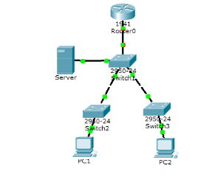
Figure 4: Example basic SMB LAN Topology AP,WLAN Controller and Layer-3 Switch not shown here) [95]
LANS are defined through the working group 802.3 ethernet standard by the Institute of Electrical and Electronics Engineers (IEEE) [96]. The Carry Sense Multiple Access/Collision Detection (CSMA/CD) [97] algorithm is utilised within the 802.3 standard for data collision detection at Layer-1 (Physical) and sending/receiving negotiation parameters between network devices at the MAC sub-layer of Layer-2 (Data-link Layer) within the Open Systems Interconnections (OSI) model [98][99].
Within the following sub-sections of this section of the report, all aspects of a LAN that will be utilised within the CNSaaS experiment will be researched and explored in detail for a greater understanding of the technologies and architecture that will need to be deployed within the development stage of this project to produce a working CSM.

3.2.1 Router Functionality, Layer-3 Protocols and Architecture
A router is defined within the OSI model as a layer-3 (Network Layer) device, which is the gateway of the LAN to either another internal LAN or a WAN. Its primary function is to route IP Packets between LAN’s and/or broadcast domains. A router does not forward broadcast messages in order to contain the large volume of broadcast traffic generated within a LAN.
A LAN router learns routes from either a dynamic Interior Gateway Routing Protocol (IGRP) [11] such as; Open Shortest Path First (OSPF) [100], Enhanced Interior Routing Protocol (EIGRP) [101] or Routing Information Protocol version 1 + 2 (RIP) [102] that use mathematical algorithms to autonomously route packets based on hop count, metrics and/or cost.[103]
Manually configured static routes are also utilised in small networks and for redundancy purposes such as a floating static route and default static route for split tunnelling of packets destined to unknown destinations i.e. the Internet [104].
The routes learned from an IGRP are stored within the routers routing table, that is called the Routing Information Base (RIB) , the best route to a destination which is predefined by the IGRP’s algorithm metrics are then stored within the Forwarding Information Base (FIB) to speed up the routing process decisions, similar to how cache memory works within a Central Processing Unit (CPU).[105]

Summary of Sub-Section
For routing traffic between each of the spokes and the hub, a static route will be used with the destination configured as the CSP NOC VM OS’s IP address and the outgoing interface will be configured as the GRE tunnel.
A ‘default static route’ will also be configured at each of the SMB LAN’s ISP router interfaces outside of the VPN tunnel facing the public WAN, aimed at traffic destined for the public Internet i.e. public Websites etc. This configuration will be applied to reduce the throughput between the SMB spokes and CSP NOC LAN GRE VPN tunnel for traffic engineering and Quality of Service (QoS) prioritisation of client-to-server traffic, in order to prevent a bottleneck within the tunnel and also to reserve bandwidth for the core network services operations between the SMB end clients and the hypervisor. This method of traffic segmentation is referred to as ‘Split Tunnelling’ within the networking industry.
Seven Cisco 1900 series LAN based routers will be utilised within the emulated WAN segment of the experiment and 1 x 2900 series LAN based router will be utilised within each of the emulated SMB LAN spokes which is a total of 4 x 2900 routers being utilised within the experiment. The mixture of the series of routers utilised within the experiment is because of the limited amount of Cisco 1900 LAN series routers within the computer laboratory where the experiment will be conducted. ISP grade routers would have been [referred to have been utilised within the emulated WAN but these devices are very expensive, and the network engineer did not have access ISP grade equipment.

3.2.1.2 Network Address Translation (NAT)
NAT is a protocol that was developed to translate a private IP address into a public IP address to solve the shortage of IPv4 addresses (2^32=4.29 Billion) due to the architecture of the 32-bit dotted-decimal IP address notation and the large amount of end devices (23.14 Billion in 2018) connected to the Internet. 128-bit IPv6 addresses (2^128=340 Undecillion) were also developed to combat this issue but has not fully been adopted within the industry partly because of the success of NAT and the reluctance of network engineers to learn IPv6 due to lack of knowledge/experience. [106]
There are 3 versions of NAT; [107]
Static NAT; This configuration of NAT maps private-to-public IP addresses on a 1:1 basis which is mostly used within industry for public Internet facing server-to-client communications.
Dynamic NAT; This configuration of NAT maps private-to-public IP addresses on a many-to-many basis from a pre-configured pool of public addresses. This version of NAT is rarely used as it is considered a waste of public IP addresses and also expensive for a client to purchase a large amount of IP addresses from their ISP.
Port Address Translation (PAT); This version of NAT is the most widely used. It translates private-to-public addresses on a many-to-1 basis using only one public IP address. It achieves this by changing the source port number within the IP packet header so that it can map private IP addresses-to-source port when traversing NAT with the requested IP packets on the return journey.

Summary of Sub-Section
Within the CNSaaS project, ‘PAT’ will be configured within the CE router at each of the SMB LAN spokes for end device WAN communication traffic destined for the public WAN i.e. the Internet, utilising a ‘Split Tunnelling’ method as previously discussed.

3.2.2 Switch Functionality and Layer-2 Protocols
A switch is defined within the OSI model as a layer-2 (Data-link Layer) device, its primary function is to switch ‘Frames’ between end devices within a LAN. This is achieved by each port learning the Media Access Control (MAC) [108] address associated with an end device by broadcasting the frame to all ports within a switch, apart from the port it received the message on to prevent switching loops, to determine the port the end device is connected to that contains the destination MAC address. Once the port-to-MAC address mapping has been created it is then stored within its Content Addressable Memory (CAM) [109] for future communications without the need to flood the ports as a broadcast message to learn the mapping again, this method speeds up the LAN communication process at layer-2. [110]
Each port within a switch is also a collision domain. A collision domain prevents ethernets frames from colliding within the contentionless based Ethernet 802.3 technology averting errors at Layer-1 (Physical Layer). [111]
Layer-3 switches are also available to purchase. These devices give an administrator flexibility to configure a port as either a switchport or a routed port. The added routed ports within Layer-3 switches provide functionality to remove bottlenecks that are created within an internal Virtual Local Area Network (VLAN) routing [112] configuration in a large enterprise network, but they are more expensive to purchase. [113]

Summary of Sub-Section
Three Cisco 2900 Series SMB LAN Layer-2 switches and one Cisco 3500 series Layer-3 switch, that each contain 24 fast ethernet 100Mb/s port interfaces will be utilised within the CNSaaS laboratory to build the layer-2 LAN segments of the CNSaaS experiment network along with the layer-2 protocols analysed within this section.

3.2.3 Summary of SMB LAN Section
Understanding the fundamentals operations of Layer-2 /3 LAN devices and the protocols that interact at each of these layers of the network is paramount for successful implementation of the CNSaaS experiment, so that the correct network topological architecture can be identified, tailored and then utilised along with the correct protocols, technologies and configurations, in order to gain granular control and a deeper understanding of how all of the data is being transmitted within the network.
Troubleshooting a problem within the network heavily relies on the underpinning networking knowledge and theory previously discussed in this section of the paper in order to pinpoint configuration/hardware/software issues that may occur so that they can be swiftly rectified.
The protocols and technologies that were described within this section of the report were selected and highlighted because they play an important role within the CNSaaS experiments that all need to be fully understood before being implemented within the CNSaaS model to successfully achieve LAN connectivity at both the emulated NOC and the emulated SMB client’s LAN to prevent compatibility issues.

3.3 Network Operations Centre (NOC)
A LAN Network Operations Centre (NOC) or Network Management Centre (NMC) as it is also referred to, is a small-to-medium sized datacentre that comprises of powerful hypervisor server clusters, that centralises the management and monitoring of internetworking devices remotely, using alarm (traps) systems notifications provided by networking monitoring tools such as; SolarWinds, WhatsUp Gold etc of link/device/protocol failures along with the severity and priority of the issues using a ticketing framework. [114]
A NOC also provides a secure backup service of client data within an external SAN or an internal SAN owned and operated by the NOC for an additional fee.
A NOC employs highly skilled network/systems engineers that monitor, troubleshoot and manage business client’s on-premise networks 24 hours a day 7 days a week within a rotating shift pattern to achieve their mission statement. An example illustration of a NOC can be found in figure 5.
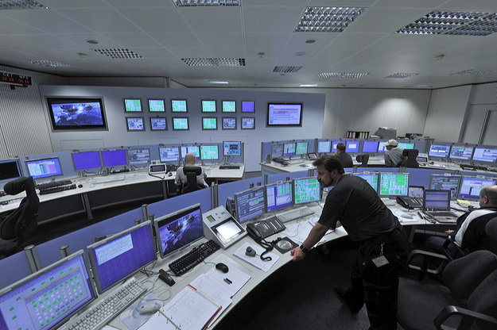
Figure 5: Example Network Operation Control (NOC) [115]
A NOC utilises ultra-high speed, symmetrical (Upload/Download) fibre optic Internet bandwidth and are often directly connected to the ISP’s backbone to achieve maximum throughput and efficiency that results in low latency connectivity for a large monthly fee. The majority of NOC clients are web hosting companies, ISP’s and corporations who own large enterprise high availability networks that need to be fully operational 24/7 to prevent economic losses due to network failure. These networks are often very complex and expensive to maintain internally so are outsourced for remote management to a NOC. [9]

3.3.1 Summary of Section
The real-world final CNSaaS model NOC will not only be responsible for the initial configuration, monitoring and management of client networks and the Internetworking equipment housed within them i.e. routers and switches but also security operations/management within the SMB client LAN networks i.e. Hardware/Software firewalls, real time threat analysis etc that traditionally a Security Operation Control (SOC) [116] would be responsible for, along with the systems engineering maintenance/configuration of the server VM’s housed within the CSP NOC datacentre [44] that will remotely provide, manage and monitor core network services along with upgrades/patches of end/internetworking devices at each of the SMB LAN’s as previously discussed.

3.4 Wide Area Network (WAN)
A WAN can be defined as a wired media network connection between two or more LAN’s over a large geographical area i.e. cities and/or countries sharing information. The Internet is made up of a multitude of WAN’s all interconnected around the globe. WAN routing protocols are implemented to route IP packets to the correct regional Autonomous System (AS) [117] that governs a group of public IP addresses that further connect to LAN’s within that region.
The majority of WAN’s are owned by ISP’s also known as because they are very expensive to implement and maintain, for this reason an ISP’s WAN connection is leased to customers for a monthly subscription fee [118]. Traditionally within the Internet era of networking there has only been one Exterior Gateway Routing Protocol (EGRP) [119] to route between various AS WAN’s and LAN’s around the globe, this protocol is called Border Gateway Protocol (BGP) [31]. Within the last 5 years another method for WAN routing has become popular within the industry that routes IP packets using a label switching technique as opposed to an IP address lookup, this new protocol is called Multiple Protocol Label Switching (MPLS) [120]. Both these protocols will be analysed and discussed in detail within this section of the report.

3.4.1 Border Gateway Protocol (BGP) Autonomous Systems (AS)
An AS with reference to BGP and the Internet as a whole, is a predetermined prefix that is assigned to a geographical WAN region that governs a large group of IP addresses, in order to map IP Addresses-to- AS Number (ASN) [121] WAN locations. ASN’s are distributed by the Regional Internet Registrar (RIR) [122] to ISP’s around the world, to identify WAN location within the longitude and latitude of the earth, so that IP packets can be routed to the correct WAN that an IP packet destination address belongs to, all AS’s are unique for this reason.[122]

The RIR is broken up into four regions that span the globe;

- ARIN governs the Americas and Africa.
- LACNIC governs the Caribbean and Latin America.
- APNIC governs Asia and Australasia.
- RIPE governs Europe.

Similar to IP addresses there are public and private ASN’s. The traditional public ASN’s range from 1-64,512 and the private ASN’s range from 64,512-65,535. Private ASN’s are not routable on the Internet and public ASN’s can only be configured by ISP’s registered with their regional RIR. Configuring public routable ASN’s on an internet facing interface that has not been registered with the RIR is a criminal offence. [121]
Due to the large amount of ISP’s and WAN’s around the globe ASN’s have been updated from 16-bit (2^16=65,535) ASN’s to 32-bit (2^32=4.29 billion) ASN’s for scalability within the fast-expanding modern Internet.

3.4.2 BGP Architecture
BGP-4 is a WAN inter-domain path-vector routing protocol, that utilises TCP for transportation on port 179. BGP utilises the ‘Best Path Selection (BPS)’ algorithm to route between AS, negating loops in the process [123]. BGP is configured within the ISP’s WAN inside the Provider Edge (PE) routers and the core WAN routers called Provider (P) routers. BGP routers are also referred to as ‘Speakers’, these ‘Speakers’ form neighbour relationships or ‘Peering’s’ with other BGP peers. Neighbour relationships can be formed internally inside the same AS, this configuration is called internal-BGP (iBGP) or externally between AS, this configuration is called external-BGP (eBGP). [124]
eBGP is the most widely used configuration of the protocol that is utilised by ISP’s within the WAN to route packets as previously discussed, that is why eBGP is also referred to as the routing protocol of the Internet. The focus of this project will pertain to eBGP when discussing the protocol and the configurations within late sections of this paper.
eBGP utilises Finite State Machine (FSM) [125] logic tables to form neighbour relationship peering sessions between speaker routers located in neighbour AS’s and can either be physically connected i.e. one hop away or logically connected i.e. multiple hops away. BGP ‘Speakers’ only attempt a TCP ‘Peering’ session with other BGP ‘Speakers’ when manually configured to do so by a network engineer, this architecture allows for granular control of AS neighbouring by the ISP. Once neighbour information is exchanged, and a relationship is fully established by eBGP FSM and the eBGP BPS algorithm can then be utilised to advertise their ASN to their neighbour. Customer LAN public IP addresses are also advertised to neighbours by ISP PE routers located in various AS’s for BPS to plot the best path to a particular AS that contains several NEXT_HOP attributes to the destination AS when requested, this path is referred to as the AS_PATH [126] in eBGP. [127]
The majority of ISP ‘P’ routers have very large routing tables because of the multitude of networks being advertised within the WAN, a router with a large routing table is very resource intensive, to combat the finite hardware utilisation, a process called route summarisation if often used to decreases the size of these routing tables and in turn utilise less hardware resources to achieve higher throughput and lower latency. [128]
BGP’s routing table is stored within the RIB that has a version number that is periodically updated if there is a change in the WAN topology. BGP’s RIB is split into three tables. The first table is called the Adjacent-RIB-out (Adj-RIB-out) which advertises local routes to BGP neighbours that are stored here. [129]
The second table is called the Adj-RIB-in, this table stores routes advertised by neighbours. The third table is the Local-RIB (Loc-RIB), local routes are stored here, along with the next hop addresses that are present within the FIB. [129]

3.4.3 BGP Functionality
The BGP process initiates within a CE router located within a ISP customer’s LAN sending a packet to an unknown destination outside of its own network, the packet is then forwarded to the Provider Edge (PE) router that starts the eBGP routing process by reading the destination public Internet Protocol (IP) addresses located within the IP packets header and then distributing the packet to its neighbour Provider (P) core router that is located within a pre-defined AS that the IP address is associated within its Adj-RIB-In.
The IP packet is then routed through various ‘P’ routers and AS’s where the process is repeated until the IP packet reaches the destination PE router associated with the AS of the IP destination address, the AS route that the packet takes to get to its destination is known as the AS_Path. Once the packet reaches its destination AS which is the end of the AS_Path, the IP packet is then forwarded to the CE router located within the LAN destination where the IGRP or static route, forwards the packet to its final destination within the LAN.
This process is very complex and puts a lot of overhead on the core ‘P’ routers within the WAN reducing throughput and adding latency to the communication process. Even though this routing protocol is not perfect it is considered within industry as a reliable protocol that routes the majority of the Internet’s traffic around the world. [130][127]

3.4.4 Summary of BGP Section
On reflection of the research into eBGP and its functionality, it has been concluded that this EGRP will be the correct protocol to utilise for the CNSaaS cloud model to emulate the WAN segment of the network because this is the protocol that ISP’s use to reliably route their traffic within their WAN’s as previously discussed, so using eBGP will give a more accurate reflection of how the CNSaaS model would function within a real world environment whilst analysing performance metrics generated from the computer laboratory experiment.

3.4.5Multiple Protocol Label Switching (MPLS)
MPLS was first devised in 1997 by the Internet Engineering Task Force (IETF), even though it was developed in 1997 it is still considered a new technology because implementation of the protocol was initially expensive and complex, so adoption of MPLS within the WAN by ISP’s and large enterprises has only become a viable alternative to BGP-4 within the last 5 years as the protocol has been further developed/understood by network engineers, and the infrastructure has been put in place to support MPLS, making it more affordable and practical within modern day networking. [131]

3.4.5.1 MPLS Functionality and Architecture
Layer-3 MPLS is a modern WAN suite of protocols, that distributes packets contrarily to the traditional BGP protocol, by routing with labels instead of IP addresses. MPLS can be defined as layer-3 routing at layer-2 speeds, because of this MPLS is regarded as a layer 2.5 protocol within the OSI model since the MPLS 32-bit label is positioned in between the layer-2 and layer-3 addresses within an IP packet header called the MPLS ‘Shim’. [132]
An illustration of an IP MPLS packet can be found in figure 6.
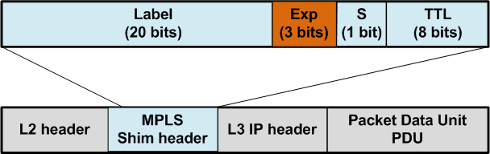
Figure 6: MPLS 32-bit Header (Layer-2.5) [133]
MPLS functions by first reading the destination IP address within the IP packet header at the ingress node which is the ISP Provider Edge (PE) router called the Label Edge Router (LER) within MPLS and then ‘Tagging’ (labelling) the IP packet with a short path label within the range of 16 to 100,000 by utilising the industry standard open vender protocol; Label Distribution Protocol (LDP) to ‘Tag’ IP packets and Cisco Express Forwarding (CEF) to forward the labelled packets or the CEF equivalent for other vendors. The ‘Tags’ that LDP applies to the packets are stored within the Label Forwarding Information Base (LFIB), these labels correspond with the next hop MPLS router of the IP packets destination.[132] [34]
The LFIB is populated by the Label Information Base (LIB) that maps label-to-Forwarding Equivalency Class (FEC) from routes stored within the Forwarding Information Base (FIB), similarly to how Address Resolution Protocol (ARP) maps IP-to-Media Access Control (MAC) Addresses. Because the FIB is utilised to determine the best path, a dynamic routing protocol i.e. BGP, OSPF, EIGRP must be utilised in conjunction with MPLS to populate local routes in order to function. Once the LFIB has been populated, an MPLS neighbour relationship is established with other MPLS routers within the network.[132][33]
This is achieved by sending MPLS ‘Hello’ messages to the multicast address 224.0.0.2 via User Datagram Protocol (UDP) port 646 transport method, Layer-4 (Transport Layer) of the OSI model to establish a connection and the correct Transport Control Protocol (TCP) connection parameters to use, so that the MPLS enabled neighbour routers can communicate via TCP using the neighbour routers LDP ID. [132][33]
All LER’s LIB’s are advertised to MPLS ISP ‘Provider’ (P) routers located within the core of the ISP WAN called Label Switching Routers (LSR), by exchanging Label Mapping Messages (LMM) to Map prefix (IP addresses) to label assignment for MPLS convergence, this process is repeated throughout the LSP. The labelled packets can then be distributed throughout the LSP once MPLS neighbour convergence has taken place. [134] [135]
LSR’s do not read the IP packet header to look for the IP address as a traditional routing protocol would, rather the short path label applied by the LER so that it can ‘Pop’ (remove) the label it has read and ‘Swap’ (replace) it for a label that corresponds with the next router within the LSP from its own LFIB to distribute the packet to the next LSR that the label is associated with. [132]
This process is repeated until the packet arrives at the LER egress node within the LAN destinations where the label is ‘Popped’ (removed) for the last time. The LER at the ‘PE’ router LAN destination then distributes the packet using a traditional routing method i.e. BGP to the CE router within the IP packets destination LAN. The IP packet is then internally routed using an Interior Gateway Routing Protocol (IGRP) i.e. OSPF, EIGRP, RIP or a static route until it reaches the end device that requested the packet.[132]
This label switching functionality negates the need for the LSR’s within the WAN to read the long IP address associated with the packets header then search its large FIB that is populated by the RIB with routes advertised by an IGRP, EGRP or manually configured static routes for the correct path to send the packet to its final LAN destination. MPLS massively reduces the overhead on the ‘P’ core routers located within the WAN because of this functionality. MPLS is transparent to the customer as all of the mechanics and configurations/functionality are located and executed within the ISP’s WAN ‘P’ and ‘PE’ routers similarly to eBGP. [132]
Although MPLS is more efficient at switching packets within the core of the WAN, the initial application of the 32-bit label depicted in the above figure 6 to each packet traversing the MPLS network by the LER ingress router and then the removal of the 32-bit label at the egress LER along with the additional overhead of the LDP within each of the WAN routers, these combined processes puts a substantial amount of CPU and RAM overhead on the hardware housed within these routers, that’s why MPLS is most commonly used by ISP’s and Enterprise networks that utilise high end core routers at the edge of their networks that have vast amounts of processing and memory hardware stored within them which are very expensive to purchase for a SMB. [136][137]

3.4.5.2 Summary of MPLS Section
After analysis of the research into MPLS and the benefits that it can offer a network in relation with throughput and latency as the data suggests, it has been decided to also include an MPLS over eBGP overlay configuration within one iteration of the CNSaaS model experiment to analyse it against eBGP’s standalone functionality, to investigate if it can improve the throughput and latency of IP packets flowing back and forth between the ‘Hub and Spokes’ within the ISP WAN, by utilising BGP’s RIB and FIB databases to populate MPLS’s LIB, to map IP-to-label routes within MPLS’s LFIB in order plot the most efficient LSP in order to achieve reachability within the emulated WAN between LER’s and LSR’s whilst routing with labels instead of lengthy IP address and routing table lookups, to identify if an MPLS overlay would make the CNSaaS model more efficient and reliable within the real world. Calculated analysis of the MPLS overhead will also take place because of the low-grade LAN routers being utilised within the CNSaaS experiment.

3.4.6 Hub and Spoke Design Architecture
A ‘Hub and Spoke’ topology is a centrally managed WAN design architecture. It consists of a ‘Hub’ that is the central LAN component within the network that contains the core internetworking equipment i.e. core routers, core switches and servers for the underlying network. The hub is a gateway for each of the spokes that are generally smaller LAN sites that are logically connected to the hub via a WAN IPv4 Site-to-Site GRE VPN tunnel to create a converged network or extended LAN over a large geographical area.
Utilising this WAN network topology gives a network administrator granular control, consolidation and efficiency of network resources i.e. file services, web services, user services (AD), security permissions etc. Individual administration and monitoring of multiple remote networks can be very expensive and complicated, so this solution is implemented when a corporation (enterprise) comprises of multiple locations spread out over a large geographical area connected via a Site-to-Site VPN, illustrated in figure 7. [47], [48], [138],[139]
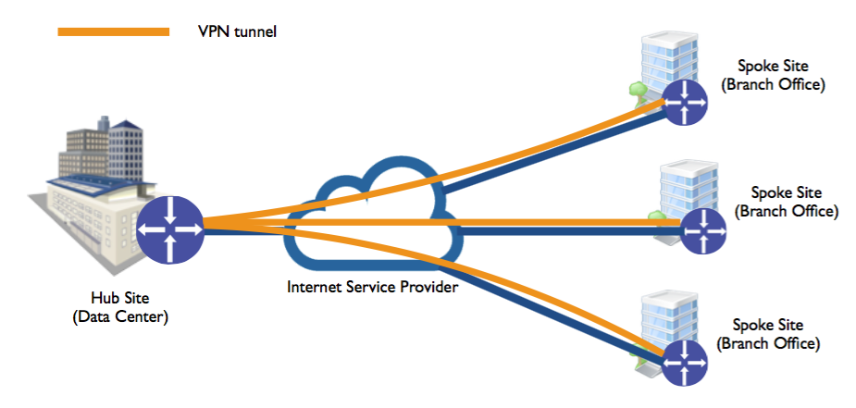
Figure 7: Traditional Hub and Spoke WAN Topology [140]

3.4.6.1Summary of Sub-Section
This WAN design architecture is perfect for the CNSaaS model because it allows for centralisation and maximum security of the NOC (Hub) to the smaller SMB LAN’s (spokes) to deliver internal LAN services to create a logically extended secure LAN. This architecture also offers granular remote and secure administration of the spokes which is one of the keys aims of the CNSaaS CSM.

3.4.7 Summary of WAN section
As with many technologies within Network Engineering where more than one protocol will achieve the same result i.e. delivering a packet from ‘A’ to ‘B’, there are usually trade-offs as each of the protocols will have its own advantages and disadvantages that must be analysed in great detail in conjunction to what the business requirements are for the network and if the strengths of the protocol/architecture outweighs its weaknesses when implementing/designing a WAN model within a production network.
Within the CNSaaS CSM as previously discussed a standalone iteration of eBGP will be implemented and then benchmarked within the emulated WAN to analyse performance metrics. Then a second iteration (experiment) will take place by utilising an MPLS overlay configuration on top of eBGP which will also be benchmarked and analysed in detail to determine the most reliable/stable and efficient WAN protocol configuration to implement within the CNSaaS CSM for maximum optimisation of the final CSM.

3.5 Network Cable Media Types
Network Cables (Media) are defined at layer-1 (Physical Layer) of the OSI model. The cables that are will be utilised within the computer laboratory CNSaaS experiment are;
Category-5 enhanced (Cat-5e) RJ45 Cable; These cables are part of the IEEE 802.3 Ethernet workgroup; the outer shield is made from plastic whilst the core is made from copper so that it can carry data that has been modulated at the MAC-Sub-Layer (Layer-2) within the NIC into electrical signal pulses. Cat-5e cables have a maximum throughput of 1Gb/s over 100 metres. They can be configured as a ‘Straight-Through’ or ‘Cross-over’ cable, these names derive from the pin configuration within the Ethernet Regional Jack-45 (RJ-45) connector at each end of the cable that is used to connect the cable to a computer device. ‘Straight-Through’ cables are utilised when connecting dissimilar devices i.e. Router-to-Switch, where as a ‘Crossover’ cable is utilised when connecting similar devices i.e. Router-to-Router. These cables are most commonly used within a SMB LAN environment. [141], [142]
Serial Cable; Serial cables were traditionally used within the WAN by ISP’s to control the bandwidth speed to customers with legacy protocols such as ‘Frame-Relay’ [143] and ‘Asynchronous Transfer Mode’ (ATM) [144].
Serial cables throughput are dependent on the serial interface used such as, WAN Interface Cards that have a throughput of 2Mb/s [145] which is not viable in today’s high-speed Internet, but are most commonly used within training environments to emulate WAN connectivity as a cheaper alternative to single mode fibre optic cabling which is most commonly used within todays modern WAN’s to achieve high throughput speeds of 10Gb/s up to a distance of 10Km [146].

3.5.1 Summary of Section
Within the CNSaaS laboratory deployment Cat-5e cables will be installed at the LAN segments of the CNSaaS experiment within the Gigabit Ethernet interfaces. The emulated WAN interfaces that will be utilised within the experiment will be WIC serial interfaces because of the low Gigabit port density within the LAN routers being utilised within the experiment located within the computer laboratory Cat-5e will not be viable to implement at the emulated WAN, this is not an efficient configuration scenario, but unfortunately serial HWIC interfaces are the only available interfaces within the computer laboratory to emulate the WAN segment of the CNSaaS experimental topology. ICMP packets are only very small packets with the default packet size being 32-Bytes from a Windows 10 client [147], so the experiment data will not be skewed within the ICMP latency tests of the CNSaaS experiment.

3.6 Server OS Architectures
Servers within an internal LAN topology provide critical core network services such as; DHCP, DNS, File Services and AD to end clients, they also provide non-core but equally important IT business services such as; Application, E-Mail and Internal Web Services (Intranet) etc.
Systems administration/engineering is a field within the IT industry that focuses on developing, configuring, maintaining and delivering these services via an internal core networking infrastructure utilising server OS’s and virtual environments such as Hypervisor or Containerisation [148] technology to achieve this. [149]
Systems administrators/engineers specialise within server hardware and OS software technologies that range from open source Linux [150] and/or Unix [151] server variants to Microsoft Windows servers [152], these diverse vendor OS’s each have unique specialised features and functionalities, but all have the same primary purpose of delivering IT services to end clients within a network.
To maximise available hardware resources within production network environments, industry best practices recommend server OS’s only utilise a Command Line Interface (CLI) for terminal input, so the hardware resources are maximised efficiently, because a Graphical User Interface (GUI) is very resource intensive and has no advantageous bearing on the quality of the services being delivered to the end clients.
GUI’s were developed to simplify the administration of servers for systems engineers, because historically configuring/maintaining a server using CLI syntax is considered a lot more difficult for less skilled systems administrators, the cost of this simplification GUI method means less granular control of configurations and also unwanted high hardware resource usage, because of this, datacentres and other large enterprises, serving a very large amounts of end clients adopt the CLI method of systems engineering to efficiently utilise their hardware resources. [153], [154]
The focus within this paper in regard to the Unix and Linux server OS’s will be a CLI only installation/configuration to maximum the available hardware resources as previously discussed and a GUI installation of Windows Server OS to emulate the most common practices within production networks, in order to achieve more accurate results akin to the real world at the benchmarking stage of the project.

3.6.1 OS Kernel and Shell functionality
The Kernel within an OS acts as an intermediary between the system hardware and the shell. The kernel is responsible for passing high level data from the Shell and translating it to low level binary data to the hardware, the effectiveness within how the kernel achieves this is what makes an OS efficient, device drivers rely heavily on this process in order for hardware devices to function within an OS, the basic principles of this architecture stem from the ‘Von Neuman Architecture’. [155]
The shell which is most commonly referred to as the CLI is where the user data is interpreted into Input/Output (I/O) requests to the low-level kernel software or direct shell syntax inputs, this 3-ring process is illustrated in figure 8.
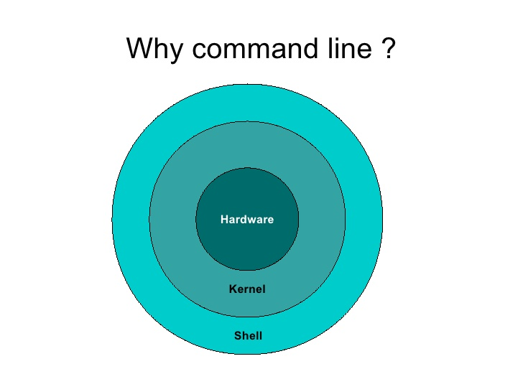
Figure 8: OS 3 Ringed Architecture [156]

3.6.2 Linux – ‘Ubuntu v18.04’
Linux was created in 1991 by Linus Torvalds [157] with a vision of an ‘Open Source’ OS platform for technology enthusiasts around the globe to utilise for free, it was heavily based on the then expensive but very efficient Unix OS architecture created by Bell Labs lead researcher Ken Thompson et al in the 1970’s, for large corporations and government mainframe server use, because of this Linux can be described as an ‘Open Source’ alternative to Unix. [157]
When referring to Linux, it is not the whole OS that is being referred to but rather the raw kernel underneath that translates I/O requests from the shell interface to the hardware as previously discussed, which acts as an intermediary between the two. The Linux kernel does this very efficiently that is why it has grown to become the most popular open source OS Kernel within the core systems engineering server OS industry. [157], [158]
There are many variants of Linux such as; Red Hat – Linux [159], Debian – Linux [160], Fedora – Linux [161], Ubuntu – Linux [13] etc, that all utilise the open source Linux kernel and file system structure but have varied shells that each have their own unique functionality. Most variations of Linux come with the BASH terminal Shell [162] that will be discussed in further detail within this section of the report and optional GNOME GUI [163], though there are now many open source shells and GUI’s available that can be tailored to create a bespoke Linux variant.
The Linux architecture is supported by a large open source community of ‘Contributors’ around the globe, that are each highly qualified specialists within their respected fields to maintain and keep Linux a free OS accessible to all. [164]

3.6.2.1 Linux File System
The Linux filesystem has no user restrictions and allows advanced system root ‘Administrator’ users the ability to configure all parts of the file system that contains everything from the kernel, shell, binary programme files and configuration files as a ‘Superuser’ as it is referred to within Linux OS’s. [165]
This is possible because of Linux’s simplistic linear tree like architectural structure of the file system that starts from the root and branches off to every part of the file system i.e. user folder, ect (programme configuration files, that can be edited/tailored with a simple text edited), bin (programme files) etc. [150]
This linear file structure approach allows for powerful I/O redirections of all files stored on the system and the data they contain to easily interact with one another with a few simple commands, even the HDD and its partitions are seen by the OS as a single file system which is an invaluable tool for systems engineers for automating laborious tasks and overcoming system issues. [158]
However, the ease in which important system files like the kernel can be configured and manipulated without user warning prompts can have catastrophic implications if the end user does not have advanced knowledge within the task that they are performing, their actions could ultimately lead to a complete system failure. That’s why core Linux installations without GUI are viewed as an advanced OS for knowledgeable systems engineers.
The Extended File System version 4 (EXT4) [166] filing system is currently utilised by the majority of Linux OS’s. EXT4 consists of two major partitioning systems call ‘Data’ and ‘Swap’, the data partition is used as expected for containing hard data, whereas the ‘Swap’ partition allows for load balancing of system memory at the hardware level between processes, this method maximises the system hardware resources and minimises the probability of a system failure when system memory is low making Linux a high availability server OS. [167]

3.6.2.2 Born Again SHell (BASH) Terminal
The CLI BASH input terminal is globally renowned for being the most intuitive and efficient CLI terminal available in today’s market that all Linux variants utilise. BASH has a unique yet powerful functionality where raw data can be ‘piped’ using I/O redirect requests from one file and/or directory into another, which is an invaluable tool for systems administrator for converging/sorting small data sets into larger data sets or the inverse for data aggregation. This is just one example of the utilisation of this function which is only limited to the engineer’s problem-solving skills. [162]
BASH scripts can also be created to automate mundane tasks and many more repetitive tasks carried out by a systems administrator utilising the BASH syntax formulated into a script with a file extension of .sh. [168]
Due to the simplistic yet powerful nature of the BASH shell and its global popularity within systems engineering, it has most recently been adopted and made available by major competing OS vendors within the OS industry i.e. Windows, Unix variants etc.
Although due to the file structure of Windows the BASH terminal CLI does not translate very well and a lot of its more powerful features can’t be utilised effectively along with the user restrictions and source code access Microsoft imposes within its OS’s.
Installation of software and/or tools is effortless within the BASH CLI using a tool called ‘Aptitude’ [169]that has the ability to download and autonomously install software using open source dedicated depositories. The Git clone tool feature to Linux/Unix is also very useful when a specific tool is not available within the Linux/Unix depository that allows a systems admin to clone into the open source code distribution site ‘Git’ via the BASH CLI terminal to download and install the tool/software effortlessly.[170]

Summary of Sub-Section
Within the CNSaaS project a Linux - Ubuntu server will be utilised as a VM to serve the ‘Edinburgh’ SMB client with a CLI installation, utilising the BASH terminal for server configuration and maintenance, in order to benchmark its performance against Unix and Windows OS architectures within a production environment across a WAN as previously discussed.

3.6.3 Unix - ‘FreeBSD v12’
As Linux is referred to as a Unix ‘Open Source’ alternative, ‘Free (Berkeley Software Distribution)’ (FreeBSD) can be described as a direct ‘Open Source’ descendant of Unix. Because Linux was heavily based on the Unix architecture, their file structures are very similar. FreeBSD also utilises ‘Swap and Data’ partitions similarly to Linux. Whereas Linux is a standalone kernel that has many custom shells and GUI’s available. Unix-FreeBSD is a complete package containing both the Unix kernel which is disputed to be slightly more efficient than the Linux kernel and the integrated shell. Because the kernel and shell were specifically built as one complete package it is also disputed that FreeBSD is more efficient at passing data from the shell to the hardware layers through to the kernel. This is one of the main reasons this experimental project was undertaken, to benchmark which of the Unix like ‘Open Source’ OS’s are the most efficient within a production environment along with and compared to the commercial Microsoft - Windows OS. [171]

3.6.3.1 Unix – FreeBSD Architecture
The traditional native FreeBSD file system is Unix File System (UFS) [172], the current version of that file system is UFS 2. The most recent updated file system that can be utilised instead of UFS2 is called the Zettabyte File System (ZFS) [173], which is a lot more efficient at passing I/O requests compared to UFS2 and EXT4. ZFS is a transactional file system that utilises storage pools to manage file space similarly to EXT4 and UFS2.
ZFS offers virtually unlimited data and metadata storage that can hold up to 1 billion Terabytes of data, this is achieved by using a flexible tree-like file structure where each new system is a ‘child’ of the previous structure. Using I/O redirects to manage file hierarchy a systems engineer can move and untether these file structures from the parent structures and move them to points outside the main ZFS structure. ZFS also autonomously tracks data within the structure stored on the system that allows for real time tracking of file space which furthermore speeds up I/O operations within the OS as a whole, this is very powerful when used in conjunction with a SAN at a datacentre. ZFS is unparalleled in this respect to other file systems such as Linux EXT4 and Windows FAT32 and NTFS file systems. [174]
The linear file structure, architecture and super user privileges within FreeBSD are very similar to Linux i.e. utilises swap partitions etc, as Linux was based on the Unix architecture so their comparatively very similar in that respect. [175]
However, FreeBSD does have a unique feature called the ‘Jail’ mechanism that is implemented at the Application layer, that allows a systems engineer to virtualise multiple partitions within the same OS for additional security and efficiency of workloads, this functionality utilises the hardware very efficiently if implemented correctly by the systems engineer, that acts as a ‘Sand-Box’ environment to partition configured segments of the file system from one another. [176]
As with Linux there is a large open source community of highly skilled contributors that update FreeBSD regularly to maintain the highly regarded open source OS, most Linux tools are also compatible with FreeBSD.

Summary of Sub-Section
Within the CNSaaS experiment ‘Bash’ will be installed as opposed to the default FreeBSD CLI TCSH because ‘Bash’ is the CLI syntax that the systems engineer within the project is most proficient with using and it is arguably the most efficient CLI within systems engineering. The ZFS file system will also be utilised within the experiment because of the efficient and robust functionality of the file system as previously discussed.

3.6.4 Microsoft – ‘Windows Server 2019 Datacentre Edition’
Windows server is predominantly a GUI server OS that utilises ‘Roles’ as services that an administrator can install to service end clients for various functions i.e. HTTP, DHCP, File Services, AD etc. Although Windows server can be administered using the ‘Core’ shell version which is a CLI that utilises Windows PowerShell [177] syntax for operations, many administrators find this over complicated, restrictive and ‘buggy’ in comparison to BASH. Because of this Windows server is mostly administered utilising the GUI mode which is very resource intensive because of this, along with Microsoft known large software package sizes often referred to as ‘Bloatware’ [178]. Windows server is not open source and has to be bought from Microsoft who provide a licence for use within a LAN for both the Server and Desktop versions. [179]

3.6.4.1 Windows Server Architecture
The current native Windows file system is New Technology File System (NTFS) [180], that replaced the older version of file system called File Allocation Table 32 (FAT32) [181] that utilises a hierarchical file structure as opposed to the ‘flat’ linear file architecture approach utilised by Linux/Unix. Unlike Unix and Linux OS’s, Windows has lots of complicated user/file restrictions that limits what can be achieved by a Windows systems administrator compared to Linux and Unix systems, this is partly because of the protected source code that Microsoft aims to protect that cannot be accessed by systems engineers along with its over complicated architecture in comparison to Linux and Unix. These restrictions make troubleshooting and automating mundane tasks a lot more complicated and lengthier for systems administrators.
Windows utilises ‘Swap’ memory as a ‘Page’ file [182] as opposed to a partition on the HDD which requires it to interact with the core file system partition, then the OS shell which is then passed to the kernel and finally the underlying hardware itself acting as an intermediary which is a lot less efficient, reliable and effective making it a counterintuitive approach when compared to the Linux/Unix method for server hardware efficiency.

Summary of Sub-Section
Although Windows Server has its limitations and pitfalls it is considered to be a lot more easier and intuitive to configure/administer than Unix or Linux because of the GUI and feature role installation that are GUI wizards, because of this a lot of SMB and small enterprises utilise Windows as their primary server OS because most systems administrators are trained and are familiar with Windows, so filling job roles as a Windows systems administrator is a lot easier and salaries are a lot less compared to Unix/Linux systems engineers that are highly skilled positions.
Unix/Linux servers are usually deployed within Internet datacentres and Large Enterprise environments for high levels of hardware efficiency and availability within a network environment with a very large amount of end clients/users as opposed to Windows.

3.6.5 Summary of Section
Within the CNSaaS experiment each server OS will be installed as a VM that will be housed within the SSD of the server, a CLI installation will be performed for the Linux /Unix OS’s and a GUI installation for the Windows Server OS to emulate a real-world controlled environment within the CNSaaS experiment to retrieve accurate benchmarking metric data of OS performance within the CSM akin to industry practices.

3.7 Core Network services
Core network services can be defined as services that are delivered to a client but are transparent to the end user, however without these services the end client would be isolated from the LAN and WAN.
There are many network/systems services that are available to an administrator to make their network more efficient and/or bespoke but not all of them can be regarded as ‘Core’ services, because without them the network and end client would still be able to function within the network. For the purpose of this project, the primary core networking services that have been previously defined within this paper will be analysed in this section of the report and then implemented within the CNSaaS prototype model to test their efficiency when being delivered across a WAN.[183]

3.7.1 Dynamic Host Configuration Protocol (DHCP)
DHCP is one of the most widely used network protocols that is at the heart of any network. It is utilised to distribute IP addresses to end clients within various subnets. The DHCP technology functions by utilising a combination of UDP broadcast and unicast messages commonly referred to as ‘DORA’;[184]
Discover: This is the initiating broadcast message sent from an end client to discover a DHCP server to let it know it would like an IP address within the LAN subnet it resides.
Offer: This is the unicast response message sent from the DHCP server to the end client that includes an offer of an available address within its DHCP pool.
Request: This is the broadcast message that sent back to the DHCP server requesting the previously offered IP address.
Acknowledge: This unicast message is sent to the client from the DHCP server to acknowledge the request for the previously offered IP address. After this message is sent the DHCP server assigns the address to the client and removes it from the pool of available addresses within the server.
The DHCP server utilises port 67 to send unicast messages to the client and the DHCP client transmits broadcast messages using port 68. DHCP is a tool for not only autonomously providing IP addresses to end clients along with their default gateway and local DNS serve. DHCP is also very useful tool for IP address management which is invaluable for systems administrators managing a network [36].
An illustration of the DHCP DORA process can be found in figure 9.
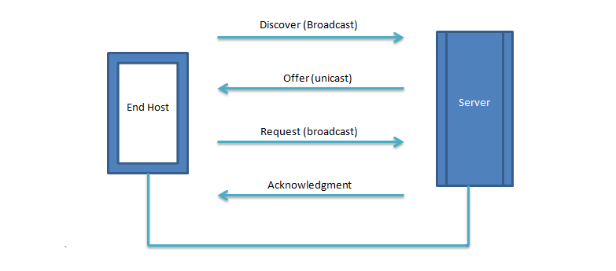
Figure 9: DHCP configuration process between client and server [185]

Summary of Sub-Section
Within the CNSaaS project a DHCP relay agent will be configured at each of the SMB LAN CE routers default gateway interfaces to encapsulate the DHCP broadcast messages into unicast messages so the DHCP packet can be routed through the VPN tunnel, so that each of the SMB end clients can access their VM server OS stored within the CSP SAN run by the hypervisor cluster to retrieve their end client private IP address.
A tool called ‘DHCPd’ will be utilised for the Linux/Unix VM’s and the DHCP service role will be utilised for the Windows VM.
Each SMB will have a private IP addressing scheme for the hub and each of the spokes, including the tunnel address to each SMB private OS within the hub datacentre. The IP address scheme can be found in Table 1.
CNSaaS  Locations | Type | IP Scheme  DHCP Pool | Public IP  Point-to-Point | Site-to-Site  VPN Tunnel | Gateway | Server Address
Swansea NOC Datacentre | Private  Hub | 172.20. 0.0/24 | 10.0.20.0/30 | [n].[n].[n].2/30 | 172.20.0.254/24 | 172.20.0.253/24  Management
London (Windows)  SMB 1 | Private  Spoke | 172.16.1.0/24 | 10.0.1.0/30 | 1.1.1.1/30 | 172.16.1.254/24 | 172.20.0.1/24
Belfast (Unix)  SMB 2 | Private  Spoke | 172.16.2.0/24 | 10.0.2.0/30 | 2.2.2.1/30 | 172.16.2.254/24 | 172.20.0.2/24
Edinburgh (Linux)  SMB 3 | Private  Spoke | 172.16.3.0/24 | 10.0.3.0/30 | 3.3.3.1/30 | 172.16.3.254/24 | 172.20.0.3/24
Internet WAN | Public | 10.0.0.0/24 | 10.0.0.0 /30 | N/A | N/A | N/A
Table 1: CNSaaS IP Address Scheme
A Class B Variable Length Subnet Mask (VLSM) IP address scheme with a Classless Inter Domain Routing (CIDR) ‘Slash’ notation of; /16 has been chosen for each of the SMB spokes for future scalability of SMB ‘Spokes’ and ease of network management by donating each SMB client to the third octet. This IP address scheme allows for 254 end device connections for each SMB spoke, with a maximum of 256 spokes.

3.7.2 Domain Name System (DNS)
DNS is utilised within networking to map/translate numeric base 10 IP addresses to human readable languages i.e. IP addresses to website names; 8.8.8.8 = www.google.com. [186]
Within an internal LAN, the primary DNS server is configured as the the domain controller for the LAN where all network addresses are resolved to their locations i.e. host names for servers, separate domains within the network, for example if a server host name was called host1 (192.168.1.200) and it resided within the www.swanseanetwork.com domain then the DNS server would treat this as a sub-domain and assign it the name www.host1.swanseanetwork.com to be accessed via a web browser. This hierarchy naming convention is called a Fully Qualified Domain Name (FQDN) [186].
DNS forwarders can also be configured to forward DNS queries to other DNS servers external from the LAN the primary server resides in. This method is often used if the primary DNS server does not have the database name-to-IP translation entries the end client has requested, for example to resolve website addresses external to the LAN that may reside within the Internet a DNS forwarder may be utilised such as Googles DNS server (8.8.8.8) that is one of the largest in the world.[187]

Summary of Sub-Section
Within the CNSaaS CSM, a DNS server will be configured for each of the SMB’s to provide reachability to the server VM, SAN and various domains within each of the LAN’s that can be accessed by the end clients.
The FQDN for each of the SMB’s within the CNSaaS experiment is as follows:
- London SMB (Windows) = host.london.wales

- Belfast SMB (FreeBSD) = host.belfast.wales

- Edinburgh SMB (Ubuntu) = host.edinburgh.wales

A forwarder will not be configured within the CSM because split tunnelling will be utilised to prevent high volumes of Internet requests and traffic flowing through the VPN to the CSP NOC, Internet bound traffic will utilise the robust Google 8.8.8.8 DNS server for Internet bound traffic that will leave the LAN directly through the WAN gateway. SAMBA48 internal DNS server will be utilised for the Unix/Linux OS’s and the AD internal DNS server will be utilised for the Windows server.

3.7.3 Active Directory (AD)
AD was created by Microsoft for ‘Windows’ to manage users within a network. AD creates ‘Domains’ to segment a network for ease of administration management and security within the network which are referred to as ‘Forests’, each LAN may contain one or more domains that are all controlled by the primary domain which is called the Domain Controller (DC) . Within AD, groups can be configured for end users that are utilising certain segments of domains and/or multiple domains, to manage users accessing these segments/domains of the network, to achieve this policies are applied called ‘group policies’, AD then creates Kerberos ‘tickets’ (security Certificates) from the group policies and assigns/applies them to the user to donate their access rights within the network. Users are created (Username and Password) and then added within an AD group that have certain restrictions/privileges within certain domains within the LAN for accessing certain network resources for security reasons. This method allows an administrator to converge user management and user access within network domains/subnets within a LAN effortlessly. [188]
Within Linux/Unix the equivalent AD technology is called SAMBA [189] that allows a Linux/Unix administrator to apply group user policies in the same manner as AD. Roaming user profiles can also be configured using AD which allows a user’s profile and the data stored within a user profile to be stored within a SAN or local HDD that can be accessed by any other end device that is connected to the domain when a user logs in with their credentials.
There are a lot more functionality within AD such as AD Federation Authority (FA) etc that does not apply to this project so will not be discussed within this paper, only the traditional basic AD functionality has been discussed within this section. [40]
Security authentication and tickets within AD/SAMBA are managed using ‘Kerberos’ [190] which will be discussed in further detail within the Network Security section of this report. Security can also be managed within AD using the AD Certificate Service (CS) which is considered less secure than Kerberos within the networking industry by network security professionals because these CS certificates can be easily forged by malicious actors as opposed to Kerberos that is a lot more diverse in this respect that has a lot less vulnerabilities making this security protocol a lot more difficult to exploit [188].

Summary of Sub-Section
Within the CNSaaS project, basic AD will be configured for user management and groups will be created that will each have varied privileges/restrictions depending on their role within the SMB i.e. Staff, HR, Managers, Accounts. Roaming profiles will also be configured for each of the users within each of the SMB LAN’s for security of data and data accessibility within the business. Kerberos will be utilised for AD/SAMBA-48 security instead of the AD-CS within the Windows server OS as previously discussed. Also, Kerberos can be utilised within Linux and Unix which will keep the security balanced across all server OS’s during the experiment in order to achieve accurate results and create a controlled security environment.

3.7.4 File Services
File services within a LAN allow users with proficient privileges to access partitions within the SAN or standalone HDD to access data stored as volumes utilising the SMB port 445. As previously discussed, certain data will only be accessible by certain staff members for security purposes such as; Intellectual Property, Accounts etc. Utilising AD/SAMBA-48 allows an administrator to create file shares and manage authorisation to certain partitions and data volumes within the HDD or SAN.[191][192]

Summary of Sub-Section
Within the CNSaaS CSM, file services will be configured for access to the hypervisors SSD with various partitions and volumes created for different types of data for data segmentation, efficiency and security purposes. This service will be provided by SAMBA-48 for the Linux/UNIX VM’s and an AD file services for the Windows 2019 VM. Each of the server OS’s file servers will then be mapped to each of the Windows 10 desktop end clients, to test the throughput of the network between each server within the throughput experiment of the project.

3.7.5 Internal HTTP Web Services
Internal HTTP web services are referred to as an ‘intranet’. An intranet is an internal website portal that is only accessible from within a LAN for a business to utilise for various reasons i.e. company news, communicate with staff and departments, post documents, provide a more user-friendly access to the file server data located within the SSD or SAN by utilising a web portal etc. [41][193]

Summary of Sub-Section
Within the CNSaaS Project an Apache2 [194] web server will be utilised for the Linux/Unix VM’s and the Internet Information Services (IIS) [177] web server role will be installed within the Windows server 2019 VM to provide internal web services to each of the SMB’s that can be accessed via an end clients web browser within each of the SMB LAN’s.

3.7.6 Summary of Section
The core network services discussed are fundamental components for a modern LAN to function, that’s why these services have been incorporated into the CNSaaS prototype CSM, to experiment if they can be efficiently centralised and delivered via the Internet to provide basic LAN services.
There are many more services that can be utilised within a LAN such as VoIP, application services etc that could be incorporated into the final production version of the CNSaaS CSM model within the future if the CNSaaS CSM experimental project is successful.

3.8 Virtualisation
Virtualisation is a modern technology that is utilised to efficiently use all of the expensive server hardware that is utilised within a LAN to provide services to end clients. Traditional virtualisation allows multiple OS’s to be packaged as VM’s [195] that are housed/installed within the SAN that utilises hypervisor technology to achieve this. Virtualisation allows for centralisation of services, maximisation of hardware efficiency and ease of management within a modern LAN.[196]
A more recent virtualisation technology called ‘Containerisation’ [197] is utilised to further maximise hardware efficiency which is referred to as ‘Micro’ services within the systems engineering industry. Containerisation will be further discussed within the Future Considerations sections of this paper. [148], [197]

3.8.1 Hypervisors
There are two main forms of hypervisors; Tier-1 and Tier-2 for the purpose of this project a Tier-1 hypervisor will be the main focus of hypervisor, because this is the most efficient version of a hypervisor, because a Tier-1 hypervisor interfaces directly with the hardware and not the underlying OS as a Tier-2 hypervisor does, which is very inefficient. [198]
A Tier-2 hypervisor are most commonly used as a sandbox (Test Bed) for security/software engineers and also end users wanting the benefits of an extra OS for various reasons. [199]
Tier-1 hypervisors are predominantly used within business LAN environments. [199]
A comparison between the two types of hypervisor can be found in figure 10.
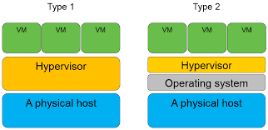
Figure 10: Hypervisor Comparison [200]
A hypervisor allows for load balancing of hardware resources i.e. CPU and RAM utilisation between VM’s that can either be set dynamically or manually that are referred to as virtual CPU (vCPU) and virtual RAM (vRAM). A Tier-1 hypervisor also has the capability to dynamically expand the virtual HDD (vHDD) for each VM which is saved as a Virtual Hard Disk (VHD) file to efficiently utilise the expensive HDD storage available within a SAN or standalone HDD. The vHDD utilisation functionality can also be set manually by the systems engineer.[199] [198]
Each VM can be configured to have virtual NIC (vNIC) interfaces that can either be bridged to the hosts physical NIC by utilising an external virtual switch (vSwitch) for external communication outside of the VM environment between end devices within various subnets/domains the VM is configured to serve. [199][17]
An internal and private vSwitch can also be configured for communications internally between the VM’s, this configuration is predominantly utilised for test bed environments to isolate the VM servers from the live environment whilst testing new configurations. An IP address can also be configured on the vSwitch for remote management of the parent OS that houses the VM’s. [201][199]

3.8.1.1 Hyper-V
There are many hypervisor vendors available within today’s market that can be very expensive to purchase. Microsoft Server 2019 Datacentre edition OS provides a free Tier-1 hypervisor called Hyper-V that can be configured by the administrator for virtualisation of the server within the LAN segment as a role/feature within the OS. When the Hyper-V role is installed within the native Windows Server OS, the Hyper-V module injects itself beneath the native OS utilising a method of generating a -1 ring between the kernel and shell during the virtualisation of the native OS, creating a true tier-1 hypervisor along with driver support for various VM OS’s that can all be managed/configured within the ‘Hyper-V’ manager GUI tool interface. [20][202]
Hyper-V is a very efficient hypervisor that allows for multiple VM’s to be installed and run concurrently within it to service the network it resides within. Virtual switches can also be created within Hyper-V so that the VM’s can be networked locally and/or externally within a private cloud utilising the physical NIC attached to the host to achieve this. [202]

3.8.3 Summary of Section
Within the CNSaaS CSM experiment ‘Hyper-V’ will be utilised as it is provided with ‘Windows server 2019’ and is an efficient Tier-1 hypervisor within its own right as previously discussed, that is available for use within the computer laboratory where the experiment will be conducted under the University licence.
Each of the VM’s that will be utilised within the hypervisor within the CNSaaS CSM experiment will be configured for dynamic vCPU and vRAM utilisation in order to further benchmark the efficiency of the hardware by each of the VM’s so that the most accurate data can be obtained to get a true analysis of each VM OS’s performance within the experiment. Each VM will also have its own vNIC interface that will be configured with the IP address of the SMB IP scheme that the VM is servicing, that will be bridged to the hypervisor host NIC utilising an external vSwitch for connectivity to the CSP router that contains the VPN tunnels for each of the SMB’s.

3.9 Network Security
Security is paramount within modern day networking as ever more sophisticated attacks are leveraged against networks each day around the globe, due to this fact, every network/systems engineer must have thorough knowledge of all the potential security implications within the network their managing/designing even if security is not their core speciality. A VPN is a major aspect of securing data traversing the public Internet from one the source to the destination of the IP packet, that all systems engineers should fully understand and incorporate within their networks from remote access to external sites or remote workers etc. [203], [204]

3.9.1 Site-to-Site GRE over IPv4 Tunnels and VPN Security Protocols
A sit-to-site VPN is utilised by businesses to logically extend their LAN for internal communications between their other LAN’s businesses that are located within separate geographical locations by utilising the public WAN for packet transportation. This form of a VPN is mostly utilised by Campus Area Networks (CAN) and large enterprises that have many branches and a headquarters located in different geographical locations that are configured within a hub and spoke topology as previously discussed, although a GRE VPN is very secure it does add additional hardware utilisation because of the additional 24-Bytes the tunnel information inserts into the IP header within each packet that traverses the tunnel.[50][51], [205]

3.9.1.1 Creating the Tunnel
The first stage of creating a site-to-site VPN is to configure a virtual tunnel interface at the gateway of each of the LAN sites routers that are being logically extended into each other. The virtual tunnel is configured by utilising the virtual tunnelling open source technology GRE, and then setting the tunnel mode GRE-over-IP for encapsulation of the packets traversing the tunnel. The outgoing interface, the tunnel IP address and the public IP address of the destination remote LAN must also be configured. This process creates a logical point-to-point connection to the remote destination traversing NAT in the process, but a GRE tunnel does not secure the connection it only creates the logical site-to-site connectivity.[51], [205]

3.9.1.2 Securing the Tunnel
In order to secure the tunnel, a suite of protocols called IP Security (IPSEC) [206] is utilised in order to encrypt the data packets being sent across the tunnel to prevent malicious actors intercepting the information by utilising a Man in the Middle (MITM) [207] attack within the WAN or by other data interception techniques the data is being routed through.
To secure the tunnel, end-to-end Internet Key Exchange (IKE) is implemented within two phases using Internet Security Association and Key Management Protocol (ISAKMP).[206]
ISKAMP Phase 1: Within industry Diffie-Hellman (DH) [208] asymmetric encryption is mostly used at this phase of an ISKAMP site-to-site GRE VPN for asymmetric Public Key Exchange (PKE) [209] of transport security negotiation parameters and creating the public encryption authentication keys from the secret keys configured by the security engineer. DH utilises a mathematical algorithm derived from two separate prime numbers, one from each side of the tunnel to obtain the same public key without having to ever broadcast the secret key via the unsecure public Internet. Once the encryption keys have been calculated they are hashed using Secure Hash Algorithm 3 (SHA3) 256-bit [210] to create an agreed upon public key. This phase completes the IKE Security Association (SA) [211] between the two sites.[212]
ISAKMP Phase 2: This phase receives the securely negotiated public keys from phase 1 SA. Phase 2 of the IPsec process is where the traffic encryption policy is configured and applied. Within industry the data encryption method that is mostly utilised within a site-to-site ISAKMP VPN is AES-256, as this encryption standard is viewed as ‘military grade’ which is the most secure data encryption algorithm currently available, the SA lifetime of the ISAKMP tunnel in seconds is also configure and established at this phase before it is terminated.
The ISAKMP policy configured by the network security engineer i.e. cryptographic types; encryption and hashing methods at each phase, is configured and implemented at the outgoing interface used by the tunnel to encrypt the data as it leaves the tunnel interface and similarly decrypts the data at the other end of the tunnel. If both phases have been configured correctly and are initialised, the GRE tunnel then becomes a highly secure site-to-site IPv4 VPN.[212]

3.9.1.3Summary of Sub-Section
Designing and establishing a VPN tunnel correctly is the key to privately connecting and securing the communications between the hub and spokes to logically extend each of the LAN’s to the CSP NOC and also for client data integrity being transmitted via the Internet which is the overarching aim of the CNSaaS CSM; to be able to deliver secure internal core LAN services remotely.
Within the CNSaaS experimental project, the IPv4 Site-to-Site GRE VPN will be configured using the configuration steps and parameters outlined above for the most secure VPN configuration. The GRE VPN tunnels will be configured at the CE router gateways at each of the LAN’s to achieve secure connectivity between the ‘Hub’ and the ‘Spokes’ to logically extend the LAN as previously discussed.

3.9.2 Kerberos
Kerberos is a third party network authentication protocol created by Michigan Institution for Technology (MIT) [213] researchers in the united states, it is utilised to identify users within a network using a secure Ticket Granting Ticket (TGT), ‘Ticketing’ system from the Key Distribution Centre (KDC) which is located at the local server, to authenticate user authenticity and permissions within domains/subnets of a LAN. Kerberos is commonly used in conjunction with AD and SAMBA as it is considered the industry standard security authentication protocol within a multi-user/multi-domain LAN as previously discussed.[214][190]
The tickets are symmetrically encrypted by the Ticketing Granting Service (TGS) secret key which is most commonly configured to encrypt the tickets using AES-256. The encryption type, ticket lifetime and secret key is configured by the network security engineer, each ticket is verified by the KDC for each user domain authentication request in conjunction with AD/SAMBA and many other technologies. [214]

Summary of Sub-Section
Within the CNSaaS CSM Kerberos will be implemented in conjunction with AD and SAMBA-48 for an additional layer of security at the application layer that will utilise AES-256 for encryption.

3.9.3 Summary of Section
The security considerations that were researched above were a key factor for secure site-to-site connectivity of all the spokes to the hub along with internal security factors that were researched to instil confidence within the SMB clients and the overall security of the client/user data stored within the final CNSaaS CSM.
These considerations must all be taken into account within the design phase of any network so that configuration/compatibility issues do not arise during the development stage along with key security components being overlooked that would make the network vulnerable to attack when put into production, a lot of the security considerations such as hardware/software firewalls , physical security, network policies, Intrusion Prevention Systems (IPS) etc have been left out of this research because it does not pertain to the first stage of CNSaaS CSM experiment, future security considerations for the CSM will be further researched and implemented for a complete security architecture of all the OSI layers within the CNSaaS CSM. This additional research and security architecture implementation will take place after the experimental first stage connectivity and identification of the most efficient server OS has taken place.

3.10 Network Metrics and Benchmark Analysis
Connectivity within a large network can be analysed using three core metrics, that are used to benchmark and/or identify bottlenecks or configuration issues within a network, these metrics are as follows: [23]
Latency; Latency refers to the roundtrip time it takes for a packet to traverse a network from its source to its destination and then back to the source. This metric is measured in milliseconds.
Throughput; This metric defines the speed in which the packet and/or frames traverse the network. This metric is measured in bits per second e.g. 1 Gb/s, Mb/s or Kb/s.
Packet Loss; This metric refers to a Bit Error Rate (BER) where packets intermittently get dropped or lost whilst traversing the network to its destination, this metric is viewed as a percentage.
A network architect will aim to optimise the connectivity of a network to have a latency <3ms, ultra-high throughput with a <1% packet loss for the most efficient configuration of a network. Utilising these metrics, a network engineer can verify if the network is operating at its full potential or if not, troubleshoot any issues using tools such as; ICMP which is most commonly referred to as ‘Ping’ and ‘Trace Route’ to identify the source of the connectivity and/or bottleneck issue. [215][23]

3.10.1 Summary of Section
Within the CNSaaS project these core metrics will be utilised to benchmark, calculate and then further analyse to determine the most efficient OS and WAN protocol to be utilised within the final CNSaaS CSM configuration.
The ICMP protocol will be utilised from each of the client spokes Windows 10, command prompt CLI terminal to each LAN’s corresponding server OS located at the CSP NOC LAN in order to collect Latency and Packet loss average roundtrip time data in milliseconds expressed as whole numbers.
The average roundtrip time of 1000 ICMP echo request packets will be recorded as the raw data, this test will be carried out 3 times to account for possible network fluctuation and instability issues as a controlled measure. This experiment will be performed for both the BGP and MPLS iteration. Each of the BGP and MPLS experiment will also be performed for each possible permutation of the SMB LAN spoke to CSP NOC LAN location in relation to hop count as a controlled measure with the furthest possible router hop count (Shortest Path) will be 4 and the closest LAN hop count will be 2 (Shortest Path) hops with the central LAN within the CNSaaS experimental topology being 3 hops (Shortest Path) away from the CSP NOC LAN. The reported metrics will be recorded into a table for further analysis of the data.
To test the throughput of the network each of the VM OS’s file servers will be utilised to Upload and Download a 100MB file from a Windows 10 client machine, this experiment will also be carried out 3 times, 30 minutes apart to get a ‘Mean’ average of the data to account for network fluctuation and possible instability issues as a controlled measure. The reported throughput speed will then be recorded into a table for further analysis.
PowerShell will also be utilised on the server parent OS to obtain the VM network metrics using the ‘VM-Measure’ module to collect the vCPU and vRAM hardware utilisation from each of the OS’s. Likewise, this experiment will be carried out 3 times with each test conducted 30 minutes apart to account for network fluctuation and possible instability issues as a controlled measure. The reported metrics will then be recorded into a table for further analysis.

3.12 SMB IT Overhead Cost Analysis
Referring to the Gartner research who are one of the leading bodies within IT statistical analysis, a SMB is categorised as a company that has fewer than 100 employees [2]. A 2017 study [216] conducted by the Centre for Economics and Business Research (CEBR) within the cost of IT in SMB’s that had fewer than 50 employees, concluded that SMB’s have an annual average expenditure of £1,000,000, 24% (£240,000) of this figure was spent on staff, 20% (£200,000) was spent on paying for external services and 19% (£190,000) was invested into new IT technologies. SMB with more than 50 employees spent an average of £3,000,000 in the same year with the same percentage of expenditure within the various sectors of the business as the SMB’s with less than 50 employees. [217][218]

3.12.1 Summary of Section
These economic figures suggest there would be a demand for the CNSaaS CSM within SMB’s so that SMB’s could outsource the core of their IT network infrastructure within their businesses to substantially lower their IT overheads by removing the server infrastructure and also the knowledgeable IT networking staff that maintain them along with the maintenance of their core network infrastructure i.e. Routers and Switches.

3.13 Review of Research Literature
After reviewing the research literature that included the networking theory of Routing and Switching (LAN and WAN), Systems Engineering (Unix, Linux, Windows), Virtualisation and Site-to-Site VPN security technologies outlined within the Research and Development Literature section of this paper that all needed to be fully understood before the design and implementation/configuration stage of the CNSaaS multi segment experimental network could be undertaken. The research stage of the project was instrumental within designing the CNSaaS CSM which gave the network/systems engineer a deeper well-rounded understanding of all aspects of networking and the magnitude of the task ahead.
The fruitful research was gathered from a range of sources using a combination of research papers, generic networking theory books, along with the vendor specific documents and protocols. The research concluded that theoretically the CNSaaS experiment can be successfully implemented to a high industry standard utilising the technologies and network theory researched during this project which the network engineer is confident will be prosperous moving forward into the development stage of the CNSaaS experimental project.

4.0 Implementation and Configuration of the CNSaaS Experiment
The implementation of the CNSaaS was conducted in a controlled computer laboratory using Cisco internetworking devices, Dell end client computers/server hardware.
The configurations that were implemented within each of the network segments of the CNSaaS network were assembled and configured using vendor specific documentation relating to the experiment located within vendor specific books and vendor configuration/knowledge-based website pages for each of the hardware/software products utilised within the CNSaaS CSM topology.

4.1 Objective 1: CSP NOC LAN Hub Design and Implementation
The network architecture for this segment of the CNSaaS CSM experiment was implemented using; 1 x Cisco 2900 series routers, 1 x Cisco 3600 series Layer-3 Switch, 1 Dell server (I7 3.4Ghz Processor, 32GB RAM and a 128 GB Kingston SSD 500MB Read/Write data speeds) hardware. The parent server OS utilised was Windows Server 2019 – Datacentre Edition. An illustration of the topology can be found in figure 12.
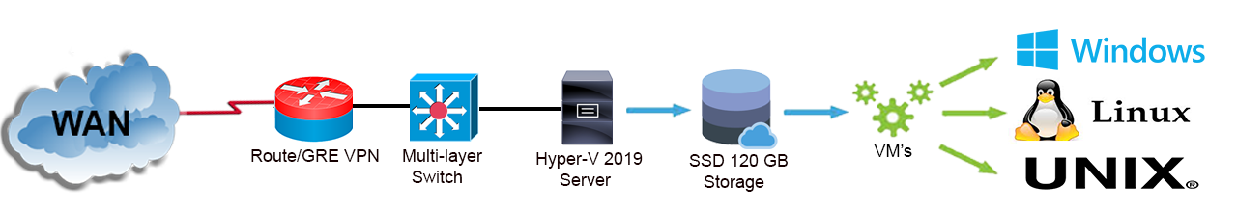
Figure 11: CNSaaS CSP NOC LAN Topology [6]

4.1.1 Development Notes
During the configuration of the Linux and Unix server VM’s, a compatibility issue was found within the new current version of SAMBA-48 and the Linux/Unix architectures whilst utilising the internal SAMBA-48 DNS server. The internal SAMBA DNS server was utilised for both the Linux and Unix VM’s which created an issue within the resolv.conf file that was being autonomously updated by the OS at the kernel level overriding the superuser FQDN configurations back to the default settings created for the SAMBA48 DNS server causing the DNS server to fail. This issue was overcome by removing the symbolic link created by the OS and issuing the [chflags schg /etc/resolv.conf] syntax for FreeBSD and the [sudo systemctl disable systemd-resolved] syntax for Ubuntu to disable the overriding kernel level function of the OS that was causing the issue.
Also, future recommendations would be to use an external DNS server such as; BIND9 rather than the internal SAMBA DNS server because of the compatibility issues outlined above and also for more granular control of the ‘A’ records and efficiency of the DNS process. The SAMBA-48 AD and File server feature that were utilised, worked very efficiently without any troubleshooting issues after installation and configuration.
The rest of the core services that were implemented from the Research and Development Literature section of this paper was installed and configured without any troubleshooting issues.
The core service connectivity to each of the OS client’s screenshots can be found in Appendix ?? of this paper.

4.2 Objective 2: SMB LAN Spoke Design and Implementation
The network architecture for the three SMB LAN segments of the CNSaaS CSM experiment were implemented using; 1 x Cisco 1900 series router, 1 x Cisco 2900 series Layer-2 Switch 1 and 1 x Dell (I6 2.5Ghz, 16GB RAM and 1 TB HDD) Computer with Windows 10 academic edition client OS installed. An illustration of the topology can be found in figure 13.
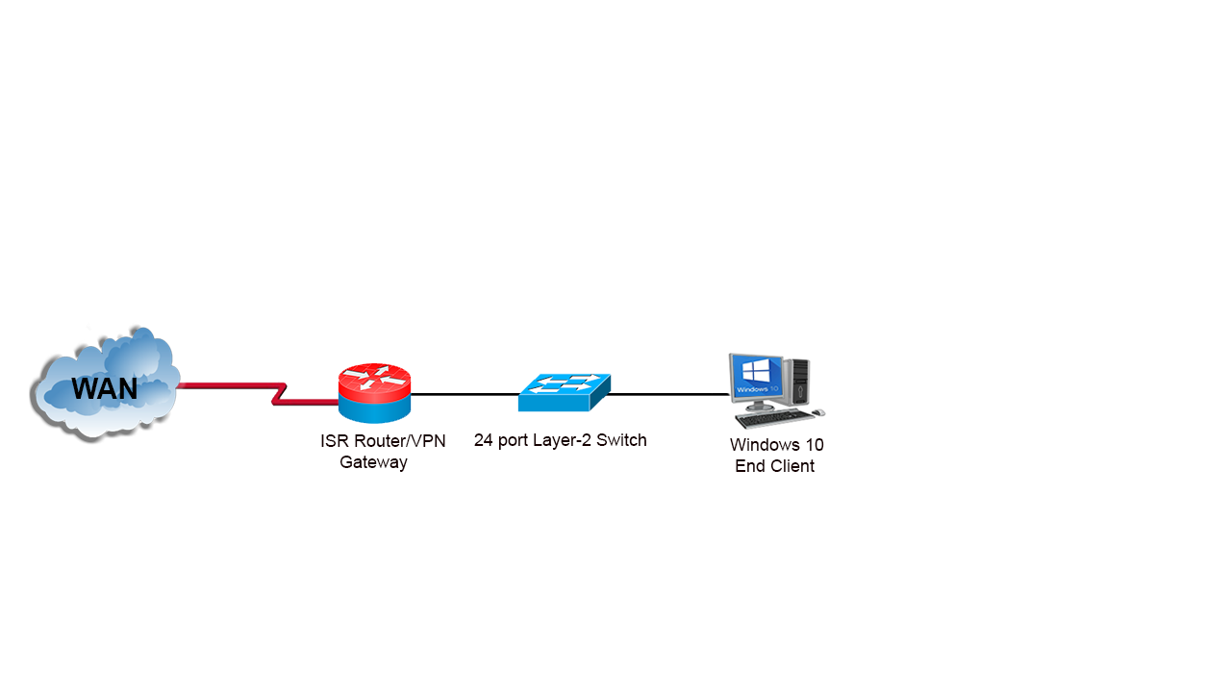
Figure 12: CNSaaS SMB's LAN Topology [6]

4.2.1 Development Notes
The SMB LAN spokes were all configured utilising the above topology discussed within the Research and Development Literature section of this paper. There were no troubleshooting issues or bugs found whilst configuring these network segments.

4.3 Objective 3: Hypervisor and Server VM OS’s Configuration
The virtualisation of the parent OS (Windows server 2019) was implemented using the Hyper-V role and Hyper-V Manager within the parent OS to install the three server VM’s along with a Windows 10 client VM that was utilised as a test bed before full network convergence.
The Hyper-V Manger tool [219] was also utilised to configure the external vSwitches and the virtual interfaces for each of the VM’s. A screenshot depicting the installation and configurations outlined above can be found in figure 14.
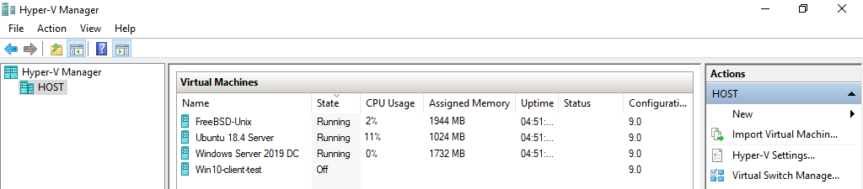
Figure 13: Hyper-V Server Manager VM Installation and Configuration [219]

4.3.1 Development Notes
The Hyper-V virtualisation and VM installation, along with the virtual networking were all implemented utilising the above topology discussed within the Research and Development Literature section of this paper. There were no troubleshooting issues or bugs found whilst configuring these network segments. The external vSwitch generated by Hyper-V was given an IP address shown within the IP table (table 1) for remote management of the server via the parent OS.

4.4 Objective 4: Wide Area Network (WAN)
The network architecture for the emulated WAN segment of the CNSaaS CSM experiment was implemented using 7 x Cisco 1900 series LAN routers. An illustration of the topology can be found in figure 15.
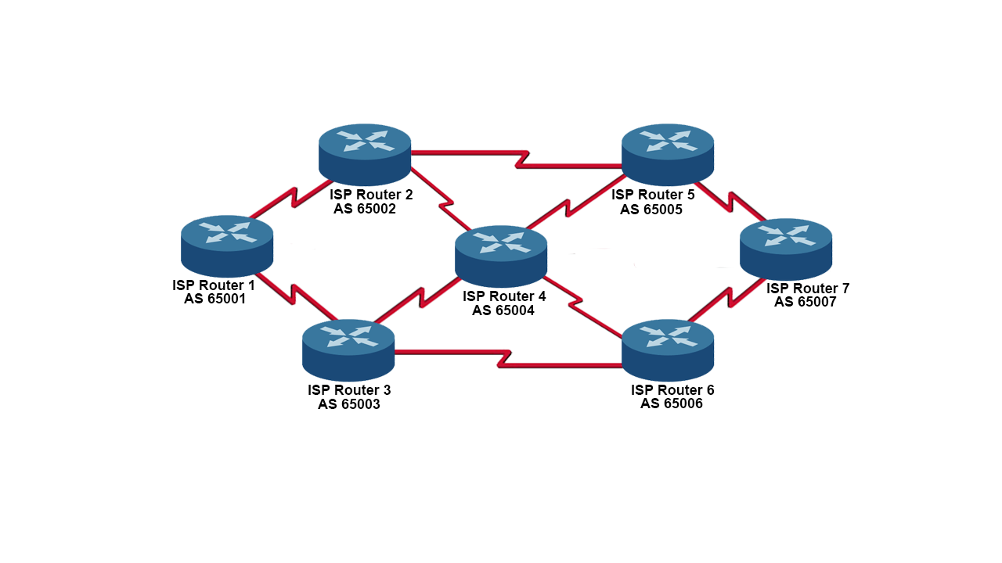
Figure 14: CNSaaS Emulated WAN Topology [6]

4.4.1 Development Notes
The emulated WAN segment was configured utilising the above network topology and the theory and development approach discussed within the Research and Development Literature section of this paper.
There were no troubleshooting issues or bugs found whilst configuring these network segments within the Cisco devices. Serial WIC interfaces were utilised as opposed to Gigabit routed Ethernet ports because of the limited number of available ports within the Cisco 1900 LAN based routers, unfortunately this created a throughput bottleneck of 350KB/s (2.8MB/s) within the CNSaaS experiment.

4.5 Objective 5: Network Convergence
The convergence of all the network segments outlined within this section of the paper can be found in figure 16.
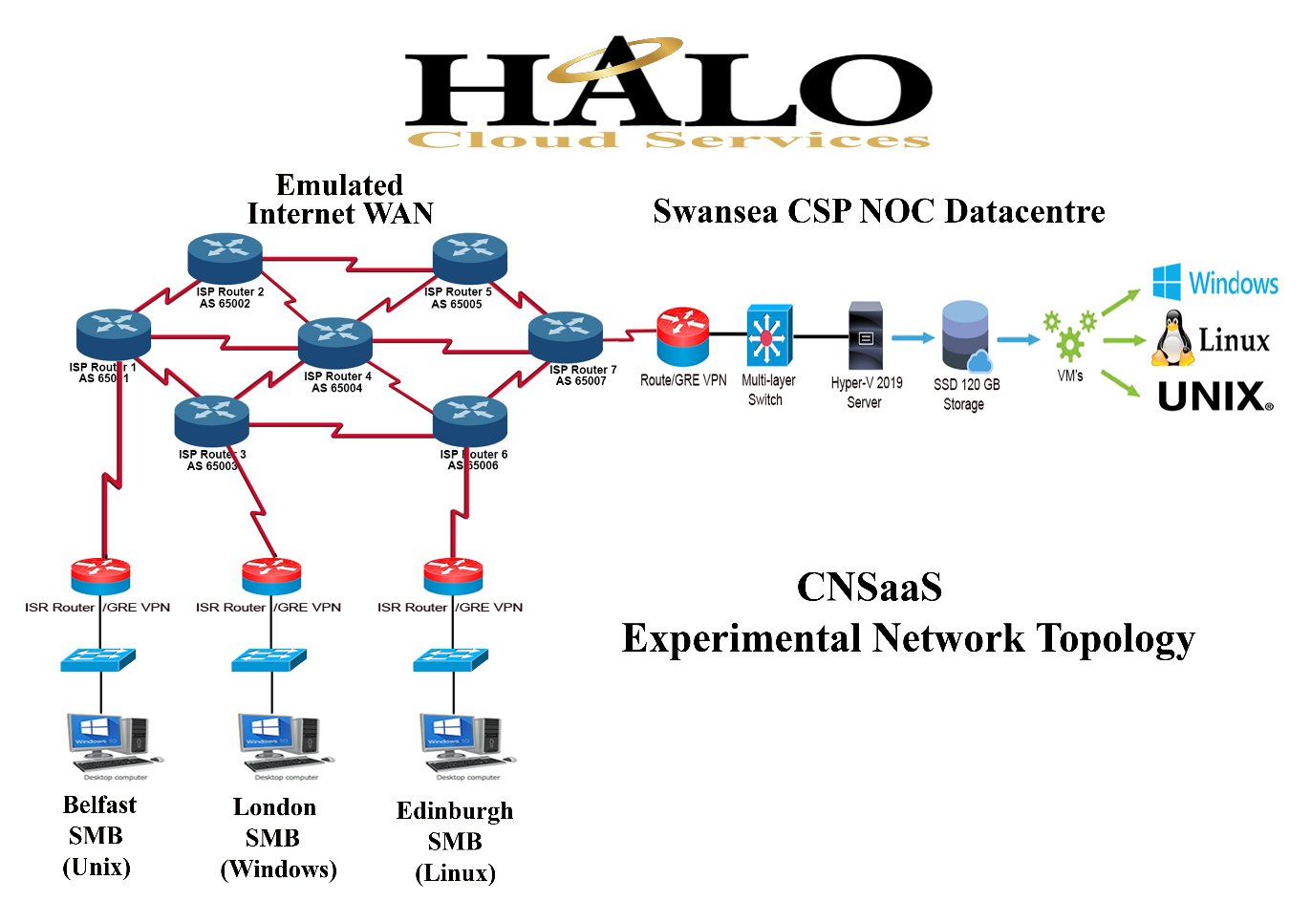
Figure 15: CNSaaS Converged Logical Topology [6]

4.6.1 Development Notes
Utilising the development methodology previously discussed in this paper allowed for the individual testing and troubleshooting of all the network segments in order to isolate any issues that occurred within each segment, this development method expedited the troubleshooting process making it less complex than if an issue was to occurred once full convergence had taken place, the development methodology identified at the start of the project allowed for a seamless convergence of the complete network topology with no issues to troubleshoot thereafter.

5.0 Network Benchmarking Metric Collection of the Raw Data
As previously discussed within the Research and Development Literature section of this paper continuous ICMP messages were generated until 1000 packets had been sent/received from a client terminal to each client LAN’s corresponding server located within the CSM NOC LAN utilising the ‘-t’ switch within the Windows client CLI in order to benchmark the CNSaaS OS VM’s and the two WAN protocols BGP and MPLS. Upload and Download throughput speeds were measured utilising a 100MB file transfers from each of the corresponding server VM OS to the end clients within the LAN the server VM OS servers as a control measure, each benchmarking test was conducted three times and the mean average was calculated to reflect the true metric data to account for possible hardware/software fluctuations and disparities during each benchmarking test.

5.1 LAN OS Client Spoke Placement in the WAN in Relation to Hop Count as a Controlled Measure
Hop count was included (shortest path) to the raw data tables as a controlled measure, with the hypothesised most efficient OS LAN (Unix – FreeBSD) spoke positioned furthest away (4 Hops) from the NOC CSP LAN and the second most hypothesised efficient OS (Linux – Ubuntu) spoke positioned the closest (2 Hops) to the NOC CSP LAN. Finally, the hypothesised least efficient OS server (Windows – Server) was positioned central (3 Hops) within the CNSaaS experimental network topology from the NOC CSP LAN also within the first controlled permutation of the SMB LAN placement experiments, to develop a baseline of the network and server OS. The hypothesis of the efficiency of each of the server OS and their overall placement was drawn from the research conducted within the Server OS Architecture research section of this paper.
A second and third permutation of SMB LAN placement in relation to the CSP NOC LAN was then performed so that each server OS generated data from each mathematically possible permutation of the LAN to WAN topological locations within the experimental network topology for further analysis. This rigorous experimental framework was implemented to collect objective non-biased data to retrieve a true representation of the final outcome from the CNSaaS experimental project
The controlled topology LAN placement in relation to hop count, data analyses framework was created to observe if firstly; hop count had a bearing on the experiment because of the small number of routers that were utilised within the computer laboratory emulated WAN as opposed to the multitude of routers that are present within the public WAN, so results to the contrary could reflect a false positive because of the variation within the amount of router hops that each packet within the emulated laboratory WAN had to make in order to traverse the network for each round trip.
Secondly the controlled placement of each of the OS LAN spokes was put in place to analyse the proposed fluctuation within CPU utilisation from each of the routers between each of the WAN protocols (BGP and MPLS) as the research suggests that MPLS is a lot more resource intensive protocol compared with BGP which would have an overall baring within the data output form the CNSaaS experiment, because low grade LAN routers were utilised within the computer laboratory to create the WAN, as opposed to high end ISP routers that are utilised within the public WAN i.e. the Internet, so a false positive of data could be produced because of the LAN grade hardware that was utilised within the computer laboratory.
This framework would also produce data that could be analysed and to further observe the latency being produced within the emulated WAN so that the remaining latency could be calculated and then subtracted from the reported LAN VM OS latency to evaluate the true latency produced from each of the VM’s in order to establish which VM OS is the most efficient moving forward with the proposed CNSaaS CSM.

5.2 Tabulated Raw Data Output Collected from the Network Metric Benchmark Experiments
The data collected from each of the CNSaaS experiments were entered into tables that were then later exported into Microsoft Excel to create graphs so that the data could be visualised to evaluate what the data was representing so that conclusions could be drawn. Evidence of the raw data collected from the CNSaaS project that was utilised in the below tables can be found in the Appendices section of this paper.

5.2.3 BGP and MPLS Experiment Raw Data
The BGP and MPLS experiments; ICMP raw benchmarking data of 1000 packets and the file server throughput (Download and Upload) tests 100MB file. Each test was conducted within 30 Minute intervals of each one another. The raw data can be found below in Tables 2-7.

5.2.3.1 SMB LAN Location in Relation to Hop Count First Permutation (Baseline Control)
The raw data from the BGP experiment can be found in Table 2.
BGP Experiment
 | Throughput (KB/s)  Maximum 355 KB/s |  | Latency (Milliseconds) | Packet loss % | Hop Count
Server OS | Download | Upload | ICMP 1000 Packets Roundtrip Average | ICMP  1000 Packets | WAN Provider Routers
Test 1
Unix – FreeBSD 12 | 355 | 355 | 1 | 0% | 4
Windows Server 2019 | 355 | 355 | 3 | 0% | 3
Linux – Ubuntu 18 | 355 | 355 | 2 | 0% | 2
Test 2
Unix – FreeBSD 12 | 355 | 355 | 1 | 0% | 4
Windows Server 2019 | 355 | 355 | 3 | 0% | 3
Linux – Ubuntu 18 | 355 | 355 | 2 | 0% | 2
Test 3
Unix – FreeBSD 12 | 355 | 355 | 1 | 0% | 4
Windows Server 2019 | 355 | 355 | 3 | 0% | 3
Linux – Ubuntu 18 | 355 | 355 | 2 | 0% | 2
Mean Average
Unix – FreeBSD 12 | 355 | 355 | 1 | 0% | 4
Windows Server 2019 | 355 | 355 | 3 | 0% | 3
Linux – Ubuntu 18 | 355 | 355 | 2 | 0% | 2
Table 2: BGP ICMP and Throughput Experiment First Permutation (Control)
The raw data from the MPLS experiment can be found in Table 3.
MPLS Experiment
 | Throughput (KB/s)  Maximum 355 KB/s |  |  | Latency (Milliseconds) | Packet loss % | Hop Count
Server OS | Download | Upload |  | ICMP 1000 Packets Roundtrip Average | ICMP  1000 Packets | WAN Provider Routers
Test 1
Unix – FreeBSD 12 | 355 |  | 355 | 3 | 0% | 4
Windows Server 2019 | 355 |  | 355 | 2 | 0% | 3
Linux – Ubuntu 18 | 355 |  | 355 | 1 | 0% | 2
Test 2
Unix – FreeBSD 12 | 355 |  | 355 | 3 | 0% | 4
Windows Server 2019 | 355 |  | 355 | 2 | 0% | 3
Linux – Ubuntu 18 | 355 |  | 355 | 1 | 0% | 2
Test 3
Unix – FreeBSD 12 | 355 |  | 355 | 3 | 0% | 4
Windows Server 2019 | 355 |  | 355 | 2 | 0% | 3
Linux – Ubuntu 18 | 355 |  | 355 | 1 | 0% | 2
Mean Average
Unix – FreeBSD 12 | 355 |  | 355 | 3 | 0% | 4
Windows Server 2019 | 355 |  | 355 | 2 | 0% | 3
Linux – Ubuntu 18 | 355 |  | 355 | 1 | 0% | 2
Table 3: MPLS ICMP and Throughput Experiment First Permutation (Control)

5.2.3.2 SMB LAN Location in Relation to Hop Count Second Permutation
The raw data from the BGP experiment can be found in Table 4.
BGP Experiment
 | Throughput (KB/s)  Maximum 355 KB/s |  | Latency (Milliseconds) | Packet loss % | Hop Count
Server OS | Download | Upload | ICMP 1000 Packets Roundtrip Average | ICMP  1000 Packets | WAN Provider Routers
Test 1
Windows Server 2019 | 355 | 355 | 4 | 0% | 4
Linux – Ubuntu 18 | 355 | 355 | 2 | 0% | 3
Unix – FreeBSD 12 | 355 | 355 | 1 | 0% | 2
Test 2
Windows Server 2019 | 355 | 355 | 4 | 0% | 4
Linux – Ubuntu 18 | 355 | 355 | 2 | 0% | 3
Unix – FreeBSD 12 | 355 | 355 | 1 | 0% | 2
Test 3
Windows Server 2019 | 355 | 355 | 4 | 0% | 4
Linux – Ubuntu 18 | 355 | 355 | 2 | 0% | 3
Unix – FreeBSD 12 | 355 | 355 | 1 | 0% | 2
Mean Average
Windows Server 2019 | 355 | 355 | 4 | 0% | 4
Linux – Ubuntu 18 | 355 | 355 | 2 | 0% | 3
Unix – FreeBSD 12 | 355 | 355 | 1 | 0% | 2
Table 4: BGP ICMP and Throughput Experiment Second Permutation
The raw data from the MPLS experiment can be found in Table 5.
MPLS Experiment
 | Throughput (KB/s)  Maximum 355 KB/s |  | Latency (Milliseconds) | Packet loss % | Hop Count
Server OS | Download | Upload | ICMP 1000 Packets Roundtrip Average | ICMP  1000 Packets | WAN Provider Routers
Test 1
Windows Server 2019 | 355 | 355 | 5 | 0% | 4
Linux – Ubuntu 18 | 355 | 355 | 2 | 0% | 3
Unix – FreeBSD 12 | 355 | 355 | 1 | 0% | 2
Test 2
Windows Server 2019 | 355 | 355 | 5 | 0% | 4
Linux – Ubuntu 18 | 355 | 355 | 2 | 0% | 3
Unix – FreeBSD 12 | 355 | 355 | 1 | 0% | 2
Test 3
Windows Server 2019 | 355 | 355 | 5 | 0% | 4
Linux – Ubuntu 18 | 355 | 355 | 2 | 0% | 3
Unix – FreeBSD 12 | 355 | 355 | 1 | 0% | 2
Mean Average
Windows Server 2019 | 355 | 355 | 5 | 0% | 4
Linux – Ubuntu 18 | 355 | 355 | 2 | 0% | 3
Unix – FreeBSD 12 | 355 | 355 | 1 | 0% | 2
Table 5:MPLS ICMP and Throughput Experiment Second Permutation

5.2.3.3 SMB LAN Location in Relation to Hop Count Third Permutation
The raw data from the BGP experiment can be found in Table 6.
BGP Experiment
 | Throughput (KB/s)  Maximum 355 KB/s |  | Latency (Milliseconds) | Packet loss % | Hop Count
Server OS | Download | Upload | ICMP 1000 Packets Roundtrip Average | ICMP  1000 Packets | WAN Provider Routers
Test 1
Linux – Ubuntu 18 | 355 | 355 | 3 | 0% | 4
Unix – FreeBSD 12 | 355 | 355 | 1 | 0% | 3
Windows Server 2019 | 355 | 355 | 2 | 0% | 2
Test 2
Linux – Ubuntu 18 | 355 | 355 | 3 | 0% | 4
Unix – FreeBSD 12 | 355 | 355 | 1 | 0% | 3
Windows Server 2019 | 355 | 355 | 2 | 0% | 2
Test 3
Linux – Ubuntu 18 | 355 | 355 | 3 | 0% | 4
Unix – FreeBSD 12 | 355 | 355 | 1 | 0% | 3
Windows Server 2019 | 355 | 355 | 2 | 0% | 2
Mean Average
Linux – Ubuntu 18 | 355 | 355 | 3 | 0% | 4
Unix – FreeBSD 12 | 355 | 355 | 1 | 0% | 3
Windows Server 2019 | 355 | 355 | 2 | 0% | 2
Table 6: BGP ICMP and Throughput Experiment Third Permutation
The raw data from the MPLS experiment can be found in Table 7.
MPLS Experiment
 | Throughput (KB/s)  Maximum 355 KB/s |  | Latency (Milliseconds) | Packet loss % | Hop Count
Server OS | Download | Upload | ICMP 1000 Packets Roundtrip Average | ICMP  1000 Packets | WAN Provider Routers
Test 1
Linux – Ubuntu 18 | 355 | 355 | 4 | 0% | 4
Unix – FreeBSD 12 | 355 | 355 | 1 | 0% | 3
Windows Server 2019 | 355 | 355 | 2 | 0% | 2
Test 2
Linux – Ubuntu 18 | 355 | 355 | 4 | 0% | 4
Unix – FreeBSD 12 | 355 | 355 | 1 | 0% | 3
Windows Server 2019 | 355 | 355 | 2 | 0% | 2
Test 3
Linux – Ubuntu 18 | 355 | 355 | 4 | 0% | 4
Unix – FreeBSD 12 | 355 | 355 | 1 | 0% | 3
Windows Server 2019 | 355 | 355 | 2 | 0% | 2
Mean Average
Linux – Ubuntu 18 | 355 | 355 | 4 | 0% | 4
Unix – FreeBSD 12 | 355 | 355 | 1 | 0% | 3
Windows Server 2019 | 355 | 355 | 2 | 0% | 2
Table 7: MPLS ICMP and Throughput Experiment Third Permutation

5.2.4 Latency to Hop Count Ratio within the Emulated LAN

5.2.4.1 Calculating the Emulated WAN Latency
The calculations discussed below were undertaken so that the WAN latency data could be separated from the overall latency observed within each of the experiments, to gain a better understanding of the true latency disparities between each of the VM OS’s that were utilised within the experiments.
After further analysis of the raw data collected from the three permutations of the SMB LAN Location in Relation to Hop Count data. Further calculations of the permutated hop count to latency ratio data were performed utilising mathematical statistical analysis; ‘Mean’ [n value + n value + n value / n values] and ‘Midrange [Midrange = (Highest Value – Lowest Value) / 2] formulas to establish the correlation between hop count and latency within the emulated WAN in decimalised form.
The ‘Midrange’ formula was applied to the ‘Mean’ of the permutation data because when the ‘Mean’ formula was applied to the ‘Mean’ of the permutation data, the reported lowest value was 2ms, this value is known to be incorrect because it is greater than the lowest value reported within the original raw dataset parameters ≥1ms and ≤5ms, when the ‘Midrange of Mean’ calculation was applied the results were within the original raw data parameters that reflected a true representation of the original raw data.
Emulated WAN - Latency to Hop Count Ration – Range Calculation
 | BGP | MPLS
Unix | Latency | Latency
Permutation 1 | 1 | 3
Permutation 2 | 1 | 1
Permutation 3 | 1 | 1
Mean* | 1 | 1.67
Windows | Latency | Latency
Permutation 1 | 3 | 2
Permutation 2 | 4 | 5
Permutation 3 | 2 | 2
Mean* | 3 | 3
Linux | Latency | Latency
Permutation 1 | 2 | 1
Permutation 2 | 2 | 2
Permutation 3 | 3 | 4
Mean* | 2.33 | 2.33
Midrange of Mean* | 0.5ms | 0.69ms
Table 8: Latency to Hop Count Ratio – Midrange of Ranges Calculation

5.2.4.2 Calculating the Virtual Machine OS Latency
The VM OS latency raw data was calculated by subtracting each WAN protocols recorded latency from the ‘Midrange of Mean’ calculation performed in table 8 at each hop within the experimental network topology. The calculated ‘Midrange of Mean’ WAN latency was divided by four and multiplied by the number of hops that each OS LAN took within the WAN during each permutation, so the calculated WAN latency could be deducted from the VM OS LAN at each hop of the network. The derived formula [Midrange of Mean / 4 * (n Routers)] could be utilised to determine the assumed latency within the CNSaaS emulated WAN if the experiment was to be scaled up for future investigation.
The ‘Mean’ formula was further utilised to correlate the data from each of the OS permutation for both the BGP and MPLS experiments.
The ‘Mean’ from each of the calculated OS ‘Mean’ values at each hop within the emulated WAN was then further calculated to isolate the WAN latency from the CSP NOC VM OS LAN latency.
The one standard deviation formula [220]; σ illustrated in figure 17 was then calculated from the ‘Mean of Mean’ calculation results from the BGP and MPLS VM OS assumed calculated latency, to determine the error rate within the performed calculations in decimalised form, to observe the error rate ± tolerance of each server at the CSP NOC VM OS LAN after the final calculations had been performed.
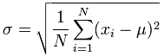
Figure 16: Standard Deviation Formula σ
The tabulated raw data from the discussed calculations within this section of the paper can be found in Table 9.
Calculated Emulated WAN Latency
VM OS | Latency (Milliseconds)
Hop Count = 4 | BGP (-0.5ms) | MPLS (-0.69ms)
Unix | 0.5 | 2.31
Windows | 3.5 | 4.31
Linux | 1.5 | 3.31
Hop Count = 3 | BGP (-0.38ms) | MPLS (-0.52ms)
Unix | 0.62 | 0.48
Windows | 2.62 | 1.48
Linux | 1.62 | 1.48
Hop Count = 2 | BGP (-0.25ms) | MPLS(-0.35ms)
Unix | 0.75 | 0.65
Windows | 1.75 | 1.65
Linux | 1.75 | 0.65
Mean | BGP | MPLS
Unix | 0.62 | 1.15
Linux | 1.63 | 1.81
Windows | 2.63 | 2.48
Mean of BGP and MPLS
Final VM OS Calculated Latency
Unix | 0.89ms
Linux | 1.72ms
Windows | 2.56ms
Calculated Mean WAN Latency Difference between BGP and MPLS
Mean of the VM OS Mean | BGP | MPLS
 | 1.63 | 1.81
One Standard Deviation σ Calculated from the Mean of the VM OS Mean (BGP and MPLS)
± 0.09ms
Table 9: Calculated VM OS Latency within a Tolerance of ± 0.09ms
The one standard deviation σ formula performed on the ‘Mean of Mean’ calculations can be found below:
σ² =
  Σ(x_{i} - μ)²
  N
=
  (1.63 - 1.72)² + ... + (1.81 - 1.72)²
  2
=
  0.0162
  2
= |  | 0.0081

σ = | √0.0081
= | 0.09ms
The latency to hop count experimental emulated WAN latency data that was calculated within table 9, could be further investigated by utilising the “2 factor ANOVA” data analysis method to observe statistically significant differences between the hop count location for both (BGP and MPLS) in regard to VM OS efficiency. This process would require considerably more raw data to be collected and correlated to accomplish, in order to provide a more accurate mathematical value of the VM OS Latency within the CNSaaS experimental network.

5.2.4.3 Calculated Mean WAN Latency Percentage Difference between BGP and MPLS ≤ 3 Hops
To get a true reflection of the efficiency differences between BGP and MPLS the permutation for each OS that comprised of >3 hops was removed from the ‘Mean’ calculation because the raw data >3 hops was skewed, this was creating an anomaly within the MPLS overall data so a true comparison between the efficiency of BGP and MPLS could not be observed from the Calculated VM OS Latency calculations in table 9. The MPLS anomaly is theorised to be caused by the greater hardware utilisation of the MPLS protocol compared with the BGP protocol within the LAN grade routers utilised within the experiment.
The ‘Mean’ from the hop count that was ≤ 3 hops was first calculated, then the ‘Mean of the Mean’ from both protocols was calculated and then finally the percentage difference was calculated from the ‘Mean of the Mean’ data [(BGP Mean of Mean - MPLS Mean of Mean) / BGP Mean of Mean * 100] to identify the percentage efficiency differences between the two protocols.
The calculations previously discussed can be found in table 10.
Calculated Mean WAN Latency Percentage Difference between BGP and MPLS ≤ 3 Hops
VM OS | Latency (Milliseconds)
Hop Count = 3 | BGP | MPLS
Unix | 0.62 | 0.48
Windows | 2.62 | 1.48
Linux | 1.62 | 1.48
Hop Count = 2 | BGP | MPLS
Unix | 0.75 | 0.65
Windows | 1.75 | 1.65
Linux | 1.75 | 0.65
Mean | BGP | MPLS
Unix | 0.69 | 0.57
Linux | 1.69 | 1.07
Windows | 2.19 | 1.57
Mean of Mean | BGP | MPLS
 | 1.52ms | 1.07ms
Percentage Difference
29.61%
Table 10: Calculated Mean WAN Latency Difference between BGP and MPLS ≤ 3 Hops

5.2.5 Hypervisor VM Hardware Utilisation Raw Data
The VM OS Virtual Hardware Utilisation within the physical server experiment; vCPU and vRAM hardware utilisation test were conducted using Windows PowerShell ‘VM-Measure’ module. The PowerShell ‘VM-Measure’ commands were executed from the parent OS. Three tests were performed 30 minutes apart, the ‘Mean’ was then calculated to reflect the overall efficiency of each VM OS. The raw test data can be found in Table 11.
Server VM OS Virtual Hardware Utilisation Experiment
Server OS | vCPU MHz | vRAM MB
Test 1
Unix – FreeBSD 12 | 1228 | 1024
Windows Server 2019 | 17 | 1988
Linux – Ubuntu 18 | 2925 | 1760
Test 2
Unix – FreeBSD 12 | 1150 | 1024
Windows Server 2019 | 17 | 1988
Linux – Ubuntu 18 | 2890 | 1760
Test 3
Unix – FreeBSD 12 | 1210 | 1024
Windows Server 2019 | 17 | 1988
Linux – Ubuntu 18 | 2910 | 1760
Mean | vCPU MHz | vRAM MB
Unix – FreeBSD 12 | 1196 | 1024
Windows Server 2019 | 17 | 1988
Linux – Ubuntu 18 | 2908 | 1760
Table 11: VM Hardware Utilisation Benchmark Experiment

6.0 CNSaaS Raw Data Visualisation and Analysis
The mean average from the experiments that were performed from each of the benchmarking stages within the project were calculated from the raw data collected from the BGP and MPLS tests, along with the two-hardware benchmarking experiments previously discussed, the data was then visualised into graph form to analyse and then further correlate the data in order to identify any patterns that emerged for further evaluation of the results, to determine the behaviour of the hardware/software technologies and configurations that were utilised within the CNSaaS experiments so that the most efficient iteration of the CNSaaS CSM could be identified.

6.1 BGP and MPLS Experiment Data Visualisation Analysis

6.1.1.1 SMB LAN Location in Relation to Hop Count (First Permutation) BGP Data Visualisation Analysis
The data depicted in figure 18 from the first controlled BGP permutation test, identifies the Unix-FreeBSD server to have the least amount of latency (1ms) despite having to traverse 66% more routers (2 Hops) from the furthest location within the network compared with the Linux OS that was at the closest point to the CSP NOC LAN (2 Hops).
The Windows server VM which was positioned within the midpoint of the network reported 3ms of latency, which was the least efficient OS within this test even though it traversed 33% less routers than Unix OS.
The Linux Ubuntu server was positioned at the closest location within the network to the CSP NOC LAN as previously discussed and reported 2ms of latency which is 50% more latency compared to the Unix OS that was positioned at the furthest point of the network which was the most efficient OS within the test even though the Linux OS traversed 66% less routers.
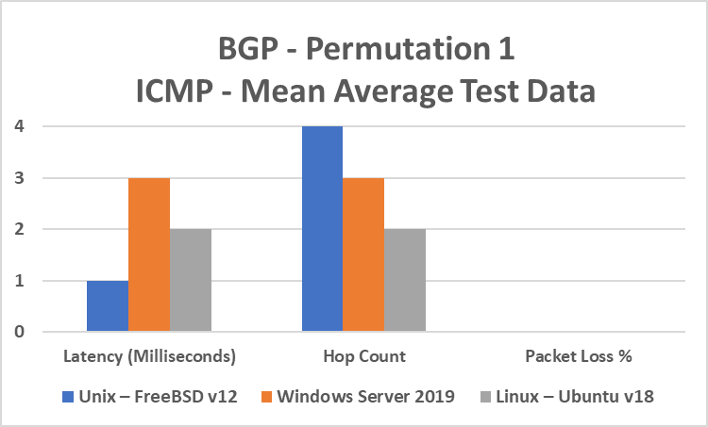
Figure 17: SMB LAN Location in Relation to Hop Count (First Permutation) BGP Data Analysis
The data was also very consistent across all three benchmarking tests within the first permutation of the BGP experiment, as there was no average latency fluctuation and 0% packet loss from any of the servers within the topology that observed the behaviour of 1000 ICMP packets which suggests the network is stable.

6.1.1.2 SMB LAN Location in Relation to Hop Count (First Permutation) MPLS Data Visualisation Analysis
The data depicted in figure 19 from this experiment, identifies that the Linux- Ubuntu LAN spoke had the least amount of latency 1ms within this test which is a 50% reduction from the BGP experiment also making it the most efficient OS within this test.
The Unix – FreeBSD LAN spoke had the highest amount of latency within the MPLS experiment (3ms) which is a 66% increase in latency from the BGP experiment also making the Unix OS the least efficient OS within the MPLS experiment.
The Windows LAN recorded the second lowest amount of latency (2ms) which is a 33% reduction in latency from the BGP experiment.
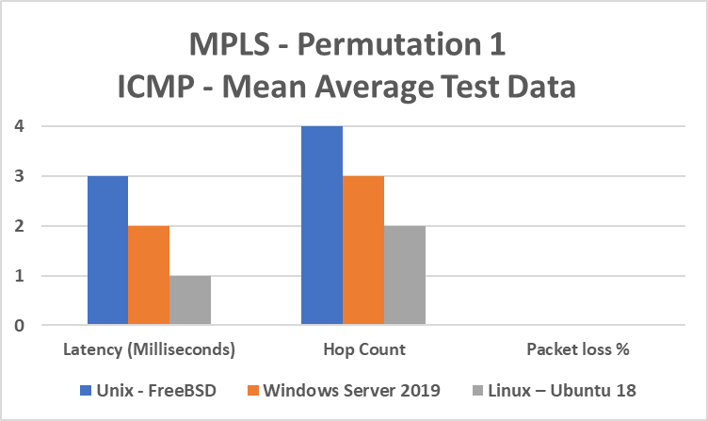
Figure 18: SMB LAN Location in Relation to Hop Count (First Permutation) MPLS Data Analysis
The data was also very consistent across all three benchmarking tests within the first permutation of the MPLS experiment, as there was no average latency fluctuation and 0% packet loss from any of the servers within the topology that observed the behaviour of 1000 ICMP packets which suggests the network is stable.

6.1.1.3 BGP vs MPLS Hop Count and Latency Correlation Analysis Permutation 1
The data from both the BGP and MPLS first permutation experiments was further correlated to visualise the comparison and relationship between hop count and latency across both experiments. The correlated visualised data can be found in figure 20.
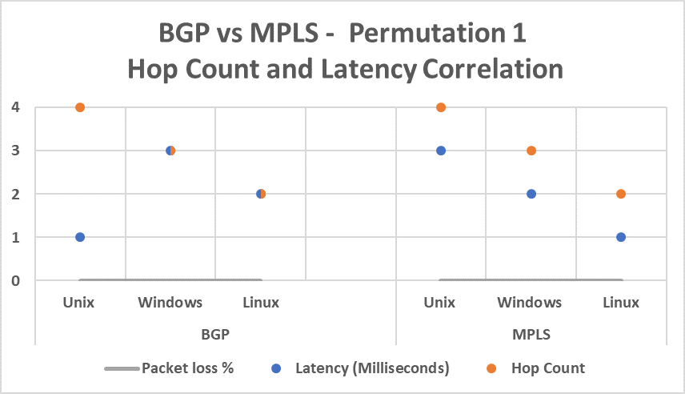
Figure 19: BGP vs MPLS Hop Count and Latency Correlation Analysis Permutation 1
The data comparison from the BGP and MPLS experiments suggests a direct correlation between hop count and latency within the MPLS experiment which had a significant impact on the network performance from each of the respective LAN’s which was a major contributing factor to the reported greater amount of latency within the Unix LAN MPLS experiment compared to the BGP experiment, that reported a 66% increase in latency in this test, making the Unix OS the least efficient OS within the first permutation of the MPLS experiment.
However, the correlated data also suggests that within the Windows MPLS experiment there was reported decrease in latency of 33% when compared to the BGP experiment.
The Linux OS also reported a decrease in latency of 50% within the MPLS experiment making the Linux OS the most efficient LAN within the first permutation of the MPLS experiment.
This data suggests a direct correlation between hop count and latency within the MPLS experiment as packets were being routed at an accelerated rate within the MPLS experiment when the hop count was ≤ 3 hops in comparison to the BGP experiment.

6.1.2.1 SMB LAN Location in Relation to Hop Count Second Permutation BGP Data Visualisation Analysis
The visualised raw data depicted in figure 21 from the second BGP permutation experiment, identifies the Unix-FreeBSD server to have the least amount of latency within the BGP experiment (1ms) which is expected because of the decrease in hop count to the closest location in the experimental WAN to the CSP NOC LAN of 2 hops, in relation to the first permutation where the reported latency was 1ms from the furthest point within the network of 4 hops which suggests the true latency for the Unix OS test is >1ms and <2ms.
The visualised raw data from the BGP Linux OS test similarly reports the latency has not changed from the first permutation from the least number of 2 hops within the network, even though the hop count was increased by 1 hop to the midpoint location within the network of 3 hops. This data suggests that the latency within Linux is between >2ms and <3ms in relation to BGP when correlated with the permutation 1 and permutation 2 test data.
The visualised raw data from the BGP second permutation test depicts the Windows server OS reporting a 33% increase in latency to 4ms at the furthest location within the network compared with the first permutation test data of 3 hops, which was the midpoint location within the network .When the data is correlated from the first permutation test to the second permutation, the hop count rose equally with the latency to 33%.
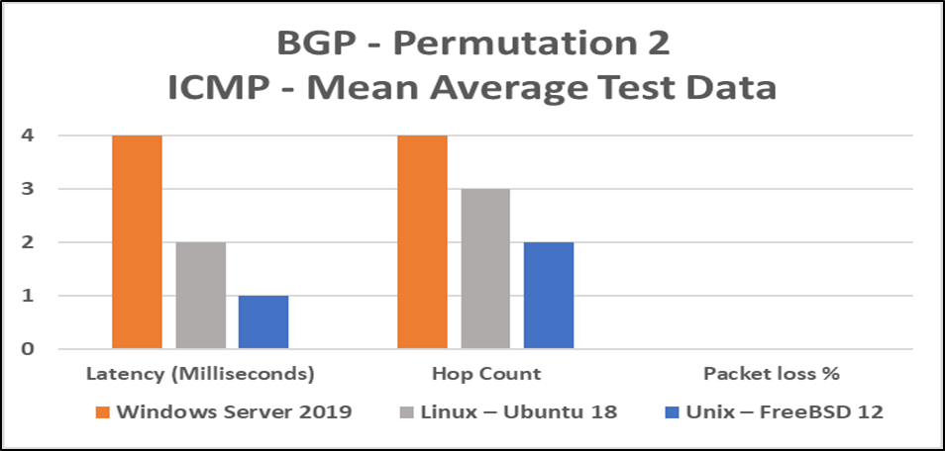
Figure 20: SMB LAN Location in Relation to Hop Count Second Permutation BGP Data Analysis
The data was also very consistent across all three benchmarking tests within the second permutation of the BGP experiment equally to the first permutation, as there was no average latency fluctuation and 0% packet loss from any of the servers within the topology that observed the behaviour of 1000 ICMP packets which suggests the network is stable.

6.1.2.2 SMB LAN Location in Relation to Hop Count Second Permutation MPLS Data Visualisation Analysis
The visualised MPLS data within the second permutation of the MPLS experiment depicted in figure 22 was consistent with the hop count to latency pattern identified in the first permutation of the MPLS experiment, with the furthest OS (Windows – 4 Hops) in relation to the location of the CSP NOC LAN, identifying a 1ms (33%) increase in latency compared to the BGP experiment.
The Unix OS that was positioned at the closest location point to the CSP NOC LAN (2 Hops) reported a 66% reduction in latency compared to the first MPLS permutation making it the most efficient OS within the second permutation of the MPLS experiment. This data when compared with the first and second permutation of the MPLS experiment suggests that when the hop count is ≤ 3 hops the latency is >1ms and <2ms.
The Linux OS that was positioned within the centre of the network in relation to WAN hop count within the second permutation of the MPLS experiment reported a 50% increase in latency 2ms that was equal to the 50% increase in hop count of 1 hop. This data when compared with the first and second permutation suggests that when the hop count is ≤ 3 hops the latency is >2ms and <3ms.
The pattern of decreased latency when the hop count ≤ 3 hops observed within the first permutation of the MPLS experiment can also be observed within the second permutation of the MPLS experiment.
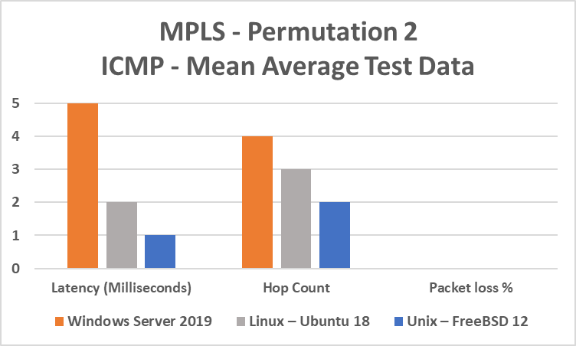
Figure 21: SMB LAN Location in Relation to Hop Count Second Permutation MPLS Data Analysis
The data was also very consistent across all three benchmarking tests within the second permutation of the MPLS experiment equally to the first permutation, as there was no average latency fluctuation and 0% packet loss from any of the servers within the topology that observed the behaviour of 1000 ICMP packets which suggests the network is stable.

6.1.2.3 BGP vs MPLS Hop Count and Latency Correlation Analysis Permutation 2
The data from both the BGP and MPLS second permutation experiments was further correlated to visualise the comparison and relationship between hop count and latency across both experiments. The correlated visualised data can be found in figure 23.
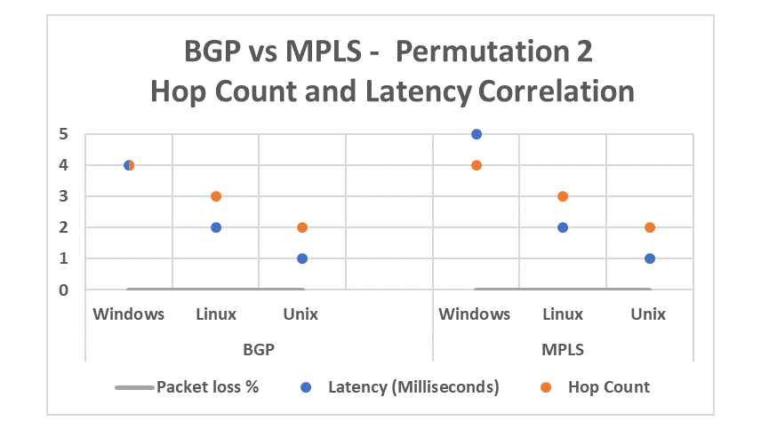
Figure 22: BGP vs MPLS Hop Count and Latency Correlation Analysis Permutation 2
The correlation between BGP and MPLS within the second permutation of the experiments identifies a direct correlation between hop count to latency ratio across both BGP and MPLS experiments, with MPLS reporting an increase of latency when the hop count is >3 hops when compared to the BGP experiment.

6.1.3.1 SMB LAN Location in Relation to Hop Count Third Permutation BGP Data Visualisation Analysis
The visualised raw data depicted in figure 24 from the third BGP permutation experiment, identifies the Unix OS to have the least amount of latency of 1ms within this test after 3 hops to the CSP NOC LAN, which was expected because it also reported 1ms of latency in the first permutation of the experiment where Unix was located at the maximum amount of hops within the network and also the second permutation of the experiment where Unix was positioned at the minimum amount of hops within the network. The previously identified Unix latency range that was >1ms and <2ms concludes that Unix is the most efficient OS within the BGP experiment across all three of the BGP permutations.
The Linux OS had the most amount of latency of 3ms within the third permutation of the BGP experiment which is a 33% increase in latency from the first two permutations of BGP experiment, making it the least efficient OS within the third permutation. After analysing the results from the first and second permutations of the BGP experiment, it can be observed that Linux has an overall latency that is >2ms and <3ms. This identified range of between 2 and 3 milliseconds concludes that Linux is the second most efficient OS across all three of the BGP permutations.
The Windows OS reported a latency of 2ms within the third permutation of the BGP experiment when it was positioned the closest to the CSP LAN NOC of 2 hops making it the second most efficient OS within this permutation of the BGP experiment, which is a 66% decrease in latency from the second permutation at 4 hops and a 33% decrease from the first permutation at 3 hops. After analysing the results from the first and second permutations of the BGP experiment, it can be observed that the Windows OS has an overall latency that is >3ms and <4ms. This identified range of between 3 and 4 milliseconds concludes that Windows is the least efficient OS across all three of the BGP permutations.
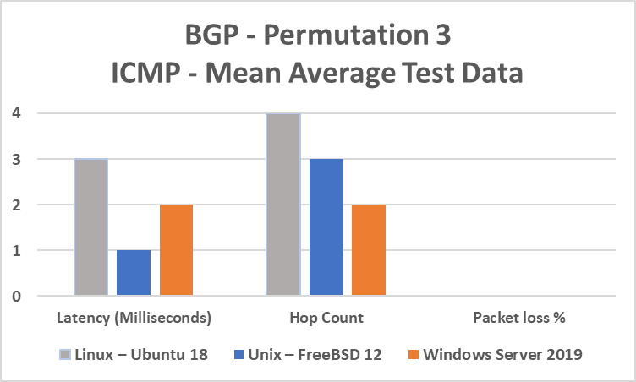
Figure 23: SMB LAN Location in Relation to Hop Count Third Permutation BGP Data Analysis
The data was also very consistent across all three benchmarking tests within the third permutation of the BGP experiment equally to the first permutation, as there was no average latency fluctuation and 0% packet loss from any of the servers within the topology that observed the behaviour of 1000 ICMP packets which suggests the network is stable.

6.1.3.2 SMB LAN Location in Relation to Hop Count Third Permutation MPLS Data Visualisation Analysis
The visualised MPLS data within the third permutation of the MPLS experiment depicted in figure 25 was also consistent with the hop count to latency pattern identified in the first and second permutation of the MPLS experiment. The Linux OS that was positioned with the maximum amount of hops from the CSP NOC LAN within the third permutation of the MPLS experiment had a 66% increase in latency from the first permutation of the experiment and a 33% increase in latency from the second permutation, this increase in latency matches the previously identified hop count to latency ratio pattern from the first and second permutation .
The Windows OS that was positioned closest to the NOC CSP LAN reported a decrease in latency of 60% from the second permutation and a 33% decrease in latency from the first permutation of the MPLS experiment. The latency from the first and third permutation of the MPLS experiment suggests that the Windows latency when the hop count is ≤ 3 hops is >2ms and <3ms.
The Unix OS that was positioned at the centre of the network (3 Hops) reported a 0% change in latency from the second permutation and a 33% decrease in latency from the first permutation.
The results analysed from the first and second permutations of the MPLS experiment when compared with the third permutation suggest a direct correlation between hop count to latency ratio pattern, that was detected within the MPLS experiments and also the relationship between the decrease in latency where the hop count is ≤ 3 hops observed within all three permutation, along with the disproportionate increase of latency when the hop count is >3 hops of the MPLS experiment. This data suggests a direct correlation between router hardware utilisation and the MPLS protocol as the research suggested.
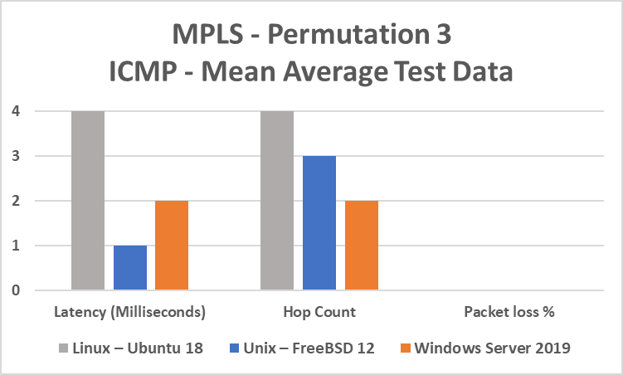
Figure 24: SMB LAN Location in Relation to Hop Count Third Permutation MPLS Data Analysis
The data was also very consistent across all three benchmarking tests within the third permutation of the MPLS experiment equally to the first and second permutation, as there was no average latency fluctuation and 0% packet loss from any of the servers within the topology that observed the behaviour of 1000 ICMP packets which suggests the network is stable.

6.1.3.3 BGP vs MPLS Hop Count and Latency Correlation Analysis Permutation 3
The data from both the BGP and MPLS second permutation experiments was further correlated to visualise the comparison and relationship between hop count and latency across both experiments. The correlated visualised data can be found in figure 26.
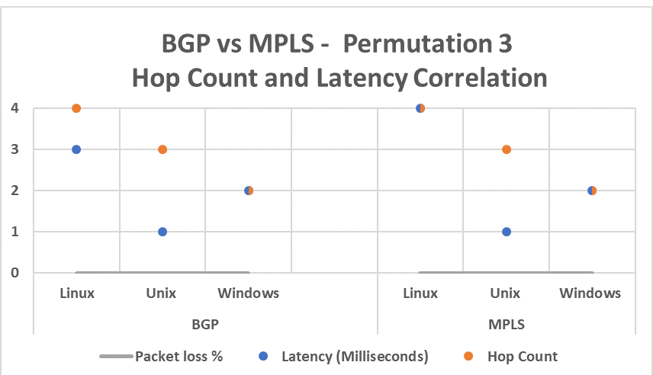
Figure 25: BGP vs MPLS Hop Count and Latency Correlation Analysis Permutation 3
The correlation between BGP and MPLS within the third permutation of the experiments identifies a direct correlation between hop count to latency ratio across both BGP and MPLS experiments similarly to the correlation within the second permutation of the experiment, with MPLS reporting an increase of latency when the hop count is >3 hops when compared to the BGP experiment.

6.1.4.1 Virtual Machine Operating System Latency Mean Average Analysis
Utilising the calculations performed on the initial raw data collected from the benchmarking experiments that were initially expressed as whole numbers (Integers) to subsequently identify the approximated latency generated within the emulated laboratory WAN, which were then subtracted from the calculated overall WAN latency from the initial raw data, in order to identify the most efficient sever OS to a value within two decimal points (float). The values that were returned from these calculations were then further calculated by applying the ‘One Standard deviation’ formula σ (sigma) to these results to return a tolerance of ±0.09ms from the approximated emulated WAN latency as previously discussed. The calculated raw data was then visualised in graph form to identify the most efficient OS and the identified tolerance error rate parameters from the calculations for each of the OS’s. The visualised raw data can be found in figure 27.
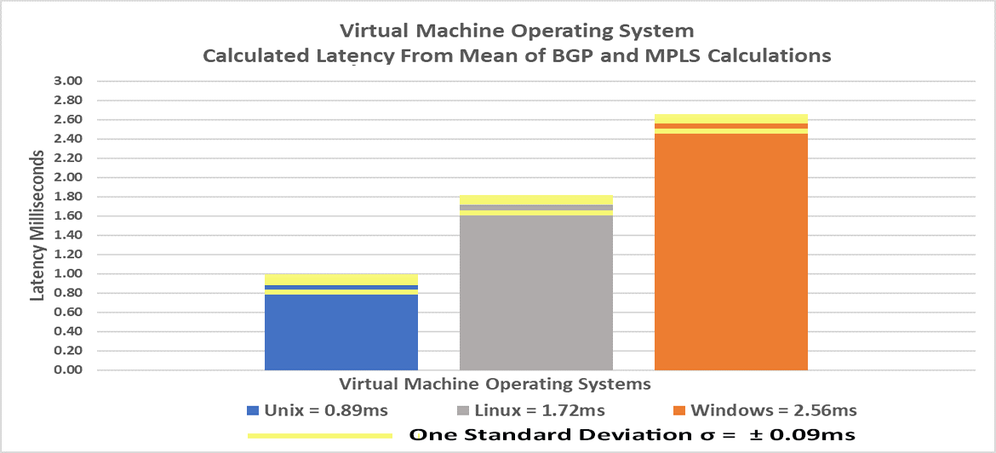
Figure 26: Virtual Machine Operating System Latency Mean Average Analysis with one standard deviation σ
After further analyses of the above graph, the Unix-FreeBSD OS was observed to be the most efficient OS within the experimental CNSaaS network, the calculated ‘Mean’ differences between the three OS’s, identified that the Unix OS was 93.26% more efficient than the Linux-Ubuntu server which was the second most efficient server OS within the experiment and 187.64% more efficient than the least efficient server OS within the experiment which was; ‘Windows server 2019-Datacentre Edition’.
The Linux-Ubuntu server was calculated to be 48.83% more efficient than the Windows OS utilised within the experiment.
The one standard deviation formula reflects the margin of error of the above calculations to a tolerance of ±0.09ms.

6.1.4.2 Emulated WAN Hop Count to Latency Ratio (BGP and MPLS) Midrange Calculation Analysis
The ‘Mean’ emulated WAN latency for BGP and MPLS data previously calculated, were individually divided by four and then multiplied by the number of router hops within the path from the furthest LAN position within the network to the CSP NOC LAN, to create a visual representation of the latency to hop count correlation within the experimental network so that an approximated tangent could be identified to emulate the behaviour of the network if additional routers were implemented within the experimental network between the LAN spokes and the Hub, to observe the additional latency that each hop would create.
The visualised data illustrating the latency within the WAN can be found in figure 28.
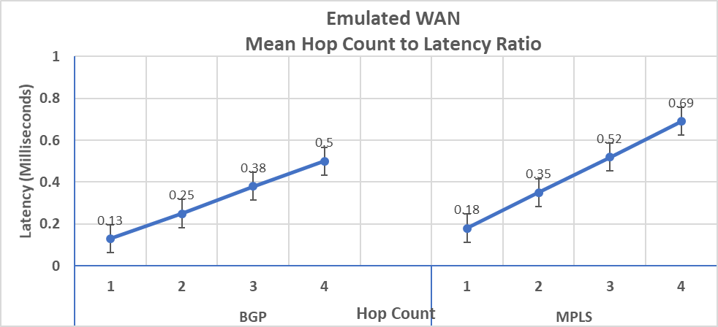
Figure 27: Emulated WAN Hop Count to Latency Ratio (BGP and MPLS) Midrange Calculation Analysis

6.2 Calculated Mean WAN Latency Variance between BGP and MPLS ≤ 3 Hops Analysis
The raw calculated data for the ‘Mean’ differences between BGP and MPLS ≤ 3 Hops was further visualised to analysis the behaviour between the two WAN protocols after the MPLS anomaly was removed from the permutation’s experiments contain >3 routers within the emulated WAN. The visualised data illustrating the Mean differences between BGP and MPLS ≤ 3 hops can be found in figure 29.
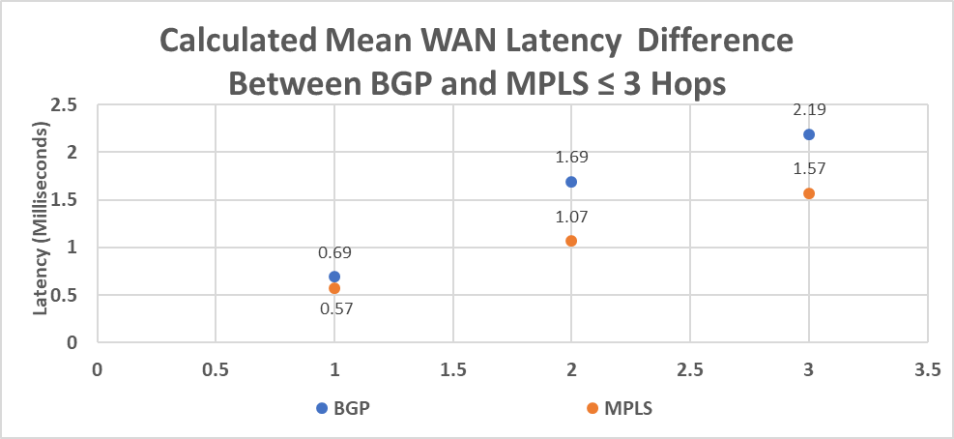
Figure 28: Calculated Mean WAN Latency Variance between BGP and MPLS ≤ 3 Hops Analysis
After the additional hop was removed from the ‘Mean’ average calculations that caused an anomaly within the original data, which is theorised to represent the increased overhead within the LAN routers hardware when the hop count is >3 hops from the additional overhead of the MPLS protocol.
The MPLS protocol was calculated to be 29.61% more efficient on average than the BGP protocol as the visualised graph depicts a significant amount of reduction in latency within MPLS compared to the correlated data visualised within the above graphs that contained >3 hops within the network.
This further investigation from the original raw data supports the theory that the MPLS efficiency dramatically decreases when the hop count is ≤ 3 hops when compared with the BGP mean data ≤ 3 hops. This data also supports the research conducted within the MPLS protocol that can be found in the Research and Development Literature section of this paper.

6.3 OS VM Hardware Utilisation Benchmark Analysis
The raw ‘Mean’ data calculations from the server VM OS virtual hardware utilisation experiment were visualised in graph form to analysis the most hardware efficient server OS within the CNSaaS experiment. The illustration of this data can be found in figure 30.
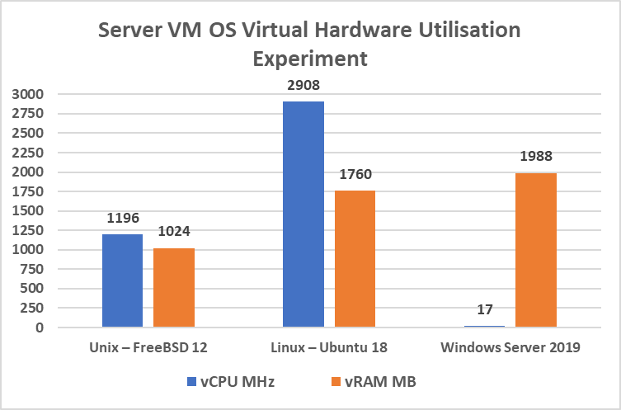
Figure 29: VM Hardware Utilisation Benchmark Analysis
After further analysis of the above graph, the data suggests that there is an anomaly within the vCPU usage within the resource intensive GUI Windows server that is suspiciously low. The low vCPU usage of the Windows VM is theorised to be because the Windows VM OS is utilising the ‘Windows Hyper-V’ parent OS’s CPU utilisation which is also a Windows OS, this data points towards a false positive within the vCPU utilisation within the Windows VM depicted in the above graph. This theory is also supported from the Virtual Machine Operating System Latency Mean Average Analysis that concluded the Windows VM OS to be the least efficient OS within the CNSaaS experiment. When the anomaly is discounted it can be assumed from the previous calculated OS VM efficiency that the vCPU usage of the Windows server is greater than both the Linux and Unix vCPU utilisation.
The graph also depicts once the Windows vCPU anomaly is discounted that the Unix FreeBSD server was utilising 143% less vCPU than the Linux server, because of the Windows anomaly the vCPU percentage difference cannot be calculated from the available data. Further investigation using a third party hypervisor such as: VMware ESXi would need to be performed to remove the Windows vCPU anomaly in order to analyse the vCPU usage differences against Linux and Unix servers.
Regarding the vRAM utilisation from each of the VM’s, the Unix VM was utilising 71.88% less RAM hardware resources than the Linux VM and 94.14% less RAM hardware resources than the Windows VM.
The Linux VM utilised 12.96% less RAM hardware than the Windows VM.
From the above analysis it can be concluded that the Unix VM was the most hardware efficient VM, Linux was the second most hardware efficient VM and Windows was the least hardware efficient VM within the CNSaaS experiment. This analysis is also supported by the previous Virtual Machine Operating System Latency Mean Average that was previously undertaken.

6.4 BGP and MPLS Throughput Analysis of Mean Data
The data comparison across all three OS file servers and both WAN protocols yielded 100% throughput of available bandwidth across all tests from the lowest throughput segment of the network which was the WIC serial interfaces 355 KB/s (2.8 Mb/s) within the emulated WAN. The visualised raw data graph can be found in figure 31.
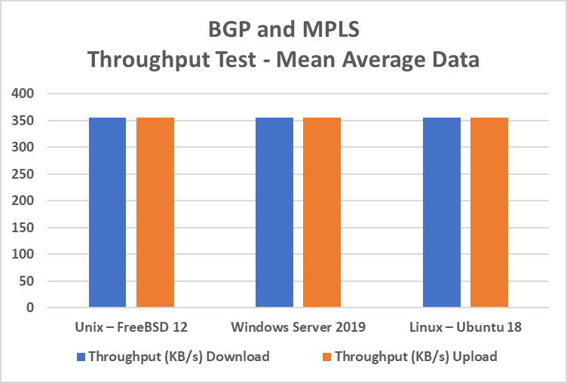
Figure 30: BGP and MPLS Throughput Analysis of Mean Data
The graph depicts 100% throughput (Upload/Download) from each of the OS’s utilised within the experiment, this is a possible false positive result because of the low throughput serial WIC interfaces utilised within the experiment along with the minimal amount of end user traffic traversing the network and being processed by each of the OS within the CSP NOC LAN. Therefore, an objective analysis cannot be performed from this metric data without further investigation utilising Gigabit throughput speed interfaces within the emulated WAN.

7.0 Evaluation of Data Analysis
After analysing the visualised raw data, an impartial evaluation was then conducted from each of the experiments in order to conclude what the data from each of the experiments conducted suggested about the behaviour of the network with the introduction of technologies that are designed to achieve and provide the same services but are built with very different architectures, from the systems engineering sector of various OS’s to the network engineering WAN protocol sector of networking as a whole. Each of the technologies utilised within the experiment are used within the networking industry today separately within various business network topologies around the globe.

7.1 BGP vs MPLS ICMP Experiments
After evaluating the visualised raw data analysis from the ICMP; BGP and MPLS permutation experiments, it can be suggested that the LAN grade router hardware utilised within the experiment had a significant impact within the emulated WAN segment of the network’s performance in relation to the MPLS experiment as the research suggested and was previously theorised, this decrease in efficiency >3 hops was because of the added MPLS field within the IP header that contains 32 bits of additional data that is inserted into each packet at the ingress LER and the removal of the label within the packet at the egress LER along with the additional hardware utilisation of the MPLS protocol within each of the routers within the experiment. MPLS utilises a lot more of the routers hardware resources to switch packets using labels instead of IP address packet header and routing table lookups as the research and the data from the experiments suggests.
However, the reduction of latency in relation to hop count within from the Calculated Mean WAN Latency Variance between BGP and MPLS ≤ 3 Hops Analysis suggests that the Layer-3 MPLS WAN protocol was 29.61% more efficient at routing packets after the label switching protocol had been processed by the router hardware within the emulated WAN, this data also suggests that during the permutation experiments the majority of the bottleneck within the network was at each of the servers and a small portion at the emulated WAN segment when the hop count was <4 hops across both experiments and when the hop count was ≤ 4 hops within the BGP experiments, this was observed from the calculated raw data and the analysis from the Virtual Machine Operating System Latency Mean Average Analysis section of this paper, so it can be concluded from this information that the latency within the emulated WAN had no baring within the CNSaaS experiment outcome of the most efficient server OS. During the MPLS experiment it can be observed from the data that the server OS portion of the bottleneck was then transferred to the WAN segment once the MPLS overhead was introduced to the network when the number of router hops was >3 which had a significant baring on the latency that was collected within the OS MPLS permutations that contained >3 hops that resulted in an accumulative increase in latency throughout the WAN.
The conclusions that can be drawn from the experimental data and analysis is that if high end ISP grade routers had of been utilised within the experiment then the order of OS LAN spoke efficiency would have remained the same from the BGP experiment and the MPLS experiment, that would have possibly further reduced the latency at each of the LAN spokes once MPLS was introduced within the high grade ISP networking equipment and in turn further bolstering the overall performance of the network at Layer-3, concluding that MPLS although very resource intensive is a lot more efficient at routing packets as opposed to BGP.
Unix-FreeBSD was identified as the most efficient OS at processing data that was theorised to be because of the combination of the ‘Swap’ partition that Unix- FreeBSD utilises along with the highly efficinet ZFS file architecture and CLI, as opposed to Linux that was the second most efficient server OS within the experiment that utilises an EXT4 file system that also utilises a swap partition and CLI, thus further theorising that the added efficiency between Linux and Unix was the kernel and file system that was utilised. Windows was the least efficient OS at processing data this was theorised to be because of the GUI, counterintuitive ‘Page’ file caching, Bloatware and NTFS file architecture but the easiest to configure and manage because of the friendly GUI interface that is favoured by the majority of Administrators around the globe within industry because of this.
In regards to the packet loss data within the experimental CNSaaS CSM network, the data collected cannot be objectively evaluated because the results suggest a possible false positive due to the very low amount of end client traffic generated within the network, this metric could only be quantitively analysed within a live environment with a large amount of different data types i.e. TCP, UDP; application, Voice, Video data etc traversing the network along with traffic engineering and a medium-to-high volume of traffic being generated by a multitude of end user clients. For this data to be quantitively analysed further investigation would have to be conducted within a live network environment with a mixture of traffic data types traversing the network and a multitude of end users to observe the true packet loss within the network across the 3 server OS’s

7.2 OS File Server Throughput Experiment
Within relation to the throughput of the network, a true conclusion cannot be drawn from the visualised data because of the low throughput of the WIC serial interfaces that were utilised within the computer laboratory used to conduct the experiments as opposed to Cat-5e Ethernet or Fibre Optic cables. The WIC serial interfaces provide a maximum throughput of 2.8 Mb/s which calculates to 355 KB/s, this reduced the overall throughput of the network to the lowest throughput segment of the network which was within the WAN WIC serial interfaces, creating a bottleneck of 355KB/s during data transfer within the network topology at the WAN segment, this resulted in a possible false positive of 100% throughput from each of the server OS’s file server upload and download tests as previously discussed. The minimal amounts of end clients utilising the server and creating traffic within the network would also have a bearing on the throughput.
However, the latency data from the ICMP tests suggest that the Unix-Free BSD server would possibly yield the highest throughput within the emulated WAN if Gigabit per second interfaces were utilised at this segment within a future experiment, within this scenario the bottleneck of the throughput would then transfer to the NOC CSP LAN VM OS and would rely on how efficient the server VM OS’s processed the data. Further investigation of this theory would need to be conducted to be able to confirm this hypothesis.

8.0 Conclusions
The final conclusions to be drawn from CNSaaS experiment is that in order to utilise the layer-3 MPLS protocol, high end ISP grade routers are needed to gain the full added routing efficiency benefits that this modern WAN protocol provides, otherwise MPLS becomes counterintuitive. However, within the real world outside of a computer laboratory, ISP provide the MPLS protocol layer-3 WAN service for an additional fee which is transparent to the client LAN that is utilising the service, so moving forward with the CNSaaS CSM, MPLS would be a much greater efficient WAN protocol delivery solution as opposed to standalone BGP, but cost analysis would first have to be performed to evaluate if the costs outweigh the benefits of a standard ISP Internet connection that utilises eBGP to lower the overall consumer cost for the end clients that will be receiving the services provided by the CNSaaS CSP.
In relation to the systems engineering segment of the network, Unix-FreeBSD was proven to be the most efficient server OS to utilise moving forward with the CNSaaS CSM, as the results from the VM OS hardware utilisation experiment reflected, that Unix-FreeBSD has a very small footprint in terms of hardware efficiency along with an efficient integrated kernel and shell that provides increased data processing that sequentially provides a high performance, low latency network delivery to end clients.
Furthermore, by utilising Unix-FreeBSD from a business perspective the server hardware housed within the CSP NOC could deliver services to far more SMB clients than if a Windows or Linux-Ubuntu server was utilised which would result in higher profits and less expensive server hardware. Also, as previously discussed Unix-FreeBSD is open source, so a commercial license would not have to be obtained in order to utilise the product which would further increase economic savings at the CSP NOC.
Centralisation in regard to the modern form of cloud computing is an ever-growing progression within computing in the Internet ‘Information Age’ we live in today. Therefore, understanding the most efficient technologies to utilise whilst creating a CSM is paramount to provide an efficient cost effective business solution to an ever growing consumer problem, which is why the experiments outlined within this paper were conducted as the first stage of the design of a new CSM aimed at SMB to outsource 95% of IT operations within these businesses to provide an affordable complete IT solution within the ever growing complex network technologies industry that has emerged within the last decade.
The proposed CNSaaS CSM that would not only provide core network services and the network hardware that provides these services but also NOC engineering maintenance and troubleshooting expertise. Therefore, CNSaaS is a unique CSM that would fill a gap in the cloud services market that has overlooked SMB to allow these less economically funded businesses to concentrate on their respective fields of expertise whilst totally outsourcing the expensive non-profitable growing complexity IT segment of their businesses.
Please refer to the Future Considerations section of this paper to outline further streamlining and testing of efficiency within the CNSaaS CSM in order to create the final iteration of CNSaaS to SMB market.

9.0 CNSaaS Project Reflection
Within the CNSaaS experimental project journey, I feel I have learnt a lot of new skills within systems engineering, network engineering, data analytics and research which are all separate fields within the IT industry that are each very broad subjects in their own rights,. The skills gained during the CNSaaS project, ranged from learning about each of the different advanced server OS file system architectures and terminal shell syntaxes, along with the many tools that are used within each of the aforementioned OS’s i.e. UNIX, Linux and Windows servers, which I was not very familiar with at the start of this project as I would of classed myself as a Cisco network engineer rather than a systems engineer.
I have also learnt some very advanced skills within Cisco network engineering that has vastly broadened my architectural design, security and advanced WAN routing and switching knowledge e.g. IPsec VPN Site-to-Site security Tunnels, MPLS, advanced BGP and many more technologies which are all topics above the scope of a degree level student, which I knew from the outset of this project as I wanted to not only be innovative but push myself to the limit as a person to gain as much knowledge within networking as quickly as possible to grow professionally and to be prepared for the barrage of networking technologies being used within modern businesses today, which was a contributing factor to why I chose do design and peruse this project although I knew it was very large and would be complex at times, the technology utilised within the CNSaaS experimental project are very current and on par with the technologies currently being used within industry today, which I feel will make me more attractive in an employability sense to networking companies within industry.
I also enjoyed the data analytics section of the project as with the data I collected, the more calculations that I was making, the more the behaviour of the data was speaking to me which is something I have never experienced before during this course or my previous career and look forward to doing more data analysis in the future and also learning the more advanced mathematics that is utilised by ‘Big Data’ analysts within industry.
I thoroughly enjoy networking as it feels more like a hobby than a career to me, which is a great balance which I am glad I finally perused as a career as I have only found this industry later on in my life as I am now 30 years of age and feel I have a lot to catch up with and learn which this project has helped me do and also grow, not only professional and academically but also personally.

10.0 Future Considerations for CNSaaS
Future considerations would be to use a virtualised containerisation solution in place of a Hypervisor VM environment to further test hardware efficiency using the identified OS; Unix-FreeBSD as the host to possibly further maximise hardware efficiency and management of SMB clients along with reducing expensive server hardware costs. A container template could also be created comprising of only the core services utilised within this paper along with a VoIP PBX server and the minimum required OS libraries and binary files to allow the container to function with maximum efficiency. A GUI wizard could also be created within the template for less skilled technicians to easily, initialise and quickly configure each new SMB client server that is required to be created.
Within the container the web server could also be utilised to provide a simplified web portal configuration manager for an appointed staff member with very limited network knowledge at each of the SMB’s to easily add/remove users and change their passwords along with the VoIP telephone numbers and AD user privilege policies via the VPN.
By utilising a GUI web portal for appointed staff members at the SMB’s to make minor user/network changes, frees up the network engineers time within the NOC for critical network infrastructure management of all the SMB’s associated with the CNSaaS CSM, that will also reduce staff costs for a help desk, because password changes, user adds/removes are the most frequent requests a local administrator has from his/her end users within a SMB LAN which are usually very regular on a daily basis and takes up most of the network administrators time.
The future paper expanding on the CNSaaS CSM described above will be called; Containerisation of CNSaaS with Docker [221].
All the screenshots from the development stage of this project that were not included within this paper can be found as evidence within the Appendices section of this paper.

11.0 References

[1] A. Lele, “Cloud computing,” in Smart Innovation, Systems and Technologies, 2019.
[2] Gartner, “What is SMB? - Gartner Defines Small and Midsize Businesses,” Gartner, 2017. .
[3] Y. Duan, G. Fu, N. Zhou, X. Sun, N. C. Narendra, and B. Hu, “Everything as a Service (XaaS) on the Cloud: Origins, Current and Future Trends,” in Proceedings - 2015 IEEE 8th International Conference on Cloud Computing, CLOUD 2015, 2015.
[4] cisco, “Understanding LANs &gt; Cisco ICND1 Foundation Learning Guide: LANs and Ethernet,” ciscopress.com, 2013. [Online]. Available: http://www.ciscopress.com/articles/article.asp?p=2092245&seqNum=2. [Accessed: 14-Feb-2018].
[5] Cisco, “WAN Technologies Overview (2.1) &gt; Cisco Networking Academy Connecting Networks Companion Guide: Connecting to the WAN,” ciscopress.com, 2014. [Online]. Available: http://www.ciscopress.com/articles/article.asp?p=2202411&seqNum=4. [Accessed: 04-May-2018].
[6] P. U. Lawrence, “Photoshop Graphic Design,” 2018.
[7] J. Liu, L. J. Zhang, B. Hu, and K. He, “CCRA: Cloud computing reference architecture,” in Proceedings - 2012 IEEE 9th International Conference on Services Computing, SCC 2012, 2012.
[8] Microsoft Azure, “What is a Cloud Service Provider – Definition | Microsoft Azure,” azure.microsoft.com, 2019. [Online]. Available: https://azure.microsoft.com/en-gb/overview/what-is-a-cloud-provider/. [Accessed: 30-Apr-2019].
[9] J. et al Metzler Ashton, “The Next Generation Network Operations Center How the Focus on Application Delivery is Redefining the NOC The Next Generation Network Operations Center How the Focus on Application Delivery is Redefining the NOC,” 2018.
[10] Y. N. Lien, “Operating systems,” in The Electrical Engineering Handbook, 2005.
[11] J. C. Doyle, “Interior and Exterior Gateway Protocols &gt; Dynamic Routing Protocols,” ciscopress.com, 2001. [Online]. Available: http://www.ciscopress.com/articles/article.asp?p=24090&seqNum=5. [Accessed: 23-Apr-2019].
[12] Omnisecu, “Difference between Interior Gateway Protocol (IGP) and Exterior Gateway Protocol (EGP),” omnisecu.com, 2015. [Online]. Available: http://www.omnisecu.com/cisco-certified-network-associate-ccna/difference-between-igp-and-egp.php. [Accessed: 14-Feb-2018].
[13] Ubuntu, “Linux - Ubuntu Server,” ubuntu.com, 2019. [Online]. Available: https://www.ubuntu.com/download/server. [Accessed: 23-Apr-2019].
[14] FreeBSD Project, “FreeBSD Server v12,” https://www.freebsd.org/releases/12.0R/relnotes.html, 2019. .
[15] Microsoft, “Comparison of Standard and Datacenter editions of Windows Server 2019 | Microsoft Docs,” docs.microsoft.com, 2019. [Online]. Available: https://docs.microsoft.com/en-us/windows-server/get-started-19/editions-comparison-19. [Accessed: 24-Apr-2019].
[16] J. Szefer and R. B. Lee, “Architectural support for hypervisor-secure virtualization,” ACM SIGPLAN Not., 2019.
[17] O. Tickoo, R. Iyer, and D. Newell, “Modeling Virtual Machine Performance : Challenges and Approaches VMM or Hypervisor,” Proc Sigmetrics Work. hotmetrics, pp. 55–60, 2009.
[18] VMware, “Hypervisor Virtualization Overview,” vmware.com, vol. 1, no. 1, p. 11, 2017.
[19] microsoft, “Hyper-V Network Virtualization - Routing and Remote Access services,” microsoft.com, 2017. [Online]. Available: https://docs.microsoft.com/en-us/windows-server/networking/sdn/technologies/hyper-v-network-virtualization/hyperv-network-virtualization-technical-details-windows-server. [Accessed: 14-Feb-2018].
[20] Microsoft, “Hyper-V Technology Overview | Microsoft Docs,” microsoft.com, 2016. [Online]. Available: https://docs.microsoft.com/en-us/windows-server/virtualization/hyper-v/hyper-v-technology-overview. [Accessed: 14-Feb-2018].
[21] J.-C. Bolot, “End-to-end packet delay and loss behavior in the internet,” ACM SIGCOMM Comput. Commun. Rev., 2004.
[22] M. Bouet, “OpenFlow - Why Latency Does Matter,” IFIP/IEEE Int. Symp. Integr. Netw. Manag., 2013.
[23] B. Rogier, “Measuring network performance: latency, throughput and packet loss,” accedian.com, 2016. [Online]. Available: https://accedian.com/enterprises/blog/measuring-network-performance-latency-throughput-packet-loss/. [Accessed: 30-Apr-2019].
[24] packet loss, “Packet Loss Overview | Opsview,” opsview.com, 2018. [Online]. Available: https://www.opsview.com/resources/network/blog/what-packet-loss-and-how-does-it-affect-your-network. [Accessed: 22-Jan-2019].
[25] M. J. Zekauskas, S. Kalidindi, and G. Almes, “A One-way Packet Loss Metric for IPPM,” IETF, pp. 1–5, 1999.
[26] G. Sadasivan, J. Brownlee, B. Claise, and J. Quittek, Architecture for IP flow information export. RFC Editor, 2011.
[27] A. Dunkels, “Throughput,” Science (80-. )., pp. 1–12, 2008.
[28] J. Postel, “Internet Control Message Protocol rfc792,” IETF, 1981.
[29] G. Sadasivan, J. Brownlee, B. Claise, and J. Quittek, Architecture for IP flow information export. RFC Editor, 2013.
[30] Microsoft, “Windows 10 | Official Site for Microsoft Windows 10 Home &amp; Pro OS, laptops, PCs, tablets &amp; more,” microsoft.com, 2018. [Online]. Available: https://www.microsoft.com/en-in/windows. [Accessed: 30-Apr-2019].
[31] D. Meyer and K. Patel, “BGP-4 Protocol Analysis,” Informational, 2006.
[32] cisco, “Cisco BGP overview,” cisco.com, 2015. [Online]. Available: https://www.cisco.com/c/en/us/td/docs/ios-xml/ios/iproute_bgp/configuration/15-mt/irg-15-mt-book/irg-overview.html. [Accessed: 14-Feb-2018].
[33] L. De Ghein, MPLS Fundamentals. 2006.
[34] E. Rosen, A. Viswanathan, and R. Callon, “Multiprotocol Label Switching Architecture,” 2001.
[35] Cisco, “Multiprotocol Label Switching (MPLS) on Cisco Routers - Cisco,” cisco.com, 2002. [Online]. Available: https://www.cisco.com/c/en/us/td/docs/ios/12_0s/feature/guide/fs_rtr22.html. [Accessed: 14-Feb-2018].
[36] W. Goralski, “Dynamic Host Configuration Protocol,” in The Illustrated Network, 2017.
[37] Microsoft, “Dynamic Host Configuration Protocol (DHCP),” microsoft.com, 2017. [Online]. Available: https://technet.microsoft.com/en-us/library/cc755282(v=ws.11).aspx. [Accessed: 11-Dec-2017].
[38] M. O’Leary and M. O’Leary, “DNS and BIND,” in Cyber Operations, 2019.
[39] Miscrosoft, “How DNS Works: Domain Name System(DNS),” microsoft.com, 2017. [Online]. Available: https://technet.microsoft.com/en-gb/library/cc772774(v=ws.10).aspx. [Accessed: 11-Dec-2017].
[40] Microsoft, “Active Directory,” microsoft.com, 2017. [Online]. Available: https://msdn.microsoft.com/en-us/library/bb742424.aspx. [Accessed: 11-Dec-2017].
[41] F. Reid, “HTTP,” in Network programming in .NET, 2007.
[42] J. E. Smith and R. Nair, “The architecture of virtual machines,” Computer (Long. Beach. Calif)., 2005.
[43] Microsoft, “Understanding Generation 1 and Generation 2 Virtual Machines,” microsoft.com, 2016. [Online]. Available: https://technet.microsoft.com/en-us/library/dn440675(v=sc.12).aspx. [Accessed: 14-Feb-2018].
[44] Cisco, “Data Center Architecture Overview - Cisco,” cisco.com, 2008. [Online]. Available: https://www.cisco.com/c/en/us/td/docs/solutions/Enterprise/Data_Center/DC_Infra2_5/DCInfra_1.html. [Accessed: 30-Apr-2019].
[45] S. Jahan, M. S. Rahman, and S. Saha, “Application specific tunneling protocol selection for Virtual Private Networks,” in Proceedings of 2017 International Conference on Networking, Systems and Security, NSysS 2017, 2017.
[46] Cisco, “VPN Overview,” 2013.
[47] Y. An, Y. Zhang, and B. Zeng, “The reliable hub-and-spoke design problem: Models and algorithms,” Transp. Res. Part B Methodol., 2015.
[48] M. E. O’Kelly, “A geographer’s analysis of hub-and-spoke networks,” J. Transp. Geogr., vol. 6, no. 3, pp. 171–186, 1998.
[49] SAID VANDEKLUNDERT, “Hub and Spoke Topology,” www.saidvandeklundert.nl, 2017. [Online]. Available: https://www.saidvandeklundert.nl/hub-and-spoke-vpn.php. [Accessed: 04-May-2018].
[50] D. Farinacci, T. Li, S. Hanks, D. Meyer, and P. Traina, “Generic Routing Encapsulation (GRE),” 2000.
[51] Cisco, “GRE Tunnel Interface States and What Impacts Them - Cisco,” cisco.com, 2017. [Online]. Available: https://www.cisco.com/c/en/us/support/docs/ip/generic-routing-encapsulation-gre/118361-technote-gre-00.html. [Accessed: 11-Dec-2017].
[52] V. Bollapragada, M. Khalid, and S. Wainner, IPSec VPN Design. 2005.
[53] cisco.com, “Introduction to Cisco IPsec Technology - Cisco,” cisco.com, 2017. [Online]. Available: https://www.cisco.com/c/en/us/td/docs/net_mgmt/vpn_solutions_center/2-0/ip_security/provisioning/guide/IPsecPG1.html. [Accessed: 11-Dec-2017].
[54] G. V GLASS, “Primary, Secondary, and Meta-Analysis of Research,” Educ. Res., 2007.
[55] E. Ingleby, “Research methods in education,” Prof. Dev. Educ., 2012.
[56] J. Spaapen, H. Dijstelbloem, and F. Wamelink, Evaluating research in context. 2007.
[57] M. J. Prince and R. M. Felder, “Inductive teaching and learning methods: Definitions, comparisons, and research bases,” J. Eng. Educ., 2006.
[58] B. Boehm, “A Spiral model of software development and enhancement,” in Software Management, Seventh Edition, 2007.
[59] M. McCormick, “Waterfall and Agile Methodology,” in MPCS Inc, 2012.
[60] A. S. Tanenbaum, Agile and iterative development: a manager’s guide. 2003.
[61] A. Kalapatapu and M. Sarkar, “Cloud computing: An overview,” in Cloud Computing: Methodology, Systems, and Applications, 2017.
[62] S. P. Mirashe and N. V Kalyankar, “Cloud Computing,” Communications of the ACM, 2010. [Online]. Available: http://portal.acm.org/citation.cfm?doid=358438.349303%5Cnhttp://arxiv.org/abs/1003.4074.
[63] Vox, “40 maps that explain the history and expansion of the Internet,” vox.com, 2014. [Online]. Available: https://www.vox.com/a/internet-maps. [Accessed: 30-Apr-2019].
[64] Amazon, “Amazon Web Services (AWS)- Cloud Computing Services,” Amazon Web Services, Inc., 2016. .
[65] Microsoft, “Confidence in the trusted cloud | Microsoft Azure,” microsoft.com, 2018. [Online]. Available: https://azure.microsoft.com/en-gb/overview/trusted-cloud/. [Accessed: 23-May-2018].
[66] Google, “Cloud Computing Services | Google Cloud,” cloud.google.com, 2019. [Online]. Available: https://cloud.google.com/. [Accessed: 30-Apr-2019].
[67] E. Gorelik and G. Eugene, “Cloud Computing Models,” 2013.
[68] J. Bond, “Who Manages Cloud IaaS, PaaS, and SaaS Services – The Enterprise Cloud Blog,” wordpress.com, 2013. [Online]. Available: https://mycloudblog7.wordpress.com/2013/06/19/who-manages-cloud-iaas-paas-and-saas-services/. [Accessed: 30-Apr-2019].
[69] C. Heinle and J. Strebel, “IaaS adoption determinants in enterprises,” in Lecture Notes in Computer Science (including subseries Lecture Notes in Artificial Intelligence and Lecture Notes in Bioinformatics), 2010, vol. 6296 LNCS, pp. 93–104.
[70] Broadcom, “SAN Design and Best Practices (1857 KB),” broadcom.com, 2017. [Online]. Available: https://docs.broadcom.com/docs/12380347. [Accessed: 22-Jan-2019].
[71] M. Kozlovszky, M. Törőcsik, T. Schubert, and V. Póserné, “IaaS type Cloud infrastructure assessment and monitoring,” in Information Communication Technology Electronics Microelectronics (MIPRO), 2013 36th International Convention on, 2013, pp. 249–252.
[72] H. L. Kosakowski and R. Saxe, “https,” Cogn. Behav. Neurol., 2018.
[73] M. Dipti, S. Charjan, M. Priyanka, S. Bochare, and Y. R. Bhuyar, “An Overview of Secure Sockets Layer,” Int. J. Comput. Sci. Appl., 2013.
[74] E. Rescorla, “The Transport Layer Security (TLS) Protocol Version 1.3,” 2018.
[75] IBM, “SSL/TLS handshake,” ibm.com, 2017. [Online]. Available: https://www.ibm.com/support/knowledgecenter/en/SSFKSJ_7.1.0/com.ibm.mq.doc/sy10660_.htm. [Accessed: 22-Jan-2019].
[76] S. Rajendran, “Organizational Challenges in Cloud Adoption and Enablers of Cloud Transition Program,” Mit, 2013.
[77] N. A. Schear, P. T. Cable, R. K. Cunningham, V. N. Gadepally, T. M. Moyer, and A. B. Yerukhimovich, “Secure and Resilient Cloud Computing for the Department of Defense,” Lincoln Lab. J., 2016.
[78] S. Cacciola and R. Gibbons, “Coase Meets the Cloud: How and When Can Outsourcing IT Improve Organizational Performance?,” 2012.
[79] B. Fogel, S. Farmer, H. Alkofahi, A. Skjellum, and M. Hafiz, “POODLEs, more POODLEs, FREAK attacks too: How server administrators responded to three serious web vulnerabilities,” in Lecture Notes in Computer Science (including subseries Lecture Notes in Artificial Intelligence and Lecture Notes in Bioinformatics), 2016.
[80] M. Mshangi, “Using Soft Systems Methodology and Activity Theory to Exploit Security of Web Applications against Heartbleed Vulnerability,” Int. J. Comput. ICT Res., 2015.
[81] M. Riley, “NSA Said to Exploit Heartbleed Bug for Intelligence for Years,” Reuters News, 2014.
[82] M. Fadhli, F. A. Munshi, and T. A. Wicaksono, “Ancaman Keamanan pada Transport Layer Security,” J. Ultim. Comput., 2018.
[83] M. Cui, Z. Cao, and G. Xiong, “How Is the Forged Certificates in the Wild: Practice on Large-Scale SSL Usage Measurement and Analysis,” in Lecture Notes in Computer Science (including subseries Lecture Notes in Artificial Intelligence and Lecture Notes in Bioinformatics), 2018.
[84] P. S, S. Pari, and A. Professor, “SSL/TLS SECURITY POSTURE IDENTIFIER,” Int. J. Comput. Sci. Mob. Comput., 2015.
[85] K. Wu, J. He, and S. Chen, “Test and analysis of sensitive factors of SSL VPN on Kylin,” in 2011 International Conference on Electrical and Control Engineering, ICECE 2011 - Proceedings, 2011.
[86] T. Robertazzi, “Advanced Encryption Standard (AES),” in Basics of Computer Networking, 2012, pp. 73–77.
[87] J. Katz, Introduction to Modern Cryptography. 2018.
[88] Intel, “Unleashing Developer Creativity Drives Demand for Cloud Services 5 PaaS: A Cloud Layer for Application Design 8 Developing for the Cloud 12 Planning for PaaS in Your Organization,” 2013.
[89] D. Beimborn, T. Miletzki, and S. Wenzel, “Platform as a service (PaaS),” Bus. Inf. Syst. Eng., vol. 3, no. 6, pp. 381–384, 2011.
[90] Informatica.com, “SaaS: Definition | Informatica US,” informatica.com, 2017. [Online]. Available: https://www.informatica.com/services-and-training/glossary-of-terms/software-as-a-service-definition.html#fbid=nTl6bY-FYD4. [Accessed: 11-Dec-2017].
[91] K. Brown, C. W., & Nyarko, “Software as a Service (SaaS).,” Cloud Comput. Serv. Deploy. Model. Layers Manag. Layers Manag., p. 50, 2012.
[92] Cisco, “Core Routing and Routers,” cisco.com, p. 12, 2017.
[93] Cisco, “What Is a Network Switch vs. a Router? - Cisco,” cisco.com, 2018. [Online]. Available: https://www.cisco.com/c/en/us/solutions/small-business/resource-center/connect-employees-offices/network-switch-what.html. [Accessed: 14-May-2018].
[94] Cisco.com, “Cisco Wireless Controller and Access Point Configuration Guide, Release 8.4 - WLANs [Cisco Wireless LAN Controller Software] - Cisco,” cisco.com, 2015. [Online]. Available: https://www.cisco.com/c/en/us/td/docs/wireless/controller/8-4/config-guide/b_cg84/wlans.html. [Accessed: 11-Dec-2017].
[95] Cisco, “Packet Tracer | Cisco NetAcad,” netacad.com, 2017. [Online]. Available: https://www.netacad.com/courses/intro-packet-tracer/. [Accessed: 11-Dec-2017].
[96] IEEE, “IEEE 802.3 ETHERNET,” ieee802.org, 2019. [Online]. Available: http://www.ieee802.org/3/. [Accessed: 30-Apr-2019].
[97] S. Sen, R. R. Choudhury, and S. Nelakuditi, “CSMA/CN: Carrier Sense Multiple Access with Collision Notification,” 2012.
[98] G. Bora, S. Bora, S. Singh, and S. M. Arsalan, “OSI Reference Model: An Overview,” Int. J. Comput. Trends Technol., 2014.
[99] SANS, “The OSI Model: An Overview The OSI Model: An Overview Rachelle L. Miller GSEC Practical Assignment Version 1.2e.”
[100] Cisco, “Open Shortest Path First (OSPF) - Cisco,” cisco.com, 2017. [Online]. Available: https://www.cisco.com/c/en/us/products/ios-nx-os-software/open-shortest-path-first-ospf/index.html. [Accessed: 11-Dec-2017].
[101] Cisco, “Enhanced Interior Gateway Routing Protocol - Cisco,” cisco.com, 2017. [Online]. Available: https://www.cisco.com/c/en/us/support/docs/ip/enhanced-interior-gateway-routing-protocol-eigrp/16406-eigrp-toc.html. [Accessed: 14-Feb-2018].
[102] juniper, “RIP Overview - Technical Documentation - Support - Juniper Networks,” juniper.net, 2017. [Online]. Available: https://www.juniper.net/documentation/en_US/junos/topics/concept/routing-protocol-rip-security-overview.html. [Accessed: 14-Feb-2018].
[103] ciscopress, “Dynamic Routing Protocols (3.1) &gt; Cisco Networking Academy’s Introduction to Routing Dynamically,” ciscopress.com, 2014. [Online]. Available: http://www.ciscopress.com/articles/article.asp?p=2180210&seqNum=4. [Accessed: 14-Feb-2018].
[104] Cisco, “Configuring Static and Default Routes Information About Static and Default Routes,” cisco.com, vol. 1–2, 2017.
[105] CCIE-ordie, “1.1.bi RIB, FIB, LFIB, Adjacency table – CCIEorDIE,” ccieordie.com, 2019. [Online]. Available: http://www.ccieordie.com/1-1-bii-load-balancing-hash. [Accessed: 30-Apr-2019].
[106] P. Francis, “Network Address Translation (NAT),” ACM SIGCOMM Comput. Commun. Rev., 2015.
[107] Cisco.com, “Network Address Translation - Cisco,” cisco.com, 2007. [Online]. Available: https://www.cisco.com/c/en/us/products/collateral/security/ios-network-address-translation-nat/product_data_sheet0900aecd8064c999.html. [Accessed: 22-Jan-2019].
[108] M. A. Management, “4 . Media Access Control,” ReVision, 2005.
[109] K. Pagiamtzis and A. Sheikholeslami, “Content-addressable memory (CAM) circuits and architectures: A tutorial and survey,” IEEE Journal of Solid-State Circuits. 2006.
[110] Cisco, “Implementing Cisco IP Switched Networks (SWITCH) Foundation Learning Guide: Network Design Fundamentals,” ciscopress.com, 2015. [Online]. Available: http://www.ciscopress.com/articles/article.asp?p=2348265&seqNum=2. [Accessed: 30-Apr-2019].
[111] E. Ethernet, “Part 3: Carrier sense multiple access with Collision Detection (CSMA/CD) Access Method and Physical Layer Specifications,” Access, 2008.
[112] C. O. Agwu, N. E. Nwogbaga, and C. N. Ojiugwo, “The Proposed Roles of VLAN and Inter-VLAN Routing in Effective Distribution of Network Services in Ebonyi State University,” Jar. Komput., 2013.
[113] Cisco, “CCNP: Layer 3 Switching &gt; Introduction to Layer 3 Switching,” ciscopress.com, 2003. [Online]. Available: http://www.ciscopress.com/articles/article.asp?p=102093. [Accessed: 24-Apr-2019].
[114] DATA-Projections, “Understanding How A Network Operations Center Works,” dataprojections.com, 2017. [Online]. Available: https://www.dataprojections.com/dp-blog/understanding-how-a-network-operations-center-works/. [Accessed: 04-May-2018].
[115] ESA, “Network Operations Centre / Estrack / Operations / Our Activities / ESA,” esa.int, 2019. [Online]. Available: https://www.esa.int/Our_Activities/Operations/Estrack/Network_Operations_Centre. [Accessed: 01-May-2019].
[116] Cisco, “SOC Conceptual Architecture &gt; Overview of Security Operations Center Technologies,” ciscopress.com, 2015. [Online]. Available: http://www.ciscopress.com/articles/article.asp?p=2455014&seqNum=7. [Accessed: 30-Apr-2019].
[117] Cisco, “Exploring Autonomous System Numbers - The Internet Protocol Journal - Volume 9, Number 1 - Cisco,” cisco.com, 2012. [Online]. Available: https://www.cisco.com/c/en/us/about/press/internet-protocol-journal/back-issues/table-contents-12/autonomous-system-numbers.html. [Accessed: 22-Jan-2019].
[118] Cisco, “WAN Technologies Overview (1.1) &gt; Service Provider WAN Concepts,” ciscopress.com, 2017. [Online]. Available: http://www.ciscopress.com/articles/article.asp?p=2832405&seqNum=4. [Accessed: 30-Apr-2019].
[119] S. Misra and S. Goswami, “Exterior Gateway Protocol,” in Network Routing, 2017.
[120] M. Bocci, S. Bryant, D. Frost, L. Levrau, and L. Berger, “A Framework for MPLS in Transport Networks,” RFC5921, July, 2010.
[121] Cisco, “Exploring Autonomous System Numbers - The Internet Protocol Journal - Volume 9, Number 1 - Cisco,” cisco.com, 2008. [Online]. Available: https://www.cisco.com/c/en/us/about/press/internet-protocol-journal/back-issues/table-contents-12/autonomous-system-numbers.html. [Accessed: 20-Apr-2019].
[122] RIPE, “The Internet Registry System — RIPE Network Coordination Centre,” ripe.net, 2019. [Online]. Available: https://www.ripe.net/participate/internet-governance/internet-technical-community/the-rir-system. [Accessed: 30-Apr-2019].
[123] Cisco, “BGP Best Path Selection Algorithm - Cisco,” cisco.com, 2016. [Online]. Available: https://www.cisco.com/c/en/us/support/docs/ip/border-gateway-protocol-bgp/13753-25.html. [Accessed: 30-Apr-2019].
[124] H. Balakrishnan, “Wide-Area Internet Routing,” 2009.
[125] S. Hares, “BGP-4 Finite State Machine Table,” IETF, p. 1, 2002.
[126] B. R. Smith and J. J. Garcia-Luna-Aceves, “Efficient security mechanisms for the border gateway routing protocol,” Comput. Commun., 2002.
[127] S. Hares, Y. Rekhter, and T. Li, “A Border Gateway Protocol 4 (BGP-4),” IETF, 2006.
[128] et al Lapukhov, “Use of BGP for Routing in Large-Scale Data Centers,” IETF J., 2016.
[129] et al Rekhter, “A Border Gateway Protocol 4 (BGP-4),” 2006. [Online]. Available: https://www.ietf.org/rfc/rfc4271.txt. [Accessed: 30-Apr-2019].
[130] Y. Rekhter and P. Gross, “Application of the Border Gateway Protocol in the Internet,” IETF, 1995.
[131] A. Viswanathan, R. Callon, and E. C. Rosen, “Multiprotocol Label Switching Architecture,” IETF, 1997.
[132] Cisco, “MPLS Unicast IP Forwarding &gt; Multiprotocol Label Switching,” ciscopress.com, 2008. [Online]. Available: http://www.ciscopress.com/articles/article.asp?p=1081501&seqNum=3. [Accessed: 30-Apr-2019].
[133] J. Hosek, “MPLS Shim header: Scientific Diagram,” researchgate.net, 2009. [Online]. Available: https://www.researchgate.net/figure/MPLS-Shim-header_fig1_255671316. [Accessed: 30-Apr-2019].
[134] M. D. Muller, C. B. Westphall, and C. M. Westphall, “Authentication on LDP (Label Distribution Protocol),” IEEE Lat. Am. Trans., 2006.
[135] I. Minei and L. Andersson, “LDP Specification,” IETF, 2007.
[136] A. Pathak, M. Zhang, Y. C. Hu, R. Mahajan, and D. Maltz, Latency Inflation with MPLS-based Traffic Engineering. 2011.
[137] S. Yasukawa, O. Komolafe, and A. Farrel, “An Analysis of Scaling Issues in MPLS-TE Core Networks,” IETF, 2009.
[138] Cisco, “WAN Technologies Overview (1.1) &gt; WAN Toplogies,” ciscopress.com, 2017. [Online]. Available: http://www.ciscopress.com/articles/article.asp?p=2832405&seqNum=4. [Accessed: 30-Apr-2019].
[139] Omnisecu, “Hub-and-spoke Wide Area Network (WAN) network topology,” omnisecu.com, 2019. [Online]. Available: http://www.omnisecu.com/basic-networking/site-to-site-wan-network-topologies-hub-and-spoke-topology.php. [Accessed: 30-Apr-2019].
[140] Packet Pushers, “Hub and Spoke Site-to-Site VPN Split Tunnel WAN Cloud Topology Diagram,” packetpushers.net, 2016. [Online]. Available: https://packetpushers.net/simplifying-wan-complexity-active-monitoring/. [Accessed: 30-Apr-2019].
[141] Cisco Press, “CCNA: Network Media Types - UTP,” ciscopress.com, 2014. [Online]. Available: http://www.ciscopress.com/articles/article.asp?p=31276. [Accessed: 11-Dec-2017].
[142] Comms-Express, “Cat5e Max Speed | Cat5e Cable Speed | Comms InfoZone,” comms-express.com, 2019. [Online]. Available: https://www.comms-express.com/infozone/article/cat5e-max-speed-cat5e-cable-speed/. [Accessed: 30-Apr-2019].
[143] M. A. Gallo and W. M. Hancock, “Frame Relay,” in Networking Explained, 2007.
[144] D. Walton, “Frame relay to ATM interworking,” BT Technol. J., 1998.
[145] Cisco, “Serial High-Speed WAN Interface Cards for Cisco 1861 Router - Cisco,” cisco.com, 2008. [Online]. Available: https://www.cisco.com/c/en/us/products/collateral/routers/1800-series-integrated-services-routers-isr/data_sheeet_serial_high_speed_waniInt_cards_for_1861.html. [Accessed: 30-Apr-2019].
[146] fiber-optic-solutions, “How Fast Fiber Optic Cable Speed Is - Fiber Optic Solutions,” fiber-optic-solutions.com, 2018. [Online]. Available: http://www.fiber-optic-solutions.com/fast-fiber-optic-cable-speed.html. [Accessed: 30-Apr-2019].
[147] T. Fisher, “Ping Command Default Packet Size,” lifewire.com, 2019. [Online]. Available: https://www.lifewire.com/ping-command-2618099. [Accessed: 30-Apr-2019].
[148] C. Pahl, “Containerization and the PaaS Cloud,” IEEE Cloud Comput., 2015.
[149] B. S. Blanchard and W. J. Fabrycky, “Systems Engineering and Analysis,” Prentice Hall International Series in Industrial and Systems Engineering. 2006.
[150] G. Beekmans, Linux From Scratch. 2018.
[151] D. M. Ritchie and K. Thompson, “The UNIX Time‐Sharing System,” Bell Syst. Tech. J., 1978.
[152] M. E. Russinovich and D. a Solomon, Windows Internals. 2005.
[153] E. Sisler, “System Administration - CLI or GUI?,” wallace.westminister.lib.co.us, 2000. [Online]. Available: https://wallace.westminster.lib.co.us/linux/cli-vs-gui.html. [Accessed: 01-May-2019].
[154] S. Bisson, “Forget the GUI: The return of the command line | InfoWorld,” infoworld.com, 2017. [Online]. Available: https://www.infoworld.com/article/3200549/forget-the-gui-the-return-of-the-command-line.html. [Accessed: 01-May-2019].
[155] Donald Bren School of Information and Computer Sciences (ICS), “Operating System Evolution and Concepts,” Irvine, 2002.
[156] Slideshare, “OS 3 Rings: Hardware, Kernal Shell,” slideshare.net, 2009. [Online]. Available: https://www.slideshare.net/anoochit/quick-guide-with-linux-command-line. [Accessed: 01-May-2019].
[157] L. Torvalds, “The Linux edge,” Commun. ACM, 2002.
[158] W. Mauerer, Linux ® Kernel Architecture. 2008.
[159] Red-Hat, “Red Hat Enterprise Linux operating system,” redhat.com, 2019. [Online]. Available: https://www.redhat.com/en/technologies/linux-platforms/enterprise-linux. [Accessed: 01-May-2019].
[160] Debian, “Debian -- The Universal Operating System,” debian.org, 2019. [Online]. Available: https://www.debian.org/. [Accessed: 01-May-2019].
[161] Fedora, “Get Fedora Server: the latest tech for your apps and services,” getfedora.org, 2019. [Online]. Available: https://getfedora.org/en/server/. [Accessed: 01-May-2019].
[162] M. Garrels, Bash Guide for Beginners. 2004.
[163] D. M. German, “The GNOME Project: A case study of open source, global software development,” Softw. Process Improv. Pract., 2003.
[164] G. K. Lee and R. E. Cole, “From a Firm-Based to a Community-Based Model of Knowledge Creation: The Case of the Linux Kernel Development,” Organ. Sci., 2004.
[165] V. Gedris, The Ottawa Canada Linux Users Group, and ExitCertified, An Introduction to the Linux Command Shell For Beginners. 2003.
[166] K. D. Fairbanks, “An analysis of Ext4 for digital forensics,” in Digital Investigation, 2012.
[167] L. Lu, A. C. Arpaci-Dusseau, R. H. Arpaci-Dusseau, and S. Lu, “A Study of Linux File System Evolution,” ACM Trans. Storage, 2014.
[168] K. O. Burtch, Linux shell scripting with Bash. 2004.
[169] Debian, “Aptitude Linux Tool,” debian.org, 2019. [Online]. Available: https://www.debian.org/doc/manuals/aptitude/rn01re01.en.html. [Accessed: 01-May-2019].
[170] L. Torvalds, “Tech Talk: Linus Torvalds on git,” Git SCM Wiki. 2007.
[171] M. Lucas and J. Hubbard, “Absolute BSD: The Ultimate Guide to FreeBSD,” Computer_Linux, 2002.
[172] Oracle, “File System Performance: The SolarisTM OS, UFS, Linux ext3, and ReiserFS,” oracle.com, pp. 3–12, 2004.
[173] N. L. Beebe, S. D. Stacy, and D. Stuckey, “Digital forensic implications of ZFS,” Digit. Investig., 2009.
[174] J. Bonwick, M. Ahrens, V. Henson, M. Maybee, and M. Shellenbaum JeffBonwick, “The Zettabyte File System,” 2001.
[175] C. Izurieta and J. Bieman, “The evolution of FreeBSD and linux,” 2006.
[176] P.-H. et al Kamp, “FreeBSD Jail Architecture,” FreeBSD, 2018.
[177] H. Schwichtenberg and H. Schwichtenberg, “Internet Information Services (IIS),” in Windows PowerShell 5.1 und PowerShell Core 6.1, 2019.
[178] Ethicalit, “White Paper: PC Maintenance,” 2015.
[179] B. Svidergol, V. Meloski, B. Wright, S. Martinez, and D. Bassett, Mastering Windows Server® 2016. 2018.
[180] G. Fellows, “NTFS volume mounts, directory junctions and $Reparse,” Digit. Investig., 2007.
[181] R. Madaan, R. Kumar, and G. Gopal, “File Allocation and Recovery in FAT16 and FAT32,” Int. J. Sci. Eng. Res., 2016.
[182] M. Gruhn, “Windows NT pagefile.sys Virtual Memory Analysis,” in Proceedings - 9th International Conference on IT Security Incident Management and IT Forensics, IMF 2015, 2015.
[183] Microsoft, “Core network components | Microsoft Docs,” docs.microsoft.com, 2019. [Online]. Available: https://docs.microsoft.com/en-us/windows-server/networking/core-network-guide/core-network-guide. [Accessed: 01-May-2019].
[184] R. Droms, “Dynamic Host Configuration Protocol,” IETF, 1993.
[185] R. Alvarez, “What is DHCP Server ? – TecAdmin,” tecadmin.net, 2018. [Online]. Available: https://tecadmin.net/what-is-dhcp-server/. [Accessed: 01-May-2019].
[186] R. Fox, W. Hao, R. Fox, and W. Hao, “Domain Name System,” in Internet Infrastructure, 2018.
[187] P. Mockapetris and K. J. Dunlap, “Development of the domain name system,” ACM SIGCOMM Comput. Commun. Rev., 2004.
[188] B. Svidergol, V. Meloski, B. Wright, S. Martinez, and D. Bassett, “Active Directory Domain Services,” in Mastering Windows Server® 2016, 2018.
[189] Rafael Bergamaschi, “Interoperabilidade com Kerberos + Samba + LDAP + Active Directory | Ginux,” 2011.
[190] MIT, “Kerberos: The Network Authentication Protocol,” 2013. 2013.
[191] Microsoft, “File and Storage Services Overview | Microsoft Docs,” docs.microsoft.com, 2016. [Online]. Available: https://docs.microsoft.com/en-us/previous-versions/windows/it-pro/windows-server-2012-r2-and-2012/hh831487(v%3Dws.11). [Accessed: 01-May-2019].
[192] H. Andi and N. Yopi, “FILE SHARING SERVER MENGGUNAKAN SAMBA SERVER DAN LINUX UBUNTU 12.04 SERVER,” Paradig. - J. Komput. dan Inform., 2016.
[193] Oracle, “Introduction to HTTP Server,” docs.oracle.com, 2018. [Online]. Available: https://docs.oracle.com/cd/E28280_01/web.1111/e10144/intro_ohs.htm#HSADM102. [Accessed: 01-May-2019].
[194] W. T. Schiano, L. J. Waguespack, and D. J. Yates, “Apache Web Server,” Int. J. Des. Manag. Prof. Pract., 2016.
[195] I. D. Craig, Virtual machines. 2006.
[196] F. Douglis and O. Krieger, “Virtualization,” IEEE Internet Computing. 2013.
[197] S. Bistarelli, L. Kotthoff, F. Santini, and C. Taticchi, “Containerisation and dynamic frameworks in ICCMA’19,” in CEUR Workshop Proceedings, 2018.
[198] D. Fox, “Hypervisor,” Datenschutz und Datensicherheit - DuD, 2012.
[199] D. Firesmith, “Virtualization via Virtual Machines,” insights.sei.cmu.edu, 2017. [Online]. Available: https://insights.sei.cmu.edu/sei_blog/2017/09/virtualization-via-virtual-machines.html. [Accessed: 01-May-2019].
[200] C. Dall, S.-W. Li, and J. Nieh, “Optimizing the Design and Implementation of the Linux ARM Hypervisor,” New York, 2016.
[201] S. Allesina and M. Wilmes, “Unix,” in Computing Skills for Biologists, 2019.
[202] T. Olzak, J. Boomer, R. M. Keefer, and J. Sabovik, “What is virtualization?,” in Microsoft Virtualization, 2010.
[203] M. H. Manshaei, Q. Zhu, T. Alpcan, T. Bacşar, and J.-P. Hubaux, “Game theory meets network security and privacy,” ACM Comput. Surv., 2013.
[204] R. Marty and B. Rexroad, “Network security,” in Building the Network of the Future: Getting Smarter, Faster, and More Flexible with a Software Centric Approach, 2017.
[205] E. C. Rosen, Y. Rekhter, and R. P. Bonica, “Use of Provider Edge to Provider Edge (PE-PE) Generic Routing Encapsulation (GRE) or IP in BGP/MPLS IP Virtual Private Networks,” IETF, 2007.
[206] Cisco, “IPsec and ISAKMP,” 2017.
[207] Norton, “What is a man-in-the-middle attack?,” norton.com, 2018. [Online]. Available: https://us.norton.com/internetsecurity-wifi-what-is-a-man-in-the-middle-attack.html. [Accessed: 22-Jan-2019].
[208] E. Rescorla, “Diffie-Hellman Key Agreement Method (RFC 2631),” in The Internet Society, 1999.
[209] S. S. Al-Riyami and K. G. Paterson, “Certificateless Public Key Cryptography,” 2010.
[210] M. J. Dworkin, “SHA-3 Standard: Permutation-Based Hash and Extendable-Output Functions,” 2015.
[211] I. K. Exchange, “Internet Key Exchange,” Microsoft Technet, 2005.
[212] Cisco, “Site-to-Site VPN,” Raleigh, 2018.
[213] MIT, “MIT - Massachusetts Institute of Technology,” mit.edu, 2019. [Online]. Available: http://www.mit.edu/. [Accessed: 01-May-2019].
[214] C. Wade, S. Hartman, and C. Owens, “The Role of Kerberos in Modern Information Systems,” 2008.
[215] Science Direct, “Packet Loss and Latency Ratio - an overview | ScienceDirect Topics,” sciencedirect.com, 2019. [Online]. Available: https://www.sciencedirect.com/topics/computer-science/packet-loss-ratio. [Accessed: 01-May-2019].
[216] CEBR, “London Loves Business – Talent is number one priority for SME investment | Centre for Economics and Business Research,” cebr.com, 2017. [Online]. Available: https://cebr.com/reports/london-loves-business-talent-is-number-one-priority-for-sme-investment/. [Accessed: 01-May-2019].
[217] Small-Business, “One million pound average expenditure for UK SMEs,” smallbusiness.co.uk, 2017. [Online]. Available: https://smallbusiness.co.uk/million-average-expenditure-uk-smes-2540658/. [Accessed: 01-May-2019].
[218] M. Rosecrans, “Small and Medium Business Trends Report,” 2017.
[219] Microsoft, “Remotely manage Hyper-V hosts | Microsoft Docs,” docs.microsoft.com, 2016. [Online]. Available: https://docs.microsoft.com/en-us/windows-server/virtualization/hyper-v/manage/remotely-manage-hyper-v-hosts. [Accessed: 01-May-2019].
[220] D. K. Lee, J. In, and S. Lee, “Standard deviation and standard error of the mean,” Korean J. Anesthesiol., 2015.
[221] Docker, “Docker container networking | Docker Documentation,” Docker Inc, 2018. [Online]. Available: https://docs.docker.com/v17.09/engine/userguide/networking/. [Accessed: 22-Jan-2019].

12.0 Bibliography

Fordham, Stuart 'BGP for Cisco Networks' (2013) CCIEv5 guide ISBN:9781496169211
Fordham, Stuart 'MPLS for Cisco Networks' (2014) CCIEv5 guide ISBN:9781499369779
Fordham, Stuart VPNs & NAY for Cisco Networks' (2015) CCIEv5 guide ISBN: 9781507646588
Bryant, Chris, 'CCNP Switch 300-115 Study Guide' (2016) ISBN-10: 1517583942
Lucas, Michael 'Absolute FREEBSD' 2nd Edition (2007) ISBN: 978-1-59327-151-0
LaCroix, Jay ' Mastering Ubuntu Server 18.04' 2nd Edition (2018) ISBN: 978-1-78899-756-0
Minsai, Mark; et al ' Mastering Windows Server 2012 R2' (2012) ISBN: 978-1-118-28942-6
Wiley 'Linux Command Line and Shell Scripting: BIBLE' 3rd Edition (2015) ISBN: 978-1-118-98384-3
Bruno, Anthony; Jordan, Steve ‘CCDA: Cisco Network Design’ 200-310 official cert guide (2016) ISBN-10: 1-58714-454-9
Horine, Gregg ‘Project Management Absolute Beginners Guide’ 4th Edition (2017) ISBN-10: 0-7897-5675-7
Odom, Wendell CCNA ‘Routing and Switching’ 200-105 official cert guide cisco press (2016) ISBN-10: 1-58720-580-7
Santos O, Stuppi J, ‘Cisco CCNA security 210-260 official cert guide’ (2016) ISBN: 1587205661
Robinson, Tony ‘Building Virtual Machine Labs: A Hands-On Guide’ ISBN-10: 1546932631

13.0 Appendix – CNSaaS Experiment Evidence
This section contains all of the evidence gathered from the CNSaaS Experiments that were obtained using screenshot capture tool; ‘Microsoft Snipping Tool.

13.1 Unix-FreeBSD12
The screenshots in figures 30-31 were taken from the first controlled permutation from the ICMP Latency and Packet Loss Experiment.
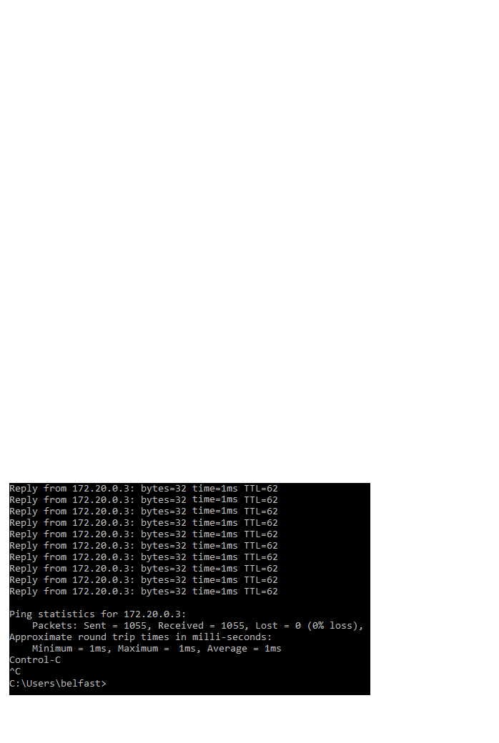
Figure 31: BGP Controlled Permutation ICMP Experiment
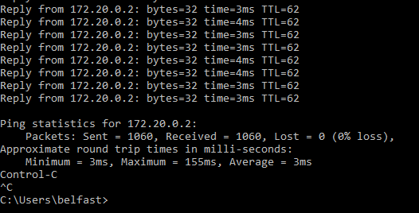
Figure 32: MPLS Controlled Permutation ICMP Experiment

The screenshots in figure 32 were taken from the Throughput Experiment.
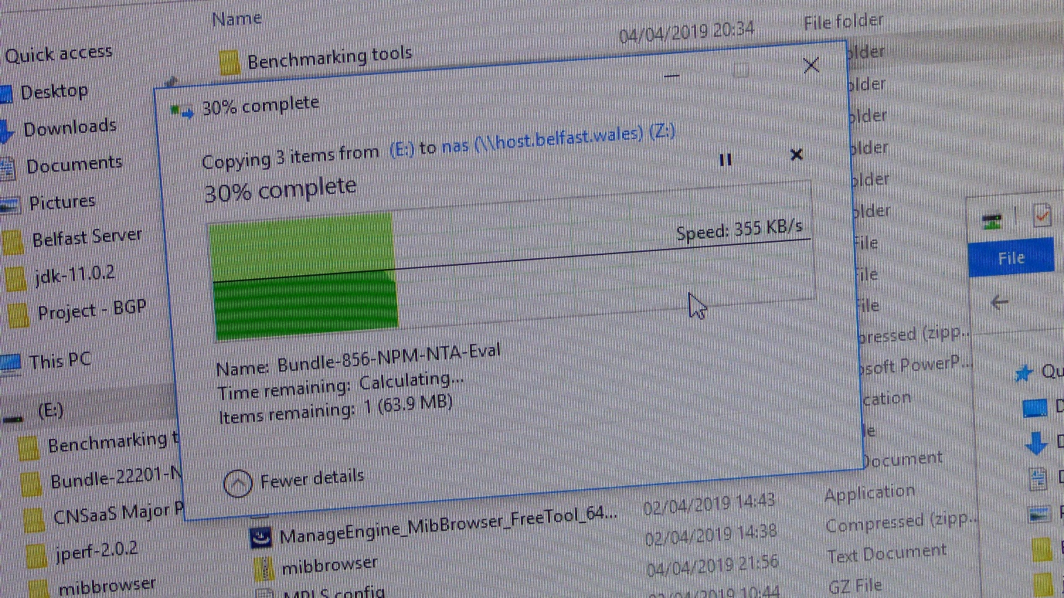
Figure 33: Throughput Experiment Unix
The Screenshots in figure 33-34 were taken from the Belfast End client core network service Windows10 Client.
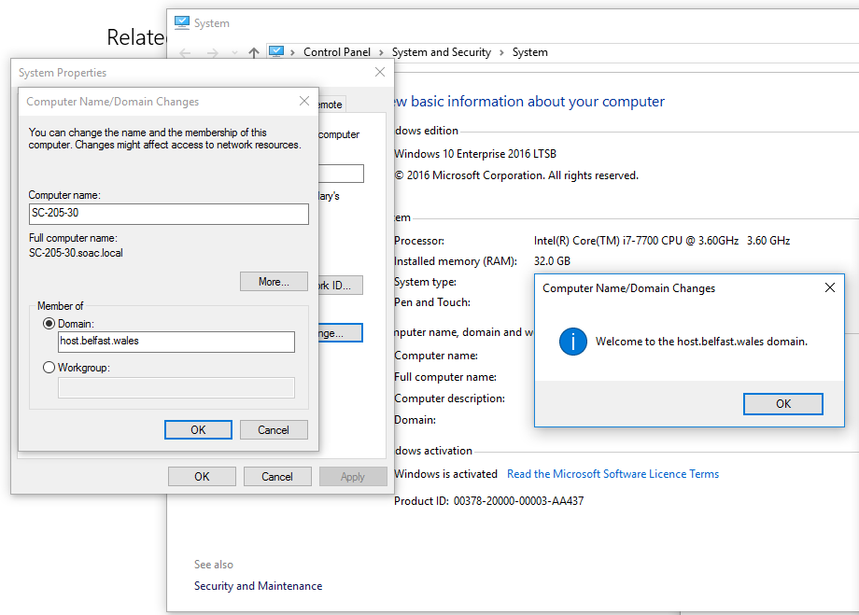
Figure 34: Domain Join to Samba from Windows Client Belfast
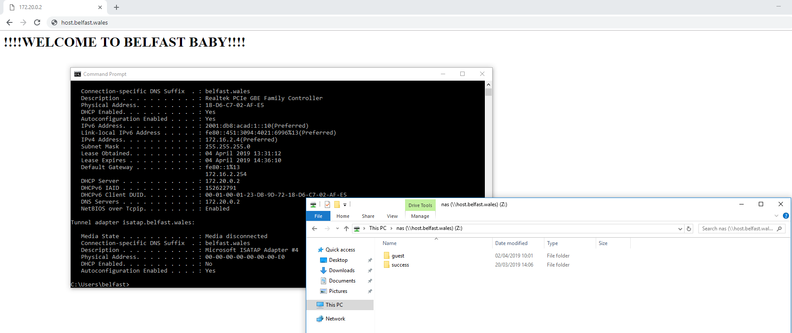
Figure 35: Belfast FQDN Webserver Index Page, Mapped File Server Drive and Domain Information i.e. DHCP,DNS

13.2 Linux-Ubuntu 18.04
The screenshots in figures 35-36 were taken from the controlled first permutation from the ICMP Latency and Packet Loss Experiment.
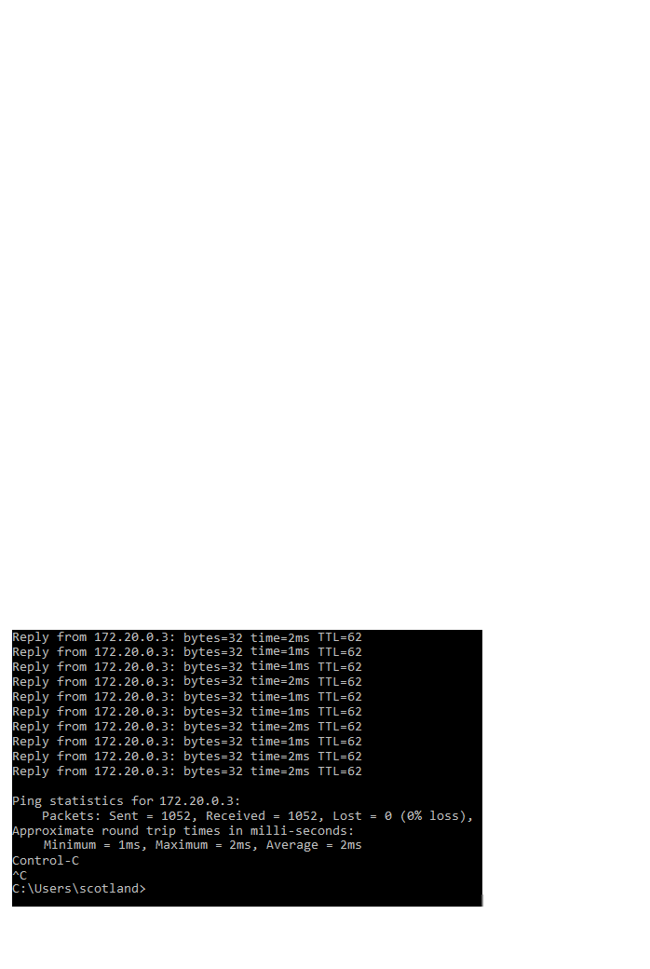
Figure 36:BGP Controlled Permutation ICMP Experiment

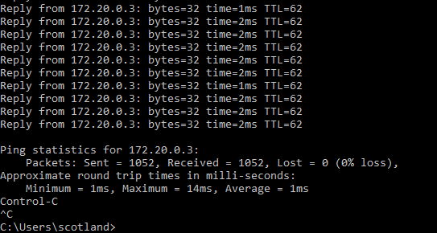
Figure 37:MPLS Controlled Permutation ICMP Experiment

No screenshots of the throughput test for this server were taken but can be viewed within the demonstration video.
The Screenshots in figures 37-39 were taken from the Edinburgh End client core network service Windows 10 Client.
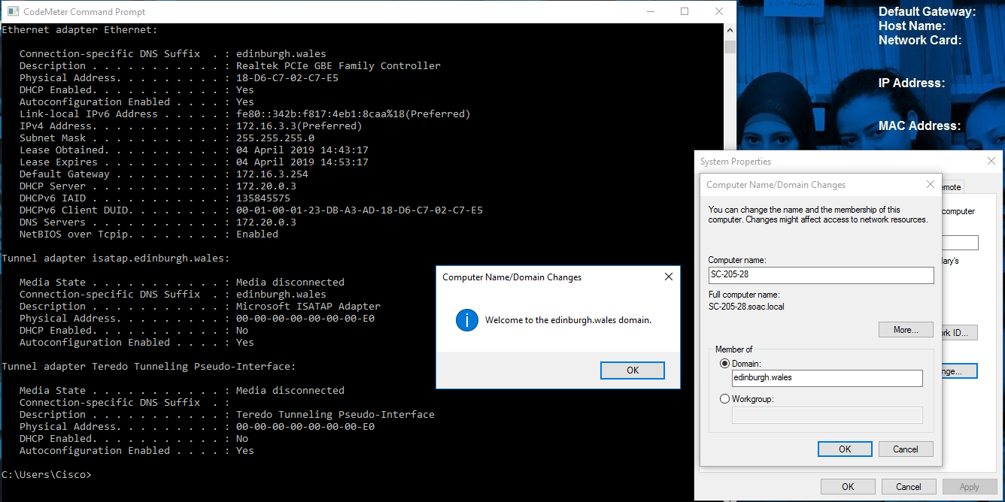
Figure 38: Linux Edinburgh Samba Domain Join Confirmation and DHCP, DNS Domain Information

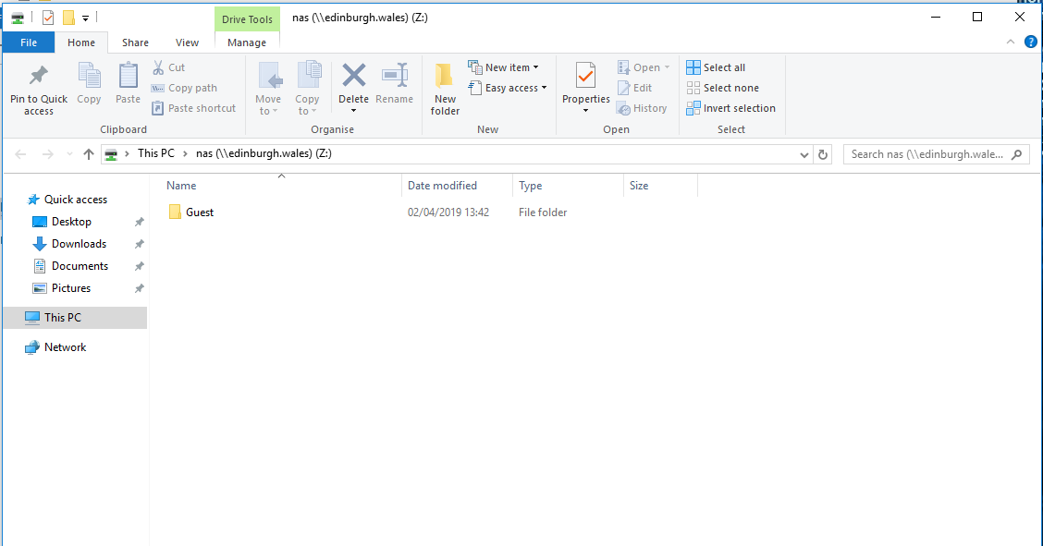
Figure 39: Edinburgh Linux Ubuntu Mapped Drive to SAMBA48 from Windows 10 CLient

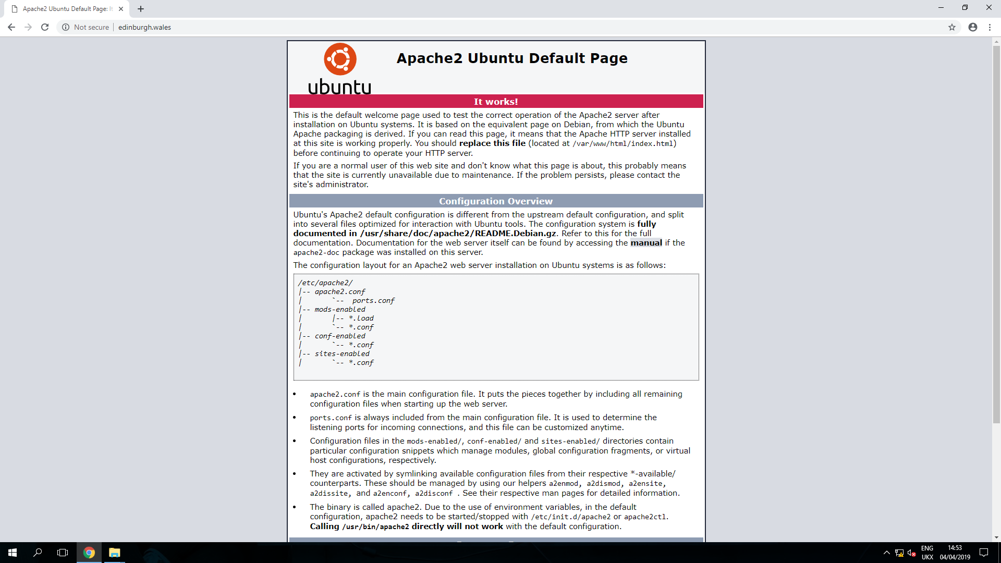
Figure 40: Edinburgh Linux Ubuntu HTTP Server Index Page Accessed Via FQDN From Windows 10 Client

13.3 Windows Server 2019 Datacentre Edition
The screenshots in figures 40 - 41 were taken from the controlled first permutation from the ICMP Latency and Packet Loss Experiment.
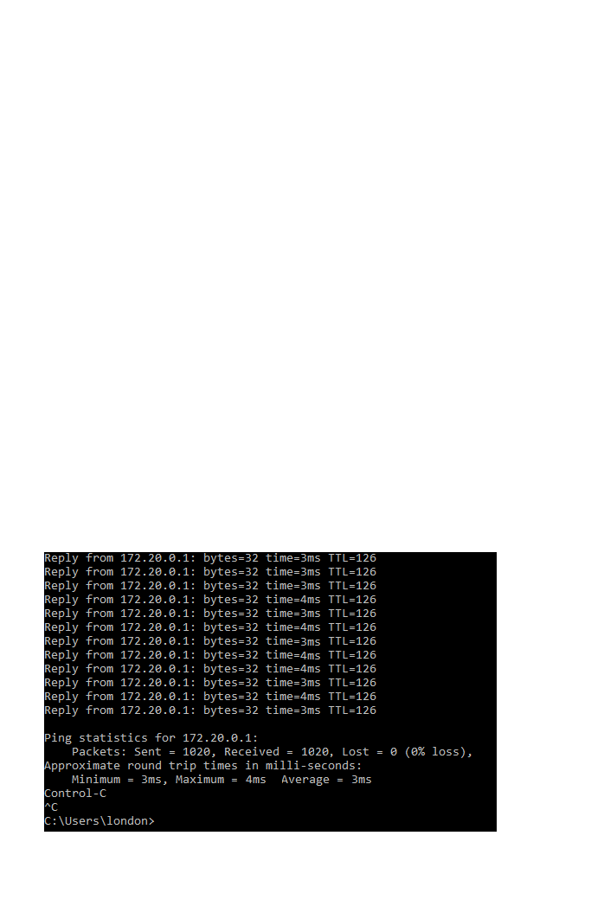
Figure 41: London Windows Server BGP ICMP Experiment First Controlled Permutation

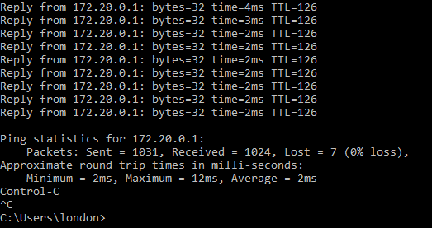
Figure 42:London Windows Server MPLS ICMP Experiment First Controlled Permutation
No screenshots of the throughput test for this server were taken but can be viewed within the demonstration video.
The Screenshots in figures 42-44 were taken from the London end client core network service Windows 10 Client.

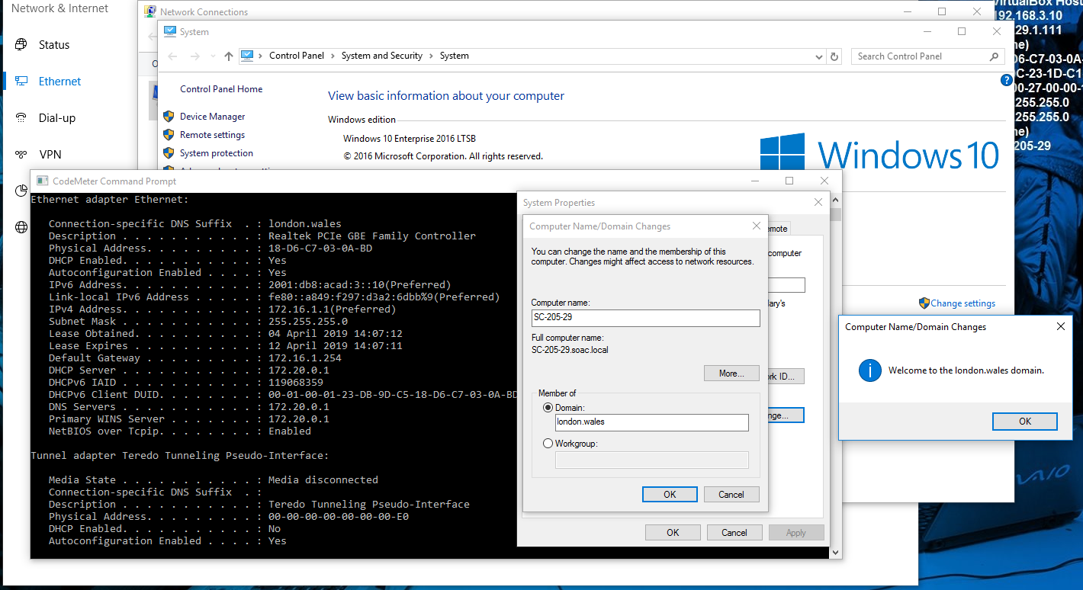
Figure 43: London Windows Server Client Domain Join and DHCP, DNS, Domain Information
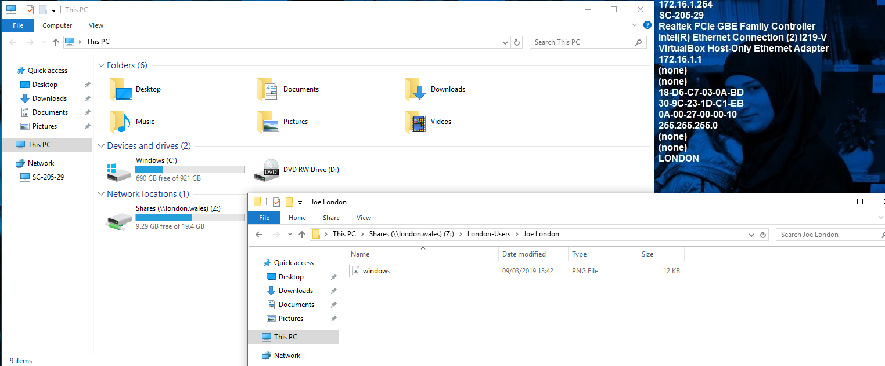
Figure 44:London Windows Server Client File Server Mapped Drive
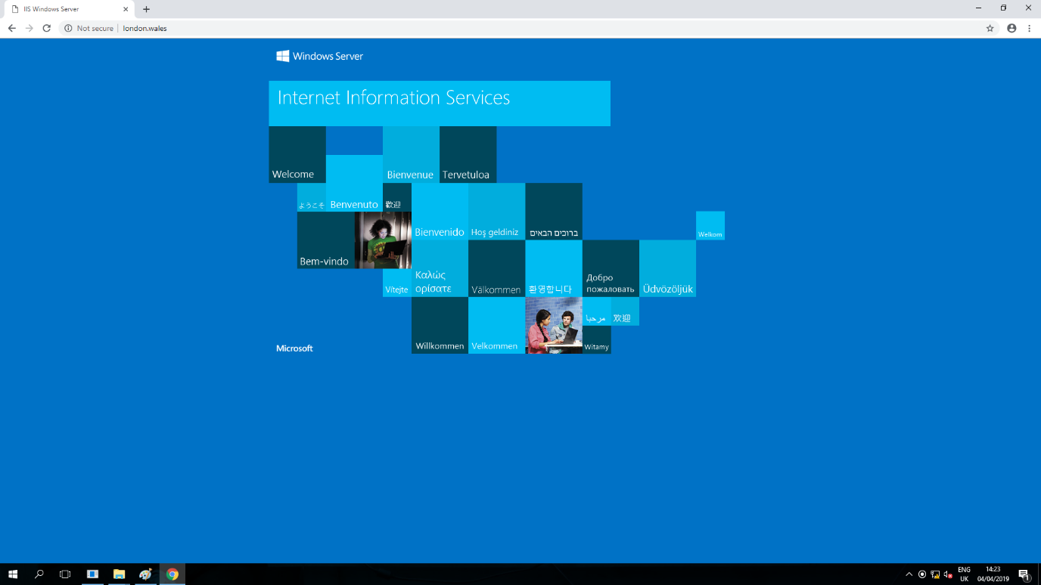
Figure 45: London Windows HTTP Server Index Page Accessed Via FQDN From Windows 10 Client

13.4 WAN and LAN Router and Switch Rack Physical Configuration
The following images in figures 45-49 were taken within the computer laboratory of the CNSaaS Experiment.
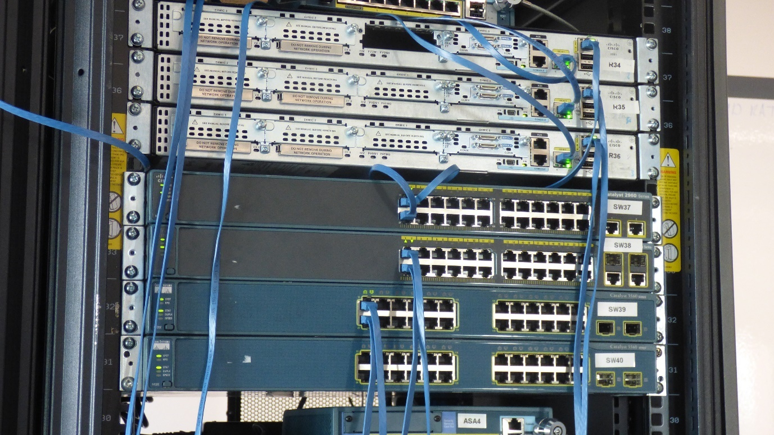
Figure 46: Physical Routers and Switches for SMB Client Gateways

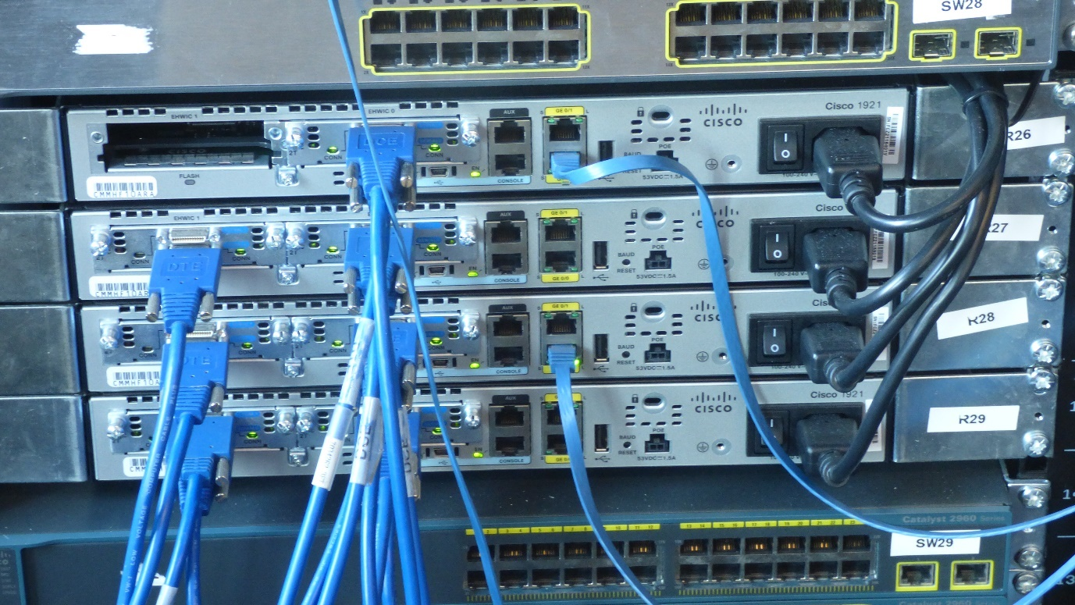
Figure 47: Physical Routers for Emulated WAN with Serial WIC Connection

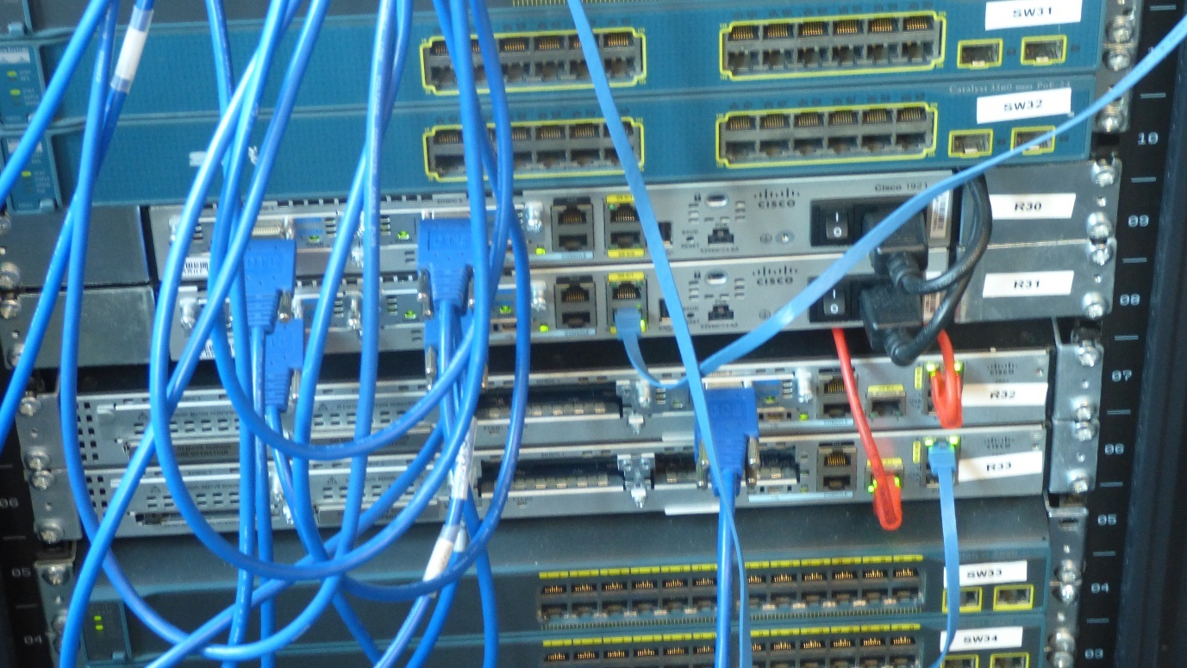
Figure 48:Physical Routers for Emulated WAN with Serial WIC Connection and Router Gateway for emulated CSP NOC LAN

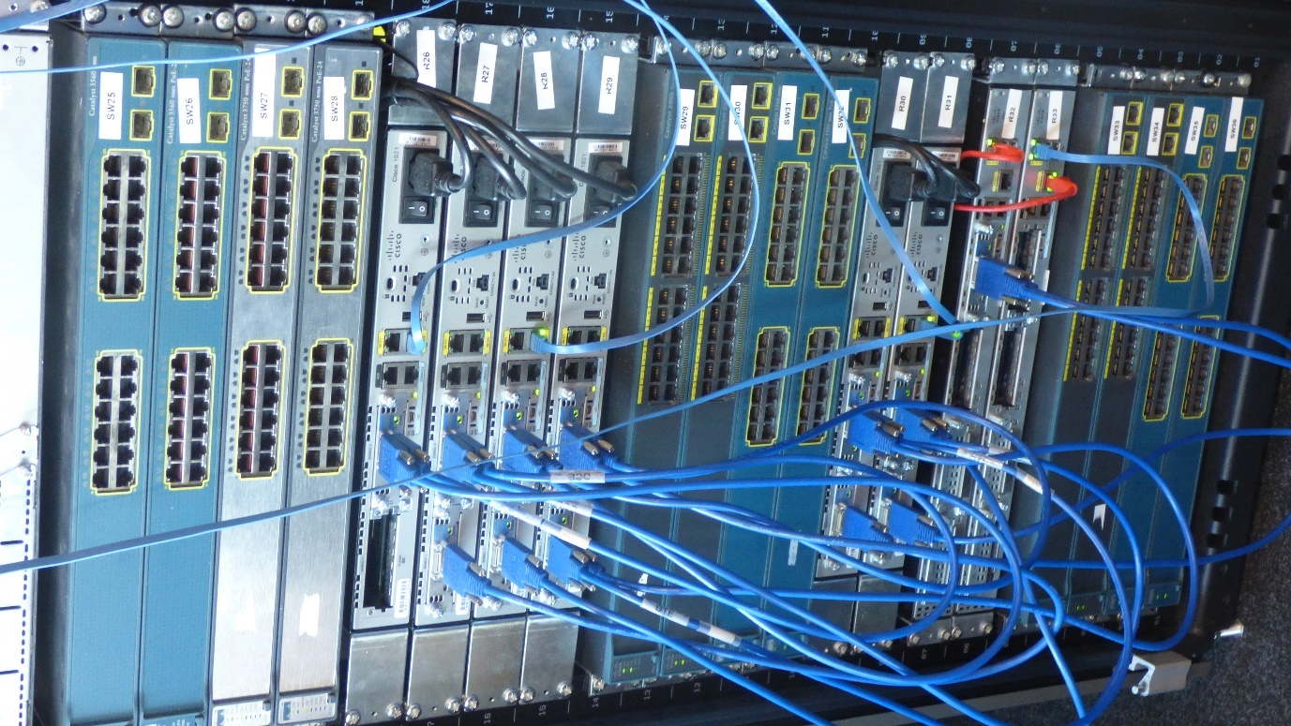
Figure 49: Left Network Rack Containing Emulated WAN Routers and CSP LAN NOC Gateway Router

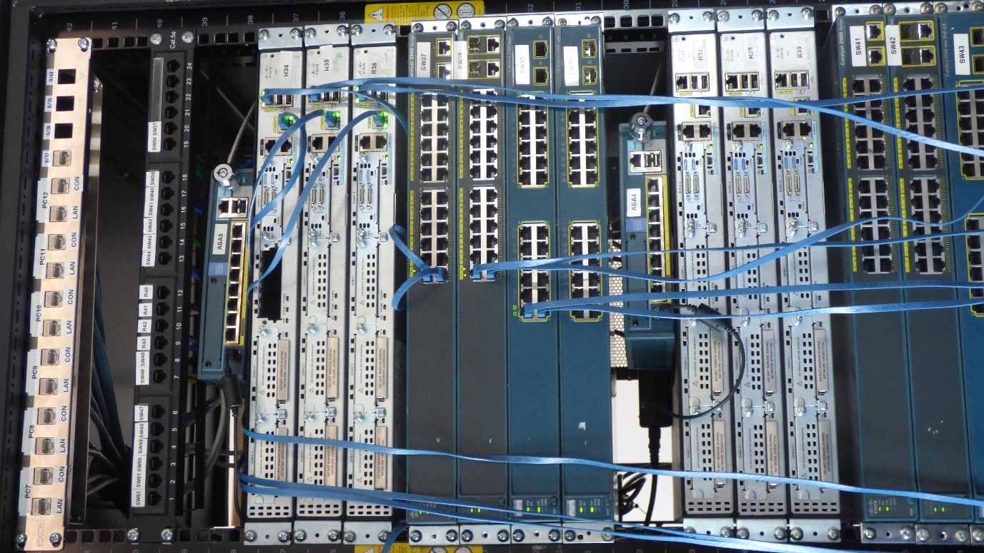
Figure 50: Right Rack Containing the SMB LAN Router Gateways and Layer-2 Switches Along With CSP NOC LAN Layer-3 Switch

