Student Name | Sancia Taylor
Student number | 2107199
Lecture | Besty Rose
BMSW404 Solving and decision making | Addressing the problem of staff shortage in proper care home

Contents
Introduction 3
Define the problem 4
The scope of the problem 4
Analysis of organisation and problem 5
Propose alternative solutions 7
Evaluation 7
Plan the interment solution 9
conclusion 11
summery 11
Reference list 12

Introduction

In this report is about writing to the manager of proper care home about finding the solution of staff shortages in proper care home. To define the problem of what is the issue with their staff shortage and the scope of the problem that it just does not lie in the care home it’s a world-wide problem, why are there shortage of not just in the care home. They need to analyse the SWOT to define the strength, weakness, opportunities, threat of how they can overcome the barriers and the threats relate to external factors. The fishbone diagram to fine the root of the problem and the major facts possible courses of the root. (PMI) evaluation pulse, min, interesting for the course you can weighting the pros and the cons of a decision-making tools. The entire solution Need to argue the case to define what is the manger fact they are short a staff that is not just apply in the care home it is a worldwide problem.

Define the problem

Chris Hopson chief executive of NHS provider stated that staff from the EU countries are essential to the NHS, EU citizens represent 15% of the medical healthcare workforce 130,000 people are working in the NHS from others EU countries they are vital (IACOBUCCI, G.,2016). The government apparently miss the opportunity to tackle NHS and social care staff shortages. according to water (2022) he stated that independent transparent planning with clear parent planner with clear projection of numbers of doctors and nurses required to meet future demand, in the year they found that the shortage of staff in social care was the biggest drive-in care staff, in England that was identified with excessive workload is the key predictor of staff stress also intention to quite due to patient dissatisfaction. The committee heard that every healthcare profession is facing staff shortages, having at least 105,000 vacancies. The situation will worse in social care because there are more care workers leaving their job in 2020–21, making the care extremely difficult. In December 2021, reported that 95% of care providers were struggling to recruit staff, and 75% were struggling to retain their existing staff.
.

The scope of the problem

According to Britnell (2019) she as travelled the world and spoken to a lot of health worker professionals she realizes that most country that are rich or poor struggles with health care staff. She believes by (2030) demands for health care workers will unfortunately rise to 80. Million. She realizes that they do not have enough staff to care for the patients, one of the reasons is the money and technology, the problem is worldwide because the demand for health care workers far less is known however about how changes in healthcare organization and financing are likely to affect the future demand for nurse unless economic improvements are made (Buerhaus, Staiger and Auerbach, 2009

Analysis of organisation and problem

To the manager of proper care this is a table of the SWOT analysis to overcome the barriers of staff shortage there are one examples of the SWOT analyse where you can determine the strength, weaknesses, opportunities, threat to overcome the staff shortages. (Gretzky, W., 2010) The information from an environmental analysis and to separate it in the internal strengths and weaknesses and external issues opportunities and threats. Strengths and Weaknesses are often internal to your organization while opportunities and threats relate to external factors. For this reason, the SWOT analysis is more times referred to as Internal-External Analysis. When this is complete, SWOT analysis will determine what may assist the firm in achieving its objectives, and what the barriers must be overcome or minimized to achieve desired results. (Singh and Singh, 2018)

Strengths | Weaknesses
Hight success rate  Excellent quality of care  Excellent location  Flexible hours  Workplace rewards  Increasing the supporting staff | Patents wating time  Bad practice  Workload  Working condition
Opportunities | Threat
Increase economic growth  Training opportunities  Excellent rate of pay  Workplace benefits | Stiff competition  patient dissatisfaction  Intense competition  Government regulation
(Ebrahim et al., 2017)
Fishbone diagram with his cause-and-effect it’s also called the Ishikawa or fishbone diagram, management of proper care home need to make massive, important improvements in quality staff shortage. The design almost looks like a skeleton of a fish. Fishbone diagrams are usually worked right to left, with each large bone of the fish branching out to include smaller bones containing more detail. This is a technique method by approaching and thinking through all the causes of the problem and then analyse all the situation. There are four stages through this prosses that you can analyse the course of the problem.
- Identify the problem
- Identify the major factor
- Identify the possible causes
- Analyse your diagram
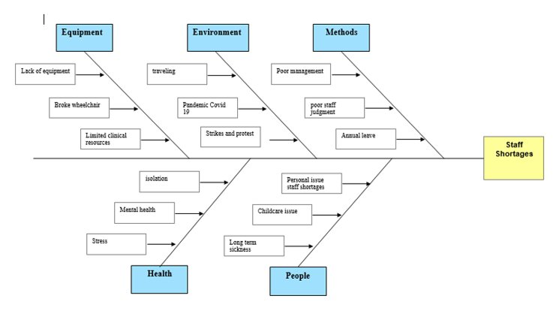

Propose alternative solutions

The outcome of the pandemic for the NHS are still evolving. (Gittleman, 2022) The number of patients waiting around for specialist treatment has exceeded to six million, a number that has been increased by about 37% since the outbreak of the crisis. It is not an area in which more funding will necessarily help in the short and medium term. Countries are using a combination of short- and long-term strategies, and financial and non-financial incentives. They are needed to make working conditions more engaging through improved support and more flexible hours workplace benefits, permanent contracts and are a common response to staffing issues. Some health systems, such as some of the EU countries, have also reached new pay agreements (Schlepper and Reed, 2022).

Evaluation

PMI weighting the pros and the cons of a decision environment
PULS | MINUS | INTERESTING
Less cars+5 | Less air pollution -1 | Clean are zone+3
Public transport+3 | Waiting in wintry weather -4 | More traveling time +4
Riding bicycle+5 | Careful of the cars on road -6 | Good exercise+6
Total=13 | Total=-11 | Total=13
 | Overall Total= +15
PMI weighting the pros and the cons of a decision methods
PULS | MINUS | INTERESTING
Hire the unqualified people+10 | Difficult Working conditions-7 | Training can be given+8
Offer more hours to the current employees+9 | Overwhelmed with work presser-4 | Have more money in their pocket+7
Increase wages+8 | Need more funding -5 | Bring in more staffs+6
Total= +13 | Total= -16 | Total= +21
 | Overall Total=18
PMI weighting the pros and the cons of a decision equipment
PULS | MINUS | INTERESTING
effective equipment +5 | Broken wheelchairs -4 | staff given excellent quality of care +6
Limited clinical resources +4 | Lack of PPI -3 | Shift can correctly run +4
Disable accesses +1 |  | To have more flexibility to maneuver +2
Total=10 | Total=-7 | Total= +12
 | Overall Total=10

Plan the interment solution

After creating and analyse the MI weighting the pro and cons of the decision-making tool methods, equipment, environment that after adding the total it clearly proven and stated that method is the most common way for staff shortages. The solution based on the decision that method is the appropriate solution to the manager of proper care home for their staff shortages. prior to the solution they need to take implement action, Base on the study you need to start advertising the job roll to start bringing unexperienced staff because training can also be given. increase the wages so they feel, they are getting a better wage for their challenging work. Meanwhile, because the government needs to provide more funding to the healthcare, the care homes has not been ring-fenced, representative organisations have warned of a need for action to prevent services that is failing and most vulnerable people being left to be deprived of care, Registered Nursing Home (Heath, 2012)
This is a diagram of the most excellent example to the manager of proper care to address the problem through the Bridgman and Davis (1998) all important viable way of the problem or achievement the goals or objectives are listed. Building on the reasonable model the policy and procedure process is often characterised as a cycle of activity when the final stage of one move through the cycle turns into the source. (Bridgman and Davis, 2003)

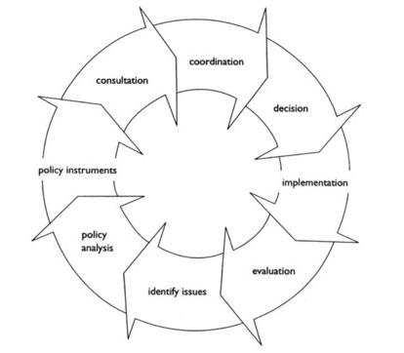
The resources needed to advertise the job for proper care home on indeed and another social network. Apply for certain funding from the government provide you need the resources for technology and facilities. Hire a building or provide and space to interview staff, and you can also provide training for the new people you are going to employed.
The timeline needs to be given for the process should be five months deadline. The first month should be about advertising the job roll. the second month should be in interviewing the people and hiring the staff you require. Third month should support the staff throw their introduction provide if they have any quires or feedback and they are enjoying their job roll. The fourth month should be that staff are given training to keep up with the regulation of the care home. The fifth month should have all the requirements put in place, so all staffs are settled in their job roll.
The person primarily responsible for ensuring the implementation of the plan should be the manager of proper care home should inform all communication to the staff and emplace the requirements that are need and inform the nurse or team leaders throw staff meetings.

conclusion

bast on the conclusion to the manager of proper care home. Bast on the statistics your problem just not lie in your care home it a worldwide problem that need to adjust. The government need to account for their action towards the healthcare system and find a solution for the future of the healthcare system. Because they need more funding, threw the pandemic they were overwhelmed with workload and stress and many nurses have leave the profession and it can lead to staff shortages.

summery

After summaries it is clearly see that more funding is needed in the healthcare. The fact that permanent contract, flexible hours, good rate of pay will impact more to interested people to go in healthcare, and not to be overwhelmed with workplace pressure and stress (Decter, 2008) so proper care home needs to analyse the SWOT, put in place the strength, weakness, opportunity, threat. They also need the fishbone analyse that comes in place for the course of the possible problem of your staff shortages

Reference list

Britnell, M. (2019). Human: Solving the Global Workforce Crisis in Healthcare. [online] Google Books. Oxford University Press. Available at: https://www.google.co.uk/books/edition/Human/at-RDwAAQBAJ?hl=en&gbpv=1 [Accessed 14 Aug. 2022].
IACOBUCCI, G.,(2016). Brexit could worsen NHS staff shortages, doctors warn. BMJ : British Medical Journal (Online), 353.
Waters, A. (2022) ‘Government “missed opportunity” to tackle NHS and social care staff shortages’, BMJ (Online), 376, pp. o422–o422. doi:10.1136/bmj.o422.
Schlepper, L. and Reed, S. (2022). The NHS isn’t alone in its problems—but other countries can help with solutions. BMJ, pp.1–2. Gittleman, M. (2022). The ‘Great Resignation’ in perspective. Monthly Labor Review. doi:10.21916/mlr.2022.20.
Singh, S.P. and Singh, P. (2018). An Integrated AFS-Based SWOT Analysis Approach for Evaluation of Strategies Under MCDM Environment. Journal of Operations and Strategic Planning, 1(2), pp.129–147. doi:10.1177/2516600x18801689.
Bridgman, P. and Davis, G. (2003). What Use is a Policy Cycle? Plenty, if the Aim is Clear. Australian Journal of Public Administration, 62(3), pp.98–102. doi:10.1046/j.1467-8500.2003.00342.x.
Gretzky, W., (2010). Strategic planning and SWOT analysis. Essentials of strategic planning in healthcare, pp.91-97. Singh, S.P. and Singh, P. (2018). An Integrated AFS-Based SWOT Analysis Approach for Evaluation of Strategies Under MCDM Environment. Journal of Operations and Strategic Planning, 1(2), pp.129–147. doi:10.1177/2516600x18801689.
American Society for Quality, Fishbone diagram. http://www.org/learn-about-quality/causeanalysis-tools/overview/fishbone.html [2] Ishikawa K, Loftus J H (Eds)1990 Introduction to quality control , Tokyo Japan: 3A Corporation.
Heath, H. (2012). How to optimise the registered nurse contribution in care homes. Nursing Older People, 24(2), pp.23–28. doi:10.7748/nop2012.03.24.2.23.c8954.
Billings, J., Ching, B.C.F., Gkofa, V., Greene, T. and Bloomfield, M. (2021). Experiences of Frontline Healthcare Workers and Their Views about Support during COVID-19 and Previous Pandemics: a Systematic Review and Qualitative Meta-Synthesis. BMC Health Services Research, [online] 21(1). doi:10.1186/s12913-021-06917-z.
Buerhaus, P., Staiger, D. and Auerbach, D. (2009). The Future of the Nursing Workforce in the United States: Data, Trends and Implications. [online] Google Books. Jones & Bartlett Publishers. Available at: https://www.google.co.uk/books/edition/The_Future_of_the_Nursing_Workforce_in_t/avRGAcF3ASMC?hl=en&gbpv=0 [Accessed 14 Aug. 2022].
Decter, M. (2008). Healthcare Systems and Organizations: Implications for Health Human Resources. Healthcare Quarterly, 11(2), pp.80–84. doi:10.12927/hcq.2008.19621.
Ebrahim, E.M.A., Ghebrehiwot, L., Abdalgfar, T. and Juni, M.H. (2017). Health Care System in Sudan: Review and Analysis of Strength, Weakness, Opportunity, and Threats (SWOT Analysis). Sudan Journal of Medical Sciences, 12(3), p.133. doi:10.18502/sjms.v12i3.924.
FUND OUR NHS. (n.d.). Staff shortages • FUND OUR NHS. [online] Available at: https://nhsfunding.info/symptoms/10-effects-of-underfunding/staff-shortages/#:~:text=The%20King%E2%80%99s%20Fund%20updated%20report%20into%20NHS%20workforce [Accessed 10 Feb. 2021].

