Management Economics
LCBB5003
Assessment Component 2: Essay

Student name: Mihaela Daniela Simcea
Student ID:2028830

Lecturer name: Vasilios Tavlaridis

Introduction
The energy sector is crucial for any country and this sector has a huge contribution to the UK economy. Since the economy of the United Kingdom is strong, therefore, it needs different energy sources for different activities such as industrial production, transportation, electrical production as well as household use. But it’s seen that the prices of the energy sector in the United Kingdom is increasing for many years. OFGEM (Office of Gas and Electricity Market) data shows that energy source prices have been rising steadily in recent years, with market consolidation likely to blame. The government must intervene, either through Demand Side or Supply Side Management, to restore equilibrium in such a market. The purpose of this study is to provide a thorough evaluation of the UK energy market. Besides, the increasing prices in the energy sector will be analyzed based on different economic theories, for instance, demand and supply, price elasticity, cost analysis, etc. Finally, how these price changes affect the managerial decision among the organizations in the United Kingdom will be described in this essay.

Analysis of the UK Energy Sector
The energy industry in the UK is vulnerable to a few problems in addition to having some prospects for expansion. There will be a number of shifts in both the micro and macro aspects of the economy as this scenario develops (Sloman, and Garratt, 2013). It has been discovered that the costs of energy sectors, for example, electricity and gas have been rising steadily over the course of the last ten years. Additionally, it may be shown from the illustration provided down below:
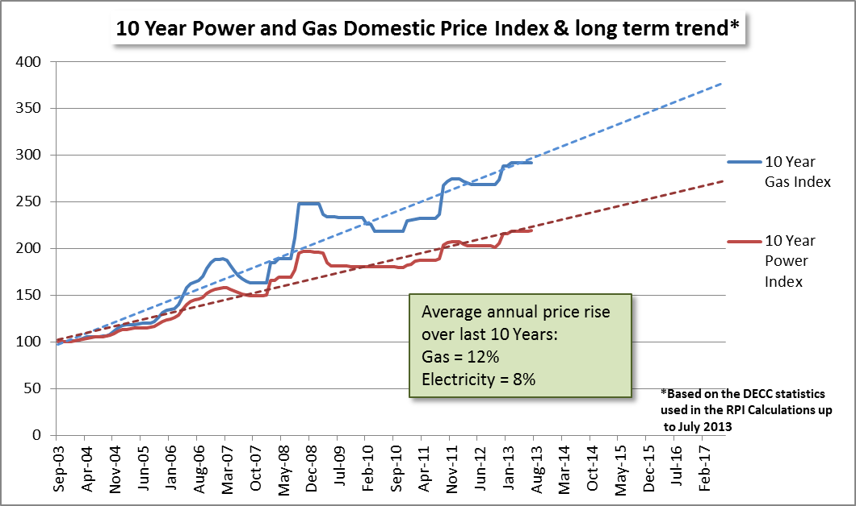
Figure 1: 10 years Gas and Power Price Index in the UK
Source: (Ryan, 2021)
Although the amount of growth in the price of electricity has been smaller in comparison to the increase in the price of gas, it is abundantly obvious that the costs of both gas, as well as electricity, have been on the rise simultaneously. In addition, the amount of money that consumers in the UK spend on energy is progressively but steadily going up, and this trend has a disproportionately negative impact on low-income communities (Renssen, 2014). It is a major worry on their behalf that they are using less than the amount of money that they are spending, as this implication suggests that they are. This circumstance is one of the most significant challenges faced by the administration, which is working hard to devise an effective plan to deal with the problem. This precarious situation may be traced back to a variety of factors, including rising oil costs, green levies as well as other forms of excessive taxation, and insufficient attention paid to improving energy efficiency.
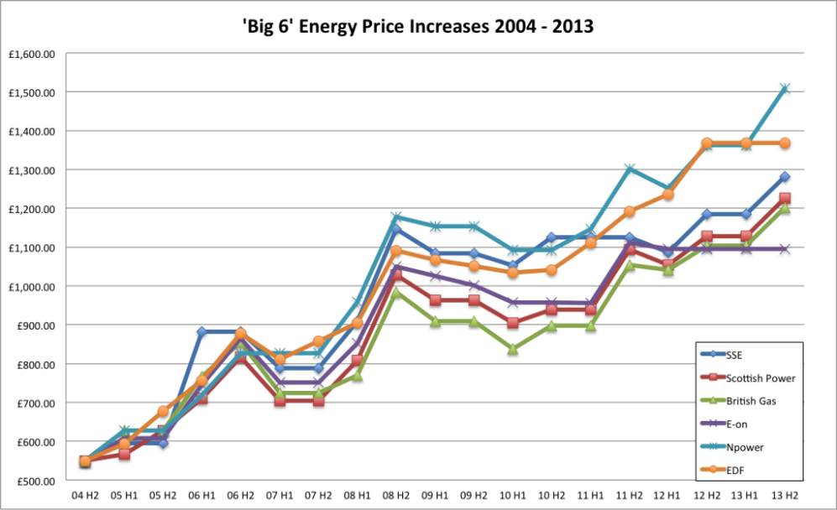
Figure 2: The "Big 6" In the UK
Source: (Willliam, 2022)
The most significant danger, on the other hand, is posed by the expanding influence of local vendors and distributors. In the United Kingdom's energy industry, there are six major companies that are generally referred to as the Big Six. These companies have a significant influence on the entire market. Scottish Power, British Gas, SWE, E. In the UK, RWE Power, as well as EDF Energy are some of the companies that fall under this category. It has been shown that these six businesses are responsible for controlling 95% of the market share (Samuelson, & Nordhaus, 2015). This implies that customers have very few alternatives available to them when it comes to switching providers. It gives the big six a stable foundation on which to base their pricing decisions, allowing them to do so at the most lucrative level possible from a financial standpoint, but without consideration of the interests of the general public.
Aside from this, when the profit of the major energy businesses was split with regard to production and supply, it was discovered that their reliance on supply was rising in relation to profit generation. This was discovered while the profit of the major energy organizations was being divided. It indicates that the majority of the cost of the price rise will be borne by end users, which is a significant change from the previous situation. In addition, expansion in both industries and households has led to a rise in the demand for energy, which can be seen reflected in the consistently rising amounts that people and companies spend on energy supply. According to the most current research, the lowest income fifth of households spent 11% (an increase of 3% from the level in 2002) of their overall disposable income on energy, while the highest income fifth of households spent 3% (an increase of 2% from the level in 2002) of their total income (Warren, 2014). Between the years 2002 and 2013, there was an overall rise of 43 per cent in the amount that households spent on various types of energy. In addition to that, it is shown in the figure in the following way:
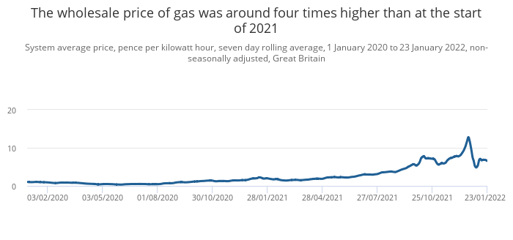
Figure 3: Price Increase of Energy Sources
Source: (National Grid, 2022)
This demonstrates that low and middle-income people are more negatively impacted by increasing costs compared to those in higher socioeconomic brackets. It is of the utmost importance to find solutions to the problem as early as possible to provide considerable relief to the people who are currently using electricity in the area.

Application of Economic Theories
Supply And Demand and Energy Prices
Energy supply is the rate at which new energy is introduced to the market, while energy demand is the total amount of energy used within a certain time period. Electricity production in terms of kilowatt hours per day, oil and gas production in terms of barrels and cubic feet per month, and coal production and sales in terms of tons per year are all useful ways to quantify quantities (Allen, Hammond, and McManus, 2008). Fossil fuels and electricity created from primary sources including hydropower, nuclear power, the sun, geothermal heat, and biomass are examples of principal energy, whereas electricity generated using fossil fuels is an example of secondary energy.
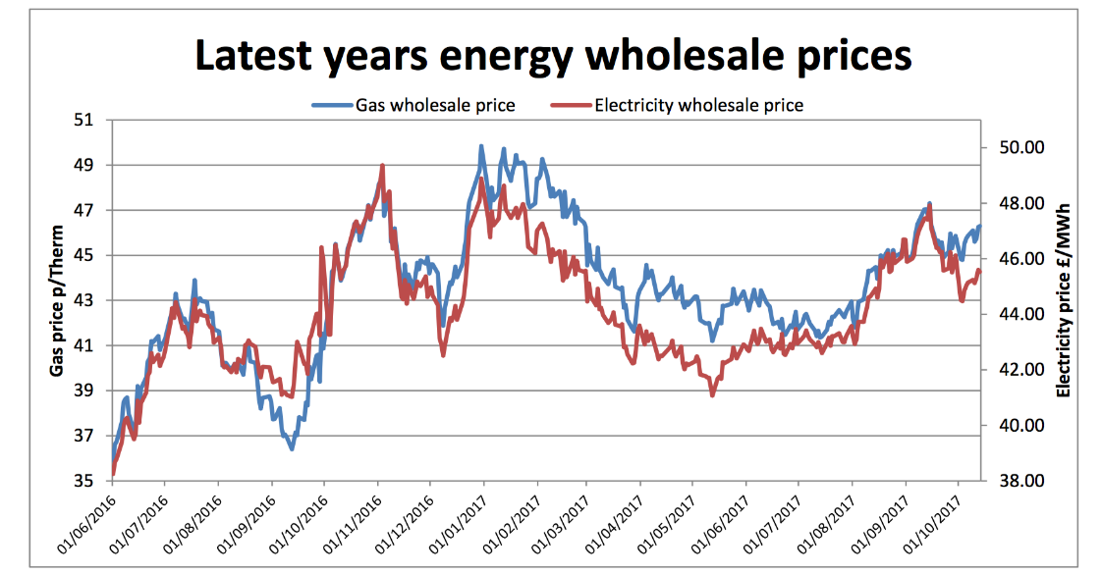
Figure 4: Price Changes
Source: (Dexton, 2022)
Last week, contracts with shorter dates rose the highest. Also climbing were winter prompt costs, especially for 2018's first quarter. Winter gas worries pushed up prices. Coal, oil, and currency market changes pushed prices up. This winter, we anticipate markets to remain volatile due to uncertainties about gas supply and the knock-on impact on power markets. If winter is warm, they may see reduced price windows, but our recommendation is to watch markets constantly as well as consider contracting if prices come down.
Aggregate costs and the price level of the Energy Sector
The energy required to produce an item or provide a service varies greatly from one sector to another. For gasoline refiners, the cost of crude oil is significant, as is the cost of natural gas for power and gas producers. Energy use in the production of other products as well as services may be much lower (Hannon, Foxon, and Gale, 2013). This implies that the relative prices of final products and services are likely to change significantly as a result of price increases, with some prices increasing more than others. Additionally, just as businesses have an opportunity to find energy-efficient alternatives, so do consumers.
Market Structure effect on the Energy sector in the UK
Because of its characteristics, the energy market in the UK is characterized as being in a position of oligopoly, in which six large companies are able to benefit from a high degree of concentration. This concentration is steadily growing as a result of the high degree of entry barriers that have been erected. In other words, these so-called Big Six companies are the ones who set prices since buyers have little authority and switching costs are enormous (Spicer et al., 2012). Because of this, the government has to work toward making the energy industry a more competitive environment so that the advantages of its policies on energy efficiency may be passed on to the customers.

The impact of the energy sector price increase on UK households, businesses, and the overall economy
The energy sector in the United Kingdom has a great impact on the overall economy including households and organizations. If increasing energy costs cause a shift in expected real expenditure by businesses and households, but interest rates remain unchanged from point B, then nominal spending might react differently. Consumer spending might be affected by a spike in energy costs, which in turn could impair demand.
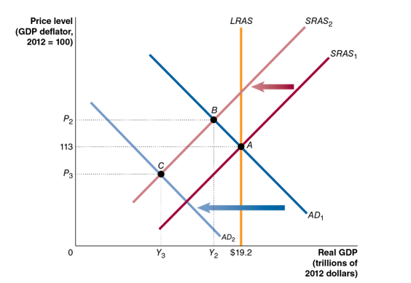
Figure 5: The impact of an adjustment in nominal demand
Source: (Michael, 2022)
As shown, a decline in the real consumption wage is one way in which rising energy costs may reduce the purchasing power of labour income. Households might anticipate a permanent decrease in buying power if the rise in energy costs is assumed to be permanent (Kihyun Park, 2012). A decrease in disposable income is expected as a result of a persistent drop in labour income. Households of varying incomes are analyzed to see how a rise in energy costs might affect them. To estimate indirect consumption, input-output factors are applied to non-energy expenditures in addition to direct expenditures from household budget studies. In the event that price changes do not lead to substitution between items or energy forms, these percentages allow for the calculation of the effect of energy costs on the families.
Millions of homes have experienced fuel poverty before the 2021 energy price increases. The Government measures fuel poverty using the LILEE indicator (Stucker, 2021). Fuel poverty is defined as a household with an income that is less than 60% of the national median after deducting the expenses of housing and energy usage from the proceeds from selling or renting a property with an energy efficiency rating of band D or lower. To avoid falling into fuel poverty, it's important to optimize energy use, increase family income, and reduce energy costs. Statistics from the Department of Business, Energy, and Industrial Strategy (BEIS) depict that the percentage of fuel-poor families in England decreased from 15% (3.52 million) in 2018 to 13.4% (3.18 million) this year (Lorence et al, 2013).
Fuel is crucial to the success of business organizations in the United Kingdom. As a result, when the cost of fuel rises, it has a significant impact on businesses across the United Kingdom. Some companies may be more vulnerable than others, depending on their sector of operation. Individuals can imagine that large, energy-intensive industries would be hit particularly hard, but even small businesses are feeling the pinch. Heating a small commercial space can be quite costly. Since the cost of fuel has increased dramatically, many product-based businesses and transport companies have seen their profits dwindle and go out the window. Consider that if your suppliers must ship one’s products from one place to another, they will inevitably pass the additional costs onto the companies that ultimately purchase the goods.
Energy authorities and the media, particularly in the European Union as well as the United Kingdom, have taken notice of the recent price spike. The origins of this growth must first be determined before speculating on its effects on the British economy. The rise in cost is due to the obvious causes of more demand and lower supply. The advanced economies have resumed regular lives and activities following the Covid-19 lockdowns, and this has increased demand (Harrison et al., 2021). However, difficulties in the supply systems of certain nations have led to a scarcity of energy. The climate has also proven problematic. As an example, last winter in Europe as well as the United Kingdom was very cold. Because of this, the usage of renewable energy was lower than normal, which only made the situation worse.

Price increase effect on managerial decisions of organizations
Managerial decision-making is an approach to resolving issues and facilitating efficient and productive corporate operations. Both large and small organizations have to make decisions and decision-making is the mental act of picking one alternative among many possibilities by using one's prior knowledge, current circumstances, as well as personal values. The current situation in the UK is increasing price changes in the energy sector. Price change plays a crucial role in making a managerial decision because the second most crucial part of the marketing mix is setting the right price. Despite the fact that market prices fluctuated constantly throughout the years for several reasons in the UK energy sector (Carroll, 2004). There are numerous variables that may affect the final pricing of a product or service, but it is generally accepted that adjustments will be necessary. Any one or more of these price shifts might be the consequence of fluctuating demand or general price increases brought on by inflation. Not always in response to the pricing set by other businesses, though. No of the justification, adjustments in pricing are always a necessary evil.
Energy sources are expected to be needed as inputs in the manufacture of a wide variety of final products and services. For instance, practically every business organization both small and large make use of electricity, and gas-fired power plants are a crucial part of the energy generation process. The energy intensity of production, or the proportion of total production costs attributable to oil and gas consumption, is a major determinant of how much-rising energy prices will raise the price of a final product or service and ultimately set the managerial decision regarding the selling prices of those products (Verhoest et al., 2010). A firm's selling price for a product or service is often calculated as a premium over the incremental cost of making one more of that product or providing that service. If, throughout the manufacturing process, energy is consumed in a constant proportion to other inputs of production such that no substitution between energy and other inputs is feasible, then, all else being equal, the marginal cost of creating a final output or service will react to an increase in energy costs that the reason for increasing the cost of goods and services provided by the large and small organizations and thus, their managerial decisions also changes based on the price increase in the energy sector in the United Kingdom.

Conclusion
Stocks that are involved in the generation or distribution of energy are considered part of the energy industry. Organizations engaged in finding new oil and gas deposits, drilling for such reserves, and processing the extracted fuels are all part of the energy industry as a whole. In the UK economy, the influences of energy source prices are significant and these prices are increasing. This essay showed the impact of increasing energy source prices on households, business organizations as well as the whole economy in the United Kingdom. For doing so, different relevant economic theories are explained and the requirements for the UK govt and companies are also shown in this essay. Moreover, according to the increasing price changes situation how organizations are making managerial decisions are also demonstrated in it.

References
Allen, S., Hammond, G., and McManus, (2008), ‘Prospects for and barriers to domestic micro-generation: A United Kingdom Perspective,’ Applied Energy, vol. 85, pp. 528-544
Carroll, K.A. (2004) “Comparative organizational structures and managerial decisions,” Property Rights and Managerial Decisions in For-profit, Nonprofit, and Public Organizations, pp. 108–125. Available at: https://doi.org/10.1057/9781403948090_8.
Dexton, B. (2022) Reduce your utility bills. Commercial Energy Brokers, Utility Helpline. Available at: https://www.utilityhelpline.co.uk/ (Accessed: November 12, 2022).
Hannon, M. J., Foxon, T. J., & Gale, W. F. (2013). The co-evolutionary relationship between Energy Service Companies and the UK energy system: Implications for a low-carbon transition. Energy Policy, vol. 61, pp. 1031-1045. doi: 10.1016/j.enpol.2013.06.009
Harrison, R., Thomas, R. and de Weymarn, I. (2021) “The impact of permanent energy price shocks on the UK economy,” SSRN Electronic Journal [Preprint]. Available at: https://doi.org/10.2139/ssrn.1898066.
Kihyun Park (2012) “Inflation, the energy price increase in a two-sector small open economy,” KUKJE KYUNGJE YONGU, 18(3), pp. 63–83. Available at: https://doi.org/10.17298/kky.2012.18.3.003.
Lorenc, A., Pedro, L., Badesha, B., Dize, C., Fernow, I., & Dias, L. (2013). Tackling fuel poverty through facilitating energy tariff switching: a participatory action research study in vulnerable groups. Public Health, vol. 127, no. 10, pp. 894-901. DOI: 10.1016/j.puhe.2013.07.004
Michael, C. (2022) Bing. Microsoft. Available at: https://t.ly/tGoG (Accessed: November 12, 2022).
National Grid (2022) Energy prices and their effect on households, Energy prices and their effect on households - Office for National Statistics. Office for National Statistics. Available at: https://www.ons.gov.uk/economy/inflationandpriceindices/articles/energypricesandtheireffectonhouseholds/2022-02-01 (Accessed: November 12, 2022).
Renssen, S. (2014). Five reasons why energy bills are so high – and still rising. The Guardian. Available from http://www.theguardian.com/big-energy-debate/five-reasons-energy-bills-high [Accessed 8 February 2016].
Ryan, J. (2021) Https://th.bing.com/th/id/R.49e1f36403069b356654071ab840bf20?rik=%2b3iwXwty28WRCw&riu=http%3a%2f%2fcountermel...: The little drummer boy, women in music, drummer boy, Pinterest. Available at: https://www.pinterest.com/pin/httpsthbingcomthidr49e1f36403069b356654071ab840bf20rik2b3iwxwty28wrcwriuhttp3a2f2fcountermel--583497695475598155/ (Accessed: November 12, 2022).
Samuelson, P. A., & Nordhaus, W. D. (2015). Economics. New York: McGraw-Hill.
Sloman, J., and Garratt, D. (2013), ‘Essentials of Economics,’ 6th edition, Pearson
Warren, P. (2014), ‘A Review of Demand-Side Management Policy in the UK,’ Renewable and Sustainable Energy Reviews, 29, pp.941 – 951.
Spicer, J. et al. (2012) “The ‘big six’ brewers and the early investigations,” Intervention in the Modern UK Brewing Industry, pp. 1–17. Available at: https://doi.org/10.1057/9780230355583_1.
Stucker, J.P. (2021) The impact of energy price increases on households, RAND Corporation. Available at: https://www.rand.org/pubs/papers/P5585.html (Accessed: November 12, 2022).
Verhoest, K. et al. (2010) “Performance of Public Sector Organizations: Do Managerial tools matter?” Governance of Public Sector Organizations, pp. 211–232. Available at: https://doi.org/10.1057/9780230290600_11.
Willliam, J. (2022) Bing. Microsoft. Available at: https://ibit.ly/k0SI (Accessed: November 12, 2022).

