Consultancy Report

MODULE NAME: ORGANISATIONAL CONSULTANCY
MODULE CODE: BMIH6005
STUDENT NAME: NARCIS CIUBOTARIU
STUDENT ID: 2027610
LECTURER: JULIA AULT

HARBOURSIDE HOTEL CASE STUDY
CN CONSULTING

29TH of MAY 2023

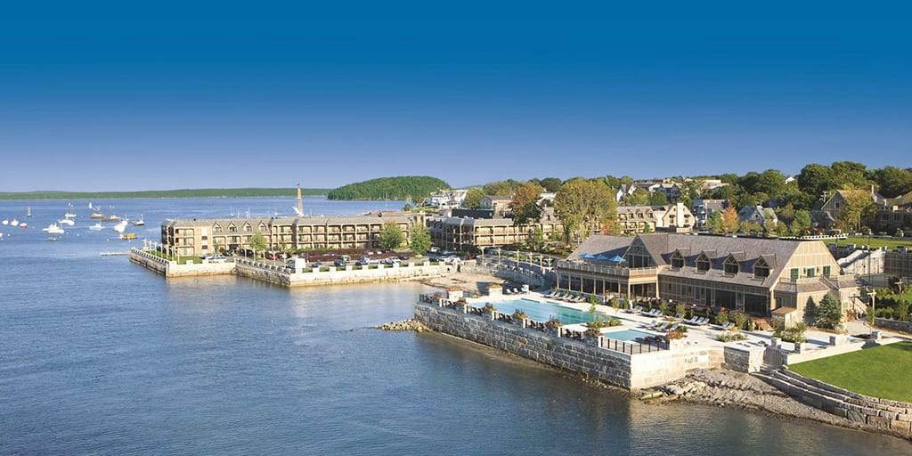

EXECUTIVE SUMMARY

Harborside Hotel, Spa & Marina Frenchman's Bay has become one of the finest hotels in downtown Bal Harbour. With 193 unique accommodations, exceptional service, and traditional Down East hospitality, Harborside has everything you need for a great Bar Harbor vacation, whether it is a romantic weekend getaway, a family getaway or a Bar Harbor getaway. It has everything. Celebrate a special anniversary. The proposal includes a hotel survival plan including problem identification, proposed scope of work and hotel strategy, including project scope, proposed methodology, data requirements, action plan, Pareto analysis, ABC analysis, which includes a SWOT analysis, Porter's 5P analysis, the final conclusions and recommendations regarding Covid-19. All these methods have been chosen as are the correct one and the most reliable ones to determine the state of a specific organisation. The report has its focus on the key issues that are related to the hotel, and on identifying some actions that can be applied to diminish or eliminate the issues.

CONTENTS
EXECUTIVE SUMMARY 3
INTRODUCTION 6
SCOPE AND ANALYSIS 6
Scope of the project and proposed actions 6
Increase operational efficiency 6
Improve customer satisfaction 7
Improvement in Staff Productivity 8
Reaching New Customers 9
ACTION PLAN AND TIMELINE 10
PARETO ANALYSIS 11
SWOT ANALYSIS 11
PORTER’s 5 FORCES ANALYSIS 12
PESTEL ANALYSIS 14
TOWS ANALYSIS 16
ABC ANALYSIS 17
Results of ABC analysis 19
ABC analysis results – split of products by sales revenue 19
Revenue against purpose of visit 19
Revenue against different Nationalities visit 20
Revenue against different room types booking 20
ABC Analysis chart by product line 20
Pareto chart showing cumulative sales revenue by product line 21
PRESCRIPTIVE ANALYSIS 21
FINANCIAL ANALYSIS OF THE DECISIONS 22
DECISION TREE 23
CONCLUSION AND RECOMMENDATION 23
REFERENCES 25

INTRODUCTION

The 4-star Harborside Hotel in Sydney Harbour was acquired in 2000 by new management of Land Containers. Management issued an ultimatum to either develop a "survival action plan" to restore viability or sell the property. Big problems usually arise when the value provided to the customer does not match the amount charged by the hotel. Communication barriers between employees and management lead to lower employee productivity. Addressing these issues requires additional cost and time and is difficult for management to manage. All the methods used for the analysis of this report, have been carefully chosen as part of a consultancy report in which a series of issues will be analysed, discussed, and planned for improvement.

SCOPE AND ANALYSIS

Scope of the project and proposed actions

Increase operational efficiency

Supply chain cost savings: Increased competition has led many companies to extend the scope of their cost management activities beyond corporate boundaries. Reducing supply chain costs has become a new source of competitive advantage. Despite the growing interest in supply chain cost reduction, little research has been done to establish a systematic approach to supply chain cost reduction. To reduce supply chain costs, one must first understand its structure (Su, 2008). Profitability should be optimized by finding low-cost suppliers or improving performance. Limits are set here by limited options, especially to reduce shipping costs.
Reduced supply chain costs: Analytical techniques can be used to analyse supply chain markets to identify accurate and more cost-effective sources. The goal is to reduce costs by at least 20%. Improving inventory management with a professional inventory monitor can help you save inventory costs.
Energy efficient products: Public subsidies are a popular means of promoting energy efficiency and reducing pollution. Game theory is becoming an increasingly popular approach in this research. Decision-making in the green supply chain of energy-saving products leveraging government subsidies is an area of ​​great scientific interest (Xue, 2019). This saves costs, meets CSR (Corporate Social Responsibility) requirements, and finds the right supplier. The only limitation is the initial economic pressure.
Energy efficient products: Search web sources and the industry for information on the latest advancements in electronics to find the best energy efficient LED devices.
An article by Brown (Brown, 2002) shows how hotel managers can use data coverage analysis to measure and improve the effectiveness of their brand's operations. The authors evaluated the competitiveness of 46 hotel brands in terms of guest satisfaction and value. According to the DEA's findings, 23 of the 46 brands analysed achieved lower customer satisfaction and value than their best-performing competitors for the same investment. Inefficient hotel brands have high guest complaints, employ poor staff, poorly maintained accommodations, and charge above market rates in a competitive market.
Hotel management is complex these days. Without the right hospitality technology solution in place, you can face many challenges in manually managing day-to-day operations across departments. This can lead to mistakes, guest dissatisfaction and lost business opportunities. In such cases, a cloud-based hotel PMS can help effectively by integrating higher levels of automation. It helps in all aspects of running a business, including reservations and room service, manage guest reviews, some OTAs update their inventory. significant reduction in working hours.

Improve customer satisfaction

Acquiring new customers is not enough to remain competitive in the market. Managers should also focus on retaining existing customers by implementing effective customer satisfaction and loyalty policies. Customer satisfaction in the hotel industry is highly dependent on the quality of service. A management strategy that emphasizes customer satisfaction can improve customer loyalty and strengthen the positive image of tourist destinations. Therefore, it is important to consider the value of hotel attributes to customers when choosing a hotel (Dominici, 2010).
Customer expansion: This refurbishment is sufficient to meet consumer demand and expand the customer base, for which an efficient design firm will be hired. The financial ability to meet this need will be an obstacle. You can conduct interviews and surveys and use secondary data from surrounding hotels to compare your hotel's performance to that of your competitors.
Changing hotel situation: Respond to customer feedback and identify regulatory and administrative gaps and limitations related to restricting access to customer opinions. To improve the hotel environment and improve customer service, experts provide advice and review the key elements of the environment: sight, hearing, taste, smell, and touch.
Due to the importance of customer retention in hotel development, customer retention has become a hot topic in both research and practice. Current research deepens our understanding of the relationship between consumer loyalty, customer satisfaction and image, adding to our knowledge base in hotel marketing (Kandampully, 2003). The study identifies image and customer satisfaction factors that are positively associated with hotel customer loyalty. Based on data collected from hotel chains, the results show that customer loyalty is positively correlated with hotel image and customer satisfaction regarding room service, hospitality, food, and price. On the one hand, room service performance was found to be one of the most crucial factors for chain hotel customers.

Improvement in Staff Productivity

Despite the huge investment’s hotels make in information technology, there is little evidence of productivity gains, leading to discussions of the 'productivity paradox'. One of the challenges in analysing productivity in service industries and hotels is determining how productivity should be defined (David, 1996).
Employee turnover: Employee morale and satisfaction should be improved through the implementation of employment policies. The limiting factor is the increased costs associated with implementing different change strategies. Reduce employee turnover by providing existing and new employees with better protection, training, and benefits. You can do this by contacting people directly.
Information exchange innovation: By choosing the best network, you can create a simple and effective access point. A limitation here is the lack of a suitable training and support network. Check out our online tools and employee interviews to find more cost-effective and convenient ways to engage with your employees.
Facilitate Communication - There is anything a manager can do to improve communication, make it easier for employees to share problems, and increase productivity. You might even consider holding regular meetings, creating an open-door policy, creating email groups, and using social media for internal communication. This gives employees a platform to discuss issues that arise before they become significant issues. When a hotel has enthusiastic and happy staff, everything and everyone benefits. Customers are satisfied. Executives are happy. And our employees are happy. Such a pleasant working environment promotes a positive attitude among hotel staff, and it is your responsibility as a manager to ensure that this trend continues.

Reaching New Customers

Consumer marketing companies spend more money on acquiring potential customers than on satisfying existing customers. In today's low-growth and highly competitive market, customer acquisition as well as customer retention is becoming a key area of ​​research and preparation. By creating the ideal consumer mix, developing a unique marketing mix, and changing the marketing organization, marketers can better engage with existing customers. To achieve sales and profit growth in the 1980s, marketers must strike a balance between acquiring new consumers and retaining existing customers (Rosenberg, 1984).
Motivate marketing team: Recruiting and selecting effective representatives for your team helps you keep up with dynamic market and industry trends. The weaknesses we face here are the lack of management skills and financial considerations. Use the Internet to find and hire professionals based on their skills and interests.
The hotel can use techniques to create an effective SEO plan. Search engine optimization can help you increase your online visibility to your target group. Promote your property to a global audience with multilingual SEO. Please note that people in different countries may use different search engines. Therefore, you should research keyword phrases that are commonly used in your field of interest. Create mobile apps for hotels that offer convenient services. Mobile apps allow guests to order room service and check-in remotely. Promote your app and integrate it into your marketing campaigns to increase customer acquisition. Develop a global social media strategy. Social media is becoming increasingly important for guests in the online booking process. Over 50% of his travel brands say their guests’ book through social media, highlighting the importance of an effective and robust social media strategy.
Technology is taking over increased areas of modern life. This is also important in the hotel industry. The expectations of such users are increasing day by day. According to a survey by HRS hotel booking portal, more people expect innovative technologies from hotels. Already 34% of guests in USA choose to use a smartphone or tablet to use lighting, air conditioning and TV. Hotels that implement digital solutions can reduce costs while increasing profits, service, and guest connections. Hotel technology solutions have a direct impact on reducing the workload of hotel staff. When considering the implementation of technology in a hotel, it is especially important to consider the entire guest stay cycle from the booking process to the check-out process. By investing in the latest hotel technology, you can increase visitor acquisition while refining your overall marketing plan. Our comprehensive technology solutions provide the management software you need to simplify your business operations and the innovative tools you need to take your business to the next level.

ACTION PLAN AND TIMELINE

To ensure proper execution, the action plan is divided into subsections. Some of the key issues that identify problems include discrepancies between value offered and hotel prices, communication barriers between staff, and lack of productivity.
Data were collected through questionnaires, interviews, and websites. After the report is released, changes will be implemented to improve operational performance, improve customer service, expand the customer base, and improve employee efficiency. Member 1 investigates issues, Member 2 obtains and analyses relevant data, Member 3 oversees calculations, and Member 4 ensures that all work is completed on time.
All the actions defined in the previous part of this report, will have a dedicated period, where the action must be fulfilled. There are no second chances, and all must go smooth from first try.

PARETO ANALYSIS

The Pareto Principle, also known as the 80/20 Principle, was first proposed by Italian economist Vilfredo Pareto in his 1896 book Lectures on Political Economy.
According to the Pareto Principle, 20% of a project's value comes from 20% of the work. Alternatively, 80% of problems can be traced back to just 20% of causes. Oke (2008) describes the combined use of Quality Function Implementation (QFD) and Pareto Analysis (PA) in the service industry. This document improves current quality control practices in case study hotels. This increases customer traffic and increases hotel profits. PA is used as a prioritization tool for financial investment decision making. The results can be extended to other hotels. It can also have a significant impact on an organization's goodwill and profit margins. This document is unique in that it represents the first application of the Pareto and QFD Principles to the hospitality industry, and an original approach to prioritization and quality improvement in hospitality systems.

SWOT ANALYSIS

There is no doubt that hospitality is a huge industry generating trillions of dollars in revenue. Still, it is important to do a SWOT analysis of hotel business. Conducting SWOT analysis of the hotel industry, or the hotel industry, will help managers have the right plan to stay ahead of their competitors.
Companies often use SWOT analysis to explore their external and internal strengths. Change is possible, but it always takes effort, and a SWOT analysis delivers on that effort. This is an important aspect of the company-wide planning process and can save a lot of time overall. A SWOT analysis will help you better understand The Harborside Hotel, Spa & Marina existing strengths, weaknesses, opportunities, and threats.
The U.S. tourism industry is booming. According to Lock (2019), domestic and international tourists in 2018 contributed her US$1.1 trillion to the country's GDP. Americans make an estimated 2.29 billion domestic trips each year, taking advantage of the opportunity to relax at home. Domestic tourism is also exceptional, with around 80 million international tourists visiting the country each year. According to Hoistington (2019), the US tourism industry employed more than 15.6 million people in 2018. According to Resende (2020), he expects 1.6 million new jobs in the catering industry to be created in 2028. They are very satisfied with their work and the employee rates the comfort of the workplace he gives 8/10. Domestic and international tourists spend a lot of money on food, lodging, transportation, and souvenirs, and the U.S. tourism industry is profitable.
Strengths - Location: When building a hotel, many consider the convenient location and perfect transportation network as advantages. Due to its location, the Harborside Hotel has immense potential for the development of the tourism and hospitality industry.
Weaknesses – lack of management experience: There are no experienced managers with experience or degrees in hotel management. "The most serious problems are high turnover, low wages and a shortage of hotel professionals," said the employee.
Opportunity – When creating a new action plan: As mentioned above, the hotel situation is serious and deteriorating, but there is an opportunity for hoteliers if the board has time to develop and implement a new action plan.
Threats - Management Alerts: An ultimatum was presented to the hotel management. The board has unanimously agreed to sell the hotel unless it can demonstrate how it intends to redevelop the property over the next two years. Pressure from customers and competitors: We live in an age of technology, and customers have more options to compare thanks to new websites that allow you to compare prices and amenities all on one page. Customer demands are more demanding than ever.

PORTER’s 5 FORCES ANALYSIS

Porter's Five Forces is a simple but valuable tool for gauging the attractiveness of a market environment and the potential profitability of a strategy, and understanding the competitive forces that drive profitability. This is beneficial as it allows strategies to be adjusted based on knowledge of global market trends that can affect profitability. For example, you can take full advantage of this situation.
This methodology was developed by Harvard Business School Professor Michael Porter to analyse industry competitiveness and projected profitability. It is one of his most successful and respected business planning tools since it was first released in 1979.
Competitors – This metric considers the number and strength of your competitors. How many competitors are there? Who are they? How are their products and services different from yours? With product differentiation and low switching costs, competition for market share is fierce. Businesses with fixed costs, especially those with high storage/transportation costs such as hospitality in most major cities, are becoming more competitive. There is a strong incentive to sell electricity at discounted prices, except on weekends and holidays.
Supplier Power – how suppliers drive prices up. How many potential suppliers are there? How unique is your product or service? And how much does it cost to switch from one source to another? Consumers are less likely to do so if switching costs are high. As a result of the switch, the image and perception of product quality and supplier quality also deteriorate, negatively impacting customer service.
Buyer Power - Harborside Hotel operators need to understand how easy it is for their customers to cut costs. How many customers do you have and how big are your orders? How much does it cost to switch from your product or service to a competitor's product or service? Your customers are effective enough to make you an offer the global hotel industry is characterized by high capital costs and high fixed costs as a percentage of total costs. The local hotel industry offers great economies of scale. Due to the excessive cost of capital, hotel projects must ensure from the outset that construction, equipment, and operating resources are used in the most cost-effective manner possible. Buyers in this category have bargaining power because they buy hotel rooms in bulk or in bulk. Examples of these categories are large customers such as travel agencies, domestic or international airlines, and conference organizers.
Threat of substitutes – Opportunities for consumers to find better ways to do what they do. For example, if you have your own software product that automates a key process, you could do this manually or outsource it, rather than using your own software product to automate the core process. Even during a recession, this pace does not threaten the operations of the city's major hotels. During a recession, domestic travel can crowd out international and international travel, and those locations can be overcrowded. The more expensive the better. In theory, the alternative would serve the same purpose while saving costs. To advance technology and/or provide better quality products and services.
Threat of new entrants – The willingness of people to enter the market can affect your position. Harborside Hotel management should remember how easy this is. How difficult is it to establish yourself in your company and market? How much does it cost and how is it regulated in your industry?

PESTEL ANALYSIS

Political considerations: The government has great power over the hotel industry. Travel bans threaten to destroy the hotel and tourism industry - the government controls the hotel industry. For example, if the ruling party imposes a travel ban, the tourism and hotel industries will be directly affected. With just one decision, a country could lose a large chunk of its economy. Hoteliers may benefit from tax reform, which is also subject to government scrutiny. U.S. tax reform that eases tax payments for hoteliers could benefit the company. Luxury and high-end hotels can use the savings to develop new rooms. Fear of a presidential election. Because the government has so much influence over the hotel industry, many hoteliers believe during the election campaign that a new president with new views will quickly influence the hotel industry and overrule the previous president's policies. I'm nervous about the possibility of overturning.
Economic factors - Currency depreciation, business cycles, and specialty products are economic variables. With large-scale investments expected to increase, the hotel industry is one of the most important investment areas for global investors, especially US investors. Growth is expected to continue in 2020 and beyond. Currency Strength Helps Industry - Currency strength can undermine a resort's attractiveness. For example, if the international currency is stronger than the US dollar, people from other countries will want to come.
Socio-cultural factors: Customers want cheaper hotels and are switching to Airbnb. Airbnb's big problem – Airbnb is the hotel industry's biggest competitor. Travelers, especially millennials, love the variety of rooms Airbnb offers. The app makes it quick and easy to book a room, often cheaper than hotels in the area. Hotels are often fully booked during the high season, and room rates increase when they are fully booked. Previously, he had no choice but to find another hotel, but now he may be able to find a suitable and cheap hotel if he checks Airbnb. This is a big problem for hotels, which often increase their profits during busy periods when rooms are in short supply. The hotel does not just offer standard his Airbnb rooms. Many hotels have additional facilities such as swimming pools, gyms or even massage parlours. You can also dine at numerous restaurants such as Starbucks and iHop.
Social networks, blogs, and sharp comments are examples of technology elements.
Be aware of modern technology. The hotel previously used only traditional media (print and broadcast) but is now looking at new media via the Internet. Social media and mobile apps such as Facebook are among the most popular tools available to hoteliers, but they should be used with caution. The Internet spreads information quickly. Thanks to social media, we have the latest news available 24/7. Events happening near your hotel can be recorded within minutes, shared with thousands of people on social networks, and reported by media sources within seconds. It happened so suddenly that the hotel owner had little control over it.
Blog reviews can make or break a hotel's reputation. Anyone can write a review and post it on their blog or share it on social media. People who have stayed at the hotel take pictures and post honestly about their experiences. That is both good and bad for the hospitality industry. Hoteliers who believe their hotels are worth paying for use social media to write about their hotels. I hope this gets noticed and the hotel chain gets new customers. But to ruin a good reputation requires rigorous scrutiny. Travel sites help hotels stay competitive - Travel sites make it easy to price hotel purchases. On these pages you can read previous customer reviews and previous ratings. So, hotels need to stay competitive, or customers will book another hotel chain.
Legal considerations - Nearly all hotels are required to comply with two major laws. The hotel's profits are wiped out by crime because everyone wants to live in a safe place. If your hotel is in a high crime area, it will be difficult to survive. Choosing an area with a low crime rate is especially important for all hoteliers. Failure to do so will result in consumers not staying at the facility. Hotel management follows the innkeeper's rules to ensure the welfare and safety of guests and their premises. Depending on the region, it may be necessary to install a pillar at the door of each inn room. Most ryokan laws stipulate the amount that the ryokan owner must pay the guest if the guest's property is stolen or damaged.
Menu Authenticity Act - Hotels that host food service establishments must comply with the Menu Authenticity Act. This mandates that food service establishments be honest about the food and drink they serve to tourists. Restaurants must clearly list calories on healthy nutrition profiles of foods.
Environmental considerations - Importance of local climate. Hotel guests stay at hotels for a variety of reasons, including visiting friends and family, business trips, and vacations. Holiday customers prefer warm and quiet places. The weather in that area can affect your decision to stay at a particular hotel. Hoteliers have no influence over this but should be aware of seasonal differences before setting prices and react accordingly.

TOWS ANALYSIS

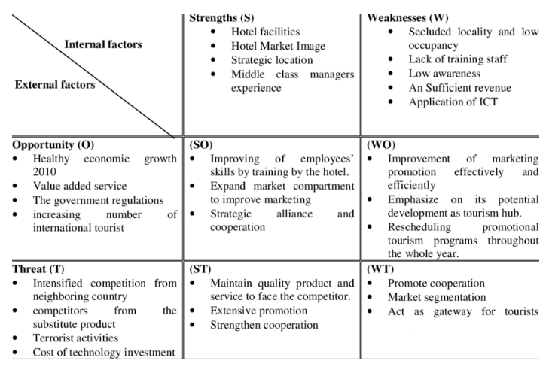
TOWS Matrix depicts The Harborside Hotel, Spa & Marina's likely success tactics based on its strengths and overcoming its weaknesses. It also depicts destinations' tactics for capitalising on alternative tourist prospects and dealing with risks. TOWS analysis provides a simple shortcut for decision makers. Based on the results, Harborside Hotel, Spa & Marina had to focus on their challenges to find solutions and then act through the actions listed.
As mentioned before, the strength of the hotel is related to the location which is convenient and well-established and connected with the means of transportation. The location for a hotel represents the most important thing out of its positive adds. The location will give the hotel its customers, in this case, the hotel has been placed in a perfect and convenient location, able to offer the hotel a proper environment for its development.
In terms of weaknesses, the hotel has quite a few, and the most important would be related to training of the staff, especially the management part. There is not enough experience within the management department, therefore, many of the actions are visible within customer side, with negative responses. Also, there are issues related to employee turnover, issues that came from an analysis on HR (Human Resources) department. The reasons for employee turnover would be low pay checks, and lack of motivation within the employees. These reasons can come out of lack of experience within management department.
In terms of opportunities, the hotel can act accordingly to improve its weaknesses, and to make sure they create a proper environment for people to work with pleasure. At the same time, there is a need, and a huge one, to work with the employees on different trainings and to deal with their personal development and track their movements and actions in terms of knowledge improvement. This must be done because the hotel is lacking experienced personnel, therefore, there is an acute need to improve this topic.
Like any other hotel in the area, there are threats that must be eliminated. In this case, the board of directors has been receiving an ultimatum to work on the issues identified, apply solutions given and to show a positive curve of learning and customer feedback. Also, the managers must pay attention to the technology trends, which can be a plus or a downsize for the organisation, depending on how they are being used or not, or applied. There are many trends within the hotel industry and the organisation must make sure they can apply them as the customers became more aware about the competition and about the fact that they must have low prices and high-quality offers.

ABC ANALYSIS

Material warehouses play a key role in the hotel's organizational structure. A company's health affects the hotel's overall performance. The Store Manager's responsibilities include presenting merchandise, preparing orders, managing inventory, keeping all system records, negotiating, and making strategic decisions. There are different opinions about what inventory management means. Technology plays a key role in improving inventory management performance. Once the goods arrive at the company, the shopkeeper can move the goods to a specific department or store them in inventory (Gadekar, 2016). Food, Beverage, Laundry, Cleaning, Services and Hygiene are part of the hotel's inventory. In general, sorting inventory is essential to running any business. Awarded to successful companies in all fields. Conduct surveys to determine inventory levels for efficient capital management and high customer satisfaction. Hotel inventory accounts for a massive portion of total working capital. Inventory management can be difficult in any industry. Customer loyalty is the most crucial factor in a hotel's success. Inventory management inevitably incurs a variety of costs, including handling costs, storage costs, obsolescence costs, damage costs, and opportunity costs. The main objective of Kumar (Kumar, 2017) is to investigate inventory management strategies in use and identify practical solutions to prevent inventory management inefficiencies. In this study, his ABC analysis was used to analyse hotel data. ABC analysis has proven useful in estimating the delivery value of inventory. This classification allows hotels to identify popular locations and distinguish them from other locations with lower sales volumes. The study found that employing these insights can help the hospitality industry better manage inventory levels and track top-performing merchandise.
ABC analysis is a data analysis technique used to find which stocks are the best performers and which stocks are the worst performers over time. In other words, it helps you find the most profitable and resource-intensive items, streamlining your inventory management. It also contributes to improving profitability. In the ABC analysis, using the Pareto Principle, or 80/20 rule, he divides the inventory into three groups based on total sales. According to research
• Deluxe Double Room (Class A)
• Deluxe Single Room and Prestige Double Room (Class B)
• Prestige Single Room, Royal Suite, Executive Class Suite (Class C)

Results of ABC analysis

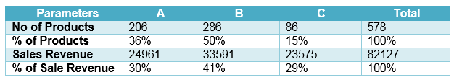
The luxurious master bedroom was the highest-grossing product in 2019, accounting for 31% of total sales at A$24,961.

ABC analysis results – split of products by sales revenue

The deluxe master bedroom is Harborside Hotel's top grossing product of 2019, reaching A$24,961, representing 31% of total sales. The sale accounted for 36% of the total sales of goods.
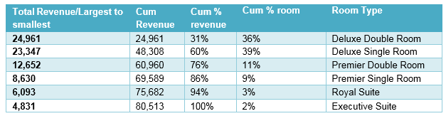

Revenue against purpose of visit

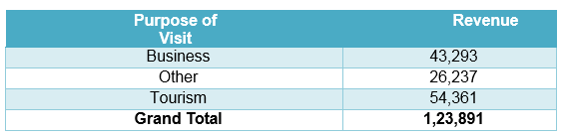

Revenue against different Nationalities visit
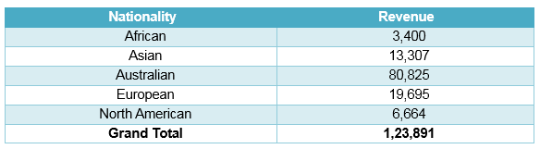

Revenue against different room types booking

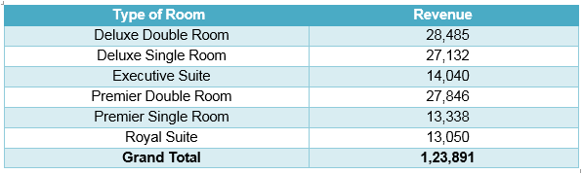
According to the 2019 data, the table above allows us to identify income based on several factors. For example, different countries, different room types, which rooms earn more, which nationality earns more, which purpose of stay earns more, etc.

ABC Analysis chart by product line
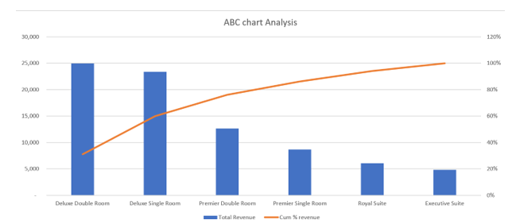

Pareto chart showing cumulative sales revenue by product line

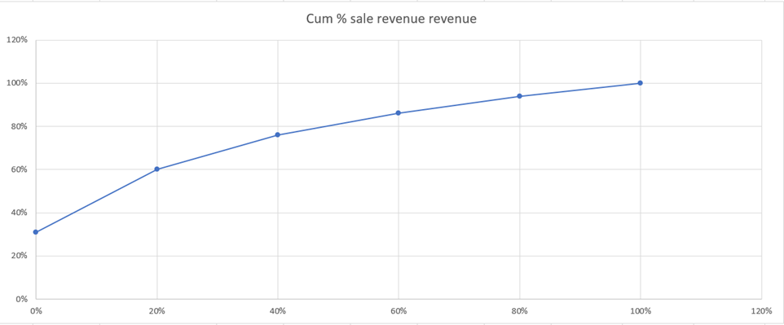

PRESCRIPTIVE ANALYSIS

The hotel industry welcomes millions of visitors every day, each with their own expectations. From bookings to hotel experiences to sharing experiences on social networks, every booking generates data. The biggest challenge hotels face is integrating relevant data into key business decisions and processes to deliver results that drive revenue and loyalty. The biggest challenge hotels face is integrating relevant data into key business decisions and processes to deliver results that drive revenue and loyalty. As hoteliers, they often don't see data as a critical weapon in our day-to-day operations. They'd be better off focusing on making your guests happy instead of messing around with numbers. Why is data important for hotels? After all, data is just the details. We not only want our visitors to have a good time, but we also want to see the right data to increase sales and traffic.
According to the data, the above tables shows various income standards. For example, different nationalities and room types, which room has the highest income, which nationality has the highest income, and which purpose of residence has the highest income. The deluxe double was the Harborside Hotel's highest-earning room in 2019, accounting for his 31% of total sales and A$24,961. Therefore, hoteliers should focus on deluxe double rooms compared to other room types. The Deluxe King Room was the best-selling item in 2003 at $24,961, followed by the Generator Room Suite, which was the next most profitable at $23,347, accounting for 29 percent of total revenue in the first half of 2019. The Australian dollar accounts for 31% of total turnover. Looking at the sales numbers, 36% of the total number of rooms booked at this hotel prefer the double deluxe room, while 29% of customers prefer the single deluxe room. This means that Deluxe Rooms (single or double) are the most affordable rooms at this hotel. Considering the purpose of visit and income, it can be seen that the guests come for sightseeing and business purposes. Nearly 80% of hotel guests come for tourism or business purposes. Australians prefer this hotel to foreigners. 50% of my income in the first half of 2019 came from living in Australia. Europeans are the second most frequented country for hotel stays. Europeans earn 16% of the income. In the first half of 2019 he had 300 bookings, 60% of which were women. Women like this hotel more than men. When comparing hotel stays here, more women stay than men. Women stay in hotels in groups, while men prefer to stay alone.

FINANCIAL ANALYSIS OF THE DECISIONS

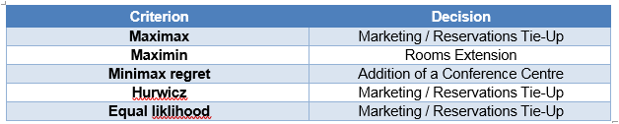
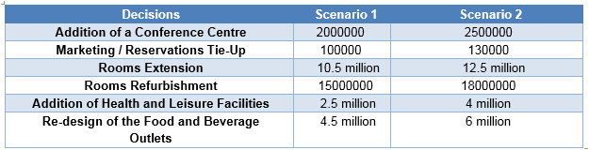
In every state of nature, one dominant decision has a greater reward than the other choice. The appropriate criteria are determined by the "risky" personality and attitude of the decision maker.

DECISION TREE

When dealing with a variety of choice problems, such as when one decision leads to many subsequent decisions and expected outcomes.
A decision tree is a real-time graphical description of a decision problem.
Graphical display of options, costs and probabilities.
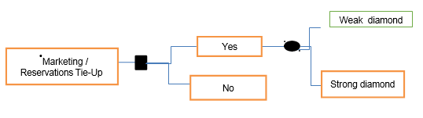

CONCLUSION AND RECOMMENDATION

Modernization is hitting the residential and commercial HVAC industry, demanding state-of-the-art, energy efficient central air conditioning systems. Therefore, choosing a suitable central air conditioning system is an important goal for the construction industry. Making the wrong choice can increase system start-up and operating costs while reducing user comfort and indoor air quality standards. In fact, choosing the right type of central air conditioning system requires prior assessment of the building type and available budget. Breakfast is not only the most important meal of the day, but also the most important amenity of any hotel, large or small. Your small hotel has nice rooms, Wi-Fi, bathrooms, and a fitness centre. On the other hand, eating a decent breakfast leaves the experience incomplete. Finally, the traveller prefers B&Bs and small hotels. The reason is because of the individualized services that these establishments offer. Guests can enjoy breakfast in a variety of ways that accommodations may not have thought of. A rich breakfast will make your stay easier and more comfortable.
Harborside's occupancy rate has increased by 2 percentage points since 2016, despite higher occupancy rates for its competitors. A slight increase in port occupancy was not offset by a sharp rise in average room rates. However, with The Landmark increasing room count and offering a limited number of two-bedroom suites, The Landmark's performance will be in line with its competitors, so occupancy rates and average room rates will increase. expected to increase significantly.
Harborside Hotel is a recognized member of the prestigious Southern Comfort Hotel Business Partnership and Reservation Program. The hotel's profitability will improve significantly, and the basic occupancy rate will be almost secured, but the level has not yet been determined. The market for double rooms is growing. There is a possibility of expanding the space on the terrace behind the hotel. About 50 more rooms can be built on the podium without affecting the rest of the hotel, according to Land Containers architects. I doubt it will make it difficult to obtain the necessary building permits. Using the expansion of the space he has discussed the idea of ​​creating one or more "dedicated floors" and the Harborside Hotel is in line with what many competing hotels are doing these days. Reduce costs in the energy industry with energy efficient electronics. This helps you save costs, meet CSR standards, and find the right suppliers. The only limiting factor is the initial cost burden.

REFERENCES

Brown, J. R. & Ragsdale, C. T., (2002). The Competitive Market Efficiency of Hotel Brands: An Application of Data Envelopment Analysis. Journal of Hospitality & Tourism Research, 26(4),p. 332–360.
David, J. S., Grabski, S. & Kasavana, M., (1996). The Productivity Paradox of Hotel-Industry Technology. Cornell Hotel and Restaurant Administration Quarterly, 37(2), p. 64–70.

Dominici, Gandolfo & Rosa, G., (2010). Customer Satisfaction in the Hotel Industry: A Case Study from Sicily. International Journal of Marketing Studies, 19 November, 2(2), pp. 3-12.

Foroohar, R. (2019) The trouble with American tourism, available at: https://www.ft.com/content/0f7d818a-c38b-11e9-a8e9-296ca66511c9 (Accessed 01 June 2023)

Gadekar, A. & Gadekar, R., (2016). Increase Customer Satisfaction and Reduce Losses Through ABC Analysis, Dual and Multiple Criteria Approach in Hotel at Mauritius. Amity Global Business Review, Volume 11, pp. 62-67.

Hoistington, A., (2019) WTTC: U.S. still leads world in travel and tourism, available at: https://www.hotelmanagement.net/own/wttc-u-s-still-leads-world-travel-and-tourism (Accessed 05 June 2023)

Kandampully, J. & Suhartanto, D., (2003). The Role of Customer Satisfaction and Image in Gaining Customer Loyalty in the Hotel Industry. Journal of Hospitality & Leisure Marketing, Volume 10, pp. 3-25.

Kumar, N. & Soni, R., (2017). ABC Analysis in the Hospitality Sector: a Case Study. International Journal of Advanced Production and Industrial Engineering, Volume 3, pp. 1-3.

Rosenberg, L. & Czepiel, J., (1984). A MARKETING APPROACH FOR CUSTOMER RETENTION. Journal of Consumer Marketing, 1(2), pp. 45-51.

Lock, S. (2019) Travel and tourism industry in the U.S. – Statistics & Facts, available at: https://www.statista.com/topics/1987/travel-and-tourism-industry-in-the-us/ (Accessed 1 June 2023)

Mejia, Z., (2018) These are the 10 most fun US states of 2018, available at: https://www.cnbc.com/2018/05/25/the-10-most-fun-us-states-of-2018.html (accessed 2 June 2023).

S.A. Oke, C. et al., (2008). The combined application of Quality Function Deployment and Pareto analysis for hotel services improvement. International Journal of Productivity and Quality Management (IJPQM), 3(2).

Su., T. & Lei, X., (2008). Research on supply chain cost reduction based on process and time analysis. IEEE International Conference on Industrial Engineering and Engineering Management, pp. 1625-1629.
X
ue, J. et al., (2019). A Green Supply-Chain Decision Model for Energy-Saving Products That Accounts for Government Subsidies. Sustainability, 11(8).

Professional Academy (2022). Marketing Theories – PESTEL Analysis. [online] www.professionalacademy.com. Available at: https://www.professionalacademy.com/blogs/marketing-theories-pestel-analysis/. (Accessed: 8 June 2023)

Sustainable Hospitality Alliance. (n.d.). Business Case for Sustainable Hotels. [online] Available at: https://sustainablehospitalityalliance.org/resource/business-case-for-sustainable-hotels/. (Accessed 8 June 2023)

Kilburn, H. (2020). CASE STUDY: utilising sustainability and emotional practice in hotel design • Hotel Designs. [online] Hotel Designs. Available at: https://hoteldesigns.net/industry-news/case-study-a-concept-for-sustainability-and-emotional-hotel-design/ (Accessed 8 June 2023)

MAXIMIZE MARKET RESEARCH. (n.d.). Hotels Market - Global Industry Analysis to 2020 – 2027. [online] Available at: https://www.maximizemarketresearch.com/market-report/hotels-market/47478/. (Accessed 8 June 2023)

‌ Ibisworld.com. (2019). IBISWorld - Industry Market Research, Reports, and Statistics. [online] Available at: https://www.ibisworld.com/global/market-research-reports/global-hotels-resorts-industry/. (Accessed 8 June 2023)
SOEG JOBS (2019). An Overview of The Hotel industry - It is definition, Segments, Types & Aspects. [online] Global Hospitality Portal. Available at: https://www.soegjobs.com/overview-hotel-industry-sectors-segments-aspects/ (Accessed 8 June 2023)
‌
Curtis, G. (2018). Hotel Industry Market Report. [online] Salience. Available at: https://salience.co.uk/insight/reports/hotel-sites-market-performance-report/ (Accessed 8 June 2023)
‌
gd-admin (n.d.). News - The Difference Between the Hotel Industry and the Hospitality Industry. [online] https://www.aolga-hk.com/. Available at: https://www.aolga-hk.com/news/the-difference-between-the-hotel-industry-and-the-hospitality-industry/ (Accessed 9 June 2023)
‌
Lacalle, E. (2022). SWOT analysis for hotels. What is it and how does it work? [online] available at: https://www.mews.com/en/blog/swot-analysis-for-hotels. (Accessed 8 June 2023)
‌
Smart Hospitality Market Analysis, Research, Size, Share, Statistics, Trends, & Forecast by 2029. [online] Available at: https://www.databridgemarketresearch.com/reports/global-smart-hospitality-market. (Accessed 9 June 2023)
‌
Dr Vijay Malik. (2022). How to do Business Analysis of Hotels. [online] Available at: https://www.drvijaymalik.com/hotels/ (Accessed 9 June 2023)
‌

