Problem-solving and decision making
Lecturer Name: Faizu Edu
Student Name: Cezar Stroescu
Student ID: 2123047

Table of Contents

Introduction 3
Workplace problem 4
Root cause analysis of lack of innovation 5
Situational Analysis Model 6
SWOT analysis 6
PESTLE analysis 7
A range of alternative solutions to the problem 8
Evaluation of the alternative solution 9
Weighted decision-making matrix lack of innovation 9
PMI analysis of lack of innovation 10
Pros and cons of each solution 11
Implementation of the solution 12
Gannt Chart 12
Communication plan with stakeholders 14
Monitoring and review techniques 16
Conclusion 17
Reference 18
Appendix 20

Introduction
Innovation means the ability to produce unique and different products from competitors. Innovation brings a competitive advantage. Weaknesses in this ability mean a lack of innovation. That means employees can not think creatively or differently. Using of old aged technology may be a cause for lacking innovation. Lack of innovation severely affects performance by losing in the competition (Zhang et al., 2015). This paper will cover the nature and impact of the lack of innovation ill find the root causes of this problem. Then specify a list of solutions to this problem. After that, PESTLE, SWOT, and PMI analysis will conduct.
Workplace problem
In today’s world, innovative product is necessary to compete in the market. Innovation brings uniqueness which attracts customers. So, it’s a great problem if organizations lack innovation. Innovation means utilizing unique and new processes and systems to produce products and services that can produce unique products. Modern lifestyle is centered on innovation. Innovative organizations embrace new possibilities, use modern technological tools, and take the lead in their sector. Innovation brings a new and unique product that other competitors do not have. Although unfavourable effects can occur, most changes brought forth by innovation are highly good. For this reason, an innovative organization can get competitive advantages. But in most cases, the organizations have antiquated methods of operation that hinder innovation (Awan et al., 2021). Lack of innovation may result from not considering customer-changing demand and world-changing nature. Organizations need to prioritize new ideas to bring innovation to the organization—a lack of innovation results in decreasing sales and failure to compete in the market. Lack of innovation hardly impacts the organization because it can not learn anything without innovation and can not change anything. Organizations will freeze over time and lose in the competition. Ultimately, they become disappear from the market. It has detrimental effects on society and the economy (Cockburn et al., 2018).

Root cause analysis of lack of innovation
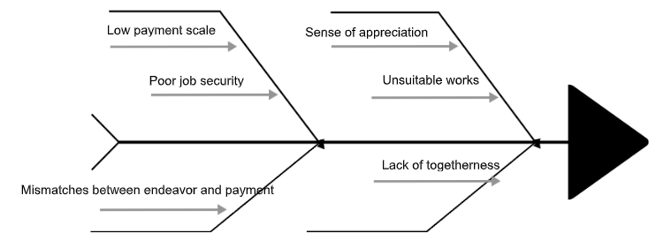
Figure: Cause and effect analysis of lack of innovation (Author’s calculation)
Organizations lack innovation because of not understand customer needs and wants. Though sometimes innovative products can be made, innovation fails because of poor sales. Unawareness of organizations of customers’ problems and demands is the main reason behind it. Updated technologies are required to make innovative products. But with primitive technologies, innovative product is not possible. However, few organizations fully use technological breakthroughs to create unique solutions further create unique solutions (Meng and Berger., 2019). Management is more likely to lose sight of long-term objectives and prospects when they are exclusively concerned with short-term success. So, managers are not innovative enough to make unique products. Organizations can not bring innovation without changes. But some organizations still choose to stay on an old-aged system of production or product. They do not consider the changing nature of customer demand, resulting in a lack of innovation. The inventive spirit might be discouraged by primitive structures and be characterized by their inflexible bureaucratic procedures and slow processes (Hung et al., 2018).

Situational Analysis Model

SWOT analysis
SWOT analysis is conducted to understand an organization’s strengths, weaknesses, threats, and opportunities. For lack of innovation, one organization can understand its weaknesses and threats by SWOT analysis (Benaven, 2015).
Strengths | Weaknesses | Opportunities | Threats
Developing production of one or few items efficiently. | General products | Offer products at a low cost | Fail in competition
Reduction of cost | No opportunity for uniqueness | Chances of further improvement | Reduction of sales
Fewer efforts are needed. | Negative prospects
Figure: SWOT analysis for lack of innovation

PESTLE analysis
Political Factors | Economic Factors | Social Factors | Legal Factors | Technological Factors | Environmental Factors
The extent of intellectual property theft and corruption | GDP, vacancy rate, | Education requirements, | Laws against discrimination and security | Automation | Weather patterns
The power of the government. | Amount of available money | Demographics of the population and proficiency. | Laws governing the quality of goods | The speed at which technology is advancing | Natural calamities
Changes to tax laws, trade restrictions, and tariffs. | Interest rate, rate of inflation, and the income available for discretion | Interests outside of work and education. | Laws that govern employment and health | Creation of unique products | Climate change
Figure: A PESTLE analysis for lack of innovation (Author’s calculation)
A range of alternative solutions to the problem
- Utilization of modern technology
- The undertaking of farsighted leadership
- Modernize the structure of the organization
- The undertaking of employee’s ideas and opinion
- Enabling understanding customers to want
- Taking the initiative to change

Evaluation of the alternative solution
Factors | Utilization of modern technology  5 | The undertaking of farsighted leadership  3 | Modernize the structure of the organization  3 | The undertaking of employee’s ideas and opinion  4 | Enabling understanding of customer want  4 | Taking the initiative to change  2
Available of fund | 5×4=20 | 3×3=9 | 3×5=15 | 4×2=8 | 4×2=8 | 2×5=10
Intention of employers | 5×3=15 | 3×4=9 | 3×5=15 | 4×3= 12 | 4×2=8 | 2×4=8
Availability of input, machinery, materials | 5×2=10 | 3×2=6 | 3×4=12 | 4×2=8 | 4×1=4 | 2×3=6
Rules and regulations of the government | 5×2=10 | 3×3=9 | 3×5=15 | 4×3=12 | 4×3=12 | 2×4=8
Stay in the competitive market | 5×1=5 | 3×3=9 | 3×2=6 | 4×1=4 | 4×4=16 | 2×4=8
Total | 60 | 41 | 51 | 44 | 48 | 40

Weighted decision-making matrix lack of innovation
Figure: A weighted decision-making matrix for lack of innovation (Author’s calculation)

"Utilization of modern technology" has been weighted with 5 points, indicating that it receives more weight than the other criteria, which only receive 1 or 2 points. The organization utilized a rating scale for the issue that reads "high" as 5, "medium" as 3, and "low" as 1. In this problem, “Stay in the competitive market” is low because sometimes organizations may not want to take the initiative to change. On the other hand, the Available fund for utilizing modern technology is high because buying and using modern technology dramatically depends on the money available in the organization to make unique products. Here, the highest score is 60, which is the utilization of modern technology.

PMI analysis of lack of innovation
Plus | Minus | Interesting
- We can put more of an emphasis on one or a few products.  - Production costs can be cut.  - Shortsighted leadership can solve the immediate problem.  - Managers can decide on their own. | - Decrease in sales  - The popularity of the organizations will not be increased.  - There will be no uniqueness in the products.  - Products will be general products. | - Organizations can take the initiative to increase innovation to create unique products.
Figure: A PMI analysis for lack of innovation (Author’s calculation)

Pros and cons of each solution
The utilization can make innovative products of modern technologies. The innovation path may be simple and incredibly beneficial for the firm with the correct resources and assistance. The ideal platform makes it simple to set logical deadlines for implementation, incubate innovative ideas, identify priority regions, and develop appropriate challenge circumstances. But the cost of buying updated types of machinery may require a high budget. Farsighted leadership means undertaking a long future. Managers should consider customers’ demands and wants in the future and the changing nature of the world. Innovative leaders have unique views and cutting-edge concepts, and they consider both the present and the future. By regularly converting the regular conversion of sound thoughts into workable concepts, they continually recognize risks and opportunities and establish an adaptation plan (Osterwalder et al., 2015). Future-oriented organizations are more likely to outperform rivals and prevail in the long run. Organizations should adopt a modern structure in the hierarchy system. They should create a unique solution and should remove bureaucratic barriers. Employees also have unique ideas and opinions to make a product different from others. Managers should consider their opinions. Because employees directly work to make a product. Organizations need financial feasibility to buy modern technologies. Customer demands and wants also need to be carefully monitored. For this reason, a survey can be conducted to identify their wants (Nylén and Holmström, 2015).

Implementation of the solution

Gannt Chart
 | Task | Date | Day to complete
Task 1 | Utilization of modern technology | 10.12.22 | 8
Task 2 | The undertaking of farsighted leadership | 17.12.22 | 5
Task 3 | Modernize the structure of the organization | 15.12.22 | 7
Task 4 | The undertaking of employee’s ideas and opinion | 20.12.22 | 3
Task 5 | Enabling understanding customers to want | 24.12.22 | 5
Task 6 | Taking the initiative to change | 28.12.22 | 6
Figure: A Gannt Chart table for the implementation plan (Author’s calculation)

Figure: A Gannt Chart for implementation plan (Author’s calculation)
Organizations will bring modern technology to produce innovative products in the first week. It will need eight days to complete. Modern machinery is more useful than primitive machinery. Then, a leader who can take farsighted leadership will be set. Farsighted leadership is required to know future customer demand. It will need five days. Thirdly, bureaucratic problems and modernizing the organization’s structure will be eliminated. It will need seven days to complete. After that, employees' innovative ideas and opinions to produce unique products will be undertaken, which will need three days. Then a survey can be taken in the market to understand customer demands and wants, which will need five days to complete. At last, initiative actions will be taken to solve this problem. Initiative actions will be taken to produce unique products.
Communication plan with stakeholders
A party with interest in a business who has the power to influence or be impacted by the endeavour and has an impact on the venture's outcome is referred to as a stakeholder. All decisions made by the organization hold their interest. Stakeholders involve directly or directly in an organization (Jones et al., 2017). The list of stakeholders in an organization is given below:
- Customers
- Shareholders
- Distributors
- Suppliers
- Trade associations
- Employees
- Communities
- Government
- Investors
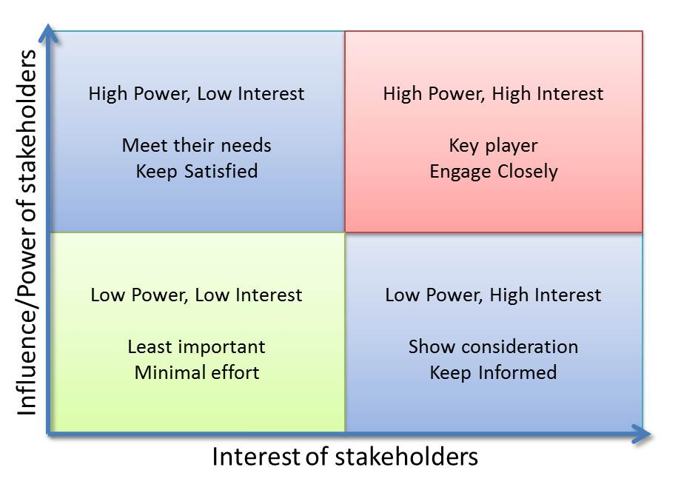
Figure: A sample of Power/Interest Grid analysis (Serra, 2020).
Each stakeholder in a project has a unique interest in it and some degree of power over it. An organization has four aspects. An organization’s interest of the stakeholder is in the “X” axis. And the organization has the power of the stakeholder in the “Y” axis. A person's influence on a task is referred to as power. Depending on the stakeholder, they may range from high to low. An organization needs to maintain a good relationship with its stakeholders. Organizations must engage with them as required. Employees may be highly powerful stakeholders because they make innovative products. Organizations need to maintain a good relationships with high-profile and key-profile stakeholders. For this reason, Organizations need to maintain a good relationship with the government because they are policymakers. On the contrary, they must keep an eye on stakeholders with little interest and influence. At last, potential customers need to be informed.
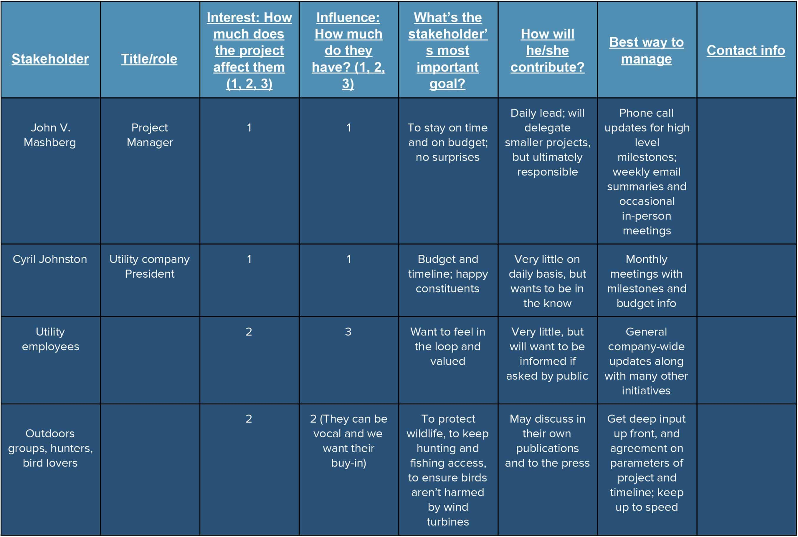
Figure: A stakeholder communication plan (Sterling et al., 2017).

Monitoring and review techniques
Works should be monitored and reviewed regularly. If any problem is found, proper steps can be taken to solve the problem. Monitoring is a continual process involving acquiring and analyzing relevant data to ensure the project goes as planned. An organization's success or failure may depend on how well it manages its performance. Lack of innovation is a great problem in an organization. Managers should closely monitor employees’ activities and influence them to think creatively. Time and effort are saved by monitoring processes. Organizations need to identify key indicators that depend on the organization’s nature (Hazır, Ö., 2015).
Conclusion
The capacity to create distinctive items that stand out from those of rivals is innovation. Through innovation gains a competitive advantage, not all organizations have innovative capabilities. There are some root causes for the lack of innovation. Such as primitive technology, resistance to change, and not understanding customer demand. There is some solution to reduce this problem. The utilization of modern technology is one of them.

Reference
Awan, U., Arnold, M.G. and Gölgeci, I., (2021). Enhancing green product and process innovation: Towards an integrative framework of knowledge acquisition and environmental investment. Business Strategy and the Environment, 30(2), pp.1283-1295.
Benaven, C. (2015) SWOT analysis. Namur: 50minutes.
Cockburn, I.M., Henderson, R. and Stern, S., (2018). The impact of artificial intelligence on innovation: An exploratory analysis. In The economics of artificial intelligence: An agenda (pp. 115-146). University of Chicago Press.
Harmon, M. and Nelson, S. (2016) “The root causes of employee turnover,” in Employee turnover: Contributing factors and Retention Strategies. Milwaukee, WI: Cardinal Stritch University.
Hazır, Ö., (2015). A review of analytical models, approaches and decision support tools in project monitoring and control. International Journal of Project Management, 33(4), pp.808-815.
Hung, L.M., Lee, Y.S. and Lee, D.C., (2018). THE MODERATING EFFECTS OF SALARY SATISFACTION AND WORKING PRESSURE ON THE ORGANIZATIONAL CLIMATE, ORGANIZATIONAL COMMITMENT TO TURNOVER INTENTION. International Journal of Business & Society, 19(1).
Jones, T.M., Wicks, A.C. and Freeman, R.E., (2017). Stakeholder theory: The state of the art. The Blackwell guide to business ethics, pp.17-37.
Meng, J. and Berger, B.K., (2019). The impact of organizational culture and leadership performance on PR professionals’ job satisfaction: Testing the joint mediating effects of engagement and trust. Public Relations Review, 45(1), pp.64-75.
Moussa, M. and Somjai, K. (2019) “Job dissatisfaction and employee turnover: A qualitative case study in Thailand,” Causes of employee dissatisfaction [Preprint]. Available at: https://doi.org/10.4135/9781526461889.
Nylén, D. and Holmström, J., (2015). Digital innovation strategy: A framework for diagnosing and improving digital product and service innovation. Business Horizons, 58(1), pp.57-67.
Osterwalder, A., Pigneur, Y., Bernarda, G. and Smith, A., (2015). Value proposition design: How to create products and services customers want. John Wiley & Sons.
Saridakis, G. and Cooper, C. (2017) Research Handbook on Employee turnover. Cheltenham, UK ; Northampton, MA, USA: Edward Elgar Publishing.
Serra, C.E.M. (2020) Stakeholder analysis, Projectizing. Available at: https://projectizing.com/stakeholders-analysis-powerinfluence-interest-matrix/ (Accessed: November 22, (2022).
Sterling, E.J., Betley, E., Sigouin, A., Gomez, A., Toomey, A., Cullman, G., Malone, C., Pekor, A., Arengo, F., Blair, M. and Filardi, C., (2017). Assessing the evidence for stakeholder engagement in biodiversity conservation. Biological conservation, 209, pp.159-171.
Zhang, X., Yu, P., Yan, J. and Spil, T.A., (2015). Using diffusion of innovation theory to understand the factors impacting patient acceptance and use of consumer e-health innovations: a case study in a primary care clinic. BMC health services research, 15(1), pp.1-15.

Appendix

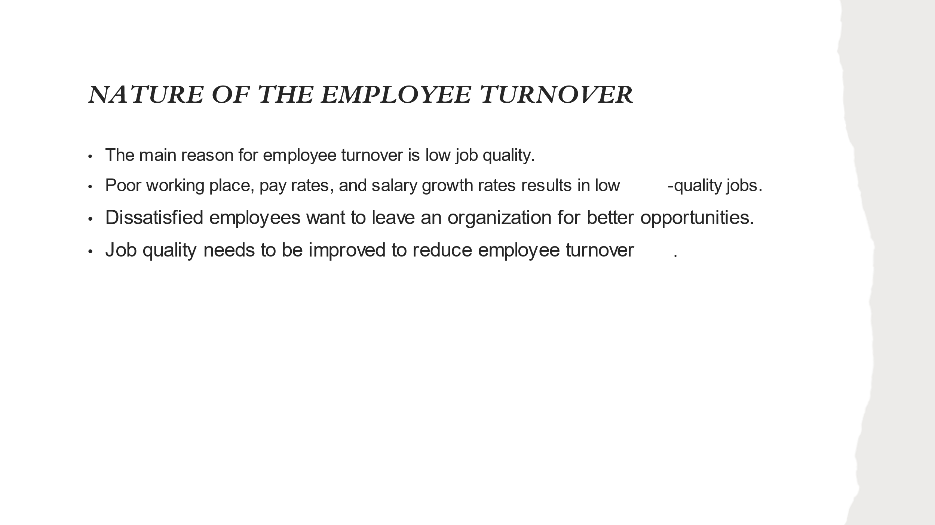

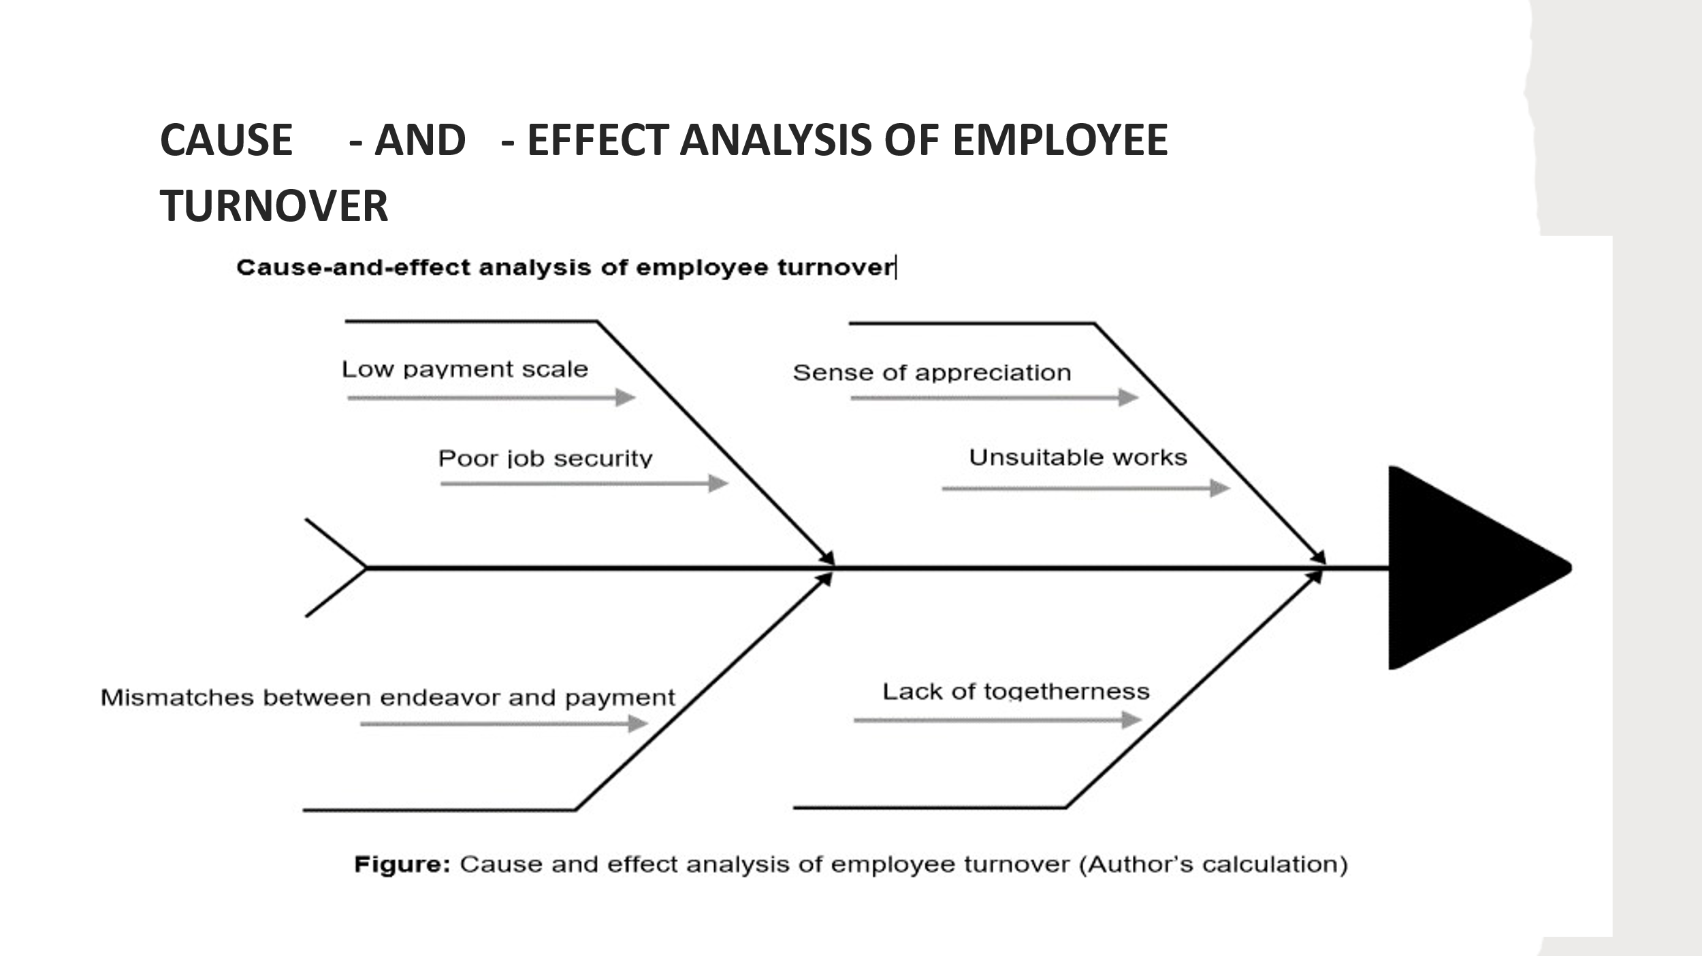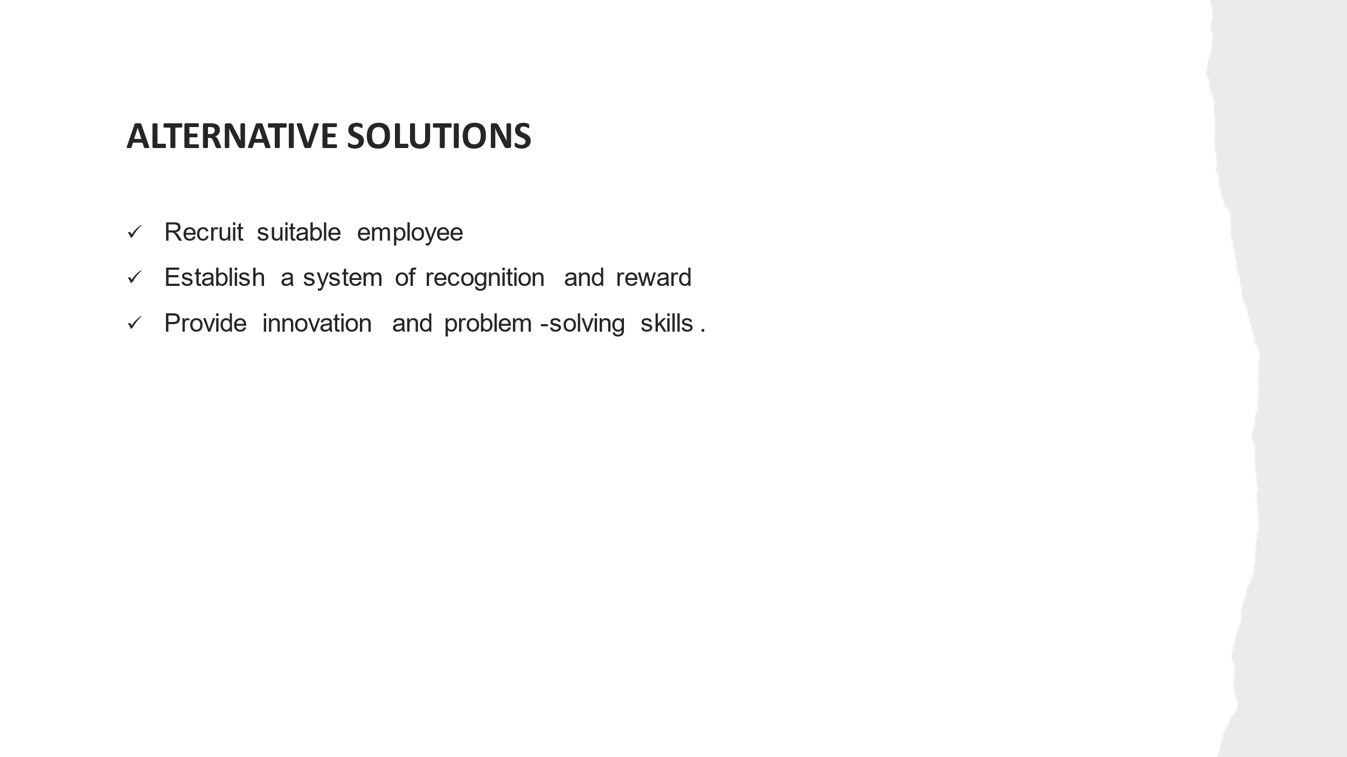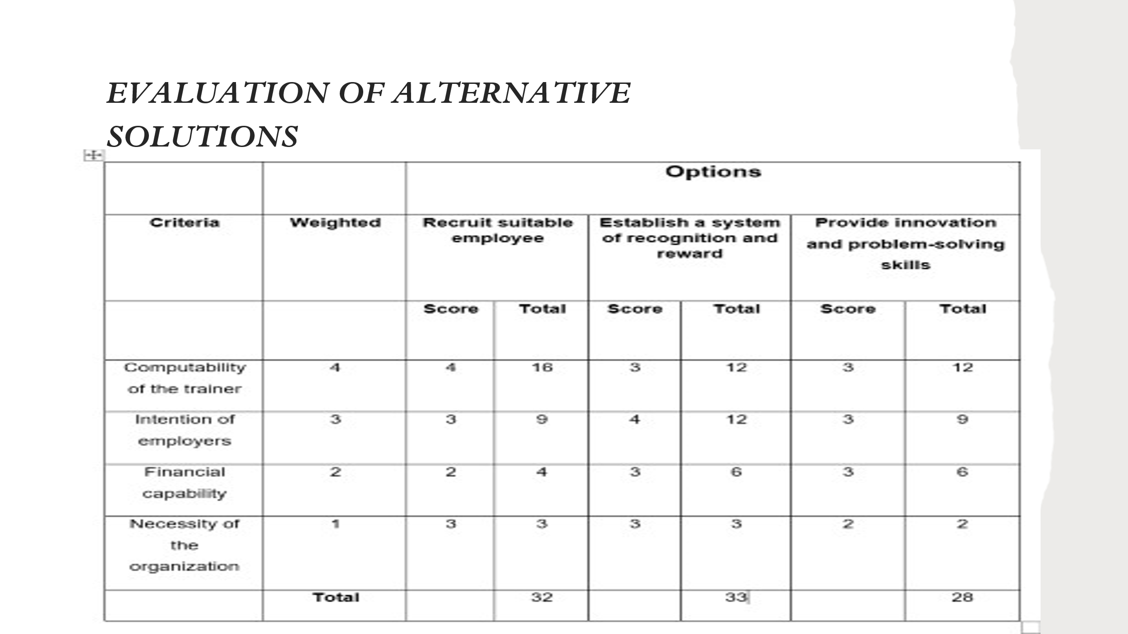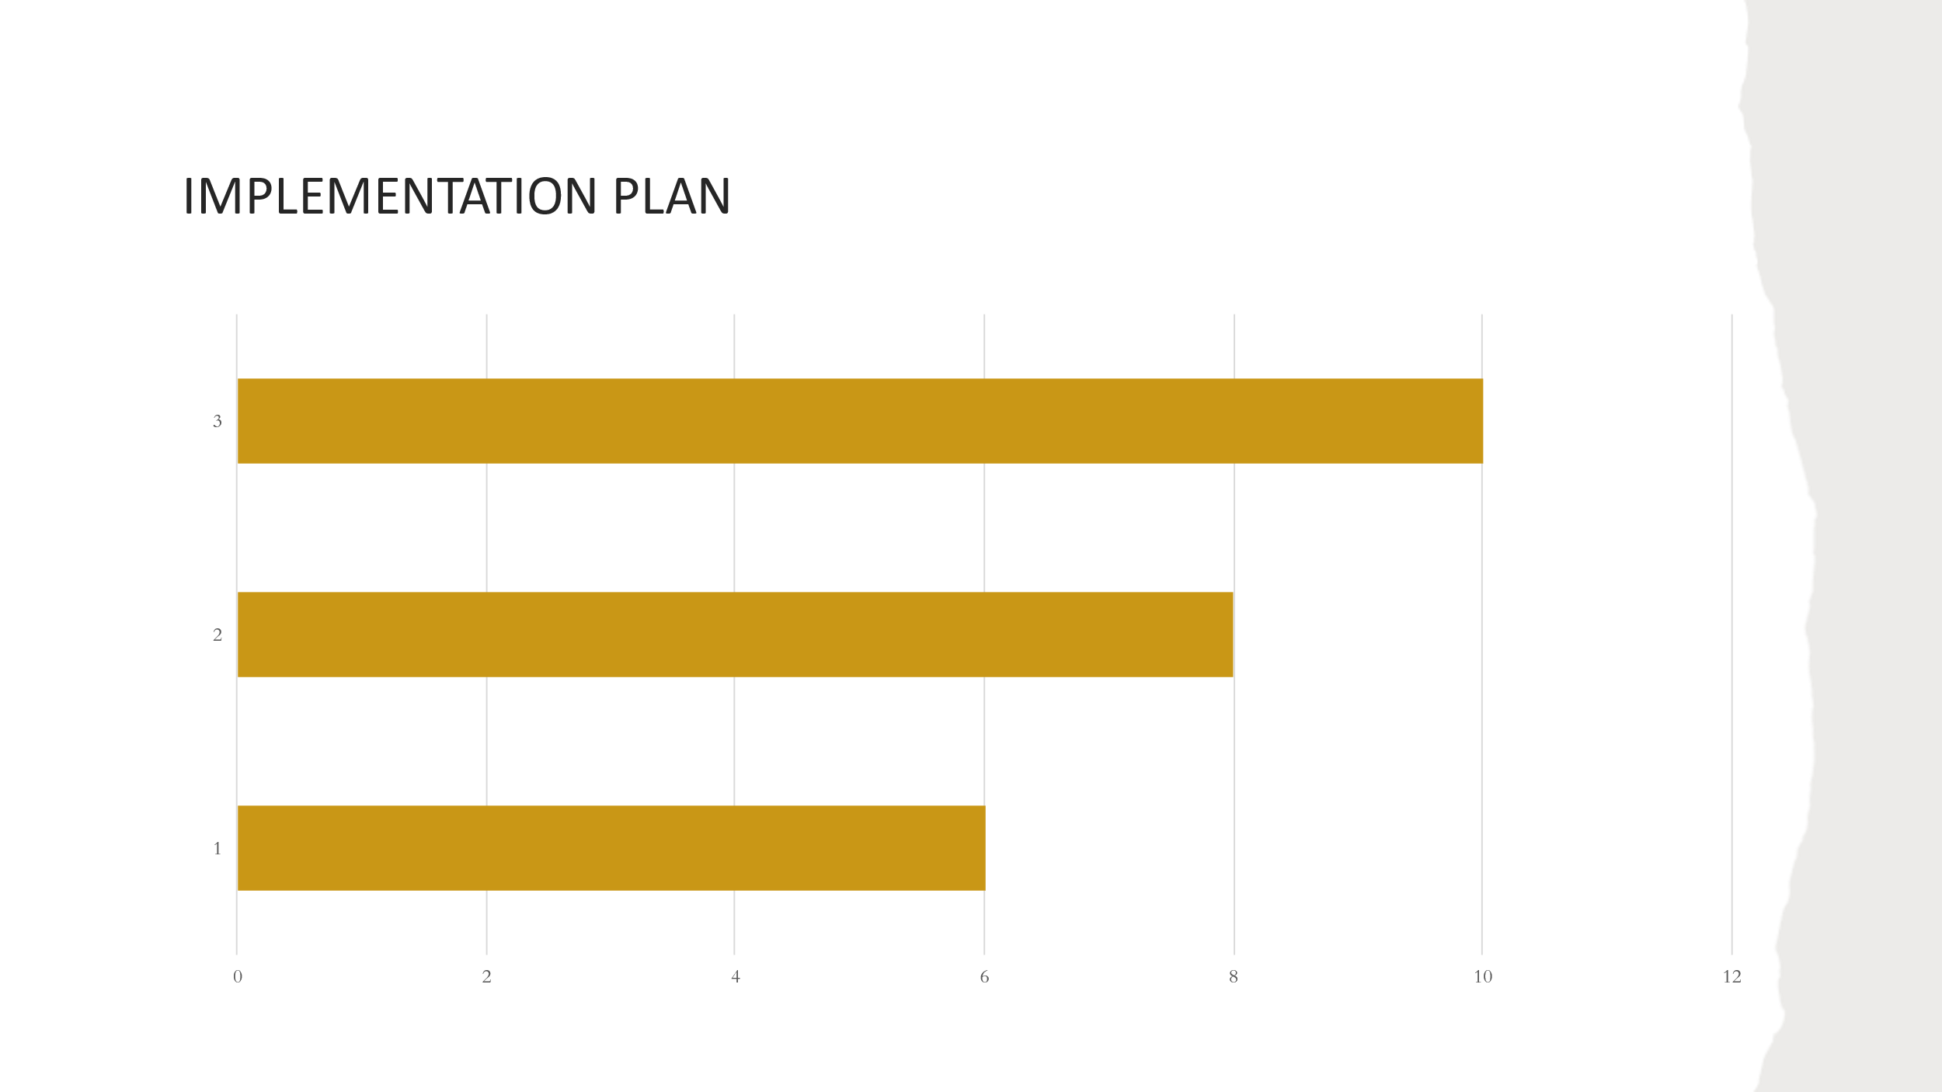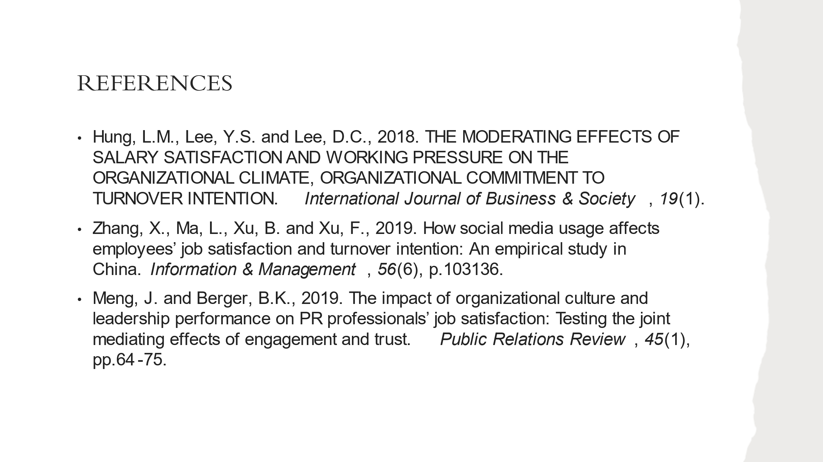Role Play
Employee
Hello, how are you? I want to discuss this with you. When will your time be? I have had some meaningful discussions with you about my dissatisfaction and feeling about the organization.
Consultant
Hello, I am fine and you? You can come to my office when you want.
Employee
I am also fine but depressed and demotivated because of my organization. Now, my colleagues want to switch to this organization. I have some tasks in my hand. After completing my tasks, I will go to your office.
Thank you.
Consultant
Ok. I will be waiting for you.

Employee
Hello, you may know that most of the employees in that organization are unsatisfied. However, the organization has argued that they have terminated the employees, but most switched the organization because they were unsatisfied.
Consultant
Yes, I know. The organization needs to terminate poor performers because it cannot profit because of its poor performance.
Can you inform the reason for job dissatisfaction? I can find the best solution to solve this problem. I hope my solution will satisfy the employees.
Employee
Well, the workload of this organization is so heavy that employees cannot complete it. There is a low pay scale. Employees find that they are less paid than their worth. This is the main reason for leaving the organization. There is a mismatch between the employee’s endeavor and payment. They must work a lot, but the payment structure is insufficient to meet this workload. Again, if employees find more attractive salaries in others organizations, they may leave the organization.
Consultant
Is the workload of the organization so big than the previous one? Do you know what the reason behind it is?
Employee
Yes, the workload is heavier than the previous one, but I don’t know why.
Consultant
When an organization's employees switch continuously, it burdens the remaining employees. The remaining employees have to do additional work for them. So, the workload is happening.
But this problem will be solved by recruiting highly qualified employees. As a result, the workload of employees will be reduced. Moreover, an attractive salary structure will be made so that employees may not want to leave the organization. Employees’ payments will be structured to their endeavor.

Employee
That’s great. But one thing should be noted. Other competitive organizations' salary structures should be carefully monitored when constructing salaries. Salary should be reasonable for competitive organizations.
Consultant
Ok, it will be considered.
Employee
Moreover, there is poor job security. There are unsuitable works that are unfavorable to employees. There is also a lack of appreciation. Employees are not recognized and rewarded for their achievements—this results in demotivation. There is also a lack of effective communication. Employees do not know to whom they submit their work. There is a lack of togetherness and harmony among employees, resulting in employee turnover.

Consultant
Do you know why the organization cannot make enough profit?
Employee
No, please inform me.
Consultant
Because of the poor performance of the employees, their poor working abilities cannot produce unique and quality products to attract more customers. Their working abilities are getting worse.
Employee
Employees try their level best to produce a quality product. But extra workload and dissatisfaction are the factors.
Consultant
To solve the problem, the organization will take some steps. First, qualified employees will be recruited so they cannot find the work unsuitable. They will be well-informed about the work to be done. Employees will be offered permanent jobs rather than permanent jobs. A permanent job will be offered to them in considering their performance. Only well performers will get a permanent job. Rewards and recognition will be provided for every achievement. But achievement should be a remarkable achievement. Though we have a reward and recognition system, we will further modify it. We will train employees so that they can make innovative decisions. Also, we train them to solve a problem effectively. These innovative and problem-solving skills may satisfy them. As a result, they may want to stay in the organization for a permanent job.
Employee
Oh, that’s great; if these things are utilized, employee turnover will be solved.
Consultant
Let me know the employee’s reaction and think about my opinion.
Employee
Of course, Thank you for your time.
Consultant
You are also welcome.

