Nathan J Morris

The following research proposal will aim to look at the dam safety implications of poor vegetation management on masonry spillways
Research proposal
Dam safety implications of poor vegetation management on masonry spillways.

Contents
Proposed research title 2
Abstract 2
Introduction 2
Aims and objectives 2
Literature review 2
Dam safety 2
Vegetation management 3
Methodology 4
Data analysis 4
Programme 4
Ethics 6
References 6

Word count - 1207

Proposed research title

The following research proposal will aim to identify :
The dam safety implications of poor vegetation management on masonry spillways

Abstract

The following research proposal will aim to identify the implications of poor vegetation management on masonry spillway structures and the implications of this within the dam safety industry.

Introduction

The researcher currently works within the dam safety industry and deals with vegetation management as part of their role. The findings of this research proposal will be beneficial to the wider dam safety industry and the grounds maintenance contractors undertaking vegetation management on spillways.

Aims and objectives

The research will hopefully identify clear associated impacts of vegetation on these spillway structures and the findings will assist all key stakeholders in clarifying the importance of vegetation management within the dam safety industry.

Literature review

Dam safety

Dams are man made structures which hold back large amounts of water to form reservoirs, they are typically formed by embankments made of compacted earth. There are thousands of these structures in the UK and without care and maintenance dams can significantly deteriorate over time. Large reservoirs are regulated to ensure that suitable provisions are made to keep these safe from failure which may cause flooding, endanger life and damage property (British dams.org,(2021).
The British Dams Society (2021) describe the spillway structure of a dam as “structures that either form part of a dam or, are found just beside one. They are used, when a reservoir is full, to pass floodwater safely, and in a controlled way, over a dam, around it or through it”.

The need for legislation to monitor and control the safety of UK reservoirs was first highlighted in 1852 following the failure of Bilberry dam, and then again in 1864 with the collapse of Dale Dyke Dam near Sheffield which resulted in the death of 244 people. This, combined with additional dam failures, resulted in the reservoirs (safety provisions) act 1930 and applied to all reservoirs in Britain over 22700m3. This has now been amended over time and evolved into what we work to today which is the Reservoirs act 1975 and applies to England and Wales with slight variations on capacity. (Toddbrook independent review, 2021). Each reservoir that is regulated by Law will be required to appoint a reservoir panel engineer, the two main types which will be of concern to this research proposal are a supervising engineer and also an All reservoirs engineer. They are defined below as:

Supervising Engineer (SupE): Is commissioned by the reservoir undertaker of a high‐risk reservoir in England and Wales or a medium or high-risk reservoir in Scotland to supervise the reservoir at all times and produces a written report at least once annually. (British dams.org,(2021).

All Reservoirs Engineer (AR): Is commissioned by the undertaker of a high-risk statutory reservoir of any type to perform a periodic reservoir safety inspection (typically once every ten years) and provide a report to the reservoir undertaker. This report is copied to the relevant regulator. The report might contain recommendations to be completed in the interests of safety and/or maintenance which must be complied with. (British dams.org,(2021).

Reports written by both the Supervising engineer and All reservoirs engineer highlight various issues of concern, one of which is known as “Measures in the interest of maintenance” this is where all vegetation management issues will fall, and it is the responsibility of the reservoir undertaker to carry out these works. (NRW, 2021)

Vegetation management

Vegetation growth in or on masonry spillways can lead to degradation of the spillway structure primarily in the following 3 ways
- Their roots break up the structure of the spillway, loosening the surface blocks and causing increasing amounts of damage over time;
- Vegetation retains moisture in the masonry, allowing chemical reactions to take place;
- Vegetation acts to physically slow the passage of water in the spillway, reducing the spillway’s effective capacity and increasing the likelihood of it overflowing
(Environment agency – design and maintenance of masonry stepped spillways, 2021)
Good housekeeping surrounding vegetation management on spillways indicate that all vegetation should be removed as soon as possible.

Methodology

This research will explore the recent failures of masonry spillways and the reports of these failures will be analysed to give their findings on whether vegetation management adversely impacted the dam and contributed to any degradation of the spillway.
Recorded / documented Interviews with supervising engineers, inspecting engineers and grounds maintenance contractors will be undertaken to understand their concerns and get their expert opinions on implications of poor vegetation management on masonry spillways.

Data analysis

Thematic analysis of the interview responses will be undertaken, and once the interview transcripts have been reviewed and the researcher has made themselves familiar with these, there will be a set of codes developed to identify patterns and common themes.
These codes will be developed and a code book created to store these.
Once the codes have been allocated to common themes, the transcripts can be dissected and each common theme will be matched up to the corresponding code.
These will then be sorted into common themes and a narrative written based on these to describe and interpret the data forming an argument for or against the original research proposal question (BPS.org.uk, 2021).

Programme

The research will take place beginning February 2022. The research into existing literature will begin immediately. This will then be followed up by 2 test interviews scheduled for the beginning of the month, these test interviews will allow the researcher to adapt / tailor these interview questions further in readiness for the final set of interview questions.
Following these test interviews, 6 further interviews will be scheduled for the month of February and these will then be analysed thematically as described above.
Both methods will then be compared and the research question hopefully answered.

The below GANTT chart will provide a rough timescale for this research.

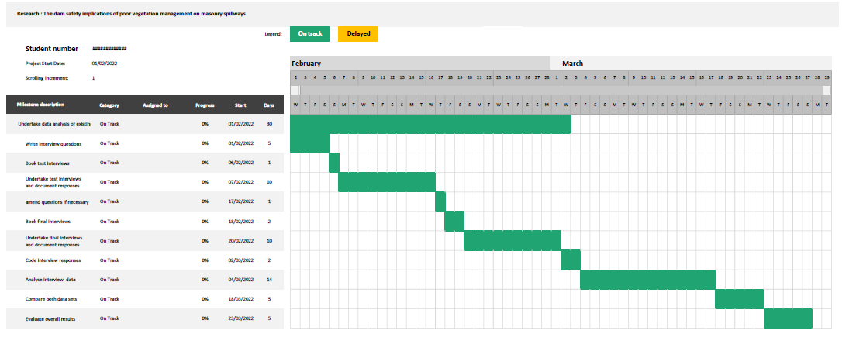

Ethics
As a researcher and also an employee within the dam safety industry, to ensure my research is impartial I will obtain fully informed consent, and recognise my dual role in relation to potential bias in the research. To ensure this does not pose a problem the researcher will ensure that questions contained within the interview schedule are open ended non leading and free from bias.

References

BPS.org.uk, 2021. The psychologist.bps.org.uk [Online] Available at: <Methods: Teaching thematic analysis | The Psychologist (bps.org.uk)> [Accessed 12 November 2021].

British dams.org, 2021. The British dam society [online] Available at: < https://britishdams.org/about-dams/dam-information/spillways-and-outlets/ > [Accessed 11 November 2021].

Britishdams.org. 2021. British dams. [online] Available at: <https://britishdams.org/assets/documents/Dam%20Legislation%20-%20England%20-%20October%202016.pdf> [Accessed 13/11/2021].

Dam failures. Org, 2021. Dam failures. Org [Online] Available at: <Technical Manual for Dam Owners: Impacts of Plants on Earthen Dams> [Accessed 11 November 2021].

Natural resources.wales,2021. Natural resources wales. [Online] Available at:< Natural Resources Wales / Know when to appoint an engineer>[Accessed 11 November 2021].

Publishing.service.gov.uk.2021 Publishing. Service.org. [Online] Available at: <Guidance_for_the_Design_and_Maintenance_of_Stepped_Masonry_Spillways.pdf> [Accessed 12 November 2021].

Publishing.service.gov.uk.2021 Publishing. Service.org. [Online] Available at: < Toddbrook Reservoir Independent Review Report f> [Accessed 12 November 2021].

Informed consent would consist of agreement to take part in the study once all aims and objectives fully explained and insurance of confidentiality has also been explained

