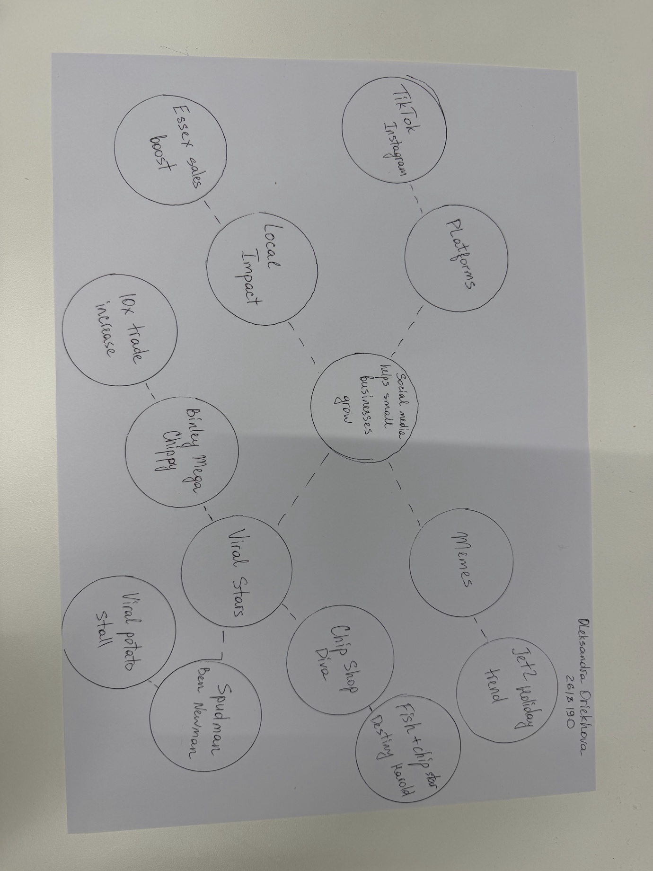
PART 1

PART 2: Answers to Questions
A. What is the main idea of the whole text?
Social media helps small businesses become popular and get many new customers. Platforms like TikTok and Instagram help local shops grow very fast.
B. What is one key point that supports the main idea, and which specific example shows this?
Social media posts can make people travel long distances for a shop. For example, customers drove three hours to Honywood Sandwich Shop to try a chicken burger after seeing it on TikTok.
C. What is a different key point that supports the main idea, and which specific example shows this?
Social media helps small shops sell products all over the world. For instance, Lindy Loo’s Boutique started on Instagram and now ships clothes to Australia.
D. Which part of the text do you think is most important, and why?
I think the part "People buy from people" is most important. It shows that customers like simple, real videos more than normal ads.
Reflection
E. What did you find difficult in this Assessment (including in-class components), and why was it difficult?
The hardest part was making A3 notes in class because we had to read fast. It was tricky to find the main points quickly.
F. What helped you with this difficulty, and how did it help you?
Using the template at home helped me a lot. It made it easy to write my answers step by step.

