- Student Name : Marcus v Daley
- Student ID : 1919780
- Module Name : BMSW4002
- Assignment Title :Effective Team Work And Communication
- Lecture’s Name : Saqib Shamim

Effective Team Work and Communication

Table of Contents
Introduction 1
1. Argos case study: communication models and communication skills in effect 2
2. Ryanair case study: lacklustre organisational communication 5
2.1. Ways to improve workplace communication 6
Conclusion 8
Reference 9

Introduction
Communication is one of the most important operational elements of any organisation. Without a functional and effective communication structure, operations cannot continue properly and the workplace environment tumbles down (Businesstopia, 2020). For large scale enterprises, maintaining effective and constant communication across the entire organisation can be quite complicated. Fortunately, there are different models that can be utilised to ensure a good communication framework or system in a business setting. Additionally, there are some key skills that contribute to the effectiveness of communication efforts, skills that are necessary for both employees and higher up the organisational chain of command (Overton, 2012). This report will focus on the effective use of such skills and models in the context of Argos. In contrast, constructive analysis of the poor communication efforts of Ryanair will be done to form an idea of the possible ways to overcome such an adverse internal situation.

Argos case study: communication models and communication skills in effect
This segment of the report will reflect on my personal experience as an employee of Argos UK. We will see how the application of communication models in different stages of the organisation has led to the company’s immense success as one of the UK’s largest retailers. Also, how different communication skills come into play, especially from an employee perspective, will also be observed.
There are three basic models of communication that are aimed at providing a better understanding of the different ways of communication, whether it is on a personal or organisational level (Businesstopia, 2020). The three models in question are the linear communication model, interactive communication model, and transactional communication model. Of these, the two models are most relevant for businesses in today’s time. The interactive communication model provides the opportunity of giving feedback to the sender, but only after the original message has been received by the receiver (Tutorialspoint, 2020). There are two renowned models that match the idea of this communication model. These are the Osgood-Schramm Model and the Westley and Maclean Model of communication.
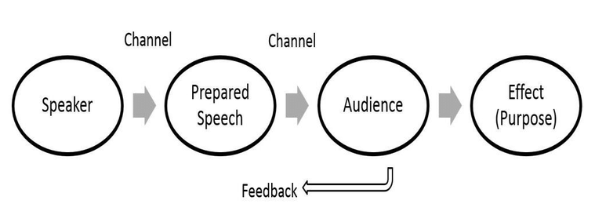
Figure 1: Interactive communication model
Source: (Businesstopia, 2020)
Transactional communication is closely related to interactive communication. This model also allows for the exchange of feedback. However, one key difference from the Interactive communication model is that the process of providing and receiving feedback can happen simultaneously in transactional communication (Changingminds, 2020). The Transactional Model and the Helical Model are two examples of such communication.
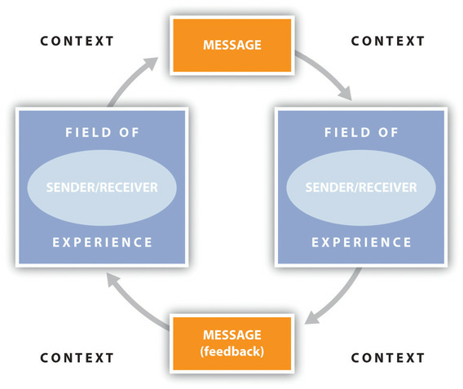
Figure 2: Transactional communication model
Source: (CallTutors, 2020)
I have been an employee at Argos for about a year, and during my time there, I have seen how internal communication can have a huge impact on the success of a company. As mentioned before, Argo’s is one of the largest and most renowned retailers in the UK with over 850 physical stores. The company also operates online, a strategy that has proven to be greatly effective during the present pandemic. For such a large company to operate properly, an effective communication model and channel must be in place (Overton, 2012). Now for Argos, there are two primary communication models used for business communication. For any type of instructions or major changes from the company executives, the interactive communication model is followed. Information is passed down from a top-down approach, and if employees or managers feel the need to provide feedback, it is done later down the line. On the other hand, in any single retail store, the transactional communication model is followed. Managers provide directions and update their subordinates of decisions during monthly meetings. Employees have the opportunity to provide any type of feedback or criticism immediately. Through the implementation of such a communication method, employees feel more involved with the organisation and can express themselves properly (Means and Hathaway, 2019). Moreover, the organisation can take employee feedback and improve upon the organisational practices and policies. For effective communication during the pandemic, Argos has established a specialised internal communication channel for employees. Employees can receive all important notices and communicate with peers and managers all under one platform. All in all, the internal communication system of Argos is well-coordinated and quite effective in reaching sales, objectives even during the on-going adversities.
Apart from useful models, there are quite a few skills that are related to effective communication. Active listening, ability to exchange feedback, empathy, confidence, respect and responsiveness are some of the necessary skills to maintain good communication, especially in the workplace, and can be referred to as communication skills (Forsyth and Kay, 2010). As an employee of Argos, I was always motivated to provide my opinion on company decisions and policies. Lack of confidence to convey the message to superiors makes it difficult to maintain communication with the organisation (Means and Hathaway, 2019). During the monthly meetings, I had to listen actively to the briefings to get a better understanding of the new changes and the reasoning behind them. Again, active listening is important to form an opinion or to provide feedback (Garibaldo, 2011). In case of any changes to management, I felt the need to adapt my style of communicating to better suit the situation. Respect as a communication skill is important for both employees and executives. Executives must protect employee integrity in the decision-making and policy formation processes (Viswanathan, 2011). Argos provides fair remuneration policies and working hours to its employees. As an employee, I always felt respected by my managers. From an employee perspective, it is important to respect company decisions and interact with superiors in a respectful manner. Such a type of attitude helps create a satisfactory working environment. The attitude of receiving and providing feedback is another two-way factor (Bambacas and Patrickson, 2014). Throughout my employment at Argos, I gradually developed the mentality to receive constructive criticism from my managers. By listening to them and implementing their advice, I have been able to significantly improve upon my performance. Inversely, managers take and utilise feedback from employees to improve the performance of the store.

Ryanair case study: lacklustre organisational communication
The airline industry is strongly competitive, especially in the budget segment. While the company is generally well-known in the budget airline space, Ryanair as an airline company has been heavily criticised for its poor customer service and bad organisational practices over the past few years. As a result, the company’s reputation has been going downhill. My Mate has been an employee in the company for about 2 years, and his experience in the workplace reflects a similar idea. While there are some advantages of working in Ryanair, such as on-site training, friendly peers, and opportunity for personal growth, there are many internal problems within the organisation. According to my Mate , the workplace is quite intense, with management placing pressure on employees to reach sales goals, long working hours, lack of free food and fair compensation for staff and crew members, and often bad managerial policies and practices in general. For most organisations, it is quite normal to have internal issues from time to time. The most crucial factor is how they are managed through proper and effective organisational communication (Worley, 2017). This is especially important in the Covid-19 situation as flights are forced to get cancelled and people are required to stay home. For an airline company in this situation, it is crucial to manage costs and operations effectively through proper internal communication and stay in business.
In the case of Ryanair, especially over the past few months in the pandemic, there have been quite a few cases of miscommunication and mismanagement within the firm . Firstly, performance and operational details are only being provided to employees via e-mails. This can be quite problematic as mails can easily get lost across several threads. Secondly, employees have not received clear instructions to use a specific communication channel during the pandemic. As a result, workers are having difficulties to follow operational directions on different digital platforms. Even before the pandemic, Ryanair had some trouble with internal management. The company often positions several managers who provide conflicting directions, which is often confusing for employees. There is a great likelihood of repetitive actions that result in a waste of resources as well as overlooking key areas of operation and improvement due to conflicting instructions on a single project (Barker and Angelopulo, 2013). Finally, the company executives never seem to maintain proper communication with their employees. As a result, employees cannot receive the extensive feedback necessary to improve performance and efficacy. Clear guidance and updates on present performance undoubtedly work as a guiding light that facilitates improvement in operational performance (Durán et al., 2012). But the employees do not have the opportunity to provide suggestions to the executive or the people in charge, which somewhat similar to linear communication. In fact, employees are sometimes criticised for expressing negative yet justified opinions regarding the company, something which my friend has gone through a couple of times.

Ways to improve workplace communication
To improve the overall performance of Ryanair, effective organisational communication is of importance. Established communication theories and models can serve as a framework of action and be applied to ensure the effectiveness of efforts to improve business communication (Ellis, 2015). Some distinct recommendations to improve communication at Ryanair are listed below-
The Circular model of business communication sees organisational communication as a bilateral process (Worley, 2017). Communication in the workplace can be effective only if efforts come from both the employee and the executive side. From an employee perspective, effective communication relies on the previously mentioned communication skills of employees, while the initiative remains the main factor from organisational perspective. Both of these elements are applicable to improve the state of communication within Ryanair.
Max Weber has given a theory on organisational communication that describes it to be clear and concise, structured, and hierarchical (Management Study HQ, 2020). The theory puts emphasis on a top-down approach and provides no room for confusion in the interpretation of information. Following the Weberian theory, communication must be maintained in a clear and concise way so that the information can be easily interpreted and without any delay. However, providing context can sometimes be helpful and even necessary in some instances (Bambacas and Patrickson, 2014). But for a large corporation like Ryanair, where operations are large-scaled, it is crucial to get messages across in a time-efficient manner. This is applicable for both upward and downward communication.
As seen from the previous section of this report, there is a lack of collaboration among executives of Ryanair. In this instance, employees must assert themselves and get their message across properly. Confidence plays a significant role in this case as well as the way the message is conveyed, such as body language or choice of words. Again, for effective workplace communication, empathy must be practiced as well (Pinner and Pinner, 2010). Displaying an understanding of other people’s ideas and opinions can help to create a healthy working environment. Not to mention, putting emphasis on others’ concerns can help address them while arriving on a middle-ground.
The Modern Model of Communication is a comprehensive model that includes feedback. It puts special importance to feedback within the organisation as a key element of success (Ellis, 2015). Executives of Ryanair should maintain proper downward communication by regularly updating employees on organisational goals and objectives and new plans. They should be open to suggestions and criticism from employees and implement them as applicable. This can be a great way to improve the organisation internally and improve performance. Sometimes, employee concerns align with customer complaints, and so addressing them can be quite beneficial for the company (Viswanathan, 2011). Workplace satisfaction can also be achieved by ensuring transparency and honesty in communication with employees. Keeping this in mind, the management of the entire organisation should be properly coordinated.

Conclusion
From this report, it is clear that proper communication or lack thereof can make or break a company. Argos has in place an effective communication system that has helped the company in both internal and external operations. On the other side, for a well-established company like Ryanair, poor communication has significantly contributed to its downfall. So it is crucial for organisations to maintain good communication both internally and externally in order to stay relevant in the industry. The case of Argos is a good example of how effective communication should be implemented and managed.

Reference
Bambacas, M. and Patrickson, M., 2014. Interpersonal communication skills that enhance organisational commitment. Journal of Communication Management, 12(1), pp.51-72.
Barker, R. and Angelopulo, G., 2013. Integrated Organisational Communication. Cape Town: Juta.
Businesstopia. 2020. Models Of Communication - Businesstopia. [online] Available at: <https://www.businesstopia.net/communication> [Accessed 9 August 2020].
CallTutors. 2020. A Brief Overview Of The Transactional Model Of Communication. [online] Available at: <https://www.calltutors.com/blog/transactional-model-of-communication/> [Accessed 9 August 2020].
Changingminds.org. 2020. Transactional Model Of Communication. [online] Available at: <http://changingminds.org/disciplines/communication/models/transactional.htm> [Accessed 9 August 2020].
Ellis, R., 2015. Communication Skills. Bristol, UK: Intellect.
Forsyth, P. and Kay, F., 2010. The Art Of Successful Business Communication. London: Institution of Engineering and Technology.
García, M., Castillo, A. and Durán, V., 2012. Online corporate communication: SMEs and differences across sectors. Journal of Organisational Transformation & Social Change, 9(3), pp.285-300.
Garibaldo, F., 2011. Information and Communication Technologies, Organisations and Skills: Convergence and Persistence. AI & SOCIETY, 16(4), pp.305-331.
Management Study HQ. 2020. Max Weber’S Bureaucratic Management Theory. [online] Available at: <https://www.managementstudyhq.com/max-webers-bureaucratic-management-theory.html> [Accessed 9 August 2020].
Means, T. and Hathaway, V., 2019. Business Communication. Boston, MA: Cengage Learning, Inc.
Overton, R., 2012. Business Communication. Boat Harbour, N.S.W.: Martin Books.
Pinner, D. and Pinner, D., 2010. Communication Skills. Auckland, N.Z.: Longman.
Tutorialspoint.com. 2020. Effective Communication - Models - Tutorialspoint. [online] Available at: <https://www.tutorialspoint.com/effective_communication/effective_communication_models.htm> [Accessed 9 August 2020].
Viswanathan, R., 2011. Business Communication. Mumbai [India]: Himalaya Pub. House.
Worley, R., 2017. Business Communication and New Media. Business Communication Quarterly, 73(4), pp.432-434.

