

Certificate of Higher Education in Skills for the Workplace

Task 2
Professional career development report

Student name:
Student ID:

Module name: Professional Career Development

Module code: (BMSW4005_LON)
Lecturer name:
Word count:
Submission date:

Table of Contents
Introduction 1
Personal reflection 2
Action plan 3
Swot Analysis 4
Personal Development Plan 5
Medium Long term Target 6
Conclusion…………………………………………………………………………………..7

Introduction
The report is based on the discussion of the aspects of the personal career development plan. In this report, I will be providing a reflective account of the specific role with the help of Gibbs’s reflective cycle. I will analyse the knowledge and skills that are needed for working efficiently and effectively as a hotel manager, that is my career ambition of mine. Further in the report, I will also be focusing on the evaluation of my current areas for development and strengths, alongside analysing the personal development plan with the help of SMART goal analysis.

• Personal reflection on the role play: Recruitment and Selection - Applying Gibb’s learning cycle.
It is a framework giving structure to the process of learning from experience through six stages:

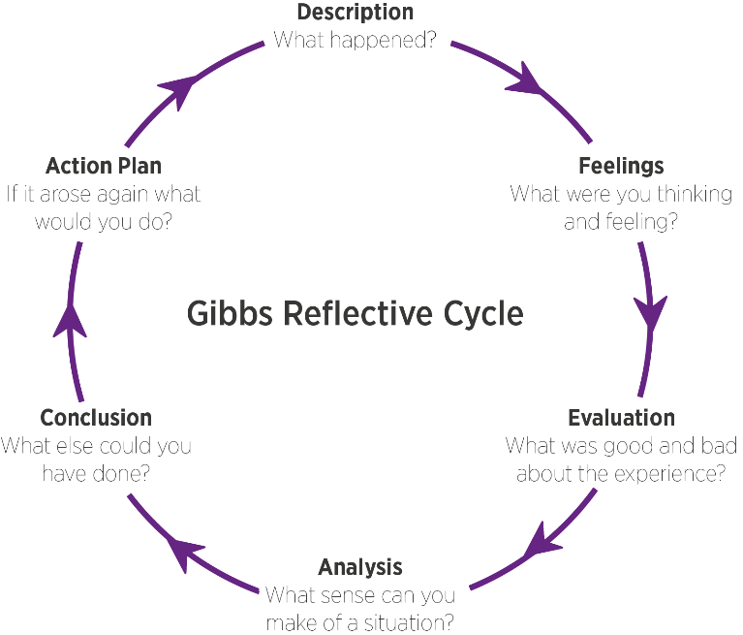
Figure 1: Gibbs reflective cycle
Source: Gibbs, 1988

1 step: description. What is the event? What happened?
The event was the interview procedure. The process of the interview was based on the job role of the hotel manager. It was predecided that the interview procedure will be proceeded by a pair. The pair will proceed for presenting as role plays for the interview, which will involve the interviewer and interviewee role that is linked to the personal level of ambition required for the job role of the hotel manager. The role-play of both interviewee and interviewer would be generally subjected to the substantial form of a piece of the reflective way of writing for being incorporated under the module of 'Recruitment and selection procedure.
2 step: Feelings in the event
I have got quite mixed feelings during the interview time, I was specifically very nervous regarding the interview process, but alongside I was equally excited too for being in the interview. For dealing with nervousness I read some articles about dealing with the factor of nervousness during the interview. From the articles I got some tips, that self-belief is really important while being in the interview. Apart from this, I also tried to control my excitement during the interview. I was feeling confident after researching for some articles since I was also feeling confident because of my good communication skills.
3 step: Evaluate positive and negative
If I evaluate the positive and negative of my performance in the interview, it can be said, that it was majorly positive and there were some least that can be specified as negative. The positive thing regarding the interview that I felt was my honesty. I was quite honest throughout the interview, regardless of which role I was doing whether it was interviewee or interview. I tried to be maximum honest in that event. Since I realised that being honest in the interview always plays a vital role. Apart from the negative thing I got was my initial stage of the interview procedure, where I was a bit nervous, but reading some articles regarding building confidence in the interview and tackling nervousness while being in the interview helped me to cope with that situation.
4 step: analysis: make sense of the situation/ most relevant things
The most relevant thing that I observed in the interview was attitude and character. These two aspects are really important for the job role of the hotel manager alongside the interview procedure too. I found that having a good and strong character and attitude in the interview helps to get successful results interview. I realised that I tried to stay confident meanwhile the interview, which helped me build up my attitude and character.
5 Conclusion: What else could I have done? What could I have done differently?
Conclusively, I can say that some things can be done ideally by me. I found that I was quite enthusiastic throughout the interview, and I find the scenario can be worked out better if I could control my enthusiasm.

6 step: Action plan: behaviour/action I will take in a similar situation in the future.
Specific | Measurable | Attainable | Relevant | Timely
To identify and address the issue | Here the procedure is to analyse the issues. | Here the purpose is to specifically proceed to attain to not majorly get outlandish. | The purpose is to not get proceed to indulge in upcoming specific reference | 1 month
To work on teamwork skills | By the procedure of doing major discussions with its entity of the group | For analysing the specific opinion and ideal approach of other significant students to learn the skills of teamwork | For ideal the level of team performance in future days | 2 months
To improve research and interview skills | It can be measured by the procedure of more significant and credible forms of specific sources on the internet on daily basis. | The purpose here is to get the factor of consistency | It would also help in my future career and studies | 3 months

• Skills and knowledge which contribute toward working effectively
Following are some key skills and knowledge that are required for working efficiently:
Communication skills: The ideal communication is the art itself, there is always a specific room for keep developing, growing and learning the talents. This is why it is required to be continuously working to develop the skill of communication. The advantage of having good and ideal communication skills is quite enormous and would have a positive influence on both aspects of professional and personal life (Li et al., 2020).
Teamwork: There are major benefits to the entity of teamwork, even though the majority of times it could feel specifically a little messy and stressful. The aspects of true teamwork can generally take time for getting going as the process of working with humans with several personalities is not always very easy (Markkanen et al., 2020). But there is a specific reason that is very basic. Some of the ideal things generally cannot be done. The ideal teamwork technique always provides the base to proceed for something successful, it could be any type of module, what is important here is to focus that building teamwork skills is really important and probably the most significant phase to clear.

• My strengths and areas for further development
I must say that there are some good things that I can count as my strengths and oppositely there are also some aspects that need to be worked on. Communication skills, I can generally count as my major strength and alongside being too much enthusiastic in different situations is something I can count as my weakness, that is an area where I need to work on specifically.
- SWOT ANALYSIS

SWOT ANALYSIS

STRENGTHS  Communication:  Communication has always been my strength. During the interview, it was my major aspect that was the reason for my confidence.  Time-Management: I have always been very punctual throughout my studies. Therefore I can say that my expertise in the process of managing time, has always worked in my time management module (Tawanwongri and Phenwan, 2019). | WEAKNESSES  Self-control:  The aspect of self-control is the key aspect that is significant for me to work on. I generally lose my enthusiasm and self-control while being in critical and tough situations.
OPPORTUNITIES  I am quite aware of this fact, that enrolling in the job of the hotel manager, I will look to the major responsibilities of management. So this is a very good opportunity for me, as the management will help me to improve on both personal and professional aspects. | THREATS  The major threat that can act as a hurdle in the way of my being a hotel manager, I have to stop multitasking first. I have observed being enrolled on so many things at the same time always works in making that work struggle all against the process.

PERSONAL DEVELOPMENT PLAN

NAME | Henri William  Rabeh | Target Job/career  Example: Teacher, Manager, Business Person | Hotel manager

PERIOD | From: | To:

What Skills do I need to achieve my goal?
SKILLS | How Will I get them | What resources or support will I need? | What can prevent me from achieving my goals: | How long should it take
Listening skills | I have felt that being alert is really important to work on my listening skills. I have been learning that one should try and consciously shut out the background activities and sounds. The alertness is a significant factor here. | It is required to have a good speaker for being a good listener. I have learned that the art of effective listening is generally based on emotional intelligence and empathy. I will require to take help from one of my friends who are good at speaking. | Distractions such as laptops, telephones, traffic noise, radio and television are generally making it very complex to listen with complete attention and focus (Vinoth Kumar et al., 2022). Therefore they have the potential to work as an obstacle to achieving my goal | 1 month
Negotiation skills | To be good the negotiation skills, I will need to be very good at listening skills, and I will have to apply a creative problem-solving approach to reaching out mutually with beneficial outcomes. | I will have to ask to person or to my senior, who can make me understand the negotiation skills. Alongside I will also be able to work on my negotiation skills with that specific person. | I will have to work on my introverted nature. My introverted nature will act as a hurdle for me in the process of being a good negotiator. | 2 months
Leadership skills | For being a good leader in future I must have a specific vision and the self-confidence, that will help me to get ideal leadership skills | I will be studying the transformational leadership theory. It will help to get the ideal leadership guidelines. | Procrastination can act as a hurdle. It can make me lazy. And laziness can never be the quality of a leader. I will have to work on this aspect. | 3 months.
S

- My short - medium – long term targets for the development of my professional career plan (using Specific, Measurable, Agreed, Realistic, Time-bound –SMART targets)

Short-term plan (3 -6 months) To improve public speaking
Specific | I will have to get more engaged in the skills of public speaking, it would specifically begin with making proper eye contact while proceeding to public speaking.
Measurable | On every weekly basis, I can set a specific target or goal to review my practice and process of learning.
Agreed | I will be focusing on transformation leadership theory and management leadership for the improvement of public speaking. The management leadership theory plays a vital role in the process of improvement.
Realistic | My public speaking skills will help me to work ideally in the hospitality sector in future.
Time-Bound | 15/10/2022
Medium-term plan (1-2 years) Critical thinking skills
Specific | To specifically begin learning these skills, I will have to collaboratively work as a team man. Teamwork skills will play a vital role here.
Measurable | Participation in different debate competitions will help me to measure my process
Agreed | I will have to focus on every step in the process of learning, meanwhile being involved in problem-solving skills will help me to believe that the goal is achievable.
Realistic | I will have to put my concentration on achieving the goal of learning critical thinking realistically.
Time-Bound | 10/10/2024
Long-term plan (2-5 years) (Time management skills)
Specific | The specification here is to properly understand why the range of procrastination is a barrier in life, and how to proceed for removing it. I will also focus on the Kaizen method.
Agreed | The technique of Kaizen method would help me attain the task.
Realistic | The specific schedule regarding my practice will provide help me to achieve my target.
Time-Bound | 10/10/2025

Conclusion
The report has specifically analysed the interview process with the help of Gibb's learning cycle. Further, the report specifically analysed the personal SWOT analysis. After this, the report proceeded to analyse the personal development plan. Lastly, the report specified the SMART goal analysis.

: References:
Adeani, I.S., Febriani, R.B. and Syafryadin, S. (2020). USING GIBBS’REFLECTIVE CYCLE IN MAKING REFLECTIONS OF LITERARY ANALYSIS. Indonesian EFL Journal, 6(2), pp.139-148.
Afolabi, T.M., Pogge, E.K., Early, N.K., Larson, S., Stein, J., Hanson, L., Storjohann, T., Raney, E. and Davis, L.E. (2022). Evaluating the impact of integrating SMART goal setting in preceptor development using the Habits of Preceptors Rubric. American Journal of Health-System Pharmacy.
Gibbs, G. (1988) Learning by Doing: A guide to teaching and learning methods. Further Education Unit. Oxford Polytechnic: Oxford.
Li, Y., Chen, W., Liu, C. and Deng, M. (2020). Nursesâ€™ psychological feelings about the application of Gibbs reflective cycle of adverse events. American Journal of Nursing, 9(2), pp.74-78.
Markkanen, P., Välimäki, M., Anttila, M. and Kuuskorpi, M. (2020). A reflective cycle: Understanding challenging situations in a school setting. Educational Research, 62(1), pp.46-62.
Tawanwongsri, W. and Phenwan, T. (2019). Reflective and feedback performances on Thai medical students’ patient history-taking skills. BMC medical education, 19(1), pp.1-8.
Vinoth Kumar, P., Gunapriya, B., Sivaranjani, S., Gomathi, P.S., Rajesh, T., Sujitha, S. and Deebanchakkarawarthi, G. (2022). Smart Home Technologies Toward SMART (Specific, Measurable, Achievable, Realistic, and Timely) Outlook. In Mobile Computing and Sustainable Informatics (pp. 711-727). Springer, Singapore.

Appendix :A

Job application form

Application for [job title] – Hotel manager

Your details

Name: Henri William Rabeh

Education and training

2021 to 2022

Skills for the workplace at university of wales

2018 to 2021

Team leader at the Mayfair Hotel

2015 to 2017

Business and management at Lewisham college

Qualifications
September 2011
Introduction to Business
June 2008
Certificate For IT Users(New CLAIT)
July 2008
Certificate in Text Processing
September 2008
Certificate in Administration

Employment history

Your current or most recent employer

Name of employer: Mayfair Hotel

Job title: Team leader

Length of time with employer: 2 year

Reason for leaving: Career progression

Duties: team leader

Communicating goals and deadlines to team members

Planning workloads and delegating tasks

Assessing team performance and providing feedback to employees

Assisting with hiring and training employees

Assisting with the daily operation of the organisation

Previous employers
Customer service job

Manage incoming customer service requests

Identify and resolve customer issues

Handle customer feedback and complaints

Provide accurate incomplete information

Supporting statement

I have applied for this job because the job is one that I am very passionate about, and my academic qualifications are suited to this type of work it is a role I will get lots of job satisfaction from.

Declaration
I confirm that to the best of my knowledge the information I have provided on this form is correct and I accept that providing deliberately false information could result in my dismissal.
Do you need a work permit to work in the UK? Yes / No
References
Please give the names and contact details of 2 people who we can ask to give you a reference. We may ask them before an employment offer is made. We will not ask your current employer until we get your permission.
Declaration
I confirm that to the best of my knowledge the information I have provided on this form is correct and I accept that providing deliberately false information could result in my dismissal.
Name: Henri William Rabeh

Signature:

Date:

Appendix B

The questions asked as interviewer in the role play
- Why do you want to work for this organisation?
- tell me about your relevant skills and experience
- Please tell us why you have applied for this position and why you think you are the best person for the job.
- Describe a situation when you made a positive contribution to your previous company and what was the outcome.
- How long would you stay with us?

