A comparison of the marketing methods of hotel brands Six Senses and Moxy
Dina Priedulena
Student ID Number: 2233688
Marketing Essentials BMIH4005
Chris Wilkin
Word Count: 2195

In his work, Kotler (2008, p.8) gives three answers to the question of what the marketing mission is.
In today's world, companies choose different goals and missions and use different marketing strategies and tools to achieve them. In this work will be used some of the marketing tools to analyze the marketing strategies of the two companies and find similarities and differences.
“Moxy is a playful, affordable, and stylish hotel brand designed to give guests everything they want and nothing they don't. With more than 60 experiential hotels open across North America, Europe, and Asia Pacific.”
(Marriott’s Group, 2023)
“Six Senses Hotels Resorts Spas manages 16 hotels and resorts and 25 spas in 19 countries under the brand names Six Senses, Evason and Six Senses Spas, and has signed a further 31 properties into the development pipeline. Six Senses is part of the IHG Hotels & Resorts family.”
(Hospitality Net, 2023)
SWOT (Micro analysis) (Fisher, Wisneski, Bakker, 2020) will be used as the first tool for our analysis.
Six Senses website is well-designed, efficient, and easy to navigate, has many different sections, including a separate section dedicated to sustainability, and caring for nature, which is an important point nowadays. Each section contains a message that shows the company's position on each topic.
Various advantageous offers, such as early booking discounts, extended stays, and groupwide offers, can also be found on the company's website.
The company also offers various additional services, such as various types of wellness and SPA procedures and classes.
The company offers its services in Asia & the Pacific, Europe, and Middle East & Africa.
(Six Senses, 2023)
The above can be added to the company's strengths.
Affordability of prices, modernity, innovative solutions, strategically advantageous locations would be considered Moxy's strengths.
(Marriott’s Group, 2023)
Studying reviews about Six Senses (researched 10 reviews dated 2021 - 2022) on the website (Tripadvisor, 2021 - 2022) , it can be concluded that the company quite often has problems with the staff (the staff is not sufficiently qualified), as well as with the quality of the requested services. The picture that the company paints on its website differs from reality in quite a few points.
Providers of expensive and luxury services should be prepared so that the potential customer will also be quite demanding, experienced, and critical and will expect the highest service level.
According to the reviews, there is an opinion that at least part of the offered product does not correspond to the high price.
Some guests compare Six Senses with other competing hotel brands and find that Six Senses is not the winner in this competition in terms of price /quality.
The solution could be to invest in employee training and perceive employees as an investment object that will pay off in the future.
Issue with the quality of services could be solved if carefully evaluate what services to offer, perhaps it is better to reduce their number, but achieve high and constant quality.
Moxy presents on its website that it is possible to get good quality for a low price, but by studying the reviews on the Tripadvisor.com website (Tripadvisor.com, 2022-2023), it can be concluded that the low price often means low quality. Complaints about insufficient cleanliness are often found in the reviews, the hotel is compared to a hostel by customers, savings are made on essential things - there is only one pillow, paper cups, no mattress protector, low food quality, it is impossible to contact the reception staff in case of any problem, etc.
Starting this year, Six Senses offers relaxation and SPA services combined with spiritual practices, meditations, and other ways of self-discovery.
Ayurvedic medicine, meditation, acupuncture, weight control, yoga, and reflexology are keywords that describe this offer. Since in today's world, a healthy lifestyle is gaining more and more popularity not only in the physical but also in the spiritual sense, it is a good opportunity for the company to expand its target audience.
(Athena Information Solutions Pvt. Ltd., 2023)
The site (Marriott’s Group, 2023) contains information that Moxy manages 62 experimental hotels in several regions of the world and plans to open another 127 hotels. This information shows that the brand is experimenting (and successfully). According to the information on the hotel website the company uses innovative and modern approaches in design solutions as well as in the usual hotel procedures (Check-in Bar).
However, Moxy brand's willingness to experiment can also be added to the threats, for example, the check-in bar option, guests with families and small children might find it inconvenient and difficult to go to the bar to check-in. The opinion of the guests is also expressed that, compared to the classic reception desk, which is available around the clock, if a problem arises, when the bar closes, communication with the staff is no longer available. (Tripadvisor.com, 2022-2023)
Six senses offer luxury hotels in different (often very exotic) parts of the world.
One of the problems could be the large investment of money, the risk of whether it will pay off, and the difficulty of finding suitably qualified staff willing to work in such exotic places.
The problem is well described in the article (Steinberg, 2022) and it can be added to the company's weaknesses and threats which can lead to a drop in service quality and, accordingly, a decrease in customers.
Also, there is a contradiction between the company's stated position on protecting nature, at the same time, the construction of large hotels in exotic places often changes the authentic environment.
Some of the Pestel analysis (Hasan Dinçer Serhat Yüksel, 2019) points were used (See Appendix 3), which could affect both brands in the short term. It can be concluded that there are several factors (economic and political) that affect both brands equally.
Moxy brand has 17 hotels located in the UK and Six Senses opened a hotel in London in 2023.
Therefore, it can be concluded that the economic and political conditions in the UK equally affect both brands(Brexit, strikes).
However, a natural disaster in Turkey will affect Six Senses more, although the economic consequences may also affect other countries (for example, exports of food and goods from Turkey).
In the following, Marketing Mix (Marušić, 2019) will be used to compare the two given brands.
Both brands are significantly different in terms of "Product".
Two different messages can be seen when opening the homepage of each company.
“It’s about natural beauty that stops you in your tracks. Far flung, yet accessible locations. A sense of community with sustainability at its heart. A level of service that doesn’t just do the right thing, but that does it well, and with wellness in mind, so you feel the difference in your mind, body and soul.”
(Six Senses, 2023)
This message is more about feelings than tangible things, it creates a feeling that something special is being offered and the price is not the most important factor.
Six Senses: hotels, resorts and SPA, luxury product with many additional values (feelings, spiritual practices, self-discovery, an unforgettable experience).
Likely a "status" product, which shows how successful the consumer is.
The product is aimed at well-off consumers, for whom money is not the main factor, but high quality, new experiences, exclusivity and luxury are more important factors.
Moxy: hotels with small but well thought out rooms, modern solutions.
The hotel's website features such words as “young at heart”, “affordable price”, “nonconformity”, “open-mindedness”, and “originality”, which outlines the portrait of the potential consumer of this service.
(Marriott International, 2023)
Motto - get what you pay for and don't pay for what you don't need.
The service is intended for modern people who need functional and easy-to-use things.
A comparison of the two brands in terms of "Price".
Six senses offer luxurious services, where price is not the determining factor, in the offer it is possible to find villas for several thousand GBP per night, the determining factor is high-class and exclusive services, in exclusive places of the world.
Six Senses takes one of the leading positions among competing companies global and industry rankings. (similarweb.com, 2023)
(See Appendix 3)
The high price is determined by the specifics of the locations, logistics to these locations, finding/training sufficiently qualified personnel, the costs of providing exclusive services.
Moxy offers functional and modern hotel rooms at democratic prices for people who don't want to pay for extras.
As can be concluded from the information found on Similarweb.com (similarweb.com, 2023), among the five competitors, Moxy is in about third place.
(See Appendix 4)
This could be explained by the fact that the simpler the offered product is, the easier it is for competitors to offer the same/better product at the same or cheaper price.
Examining both brands in the sense of "Place", it can be concluded that Moxy is in a more advantageous position, because the simplicity of the offered product reduces costs and expands the range of possible places. A strategically important factor could be the ability of potential consumers to get to the hotel, because, most likely, the customer will not want to make a long and difficult journey just to spend the night.
However, Six Senses could face much higher costs related to location, logistics, but the price cannot be unreasonably high, because on the other hand, competitors' prices affect consumer choice.
In the appendix (See Appendix 5) compares the marketing channels of both brands, in both cases organic search (relevance to the user's search query) dominates, as well as direct marketing channel (personalized messaging.)
In this appendix, a comparison has also been made of the top referring websites of the given brands. In the case of Moxy, the parent company (Marriott) plays a big role here, more than half of the websites are related to Marriott, while in the case of Six Senses, Google.com, the website of Six Senses and Tripadvisor.com are in roughly equivalent positions.

If it could be assumed that one of the important attributes of the company's success is the right people in the company, then it can be considered that both companies are struggling with sufficiently qualified employees. Quite a few complaints about the staff can be found on (Tripadvisor.com, 2022-2023).
In the case of Six Senses, the specific location (specificity of the local population, living far from home due to work) and the high level of the requested services could be one of the reasons for the problem.
Moxy advertises its product with simplicity, which can be perceived as a stereotype by the staff: simplicity - no need to try too hard. Low prices usually mean low wages for employees. Frequent turnover of employees could lead to a drop in service level which does not create a good environment for employees to stay in the company.
All booking-related activities are available online (both on brand websites and on platforms such as booking.com). Links to social networks (twitter, Facebook, Instagram, etc.) are also available on the website.
After studying the reviews on Tripadvisor.com (Tripadvisor.com, 2022-2023), it was found that Six Senses responds promptly to customer reviews, as well as the method of communication on the Six Senses website is convenient for customers (a special form has been created as well as a reviewable list with contact information in different countries), in the same time there is no easy way to communicate on the Moxy website.
On the other hand, Moxy has replaced the usual check-in desk with a check-in bar, which, as mentioned above, is a debatable innovation.
The attached poster (See Appendix 2) summarizes comparative information about the website performance, demographics and audience interests.
Device distribution is roughly similar for both brands, but visit duration is significantly different.
The Top countries are also different, and when it comes to Top referring websites, in the case of Moxy, the leading position is taken by Google.com with 61.99%, while in the case of Six Senses, none of the referring websites takes more than 20%.
Analyzing branded and non-branded keywords searching, it can be concluded that the distribution is diametrically opposite for both brands. In the case of Six Senses, branded keywords searching is 70% of cases, which is a good sign for the brand, as it shows that the consumer is looking directly for the offers of this brand.
On the other hand, Moxy branded keywords searching is only 6% of cases, which shows that the consumer is looking for any accommodation option that meets their requirements, which in turn means that a competitor's product can easily be chosen.
The use of social traffic also differed significantly.
Browsing habits of visitor’s comparison combined with the above information allows us to draw a different portrait of the audience for both brands.

Considering all the above, it can be concluded that Moxy uses objective positioning, while Six Senses uses more subjective positioning.
It could also be considered that Moxy uses undifferentiated targeting with differentiated targeting elements (age, interests, lifestyle), while Six Senses offers a luxury product using differentiated targeting, possibly with concentrated (niche) marketing elements.

References:
Athena Information Solutions Pvt. Ltd., 2023. Six Senses Vana marks launch of brand's first dedicated wellness retreat. Business World; New Delhi, 11 January.
Greg Fisher, John E. Wisneski, Rene M. Bakker, 2020. SWOT. New York: Oxford University Press.
Hasan Dinçer Serhat Yüksel, 2019. The Importance of PESTEL Analysis for Environmental Scanning Process. s.l.:IGI Global.
Hospitality Net, 2023. hospitalitynet.org/brand. [Online]
Available at: https://www.hospitalitynet.org/brand/23000262/six-senses.html#:~:text=Six%20Senses%20Hotels%20Resorts%20Spas,the%20IHG%20Hotels%20%26%20Resorts%20family.
[Accessed 9 February 2023].
Kotler, P., 2008. FAQs on marketing : answered by the guru of marketing. Singapore: Marshall Cavendish Business.
Marriott International, I., 2023. moxy-hotels.marriott.com. [Online]
Available at: https://moxy-hotels.marriott.com/our-locations/
[Accessed 10 February 2023].
Marriott’s Group, 2023. https://news.marriott.com/brands/moxy-hotels/. [Online]
Available at: https://news.marriott.com/brands/moxy-hotels/
[Accessed 01 February 2023].
Marušić, T., 2019. IMPORTANCE OF MARKETING MIX IN SUCCESSFUL POSITIONING OF PRODUCTS AND SERVICES ON THE MARKET. Ekonomska Misao i Praksa; Dubrovnik, 28(1), pp. 431-446.
Ravilious, K., 2023. theguardian.com. [Online]
Available at: https://www.theguardian.com/world/2023/feb/10/geological-impact-of-turkey-syria-earthquake-slowly-comes-into-focus
[Accessed 10 February 2023].
similarweb.com, 2023. similarweb.com. [Online]
Available at: https://pro.similarweb.com/#/digitalsuite/websiteanalysis/overview/website-performance/*/999/2022.11-2022.11?webSource=Total&key=sixsenses.com,banyantree.com,amanresorts.com,unusualhotelsoftheworld.com,fourseasons.com
[Accessed 11 February 2023].
Six Senses, 2023. https://www.sixsenses.com/en. [Online]
Available at: https://www.sixsenses.com/en
[Accessed 1 February 2023].
Steinberg, J., 2022. Luxury resort Six Senses Shaharut offers Negev oasis with unlikely neighbors. The Times of Israel, 24 April.
Taylor, M., 2022. Summer 'airmageddon' to extend the staycation boom. Investors Chronicle; London, p. 11.
Tripadvisor.com, 2022-2023. Tripadvisor.com. [Online]
Available at: https://www.tripadvisor.com/Hotel_Review-g528813-d13120977-Reviews-MOXY_London_Heathrow_Airport-Hounslow_Greater_London_England.html#REVIEWS
[Accessed 9 February 2023].
Tripadvisor, 2021 - 2022. Tripadvisor.com. [Online]
Available at: https://www.tripadvisor.com/Hotel_Review-g667128-d23341248-Reviews-Six_Senses_Ibiza-Portinatx_Sant_Joan_de_Labritja_Ibiza_Balearic_Islands.html
[Accessed 01 February 2023].
Yates, J., 2019. NFU 'staggered' farming left off jobs shortage list. Farmers Weekly; Sutton, 171(12), pp. 10-11.

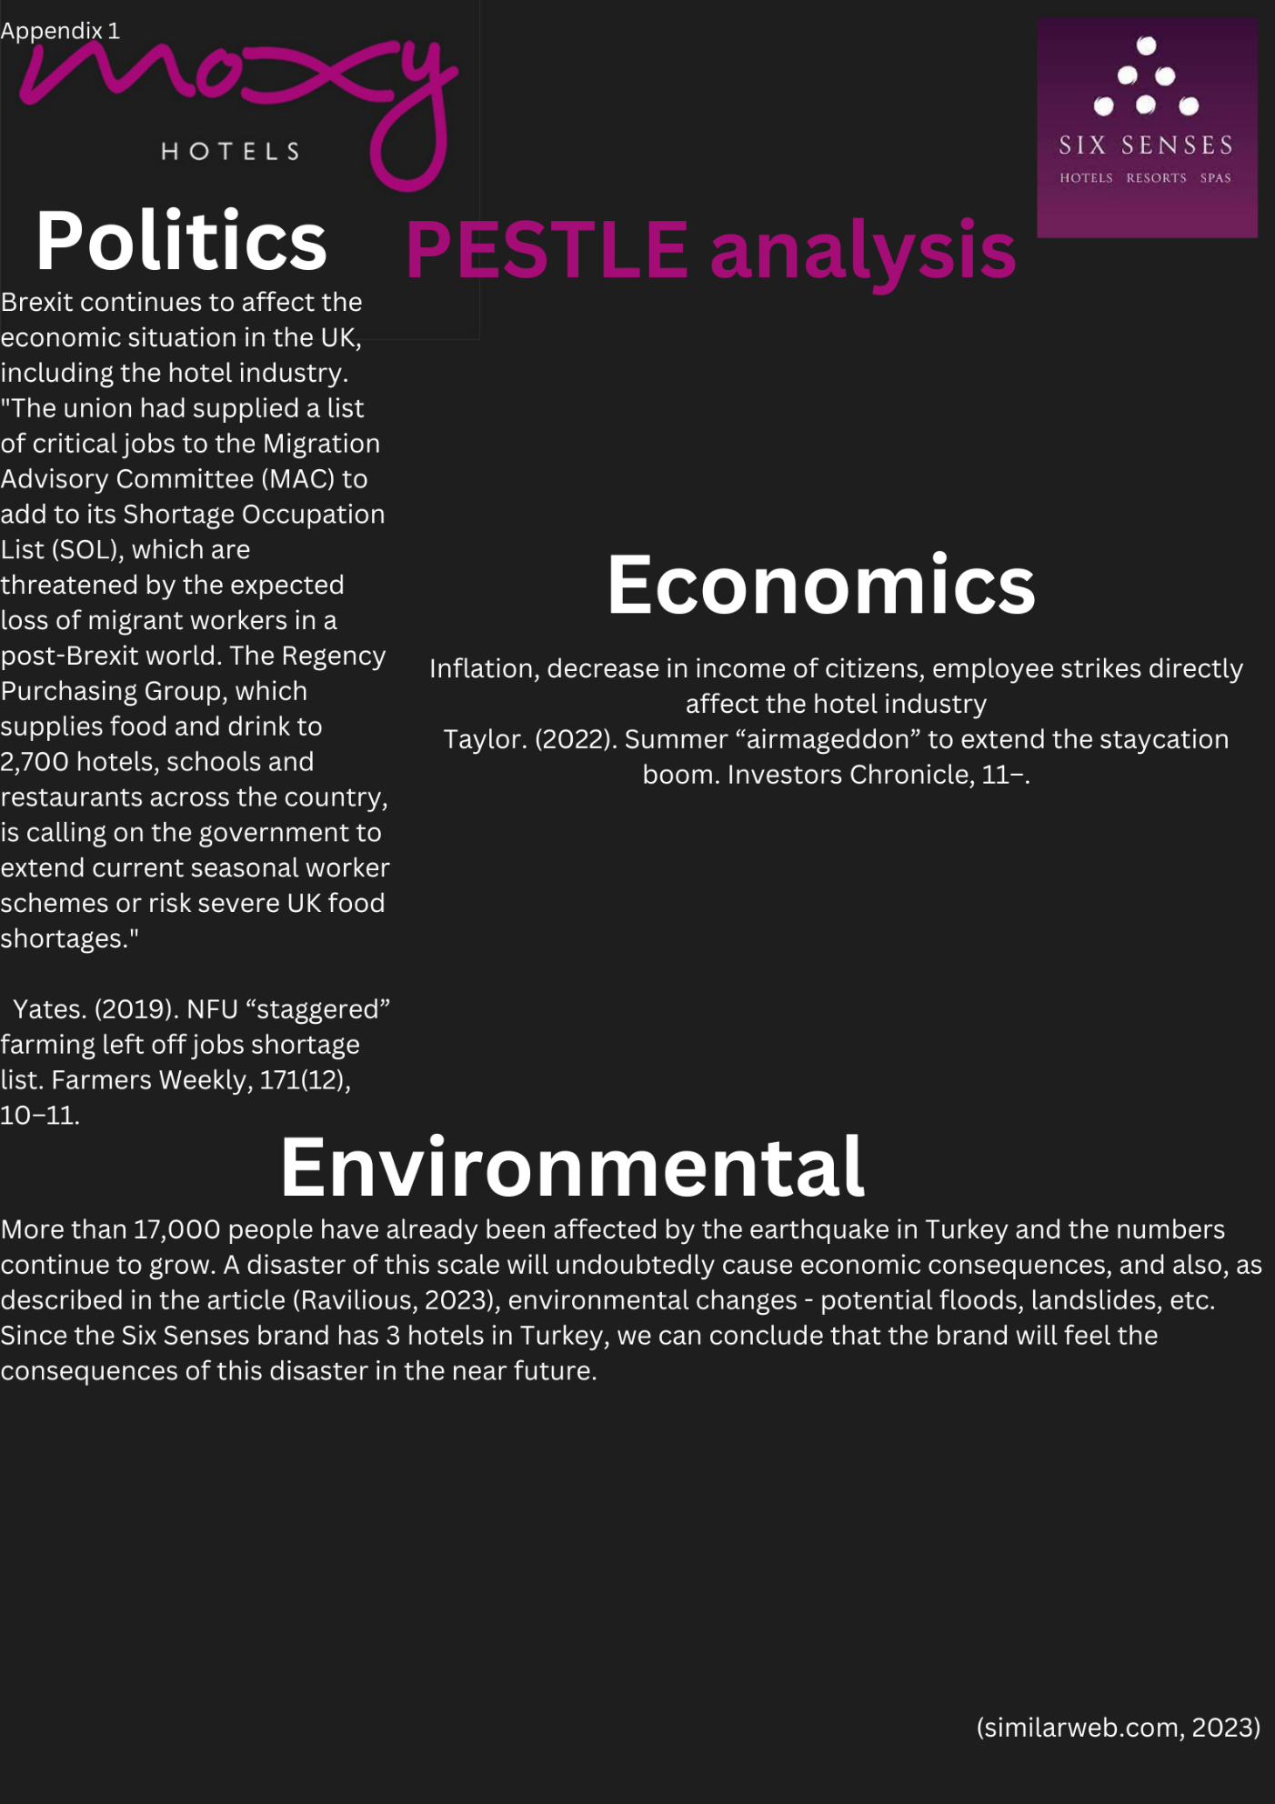
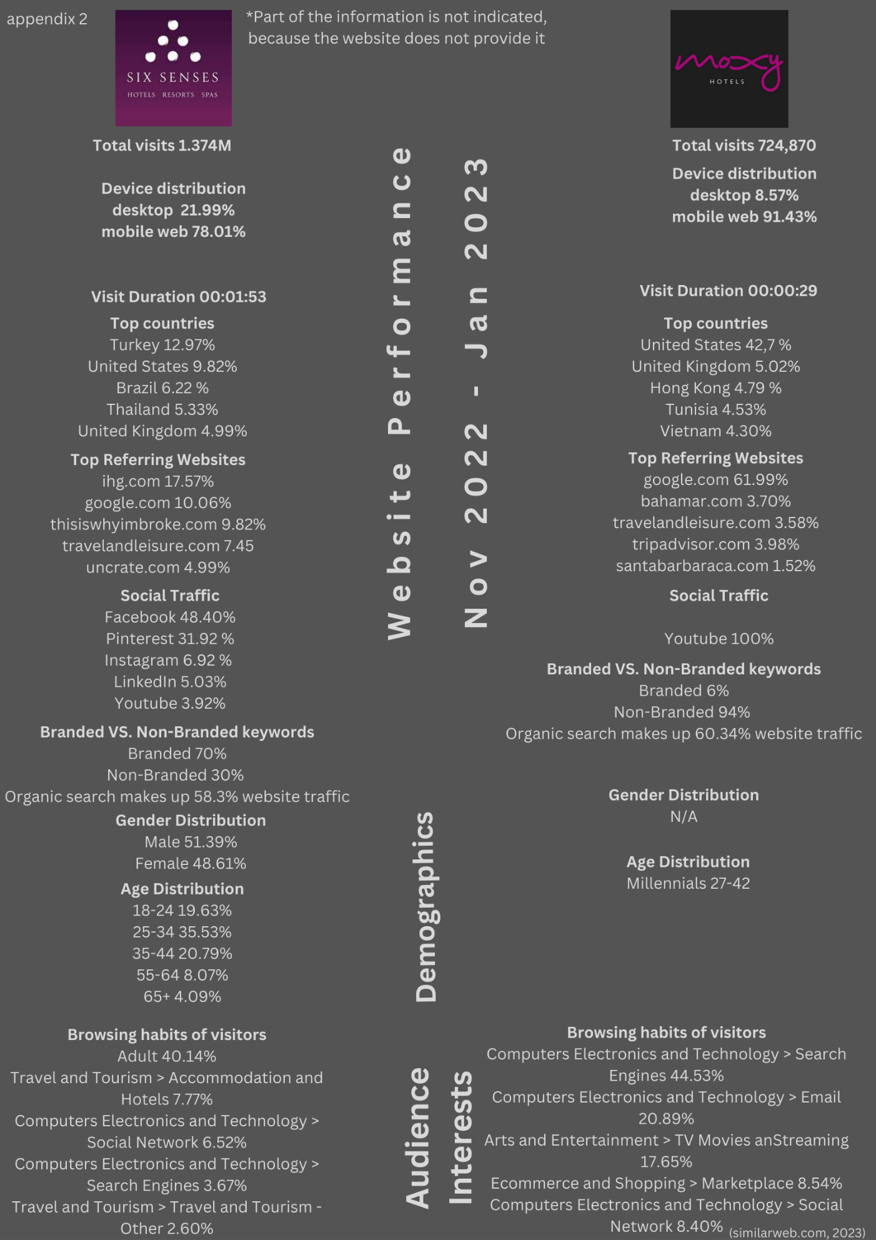 Appendix 4
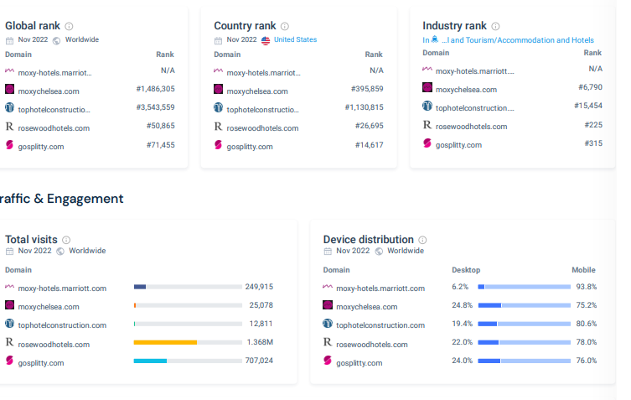
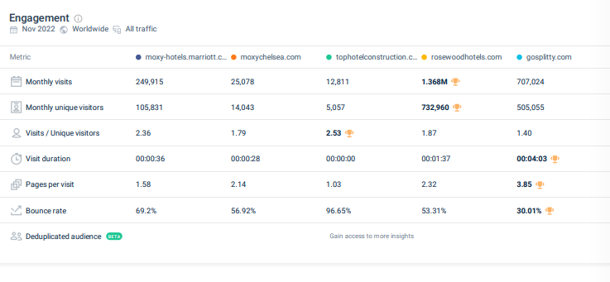
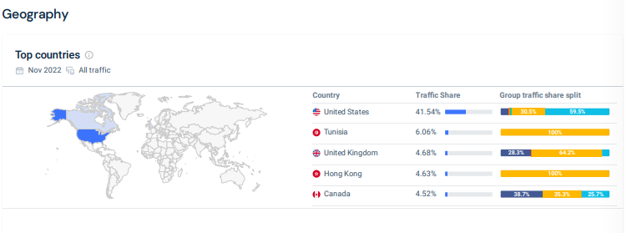 *Part of the information is not indicated, because the website does not provide it
(similarweb.com, 2023)

Appendix 5
Six Senses
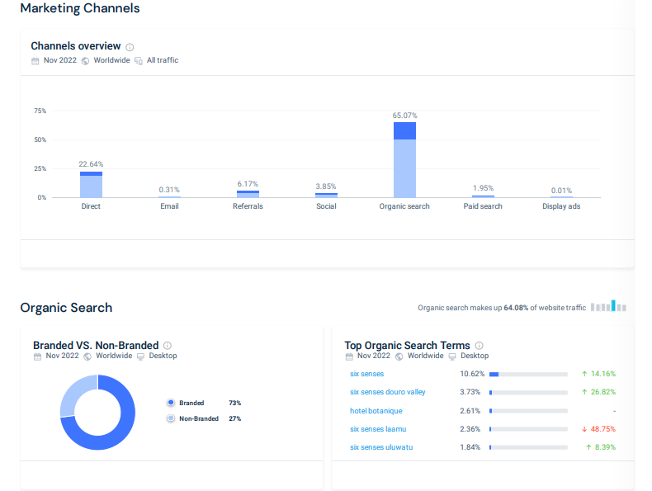
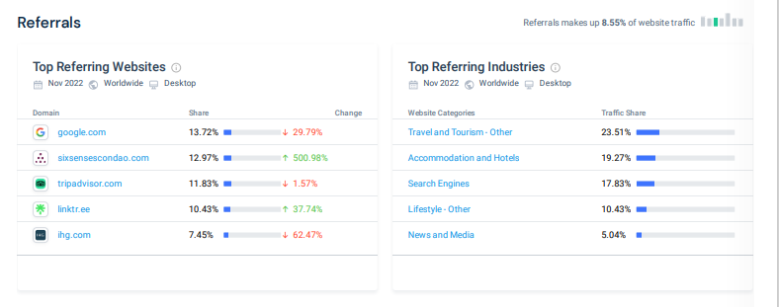
Moxy
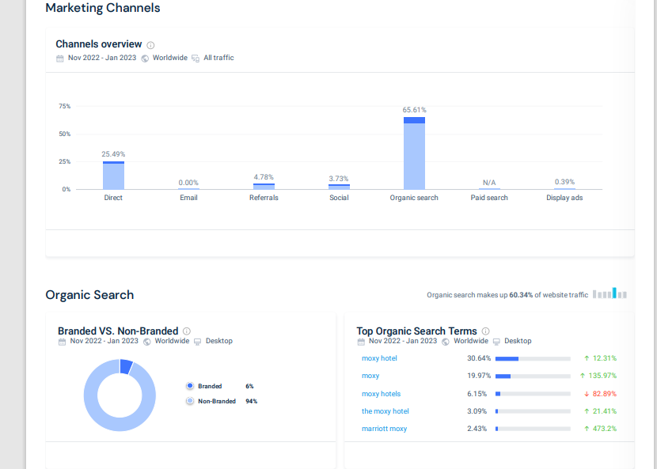
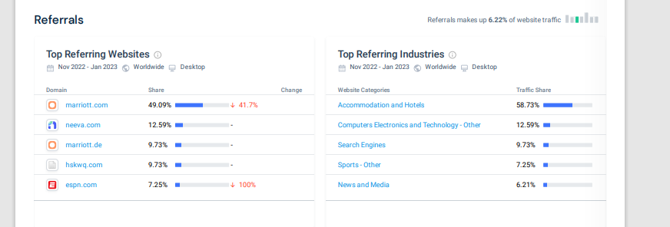

(similarweb.com, 2023)

Appendix 3
Six Senses in relation to competitors

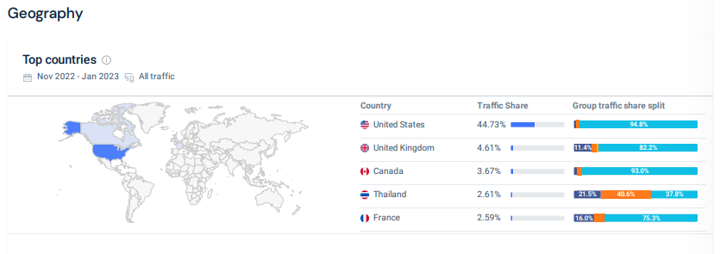

(similarweb.com, 2023)

Appendix 4
*Part of the information is not indicated, because the website does not provide it
(similarweb.com, 2023)

Appendix 5
Six Senses

Moxy

(similarweb.com, 2023)

