09/12/2025
IWD
Assignment 2 : Website design and development

Student Name: Maricor Lindo
Student ID: 2440415
Suneth Fernando
Lecturer
Table of Contents
Introduction 2
User Requirements 3
Website Implementations 4
Home page 4
Validating my website 10
Self-evaluation of my website 12
Usefulness (usability and utility) 12
Search Engine Optimisation (SEO): what type of actions 12
Website Accessibility 13
References 14

Introduction
The main business that I have chosen for this website project is a Bake shop that serves different kind of cakes for all occasions such as Birthdays, Weddings, Anniversary and other special occasions. This is a business is a retail sector that provides product directly to the customers.
The main function of my business is to develop a website that will focus on its marketing strategy and sales strategy. This website will be used to promote the shops product, present the new cake flavours, share all the special offers that the store has and most importantly provide information about the stores opening and location.
With this business function, I believe that the website will help the shop to attract more customers and increase overall sales.

User Requirements
- Home Page
The website will support my Home Page by:
- Creating strong impression from the customers about your product.
- Improving the visibility from the search engines.
- Providing the information about what product we offer.
- Guides the visitor through your website.

- Gallery Page
- Showcase them the new products and promotion of the store.
- Show the list of available product the shop has.

- Services
- This includes what are the other things that the shop can offer to the customers.
- It gives the customer additional ideas what to do on their party apart from just ordering a cake.

- Contact us page
- It includes the form on how the customers can order.
- It also have customer form if they have any query.
- An email and phone number if they want to contact us.

Website Implementations
With this task, I used Visual Studio Code because it gives advanced coding features, and an easy-to-use interface. It is also completely free to download and can be installed on Windows, macOS, or Linux without any cost, making it accessible for every users.
To develop the website, I used front-end languages such as HTML and CSS. HTML is very beginner-friendly because it uses simple, tag-based structures, allowing even users with no programming experience to learn it easily. It is also widely supported by all major web browsers, including Chrome, Firefox, Safari, Edge, and Opera, ensures compatibility with different devices.
CSS also played a major role in building my site. It provides a wide range of design options and helped me style the appearance of my website. With CSS, I was able to customize colors, fonts, backgrounds, layouts, animations, and much more, which made the site visually appealing and well-structured.

Home page
This Homepage shows the key features of the bakery on which I highlighted my chosen logo on the top, a navigation menu, a large image of decorated cupcakes in the centre and the footer section at the bottom.
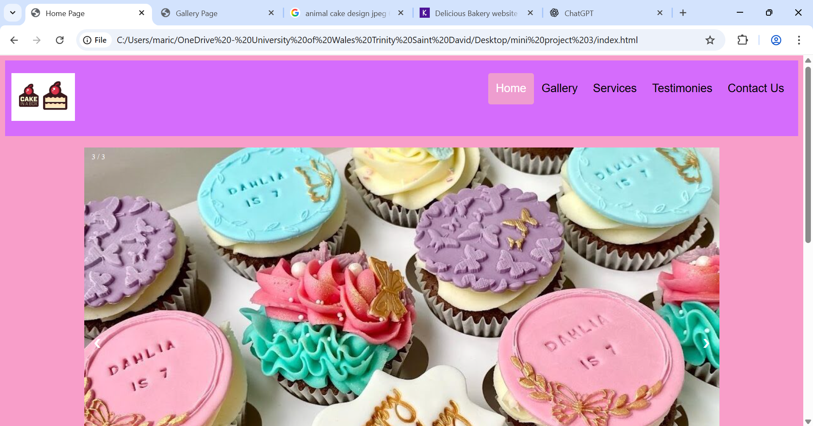
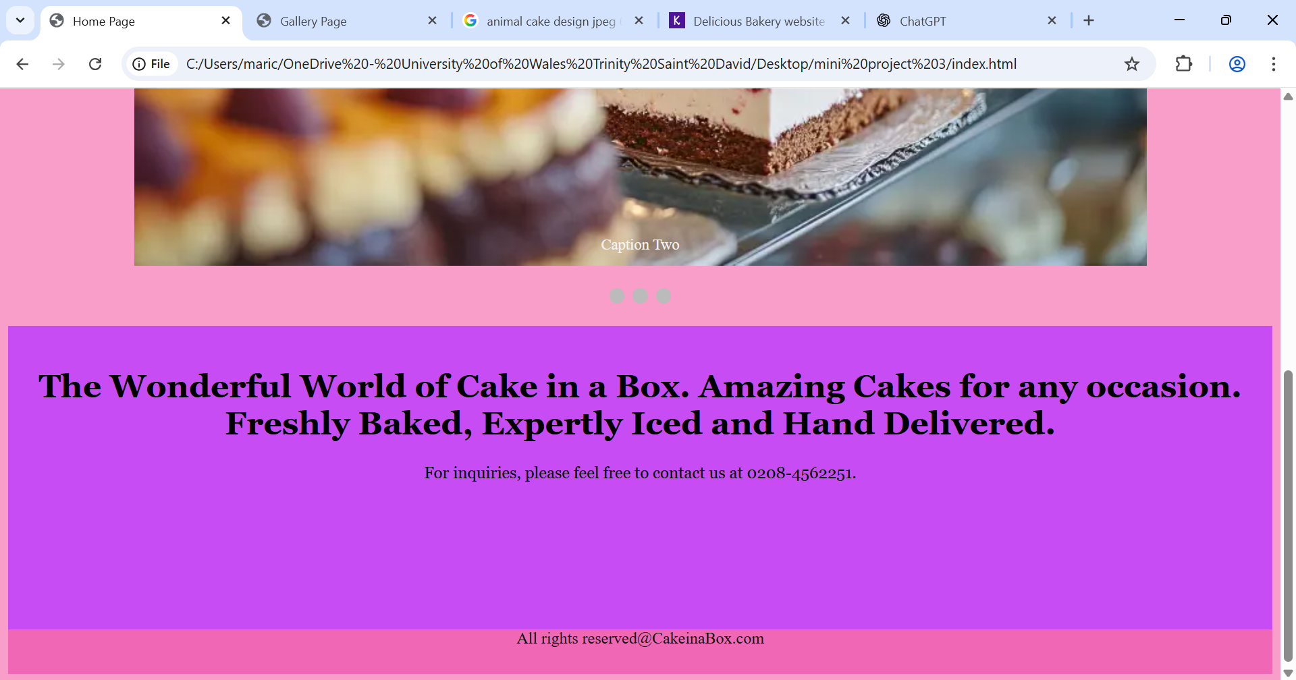

Gallery page
My Gallery Page displays the collection of cake imagesthat the shops offer, each neatly arranged in a grid layout. Each cake has a photo, accompanied by a label. The Overall design uses a clean colourful layout with a purple theme making it easy for the users to browse different cake options.
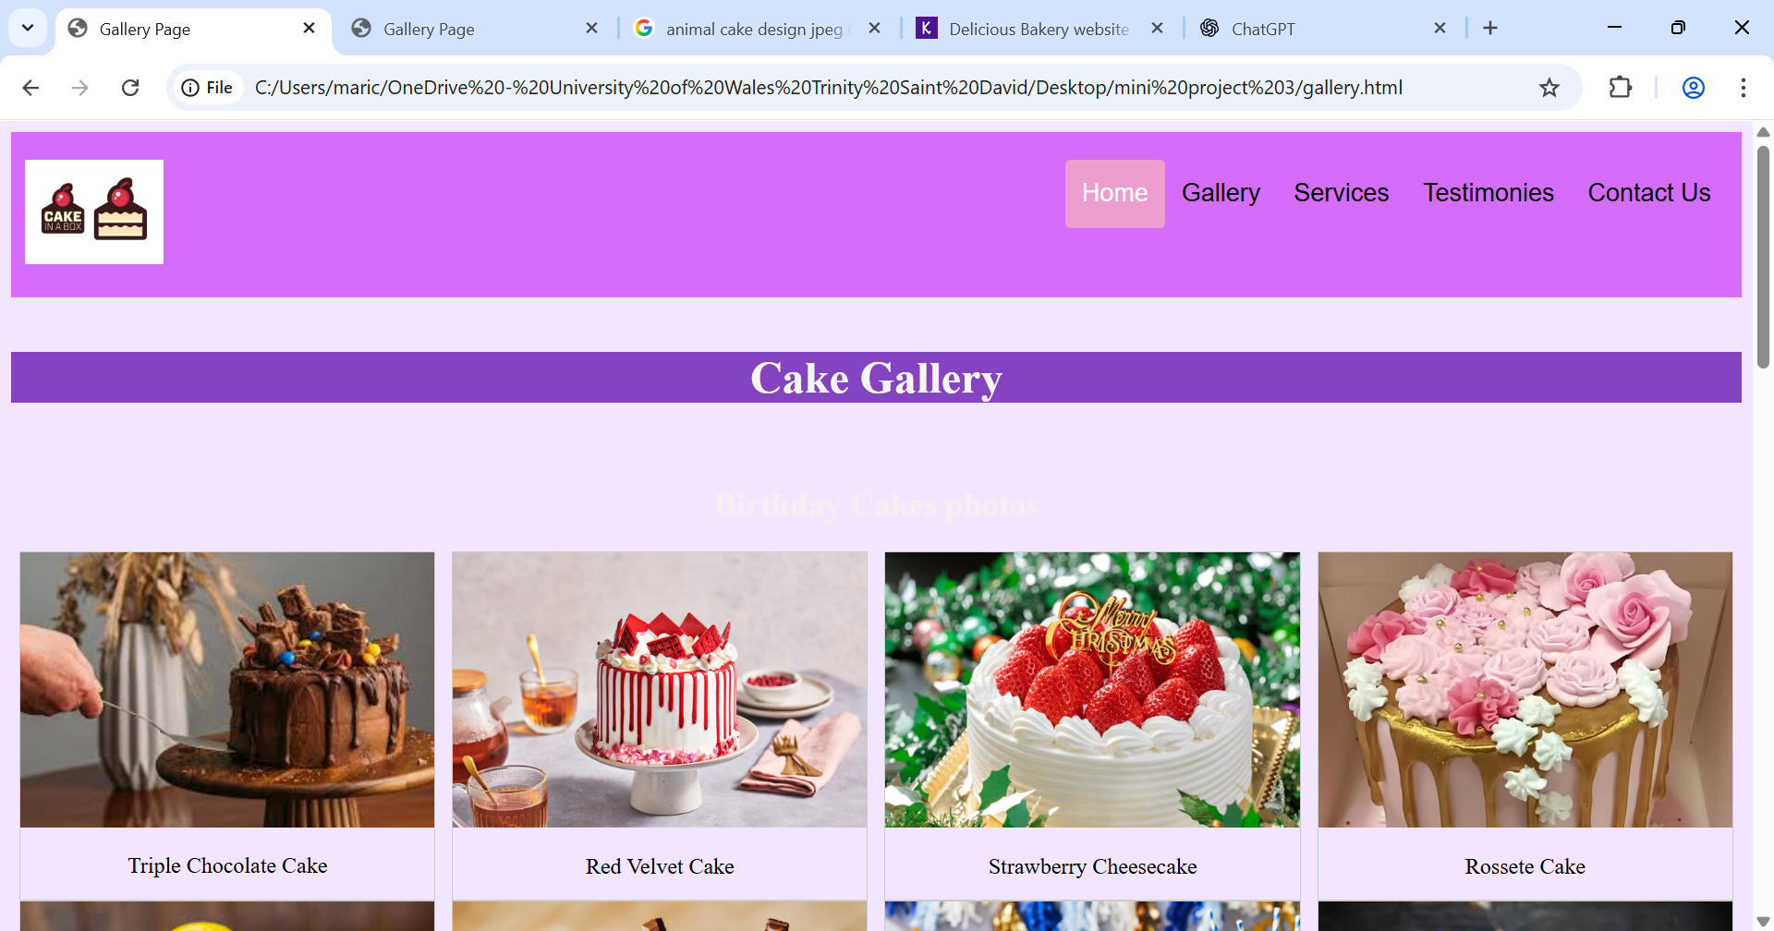
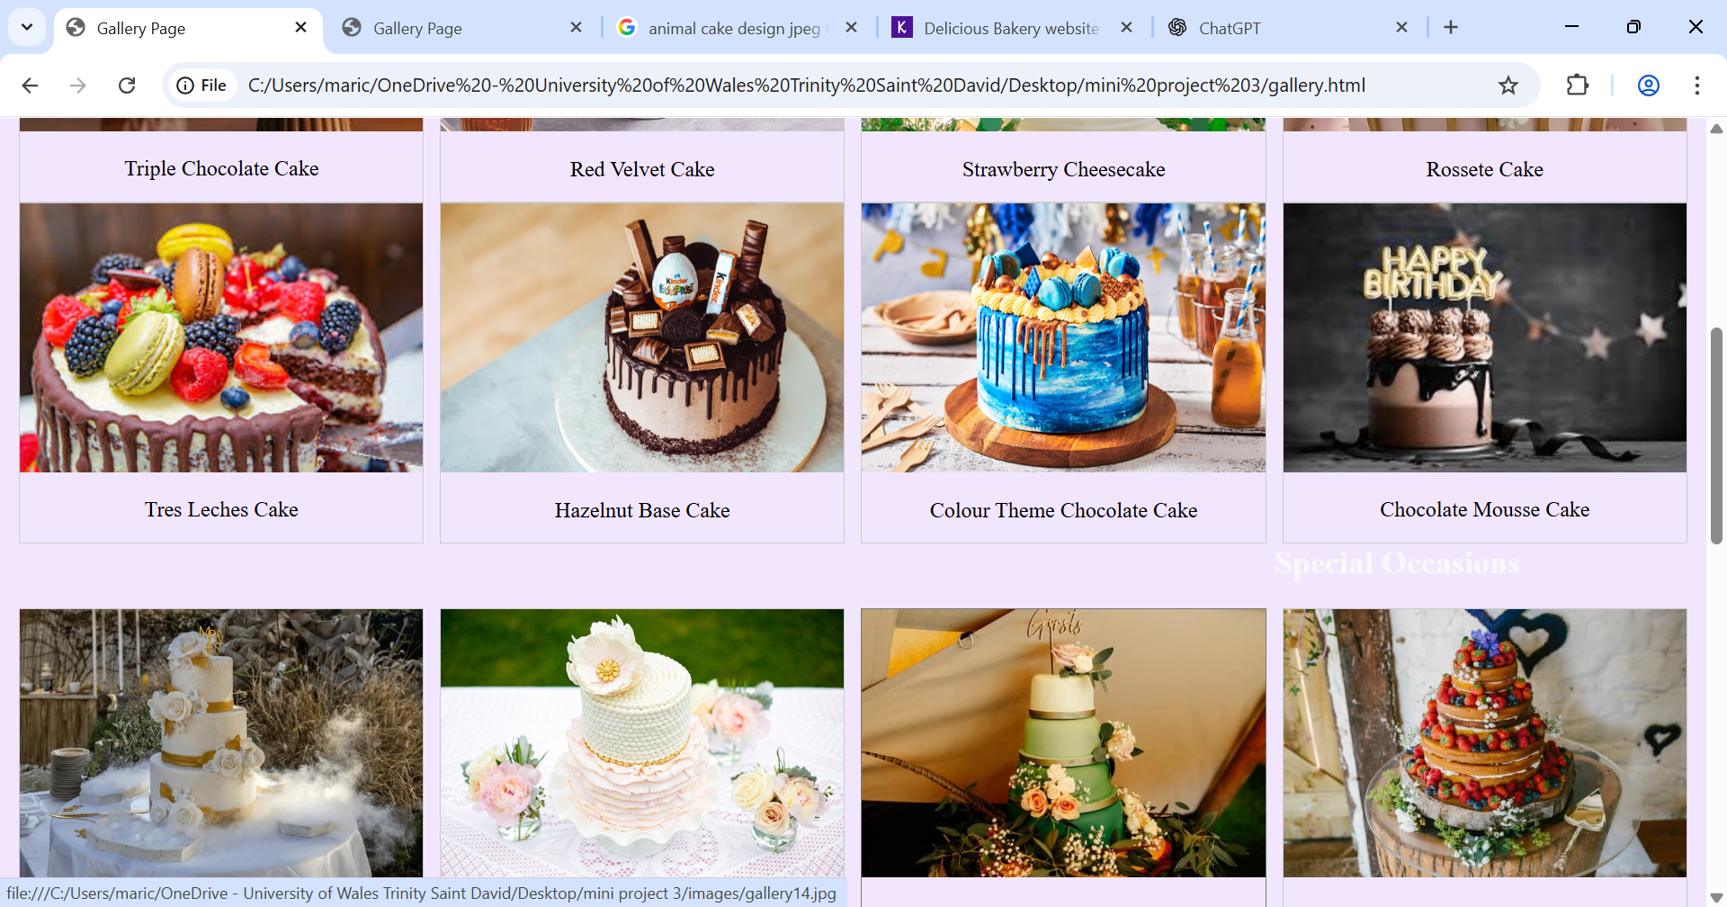
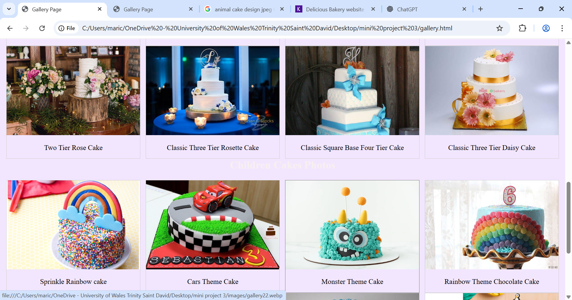
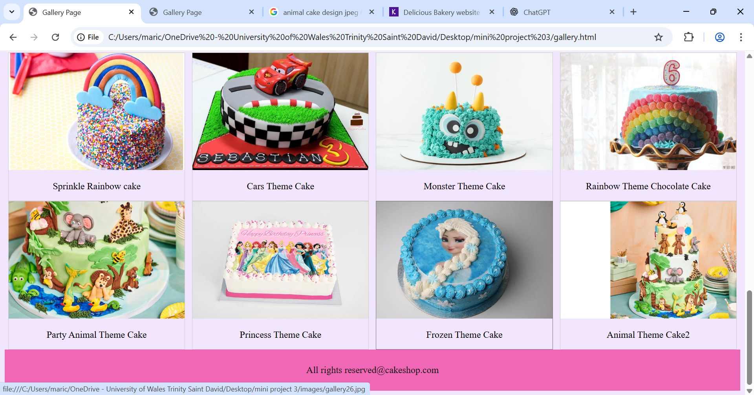

Services page
My Services page shows a clear and organised overview of the different services the bakery offers. The top features the “services offered” header title, followed by sections that are orderly divided with images and label.
The first section focuses on Delivery Services, showing different options and requirement. Each service is represented with the proper image, making the information easy to understand.
Next is the Decoration Services, displaying different packages that is suitable for every needs of the customers.
The design muses consistent purple theme, clear images and well space layout, making the page appealing and user friendly.
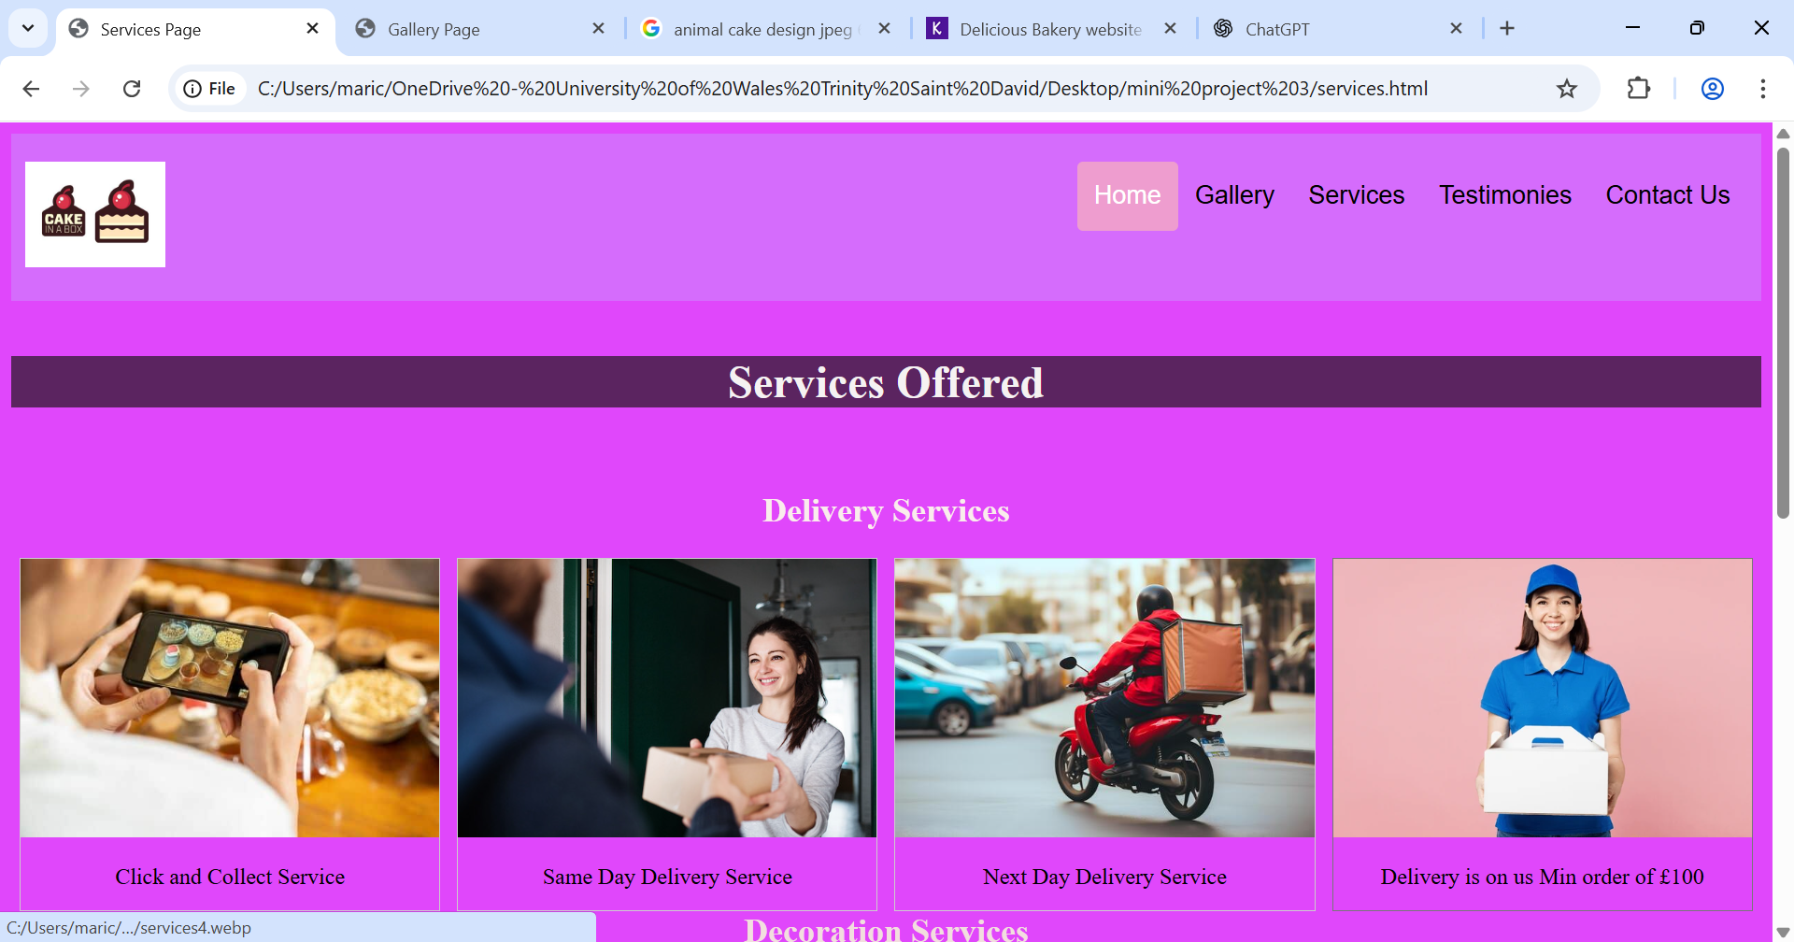
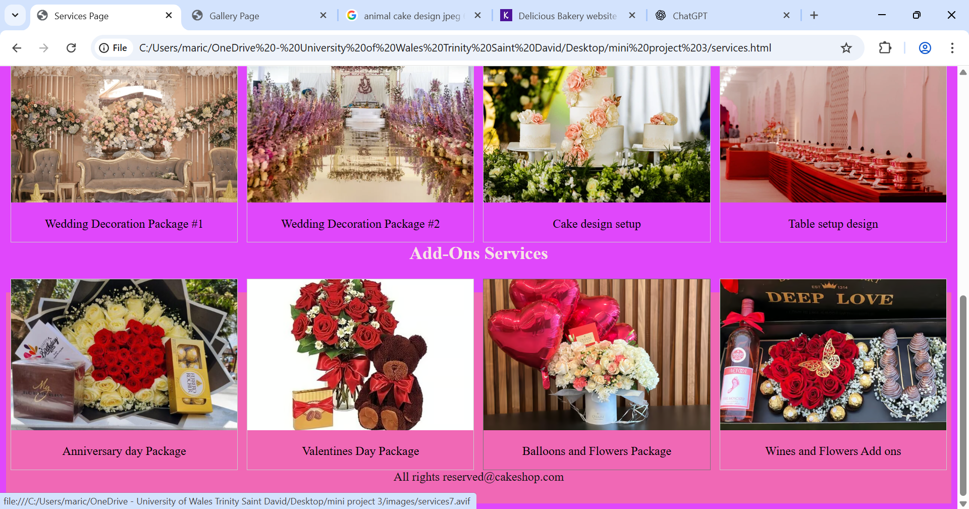

Testimonial Page
My Testimonial Page display the feedback from my customers. Each testimonials includes the persons photo, name along with their comments about the service of the shop. I believe putting a testimonial page highlights the experiences and helps build the trust of the potential customers.
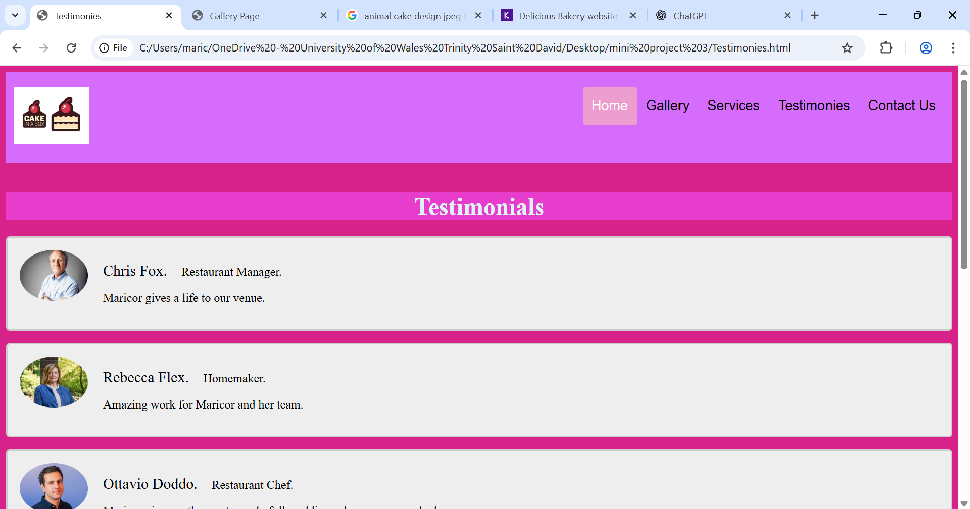

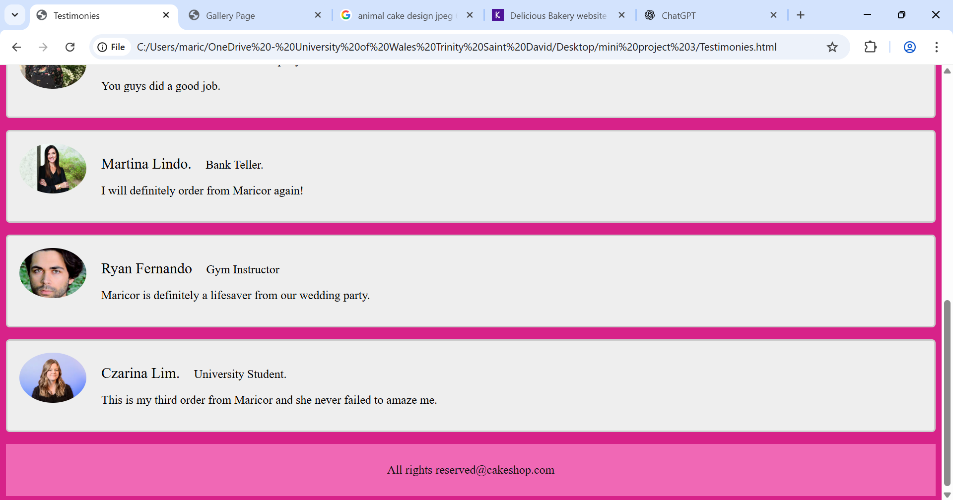

Contact Page
Lastly is my Contact Page allows the guest to easily get in touch by filling out the form. I believe that the layout and Clearfield make it straightforward for the users to send enquires and gives feedback.
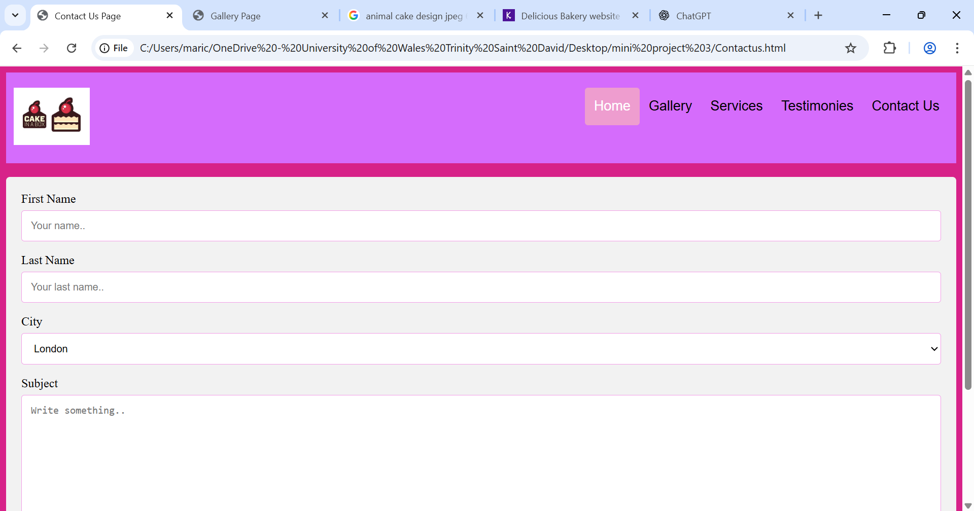
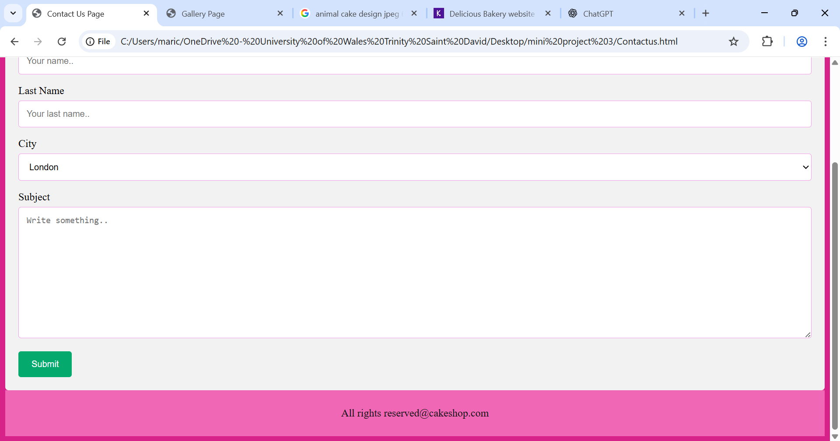

Validating my website
HTML VALIDATION
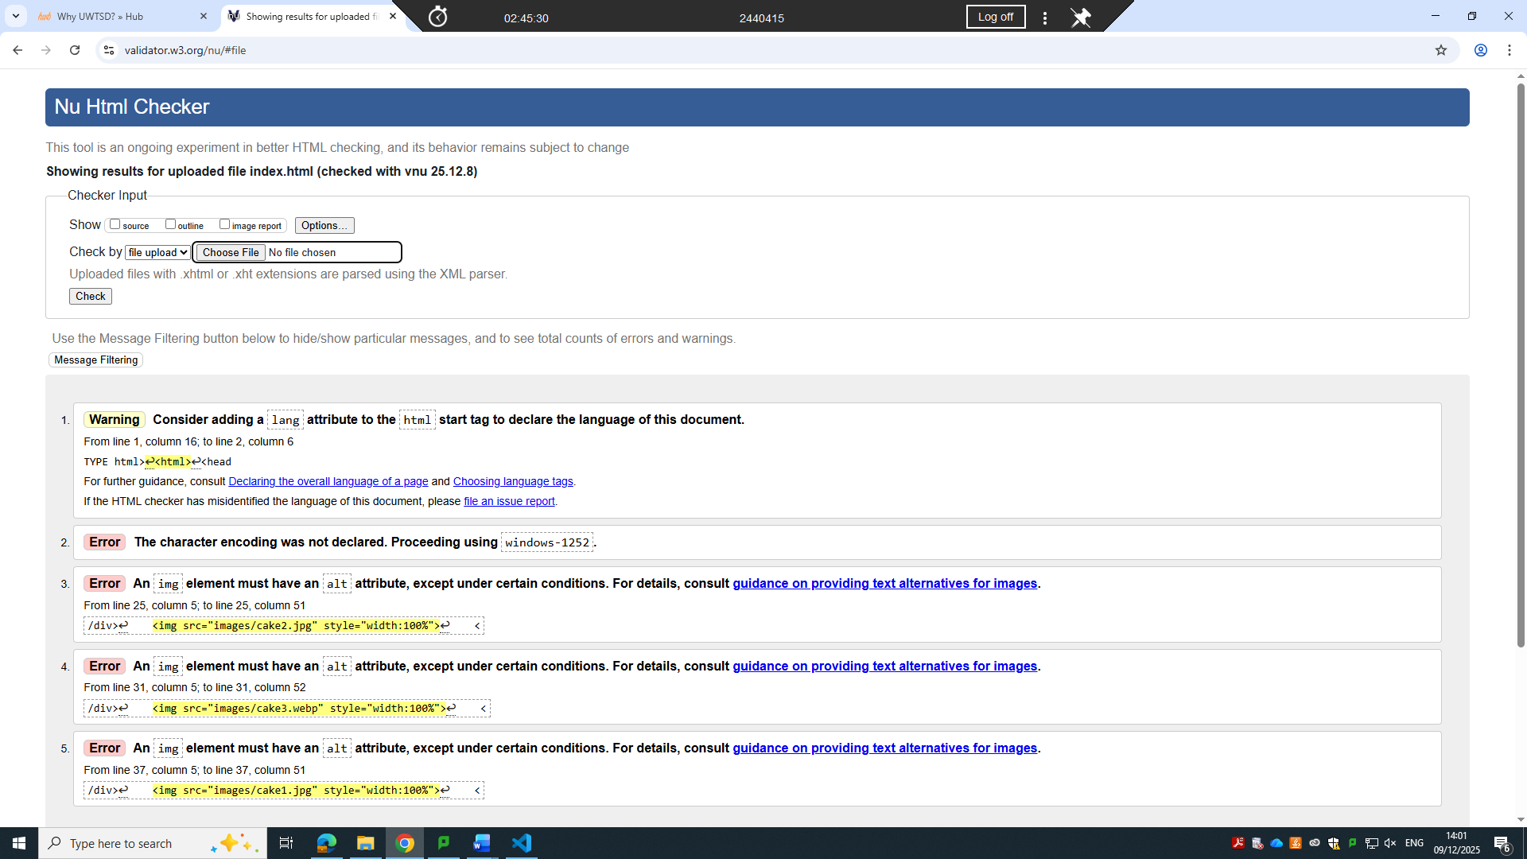

The first error is the lang attribute on the opening is missing. Instead of <html> the tag should be: <html lang=”en”>. The lang attribute lets the browsers, screen readers, and search engines what language the document is written in.
The second error is the character encoding was not declared by using windows-1252. The HTML file does not specify a <meta charset=”…”> tag, means the validator is guessing the encoding. The tag should be: <meta charset=”UTF-8”>
The third, fourth and fifth has all the same error which is an img element should have an alt attribute, only certain circumstances do have exception.

CSS VALIDATION
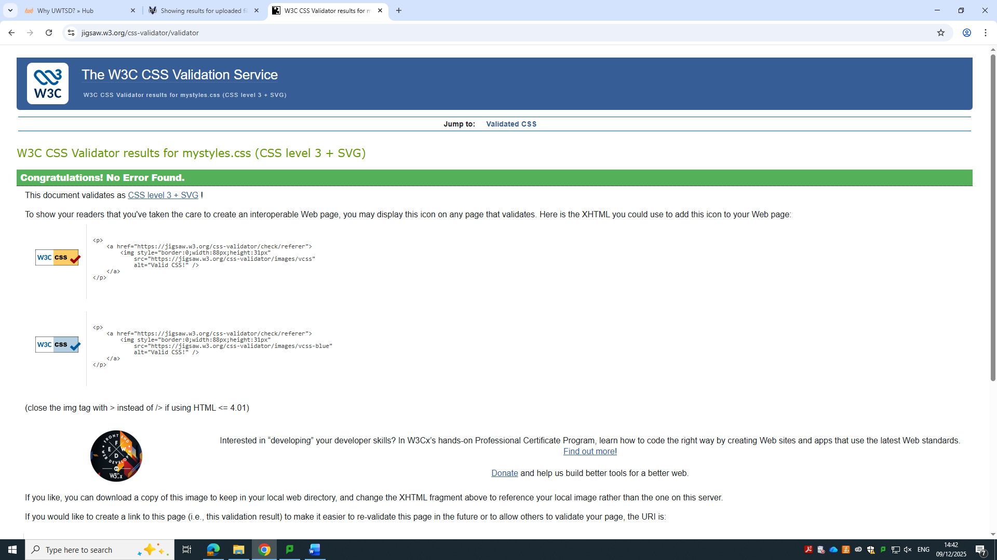
There is no error because the CSS file follows all the W3C and contains only valid properties, values and syntax. As an outcome, the W3C CSS validator confirms that the file meets the required standard of this report.

Self-evaluation of my website

Usefulness (usability and utility)
Now a days the demand for the higher education institution to have a credible, efficient and attractive web is growing because of online technology plays a very huge part in education process. The higher education institution plays a vital role in the improvement of the society while the higher education website has many responsibilities to fill.
As of today, it is very impossible for a university to exist without website, the higher education institute has a big demand for an effective website to help attract new students also for meeting the needs of the current students. Some higher education institution need to create the website to highlight the opportunities they offer and making them accessible for the people around the world, they also need to remain competitive in the global criteria for them to have an accessible website which showcase their academic offerings and campus opportunities. [1]
In the early days of e-commerce, website designers often focused on creating visually appealing websites, with some attention given to usability. In e-commerce, the website serves as the firm’s interface with the customer, and its usability is crucial to the success of the venture. E-commerce success is figured in part by trust and the study shows a strong relationship between interface quality and trust. In addition, understanding of its website ability and its theory is very useful and essential for those who wish to succeed in the e-commerce business. [2]

Search Engine Optimisation (SEO): what type of actions
In todays technological world, the influence of the internet is growing so fast, online business activities and digital advertising are also evolving rapidly. To be on top of everything, it is very important to maintain strong visibility and meet the needs of the audience. Since the search engines are one of the primary way were people gather information, they serve the most important tool for guiding users to website. When users do not know the exact website address, they rely on the search engine to locate the exact site. Google by far is the leading search engine, holding 90.76% of the market share. [3]
SEO Advantage
Understanding SEO gives you a significant advantage. It’s important to develop this knowledge whether you handle your own web page coding, collaborate with internal developers, or hire outside experts to design and implement your site. Although some websites perform well without intentionally using SEO, creating a deliberate strategy that includes SEO practices will help your site and pages do better than those that don’t use them. Other way to look at this is that sites use core SEO have an progressive higher position in search results.
SEO has the chance to increase the amount of traffic to your website. If you approach it thoroughly, you can also encourage the type of visitors coming to your site. This means SEO should be combined into your overall market research and business strategy. While most businesses want more visitors, the focus shouldn’t be on just any traffic. Just like a physical store aims to encourage customers who have money and are ready to make a purchase, an online business should target qualified traffic—people who are genuinely interested and able to buy. [4]

Website Accessibility
Web Accessibility means creating websites, apps and digital tools so that everyone, including people with disabilities, can use them easily. It’s not only about helping those with disabilities, web accessibility focus to enhance the overall experience and quality of the internet for all users. The Web Content Accesibility Guidelines assist website developers and designers in focusing the needs of all users, including people with disabilities and older adults. These recommendations are not only useful for developers and designers but also for creators of web accessibility assesment tools and also with anyone seeking for acknowledgement standard to assess the accessibility of particular web content. [5]
The key factor for web accessibility is to include people with sensory, physical, or cognitive disabilities, letting them access to web resources in addition to have a broader audience. Disabled individuals often face social isolation due to barriers that limit their ability to perform everyday activities, such as accessing information, communicating, shopping, education, healthcare, entertainment, and participating in democratic processes like voting.
The world wide web was created by Tim Bernes Lee was intended by information and communication space which contribution was not included by personal scenario like disability. Bernes Lee predicted the possibility of digital information and web services to conquer many challenges faced by the people with disabilities in physical world. [6]

References

[1] | M. Manzoor, W. Hussain, A. Ahmed and M. J. Iqba, The Importance of Higher Education Websites and its Usability, Science Publishing corporation .
[2] | K. Macmahon, An exploration of the importance of website usability from a business perspective, 2005.
[3] | G. Egri and C. Bayran, “The Role of Search Engine Optimization on Keeping the User on the Site,” Procedia Computer Science, vol. 36, 2014.
[4] | H. Davis, Search Engine Optimization. building traffic and making money with SEO, O Reilly Media.
[5] | F. Filipe, M. I. Piges and A. J. Gouveia, Why Web Accessibility Is Important for Your Institution, Portugal: Procedia Computer Science, 2023.
[6] | D. Sloan, The Importance of Web Accesibility, Facet Publishing, 2008.

