
[new buisness opening]
[Managing Enterprise]

June 29, 2020
[Stacey evans]
[Swansea Trinity University]

Introduction
The type of business I have picked is a sole trader. I will be setting up my own business doing beauty therapy. the name of my business is ‘Beauty before Beast’. I have chosen this because I think by visiting a beauty salon, we all can have healthy and beautiful skin under the guidance of beauty experts. I will be providing services like manicures, pedicures, spray tan, waxing and skin care treatments. I will be employing two people. One to work on reception, taking bookings and answering phone calls and one trainee to give out refreshments, clean up after any treatment and also they will be learning all the aspects of beauty therapy.

Product/services
My aim of this salon will be to provide services to clients and to aim to achieve a profit. I am going to start off by getting my products from a manufacturer then hopefully if my business increases, I will then be making my own products and selling them to clients. The services I will be providing are manicures, pedicures, spray tan, waxing and skin care treatments.

Better team (2018) states that Beauty Therapists perform various non-medical face and body treatments using their knowledge of skin biology, skin physiology, and cosmetic chemistry. They provide skin and hair removal treatments, massage therapy, as well as manicures and pedicures.

Liability as a sole trader.

A sole trader is a self-employed person who owns and runs their own business as an individual, but you will be responsible for any losses your business makes. As a sole trader I will be responsible for liabilities of my business. If I get injured or ill in work, I will not be able to claim compensation. As an owner I will be liable for any debts and I may have to pay out of my own pocket if my business is not making much profit. This is called unlimited liability. I am employing staff so it is law that I get liability insurance this will then cover any of my staff if they get injures or are ill that is caused by work. As a sole trader I will need contents insurance as well as liability insurance.

PolicyBee (2016) states that Employees' health and safety is every employer's responsibility. If a member of staff is injured or falls ill at work, and it's the employer's fault, the employee can claim against the employer for damages.

Marketing activities
To let people know my business is opening I will be handing out leaflets in shops and also, I will be sharing it on social media. This is to let people know there is a beauty salon opening in Llanelli town centre. I will be printing out 500 leaflets. This will cost me £37.89 for leaflets. The online source I’ve had this from is www.bizay.co.uk.


I will also be doing special offers and packages for treatments from bronze, silver to a gold package. The bronze package will include spray tan, eyebrow wax, and manicure for £35. The silver package will include facial, manicure and pedicure for £40 and gold package will include facial, manicure, pedicure, any area of waxing of your choice and a spray tan for £55. I will also be doing 20% off for my first 20 customers that come in the salon for treatment.
Cooper N (2017) says to gain customers in a competitive marketplace there are many means of marketing yourself these are looking apart, knowing who your customers are, offline marketing, exploit readymade opportunities.
Gregory A (2010) states that the 4 strategies to marketing and these are: cause marketing also known as cause related marketing which links to a company and its products and services to a social cause or issue. Relationship marketing is to enhance your relationships with customers to form loyalty. There’s two marketing are called ‘positive’ meaning they benefit other. The other two marketing are scarcity marketing which means a perception of shortage making people think they need to buy the product out of fear that they won’t be able to purchase it in the future and the last type of marketing is undercover marketing this involves marketing to consumers in a way they do not know they are getting marketed to. These last two marketing are called unconventional and potentially controversial techniques.

I have done a questionnaire based on the new opening of my beauty salon. I have done a questionnaire because I think it is always good to find out what type of clients are going to be visiting the salon, what treatments they would mostly want, how often customers visit salons and how far they would travel etc. This will help me to find out how it can impact and influence my business.

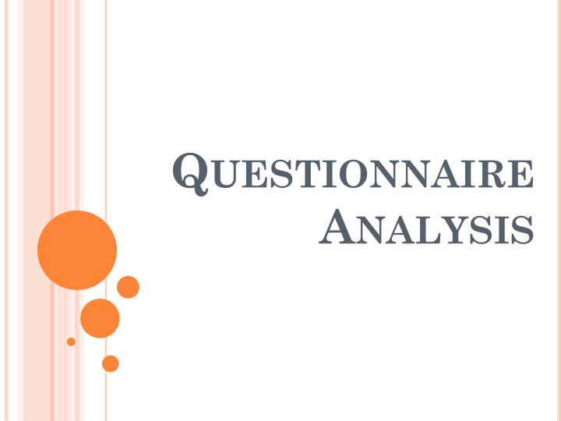
With my 10 questions and my 10 responses that I have received I have found out that 80% of people who visit a salon are women and the other 20% are male. I’ve also found out that customers would travel 2.5 miles to a beauty salon. This could vary as the location of my beauty salon is in Llanelli town centre so for the people who do visit Llanelli town centre, they will see my shop and hopefully they will come in for treatment. Most customers use Facebook so my aim to get this a bit higher is to advertise my salon on Facebook which most people use going from my questionnaire. Also, the most popular age category who visit a salon is 25-34. Most customers visit a salon monthly and most customers like manicure and pedicure which means I need to focus on advertising manicures and pedicures. Customers are willing to pay £30-60 pound meaning I need to focus on advertising my bronze, silver and gold package deals which cost £30-£60 depending on the package. Please see graphs in appendices.

Physical resources
The location of my salon will be based in Llanelli town centre. I will be buying a small shop. Small beauty salons cost around 70,000 to 80,000. Hopefully if my business increases, I can then move to bigger shop and then I can also offer more treatments. The things I will need for my salon is a basic second-hand till, this will cost me around £80. I will also need a massage table bed couch where customers can lay down and relax while having their treatments done. The bed will cost around £100 second-hand. I will need a spray tan gun and tent which I already have so there will be no cost to that. I will also need little things like cotton buds, nail polish/nail polish remover, nail clippers, hand /nail moisturiser, massage oil/cream, wax strips, applicators and spray tanning liquid all of these will cost me around £100. In total I will need £300 for my equipment and products. The sources I have used to find out costings are www.ebay.com, www.zoopla.co.uk and www.salonsdirect.com.

Schofiled T (2003) states that Physical resources are necessary for all types of business. Product-based businesses use physical resources for providing the goods for sale and for the operation of the business.

Financial resources
I have savings of 100k. If my business was to expand in the future, I may need a bank loan. There are a few advantages and disadvantages of loans. The disadvantages of loans are they are not very flexible and usually have high interest rates and I could be paying interest on funds that I am not using, if I’m not having much custom I won’t be earning enough profit to pay the monthly repayments and this could lead to cash flow problems. Therefore, I don’t think a bank loan will be suitable while I’m just starting up my new business, as I don’t know how much profit I will be earning. If I do earn enough profit and I’m able to expand then I know I will be able to pay back monthly repayments on a bank loan. The advantages of a bank loan are that there is no need to provide the bank with a share of the business and interest rates may be fixed for the term, so this will make it easier to forecast interest payments. The finances I have worked out and that I will need are:
- Broadband and telephone which will cost around £22.99 a month (www.moneysupermarket.com)
- Electric £80 month (may vary)
- Products £250 month (may vary)
- Equipment £100 month (may vary)
Contents insurance is something that I will need, and this will cover my shop if there was any flood, fire etc. Without this it can lead to major difficulty with cash flow and could lead to closure of the business. Contents insurance costs £240 a year. I will also need legal and accountancy, account is responsible for keeping financial records and this will cost me around £300 a year. Liability insurance will cost around £200 a year. I’ve had all these costing from an online source. www.comparethemarket.com.
Scarpellini S, Vinuesa L, Tarragona P, Moneva J. (2018) says that Technological and environmental management capabilities of the company can influence echo-innovation.
Arsene C (2019) says that Financial services marketing refers to the collective use of marketing tactics employed by marketers in the financial services sector to attract new customers or retain existing ones.

Contingency planning
Contingency is a process of being prepared for events beyond their control using a ‘what if’ process.


Woods C states that Contingency planning is developing responses in advance for various situations that might impact business. Although negative events probably come to mind first, a good contingency plan should also address positive events that might disrupt operations - such as a very large order.

Human resources
I will be employing one receptionist to take booking and answering phone calls and one trainee who will be giving out refreshments and tidying up as well as learning all aspects of beauty therapy. The qualifications needed for a receptionist is communication skills and IT skills, an NVQ level 3 in beauty therapy would be a bonus. A trainee will not need any qualifications and they will start off at level 1 and work their way up to level 3 in the salon as well as going to college.

Umum (2020) states that Human resources often act as a go- between for employees and managers, you will need to hire an HR manager if you’re expanding rapidly, you cant keep on top of changes to law employment, employee disputes are on the rise or if your spending too long on personal issues.



A business idea is starting point, it is the beginning of a new life and the life of an entrepreneur.
Having a vision provides a sense of purpose and direction for a business.
A business plan will help make better decisions.
Success provides confidence and the ability to aim for a greater level.
Competition motivates companies to increase sales.
Marketing is a way to promote business and improve profit.

Swot Analysis
A swot analysis is a roadmap of how you should move forward with your business, which opportunities your missing out on, and which challenges you should tackle. Forsey C (2019)
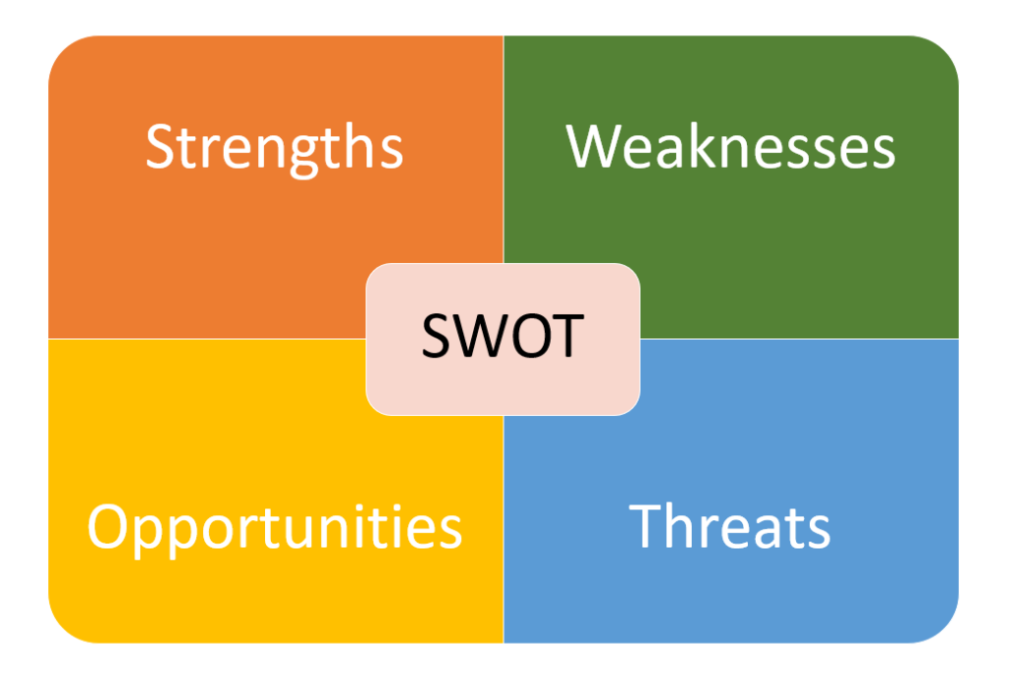
Strengths
- Excellent customer experience
- Good location
- Extended opening hours
- Free Wi-Fi
Strengths of my business are excellent customer experience and it is also stated in the job description that you will need good customer experience meaning whoever I employ will need to be happy, cheerful, have good communication and meet all customer needs.
Another strength is my business is in a good location it is important to have a location where people are most likely to pass. My business will be in Llanelli town centre where there are always people.
Extended opening times is another good strength. My salon opening times will be Monday, Wednesday, Friday and Saturday 9am- 5pm and Tuesday and Thursday 9am- 7pm this gives customers the opportunity to come for their treatment after work.
Most people use internet these days and I think by having Wi-Fi in my salon it could attract more customers.
Weaknesses
- Not much treatments to offer
- Still using paper appointment book
- New business
The weaknesses of my business are there is not much treatments to offer but this can also be an opportunity, as the business grows there will be a lot more treatments to offer.
Another weakness is that I will be using paper to book appointments, this can also be an opportunity as the business grows, I will invest in buying a computer to book in my appointments.
As this is a new business most people have already got their regular place where they go for treatments. Therefore I think advertising is so important when starting off.
Opportunities
- Always room to grow
- New product opportunities
There’s always room to grow if my business is successful and making enough profit, I will then move to a bigger place, offering more treatments and employing more staff.
Another opportunity is that I can offer new products and even sell these products to make more profit.
Threats
- Mobile beauticians
- Internet marketplaces
- Competition
A threat of a beauty salon is mobile beauticians this is a big threat as some people like to be in the comfort of their own home and have treatment, as this saves them from going out.
Competition is another threat as there is always other business that are making more profit than you.

Job description for receptionist
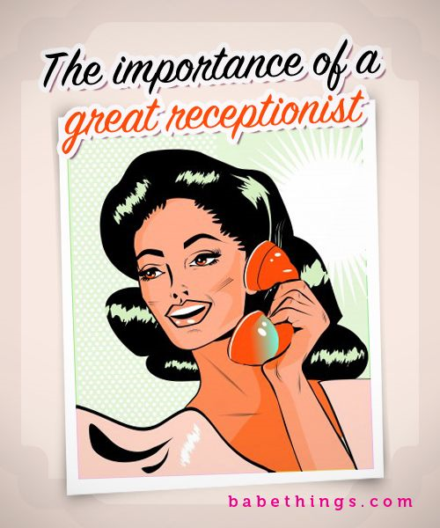
I am looking for a polite, friendly, dedicated receptionist to work part time of 16 hours per week at £8.72 per hour.
Experience
- Must have computer knowledge
- Excellent telephone skills
- Communication skills
- Ability to work under pressure
- Warm outgoing personality
- I.T Skills
Duties
- Serve customers by welcoming and greeting.
- Keep a safe and clean reception area by complying with procedures, rules and regulations.
- Answering telephone
- Taking bookings and messages

Job description for a trainee


A traineeship gives a opportunity to improve you chance of an apprenticeship or a job as a beautician and will include the following opportunities
- Essential employability skills
- A work placement

Experience
No experience is needed for this role. Must have your heart in beauty therapy looking for someone who is happy, cheerful, talkative.

Duties
- Brushing/ moping floor
- Giving refreshments to customers
- As well as learning all aspects in beauty therapy this will include manicures, pedicures, waxing, facials, massage and eyelashes.

A definition of this job role is to be successful in beauty therapy you should have experience with beauty therapies and good knowledge to skin and body care products.



CV’S need to be handed in by the 30/06/2020. If your successful you will have a phone call. I will then ask you to come into the salon for a face to face interview.
Doyle A (2020) says that employers use phone interviews to identify and recruit candidates for employment. Phone interviews are often used to narrow down applicants.

Financial plan- Cash flow

Cash is the energy that keep business flowing. The 6 rules to keep cash flowing and to avoid getting caught with insufficient funds are:
- Collect cash as soon as possible.
- Pay your bills by the due date and not earlier.
- Check your available cash daily
- Lease or finance instead of buying equipment where practical
- Avoid buying inventory you do not need
- Plan for seasonal or contractual needs by seeking financing early.



Appendices

1.
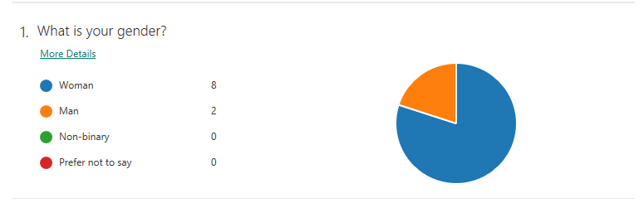
By this repossess I have received on this question there may be a little bit more women coming into the salon than it is men.
2.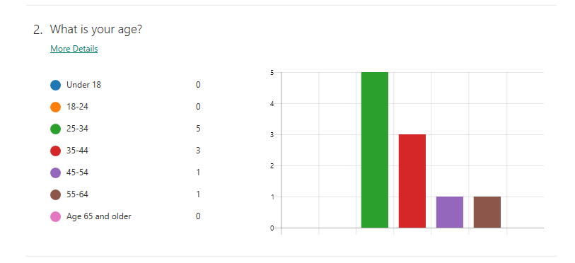
On this question the most popular age category will be 25-34.

3.
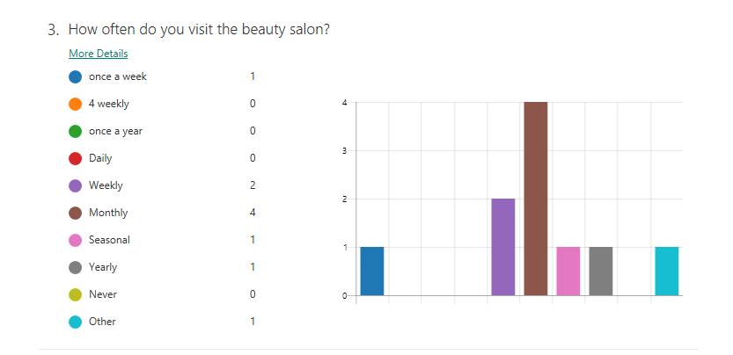
Most people answered that they visit a beauty salon monthly as you can see. 40% of people said they visit a salon once a week, seasonal, yearly and other (fortnightly).

4.
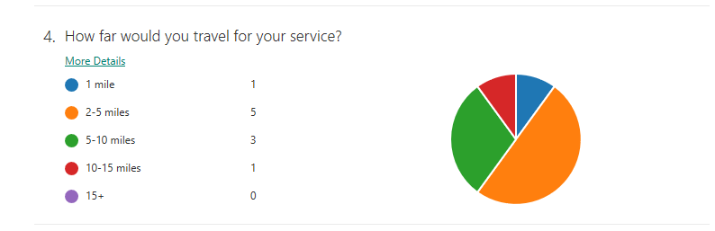
By the responses of this question, 50% people will travel 2-5 miles to a beauty salon. 30% of people will travel 5-10 miles. An even spread across the other categories and no response for 15+ miles. This graph shows me that I will be having locals and a very few that will travel. By having my beauty salon in Llanelli town centre this will influence my business because people who do travel to go into Llanelli town centre will notice my beauty salon and hopefully will come in for a treatment.

5.
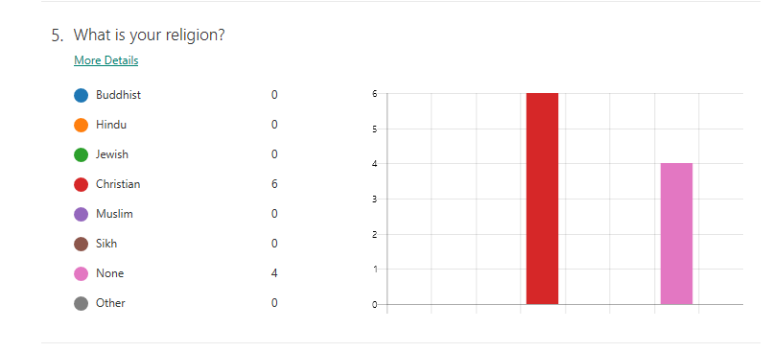
By the responses on this question it shows that there will be a quite a few Christians coming into the salon and some that have no religion at all.

6.
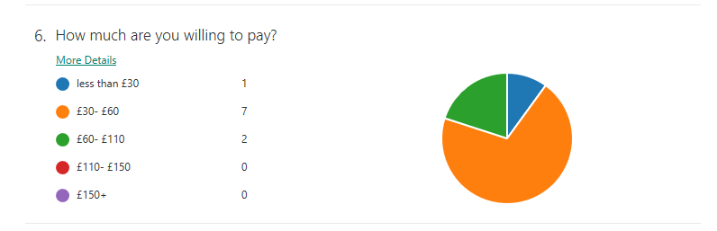
The results from this question is that most people will pay £30-£60 for a treatment. 20% are willing to pay £60-£110 and 10% will pay less than £30. By this chart it shows me that by doing beauty packages it will come under the £30-£60 range meaning I could be successful in doing the packages.

7.
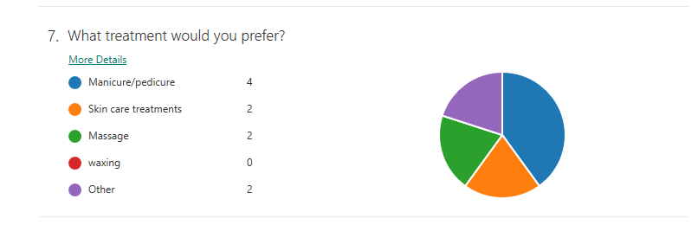
By this chart 40% of people prefer a manicure/pedicure this shows me I will need to stock up on manicure and pedicure products to make sure I have enough. An even spread of 20% each with Skin care treatment and massage is quite popular. There’s been no responses to waxing, this will have a Impact on the business and I will be revaluating this and if it doesn’t seem to be any customers having that certain treatment then I may then stop offering that treatment.

8.
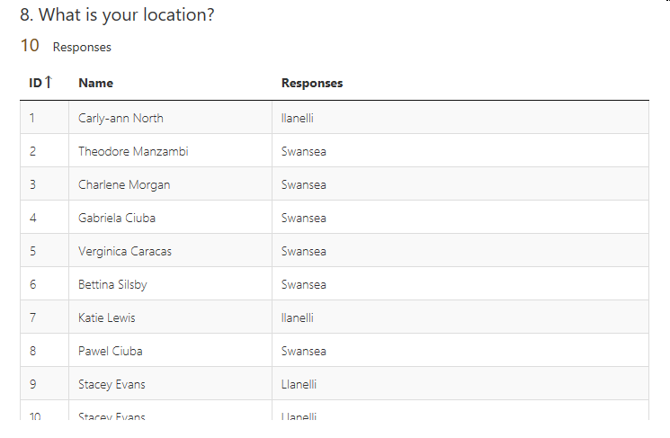
9.
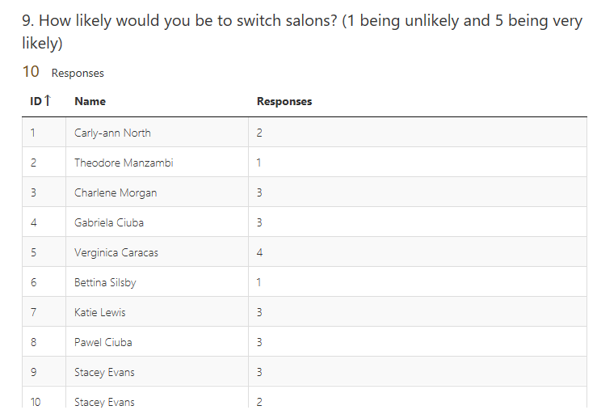
This shows me that not many people would switch salons. Once they got their regular salon where they go to its quite likely they are going to change.

10.
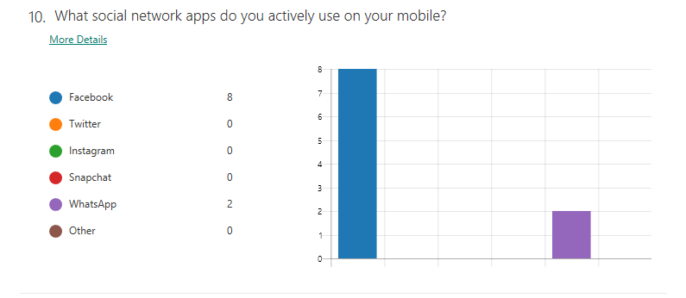
This shows me that most people use Facebook on their mobile’s. This will influence my business when I go to advertise the new opening on Facebook as 80% of the population use Facebook. This is a huge difference compared to the other 20% that use WhatsApp.

Conclusion
The key strengths of my business are it is in a good location and it has extended opening times which is a good strength for the people that work and can’t come to have treatment until they finish their work. I’ve come to the conclusion that from my questionnaire that customers have filled out most clients would prefer a manicure and pedicure. Going from my swot analysis there’s not much treatments to offer at the minute as I’m just starting off but when my clientele picks up and I earn more profit I will then be offering more treatments. My weakness of my salon is that I will be using a paper appointment book unlike other salons their appointments are all done through a computer and I will be looking more into getting a computer to make my bookings in the near future. There’s always room to grow in a beauty salon if you make enough profit.

Reference List

Cooper N (2017) ‘How to Market Yourself as a Massage or Beauty Therapist’ Available at: https://www.ncchomelearning.co.uk/blog/how-to-market-yourself-as-a-massage-or-beauty-therapist/ [Accessed on 07/06/2020 at 15.20]

Betterteam (2019) ‘Beauty Therapist Job description’ Available at: https://www.betterteam.com/beauty-therapist-job-description [Accessed on 07/06/2020]

Forsey C (2019) ‘ How to run a SWOT Analysis for your Business’ Available at: https://blog.hubspot.com/marketing/swot-analysis [Accessed on 07/06/2020 at 20.42]

Schofield T (2003) ‘What are Physical Resources in Business’ Available at: https://study.com/academy/lesson/what-are-physical-resources-in-business.html [Accessed on 07/06/2020]

PolicyBee (2016) ‘Do sole traders need employer’s liability insurance?’ Available at: https://www.policybee.co.uk/blog/sole-trader-need-employers-liability-insurance [Accessed on 08/06/2020 at 20.08]

Gregory A (2010) ‘4 types of marketing strategies to spice up your campaigns’ Available at: https://www.sitepoint.com/4-types-of-marketing [Accessed on 09/06/2020 at 09.45]

Doyle A (2020) ‘Steps in the job interview process’ Available at: https://thebalancecareers.com/steps-in-the-job-interview-process-2061363 [Accessed on 09/06/2020 at 13.48]

Arsene C (2019) ‘9 effective financial services Marketing Techniques’ Available at: https://www.digitalauthority.me/resources/financial-services-marketing-2019/ [Accessed on 09/06/2020 at 14.05]

Umum (2020) ‘What does Human resources do and when do you need them’ Available at: https://www.unum.co.uk/resources/what-does-human-resources-do [Accessed on 09/06/2020 at 14.24]

Scarpellini S, Vinuesa L, Tarragona P, Moneva J. (2018) ‘Defining and measuring different dimensions of financial resources for business eco-innovation and the influence of the firm’s capabilities’ (Vol. 204) Pages 258- 269. University of Zaragoza, department of accounting and finance. Available at: https://www-sciencedirect-com.ezproxy.uwtsd.ac.uk/science/article/pii/S0959652618326817 [Accessed on 09/06/2020 at 21.25]

Woods C. ‘What is contingency planning in business? Definition, example + importance’. Available at: https://study.com/academy/lesson/what-is-contingency-planning-in-business-definition-example-importance.html [Accessed on 09/06/2020 at 22.12]

Cash flow

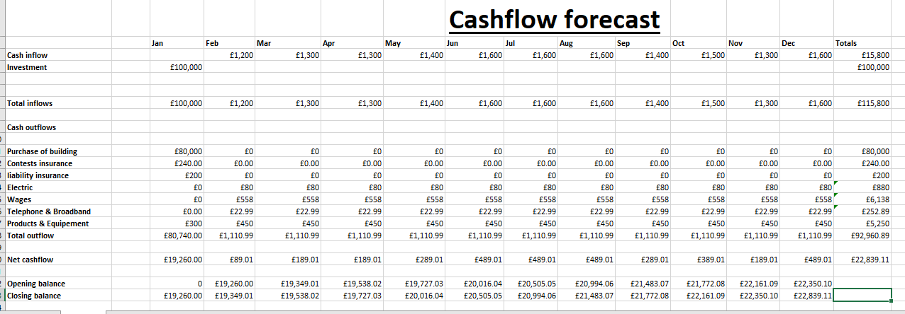



I Have 100k of savings I will be buying my shop in January. I will also be getting contests insurance, liability insurance, products and equipment in January. In February I will then be opening my shop and getting my receptionist in and my trainee so ill have wages to pay in February I will also have electric, telephone and broadband and also my products and equipment will be £450 every month starting from February.
My start-up costs will be:
Buy a salon- £80,000 this source is from www.zoopla.com
Liability insurance- £ 200 for a year this source is from: www.comparethemarket.com
Contests Insurance- £240 for a year this source is from: www.comparethemarket.com
Products and Equipment- £300 to start up this source is from: www.salonsdirect.com
This will leave me with £19,260

I’m aware there will be certain peaks throughout the year and these peaks are from June to August as these are summer months and also December (Christmas time). From the cash flow the slower months are February, march, April, May, September and November.

My outgoings each month will be:
Electric- £80 a month (may vary) source from: www.sse.co.uk/energy
Telephone and broadband- £22.99 month source from: www.moneysupermarket.com
Products- £250 month (may vary) source from: www.salonsdirect.com
Equipment- £200 month (may vary) source from: www.salonsdirect.com

