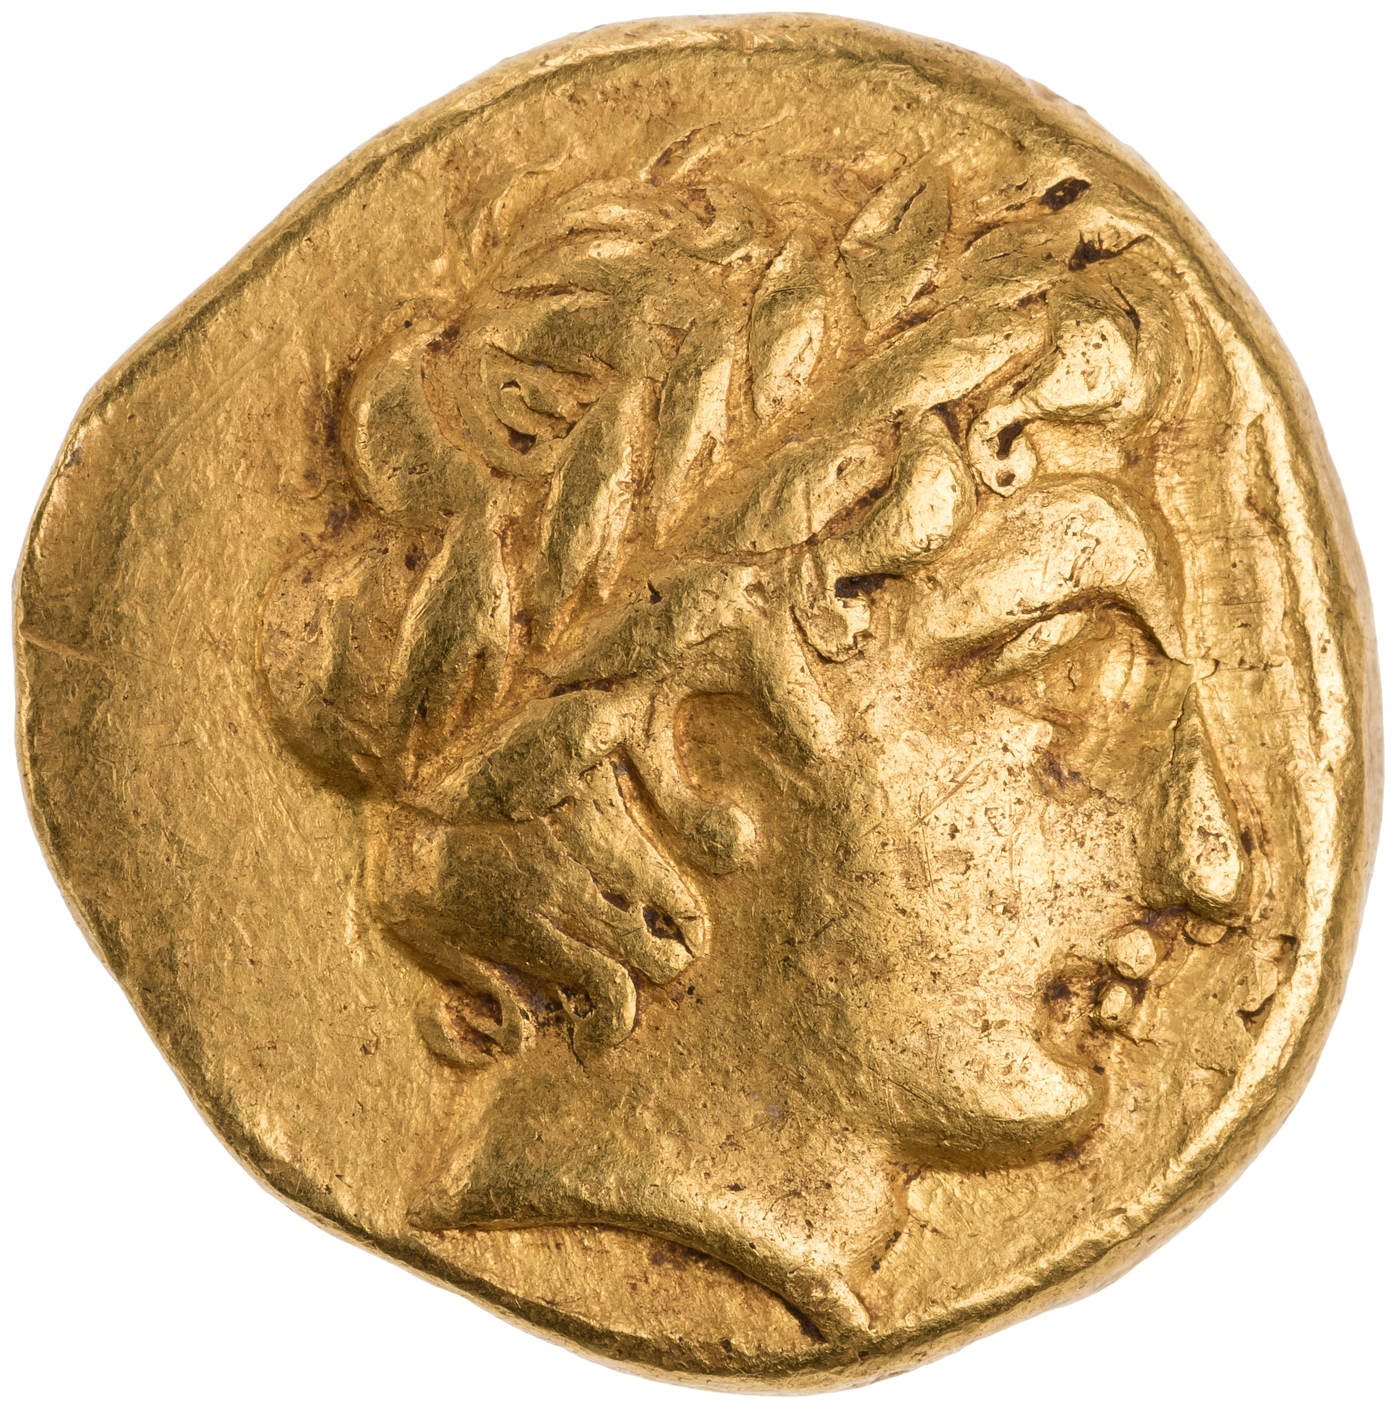
Gold Olynthian Stater, 432 BC - 348 BC
Figure 1: Obverse of a Gold Olynthian Stater, 432 BC - 348 BC, 1954.255.4, Sourced from: http://numismatics.org/collection/1954.255.4?lang=en
This Gold Stater was minted between the years 432-348 BC in the region of Macedon, with a die axis of 12 and It weighs around 8.599g (American Numismatic Society, 2015). It was discovered in Olynthus, which was the capital of the Chalcidic League, crated in 432/431 BC (Kraay, 1976). According to Kraay, for around 70 years (420-348) the Olynthian Stater was the most important coinage of the whole Macedonian area (Kraay, 1976, p138). It’s no wonder that after the siege of Olynthus in 348 BC, Philip used the Stater as a model for his own coinage (Kraay, 1976, p138). The design of Apollo was used on many coins produced by the Olynthians’ as we have lots of archaeological evidence which show Tetradrachms and Tetrobols bearing his face on the obverse, while on the reverse either the cithara or a tripod is presented (Kraay, 1976).

The imagery on this coin consists of a side profile image of Apollo on the obverse (American Numismatic Society, 2015), who is the god of the sun and music (V. Ions, 1978). Apollo was important to the Olyhnthian’s and to the Macedonian region because they were great benefactors and allies of Delph (Strabo, 1959), and when Phillip II saved Delphi from the Phocians at the end of the Third Sacred War, Macedonia were seen as Apollo’s saviour (Worthington, 2008), as Delphi was a PanHellenic sanctuary, dedicated to Apollo. The sanctuary and was of huge importance to the Greek Polis due to the presence of an oracle of Apollo residing there, meaning that the site was sacred to him (Rhodes, 2010).
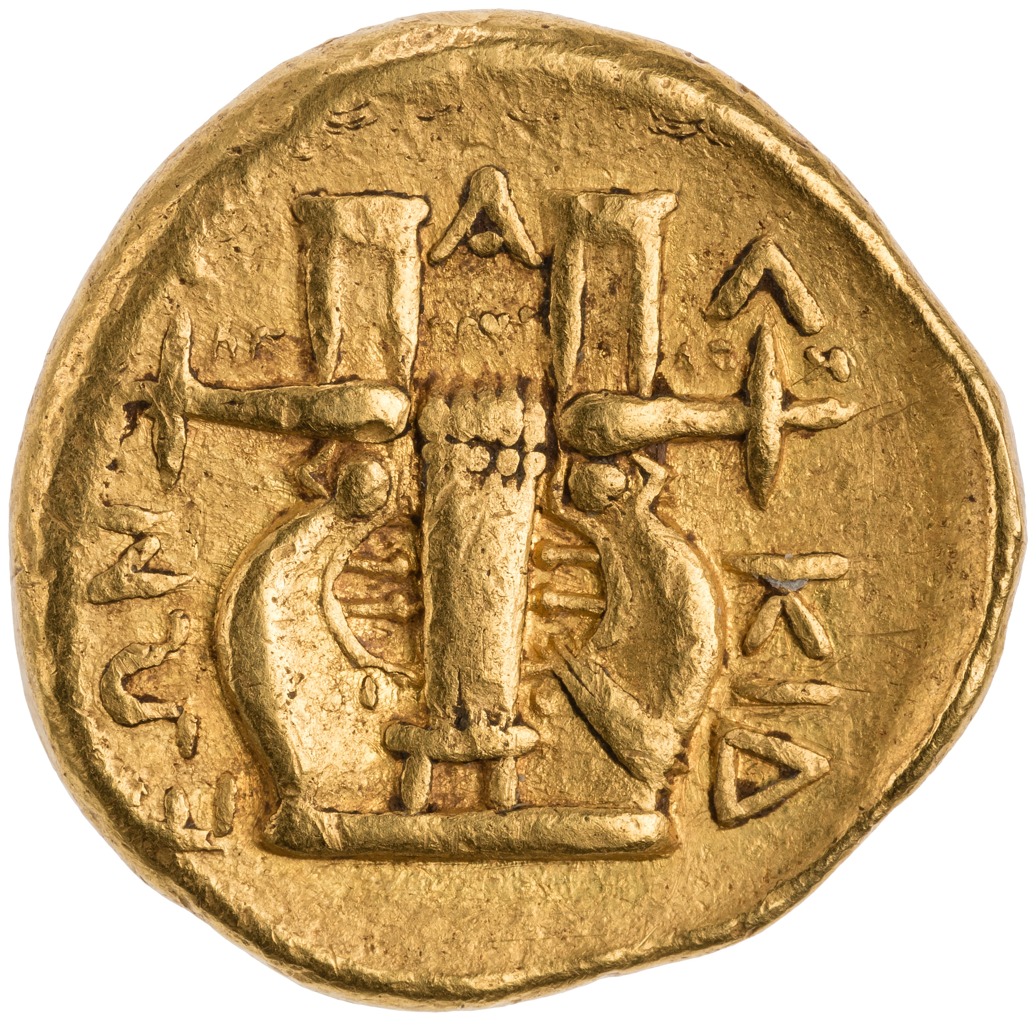
On the reverse side of the coin, the imagery is of a cithara which is associated with Apollo as he was gifted the musical instrument by Hermes (Ions, 1978). The myth goes that Hermes stole 50 of Apollo’s sacred cows and when Apollo found out, he went to Zeus to try and resolve the issue (Ions, 1978). Zeus told them to sort it out themselves and so when Hermes retuned the cows, he also have Apollo the cithara and in return Apollo gave Hermes the caduceus, a winged staff with two snakes wrapped round it (Ions, 1978).
Figure 2: Reverse of a Gold Olynthian Stater, 432 BC - 348 BC, 1954.255.4, Sourced from: http://numismatics.org/collection/1954.255.4?lang=en

References:
American Numismatic Society (2015), ‘Gold Olynthian Stater, 432 BC - 348 BC’, Available at: http://numismatics.org/collection/0000.999.9884?lang=en (First accessed 16th January 2020)

Ions V. (1978), ‘The Worlds Mythology in Colour’, London, The Hamlyn publishing Group

Kraay C.M. (1976), ‘Archaic and Classical Greek Coins’, Los Angeles, University of California Press

Rhodes P.J. (2010), ‘A history of the classical Greek world, 478-323 BC’, 2nd ed, Chichester, West Sussex, U.K. ; Malden, MA: Wiley-Blackwell

Strabo, H.L. Jones (1959), ‘The Geography of Strabo’, London, Heinemann.

Worthington. I (2008), ‘Philip II of Macedonia’, New Haven, Yale University Pres

Gold Olynthian Stater, 432 BC - 348 BC. 1954.255.4, American Numismatic Society, United States of America, http://numismatics.org/collection/0000.999.9884?lang=en
First accessed 23rd January 2020

