MODULE: BMSW 6103

MODULE NAME: LEADING AND IMPLEMENTING WORKPLACE CHANGE

STUDENT: ANDREEA MARIANA IORDACHE

STUDENT ID: 1918418

LECTURER: NAUMAN ALI

CONTENT PAGE:

Introduction: (200 words)
This portfolio discusses about the problem that the Post Office is facing now, employees going on strike, or reducing their work attributions, due to an unfair pay rise.
Definitions of power and politics will be given, as well as how they relate in an organisation and more specifically within the Post Office. Description of how the situation is affecting the organisation and how the moral issues rise from the conflict will be highlighted. A change in management theory will be used in order to give a solution to the current situation. Two theories of stakeholder analysis will be debated, and also two models of stakeholder analysis will be applied in order to identify them within the company. Limitations of the models and the relations between the two will be discussed. To solve the ongoing conflict Thomas-Kilman's Conflict resolution model will be used and applied. The limitation of the model will be highlighted. In the end, the conclusion will be drawn, and recommendations will be made in order for the Post Office to solve the issue and avoid further strikes.

Q.1

In the current dynamic business environment, the word power is very vague and provides a diversified viewpoint, raising the question, what is power? There is no one right description provided about the power or the components that make power provided yet. One of the definitions considered a practical approach with reference to power is “a relationship between individuals and is stated through straightforward symbolic notation”. A declaration of power is based on the comparability through the relative level of power held by two or more people.’’ (Dahl, 1957)
There has always been a strong connection between power and ‘’politics’’. They usually come together, in most countries in the world, for different reasons, but with the same goal of defining the decision-making and effect. Politics is not just one thing, it involves law and order, business transactions, societal ideals, and the many ways that people from various countries engage with one another. Political allegiances are reflected in contested moral principles, cultural identities that form people's conceptions of who they are, and political ideologies. (Axford et al.1997)
As mentioned above there has always been a relation between the two, power usually comes with a title, and when in politics, power comes along with the description. Realists throughout the ages have argued that power is the decisive determinant in the relations among separate political communities and of crucial importance to understanding the dynamics of war and peace. (Berenskotter & Williams, 2007)
In the study case power and politics are both present. The power comes from the fact that the 114 branches will be closed, and taking that decision was a demonstration of power, while the politics appear under the fact that not all the branches will be closed, even if all of the branches are equally affected, the ones that will not close, fear the politics more than acknowledging that they have the power of standing up for their beliefs and asking for what is rightfully theirs. Here the power and politics come into conflict because not all branches support the decision of going on strike.
The 114 branches going on strike, might feel unsupported by the rest of the branches, even if they stand up for the whole organisation. This can affect the organisation by dividing the strikers, from the ones that will only reduce their services. The ones following the power might feel more stressed about the situation, taking into consideration the fact that is a small number, compared to the ones following the politics. The difference comes from the management, and how they are dealing with the situation Royal Mail is facing at the moment. The Assistant secretary blames the management for provoking the employees with the made decisions and confirms that there is no affordability issue, but just power games. He urges the Post Office to take into consideration the inflation and reassures them that the strike will happen. (Bird, 2022)
In terms of how the situation is affecting the Post Office, the answer is it is affecting its customers firstly and directly (Daly, 2022). This means the image and income of the Post Office are going to be affected directly, by customers looking for an alternative company to work with. They will lose customers which affect the revenue. Customers will not look with the same eyes, at the company, and with all the increases and the inflation, the population understands the point that the employees have, and the decision they took.
The strike was ‘’in protest at a 3% pay offer for the 2022-23 financial year, alongside a one-off lump sum payment of £500, and no pay increase for the 2021-22 financial year.’’ (Jones, 2022) The employees felt they were not fairly paid, even if they brought revenue to the company even in uncertain and hard times, and they know for sure that the company has the money for the pay rise, but the management does not want to pay them.
This situation affects the company as a whole. The image, the workflow, and the revenue get damaged for the organisation. Customers will now know that the employees of the Post Office are not paid fairly, and will blame the company, the image will be damaged, and some customers will simply choose to work with another company that offers the same services but does not have the same internal issues. Not having as many customers means, the income will be less, this meaning the financial part will also be affected, but mostly what the main issue seems to be is the morals of the company. If they come to an understanding the rest of the branches that did not go on strike, will also benefit from the new deal.
What are morals? According to Collins Dictionary (2022), ‘’ Morals are principles and beliefs concerning right and wrong behaviour.’’ Within an organisation, morals are the principles and beliefs that everyone has. So, this situation urges the fact that the morals of the company are not right, and a change in the management is needed. To do that Kotter’s Change Management Model is used in order to change the management that is not following the values of the company. (Calegari, Sibley, Turner, 2015)

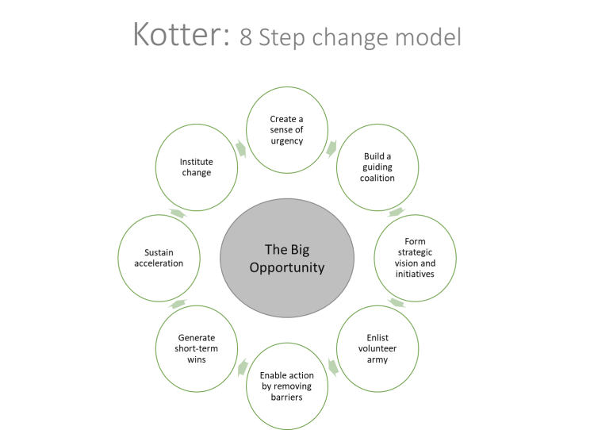
This Photo by Unknown Author is licensed under CC BY-NC
Fig. 1
Kotter’s change management theory focuses on the people directly responsible for the change. He proposed eight steps:
- Create a sense of urgency to motivate people
- Build your change team with leaders and change agents of various skills and departments
- Define your strategic vision for what you want to accomplish
- Communicate with everyone involved in the change management process to get them on board and make sure they know their role
- Identify roadblocks and address anything causing friction
- Create short-term goals to break your change management plan into achievable steps
- Keep up the momentum throughout the process of implementation
- Maintain the changes after the initial project is complete (Hicks, 2022)
For the Post Office this model will look as it follows:
- The urgency is already there the inflation, the non-existing pay rise, and the fact that the management is not respecting the morals of the company anymore
- Employ the managers that you need for the company, or rotate their roles or department, in order to always be sure, they follow your instructions
- Make sure you share your vision, and everyone accepts it
- Communicate with everyone and make sure they are ready to part of the new system
- Ensure there are no obstacles in the implementation
- Make small goals this way is easy to go back and change the process if something is not right
- Celebrate every little achievement and communicate it with everyone
- Keep the changes even after the main goal is achieved.

Q2.
To identify the stakeholders, the definitions of what is a stake and what is a stakeholder will be given. ‘’ A stake in a firm is a percentage of ownership or a position where you stand to profit if it succeeds. Owning stock in the business or making other investments with the organisations can be examples of this.’’ There are three types of stakes: equity, economic and influencer stakes. (Indeed, 2022). While a stakeholder is ‘’ anyone with an interest in a company is considered a stakeholder. Stakeholders are people, organisations, or groups who are impacted by a company's operations.’’ There are two types of stakeholders primary and secondary. (BBC, 2022)
There are two models of stakeholder management
- The neo-classical theory is all about maximising profits, this is the main purpose of the organisation, to make a profit and they are only accountable to themselves and the shareholders.

Fig. 2
- The Socio-economic theory includes the individuals or groups who are harmed or benefit from the organisation's activities. It implies that the company has obligations to the individuals or organisations as they have to the shareholders, and also the responsibility to create value, not just in terms of money. They have a responsibility for the values within the company which include responsibility for the environment, society, and the needs of the individuals and groups. (ESSEC, 2013)

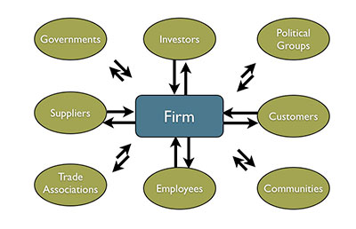
This Photo by Unknown Author is licensed under CC BY
Fig.3

For this portfolio, the chosen model is the socio-economic because it is larger, fits the stakeholders of the neo-classic, but is more developed and more elaborate. It is more specific and of wider range.
To be able to identify the critical stakeholders two models of stakeholder analysis will be discussed.

- Salience Theory, Mitchell et. al, (1997) said it is ‘’the degree to which managers give priority to competing stakeholder claims'’ and gave us the concept of it. They dived it in three big points: Power, Legitimacy and Urgency.
The power the stakeholders have, to influence the firm, the legitimacy of the stakeholders relating to the firm and the urgency the stakeholders claim on the firm.
‘’ This model takes into consideration only those who have power, urgency and legitimacy, eliminating those without any such attribute, reducing the noise in the system’’ (Kuthiala, 2014)

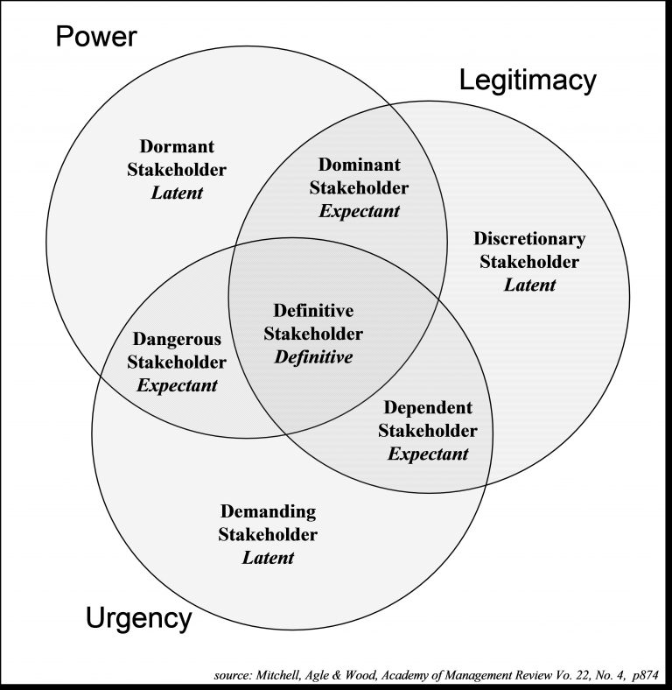
This Photo by Unknown Author is licensed under CC BY

Fig. 4

- The power interest matrix: Johnson and Scholes (1999) ‘’ create a power-interests matrix using the preceding work as a foundation. This looks at how much each stakeholder group is interested in having their expectations for project decisions reflected, as well as how much influence they have. The company can comprehend how these topics’ influence changes during the project’s implementation by situating the external stakeholders in the power-interest matrix. Studies unmistakably demonstrate how the impact of external stakeholders can change depending on the project’s stage of implementation, sometimes substantially. (Caputo, 2013) The objective here is to categorise stakeholders based on the power and the interest they have within the organisation.

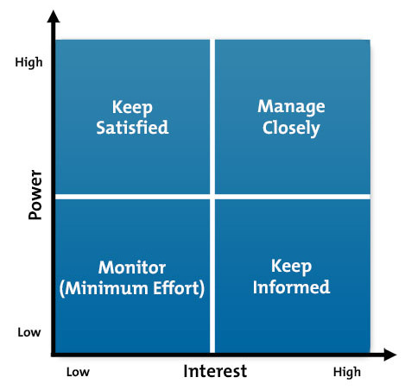
This Photo by Unknown Author is licensed under CC BY-SA-NC

Fig. 5
The stakeholders of the Post Office are:
Employees/ Directors, Shareholders, Government, Suppliers/ Creditors/ Bank, Customers, Competition and Community.

INTERNAL | EXTERNAL
- Employees/ Directors  - Shareholders | - Government  - Suppliers/ Creditors/ Bank  - Customers  - Competition  - Community
Table 1
High Power, Low Interest: Employees/ Directors and Government, these stakeholders, have high power in the company, without the employees the company cannot function, or if a big majority will leave, they can be replaced, but the cost of training new people and the time that will take will only bring losses to the company, but those apart from having high power they have low interest. The Government can make more regulations that will put in difficulty the company, as they do have the power, but there is no interest in doing it.
Low Power, Low Interest: Community, these stakeholders have low power as the company is not affected much by the community and is not affecting it much either, if a branch opens in a new area, community, it will bring more jobs, and attract possible developers with it. The interest is also low with these stakeholders, as they do not have a big impact on the organisation.
Low Power, High Interest: Shareholders, Customers and Competitors, those stakeholders have low power in the company, the shareholders, could be influential, but they still will not want to affect the company they have a stake in, but their interest is high, the customers have a low power on the company, because there is always someone that can replace a lost customer, a new customer, and the competition has a high interest in the company but it cannot affect it very much.
High Power, High Interest: Suppliers/ Creditors/ Bank, these stakeholders have high power as the company is directly dependent on them, and also, they have high interest, it is in their interest that the company is doing well, so they will get their business going on.

High Power, Low Interest | Low Power, Low Interest | Low Power, High Interest | High Power, High Interest
- employees/ directors  - government | - community | - shareholders  - customers  -competitors | - suppliers/ creditors/ bank
Table 2

Even if the Salience model has three different areas of action, and includes more stakeholders, the Power Interest matrix is more objective and more assertive. The position of the stakeholders from the matrix will have a different position in the Salience model, as there are different areas of definition. Even if the models look very different, there will still be the same stakeholders for both. They will have maybe a different level, of definition, but will still be the same. With the Salience model, the view of stakeholders is very broad. The model contends that these additional external (to the organisation) groups' capacity to influence the organisation is growing. Relationships with these organisations are crucial, which reinforces the necessity for a new stakeholder-based strategy for strategic management. (Sheehan & Ritchie, 2005). Attempts to develop it further have been relatively limited, that urgency is irrelevant for identifying stakeholders; that stakeholder salience is primarily determined by the moral validity of the claim made by the stakeholder; Lastly, different degrees of the traits will affect how important stakeholders are. (Neville et. al, 2011). While power interest matrix analysis seeks to assess and comprehend stakeholders from the viewpoint of an organisation or to ascertain their applicability to a project or policy. The position, interest, influence, interrelations, networks, and other features of stakeholders are investigated during the analysis. (Brugha & Varvasovszky, 2000). While Salience bases its view on stakeholders from an outside point of view, the Power matrix assesses the stakeholders from an inside point of view. The relation between them is the fact that even with different points of assessing the stakeholders, the results will be the same.
The chosen model for the portfolio is Power Interest Matrix, but it does not mean it is the best one in order to define and allocate the stakeholders of the Post Office. By doing a critical evaluation of important current theories on corporate governance, it exposes the weakness of traditional methods used in corporate governance theory. It turns out that the model is outdated and the traditional ideas, presuppositions, and beliefs that underlie their perspectives, are less trustworthy and valid in light of how corporate governance is always evolving. (Letza, et, al., 2004). Also, results cannot be generalised since the sample size is typically too small to permit statistical examination of viewpoint differences. If you wish to involve many stakeholders, it will take time. When stakeholders are geographically scattered, it is challenging. the inability of stakeholders to come to a consensus. (O’Haire, et al., 2011)

Q3
To be able to give a solution to the Post Office situation, Thomas Kilman’s Conflict resolution model will be described and then applied to the case. The Thomas-Kilmann Conflict Model Instrument (TKI) assesses an individual’s behaviour in conflict situations—that is, situations in which the concerns of two people appear to be incompatible. In conflict situations, we can describe a person’s behaviour along two basic dimensions*: (1) assertiveness, the extent to which the individual attempts to satisfy his or her own concerns, and (2) cooperativeness, the extent to which the individual attempts to satisfy the other person’s concerns. These two dimensions of behaviour can be used to define five methods of dealing with conflict. (Thomas, 2008)

Fig. 6
Competing: is a power-oriented, forceful, and uncooperative mode. When competing, a person puts their own interests ahead of the other person's and will use all means necessary to advance their position. Competing could mean protecting your rights, sticking up for a cause you believe in, or just going for the win.
Collaborating: is cooperative and forceful. When collaborating, a person makes an effort to work with the other person to come up with a solution that fully addresses both of their issues. Finding a solution that addresses both sets of concerns requires examining an issue in detail to determine the underlying issues of the two parties. Collaboration between two people can take the form of addressing a circumstance that would otherwise result in them competing for resources, investigating a disagreement to learn from each other's perspectives, or coming up with a novel solution to an interpersonal issue.
Compromising: is a middle-level cooperative and forceful. Finding a quick, amicable solution that somewhat satisfies both parties is the goal while compromising. Between competing and accommodating, compromising involves giving up more than competing but less than accommodating. Similar to avoiding, it deals with a problem more directly but less thoroughly than collaborating. If you want to compromise, you might split the difference, make compromises in exchange, or look for a quick middle ground.
Avoiding: is uncooperative and unassailable. When someone avoids, they don't quickly address their own or the other person's problems. The disagreement is not mentioned by either part. Avoiding can take the form of politely avoiding a situation, delaying a situation until a better opportunity, or simply removing oneself from a dangerous circumstance.
Accommodating: is friendly, and cooperative. There is a certain amount of self-sacrifice involved when someone is accommodating; they put other people's needs ahead of their own. It is possible to be accommodating by being benevolent or charitable, following someone else's instructions when you would prefer not to, or submitting to their point of view.
The conflict resolution strategies intention to give solutions; they have nothing to do with competence or demonstrated behaviour. Natural or normal conflict dealing method is assessed using the TKI questionnaire that goes along with the Thomas Kilmann model. It may be argued that when we are confronting a coachee, we are in a conflict situation and may therefore also adopt a natural approach. The distinction in coaching is that the coach has very few "concerns." Along with those of the sponsoring organisation and other stakeholders, there are the demands and worries of the coachee. It is possible to disagree with the coachee's concerns if, as a coach, we represent the sponsoring company's interests and the absent stakeholders. (Day, 2012).
Competing will not resolve the problems within the Post Office, it will intensify the issues more, and in the end, someone will lose, either the company either the stakeholders or just the employees.
Avoiding the situation, will just deepen the conflict and then the problems will become larger and wider, so this is not a good solution either.
Accommodating means someone will have to sacrifice and is not a long-term solution for such a big company.
Compromising means both parts will have to lose something, and this may mean that the problem will soon be back with bigger issues to be solved.
Collaborating even if there is an extra effort in the process, is sustainable and long-term. Both sides, management and employees have to collaborate in order to reach a mutual goal.
Even if collaborating seems like the right thing do to, from the article we can understand that the problem is beyond this point, and there was no intention of doing so.
Conflict resolution may not always be the desired one. What happens when two parties discuss their conflict resolution strategies together? Conflict parties frequently perceive their interests as being diametrically opposed. Win-lose scenarios or a compromise are thought to be the two possible outcomes. However, the outcome of violent disputes is much more frequently both lose. Conflicting parties may impose such high costs on one another if neither is able to force a resolution or is willing to compromise that all parties are left worse off than they would have been had another tactic been used. This is discovered to be a lot more frequent consequence in conflict resolution studies than is typically believed. There is a significant motivation based on self-interest for working towards alternate outcomes, such as a compromise or a win-win situation, which will be the optimal one, when this becomes apparent to the participants, which is typically very late. The range of possible outcomes may be greater than disputants believe. (Ramsbothan, 2011)
Proper use of the model will be combining more of the steps. Accommodating, Compromising and Collaborating, are all needed for the solution to be long-term and for a prosperous future for the organisation. Both parties need to start with a lose-lose situation, get to the win-lose situation, to then arrive at the desirable win-win situation.
Conclusions
In conclusion, we can say that the management is wrong and is using the power and politics in the wrong way within the company. The affected part is not just the employees but also the stakeholders. The company will suffer losses if the situation is not solved, and the participant parts do not meet at a common point. Changing the management is possible but will take time and is not in everyone's interest. Stakeholders have different rankings, but they will all be affected if the situation continues to be the same, meaning the company will have great losses. To solve the conflict, a conflict resolution model has been given with important phases to follow in order to resolve the problem. It seems like the company has lost core values, and it does not think about its employees anymore. This situation forced the employees to go on strike and create awareness about the company, creating a bad reputation for such an old and respected organisation that used to be very trustworthy.
Recommendations
Even if is not what everyone wants, in my opinion, a change in management is needed and is needed now. Once the values are lost within a firm, it cannot function anymore, so it needs a new way of thinking and structure implementation. Apart from using the above-mentioned collaboration phase from the conflict resolution model, I will suggest they come to an agreement with the employees so no further strikes, to affect the image and direct the revenue of the organisation. The management should give the employees what they are asking for so far, a decent pay rise. As mentioned above, the issue is not the money, but the power games that the management is playing. The scope of the said power games is not known yet, but it made them lose credibility not just with the employees but with stakeholders too.

REFERENCES

- Axford, B. et al. (1997) Politics: An Introduction. 1st edn. London. Available at: https://www.taylorfrancis.com/books/mono/10.4324/9780203978252/politics-introduction-barrie-axford-victoria-browne-richard-huggins-rico-isaacs (Accessed on: 08/07/2022)
- BBC, (2022) Stakeholders. Available at: https://www.bbc.co.uk/bitesize/guides/z4gcd2p/revision/1 (Accessed on: 10/08/2022)
- Berenskotter, F. and Williams, M.J. (2007) Power in World Politics. 1st edn. London. Available at: https://www.taylorfrancis.com/books/edit/10.4324/9780203944691/power-world-politics-felix-berenskoetter-williams (Accessed on: 08/07/2022)
- Bird, J., (2022) Post Office staff strike over pay freezes as living costs rise. Available at: https://employeebenefits.co.uk/post-office-strike-pay-freezes-living-costs-rise/ (Accessed on: 10/08/2022)
- Brugha, R., & Varvasovszky, Z., (2000) Stakeholder analysis: a review. Health policy and planning, 15(3) pp. 239-246
- Calegari, M. F., Sibley, R. E., Turner, M. E., (2015) A roadmap for using Kotter’s Organisational Change Model to build faculty engagement in accreditation. Academy of Educational Leadership Journal, 19(3), pp. 31-43.
- Collins Dictionary, (2022) Definition of 'moral'. Available at: https://www.collinsdictionary.com/dictionary/english/moral (Accessed on: 10/08/2022)
- Caputo, A. (2013). Systemic Stakeholders’ Management for Real Estate Development Projects. Global Business and Management Research: An International Journal. pp 66-82.
- Dahl, R.A. (1957) The concept of power. Available at: https://onlinelibrary.wiley.com/doi/10.1002/bs.3830020303 (Accessed on: 08/07/2022)
- Daly, P., (2022) How long will Post Office strikes last and what date is my post affected? Mirror Available at: https://www.mirror.co.uk/news/uk-news/how-long-post-office-strikes-27462541 (Accessed on: 10/08/2022)
- Day, I., (2012) Conflict and challenge (The Thomas-Kilmann Model). New and Muse. Available at: https://challengingcoaching.co.uk/conflict-and-challenge/ (Accessed on: 10/08/2022)
- ESSEC, (2013) What is the stakeholder theory? by R. Edward Freeman | ESSEC Classes. Available at: https://www.youtube.com/watch?v=epxmG3YRgok (Accessed on: 10/08/2022)
- Fig.1 Available at: https://ccigsolutionsblog.files.wordpress.com/2019/06/kotter-8-steps-2.png?w=750 (Accessed on 10/08/2022)
- Fig.3 Available at: https://i1.wp.com/www.the-vital-edge.com/wp-content/uploads/2013/05/Stakeholder.011.jpg (Accessed on: 10/08/2022)
- Fig. 4 Available at: https://sarm.org.uk/wp-content/uploads/2018/08/SARM-Stakeholder-Model-768x788.jpg (Accessed on 10/08/2022)
- Fig. 5 Available at: https://hrtitansoft.files.wordpress.com/2016/05/power-interest-matrix.jpg?w=469 (Accessed on: 10/08/2022)
- Fig. 6 Available at: https://www.researchgate.net/figure/Modes-of-conflict-management-Thomas-Kilmann-1976_fig1_273133939 (Accessed on: 10/08/2022)
- Hicks, K., (2022) Top 8 change management models: A comparison guide Available at: https://www.zendesk.co.uk/blog/change-management-models/ (Accessed on: 10/08/2022)
- Indeed, (2022) What Is a Stake in Business? Definition and Who Uses Them. Available at: https://www.indeed.com/career-advice/career-development/what-is-stake-in-business (Accessed on: 10/08/2022)
- Jones, A., (2022) Post Office workers hold 24-hour strike in dispute over pay Available at: https://www.independent.co.uk/news/uk/post-office-strike-pay-dispute-b2122833.html (Accessed on 10/08/2022)
- Kuthiala, P., (2014) Stakeholder Analysis: Salience Model. Available at: https://www.linkedin.com/pulse/20140927071637-3351237-stakeholder-analysis-salience-model (Accessed on: 11/08/2022)
- Letza, S., Sun, X., & Kirkbride, J., (2004) Shareholding versus stakeholding: A critical review of corporate governance. Corporate Governance: An International Review. 12(3) pp. 242-262
- Mitchell, R.K., Agle, B.R, and Wood, D.J., (1997) Toward a Theory of Stakeholder Identification and Salience: Defining the Principles of Who and What Really Counts. Academy of Management Review, pp. 853-886
- Neville, B. A., Bell, S.J., & Whitwell, G.J., (2011) Stakeholder salience revisited: Refining, redefining, and refueling an underdevelopment conceptual tool. Journal of business ethics. 102(3) pp. 357-378
- O’Haire, C., et al., (2011) Engaging Stakeholders To Identify and Prioritize Future Research Needs Available at: https://www.ncbi.nlm.nih.gov/books/NBK62575/ (Accessed on: 11/08/2022)
- Ramsbotham, O., Miall, H., & Woodhouse, T., (2011) Contemporary conflict resolution. Polity
- Sheehan, L. R., & Ritchie, B., J.R. (2005) Destination Stakeholders Exploring Identity and Salience. Annals of Tourism Research, 32(3) pp. 711-734
- Thomas, K. W., (2008) Thomas-Kilmann conflict mode. TKI Profile and Interpretive Report 1(11)

