PCET
ECPT6006
Rebecca Sparkes

Digital innovation and professional practice
A critical evaluation of the role of digital innovation in professional practice

Table of Contents

A critical evaluation of the role of digital innovation in professional practice 2
Review of the literature 2
- Introduction 2
- Formative assessment 3
- Feedback 3
- Digital innovation 4
- Conclusion 7
Selection and Justification of appropriate teaching tool 8
Application of the chosen learning tool 11
Evaluation and Reflection 18
Reference List 22

A critical evaluation of the role of digital innovation in professional practice

Digital technology is made up of digital resources, systems and devices that help to improve the experience of the consumer (Bodgers et al, 2021). Through innovation, which can be defined as the process of a product or service that is constantly being developed to enhance its quality, experience and opportunities, the world has more access to digital technologies than ever before (Bodgers et al, 2021). Technology within education has rapidly become fundamental to the way that teachers teach, and the way learners learn (Okoye et al, 2023: Bodgers et al, 2021). Specifically in higher education, pedagogy is now more accessible, encouraging and provides equal opportunities for individuals to learn (Okoye et al, 2023).
This paper sets out to review the literature on formative assessment, feedback, and the role of digital innovation in these teaching strategies. This paper will then explain the selection and justification of the chosen digital tool Padlet, that will be integrated into a lesson within higher education: this section will discuss the theory that supports the choice of using the digital tool and offer a justification for integrating it into the lesson to enhance the pedagogy. The paper will then evidence the implementation of the Padlet tool, with the paper concluding with an evaluation and reflection on the experience of using the chosen digital learning tool.

Review of the literature

Introduction
This section will offer a review of the literature for formative assessment and feedback in higher education, and it will evaluate the role that digital technologies play in pedagogy. It will look at digital technologies in education on a global level, and at a national level, with particular focus on Welsh legislation that underpins the implementation of digital technologies. The review of literature will identify challenges that professionals could encounter when integrating digital technologies into formative assessment and feedback. This section will conclude with a summary of the findings from the reviewed literature.

Formative assessment
Literature offers many definitions for formative assessment (FA), with Shepard, Penuel and Pellegrino (2018) stating that FA is based around the student, with a main feature being the identification of the needs of the student. Offering a similar view, Awajan (2023) suggests that FA has benefits for both students and educators, it provides educators with opportunities to identify the students strengths and weaknesses, and can allow for them to give personalised feedback, frequently. However, Schildkamp et al, (2020) imply that FA may not be fully understood by educators which can lead to FA being ineffective. It is suggested that FA is not just effective practice to use at the end of a lesson, but if implemented and used correctly, it can be continual throughout a lesson to gather research of learning and guide and support learning throughout (Schildkamp et al, 2020).
Globally, teachers demonstrate effective practice by formatively assessing students’ learning through various techniques that include discussion, introduction activities and quizzes (Elmahdi, Al-Hattami and Fawzi, 2018: Kaya-Capocci, O’Leary and Costello, 2022). Based on the ideas of Elmahdi, Al-Hattami and Fawzi (2018) evaluation of teaching strategies for FA by the educators themselves provide them with the opportunity to adapt strategies depending on the student’s needs, which demonstrates effective practice in teaching.
Championing Awajan (2023) ideas, Elmahadi, Al-Hattami and Fawzi (2018) believe that whilst FA is a core part of learning within the classroom, it can provide both teacher and learner guidance on moving forward in the lesson or module so that the learning outcomes can be met, and feedback can be formulated. It is suggested from the literature that FA and feedback go hand in hand (Elmahadi, Al-Hattami and Fawz, 2018: Awajan, 2023: Shepard, Penuel and Pellegrino, 2018: Jurane-Bremane, 2023).

Feedback
Whilst FA is used to ascertain the learning progress of the students and identify their strengthens and weakness’s, it is effective practice to support this with feedback (Elmahadi, Al-Hattami and Fawz, 2018: Awajan, 2023: Shepard, Penuel and Pellegrino, 2018: Jurane-Bremane, 2023: Kaya-Capocci, O’Leary and Costello, 2022). Feedback provides students with guidance and support in their learning and feed-forward can allow for improvements for future learning (Race, 2014: Race and Pickford, 2007). Feedback also assists educators to reflect on their own teaching and to determine what adaptations, if any, need to be made to their strategies (Rac, 2014: Race and Pickford, 2007: Jurane-Bremane). By way of explanation, “Formative assessment informs instruction” (Elmahadi, Al-Hattami and Fawz, 2018, p.183).
As digital technology is integrated within daily lives for various purposes, it can be argued that students have an expectation that technology is integrated within their learning in higher education, providing them with a more immersive and personal learning experience (Lewohl, 2023). Race and Pickford (2007) champion the use of technology, such as sending emails, when it comes to providing students with feedback. It is suggested that it is more personalised and allows for the student to reflect on the feedback in their own time, without the potential pressure of the teacher delivering feedback face-to-face (Race and Pickford, 2007).

Digital innovation

The advancement in technology and the educational and employment landscape are some of the main drivers behind technology in education. OECD (2019, p.6) asks “How can we prepare students for jobs that have not yet been created, to tackle societal challenges that we cannot yet imagine, and to use technologies that have not yet been invented?”. Echoing the OECD’s 21st Century Skills (OECD, 2019) there is a crucial need for students to develop and strengthen a skill set that will allow for them to be creative and critical thinkers and allow them to adapt to a contemporary digital world, with efficacy. Awajan (2023) puts forward that education has been significantly impacted by the technological revolution, which is providing vast amounts of opportunities for improvements within the sector. With Jurane-Bremane (2023) adding that the innovation of the digital world has seen many opportunities to embed technologies in teaching and learning, particularly in assessment.
The Welsh Government (2019) set out that “Digital technology will change the roles of learning professionals, and require them to develop new skills, and will also (when used effectively) enable new approaches and enhance the learning experience” (p.6). Amongst the many objectives set out by the Welsh Government (2019) is that all learning providers must ensure that consideration is taken to integrate appropriate digital tools and resources that aid assessment. However, research carried out by Mercader and Gairin (2020) suggests that barriers to teaching and learning, using digital technologies, include the lack of digital skills that educators have that can result in the resistance of implementing digital technologies within a lesson and to FA. Whilst theory informs policy, and policy informs practice, the practice must be carried out effectively and collaboratively, allowing professionals to share knowledge and practice within the institution to further aid development and innovation in education (Pellegrini and Vivanet, 2020: Vaataja and Ruokamo, 2021). Mercader and Gairin (2020) study summarises that the professional development of academic staffs’ digital skills needs to be strengthened through continuing training; it is suggested that the discipline must be considered when integrating digital tools, meaning that certain subject areas are more susceptible to using digital tools than others.
In order for higher education institutions to incorporate digital innovation, a framework for digital transformation has been developed (Jisc, 2023). The framework (Jisc, 2023) suggests that re-evaluation of long-established assessment and feedback design should acknowledge the efficacy of digital technologies, whilst providing both staff and students with adequate digital skills. Using digital technologies within education for FA and feedback is a way of developing and strengthening students’ digital competencies (Robertson, Humphrey, and Steele, 2019); through experimenting with new digital resources and tools, collaborating digitally, using technologies to become more time efficient, and enhancing data literacy (Jisc, 2023: Kaya-Capocci, O’Leary and Costello, 2022).
Digital FA can take the form of Kahoot quizzes, collaborative tools such as Canva mind maps, Microsoft Whiteboard and Google Classrooms. These digital tools can be used in face-to-face teaching and through virtual learning environments (VLE) such as Microsoft Teams. Elmahadi, Al-Hattami and Fawz (2018) identify significant advantages to using digital tools for FA within the classroom, implying that it offers support to individual learners, and it creates an interactive learning environment amongst the students and teacher (Kaya-Capocci, O’Leary and Costello, 2022).
One of the benefits is suggested to be that digital tools can be used to gather research for learning and provide real time feedback, making FA and feedback more time efficient (Jamieson and Musumeci, 2017: Beatty and Gerace, 2009: Kaya-Capocci, O’Leary and Costello, 2022). Robertson, Humphrey and Steele (2019) champion the use of digital technology for storing the results and feedback of formative assessment, this allows for both educator and students to be able to revisit work and evaluate the progress of learning. Contrary to this, if feedback is given in a digital form, as opposed to in person, the learner may not be able to access the feedback, or they may miss or not receive a notification informing them that they have feedback. Another issue that could arise from digital feedback is the absence of body language and ques, this could lead to confusion and upset if feedback is interpreted differently to what its intended.
Elmahadi, Al-Hattami and Fawz (2018) found that students welcomed digital technology in lessons as a form of FA, finding it engaging and fun; adding that using digital tools can provide equal opportunities for participation within the classroom. It is put forward that higher levels of student engagement can be linked to higher attainment outcomes, meaning that empowering learners could have a positive impact on them to want to learn and achieve (Bond et al, 2020). Race (2014) argues that there is a ripple effect can describe the factors of learning, stating that before learning can happen there must be a want or a need to learn. From this it could be suggested that digital technologies can encourage the want to learn as they can be more accessible and time efficient for students learning (Kaya-Capocci, O’Leary and Costello, 2022).
The use of appropriate digital technologies and the promotion of engagement in learning align with Professional Standards for higher education, demonstrating effective teaching practice (Advance HE, 2023). Whilst this study (Elmahadi, Al-Hattami and Fawz, 2018) was carried out in Bahrain, the use of digital tools for FA and feedback can be applied in global context to education. In Wales, incorporating digital tools and technologies for teaching and learning is underpinned by the Wellbeing of Future Generations (Wales) Act 2015. By providing equal opportunities to all students using digital tools for education, is a way of creating a more equal Wales, ultimately, providing knowledge and skills for future employment in a digitally evolving Wales (Future Generations Commissioner for Wales, 2023).

Conclusion

The literature suggests that FA has positive impacts for both teacher and learner and can be enhanced by the implementation of digital technologies. However, it is pointed out that teachers must fully understand the role of FA in order to effectively implement it into their teaching, that will provide learners with an immersive and engaging environment where they can develop their learning. Feedback is found to be linked directly to FA, and using digital technologies, students can get immediate and real-time feedback that can further instruct their learning process. Higher education students need to be equipped with skills that can adapt to the innovation of technology, set out in the digital transformation framework. Findings suggest that with digital technologies changing education and providing significant opportunities for teaching and learning, educators must develop and strengthen their digital skills through continual development, to ensure that they can facilitate learning as effectively as possible.

Selection and Justification of appropriate teaching tool
To embed technology into the classroom there are several common frameworks that can be used by educators to understand why and how they can use technology in their teaching (Blundell, Mukherjee and Nykvist, 2022). It is important for educators to not devaluate the pedagogy by using technology, but rather to enhance or positively transform the pedagogy (Morais Bicalho et al, 2023). Common frameworks include RAT, SAMR, TPACK and TIM (Crompton and Sykora, 2021). For a lesson using digital technology, I selected to use the SAMR framework to assess why and how tech could enhance or transform the teaching and learning (Blundell, Mukherjee and Nykvist, 2022). Dr R. Puentedura developed the SAMR framework (Crompton and Sykora, 2021) and divided it into four sections: Substitution, Augmentation, Modification and Redefinition (Jisc, 2022: Morais Bicalho et al, 2023: Crompton and Sykora, 2021). The sections substitution and augmentation are where digital technology enhances the teaching and learning, and the modification and redefinition is where the teaching and learning is transformed by the use of digital technologies (Jisc, 2022: Morais Bicalho et al, 2023). The lesson I was delivering was via Microsoft Teams as part of the blended programme and was to be a workshop on lesson planning.
As the lesson was a cognitive style, learners are required to use existing knowledge to make decisions, use strategic thinking, design thinking, and problem solving (Lwande, Muchemi and Oboko, 2021), so that they can collaboratively create a lesson plan for a predetermined aim. I want to have the opportunity to formatively assess students understanding and learning throughout the workshop and also at the end. I want to make the workshop engaging, collaborative, accessible and where results could be immediate, and feel that the use of a digital tool would enhance and transform the workshop.
I have decided to use Padlet, a free digital platform that fits the criteria of what I require for the workshop and as a substitution with functional improvement (Morais Bicalho et al, 2023). A useful element of Padlet is that it allows for continual real-time FA (Gill-Simmen, 2021). As a trainee teacher, it will give me the opportunity to immediately see the contributions from the students and gain an understanding of the learning that is taking place (Morais Bicalho et al, 2023). This is the augmentation stage of the SAMR framework, that will enhance the teaching and learning (Blundell, Mukherjee and Nykvist, 2022). Other uses for Padlet are classroom diaries, brainstorming and to share resources that include hyperlinks, videos, and images (Deni and Zainal, 2018). The platform also provides the opportunity for students and teachers to participate in a collaborative piece of work, from different devices.
By using Padlet, it will give me the opportunity to scaffold the learning (Richardson et al, 2022: Shvarts and Bakker, 2019) by structuring the task of writing a lesson plan, into smaller sections for the learners and support them through each part (van de Pol, et al, 2015); and provide feed-forward to them which will aid their summative assessment (Mansfield, 2020). The workshop will be supported by the scaffolding learning theory (Shvarts and Bakker, 2019) as students will be given some information, instructions and then left to put their knowledge into practice by completing each part of a lesson plan. Richardson et al, (2022) suggest that to engage students and to meet the learning outcomes, scaffolding is crucial when delivering lessons in a virtual learning environment, adding that it can also be a way of enhancing students’ confidence.
To transform the lesson, the modification stage of the SAMR framework is where the use of the digital tool Padlet will provide a significant task redesign (Blundell, Mukherjee and Nykvist, 2022: Morais Bicalho et al, 2023). Padlet provides the opportunities for the activity to be collaborative and engaging and allows for results to be immediate so all learners and I can see.
Through redefinition (Blundell, Mukherjee and Nykvist, 2022: Morais Bicalho et al, 2023), the digital tool will allow for the creation of a lesson plan that all students can collaborate on, providing immediate results which will allow for them and myself to see their progress (Gill-Simmen, 2021). The digital tool has a feature that allows for the Padlet to be saved, and by doing this I will be able to save and upload the work that the students create, to the Teams channel that they all have access to. This will then allow them access to the Padlet, at any time, if they want to revisit and reflect on the work that they and the other students would have created.
If a digital tool is not integrated for this activity, then I believe that the teaching and learning would be devalued (Crompton and Sykora, 2021). If students complete the task as a group, in their breakout rooms, this will still allow them to discuss the work, but it will not provide them with the opportunity to all input into one piece of work which they could all see in real-time. Therefor, the use of the digital tool in this lesson will transform the activity and enhance the pedagogy, allowing students to work together and learn from one another.

Application of the chosen learning tool
This is the lesson plan that incorporates the digital tool Padlet for the workshop activity.


Lesson Plan

Topic: Curriculum and Assessment Studies |  | Class: Level 6
Date: 15/11/2023 | Length of lesson: 3 hours - Teams |  | Number of students: 14
Resources required:
- Digital device with access to the internet
- Microsoft Teams
- PowerPoint
- Padlet

Aim of Lesson
- The learner will create a lesson plan for a pre-empted aim.

Learning Outcomes – The Learners Should Be Able To:
- Apply their existing knowledge of the curriculum and assessment to plan a lesson.
- Contribute to a collaborative digital resource to produce a detailed lesson plan for a two-hour lesson.
- Present their lesson plan to their peers with justification of its effectiveness.

Previous student knowledge required for the session:
- Lesson planning
- Curriculum and assessment

Anticipated difficulties (if applicable):
- Technical issues
- Internet connection issues

ALN:
- One student with ASD – no significant triggers

Professional Standards (where are these being met within the session)
- Putting students in small breakout rooms can promote engagement in learning and equity of opportunity for all to reach their potential
- Using Padlet for students to present their work is an appropriate way of using digital technologies and resources for learning
- This prepared lesson plan that includes activities aligns with the design and plan learning activities standard
- After each stage of the task is completed by students, they have the opportunity to feedback which allows them to be assessed on their learning process and gain feedback for themselves at each stage.
- Throughout the lesson the students will be supported and guided through each stage of writing a lesson plan
- I have familiarized myself with the digital tool Padlet so that I can use this within the lesson and assist students with its use, enhancing my practice through continuing professional development

Lesson Detail:

Stage | Focus | Strategy | Time
Introduction  Development  Plenary/conclusion | Recap learning from previous session  Create learning outcomes for a pre-empted aim using Bloom’s Taxonomy  Feedback  Create introduction of lesson plan  Feedback  Create main activities of lesson plan  Break  Feedback  Create the plenary to the lesson plan  Feedback  Gain an understanding of the learning that has taken place | Q & A  Ask students if they have any questions  Explain the task  Padlet/breakout rooms  Groups: 4 x 3/ 1 x 2  Give students the aim for their lessons.  Back in main room, ask each group to give brief feedback on writing their learning outcomes  Back in breakout rooms, learners to create the introduction part of their lesson plan in their groups using Padlet  Back in main room, ask each group for brief feedback on writing their introduction  Back in breakout rooms, learners to create the development stage of their lesson plan using Padlet, incorporating the following:  - Use of digital technology  - Group work  - Formative assessment  Inform them of 20-minute break at 10:50 (back for 11:10) to feedback  Welcome back from break  Feedback for their lesson plan activities in the main room  Back into breakout rooms with Padlet  Plenary criteria to include:  - Formative assessment  In main room, each group to present and justify their whole lesson plan to peers. Share Padlet screen to main room  Q&A:  - How did they find it?  - How easy was it to include cross-curricular activities?  - What could they now do with this lesson plan? (tweak it for their assignment)  - Ask students if they have any questions | 9:30  9:40  9:55  10:05  10:15  10:20  10:50  11:10  11:25  11:45  12:15

Assessment Strategies: when and how are they included within the lesson?
- Recap of previous learning in introduction
- Feedback after each stage of the lesson plan to gain an understanding of the learning, during the development stage of lesson
- Students present their whole lesson plan at the end of the lesson to demonstrate the learning that has taken place

Informal reflection (to be completed after the session)

- Overall, the lesson went well, and the lesson plan was effective for both timing and activities.
- There were no significant issues with technology, apart from one student being unable to see the PowerPoint slide that displayed the Padlet link. I resolved this by putting the link directly into the chat, allowing him to access the collaborative resource.
- Although no students used the camera feature during the lesson, I could measure the engagement levels by the work that they were producing in live time by the Padlet tool.
- I felt quite confident and calm during the session and really enjoyed delivering the workshop I had created for the students.
- I felt confident in answering students' questions and when I asked questions, I allowed time for students to process and formulate their responses. If no one answered I reframed the question, in future I would also use the direct questioning technique that would encourage engagement of students who may not have been engaged in the question and answers.
- Regarding technology, I am confident in using Teams for delivering a lesson and I would use Padlet as a tool again. However, I would also like to try out different digital tools in my future practice to see how they would enhance teaching and learning.
- The formative assessment worked well at the end of the session, with each group talking through their collaborative lesson plans that they had constructed throughout the lesson. This allowed me to gain an understanding of their learning and for the students to see that they had achieved the learning outcomes of the lesson.

Image A is a screenshot of the final collaborative Padlet created by Level 6 students for the lesson planning workshop. The following link will take the reader directly to the Padlet to view in an enhanced format.
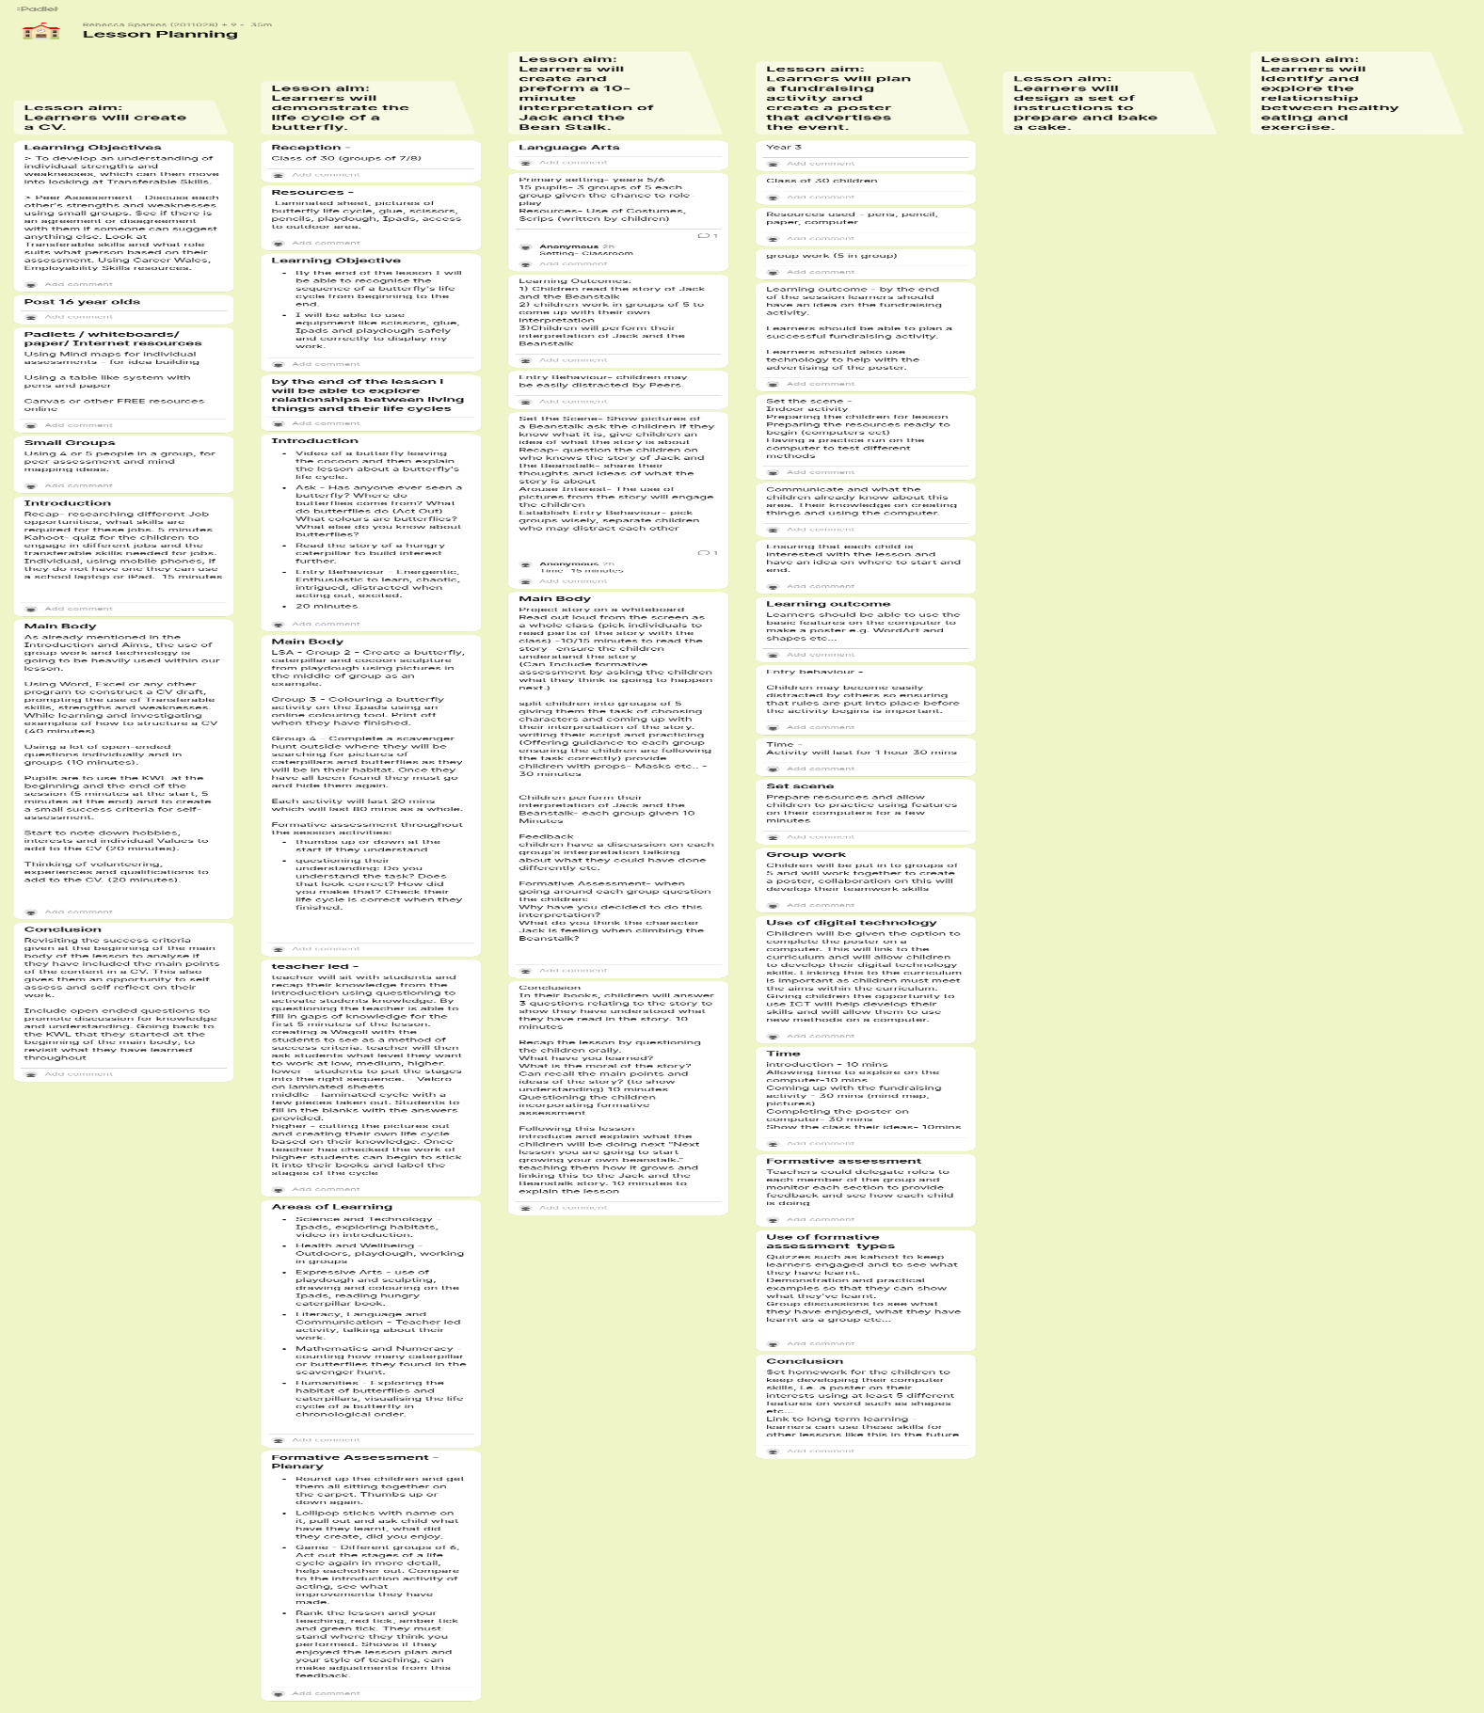
https://padlet.com/2011028_/lesson-planning-17m1j6u2gbppcd4f
Image A.
Image B is a screenshot of the PowerPoint slide used within the workshop presentation, that contains the Padlet link and QR code for students to access.
Image B.
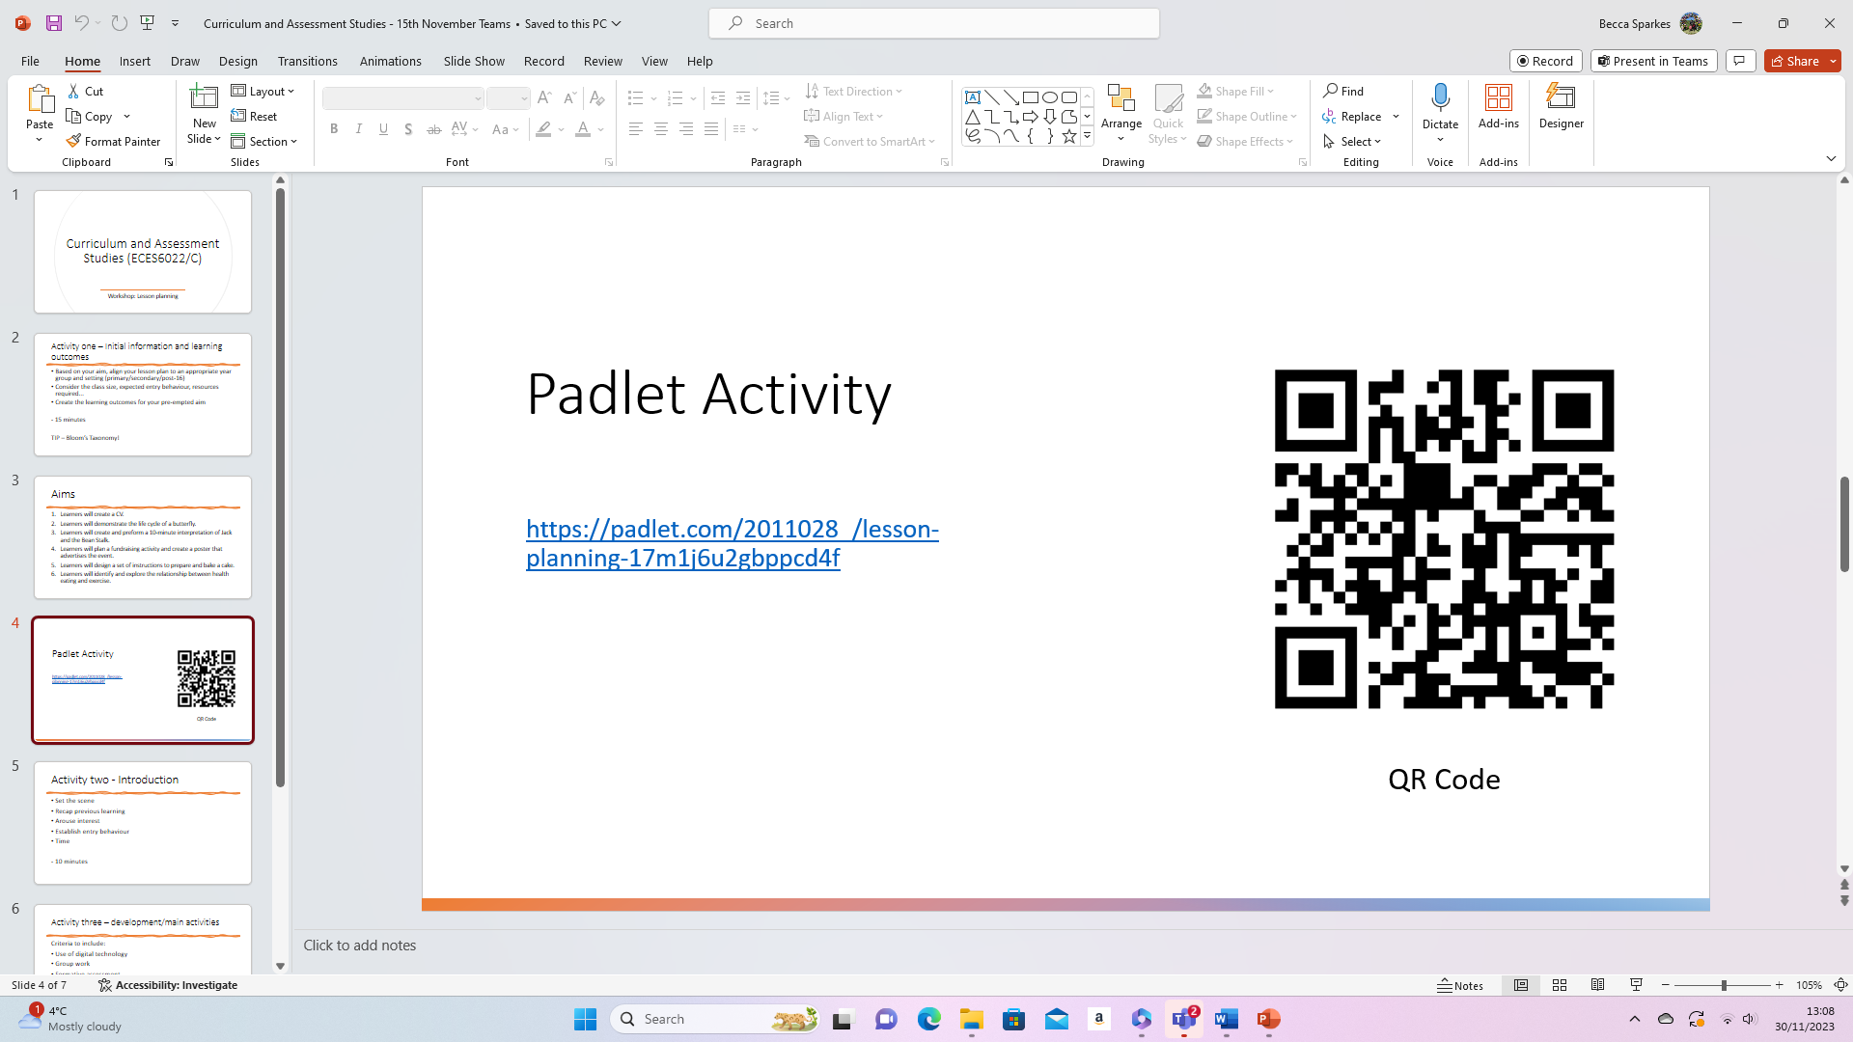

Evaluation and Reflection
What?
I was tasked with planning a workshop style lesson for level six students on the Education Studies programme. The workshop was based on lesson planning and previous knowledge on the topic had been taught, so students had existing knowledge of planning a lesson. The workshop took place on Microsoft Teams and the duration was three hours. I created my lesson plan in advance and decided that I would use the digital tool Padlet for students to collaboratively create their own lesson plan, this aligned with the Professional standards framework for planning a lesson (Advance HE, 2023). Additionally, I wanted a digital tool that would allow for me to formatively assess the learning that was taking place, continually throughout the workshop. My original idea was to use Microsoft Whiteboard, but from previous experience there has been some issues with inputting ideas onto it, and issues with students being able to access it.
I decided that I would use the scaffolding learning theory for the workshop so that I could support the students at each instruction of the task and to ensure learning was taking place (Shvarts and Bakker, 2019). Providing a lesson aim and certain criteria, students were placed into breakout rooms of two to three students, with access to the Padlet, and asked to work collaboratively to produce a lesson plan. After each part of the lesson plan had been completed, students returned to the main room to give brief feedback. This gave me the opportunity to provide students with feedback and feedforward, and to formatively assess their understanding and learning, this demonstrated use of the Professional Standards Framework for assessment and feedback for learning (Advance HE, 2023). When each group had fully created their lesson plan, I brought everyone back into the main room and each group were given five minutes to talk through and justify their lesson plan from beginning to end, to the rest of the class.
In an online learning environment, it is more difficult to gauge a sense of engagement from the learners if they do not use their cameras. For this reason, I feel that it is more important to engage the learners from the very beginning of the lesson, but to also provide them with FA throughout, to ensure the engagement of the learners and their understanding (Bond et al, 2020). The Padlet served this purpose well within the lesson, as it is a live platform, and it allows you to see which students are engaged and participating.
So what?
I decided to use Padlet as it allowed for all students to input their ideas into the collaborative digital tool, and it allowed for all groups to see the developing work of others. I had not used the digital tool Padlet prior to planning the lesson, so I decided to run through it with my mentor and another lecturer beforehand to ensure that the link and QR code worked and that the Padlet was accessible. The only problem that arose from using Padlet within the workshop was that one student could not see the link or QR code, but that was due to the PowerPoint slide not being visible on his device. I solved this issue promptly by putting the link into the Teams chat, which enabled him to access the Padlet.
Due to the Padlet being a live collaborative tool, I was able to see students work immediately which allowed me to formatively assess the understanding and learning throughout the lesson, which aligns with the Professional Standards Framework to assess and give feedback for learning (Advance HE, 2023). This was also a way for me to offer feedback and feedforward which would aid towards their summative assessment.
Towards the end of the lesson, I was able to share the digital Padlet via my screen on Microsoft Teams, allowing for all students to see on their devices. From this all groups were asked to feedback and justify their lesson plan to the rest of the students. By doing this it also gave the students the opportunity to reflect on what they had created and learn from this (Reece and Walker, 2007). This was an effective opportunity for students as they had to create a lesson plan for an upcoming assignment, having now gained the experience of putting a lesson plan together, it can help towards summative assessment.
Upon completion of the lesson plans and when each group had talked through their creation, this provided me with an opportunity to give students feedback on their learning. By formatively assessing students throughout the lesson, and at the end, I was able to identify that the learning outcomes had been met. Aside from this, it also gave me the opportunity to reflect on my teaching strategies and the integration of the digital tool, which will enhance my practice through my continuing professional development (Advance HE, 2023: Rac, 2014: Race and Pickford, 2007).
I wanted students to have a copy of the work they had created during the workshop so that they could go back and revisit it and reflect, if they felt they wanted to or needed to. Padlet allowed for me to be able to provide this to the students as there is an option on the digital tool to save to the device as a picture. I was then able to share this image onto the Teams channel so that the students had access to the work that they had done collaboratively. There was a slight issue with the accessibility of the image, as it requires you to zoom in to enlarge it, to make it more accessible. Whilst this may be considered as a minor issue, the image was shared to the students.
Now what?
Integrating Padlet as a digital tool in this workshop worked well and enhanced the learning experience overall. It allowed me to gain an understanding of the learning and the progress of the students in creating a lesson plan, if there were any challenges any particular student or group faced, the teaching strategies that were used and the use of the digital tool used.
I created a feedback questionnaire using Microsoft Forms and posted the link to the Teams channel that the students have access to. I wanted to gain feedback from the students about the use of Padlet for the workshop. Overall, four students responded to the feedback form. Three out of four students felt that their overall learning experience was enhanced by the use of Padlet, with all four students opting that that would like to use Padlet again for learning and FA. One student stated that they liked using Padlet because it allowed you to see the other students work which gave them the opportunity to see if they were on the right path with the task. Another student noted that it was an easy way to store work and it allowed for more than one person to access it at the same time.
The feedback from the students solidified that the use of Padlet for the purpose of the workshop did work well. Enhancing engagement, being accessible and easy to use overall, and allowed for the learning outcomes to be met.
However, not all students responded to the feedback which does not give a clear overall view of the integration of Padlet into the workshop. Although all students contributed to the workshop and many voiced that the workshop was really helpful to them, gaining feedback from all students would have been more beneficial for an overall picture.
The use of Padlet for the workshop only had one minor issue, with access, which was quickly solved. Many issues could of arose from integrating technology within the lesson, such as connectivity issues or technical problems. Going forward in my professional practice, I would use Padlet again for FA and feedback, and would see other ways that it could be used for pedagogy. I would also ensure that learning and teaching is enhanced by the use of technology, by following a common framework such as SAMR (Crompton and Sykora, 2021).

Reference List
Advance HE (2023) Professional Standards Framework. Available at: https://www.advance-he.ac.uk/teaching-and-learning/psf (Accessed: 30 November 2023).
Awajan, N.W. (2023) ‘The effect of implementing technology in formative assessments to ensure student learning in higher education English Literature courses after COVID-19', Online Journal of Communication and Media Technologies, vol 13(2). Available at: https://doi.org/10.30935/ojcmt/13049 (Accessed: 26 November 2023).
Beatty and Gerace (2009) ‘Technology-Enhanced Formative Assessment: A Research-Based Pedagogy for Teaching Science with Classroom Response Technology’, Journal of Science Education and Technology, vol 18, pp. 146-162. Available at: https://link.springer.com/article/10.1007/s10956-008-9140-4 (Accessed: 27 November 2023).
Blundell, C.N., Mukherjee, M. and Nykvist, S. (2022) ‘ A scoping review of the application of the SAMR model in research’, Computers and Education Open, vol 3. Available at: https://www.sciencedirect.com/science/article/pii/S2666557322000210 (Accessed: 30 November 2023).
Bodgers, M.L.A.M., Garud, R., Thomas, L.D.W., Tuertscher, P. and Yoo, Y. (2021) ‘Digital innovation: transforming research and practice’, Innovation: Organization and Management, vol 24, pp. 4-12. Available at: https://www.tandfonline.com/doi/full/10.1080/14479338.2021.2005465 (Accessed: 30 November 2023).
Bond, M., Buntins, K. Bedenlier, S., Zawacki-Richter, O. and Kerres, M. (2020) ‘Mapping research in student engagement and educational technology in higher education: a systematic evidence map’, International Journal of Education Technology in Higher Education, vol 17(2). Available at: https://educationaltechnologyjournal.springeropen.com/articles/10.1186/s41239-019-0176-8 (Accessed: 29 November 2023).
Crompton, H. and Sykora, C. (2021) ‘Developing instructional technology standards for educators: A design-based research study’, Computers and Education Open, vol 2. Available at: https://www.sciencedirect.com/science/article/pii/S266655732100015X (Accessed: 30 November 2023).
Deni, A.R.M.and Zainal, Z.I. (2018) ‘Padlet as an educational tool: pedagogical considerations and lessons learnt’, Proceedings of the 10th International Conference on Education Technology and Computers, pp.156-162. Available at: https://dl.acm.org/doi/10.1145/3290511.3290512 (Accessed: 30 November 2023).
Elmahdi, I., Al-Hattami, A. and Fawzi, H. (2018) ‘Using Technology for Formative Assessment to Improve Student’s Learning’, The Turkish Online Journal of Educational Technology, vol 17(2). Available at: https://www.researchgate.net/publication/324280815_Using_Technology_for_Formative_Assessment_to_Improve_Students'_Learning (Accessed: 22 November 2023).
Future Generations Commissioner for Wales (2023) Wellbeing of Future Generations (Wales) Act 2015. Available at: https://www.futuregenerations.wales/about-us/future-generations-act/ (Accessed: 30 November 2023).
Gill-Simmen, L. (2021) ‘Using Padlet in instructional design to promote cognitive engagement: a case study of undergraduate marketing student’, Journal of Learning Development in Higher Education, (20). Available at: https://journal.aldinhe.ac.uk/index.php/jldhe/article/view/575 (Accessed: 30 November 2023).
Jamieson, J. and Muscumeci, M. (2017) ‘Integrating Assessment with Instruction through Technology’, In C.A. Chapelle and S. Sauro (Eds), The Handbook of Technology and Second Language Teaching and Learning, pp. 293 – 316. Available at: https://onlinelibrary.wiley.com/doi/10.1002/9781118914069.ch20 (Accessed: 27 November 2023).
Jisc (2022) Applying the SAMR model to aid your digital transformation. Available at: https://beta.jisc.ac.uk/guides/applying-the-samr-model-to-aid-your-digital-transformation (Accessed: 29 November 2023).
Jisc (2023) Framework for digital transformation in higher education. Available at: https://beta.jisc.ac.uk/guides/framework-for-digital-transformation-in-higher-education (Accessed: 27 November 2023).
Jurane-Bremane, A. (2023) ‘Digital Assessment in Technology-Enriched Education: Thematic Review’, Education Sciences, vol13(522). Available at: https://doi.org/10.3390/educsci13050522 (Accessed: 26 November 2023).
Lewohl, J.M. (2023) ‘Exploring student perceptions and use of face-to-face classes, technology-enhanced active learning, and online resources’, International Journal of Educational Technology in Higher Education, vol 20(48). Available at: https://educationaltechnologyjournal.springeropen.com/articles/10.1186/s41239-023-00416-3 (Accessed: 29 November 2023).
Lwande, C., Muchemi, L. and Oboko, R. (2021) ‘Identifying learning styles and cognitive traits in a learning management system’, Heliyon, vol 7(8). Available at: https://www.ncbi.nlm.nih.gov/pmc/articles/PMC8358419/ (Accessed: 30 November 2023).
Mansfield, S. (2020) ‘Changing the face of academic skills workshop’, Journal of Learning Development in Higher Education, vol 17. Available at: https://journal.aldinhe.ac.uk/index.php/jldhe/article/view/508 (Accessed: 30 November 2023).
Mercader, C. and Gairin, J. (2020) ‘University teachers’ perception of barriers to the use of digital technologies: the importance of the academic discipline’, International Journal of Journal of Educational Technology in Higher Education, vol 17(4). Available at: https://educationaltechnologyjournal.springeropen.com/articles/10.1186/s41239-020-0182-x#Sec8 (Accessed: 28 November 2023).
Morais Bicalho, R.N.D., Coll, C., Engel, A. and Santos Lopes de Oliveira, M.C. (2023) ‘ Integration of ICTs in teaching practices: propositions to the SAMR model’, Educational technology research and development, vol 71, pp. 563-578. Available at: https://link.springer.com/article/10.1007/s11423-022-10169-x (Accessed: 30 November 2023).
Okoye, K., Hussein, H., Arrona-Palacios, A., Quintero, H.N., Pena Ortega, L.O., Lopez Sanchez, A., Ortiz, E.A., Escamilla, J. and Hosseini, S. (2023) ‘Impact of digital technologies upon teaching and learning in higher education in Latin America: an outlook on the reach, barriers, and bottlenecks’, Education and Information Technologies, vol 28, pp. 2291-2360. Available at: https://link.springer.com/article/10.1007/s10639-022-11214-1 (Accessed: 30 November 2023).
Pellegrini, M. and Vivanet, G. (2020) ‘Evidence-Based Policies in Education: Initiatives and Challenges in Europe’, ECNU Review of Education, vol 4, pp. 25-45. Available at: https://journals.sagepub.com/doi/10.1177/2096531120924670 (Accessed: 29 November 2023).
Race, P. (2015) Making Learning Happen. 3rd edn.SAGE Publications Ltd: London.
Race, P. and Pickford, R. (2007) Making Teaching Work. SAGE Publications Ltd: London.
Richardson, J.C., Caskurli, S., Castellanos-Reyes, D., Duan, S., Shams Ud Duha, M., Fiock, H., and Long, Y. (2022) ‘Instructors’ conceptualization and implementation of scaffolding in online higher education courses’, Journal of Computing in Higher Education, vol 34, pp. 242-279. Available at: https://link.springer.com/article/10.1007/s12528-021-09300-3 (Accessed: 30 November 2023).
Robertson, S.N., Humphrey, S.M. and Steele, J.P. (2019) ‘Using technology tools for formative assessments’, Journal of Educators Online, vol 16(2). Available at: https://www.thejeo.com/archive/2019_16_2~2/robertson_humphrey__steele (Accessed: 27 November 2023).
Schildkamp, K., Kleij, F.M.V.D., Heitink, M.C., Kippers, W.B. and Veldkamp, B.P. (2020) ‘Formative assessment: A systematic review of critical teacher prerequisites for classroom practice’, International Journal of Educational Research, vol 103. Available at: https://www.sciencedirect.com/science/article/pii/S0883035520300082 (Accessed: 28 November 2023).
Shepard, L.A., Penuel, W.R. and Pellegrino, J.W. (2018) ‘Using Learning and Motivation Theories to Coherently Link Formative Assessment, Grading Practices, and Large-Scale Assessment’, Educational Measurement, vol 37, pp. 21-34. Available at: https://onlinelibrary.wiley.com/doi/10.1111/emip.12189 (Accessed: 27 November 2023).
Shvarts, A. and Bakker, A. (2019) ‘The early history of the scaffolding metaphor: Bernsteind, Luria, Vygotsky, and before’, Mind, Culture, and Activity, vol 26, pp. 4-23. Available at: https://www.tandfonline.com/doi/pdf/10.1080/10749039.2019.1574306 (Accessed: 30 November 2023).
Vaataja, J.O. and Ruokamo, H. (2021) ‘Conceptualizing dimensions and a model for digital pedagogy’, Journal of Pacific Rim Psychology, vol 15. Available at: https://journals.sagepub.com/doi/full/10.1177/1834490921995395 (Accessed: 29 November 2023).
Van de Pol, J., Volman, M., Oort, F. and Beishuizen, J. (2015) ‘The effects of scaffolding in the classroom: support contingency and student independent working time in relation to student achievement, task effort and appreciation of support’, Instructional Science, vol 43, pp. 615-641. Available at: https://link.springer.com/article/10.1007/s11251-015-9351-z#citeas (Accessed: 30 November 2023).
Welsh Government (2019) Digital 2030: A Strategic Framework. Available at: https://www.gov.wales/digital-2030-strategic-framework (Accessed: 27 November 2023).

