
Strategic Approach for Johnson & Johnson in the Post-Pandemic Era

Strategic Management

BMMB7013

Professor：Daniela Hellyer

Student Name：WENXUAN LIAO

Student ID ：2224763

Executive Summary
Johnson & Johnson, a renowned healthcare company, has a robust presence in the global healthcare sector, with strong financial performance, diversified product portfolio, and considerable R&D capabilities. However, the pandemic has influenced significant changes in consumer behavior, with a notable shift towards digital health solutions and personalized care. This report provides a comprehensive analysis of Johnson & Johnson's current position and explores strategic options for improving customer care in the backdrop of the COVID-19 pandemic and the rapidly evolving healthcare industry.
The report's external analysis reveals a growing market for digitally-enabled, personalized health services. Similarly, the internal analysis identifies a need for Johnson & Johnson to enhance its customer care by incorporating more personalization and digital solutions. After considering various strategic options, including personalized digital health platforms, AI-driven customer support, and integrated health services, a combination of the first two emerged as the most viable choice. These strategies align with the company's core objectives and evolving market trends, promising improved customer satisfaction and competitive advantage. The implementation of these strategies requires substantial resources, including technology investments, human capital development, and change management initiatives. Furthermore, a detailed implementation plan and robust risk management strategies will be crucial for success. The impact analysis suggests potential structural, financial, and HR impacts but also forecasts improved market positioning and
customer perception. The conclusion emphasizes the benefits of the chosen strategy and recommends a systematic approach towards its implementation. With an effective execution of this strategy, Johnson & Johnson can significantly enhance its customer care and strengthen its position in the post-pandemic healthcare industry.

Content
Executive Summary 2
1.Introduction 5
2. Current Organizational Overview 6
3. External Analysis 8
3.1 Pandemic analysis(PESTEL model) 8
3.2 Industry Analysis(Porter’s five force model) 11
3.3 Market Analysis(Ansoff’s Matrix) 13
4. Internal Analysis 15
4.1 SWOT analysis 15
4.2 Financial Performance 16
4.3 Capability Analysis 18
4.4 Customer Care Analysis 19
5. Strategic Options for Customer Care 19
5.1 Option 1: Personalized Digital Health Platform 20
5.2 Option 2: AI-Driven Customer Support 21
5.3 Option 3: Integrated Health Services 22
6. Strategies implementation 23
7. Planning and Execution 26
7.1 VIRO analysis 26
7.2 Timelines and Responsibilities 27
8. Key Performance Indicators 28
8.1 Financial Metrics 28
8.2 Customer Metrics 29
8.3 Internal Process Metrics 29
8.4 Learning and Growth Metrics 29
9. Conclusion 30
10. Recommendations 30
References 33

Table of Figures
Figure 1 BCG Matrix for Products 7
Figure 2 PESTEL Analysis under Pandemic 9
Figure 3 Porter's five forces for J&J 12
Figure 4 Ansoff's Matrix for Medical Market 14
Figure 5 SWOT analysis for J&J 16
Figure 6 Hierarchy of Strategy 21
Figure 7 McKinsey 7S Framework 24
Figure 8 4P Model 26
Figure 9 VIRO Model 27
Figure 10 BSC Model for KPIs 29

1.Introduction
Johnson & Johnson (J&J), founded in 1886, is one of the largest and most diversified healthcare firms in the world. With a global workforce exceeding 130,000 employees, our company maintains a presence in nearly every nation and offers products for sale in over 175 countries. The company's operations are structured into three distinct business segments: Consumer Health, Pharmaceuticals, and Medical Devices.
The vision of Johnson & Johnson is to assume a leadership role in the healthcare industry, propelling it towards the future, and ultimately striving to establish a world free from disease. The company's dedication to innovation is fueled by its forward-thinking vision, motivating it to continuously explore novel approaches in disease prevention, interception, treatment, and cure. As of 2022, Johnson & Johnson maintains a prominent presence in the healthcare industry, with a significant global reach and a strong brand reputation. Nevertheless, there is a significant shift occurring in the healthcare industry. The COVID-19 pandemic has brought about profound changes globally, resulting in notable shifts in health trends and consumer behavior. The rapid adoption of digital technologies in the healthcare sector has resulted in accelerated digital adoption, significant changes in regulatory frameworks, and prompted organizations to reevaluate their operations and strategies(Javaid & Haleem, 2019).
Our objective is to ensure that it is in line with the changing market dynamics and customer demands. The objective is to assist Johnson & Johnson in further establishing trust and loyalty among its customers, strengthening its competitive edge, and actively contributing to its vision of transforming the future of healthcare for all individuals.

Current Organizational Overview
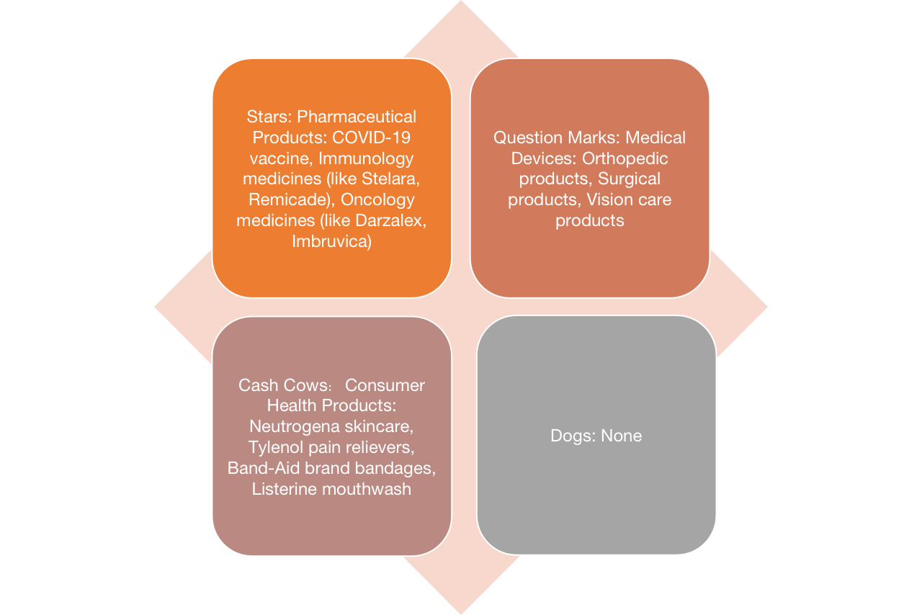
Figure 1 BCG Matrix for Products
As of the second quarter of 2023, Johnson & Johnson, a globally recognized healthcare conglomerate, maintains a strong presence in the pharmaceutical and consumer health product sectors, asserting its positions within the 'Stars' and 'Cash Cows' quadrants of the Boston Consulting Group (BCG) matrix. The corporation comprises three primary segments: Consumer Health, Pharmaceuticals, and Medical Devices. From Report of unscheduled material events or corporate event in Johnson & Johnson(2023), a global corporation, boasts a workforce of approximately 132,200 employees across the globe. In the fiscal year of 2022, the company achieved impressive revenues amounting to $82.6 billion.
Within the 'Stars' quadrant, the company's pharmaceutical products like their COVID-19 vaccine and oncology medicines are represented due to their strong growth rate and substantial market share. The 'Cash Cows' quadrant houses products like Neutrogena skincare and Tylenol pain relievers, which yield a steady income stream with a considerable market share but a slower growth rate. The Medical Devices segment, despite being part of a rapidly growing market, faces intense competition resulting in a lower relative market share, placing it in the 'Question Marks' quadrant.
Johnson & Johnson has a legacy of focusing on the development and marketing of high-quality products, conducting extensive research and development, and cultivating robust relationships with healthcare professionals. This approach has proven its effectiveness, contributing to the robust market position and consistent financial performance(Paul et al., 2021). Johnson & Johnson primarily utilizes a traditional approach to customer care, which involves providing detailed product information, responding promptly to inquiries, and resolving issues and complaints effectively(EZHILMARAN, 2019).
Significant changes in healthcare were instigated by the COVID-19 pandemic, which led to transformations in patient behavior, regulatory landscapes, and market dynamics(Tung et al., 2008). Telemedicine and online health consultations were expedited due to lockdowns and social distancing measures. This shift has resulted in an increase in customer demands for health solutions that are personalized, convenient, and digitally capable.Based on a report by Nau(2022), the utilization of telehealth services has reached a state of stability, with usage levels currently 38 times greater than those observed prior to the onset of the pandemic(Lee et al., 2019). From an operational standpoint, Johnson & Johnson, along with numerous other multinational organizations, encountered difficulties arising from disrupted supply chains, fluctuating demand patterns, and the imperative to swiftly develop and distribute COVID-19 related treatments and vaccines(Sharma et al., 2023). These challenges, however, have revealed areas that could benefit from enhancements, particularly in terms of agility, digital capabilities, and personalized care.

External Analysis

3.1 Pandemic analysis(PESTEL model)
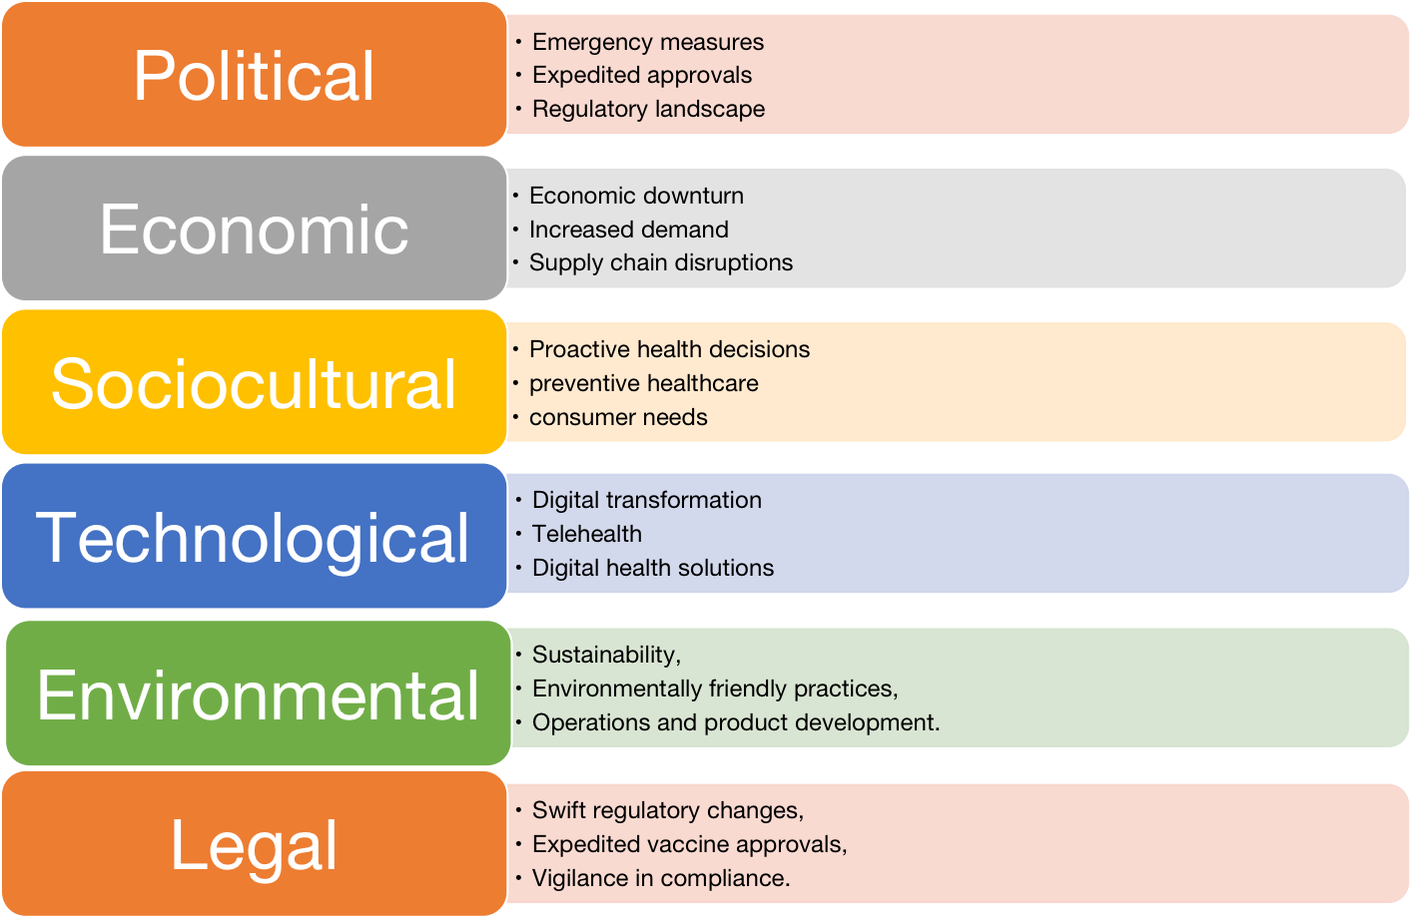
Figure 2 PESTEL Analysis under Pandemic
The COVID-19 pandemic prompted swift policy responses worldwide, directly influencing healthcare industry dynamics, particularly for companies like Johnson & Johnson. Governments fast-tracked approvals for COVID-related treatments and vaccines, creating an advantageous environment for Johnson & Johnson to roll out their vaccine quickly. However, this politically charged situation also meant a need for increased vigilance to swiftly adapt to changing regulations and guidelines, thereby ensuring seamless operations(Barshikar, 2020) .
The global economic downturn brought on by COVID-19 affected consumer spending across sectors. However, Johnson & Johnson, as a provider of essential health products and services, may have been insulated from the worst of this impact(Ayati et al., 2020). Furthermore, the pandemic led to increased spending on health and hygiene products by governments and individuals alike, opening up additional revenue streams for the company.
The pandemic also spurred significant sociocultural changes. It catalyzed a shift in consumer behavior within the healthcare sector, with individuals becoming more proactive in their healthcare decisions(Almurisi et al, 2021). Health and wellness became central to people's lives, accompanied by a surge in preventive healthcare practices (Lee & Lee, 2021). This paradigm shift represents a growing market for personalized health solutions, creating opportunities for Johnson & Johnson to innovate and cater to evolving consumer demands.
The acceleration of digital transformation in healthcare was another notable trend born from the pandemic crisis. Before COVID-19, telehealth services, though growing, were comparatively underutilized(Khan & Basak, 2021). The pandemic necessitated remote healthcare delivery, promoting telehealth from a mere convenience to a necessity(Ding, 2018). This shift is supported by an Accenture report indicating that 60% of patients now prefer using technology for healthcare communication and management (Khiong, 2022). This trend underscores the need for companies like Johnson & Johnson to incorporate digital components into their service offerings to meet the changing demands.
While the direct environmental impact of the pandemic on Johnson & Johnson's operations might have been minimal, the broader emphasis on sustainability and corporate responsibility has grown significantly(David, 2015). This calls for Johnson & Johnson to enhance its commitment to environmentally friendly practices in its operations and product development, contributing positively to its corporate reputation.
Lastly, the pandemic also heralded swift regulatory changes. These changes, such as expedited approvals for vaccines and treatments, brought opportunities but also posed potential legal risks(Taylor, 2015). This necessitates Johnson & Johnson to stay agile and compliant, effectively navigating this complex legal landscape(DiMasi, 2016).
The pandemic has presented operational challenges for Johnson & Johnson, particularly disruptions in global supply chains and heightened demand for specific products(Hayler et al., 2018). The company encountered delays in product delivery and struggled to accommodate sudden surges in demand, especially for health and hygiene products and COVID-related treatments and vaccines (Zamiela et al., 2019). These challenges underline the need for Johnson & Johnson to review and revise its supply chain strategies, enhancing resilience against future global crises. A Harvard Business Review study recommends supply chain diversification and digitization as effective strategies to combat such disruptions(Schuhmacher et al., 2016).

3.2 Industry Analysis(Porter’s five force model)
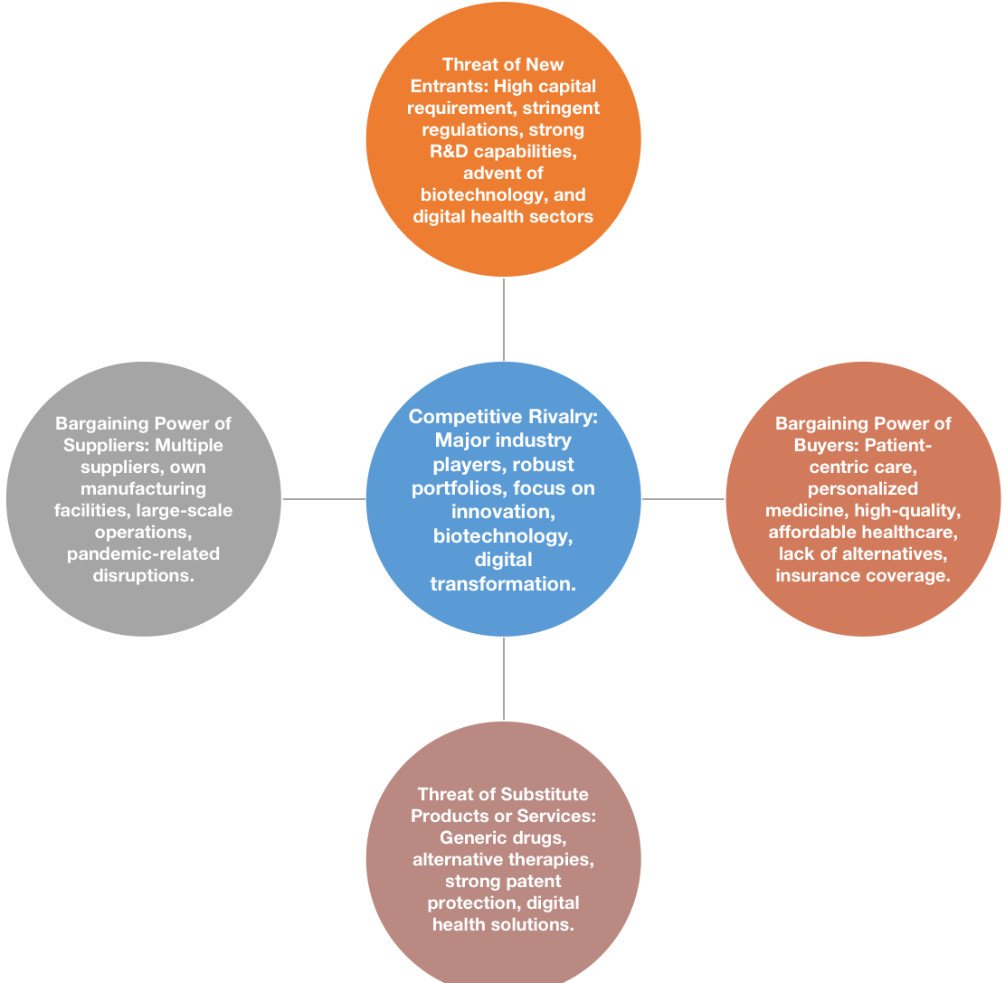
Figure 3 Porter's five forces for J&J
Projected to generate $1.6 trillion by 2024 according to the 2023 Proxy Statement, the global pharmaceutical industry indeed offers enormous financial opportunities. However, these are bound to complex dynamics that necessitate a robust strategic framework for effective navigation. Applying Porter's Five Forces analysis offers valuable insights into these complexities.
The pharmaceutical industry is marked by fierce competition. Heavyweights such as Pfizer, Roche, and Novartis, not only present significant rivalry to Johnson & Johnson but also shape the industry dynamics with their broad product portfolios and strong market presence(DeAngelis & Fontanarosa, 2008). Their competitive strategies further intensify this rivalry, making innovation and differentiation critical for maintaining Johnson & Johnson's market position.
The biotechnology, personalized medicine, and digital health sectors are experiencing significant growth(Brennan et al., 2006). These emerging fields, albeit characterized by high risks and uncertainties, offer new avenues for startups and could increase the threat of new entrants. With advancements such as artificial intelligence and machine learning increasingly being integrated into drug discovery, development, and patient care, it is incumbent upon Johnson & Johnson to continuously innovate to maintain its competitive edge (Hartley, 2019).
Another salient trend in the pharmaceutical industry is the shift towards personalized and patient-centric care. This trend is increasing the bargaining power of buyers or patients, demanding high-quality, effective, and affordable healthcare solutions(Mak, K.K. & Pichika, 2019). It is critical for Johnson & Johnson to recognize this growing market demand and offer tailored health solutions.
The emphasis on sustainable and ethical sourcing and production practices in the industry can affect the bargaining power of suppliers. Johnson & Johnson, while operating many of its own manufacturing facilities, relies on third-party suppliers for certain needs(Ahmed et al., 2020). The need for sustainable suppliers could affect supplier dynamics and underscores the importance of Johnson & Johnson's commitment to responsible business practices.
The regulatory environment presents its own set of challenges. While the pandemic led to an accelerated approval process for COVID-19 treatments and vaccines (Marks & Schuchat, 2021), the standards for other drug approvals remain rigorous. Johnson & Johnson must continually adapt to these changes to mitigate legal risks and potential threats from substitute products, such as generic drugs and alternative therapies.

3.3 Market Analysis(Ansoff’s Matrix)
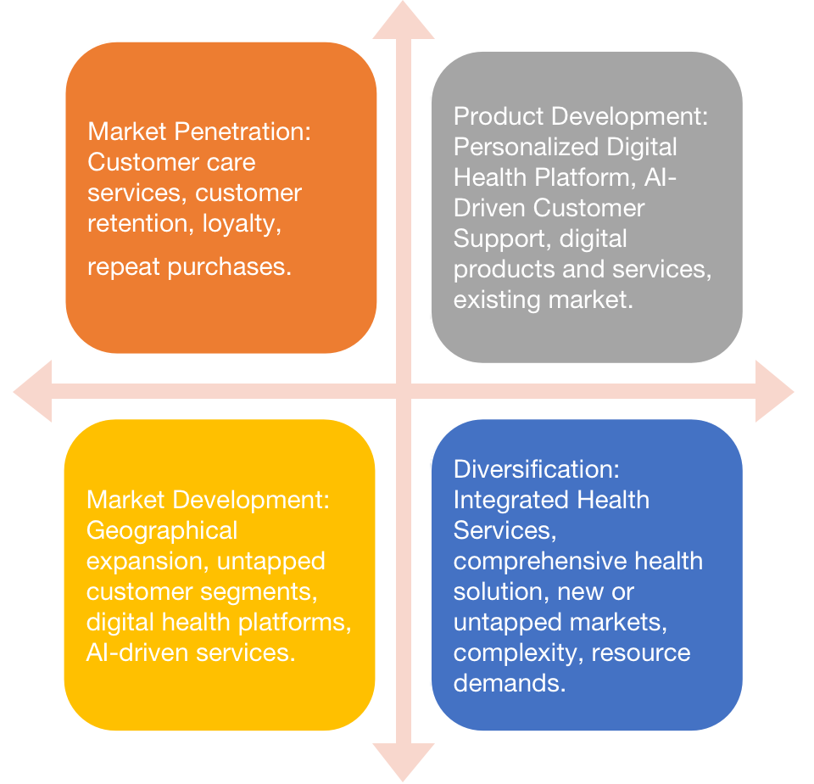
Figure 4 Ansoff's Matrix for Medical Market
With the United States accounting for 51.6% of Johnson & Johnson's total revenues in 2022, it is clear that Johnson & Johnson holds a strong market presence domestically. According to a report by Vogenberg(2019), this market is projected to grow considerably, anticipated to reach $6 trillion by 2027, with a CAGR of 5.8% from 2022 to 2027. To effectively capitalize on this opportunity, a strategic framework such as Ansoff's Matrix can guide the company's approach.
In this mature, highly competitive market where Johnson & Johnson contends with established domestic pharmaceutical companies like Pfizer, Merck & Co., and Gilead Sciences, as well as international rivals and emerging biotechnology firms, enhancing market penetration can be a viable strategy. By improving customer care services and driving up customer retention and loyalty, the company can strive to increase its market share for existing health products and services(Yang et al., 2022).
Recognizing the U.S. market's growing need for personalized, environmentally friendly health products and services supported by technology, Johnson & Johnson can drive product development strategies. Innovations such as the "Personalized Digital Health Platform" and "AI-Driven Customer Support" could cater to this demand, offering unique value propositions to existing customers and drawing in new ones.
Although Johnson & Johnson already has a strong U.S. market presence, there is scope for market development. The company could consider expanding its new digital health platforms and AI-driven services into other geographical markets or untapped customer segments within the U.S(Holzinger, et al., 2019). This would enable the company to reach a larger customer base and potentially increase market share.
Finally, the shift towards convenience and transparency in healthcare, as well as the increasing demand for personalized solutions, calls for diversification strategies. Johnson & Johnson's "Integrated Health Services" approach fits into this category, proposing a comprehensive solution that combines existing and new products and services(Amann et al., 2020). Although this strategy comes with greater risks, given its complexity and resource demands, it also opens up new avenues of growth for the company in the rapidly evolving U.S. healthcare market.

Internal Analysis

SWOT analysis
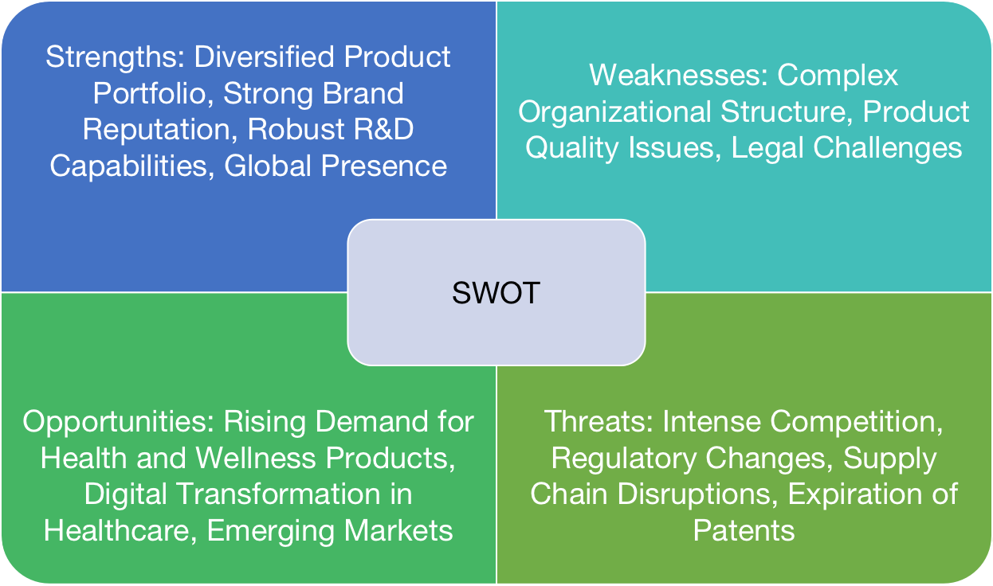
Figure 5 SWOT analysis for J&J
Johnson & Johnson's SWOT analysis reveals a potent combination of strengths, including a diversified product portfolio, strong brand reputation, robust R&D capabilities, and global market reach. However, it also highlights certain areas of improvement, specifically its complex organizational structure and recurring product quality issues. Additionally, the company faces ongoing legal challenges that pose reputational and financial risks(Ahuja, 2020). Opportunities present themselves in the increased consumer focus on health and wellness, the fast-paced digital transformation in healthcare, and potential expansion in emerging markets. Threats include intense competition from established players, rapid regulatory changes, potential supply chain disruptions, and the looming expiration of patents on key products. Understanding these elements provides a roadmap for strategic decisions, aiding Johnson & Johnson in maintaining its competitive advantage while continuously adapting to evolving customer expectations and market trends.

4.2 Financial Performance
Over the years, Johnson & Johnson has demonstrated a robust financial performance, reinforcing its solid standing in the pharmaceutical industry. For instance, in 2022, the company reported an impressive revenue of $82.6 billion. Notably, the largest share of this revenue (54.3%) was contributed by the pharmaceutical division. This is noteworthy as it indicates the substantial market demand for Johnson & Johnson's pharmaceutical products. Despite operational challenges posed by the global pandemic, Johnson & Johnson managed to increase its revenues by 6.1% from 2021 to 2022(James et al., 2019). This financial resilience underscores the company's effective crisis management strategy and its robust business model. Moving forward, this consistent financial performance can allow the company to invest more in R&D, market expansion, and innovation to keep up with industry changes and consumer demands.
Johnson & Johnson's extensive workforce, comprising approximately 132,200 employees globally, is a significant asset. This diverse and skilled human capital plays a crucial role in driving the company's growth and innovation(Alhosnai et al., 2021). The company's substantial investment in employee development and welfare is evidenced by programs such as the Leadership Imperatives program. This program is designed to cultivate crucial leadership skills that are key to the company's success. However, with the rapid digital transformation sweeping across the industry, there's a growing need for upskilling and reskilling the workforce. This involves providing training in areas such as digital literacy, data analytics, and digital customer care to ensure that the workforce remains competitive in the digital era.
Johnson & Johnson's robust intellectual property portfolio is a testament to its commitment to innovation. As of the end of 2022, the company had over 36,000 patents granted worldwide. This vast intellectual property provides a competitive advantage as it protects the company's unique products and technologies from being copied by competitors(Ullah, 2021). However, in the face of emerging trends such as personalized medicine and digital health solutions, there's a need for continued innovation and patent creation to stay ahead of the curve.
Johnson & Johnson's global operations are supported by its expansive network of 129 manufacturing facilities. These facilities play a critical role in ensuring the efficient production and distribution of the company's products. To further bolster its operational efficiency and customer care, the company has been investing in technology. This includes the incorporation of Artificial Intelligence (AI) in drug development and customer service, reflecting the company's readiness to embrace technological advancements to maintain its industry leadership(Gopal et al., 2019). This investment in AI not only optimizes operational efficiency but also enhances customer care by providing personalized, efficient services.

4.3 Capability Analysis
Johnson & Johnson's strong footing in the pharmaceutical industry is attributed to several strategic strengths. Its comprehensive product portfolio spans various healthcare sectors, including pharmaceuticals, consumer health products, and medical devices, providing it with diversified revenue streams and a protective shield against sector-specific downturns. Additionally, its robust research and development (R&D) capabilities are a significant strength. In 2022 alone, Johnson & Johnson invested $11.4 billion into R&D, equating to approximately 13.8% of its total revenue, a testament to its commitment to innovation and advancement. This significant financial investment has fueled the development of successful products and a robust product pipeline that promises future growth(Shahzad et al., 2020). The company's financial performance remains robust despite global economic challenges, allowing it to invest in growth opportunities and cushion against industry uncertainties. Lastly, its extensive global reach provides access to diverse markets and customer segments, reinforcing its competitive positioning.
Johnson & Johnson's commitment to research and development sets it apart from many competitors. This competency is showcased by its sizable annual investment in R&D, which, in 2022, stood at $11.4 billion. This investment demonstrates Johnson & Johnson's focus on innovation, with R&D playing a critical role in the company's growth strategy(Lepore et al., 2023). The constant infusion of capital into R&D not only generates new products but also ensures a strong product pipeline, thereby enabling the company to stay ahead of competitors and continually meet evolving consumer needs in the healthcare industry. Such a competency provides Johnson & Johnson with a distinct competitive edge.

4.4 Customer Care Analysis
Johnson & Johnson's customer care strategy has traditionally been centered around providing thorough information regarding its wide array of products, addressing inquiries, and resolving customer complaints. The company offers these services across a multitude of channels, such as phone support, email, social media, and online chat. One of the cornerstones of its customer care approach is utilizing customer feedback to continually improve its products and services, demonstrating its commitment to customer satisfaction(Hermes et al., 2020).
Despite its effectiveness, Johnson & Johnson's customer care approach does present some shortcomings(Lee & Yoon, 2020). Specifically, the current customer care model appears to lack personalization. In the current era, personalized healthcare and individualized customer service are rapidly becoming the norm, driven by advancements in data analytics.

Strategic Options for Customer Care
This section outlines three potential strategies to enhance customer care at Johnson & Johnson: Personalized Digital Health Platforms, AI-Driven Customer Support, and Integrated Health Services. Hierarchy of strategy is shown as follow:
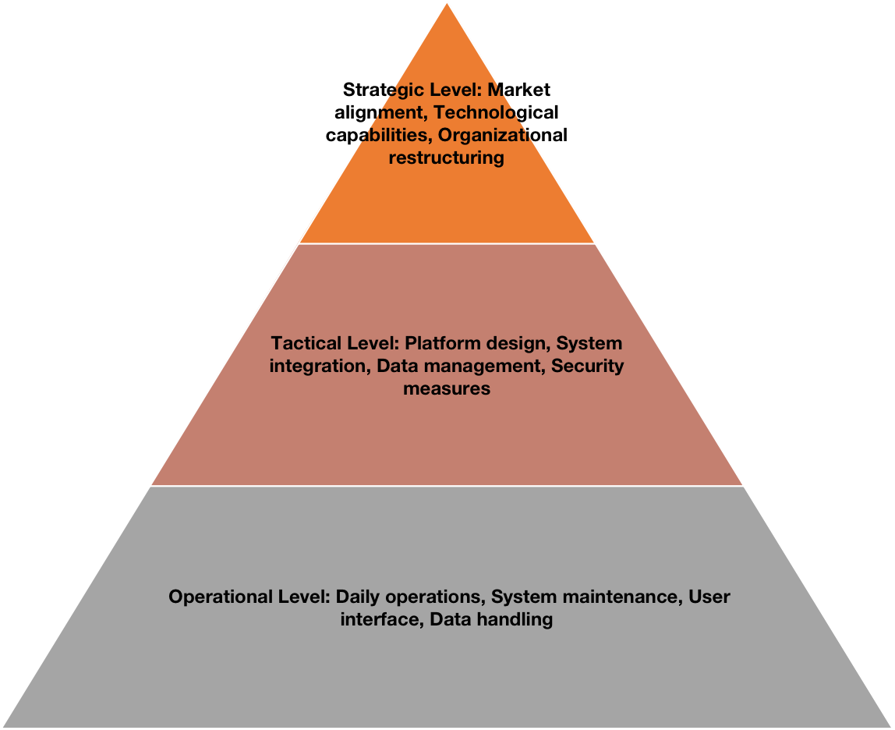
Figure 6 Hierarchy of Strategy

5.1 Option 1: Personalized Digital Health Platform
The Personalized Digital Health Platform represents a comprehensive suite of health services, tailored to individual health profiles of customers. This innovative approach aligns with current market trends towards personalized and digital health solutions, aiming to provide more targeted and effective care.
Strategically, implementing this platform would necessitate a significant investment, particularly in new technologies and a potential organizational restructure, such as creating new divisions or expanding existing digital or IT teams. However, given Johnson & Johnson's substantial resources and technological capabilities, such an investment is feasible.
Tactically, platform design and development, system integration, data management, and security measures become key concerns. Specific attention would need to be given to user interface design, ensuring that the platform is not only functional but also easy and intuitive for customers to use.
Operationally, the focus would be on the daily management of the digital health platform, which includes routine system checks and maintenance, ensuring a user-friendly interface, and effective data handling to secure user data and provide a reliable service.

5.2 Option 2: AI-Driven Customer Support
AI-Driven Customer Support strategy would enhance Johnson & Johnson's interaction with its customers. The system can provide 24/7 customer service, anticipate customer needs, and address them proactively, leading to increased customer satisfaction.
Strategically, this option leverages the rapid advances in AI technology to improve customer interactions. Initial costs for AI system implementation might be high but considering the potential benefits and the existing technological prowess of Johnson & Johnson, the feasibility of this strategy is strengthened.
Tactically, this strategy would involve implementation of AI systems, training AI with customer interaction data, and managing escalated customer queries. It's crucial to ensure the AI system is trained effectively to handle most customer inquiries, with a fallback option for human intervention for complex queries.
At an operational level, the focus would be on the daily operation of AI systems, which includes handling routine customer inquiries, system updates, and addressing complex customer queries. Continuous monitoring and system updates would be essential to maintain effective service.

5.3 Option 3: Integrated Health Services
The Integrated Health Services strategy offers a unique value proposition by combining diverse product and service offerings into a comprehensive health solution. This strategy aims to provide an integrated care approach, which is not only efficient but also provides a seamless experience to customers.
At a strategic level, the proposal demands significant coordination across different business segments, which might lead to high complexity and increased resource allocation. Nevertheless, the prospect of enhancing customer satisfaction through a unified service offering makes it an appealing option.
Tactically, the challenge lies in combining product and service offerings, establishing operational links among business segments, and resource planning and allocation. Establishing a cohesive strategy across all business segments would be key to implementing this initiative.
Operationally, this strategy involves the daily provision of combined health services, coordination of service delivery, feedback collection and incorporation, and handling customer queries and concerns. Consistent coordination and communication across different departments would be crucial for the success of this strategy.
Upon careful evaluation, a combination of Personalized Digital Health Platforms and AI-driven Customer Support emerges as the most viable strategy (Devyania et al., 2020). These approaches not only align with Johnson & Johnson's core objective of improving health outcomes and customer satisfaction, but they also meet the growing consumer demand for personalized, prompt, and digitally-enabled services. The Integrated Health Services strategy, despite its potential for high disruption, might be more suitable as a long-term strategic initiative due to its high complexity and resource demands. The selected combination promises to strengthen Johnson & Johnson's competitive position in the healthcare industry.

Strategies implementation
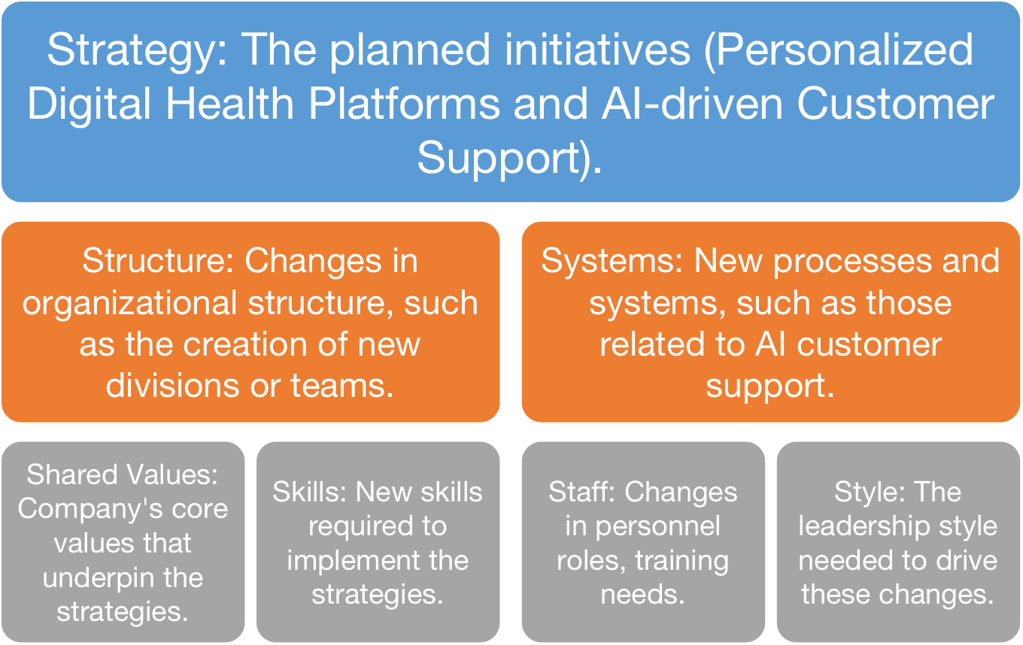
Figure 7 McKinsey 7S Framework
Implementing Personalized Digital Health Platforms and AI-driven Customer Support will undoubtedly have extensive ramifications across Johnson & Johnson's operations. These effects span structural, financial, human resource, and market implications. While the proposed strategies involve significant changes and investments, they hold the potential for substantial returns and long-term competitive advantage. Careful planning, effective change management, and constant monitoring and adjustment will be key to their successful implementation.
6.1 Structural Impacts
The execution of Personalized Digital Health Platforms and AI-driven Customer Support will likely instigate changes in Johnson & Johnson's structure - a key aspect in the 7S framework. A dedicated division for digital health may emerge or an expansion of existing digital departments to accommodate these new initiatives could be necessary (Oliveira et al., 2021). Additionally, an AI management team within the customer service department may be instituted to address complex queries and train the AI system with customer interaction data. Therefore, the implementation of these strategies aligns with the 'Structure' aspect of the 7S model, facilitating the organization's adaptation to innovative healthcare trends.
6.2 Financial Impacts
Aligning with the 'Strategy' component of the 7S framework, the financial implications of these initiatives must be considered. The creation of a digital health platform and the implementation of AI-driven customer support will require significant initial investments. However, the expected return on investment over time, particularly from increased customer engagement and potential cost reductions, make these initiatives a strategic move in securing a competitive edge in the digital healthcare market.
6.3 Human Resource Impacts
The proposed strategies' human resource implications align with the 'Staff' and 'Skills' elements of the 7S framework. The implementation of digital platforms and AI technologies will necessitate the development of new skills and may require a change in staff roles or additional hiring. Johnson & Johnson will need to strategically manage this change to maintain morale and a positive work culture amidst these transformations.
6.4 Market Impacts
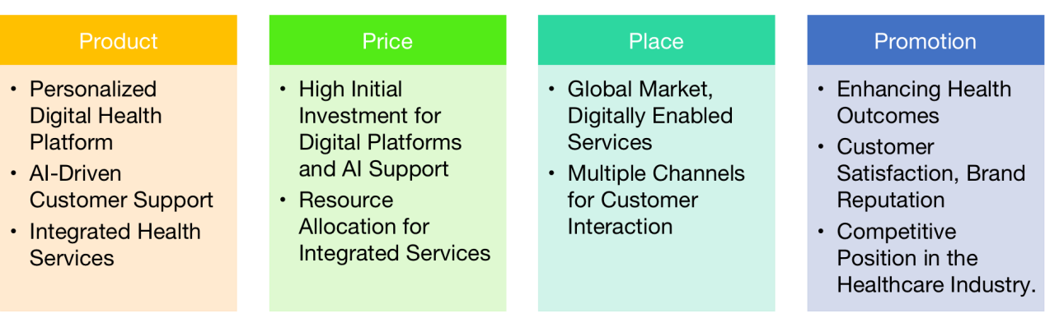
Figure 8 4P Model
Implementing these strategies will allow Johnson & Johnson to enhance its market position significantly, which relates to the 'Strategy' component of the 7S model and 4P model above. As a front-runner in personalized digital health services and AI-driven customer care, the company will solidify its position as an innovative leader in the healthcare industry, which will positively impact the perception of its customers (Javaid & Haleem, 2019).

Planning and Execution

7.1 VIRO analysis
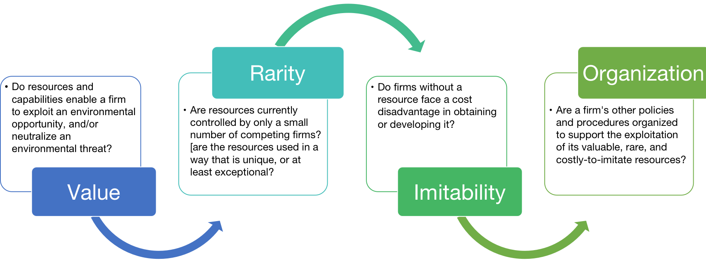
Figure 9 VIRO Model
Implementing a strategy of Personalized Digital Health Platforms and AI-driven Customer Support within Johnson & Johnson's expansive operation will require meticulous planning and execution. It's important to outline the resources required, assign responsibilities, delineate timelines, and determine key performance indicators for the strategy's successful implementation.
The strategy is underpinned by rare resources – a unique blend of healthcare knowledge and technical expertise within the organization. Notably, the multidisciplinary team that Gunasekeran et al. (2021) suggest for a successful digital health platform is uniquely available within Johnson & Johnson due to its broad talent base.
Moreover, these resources may prove costly to imitate. Competitors will face a significant cost disadvantage when trying to replicate the proposed platform due to the specialized nature of the resources required. The need for advanced technological infrastructure, including servers, storage, and networking capabilities, as well as robust cybersecurity measures, further increases the cost of imitation. Additionally, partnering with a reputable AI solution provider for leveraging top-tier technology, as suggested by Le et al. (2018), could be a critical success factor that others may find challenging to emulate.

7.2 Timelines and Responsibilities
A phased approach can be beneficial for this large-scale transformation:
Phase 1 (0-6 months) could focus on setting up the core teams, defining the project scope, and initiating the development of the digital health platform and AI systems. The responsibility would primarily lie with the IT department and any third-party developers involved.
Phase 2 (6-12 months) could include the development and testing of the digital health platform and AI systems. The core team would be responsible for the development, while a separate team should handle testing and quality assurance.
Phase 3 (12-18 months) could focus on the deployment and integration of these systems, as well as employee training. The IT department would manage system deployment, HR would handle training, and customer service teams would take on the task of working with the new systems.
Phase 4 (18-24 months) would involve refining the systems based on customer feedback, and continual optimization and updating. The core team, along with customer service teams, would manage these tasks.

Key Performance Indicators
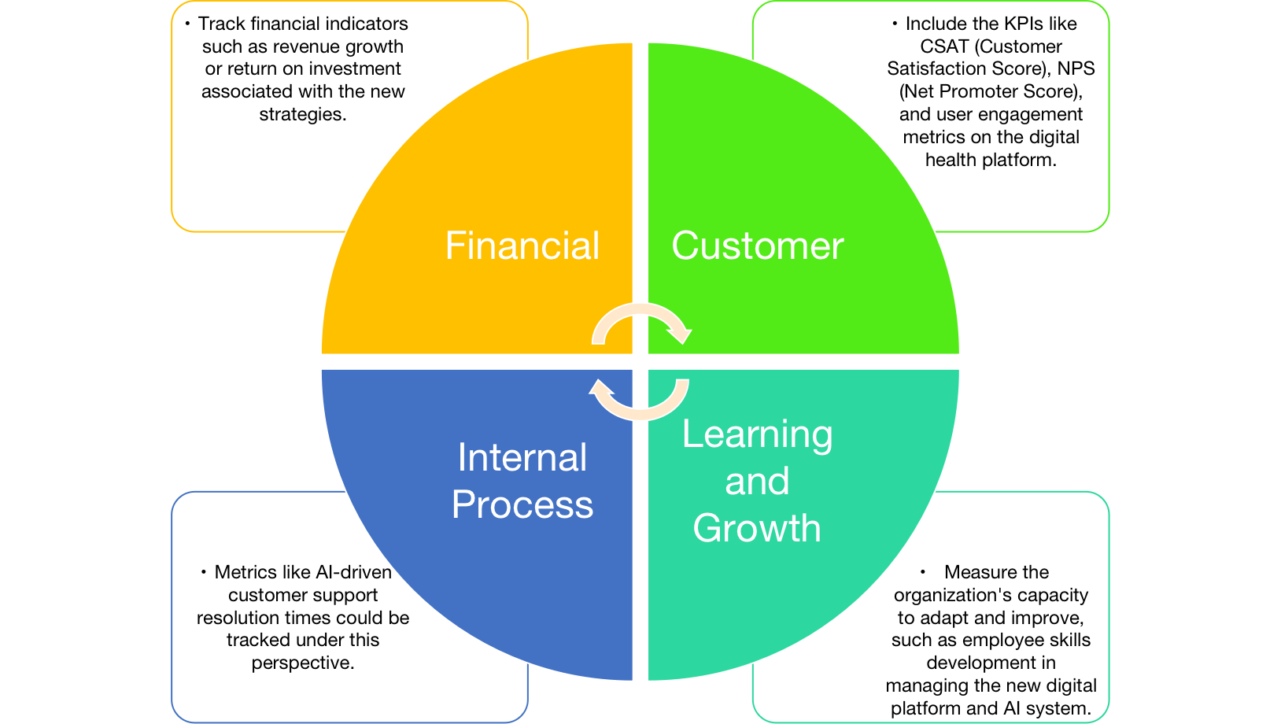
Figure 10 BSC Model for KPIs
In monitoring the effectiveness of the newly implemented strategies, we will apply the Balanced Scorecard (BSC) model. This model allows us to track performance from multiple perspectives, providing a holistic view of the progress and success of our strategic objectives. The BSC focuses on four perspectives: Financial, Customer, Internal Process, and Learning & Growth.

8.1 Financial Metrics
The financial perspective will focus on traditional financial performance measures to assess if the strategic changes are contributing positively to the bottom line. Key indicators such as revenue growth and return on investment (ROI) associated with the newly implemented strategies (Personalized Digital Health Platform and AI-Driven Customer Support) would be tracked. Positive trends in these financial metrics would be a strong indication that these strategies are beneficial from a financial standpoint.

8.2 Customer Metrics
The customer perspective examines how well Johnson & Johnson is serving its customers and how customers perceive the company. KPIs such as CSAT (Customer Satisfaction Score), NPS (Net Promoter Score), and user engagement metrics on the digital health platform are considered here.
High CSAT scores are generally indicative of customer loyalty, leading to increased revenue and growth (Dawes et al., 2021). NPS score serves as an indicator of overall customer satisfaction and loyalty, and a higher NPS often correlates with the growth rate of a company (Baehre et al., 2018). User engagement on the digital health platform, measured by parameters such as the number of active users, session length, and bounce rate, can indicate customer retention (Borghouts et al., 2021).

8.3 Internal Process Metrics
The internal process perspective focuses on the key processes that need to be excelled at to achieve the customer and financial objectives. Here, we will measure the resolution time as a KPI to assess the effectiveness of the new AI-driven customer support system. Decreased resolution times, a likely outcome of the AI implementation (Buhalis & Moldavska, 2022), would signify improved customer service efficiency and higher customer satisfaction.

8.4 Learning and Growth Metrics
The learning and growth perspective provides insight into the organization's capacity to learn, innovate, and improve. This could involve tracking metrics that measure employee skills development, particularly in managing the new digital platform and AI system. Successful training and skill development in these areas would be essential for the effective operation and ongoing improvement of these new strategic initiatives. In the long run, this capacity for learning and growth will be crucial for maintaining a competitive edge in the evolving healthcare industry.

Conclusion
In summary, the dynamic changes occurring in the healthcare sector, propelled by the impact of the COVID-19 pandemic and swift digital advancements, require an inventive approach to providing customer care. Based on a thorough evaluation of Johnson & Johnson's capabilities, market position, and customer care effectiveness, we recommend the implementation of a strategic approach that combines Personalized Digital Health Platforms and AI-driven Customer Support. The implementation of this dual strategy is in line with the organization's dedication to improving health outcomes. It also addresses the increasing consumer expectations for digital and personalized services. Moreover, it effectively utilizes Johnson & Johnson's technological expertise and strong financial position.

Recommendations
In light of the identified trends, competitive forces, and SWOT analysis, Johnson & Johnson should prioritize the "AI-Driven Customer Support" and "Personalized Digital Health Platform" strategies. These proposed strategies align with the rising consumer demand for personalized, prompt, and digitally-enabled healthcare services, and thus position Johnson & Johnson favorably in the evolving healthcare market.
To facilitate the successful execution of these strategies, Johnson & Johnson must formulate a comprehensive implementation plan. This plan needs to articulate the necessary resources, set achievable timelines, assign responsibilities, and delineate key performance indicators (KPIs) to assess progress. Concurrently, Johnson & Johnson may need to recalibrate its operational and organizational structures, infusing digital technology and innovation into its core operations.
The proposed transition towards a digitally-focused strategy carries several critical implications for Johnson & Johnson. First, the organization will need to invest heavily in employee training and development, nurturing a digital-first mindset across all organizational levels. This training will not only enhance digital competencies within the workforce but also prepare the staff for the impending technological transformation.
Second, the transition may necessitate modifications to Johnson & Johnson's organizational structure. This may include establishing dedicated teams or departments for digital health initiatives, instilling a culture of innovation, and promoting cross-functional collaboration. These changes will ensure that the organization is structurally aligned with its strategic goals, thus facilitating efficient strategy execution.
Lastly, potential risks associated with these recommendations need to be proactively managed. These may include resistance to change, data security concerns, and potential technology failures. Johnson & Johnson must build robust risk mitigation strategies to address these challenges effectively and promptly. This may include conducting regular risk assessments, ensuring stringent data security measures, and fostering an open, inclusive organizational culture that embraces change.

References
Javaid, M. and Haleem, A., 2019. Industry 4.0 applications in medical field: A brief review. Current Medicine Research and Practice, 9(3), pp.102-109. https://www.sciencedirect.com/science/article/abs/pii/S2352081719300418
2023 Report of unscheduled material events or corporate event. Johnson & Johnson's
https://johnsonandjohnson.gcs-web.com/node/51721/html
Paul, S., Riffat, M., Yasir, A., Mahim, M.N., Sharnali, B.Y., Naheen, I.T., Rahman, A. and Kulkarni, A., 2021. Industry 4.0 applications for medical/healthcare services. Journal of Sensor and Actuator Networks, 10(3), p.43.
https://www.mdpi.com/2224-2708/10/3/43
EZHILMARAN, M.K., 2019. Marketing Strategy of Johnson & Johnsons Baby Products In Chennai City–An Overview. Think India Journal, 22(10), pp.7878-7890. https://thinkindiaquarterly.org/index.php/think-india/article/download/13034/8304
Tung, F.C., Chang, S.C. and Chou, C.M., 2008. An extension of trust and TAM model with IDT in the adoption of the electronic logistics information system in HIS in the medical industry. International journal of medical informatics, 77(5), pp.324-335.
https://www.sciencedirect.com/science/article/abs/pii/S1386505607001219
Nau, D., 2022. The era of telehealth pharmacy practice. Journal of the American Pharmacists Association, 62(1), pp.13-14.
https://www.japha.org/article/S1544-3191(21)00490-8/fulltext
Lee, Y.H., Lu, T.E., Yang, C.C. and Chang, G., 2019. A multilevel approach on empowering leadership and safety behavior in the medical industry: The mediating effects of knowledge sharing and safety climate. Safety Science, 117, pp.1-9.
https://www.sciencedirect.com/science/article/abs/pii/S0925753516306683
Sharma, A., Kumar, D. and Arora, N., 2023. Risk assessment for pharmaceutical industry in uncertain environment: An integrated multi-criteria decision-making approach. Decision Making: Applications in Management and Engineering, 6(2), pp.293-340.
https://www.dmame-journal.org/index.php/dmame/article/view/688
Barshikar, R., 2020. Covid 19–Impact and new normal for pharmaceutical industry (Part–I). Journal of Generic Medicines, 16(3), pp.112-119. https://www.researchgate.net/profile/Mrinal-Gupta-4/publication/340211524_COVID-19_and_economy/links/5ebc3928299bf1c09abbb530/COVID-19-and-economy.pdf
Ayati, N., Saiyarsarai, P. and Nikfar, S., 2020. Short and long term impacts of COVID-19 on the pharmaceutical sector. DARU Journal of Pharmaceutical Sciences, 28, pp.799-805.
https://link.springer.com/article/10.1007/s40199-020-00358-5
Almurisi, S.H., Al Khalidi, D., AL-Japairai, K.A., Mahmood, S., Chilakamarry, C.R., Kadiyala, C.B.N. and Mohananaidu, K., 2020. Impact of COVID 19 pandemic crisis on the health system and pharmaceutical industry. Letters in Applied NanoBioScience, 10(2), pp.2298-2308.
https://www.researchgate.net/profile/Chaitanya-Chilakamarry-2/publication/346719081_Impact_of_COVID_19_Pandemic_Crisis_on_the_Health_System_and_Pharmaceutical_Industry/
2022 Annual Report. Johnson & Johnson's https://www.investor.jnj.com/asm/2022-annual-report
Lee, S.M. and Lee, D., 2021. Opportunities and challenges for contactless healthcare services in the post-COVID-19 Era. Technological Forecasting and Social Change, 167, p.120712.
Khan, M.M.R. and Basak, K., 2021. Shifts in pharma-marketing trends in post COVID-19 era. International Journal of Multidisciplinary: Applied Business and Education Research, 2(2), pp.108-114.
http://www.ijmaberjournal.org/index.php/ijmaber/article/view/47
Ding, B., 2018. Pharma Industry 4.0: Literature review and research opportunities in sustainable pharmaceutical supply chains. Process Safety and Environmental Protection, 119, pp.115-130.
https://www.sciencedirect.com/science/article/abs/pii/S0957582018303720
Khiong, K., 2022. Impact and Challenges of Digital Marketing in Healthcare Industries during Digital Era and Covid-19 Pandemic. Journal of Industrial Engineering & Management Research, 3(5), pp.112-118.
https://www.jiemar.org/index.php/jiemar/article/view/408
David, B., Wolfender, J.L. and Dias, D.A., 2015. The pharmaceutical industry and natural products: historical status and new trends. Phytochemistry Reviews, 14, pp.299-315.
https://link.springer.com/article/10.1007/s11101-014-9367-z
Taylor, D., 2015. The pharmaceutical industry and the future of drug development.
https://books.rsc.org/books/redir?redir=https%3A%2F%2Fpubs.rsc.org%2Fen%2Fcontent%2Fchapterhtml%2F2015%2F9781782622345-00001%3Fisbn%3D978-1-
DiMasi, J.A., Grabowski, H.G. and Hansen, R.W., 2016. Innovation in the pharmaceutical industry: new estimates of R&D costs. Journal of health economics, 47, pp.20-33.
https://www.sciencedirect.com/science/article/abs/pii/S0167629616000291
Hayler, J.D., Leahy, D.K. and Simmons, E.M., 2018. A pharmaceutical industry perspective on sustainable metal catalysis. Organometallics, 38(1), pp.36-46.
https://pubs.acs.org/doi/abs/10.1021/acs.organomet.8b00566
Zamiela, C., Hossain, N.U.I. and Jaradat, R., 2022. Enablers of resilience in the healthcare supply chain: A case study of US healthcare industry during COVID-19 pandemic. Research in Transportation Economics, 93, p.101174.
https://www.sciencedirect.com/science/article/pii/S0739885921001463
Schuhmacher, A., Gassmann, O. and Hinder, M., 2016. Changing R&D models in research-based pharmaceutical companies. Journal of translational medicine, 14(1), pp.1-11.
https://translational-medicine.biomedcentral.com/articles/10.1186/s12967-016-0838-4?source
2023 Proxy Statement. Johnson & Johnson's https://www.investor.jnj.com/asm/2023-proxy-statement
DeAngelis, C.D. and Fontanarosa, P.B., 2008. Impugning the integrity of medical science: the adverse effects of industry influence. Jama, 299(15), pp.1833-1835. https://www.iied.org/sites/default/files/pdfs/migrate/9189IIED.pdf?
Brennan, T.A., Rothman, D.J., Blank, L., Blumenthal, D., Chimonas, S.C., Cohen, J.J., Goldman, J., Kassirer, J.P., Kimball, H., Naughton, J. and Smelser, N., 2006. Health industry practices that create conflicts of interest: a policy proposal for academic medical centers. Jama, 295(4), pp.429-433. https://jamanetwork.com/journals/jama/article-abstract/202261
Hartley, A., 2019. Exclusive: Johnson & Johnson's Katherine Amos discusses her BEPS 2.0 proposal. International Tax Review. https://www.proquest.com/docview/2341186944?pq-origsite=gscholar&fromopenview=true
Mak, K.K. and Pichika, M.R., 2019. Artificial intelligence in drug development: present status and future prospects. Drug discovery today, 24(3), pp.773-780. https://www.sciencedirect.com/science/article/abs/pii/S1359644618300916
Ahmed, Z., Mohamed, K., Zeeshan, S. and Dong, X., 2020. Artificial intelligence with multi-functional machine learning platform development for better healthcare and precision medicine. Database, 2020, p.baaa010. https://academic.oup.com/database/article/doi/10.1093/database/baaa010/5809229
Yang, Z., Xia, S. and Feng, S., 2022. Network information security platform based on artificial intelligence for the elderly’s health “Integration of Physical, Medical, and Nursing Care”. Computational and Mathematical Methods in Medicine, 2022. https://www.hindawi.com/journals/cmmm/2022/5975054/
Holzinger, A., Langs, G., Denk, H., Zatloukal, K. and Müller, H., 2019. Causability and explainability of artificial intelligence in medicine. Wiley Interdisciplinary Reviews: Data Mining and Knowledge Discovery, 9(4), p.e1312. https://wires.onlinelibrary.wiley.com/doi/full/10.1002/widm.1312
Amann, J., Blasimme, A., Vayena, E., Frey, D. and Madai, V.I., 2020. Explainability for artificial intelligence in healthcare: a multidisciplinary perspective. BMC medical informatics and decision making, 20(1), pp.1-9. https://bmcmedinformdecismak.biomedcentral.com/articles/10.1186/s12911-020-01332-6
Ahuja, A.S., 2019. The impact of artificial intelligence in medicine on the future role of the physician. PeerJ, 7, p.e7702. https://peerj.com/articles/7702/
Marks, P. and Schuchat, A., 2021. Joint CDC and FDA statement on Johnson & Johnson COVID-19 vaccine. US Food & Drug Administration. https://www.notofman.com/wp-content/uploads/2022/05/Joint-CDC-and-FDA-Statement-on-Johnson-Johnson-COVID-19-Vaccine-FDA
Vogenberg, F.R., 2019. US healthcare trends and contradictions in 2019. American health & drug benefits, 12(1), p.40. https://www.ncbi.nlm.nih.gov/pmc/articles/PMC6404804/
James, M.M.A., Kee, D.M.H., Xian, T.H., Han, K.C., Ching, K.K. and Alshammari, M.S., 2019. Johnson & Johnson’s product safety issues and ways the company can address those issues. Asia Pacific Journal of Management and Education (APJME), 2(3), pp.7-18. https://ejournal.aibpmjournals.com/index.php/APJME/article/view/623
Alhosnai, K., Kharbanda, K., Almazrouei, H.S., Alzaabi, A.I., Aldhanhani, W., Mostafa, S., Alhajiri, S.M. and Nobanee, H., 2021. Financial analysis of Johnson & Johnson in light of the COVID-19 vaccination research developments. Available at SSRN 3896177. https://papers.ssrn.com/sol3/papers.cfm?abstract_id=3896177
Ullah, N., 2021. A Comparative Analysis between Unilever and Johnson & Johnsons. https://mpra.ub.uni-muenchen.de/108582/
Wang, X., 2022. Stocks Valuation of Johnson & Johnson (J&J): Analysis of Ongoing Risks of Pharmaceuticals Corporations in Post-Pandemic Era. Highlights in Business, Economics and Management, 1, pp.36-40. https://drpress.org/ojs/index.php/HBEM/article/view/2315
Gopal, G., Suter-Crazzolara, C., Toldo, L. and Eberhardt, W., 2019. Digital transformation in healthcare–architectures of present and future information technologies. Clinical Chemistry and Laboratory Medicine (CCLM), 57(3), pp.328-335. https://www.degruyter.com/document/doi/10.1515/cclm-2018-0658/html
Shahzad, A., Hassan, R., Abdullah, N.I., Hussain, A. and Fareed, M., 2020. COVID-19 impact on e-commerce usage: An empirical evidence from Malaysian healthcare industry. Humanities & Social Sciences Reviews, 8(3), pp.599-609. https://www.researchgate.net/profile/Rohail-Hassan/publication/341867520
Lepore, D., Frontoni, E., Micozzi, A., Moccia, S., Romeo, L. and Spigarelli, F., 2023. Uncovering the potential of innovation ecosystems in the healthcare sector after the COVID-19 crisis. Health Policy, 127, pp.80-86. https://www.sciencedirect.com/science/article/pii/S0168851022003098
Hermes, S., Riasanow, T., Clemons, E.K., Böhm, M. and Krcmar, H., 2020. The digital transformation of the healthcare industry: exploring the rise of emerging platform ecosystems and their influence on the role of patients. Business Research, 13, pp.1033-1069. https://link.springer.com/article/10.1007/s40685-020-00125-x
Lee, D. and Yoon, S.N., 2021. Application of artificial intelligence-based technologies in the healthcare industry: Opportunities and challenges. International Journal of Environmental Research and Public Health, 18(1), p.271. https://www.mdpi.com/1660-4601/18/1/271
Devyania, R.D., Jewanc, S.Y., Bansal, U. and Denge, X., 2020. Strategic impact of artificial intelligence on the human resource management of the Chinese healthcare industry induced due to COVID-19. IETI Transactions on Economics and Management, 1(1), pp.19-33. https://paper.ieti.net/tem/2020V1S1
Oliveira, M., Zancul, E. and Fleury, A.L., 2021. Design thinking as an approach for innovation in healthcare: systematic review and research avenues. BMJ Innovations, 7(2). https://innovations.bmj.com/content/7/2/491.abstract
Javaid, M. and Haleem, A., 2019. Industry 4.0 applications in medical field: A brief review. Current Medicine Research and Practice, 9(3), pp.102-109. https://www.sciencedirect.com/science/article/abs/pii/S2352081719300418
Gunasekeran, D.V., Tseng, R.M.W.W., Tham, Y.C. and Wong, T.Y., 2021. Applications of digital health for public health responses to COVID-19: a systematic scoping review of artificial intelligence, telehealth and related technologies. NPJ digital medicine, 4(1), p.40. https://www.nature.com/articles/s41746-021-00412-9
Le, D.N., Van Le, C., Tromp, J.G. and Nguyen, G.N. eds., 2018. Emerging technologies for health and medicine: virtual reality, augmented reality, artificial intelligence, internet of things, robotics, industry 4.0. https://www.mdpi.com/1660-4601/18/1/271
Dawes, J., Stocchi, L. and Dall’Olmo-Riley, F., 2020. Over-time variation in individual’s customer satisfaction scores. Internation https://journals.sagepub.com/doi/abs/10.1177/1470785320907538
Baehre, S., O’Dwyer, M., O’Malley, L. and Lee, N., 2022. The use of Net Promoter Score (NPS) to predict sales growth: insights from an empirical investigation. Journal of the Academy of Marketing Science, 50(1), pp.67-84. https://link.springer.com/article/10.1007/s11747-021-00790-2?fbclid=IwAR1_IllZZ3n2R7uUQl-WtrttDhJPmaqPIGRi6l7F-PE48rF4xuJIBV5R3VY
Borghouts, J., Eikey, E., Mark, G., De Leon, C., Schueller, S.M., Schneider, M., Stadnick, N., Zheng, K., Mukamel, D. and Sorkin, D.H., 2021. Barriers to and facilitators of user engagement with digital mental health interventions: systematic review. Journal of medical Internet research, 23(3), p.e24387. https://www.jmir.org/2021/3/e24387/
Buhalis, D. and Moldavska, I., 2022. Voice assistants in hospitality: using artificial intelligence for customer service. Journal of Hospitality and Tourism Technology, 13(3), pp.386-403 https://www.emerald.com/insight/content/doi/10.1108/JHTT-03-2021-0104/full/html
MU, N., Mehar, J.G., Mudliar, S.N. and Shekh, A.Y., 2019. Recent advances in microalgal bioactives for food, feed, and healthcare products: commercial potential, market space, and sustainability. Comprehensive reviews in food science and food safety, 18(6), pp.1882-1897. https://ift.onlinelibrary.wiley.com/doi/abs/10.1111/1541-4337.12500
Thelen, P.D. and Formanchuk, A., 2022. Culture and internal communication in Chile: Linking ethical organizational culture, transparent communication, and employee advocacy. Public Relations Review, 48(1), p.102137. https://www.sciencedirect.com/science/article/pii/S0363811121001302

