Are Kenfig sand dunes under-stabilised, or over-stabilised?

Introduction
The sand dune system is a dynamic ecosystem, this means their movement, which is often attributed to aeolian processes (NRW, 2023), can be either beneficial or detrimental. This is because it can either create new land and habitats or bury them. This study will determine whether the dune system needs further stabilization or is already stabilized. In order to do this, the study will determine is the dune system has sufficient vegetation cover. The vegetation cover is key to understanding the maturity of the dune system (Gao, et al., 2023) as a healthy level of vegetation will bind the sand particles, promoting stability and preventing erosion.
This is important to know in order to manage the site. This will help the site manager understand how to effectively manage resources such as where there might be a need for intervention or where to plant infrastructure development. In addition to this, it is necessary to understand the stage of the sand dune stabilization (Gao, et al., 2023) in order to protect its ecosystems. Uncontrolled sand movement can smother (Key, 2024) and bury existing vegetation and disrupt the ecosystem.

Location
East of Swansea, running between Port Talbot and Porthcawl is Kenfig sand dune system. Kenfig has been entitled as a Site of Special Scientific Interest (SSSI) (Cottam, 2019) and a Special Area of Conservation (SAC) due to its crucial role in protecting biodiversity. Due to its statuses Kenfig dunes are currently being managed in order to preserve its natural ecosystem and beauty (NRW, 2023). The study will take place along one of the many footpaths as it is a clear transect of the dune system. This is shown below in Figure 1.

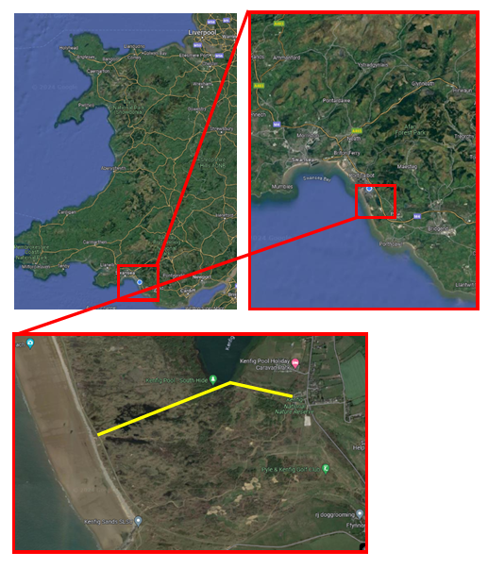

Figure 1 – Site Location (Google Maps, 2024)

Rationale
To understand how to manage a sand dune system it is important to understand how they form and how they survive. Sand dunes need various conditions to survive these include a beach with a large tidal range (Internet Geography, 2024). This is important as the beach needs to be exposed for long periods of time so that the wind can blow the sand back to create the dune. This also means that there has to be an abundant supply of sand as it takes a vast amount of sand (Internet Geography, 2024) and sediment to create a whole dune system. Where the sediment will come from will vary per dune system.
The aeolian processes also have to be very strong to transport such large quantities of sand from the beach to the dunes through the process of called Saltation (Sloss, et al., 2012 ). Saltation occurs when grains of sand are bounced along the surface (Sloss, et al., 2012 ) of the beach by the wind. Then sand dunes start to form when an obstacle causes wind speeds to reduce and then deposit the sand on the lee side. These obstacles can include seaweed, driftwood or even litter.
Other processes that also play a major role in the formation of sand dunes is vegetation. Vegetation has a major role in both helping to trap more sediment (Mudd, et al., 2010) in the dune and holding it together to prevent erosion. In time, pioneer plant species (Mudd, et al., 2010) such as Saltwort and Marram Grass begin to establish and colonise themselves on dunes that form closest to the shore, these are known as embryo dunes. These species have adapted to survive in harsh environments that may include a lack of: nutrients, freshwater and soil and high winds.
Dune slacks can also form from a blowout (Dynamic Dunescapes, n.d.). A blowout is a trough-shaped hollow formed in a dune. This is formed if there is an increased traffic or trampling, by humans and animals, which erode away the plants and sand. Then because the dune is left exposed with little vegetation aeolian erosion (Geology, 2024) occurs; hollowing out a trough in the dune and therefore forming a blow-out.
As the distance from the sea increases the dunes will increase in height because a greater amount of plant species will colonise there. This leads to plant succession. At the back of a dune system grey dunes (Dynamic Dunescapes, n.d.) will be present. These have a greater biodiversity due to better environmental conditions. These include, less salt, deeper soils, more fresh water, less salt, lower wind speeds and more organic nutrients from animals. This can result in climate climax vegetation like Oak trees.
In order to study whether the dunes are over or under stabilised the following hypothesis will be tested:
1. How does plant height increase with distance from the sea?
2. How does plant biodiversity change with distance from the sea?
3. How does percentage cover change with distance from the sea?

Methodology
To test the 3 hypothesis’ and therefore understand if Kenfig dunes are over or under stabilised, a 1.5km transect will be run along the dune system from the coastal path and tests will be conducted every 100m to gain 15 testing sites. This is known as systematic sampling (Hayes, 2024) and is a straightforward method that will represent clearly how the sand dunes progress along the transect. This will also mean there will be no bias and the results will be more representative. One drawback to this method is that it is along a path that may contain slacks of other features that may skew the results.
Prior to arrival at the site the following apparatus will be collected:
- Measuring tape
- Smart phone camera
- Meter ruler
- Ranging rod
- Quadrat
Once the site was measured out using a tape measure (as seen in figure 2) and marked by the ranging rod, opportunistic sampling (Nikolopoulou, 2022) was used to test hypothesis 1.
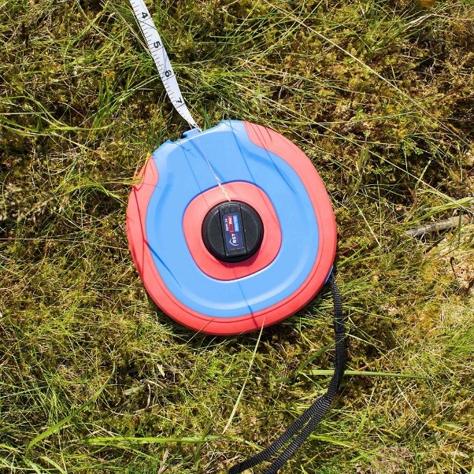

Figure 2 – Tape Measure
To test it the most common plant, shortest plant and tallest plant at the site was identified, measured using the meter rule (from the base of the plant to the tallest point) and recorded. It is expected that the plant height will increase along the dune system as distance from sea increases. In the first stage of the dune system, it is expected that the plant height will be relatively short. This is because they will be exposed to such harsh conditions. Therefore, most of the plants, energy will be expended on survival and not growth.
Subsequently, hypothesis 2 was tested by measuring 2 meters along from the ranging rod along the transect and it was noted how many different species were present. These species were then also photographed so they could later be identified. It is expected that in the embryo (Dynamic Dunescapes, n.d.) and foredunes there will be less biodiversity due to harsher conditions. As a result of this very few species can survive and will result in a lack of biodiversity. As distance increases from the sea the hummus of the soil will increase (Yang, 2005), this will mean there is likely to be a wider range of different species and therefore more biodiverse.
Finally in order to test hypothesis 3 a quadrat will be placed next to the ranging rod as seen in figure 3 and it was calculated how many squares had vegetation in them and recorded.
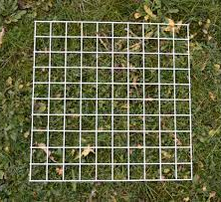

Figure 3 - 10 x 10 Quadrat
When the distance from sea is relatively low, it’s expected that the percentage cover will be low. This is because there will be high activity of Aeolian processes (NRW, 2023) (particularly erosion). This will make it a lot harder for plans and seeds to settle. As a result, there will be fewer plants here with the exception of pioneer plants. Then as distance increases from sea and it is likely to see a higher percentage cover, this will be a result of the dunes being more sheltered. This means, there will be a much lower rate of aeolian erosion (NRW, 2023) and more plants will be found here.

Results and analysis
Hypothesis 1
The results were as expected that on average the plant height increased with distance from sea. This can be shown in Figure 4.

Figure 4 - Average Plant Height Across a Transect
The results show a fairly even relationship with distance from sea and average plant height; site 15 being closest to the sea and site 15 being closest in land. However, there is an anomaly at the third site. An observation was made at site 3 that there was ongoing work and signs of vegetation being cutback this can be seen in Figure 5. This may have been a form of managing the area as it is in close proximity to Kenfig Pool which is a recreational area.
The correlation between plant height and distance form sea may be from, reduced salinity (Yang, 2005). Salt spray will reduce with distance from the sea will create harsh conditions for most plants. Salt can dehydrate plants and damage their tissues (Jauron, 2024) making it less likely for them to grow to their full height and potential. As distance from the sea increases, the salinity of the soil and air reduces, creating a more favourable environment for taller plants to thrive.
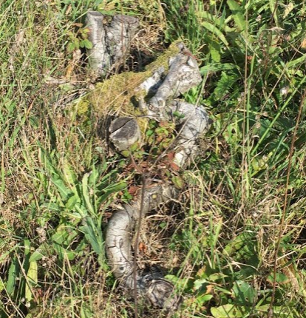

Figure 5 - Tree Stump

Hypothesis 2
Hypothesis 2 was investigating the relationship between the species abundance and distance from sea. The results from the method used support this with minor anomalies that are expected in fieldwork studies. This is shown in figure 6.

Figure 6 - Species Abundance Relationship with Distance from Sea

There are two anomalies present at site 4 and 8 similarly to hypothesis 1 the site 4 anomaly was likely due to human intervention and management of the site where as site 8 was more noticeably water logged and bog like. This will also effect the biodiversity and species abundance as only certain species can survive in this type of habitat (National Geographic, 2024).
Hypothesis 3
Hypothesis 3 studies the correlation with distance from sea and percentage cover of vegetation. Although there was an expectation for a clear correlation between distance form sea and percentage cover, this wasn’t displayed in the results. The results can be demonstrated in Figure 8 and Figure 9.

Figure 8 - Percentage Cover Change Across Sites

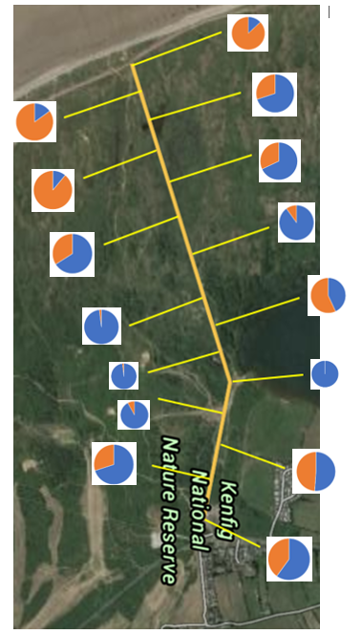

Figure 9 - Percentage Cover of Vegetation at Each Site
This maybe be as a result of the methodology used for this hypothesis. For example, there maybe have been too much subjectivity in particular with vegetation that has complex or overlapping foliage. This can affect the accuracy of the data and may explain the lack of trend in the results.
In addition to this, a single quadrat only provides a data set for a relatively small area. To get a more accurate representation of the entire vegetation cover, multiple quadrats need to be placed and sampled across the study site. If this hypothesis were to be retested then the quadrat would be placed down multiple times across the testing site (Mackenzie, 2019).
Furthermore, quadrats are a valuable tool for estimating vegetation cover, but their limitations should be acknowledged. For more robust data, using multiple quadrats, considering factors like quadrat size and potentially incorporating other sampling methods would improve the accuracy of the test.

Conclusion

All the hypothesis show a clear indication of sand dune succession across the transect. This shows that the management techniques used on the site are appropriate and allowing the site to progress naturally and allowing the ecosystem to develop. All the results were as expected and follow the progression of the system excluding the second hypothesis. However this was due to a fault in the methodology.

References
Cottam, L., 2019. SSSI Definition: what is it and what does it mean for conservation and development?, s.l.: Woodland Trust.
Dynamic Dunescapes, n.d. Dune Lifecycle. [Online]
Available at: https://dynamicdunescapes.co.uk/about-sand-dunes/dune-lifecycle/
[Accessed 12 03 2024].
Gao, J., Kennedy, D. M. & McSweeney, S., 2023. Patterns of vegetation expansion during dune stabilization at the decadal scale. Wiley, 48(15), pp. 3059-3073.
Geology, 2024. National Park Sciences. [Online]
Available at: https://www.nps.gov/subjects/geology/aeolian-landforms.htm
[Accessed 12 03 2024].
Google Maps, 2024. Google Maps. [Online]
Available at: https://www.google.com/maps/@51.5969548,-4.0696597,10893m/data=!3m1!1e3?entry=ttu
[Accessed 10 January 2024].
Hayes, A., 2024. Systematic Sampling, s.l.: Investopia.
Internet Geography, 2024. How are sand dunes formed?, s.l.: s.n.
Jauron, R., 2024. Minimize Deicing Salt Damage in the Home Landscape, Ames: Iowa State University.
Key, R., 2024. Coastal sand dunes, s.l.: Buglife.
Mackenzie, R. J., 2019. Repeatability vs. Reproducibility, s.l.: Technology Networks.
Mudd, S. M., D'Alpaos, A. & Morris, J. T., 2010. How does vegetation affect sedimentation on tidal marshes? Investigating particle capture and hydrodynamic controls on biologically mediated sedimentation. Earth Surface.
National Geographic, 2024. Bog, s.l.: National Geographic.
Nikolopoulou, K., 2022. What Is Convenience Sampling? | Definition & Examples. Scribbr.
NRW, 2023. Coastal sand dunes in Wales, s.l.: Natural Resources Wales.
NRW, 2023. Sites of special scientific interest (SSSI): responsibilities of owners and occupiers, s.l.: Natural Resources Wales .
Sloss, C. R., Hesp, P. & Shepherd, M., 2012 . Coastal Dunes: Aeolian Transport. Knowledge Project, 3(10), p. 21.
Yang, B., 2005. Developmental characteristics of aeolian dunes and environmental changes in the adjoining region of Puruogangri ice sheet, North Tibetan Plateau, s.l.: Research Gate.

