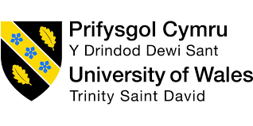

Managing Enterprise
In the 21st Century
(Reflective Report)

Natasha Coeur de Lion
1814417

Module: BMSK4006

Lecturer: Dr Husam Hemi

Introduction
The aim of this reflective report is to demonstrate my self-awareness and learning experience, that I have undertaken during the team business startup presentation. I will also cover my development of my personal skill set for employment or self-employment. To construct my reflective report, I will integrate academic viewpoints such as models and theories to explain my observation in team working.

To begin my reflection, Gibb’s Reflective Learning Cycle will be my main focal point on my learning journey. Professor Graham Gibbs first publish his insight on reflective learning cycle in 1998. The purpose of this cycle is to assist individuals to make sense of situations in a professional or personal capacity, so they can build on their resilience and what they could do better in the future.

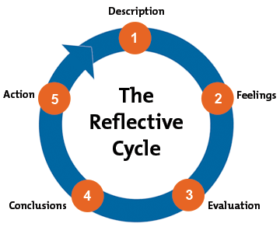
Figure 1 (Gibb’s Reflective Learning Cycle, 1998)

Description
We were instructed to form a group to build a business or a startup plan, and present to the class as well as to the lecturer and senior staff. Three weeks into the course, and still feeling anxious of my academic abilities after a long pause in my education and being a mother to an active four-year-old it became overwhelming. Despite of this it was a challenge that I needed to overcome, to realise my full potential and an opportunity to connect with like-minded students. The forming of the group was relatively easy, as a few of us had been congregated at the front of the class and decided to be grouped. Our group comprise of four (three females and one male) for the purpose of this reflective report I will refer them as member one (me, team leader), member two, member three and member four. In order to get a greater understanding of my learning journey, I will be examining the following areas.

- Communication Skills
Communication is the ability for people to verbally or non-verbally express information and ideas (Phutela,2015). Fundamentally, it is part of team working life. Motivation and attitude are key to achieving productivity in an organisation. With careful consideration how to convey when speaking and actively listening, will develop accomplishments and relationships in our interpersonal skills.

- Team working
Individuals collaborating to achieve a specific task or goal, a particular skill set, or knowledge needed to deliver a task. Moreover, effective team work is reflected in the culture and setting within an organisation, (Ellis,2018).

- Ability to Manage and Lead
A key role for a team leader, who has gained the trust and respect of the team by fulfilling this role effectively, and ensuring the team has the empowerment to carry out procedures, following through decision and get the task done, (Crawford, Kydd & Riches, 1997). Finding ways of doing things differently and creatively, but support is needed rather than blaming.

- Personal Attributes
Character and skills set are developed through our personal and professional journey. To strengthen and to gain a real insight of who we are. Our attributes can also influence others.

Feelings
Now that the group is underway, my emotions were still unsettled of intense strain by the thought of presenting in front of others, a topic I had no idea where to begin, and furthermore in a team that I was unsure of their skills set abilities.

- Communications
I felt the communication had been very effective throughout the duration of the task, as soon as we were teamed up, team member two set up a WhatsApp group and personal emails exchanged. Moving forward communication was frequent, a feeling of relief came upon me. By week four this is when I noticed the true dynamics of the team started to come through, still with no concise business plan to present, I became overwhelmed and frustrated. The team was showing signs of procrastination, my focus now was to ensure we deliver a presentation. Surprisingly week five, team member three came with an idea inspired by a funeral she attended. As there was no real concrete idea, I decided to air my views and concerns on the group text. Soon after, I came across the start-up plan put together by team member three. A flower stall, The Walk Away Florist. Pondering on this idea, we agreed to build our presentation based on a start-up plan.

- Team working
As a team, we worked well we established what we wanted to achieve from this presentation and efforts will be required from all, but most importantly communication to be open and honest. Throughout the duration of the task, team members true characters started to show. For instance, team member three came across very dominant with her viewpoints unrelated to the presentation, so I had to always pull back the conversation to the relevance of what we are here to achieve. Team member four did not put as much effort and was happy to go along with the majority, I felt real frustration as every so often I was trying to catch his attention to get his opinion, but at times it was very minimal. On occasions to remain mentally calm, I had to step back and visualize the presentation coming together perfectly. I personally found working alongside team member two very fitting, we were both committed in getting things done, we had become taskmasters.

- Ability to Manage and Lead
The role of the team leader was not by choice, moreover, the result of no one willing at that moment to take the lead; however, I wanted to seize this opportunity to improve on my interpersonal skills, as well as to boost my inner confidence. At the start of the course, I had doubts of my academic abilities the feeling of anxiousness was at an all-time high. Sporadically, that feeling does resurface. I captained my role to the best of abilities.
I would communicate with the team regularly with motivational captions to increase morale, detailed written communication through group WhatsApp and follow up email reminders, to ensure we were on track with presentation. My aim was to work with their strength and support each other with our weaknesses. It did come to light both team members three and four was not proficient in PowerPoint, even though I did encourage them to work on their segment of the presentation. With much welcome relief team member two and I were competent in this technical area, shared leadership was in progress to assist with the micromanaging that had been displayed.

- Personal Attributes
To showcase my personal attributes, I felt enthusiastic and confident to do so. Taking on the team leader role I wanted to exhibit a few of my qualities for the key requirements for this task, to hopefully influence the team attitude. For instance, the importance of being punctual, the ability to organise effectively that leads to preparation, adapting to new concepts, hardworking, sharing the same vision to remain committed, be dedicated and focus, but importantly honesty and integrity as a team.

Evaluation/Analysis
Week seven approaches team member two and I were at the final stages of collating information, mainly academic research to compliment the business start-up plan.
The interpersonal communication between the team was very positive, at times repetitive, primarily with team member four when it came to research his piece on the presentation, unique selling point (USP). As there was no real effort to do the ‘homework’. Research suggests, internal factors can disturb the message process known as the perceptual filters, (Morgan,2017). How the information is being process and then translated. However, there could be other contributing factors such as, lack or no experience in that specific area. Coupled with Professor Albert Mehrabian experiment, we are influenced by non-verbal communication, (Webb,2010). illustrated in figure 2.
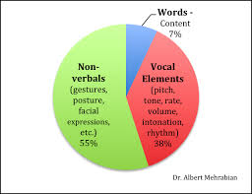
Figure 2 (Professor Albert Mehrabian Model, 1960)
This is what I think, as both theories have weight, non-verbal communication speaks volumes. It is of equal importance to consider when communicating with those of cultural backgrounds.
Teamworking or workplace collaboration is increasingly common, I was enlightened by my research as well as lectures, that it is not just team performance but the individual roles they play in a team. R. Meredith Belbin, pioneered Belbin’s Team Roles, figure 3.
When teams are formed job roles can relatively be easy to assign to team members. As the task becomes complex then so do the abilities required by individuals. Belbin considered team members potential contribution can be assessed by four traits for example,
- Intelligence
- Dominance
- Self Confidence / Introversion
- Stability / Anxiety
Based on the above traits he identified the team role behavior, described in figure 3.

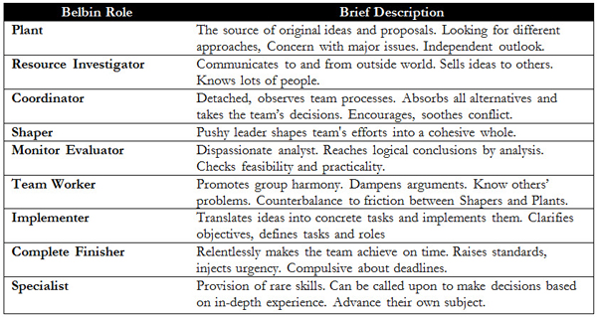
Figure 3 (Belbin Team Role Model, 1969)

The only criticism with regards to Belbin Team Role Model, individuals can hold more than one role according to their abilities or mental strength. Collectively, there could be team members with identical strengths, drive and passion. This then could lead to team conflict, competitiveness and inevitably poor performance.
From reviewing Belbin Team Role Model, I can confidently say I am a Complete/Finisher and Team Worker. Reflecting on my overall contribution to the team it has given me a greater perspective to explore other areas within this model.
I am not a natural born leader, taking the role as the team leader was by choice; however, I felt I had the capabilities to do so, and take accountability for any action for the team. Considering there were elements of micromanaging it was proving difficult to view my point across, without being overpowered by team member three dominance in her views. In team working, individuals develop a sense of belonging and will find ways to demonstrate their full potential. Hierarchy is out and influencing skills are in, (Vries & Korotov, 2010).

Conclusion
A week prior to the presentation. I drafted a comprehensive text of how the presentation will run including attire, and emphasis on props as well as preparation sent via WhatsApp group. Due to commitments team members were unable to meet for a practice run, the pressure was on. I had to trust the team to deliver the presentation.
An hour to our presentation feeling anxious, nerves were kicking in. Speaking in front of people is not my strongest trait, as uncomfortable it may feel a rule for my own personal development to take on new challenges; having said that I was excited. With much relief I was first to present, sure enough I stumbled not because of fear, but the sheer mental exhaustion of micromanaging and collating the presentation. As we progressed through slowly but surely, a sigh of relief. In fairness I was slightly disappointed in the overall delivery of the presentation, due to the lack of knowledge in floristry which was evident by the questions hurled at us. All things considered we accomplished our goal; the outcome would always be the learning experience.

Action Plan
Moving forward, if an opportunity arises for me to become a team leader the below table summarises what is required on my part.

What do I need to learn? | How will I achieve this? | What resources or assistance will I need? | Success Criteria | Review and Completion Date?
Leadership Skills | Participate in further group activities and attend workshop that are leadership focus | Commitment and money | Take on responsibilities and to inspire others | End of 2021
Confidence in my abilities | Take on new challenges, Networking to develop relationships with people who have knowledge | Discipline and more importantly time | Seek new opportunities, making a positive impact and making connections | Ongoing with quarterly review
Team and Empowerment | Allow team members to express ideas and trust individual abilities | Regular team meetings and commitment. | A successful collaborative team | Ongoing
Commercial Awareness | A comprehensive research on the topic. | Business case studies | Thinking strategically, how things can be done differently | End of 2021

Conclusion
In conclusion, my personal skill set that I possess has been reinforced during this task. It has given me a slight boost of confidence that I can lead and collaborate in a group capacity. Should my journey lead me to become my own boss, this experience has made me realise new skills is imperative and enhancing the skills I have, to enable me to seize opportunities with greater confidence.
References
Aritzeta, A., Swailes, S. and Senior, B. (2007). Belbin's team role model: Development, validity and applications for team building. Journal of Management Studies, 44(1).

Crawford, M., Kydd, L. and Riches, C., 1997. Leadership and teams in educational management. McGraw-Hill Education (UK). Available at: https://books.google.co.uk/books?hl=en&lr=&id=aVzlAAAAQBAJ&oi=fnd&pg=PP1&dq=team+working+leadership+management&ots=8rvlDcFuqK&sig=y5uxBdz2bd9PB5pdZrLWJiWrg0M&redir_esc=y#v=onepage&q=team%20working%20leadership%20management&f=false (Accessed at: 03 August 2019)

Ellis, P., 2018. Leadership, management and team working in nursing. Learning Matters. Available at: https://books.google.co.uk/books?hl=en&lr=&id=NT9XDwAAQBAJ&oi=fnd&pg=PT10&dq=effective+team+working+individuals&ots=U1Gu64zS7D&sig=Wq9Pj0P9nFCZZkY_Egx--YfDCXE&redir_esc=y#v=onepage&q=effective%20team%20working%20individuals&f=false (Accessed on: 03 August 2019)

Kets de Vries, Manfred F.R.& Korotov, K. (2010) Developing Leaders and Leadership Development. INSEAD Working Paper No. 2010/77/EFE/IGLC. Available at SSRN: https://ssrn.com/abstract=1684001 or http://dx.doi.org/10.2139/ssrn.1684001 (Accessed on 19 July 2019)

MINDTOOLS. Available at: https://www.mindtools.com/pages/article/reflective-cycle.htm (Accessed 01 July 2019)

Morgan, P. (2017). The Business Students Guide to Study and Employability. UK, Sage Publications Ltd.

Phutela, D., 2015. The importance of non-verbal communication. IUP Journal of Soft Skills, 9(4), p.43.

Webb, L. (2010). The Happy Handbook, A compendium of Modern Life Skills. UK, Grosvenor House Publishing Ltd.

