

Cover Page
Student Name: Precious Grant Whittaker
Student Number: 2412252
Module Code: BMHP5015
Lecturer Name Olufemi Oluranti
Module Name: Changemaker Building My Personal Brand for Sustainable Employment

Personal Band task 1

Introduction

Personal branding involves actively shaping and communicating one’s unique skills, values, strengths, and professional identity to create a distinct reputation among employers and peers (Gandini, 2016). It influences how I am perceived in the workplace and helps differentiate me from other candidates. Strong personal branding is essential for aligning my current experience with my long-term future career goals, particularly as I aim to progress within the health and social care sector (Shepherd, 2005). As I work toward my ambitions, my brand reflects both my existing expertise and the professional direction I am moving toward.
Currently, I work as a Senior Phlebotomist, and my brand is built on clinical competence, patient-centred care, and reliability. I am known for working accurately under pressure, maintaining strict safety standards and building trust with patients and colleagues. These qualities form a strong clinical foundation, but I am now studying a degree in Health and Social Care to broaden my understanding of care management, legislation, and service delivery. My long-term goal is to eventually set up and run my own small rehabilitation unit. where I can combine clinical experience with leadership and service development.

Conclusion
However, there are areas I want to strengthen to achieve this future vision. I would like to develop stronger leadership skill, including decision-making, team management and confidence in guiding others. I also want to gain more experience in rehabilitation settings to understand the operational, regulatory and therapeutic aspects of running a service. By continuing to build and refine my personal brand, I am preparing myself for future business ownership and a more strategic role in health and social care.

Network Map and Rationale task 2

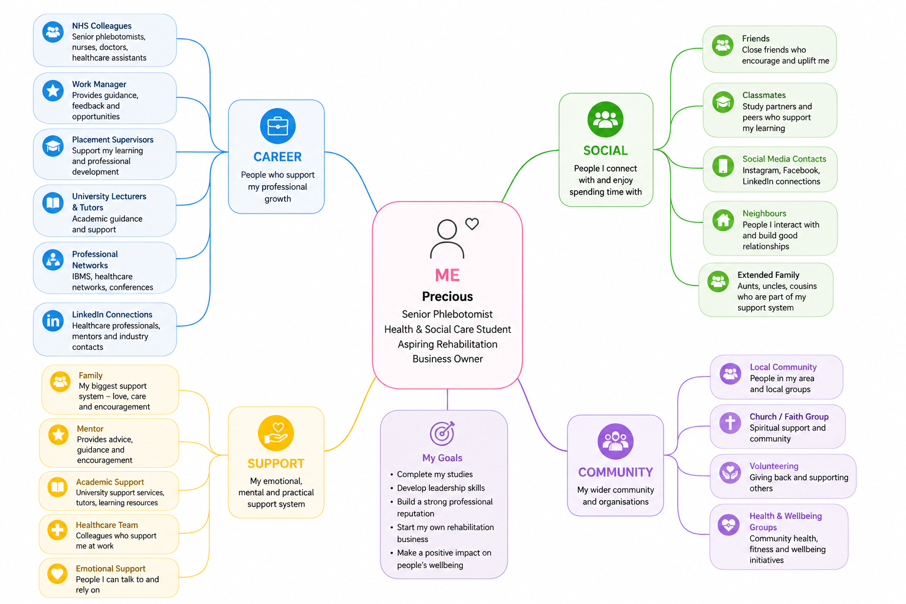

Supporting Rational
My network is best described as hybrid, it combines features of open, selective and closed networks, open because I regularly meet new people through work and community activities, selective because I maintain only a smaller trusted circle of close contacts and closed in the sense that my core support group is stable and rarely changes. This structure allows me to access new opportunities while keeping strong reliable relationships (Granovetter, 1973).
The strongest dimension within my network is career and support networking. As a senior phlebotomist and student in Health and Social Care, I regularly interact with healthcare professionals, tutors and peers who contribute to my learning and professional growth. My support network is also strong because I receive encouragement from family and trusted colleagues. However, my community and bridging social capital could be improved.
Although I communicate with a range of people in healthcare settings, I have limited connections with professionals outside my immediate workplace and academic environment. This may reduce opportunities to gain wider perspectives, professional advice, and future career opportunities. According to Putnam and Robert (2000) social capital is strengthened through participation in wider networks and community engagement.
To improve my network, I plan to attend professional events, engage more with community organisations, and build relationships with individuals in leadership positions. Expanding these connections will help strengthen my confidence, professional identity, and long-term career development.

Task 3- Blog

Access to GP Appointments in England: Challenges and Improvements
Introduction:
Accessing a GP appointment has become one of the most talked-about issues in UK healthcare. Many patients describe spending long periods trying to get through to their GP surgery, only to find that all the appointments have already been taken. This experience is common across England, where demand for primary care has risen sharply in recent years. For many people, navigating long morning phone queues or trying to secure a same-day appointment can feel frustrating, stressful and sometimes disheartening. While GP practices are under increasing pressure, the NHS has introduced several measures to improve access, including online consultation forms, upgraded telephone systems and the NHS App, which allows patients to request help, book appointments and manage their healthcare digitally (Laverty et al., 2022).
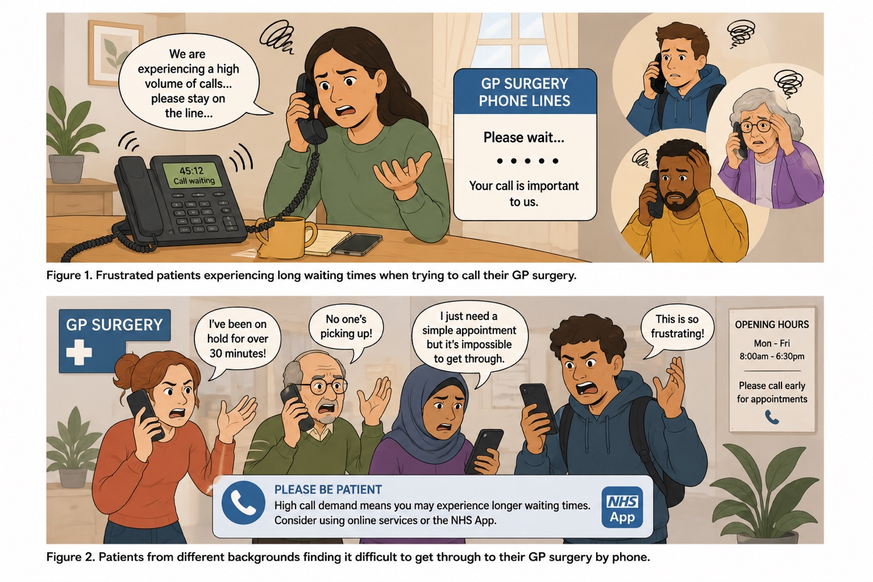
Despite ongoing concerns, recent NHS data shows that GP practices are delivering more appointments than ever before. In November 2023, more than 31.4 million GP appointments were provided across England, around four million more than before the COVID-19 pandemic (NHS England, 2024). Almost 43% of these appointments were booked and attended on the same day, demonstrating that urgent access is still being prioritised. Additionally, nearly 70% of appointments took place within a week of booking, suggesting that most patients are being seen relatively quickly.
To support this growing demand, the NHS has invested in improving communication systems. Around 80% of GP practices have now upgraded their telephone systems, making it easier for patients to join call queues, receive call-back options and avoid the frustration of constant engaged tones. The NHS has also recruited over 34,000 additional staff into general practice teams since 2019, including pharmacists, physiotherapists, mental health practitioners and care coordinators. These roles help ensure that patients are directed to the most appropriate professional, freeing up GP time for more complex cases (NHS England, 2024).
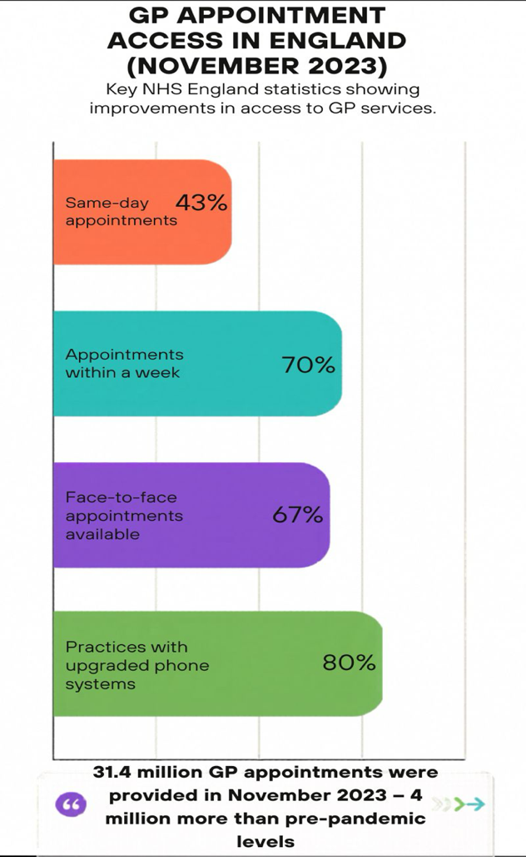

Source: canva
Conclusion
Although challenges remain, efforts to improve access to GP services are beginning to show positive results. By expanding digital services, increasing staffing levels and improving communication systems, the NHS aims to make it easier for patients to receive timely, high-quality care. Continued investment in primary care will be essential to ensure that GP services remain accessible, efficient and responsive to the needs of patients across the UK (NHS England, 2014).

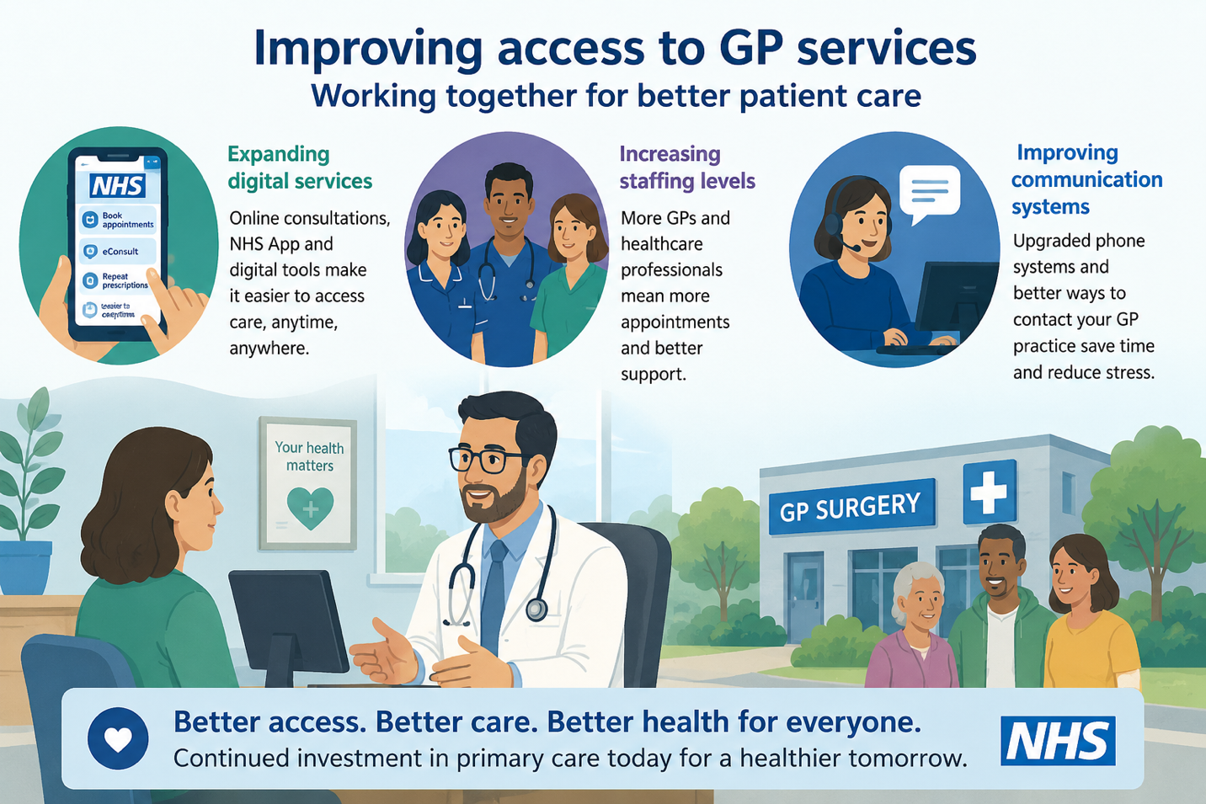

Source: canva

Task 4- NHS Equality and Diversity Quiz
1.What is the primary goal of the NHS Equality, Diversity, and Inclusion Improvement Plan?
The primary goal of the NHS EDI Improvement Plan is to create a fair, inclusive and equitable NHS where all staff can thrive, by reducing inequalities in experience, opportunity and outcomes across the workforce. It aims to embed EDI into everyday leadership, culture and organisational practice so that fairness becomes part of how the NHS operates.
2. How does the NHS EDI Improvement Plan propose to tackle the gender pay gap?
The NHS EDI Improvement Plan tackles the gender pay gap by increasing transparency in pay data, improving women’s representation in senior roles, and ensuring fair, bias free recruitment and promotion processes. It also strengthens access to flexible working and career-development support to remove structural barriers that disproportionately affect women.
3. What is meant by the term ‘intersectionality’ as used in the NHS EDI Improvement Plan?
Intersectionality means recognising that people may have multiple overlapping personal characteristics (such as race, gender, disability, or age) that combine to shape their experiences of advantage or disadvantage. In the plan, it is used to ensure policies and support address the unique, combined barriers some individuals face, rather than treating each characteristic in isolation.
4. Why is it important for the NHS to create a psychologically safe work environment?
A psychologically safe environment allows staff to speak up, raise concerns, and be their authentic selves without fear of retaliation, which improves staff wellbeing, retention, and ultimately patient care quality.
5.How does the NHS EDI Improvement Plan suggest improving the experience of internationally recruited staff
The plan suggests providing dedicated induction support, mentoring, and cultural orientation programmes to help internationally recruited staff integrate effectively and feel valued within the NHS.

6.What role does leadership play in advancing EDI objectives according to the NHS Improvement plan?
Leaders are expected to visibly champion EDI values, hold teams accountable for inclusive behaviours, and embed EDI goals into organisational strategy and everyday practice.
7.Identify one way the NHS EDI Improvement Plan aims to reduce health inequalities with workforce.
One way is by ensuring line managers and supervisors conduct regular, effective wellbeing conversations with their teams utilising the national NHS Health and Wellbeing Framework.
8.Why does the NHS EDI Improvement Plan emphasise the importance of collecting and analysing data on protected characteristics?
The emphasises data collection to ensure NHS boards can track and monitor specific pay gaps, recruitment biases, and career progression disparities. Robust data provides the necessary baseline to design targeted, evidence-based interventions rather than relies on assumptions.
9.Explain how flexible working policies can contribute to equality and inclusion in the NHS workforce.
Collecting and analysing this data helps identify gaps, disparities, and areas where discrimination or disadvantage exists, so actions can be targeted and measured. It provides the evidence needed to design effective policies, track progress, and ensure accountability for improving equality and inclusion.
10.What is one strategy mentioned in the NHS EDI Improvement Plan to combat bullying and harassment in the workplace?
One strategy is implementing clear, zero-tolerance policies alongside better reporting mechanisms, training for all staff on acceptable behaviour, and dedicated support for those who experience bullying or harassment. It also includes holding those responsible to account and fostering a culture where such behaviour is never accepted.

Task 5

A Letter to My Younger Self
Dear Younger precious,
I’m writing to you from many years in the future, carrying the strength, clarity, and emotional understanding that you will one day grow into. when you first begin working in the NHS in the early 1980s, you will face challenges that feel heavy and unfair. You will experience bullying, and when you try to speak up, managers will not always listen. You will witness moments where patients are not cared for as they should be, and you will feel powerless to change what you know is wrong. There will be days when you wake up with a knot in your stomach, not wanting to go to work because the environment feels hostile, draining and unpredictable. I want you to know that your feelings are real, and you deserved better support than you received.
What you cannot yet see is how these experiences will shape your resilience. Over time, you will learn the power of self-awareness recognising your emotions instead of suppressing them. You will develop self-management, learning to stay calm, grounded and professional even when others are unkind. You will grow in empathy, understanding not only your own feelings but the struggles of colleagues and patients. These emotional intelligence skills will become your armour, helping you navigate conflict, protect your wellbeing and support others who feel unheard.
As the NHS evolves, so will you. You will become into a confident, compassionate phlebotomist who treats every patient with dignity and care. You will be the colleague you once needed someone who listens, speaks up, and stands firm against unfairness. Your resilience will become your anchor, and your empathy will become your strength.
Hold on. Better days are coming, and you will rise far above the challenges you face now.
With pride,
Your Future Self Precious.

Task 6- GANTT Chart (200 words equivalent)
Health and Social Care management/business
Task | Start Date | End Date | Duration | Dependency | Milestone
Complete Level 5 Health & Social Care | Sept 2025 | Jul 2026 | 10 months | None | 90% complete
Continue Community Volunteering | Jan 2026 | Ongoing | Ongoing | None | 80% complete
Complete Level 6 Health & Social Care Degree | Sept 2026 | Jul 2027 | 10 months | Level 5 Complete | not yet accomplish
Attend Leadership/Management Training | Oct 2026 | Jun 2027 | 9 months | None | Not yet started
Update CV and LinkedIn Profile | Apr 2027 | May 2027 | 2 months | Degree Near Completion | Not yet started
Research Health & Social Care Management Roles | Apr 2027 | Jun 2027 | 3 months | None | Not yet started
Apply for Health & Social Care Business Roles | May 2027 | Aug 2027 | 4 months | CV Complete | Not yet started
Prepare for Interviews | Jun 2027 | Sept 2027 | 4 months | Applications Submitted | Not yet started
Secure Employment in Health & Social Care Management | Sept 2027 | Dec 2027 | 3 months | Successful Interview | Not yet started

My future employment goal is to work within Health and Social Care Management. To achieve this goal, I have developed a Gantt chart which outlines the key tasks and milestones required. My priority is to successfully complete my Level 5 studies in July 2026 and then progress to Level 6 in September 2026. Alongside my studies, I will continue volunteering within my local community centre, supporting older adults through social and wellbeing activities. This experience will further develop my leadership, communication and organisational skills.
During my final year of study, I plan to attend leadership and management training opportunities to increase my knowledge of healthcare services and business management. As I approach graduation, I will update my CV and professional profiles, research suitable management opportunities, and begin applying for positions within health and social care organisations.
The final stages of my plan involve preparing for interviews and securing employment in a health and social care management role. The Gantt chart helps me organise these activities, identify dependencies between tasks, and ensure I remain focused on achieving my long-term career goal. It provides a clear timeline and allows me to monitor progress towards gaining a management position within the health and social care sector.

80%

Task 7- Making Changes- Report.

Implementing Digital Handover Systems to Improve Communication and Patient Safety in an NHS Hospital
Introduction
This report proposes the implementation of a digital handover system within an NHS hospital ward to improve communication, reduce errors, and strengthen continuity of care. Digital handover tools replace paper-based notes with a secure electronic platform, supporting clearer, more consistent information sharing between healthcare professionals. This change aligns with NHS priorities to improve safety and reduce communication-related incidents (NHS England, 2023).
Planning the change (Using Lewin’s Change Theory)

The proposed change involves introducing a digital handover platform to standardise information sharing during shift changes. Paper notes can be incomplete, illegible, or misplaced, increasing communication risks (NHS England, 2023). Lewin’s Change Theory provides a structured approach to implementing this change. (Lewin, 2014).

Unfreeze

The first stage involves preparing staff by highlighting the limitations of paper handovers and presenting evidence from incident reports. NHS England (2023) emphasises that digital communication improves accuracy and safety, helping create urgency for change. Staff meetings, open discussions, and demonstrations help reduce anxiety and build motivation.
Change
The digital handover tool is introduced through training sessions, demonstrations, and a pilot on a selected ward. According to Cummings and Worley (2019), successful organisational change requires clear communication, staff involvement, and practical support. Staff are encouraged to test the system, provide feedback, and identify improvements, helping build confidence and ownership of the new process.

Refreeze
Once the system is functioning effectively, the new process is embedded into daily practice. Policies are updated, the tool is added to induction training, and regular audits ensure consistent use. Recognising staff contributions and celebrating early successes helps stabilise the change and prevents a return to old habits.
Skills Required
Key managerial skills include communication to explain the purpose of the change, leadership to motivate staff, and time management to coordinate training. Conflict resolution and digital literacy are also essential to support staff and model confidence in the new system.

Barriers and Solutions

Barriers may include staff resistance, time pressures, and limited access to devices. Resistance can be reduced by involving staff early and offering hands-on demonstrations. Time pressures can be managed through short, flexible training sessions. Resource limitations can be addressed by working with IT teams and phasing implementation to spread costs (NHS England, 2023).
Conclusion
Implementing a digital handover system will improve communication, enhance efficiency, and support safer patient care. With effective planning, strong leadership, and proactive management of barriers, the change can be successfully embedded across the hospital.

References
Baird, B., Charles, A., Honeyman, M., Maguire, D. and Das, P. (2016). Understanding pressures in general practice. Available at: https://assets.kingsfund.org.uk/f/256914/x/62ae34157d/understanding_pressures_general_practice_2016.pdf (Accessed: 22 May 2026).
Cummings, T. and Worley, C. (2019) Organisation Development and Change. 11th edn. Boston: South-Western College Pub
Gandini, A. (2016) The Reputation Economy: Understanding Knowledge Work in Digital Society. London: Palgrave Macmillan.
Granovetter, M.S. (1973) ‘The strength of weak ties’, American Journal of Sociology, 78(6), pp.1360–1380. Available at:
https://www.jstor.org/stable/2776392#:~:text=https://www.jstor.org/stable/2776392 (Accessed: 17 May 2026).

Laverty A.A., Reidy, C., K.C., S., Papoutsi, C., Gudgin,B., Majeed, A., and Powell, J. (2026). ‘The NHS App should focus on inequalities to improve population health’, Journal of the Royal Society of Medicine,119(2), pp.37-41. Available at: doi:10.1177/01410768261421427 (Accessed: 17 May 2026).
Lewin, K. (1951). Field Theory in Social Science. New York: Cengage Learning.
NHS England (2014). Technology Enabled Care Services (TECS). Available at: https://www.england.nhs.uk/wp-content/uploads/2014/12/TECS_FinalDraft_0901.pdf (Accessed: 29 May 2025).
NHS England (2023) Improving clinical communication: Safety and quality guidance. Available at: https://www.england.nhs.uk/patient-safety/the-nhs-patient-safety-strategy/ (Accessed: 30 May 2026).
NHS England (2023). NHS Long Term Workforce Plan. Available at: https://www.england.nhs.uk/long- /nhs-long-term-workforce-plan/ (Accessed: 30 May 2025).
NHS England (2024). Millions more people receive GP appointments compared to before the pandemic. Available at: https://www.england.nhs.uk/2024/01/millions-more-people-receive-gp-appointments-compared-to-before-the-pandemic/ (Accessed: 4 June 2026).
Putnam, R.D. (2000) Bowling Alone: The Collapse and Revival of American Community. New York: Simon & Schuster.
Shepherd, I.D.H. (2005) ‘From Cattle and Brands to People and Brands: A Brief History of Branding’, Journal of Brand Management, 13(1), pp. 7–17. Available at: https://doi.org/10.1362/0267257054307381 (Accessed: 16 May 2026).

