School offers a flexible approach to learning
Print this page
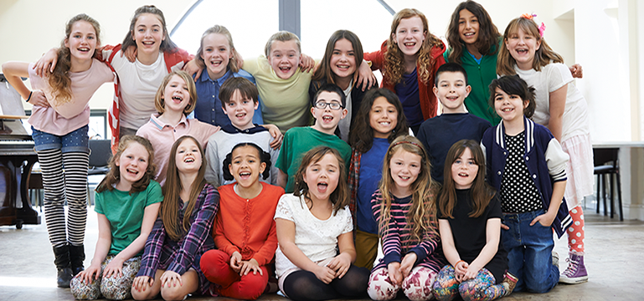

When studying a local war hero pupils were encouraged to use their own opinions to shape their history lessons. As the project grew it influenced the class in a new direction. Pupils gained a sense of personal achievement by knowing that their ideas contributed to changes in what they studied. Pupils were given an open approach to class planning, which enabled them to produce their own play on their research findings.

Number of pupils: 232 ​
Age range: 3 - 11
Date of inspection: May 2018

Information about the school:
Westwood Community Primary School is in Buckley in Flintshire. It provides education for 232 pupils aged from three to eleven years old, including 27 who attend the nursery class part-time. Pupils are organised into 10 classes. The school was last inspected in 2012. The headteacher was appointed in January 2010.
The three year average for pupils eligible for free school meals is around 32%. This figure is well above the Welsh average of 19%. A very few pupils speak English as an additional language, and no pupils speak Welsh as their first language.
The school identifies around 42% of pupils as having additional learning needs and a very few pupils have a statement of special educational needs. A very few pupils are cared for by the local authority. Very few pupils come from an ethnic minority background.

Context and background to the effective or innovative practice:
Historical learning experience and pupil-led curiosity into the local World War heroes, led to the deeper research of a specific local soldier. The research work linked to this highly commended soldier led the pupils to the local historical society, including community and town council members and links to the extended family around him. When asked how else they could present their findings, the pupils suggested a play.

Description of nature of strategy or activity:
The initial medium term planning for this particular topic on the World Wars did not intend to explore specific people involved in the conflicts. Following a planned visit to the local war memorial, pupils noticed that certain soldiers had letters after their name. This identified Fred Birks VC, MM and stimulated a tangent of thoughts and ideas to explore this particular soldier in greater depth back in school with the help of the local history society. This rulted in teachers altering their intended course for the medium term plans as pupils had influenced a new direction. This resulted in a comprehensive and wide-ranging study of the soldier’s life, cumulating in all pupils being involved in the project and producing their own play based on his life experiences.
The pupils identified the need for Fred Birks’ memorial to be restored as a family member had highlighted the plight of its deteriorating state. The pupils wrote letters to the local town council to raise awareness and encourage a rapid community response to helping its restoration. From that, the idea for a play came up through discussion with pupils.
The play was performed at the local church, with the Buckley historical society in attendance. The local press wanted to cover the story especially as Fred Birk’s great niece had travelled from Scotland to see the pupils perform and honour her relative.
After the play, the pupils decided to lobby the Town Mayor and Councillors to further raise awareness and to allocate funding for the restoration of the local memorial. The enthusiasm and passion to celebrate this community icon continued to grow momentum and resulted in the history society approaching the pupils again to adapt the performance to be suitable for a wider audience. Naturally, this required the teaching staff to explore creative ways of developing this project whilst still covering and tracking pupil progress within the curriculum.
Ultimately, this led to greater awareness of the project throughout the wider community and even touched on national and global interest which included television and radio coverage, representatives of Westminster, the Australian High Commission and even forged a later link to Mahana School in New Zealand.

What impact has this work had on provision and learners’ standards?
This evolving project not only promoted the story of the World War hero, it elevated the school’s position within the community it serves. Because of the increased success of the play, the pupils were filled with a huge sense of personal achievement knowing that their ideas and suggestions contributed to the changes in the planning and what they studied. The impact of their voice had far-reaching impacts beyond their classroom. The whole process developed and enhanced a variety of key skills within the literacy framework, such as developing play scripts for different audiences, historical reports, research and recounts. Performing such an influential, personal and sensitive play in front of a large audience, expanded the pupils’s confidence and heightened their expectations. The level of pupil engagement was extensive.
As a result, this project has been the catalyst for future projects within the school environment and it has encompassed a wider community circle and extended provision. The school was later awarded with a creative arts Wales grant to support future projects and to ensure that flexible, pupil initiated productions are built upon.
In Foundation Phase, pupils are introduced to the concept and benefits of pupil voice through their open contributions to teacher planning through topics. Pupils have access to independent work books to record and explore a range of approaches following a stimulus. Consistency throughout the school empowers the teachers to adopt a flexible and open approach to planning that facilitates the curiosity of learners.

How have you shared your good practice?
The successful production relating to the life of a local World War hero was shared throughout the community, around the county and attracted a variety of influential guests. As well as appearing in the local press, the story was televised by the BBC and ITV news including presenter interviews with pupils, staff and other guests. These interviews captured the whole process of the production from start to finish as well as recognising the significance and achievements of the whole school.
Other primary school settings visit Westwood to observe how to initiate and facilitate a flexible approach to planning throughout the school. The good practice is shared through working collaboratively with other organisations such as the local history society and Theatre Cymru to enrich the pupils’ experiences.
Staff members in foundation phase were asked to demonstrate their methods to facilitate pupil voice in their lessons and to share their impact on standards and pupil outcomes.
Link: http://www.westwoodprimary.co.uk/

