

Module Name: Public Health and Social Care Dissertation
Module Code: LCHS7004

The prospective of the people who are the managerial role in reducing medication error in the N.H.S (UK) - Qualitative systemic review

STUDENT NAME: HIMALAYBHAI SURESHBHAI MANDANAKA
STUDENT NUMBER: 2433934
SUPERVISOR NAME: DR. FAHAD KHAN

Dissertation submitted as part of the requirements for the award of MSc Public Health and Social Care in Practice

MAY/2026
Declaration
I, HIMALAYBHAI SURESHBHAI MANDANAKA, declare that I have written this dissertation by myself that the work herein contained is mine, unless it is otherwise mentioned in the text, and that this work has not been offered to any other degree or qualification, in whole or in part, other than that mentioned.
Signature: HIMALAYBHAI MANDANAKA
Student ID: 2433934
Date: 12/05/2026
Acknowledgement
I would like to declare my utmost thanks to my supervisor due to his continuous guidance, useful feedback, and support during the process of completing this dissertation. They have been of great help in making this study through their knowledge and support.
Another thing I am grateful for is the help of academic staff and librarians who helped to obtain the necessary resources and offered me academic guidance. I would like to thank my peers and colleagues who supported me and were willing to discuss this journey positively.
Lastly, I would also like to give my family the credit that they were supportive, patient and motivated, which helped me complete this dissertation successfully.
Abstract
Background
Medication errors are a major patient safety issue in the National Health Service (NHS) that causes unfavourable patient outcomes, higher healthcare expenses, and poor quality of care. Although the available studies mostly concentrate on clinical staff, there has been a limited emphasis on the perspectives of healthcare managers. This paper has examined the thoughts of NHS managers about their role in reducing medication errors. Furthermore, it has determined important organisational and leadership factors that affect medication safety.
Methods
This study used a qualitative systematic literature review (SLR) to combine the available information on managerial views in the NHS. Databases (PubMed, ScienceDirect, SAGE Journals, and Google Scholar) were searched using predefined inclusion and exclusion criteria to identify relevant studies. Based on PRISMA, 12 qualitative studies have been selected. The thematic analysis was conducted to examine the patterns and themes that repeat regarding leadership, organisational, and medication safety based on the framework by Braun and Clarke.
Results
The results showed that there are various organisational and systemic factors that affect medication errors. There were five major themes, which include leadership and managerial involvement, communication and reporting systems, workload and staffing pressures, organisational learning, and technological systems. It was discovered that effective leadership was essential to encourage safety culture and staff engagement. However, issues like lack of communication, insufficient staffing, feedback deficits, and technology problems were analysed as the obstacles to the reduction of medication errors.
Conclusion
The research has made the conclusion that the healthcare managers can make a significant contribution to the prevention of medication errors by means of leadership and policy implementation, as well as organisational support. To enhance medication safety, the use of a systems-based approach that combines leadership, communication, workforce management, and technology is necessary. Enhancing organisational culture and managerial practices can contribute greatly to patient safety outcomes in the NHS.

Keywords
Medication errors, NHS, healthcare managers, patient safety, leadership, safety culture, systematic literature review
TABLE OF CONTENTS
CHAPTER 1: INTRODUCTION AND BACKGROUND 13
1.1 Introduction to the topic 13
1.2 Background and Current Context 13
1.3 Rationale for Research or Problem Statement 17
1.4 Research question 17
1.5 Research Aim 17
1.6 Research Objectives 17
1.7 Chapter Summary 17
CHAPTER 2: LITERATURE REVIEW 19
2.1 Introduction to Literature Review 19
2.2 Literature review 19
2.2.1 Conceptualising medication errors 19
2.2.2 Medication errors as a public health issue 19
2.2.3 Role of healthcare managers in medication safety 21
2.2.4 Organisational factors influencing medication errors 22
2.2.5 Challenges faced by healthcare managers 23
2.2.6 Strategies to reduce medication errors 24
2.2.7 Theoretical Framework 24
2.2.8 Conceptual Framework 28
2.2.9 Literature Gap 29
2.3 Chapter Summary 30
CHAPTER 3: METHODOLOGY 31
3.1 Introduction to the chapter 31
3.2 Systematic Literature Review (SLR) 31
3.3 Search Strategy 32
3.4 Search Terms 33
3.5 Keywords 34
3.6 Databases 34
3.7 Inclusion/Exclusion Criteria 35
3.7.1 Data Evaluation through CASP Tool 36
3.8 Search Results 37
3.8.1 PRISMA flow diagram 38
3.9 Ethical Considerations 40
3.10 Chapter Summary 41
CHAPTER 4: DATA EXTRACTION AND EVALUATION 42
4.1 Introduction to the Chapter 42
4.2 Data Extraction 42
4.3 Brief introduction to critical appraisal and paper quality assessment 42
4.4 Critical Appraisal Tools 43
4.5 Evaluation of Qualitative Studies using any appropriate tool 44
4.6 Chapter Summary 54
CHAPTER 5: DATA ANALYSIS AND SYNTHESIS 55
5.1 Introduction to Chapter 55
5.2 Thematic Analysis 55
5.3 Data Analysis Tool 55
5.4 Characteristics of the Identified Studies 55
5.5 Emerging Themes from Included Studies 56
5.5.1 Themes identified through thematic analysis 56
5.5.2 Theme 1: Leadership and Managerial Influence on Medication Safety 57
5.5.3 Theme 2: Communication, Reporting Systems, and Safety Culture 59
5.5.4 Theme 3: Workload Pressure, Staffing Levels, and Environmental Factors 61
5.5.5 Theme 4: Organisational Learning and Continuous Improvement 63
5.5.6 Theme 5: Technological Systems and Process-Related Factors 65
5.6 Chapter Summary 67
Chapter 6: DISCUSSION 68
6.1 Introduction to the Chapter 68
6.2 Discussion of Key Findings 68
6.2.1 Discussion based on Objective 1 68
6.2.2 Discussion based on Objective 2 70
6.2.3 Discussion based on Objective 3 71
6.3 Strengths and Limitations 72
6.4 Chapter Summary 73
Chapter 7: RECOMMENDATIONS AND CONCLUSION 74
7.1 Introduction to the Chapter 74
7.2 Linking with objectives 74
7.3 Recommendations for Practice 75
7.4 Recommendation Summary Table 76
7.5 Recommendations for Future Research 77
7.6 Conclusion 77
Reference List 79
Appendices 93
Appendix 1: CASP Assessment 93
Appendix 2: Theme Development 95

LIST OF TABLES
Table 1: Literature Gap 29
Table 2: PICO Model 33
Table 3: Search Terms 33
Table 4: Databases 35
Table 5: Inclusion/Exclusion Criteria 35
Table 6: Reasons for not selecting other tools 37
Table 7: Data Extraction Table 44

LIST OF FIGURES
Figure 1: Medication and safety errors in the NHS 14
Figure 2: Number of Medication Errors in England 16
Figure 3: Medication Errors by Healthcare Setting 20
Figure 4: Causes of Patient Dissatisfaction 21
Figure 5: Causes of Patient Dissatisfaction 22
Figure 6: Safety Culture Theory 26
Figure 7: Transformational Leadership Theory 27
Figure 8: Conceptual Framework 28
Figure 9: PRISMA flow diagram 38
Figure 10: Theme Development 57

ABBREVIATIONS
CASP: Critical Appraisal Skills Programme
EHR: Electronic Health Records
NHS: National Health Service
PEO: Population, Exposure, Outcome
PICO: Population, Intervention, Comparison, Outcome
PRISMA: Preferred Reporting Items for Systematic Reviews and Meta-Analyses
SLR: Systematic Literature Review
UK: United Kingdom

CHAPTER 1: INTRODUCTION AND BACKGROUND

1.1 Introduction to the topic
Medication errors may be defined as instances that may result in pre-appropriate medication use or patient injury at any stage of medication process that encompasses prescription, dispensing, administration and monitoring. In the United Kingdom, medication errors are an important health issue in the National Health Service (NHS) as they lead to negative outcomes in terms of patient safety, health care expenses, and quality of care (Mahat et al., 2022). These mistakes can cause adverse drug incidents, extended hospitalisation, and in the worst-case scenario, the patient may die.
In order to comprehend this question, it is important to realise that medication errors are not necessarily caused by personal clinical errors. These can be a breakdown in communication, workload stress, poor protocols, and leadership difficulties (Howick et al., 2024). Therefore, healthcare managers are crucial in formulating policies, resource allocation and creating a safety culture that can reduce such errors.
This research has focused on the attitudes of healthcare administrators in the NHS as pertaining to their contribution to minimising the minimisation of medication errors minimised. In that case, there has been a focus on frontline clinical staff, and the research is a gap as it focuses on managerial perspectives. Furthermore, it helps build a more comprehensive aspect regarding the role of leadership and organisational practice in healthcare systems and the ways it affects the safety of medicine.

1.2 Background and Current Context
In the healthcare system, medication safety has emerged as a priority of both international and national healthcare systems in this complicated and resource-consuming facility like the NHS. The growing healthcare services demand and the growing complexity of patients aligned with polypharmacy have increased the likelihood of medication-related incidents. The NHS registered 379 "Never Events" such as wrong-site surgeries, 27 misplaced injections, and 90 foreign bodies left in patients, which reflect the healthcare system's failures to prevent patient safety.See Figure 1 below for further elaboration (Fleck, 2022). Medication errors are found at various points of the medication use process, such as it can be prescribing, transcribing, dispensing, administration, and monitoring, which need to be addressed systemically.
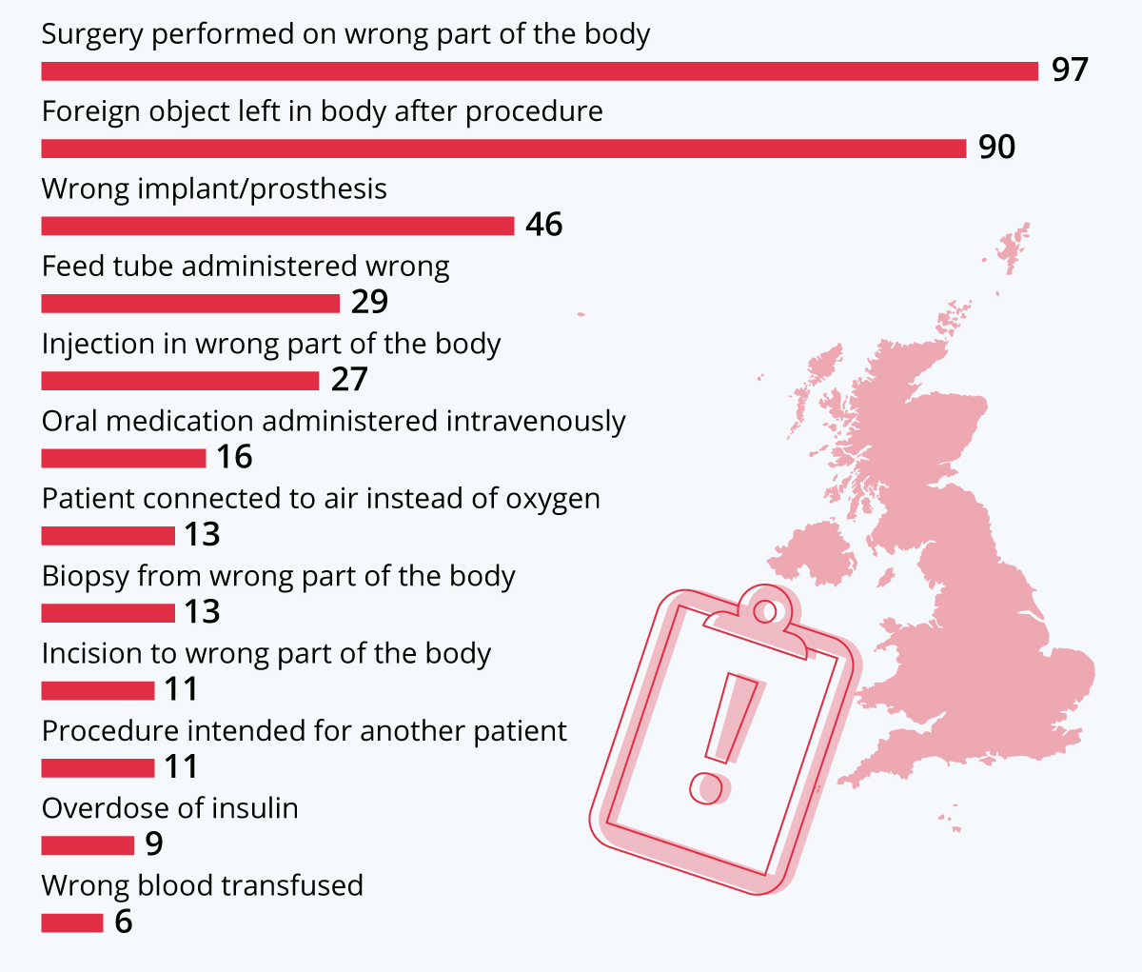
Figure 1: Medication and safety errors in the NHS
(Source: Fleck, 2022)
Medication errors in the NHS have been commonly identified as a long-standing problem of both patient outcomes and organisational performance. It has been noted that these errors are hardly attributable to the result of human, organisational and technological problems. The frequent causes involved are poor communication between healthcare practitioners, shortages in staffing, time constraints, absence of standardised practices, and under-training (Sardi et al., 2024). The complexity of the healthcare systems further contributes to these challenges as various professionals also must interact in dynamic and sometimes high-pressure settings.
Conventionally, the strategies targeted at reducing medication errors were focused on the enhancement of clinical practice such as precision of prescription, use of electronic prescription systems and education of medical staff. Healthcare managers are assigned with the role to develop and implement policies, coordinate the distribution of resources, ensure that the multidisciplinary teams adhere to the regulatory standards, and offer communication opportunities between the multidisciplinary teams. Their leadership defines safety measures, risk management, and efficiency in dealing with incidents by organisations (Phillips et al., 2026). To illustrate this point, the managers are at the centre of ensuring mechanisms of reporting incidents, motivating employees to embrace safety measures and implementing their learnt lessons in response to errors.
With positive safety culture, there is promotion of openness, transparency and error learning which are vital in the prevention of medication errors. The negative culture, on the other hand, may de-motivate reporting and learning about the organisation thus the organisation will tolerate systemic problems. Hence, the behaviours and attitudes towards patient safety are critical to be shaped by leadership approaches and managerial practices.
Over the past few years, emphasis on system-based approaches to patient safety has increased, where errors are commonly seen as a consequence of ineffective processes and not personal negligence.As of 2022/23, there are 1,392 obstetrician clinical negligence claims in NHS England, as compared to any one speciality, the highest number see figure 2 below for further elaboration (Statista, 2023). In this context, healthcare managers are considered important agents of change who can affect the design of the system, processes in the workflow, as well as organisational priorities.
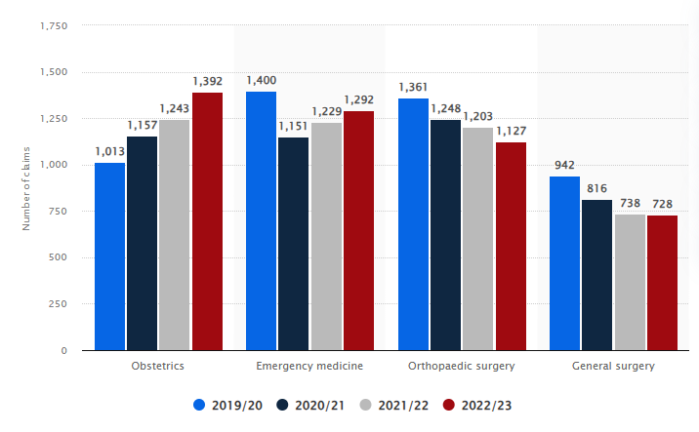
Figure 2: Number of Medication Errors in England
(Source: Statista, 2023)
This paper fills this gap by performing a qualitative systematic literature review that deals with the managerial views in the NHS. The study has enabled the researcher to determine shared themes related to leadership practices, organisational issues, and medication safety improvement strategies through the synthesis of the results of various studies. The given approach offers a full aspect of the role that can be played by healthcare managers in preventing medication errors, and which aspects of the policy and practice could be improved.
With patient safety as one of the fundamental concerns of the modern healthcare environment, the managerial aspect of medication safety is becoming a more significant subject to be acquired. As the healthcare systems are changing, the role of managers to introduce quality improvement and safe medication practices will become more crucial (Bolous et al., 2023). This study would be applicable in this on-going debate because it offers evidence-based information on the attitudes held by managers that can help to develop more viable and sustainable strategies to eliminate medication errors in NHS.

1.3 Rationale for Research or Problem Statement
This study was selected to fill a major gap in the current literature on the issue of medication safety in the NHS. Although much research has been done on clinical causes of medication errors limited the perceptions of healthcare managers regarding their role in preventing the occurrence of medication errors. This gap limits the establishment of holistic strategies, which encompass both the clinical and organisational viewpoints.
This research is aimed at discussing the perspectives of managers and determining leadership practices, challenges, and strategies that have an impact on medication safety. The research focused on exploring to offer comprehensive information on organisational factors that support or are unfair errors reduction by concentrating on the qualitative evidence. The research is restricted by a qualitative systematic review of peer-reviewed publications published in the last five years and addressed the UK healthcare situation.

1.4 Research question
RQ1. What are the perspectives of healthcare managers in the NHS (UK) regarding their role and how important is reducing medication errors?

1.5 Research Aim
The aim of this research is to explore the perspectives of NHS managers regarding their role in reducing medication errors, identifying common themes related to leadership, decision-making, and organisational practices that influence medication safety.

1.6 Research Objectives
- To explore NHS managers’ understanding of medication errors and their causes.
- To identify managerial strategies used to reduce medication errors.
- To examine perceived barriers and facilitators to improve medication safety and theoretical framework used by this manager to improve medication safety.

1.7 Chapter Summary
The chapter has proposed a research question that is vital in the context of research and the literature on medication errors in the NHS, since the problem is a public health issue. It has offered the background and the situation that is prevailing, and the key role of the healthcare managers in enhancing medication safety. It highlighted the significance of knowing managerial views to help overcome systemic factors that cause medication errors. In the second chapter, relevant literature and theoretical bases of this research will be critically reviewed.

CHAPTER 2: LITERATURE REVIEW

2.1 Introduction to Literature Review
The chapter is a critical review of the literature available on the topic of medication errors and the contribution of healthcare managers in minimising these errors in the NHS. It strives to provide a theoretical and empirical background of the study by discussing the main concepts, models, and past research findings. The review examines the nature of medication errors, their effects on patient safety, and organisational factors that contribute to their occurrence. It examines the theories involved, such as safety culture and leadership models, to learn about the influence of managers. This chapter establishes the gaps in the existing literature and justifies the necessity of studying managerial approaches to medication safety enhancement.

2.2 Literature review

2.2.1 Conceptualising medication errors
Medication errors are described as the predictable events that can result in inappropriate medication utilisation of the patient throughout the medication management within the possession of medical professionals or patients. According to Asamoah (2025), these mistakes can arise at any point in the drug cycle, such as during prescription, transcription, dispensing, administration and monitoring. They are usually classified into various categories, including dosing errors, wrong medication, incorrect timing and documentation errors. Alrshah et al. (2024) further stated that Errors in medication are not viewed as individual negligence cases but are rather seen as a product of systemic failures such as sub-optimal communication, inadequate protocols and workload burden.

2.2.2 Medication errors as a public health issue
Medication errors have been broadly acknowledged as a major health concern as they affect patient safety and quality of healthcare, as well as financial costs. As stated by Lennox et al. (2022), medication-related harm has an annual impact on millions of patients worldwide, causing morbidity and death among patients that can be prevented. These medication mistakes in the NHS have increased the number of hospitalized patients, extended hospital stays, and additional costs of treatment and have resulted in excessive burdens on limited healthcare resources.
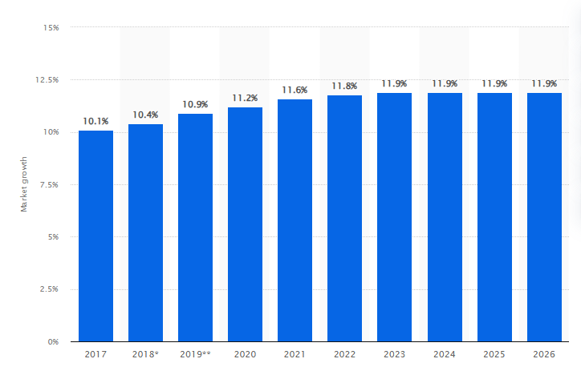
Figure 3: Medication Errors by Healthcare Setting
(Source: Duffin, 2026)
The issue of medication errors has become a concern for managers as the healthcare system is becoming more sophisticated, and the circumstances of the patients are getting more complicated, especially in high-stress clinical settings. According to Duffin (2026), the medication error reporting market has global figures of 326 million in 2018, 362 million in 2019 (10.9% growth), and 44000-98000 annual deaths in the U.S. are attributed to medication errors. See Figure 3, given above for further elaboration.
Medication safety is vital to effective and equitable healthcare delivery, according to the view of public health. The decrease in medication errors benefits patient outcomes, which increases trust in healthcare systems. To resolve the problem of medication errors, according to Kirk et al. (2023), the organisational and policy levels should be aligned, and effective managerial leadership is another important factor that will contribute to the impactful achievement of safety-enhancing results.

2.2.3 Role of healthcare managers in medication safety
Healthcare managers play a role in medication safety due to the impact they make on the structure, policies and practices in healthcare establishments. They are involved in administrative duties in designing and deploying safety measures, performance monitoring, and advancing a patient safety culture. According to Armstrong (2026),NHS satisfaction was found to be at 53% (lowest since 2007) with reference to waiting times, staff shortages, and funding issues. See Figure 4below for further elaboration. The managers of the NHS are instrumental when it comes to the establishment of the governance systems that could support the safe practice of medication and compliance with the regulatory standards.
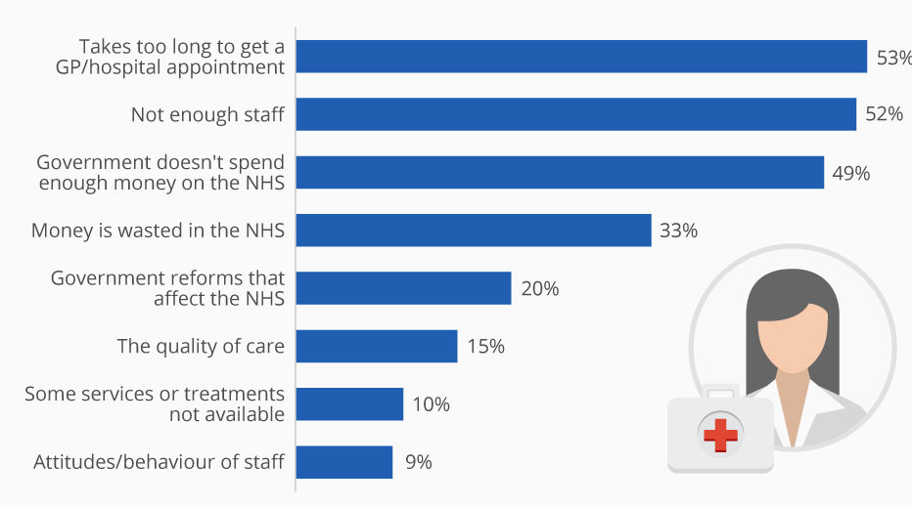
Figure 4: Causes of Patient Dissatisfaction
(Source: Armstrong, 2026)
Development of effective communication and coordination between multidisciplinary teams comprising doctors, nurses, and pharmacists is among the most important roles of healthcare managers. Damiani et al. (2023) stated that, with the support of collaboration and information exchange, managers contribute to the mitigation of the threat of miscommunication, one of the most common root causes of medication errors. Moreover, they need to distribute resources and staffing and make sure healthcare specialists are properly trained and supported. As opined byNaseralallahet al.(2022), managers are critical towards encouraging reporting of incidents and organisational learning.

2.2.4 Organisational factors influencing medication errors
Organisational forces are influential determinants of the prevalence of medication errors in health contexts. Communication, especially with multidisciplinary teams, is one of the most important. As opined by Ahmed and Tamim (2025), lack of effective communication among doctors, nurses, and pharmacists may result in misunderstanding, lack of transmission of information and eventual mistakes regarding medications. According to Sharma et al. (2024), workload caused by high patient-to-staff ratios, staff time pressures, and staff burnout may lower the focus on detail in medication processes and raise the chances of error. With the lack of staff, the ability of medical personnel to remain compliant with safety measures can be decreased.
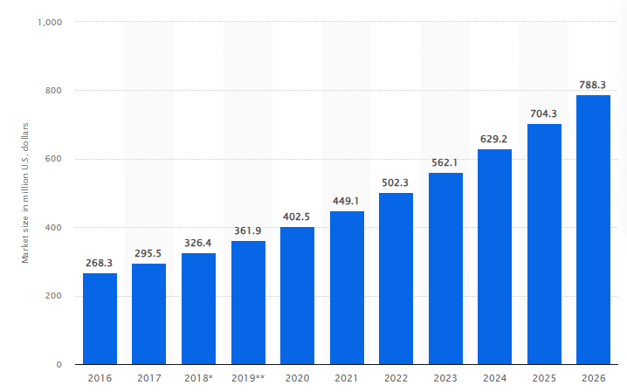
Figure 5: Causes of Patient Dissatisfaction
(Source: Duffin, 2026)
The other consideration is the performance of the incident reporting system and organisational learning. Unless healthcare organisations have coherent systems of reporting and analysis of the errors, they might miss good chances to improve. Blame culture can result in a lack of reporting, but a positive environment will foster transparency and learning. According to Duffin (2026), it is the major cause of deaths, with 44,000-98,000 deaths annually, and is getting an annual medication error reporting revenue of $326 million in 2018 and is projected to reach $790 million by 2026.See Figure 5given above for further elaboration. Tamata and Mohammadnezhad (2023) stated that medication safety can be affected by technological systems like electronic prescribing. Although technology can minimise human error, the system design or lack of training can pose another risk in healthcare organisations.

2.2.5 Challenges faced by healthcare managers
The healthcare managers have a broad spectrum of challenges in their endeavours of minimising medication errors and enhance patient safety in the NHS. Mistri et al. (2023) add that one of the key challenges is the resource constraints which involve limited budget resources, staffing, and rising patient demand. The managers are forced to strike a balance between affordability and the need to offer quality standards of care, therefore, they might struggle to allocate sufficient resources towards training programs, technological and safety programs.
Exposure to fatigue, stress, and inattention to detail related to a high volume of patients and shortage of staff can expose healthcare professionals to the risk of committing a medication error (Hult et al., 2023). During continuity of care, managers are prone to finding it difficult to maintain optimum staffing. Ranasinghe et al. (2022) stated that the installation of new safety measures, technologies, or organisational measures could receive resistance among the workers because of the well-established routines, insufficient training, or the fear of extra workload. This may delay the process of safety improvement and decrease their success.
In contrast, Ng (2022) stated that, the healthcare managers must operate in a complicated organisational setup and regulatory demands in the NHS. It may be difficult to ensure compliance with policies, but to meet current changing healthcare needs. It is difficult to establish positive culture of safety, in which the culture failed to manage reporting of errors brought about by blame and fear. To sustain unremitting improvement of medication safety, managers should undertake to foster the growth of trust, as well as guaranteed transparency.

2.2.6 Strategies to reduce medication errors
The interdisciplinary strategy to reducing medication errors is comprised of organisational, managerial and technological solutions aiming to increase patient safety in the healthcare systems. According to Tamata and Mohammadnezhad (2023), the enhancement of leadership and governance is one of the best methods. Healthcare managers are critical in developing explicit safety policies, accountability, and incorporating medication safety in organisational priorities. Effective leadership encourages a culture of safety that is given precedence and constantly observed.
In that case, Ominyiet al. (2025) stated that regular training programmes have been found to increase the level of knowledge among staff, clinical competence, which ensures the staff comply with medication safety procedures. Ongoing professional growth assists the medical staff to be aware of the best practices and minimises the chances of making mistakes.
The other important strategy is the enhancement of communication systems. Ranasinghe et al. (2022) confirmed that such misunderstanding between the members of a multidisciplinary team could be minimised with the help of standardised communication tools, such as structured handover procedures and clear documentation practices. Communication effectiveness will guarantee the proper movement of medicine-related information through various levels of care.
Human errors can be minimised with technological interventions, including electronic prescribing systems, barcode medication administration, and automated warning alerts. However, Howick et al. (2024) stated that they should be implemented, and staff trained to ensure that they are optimised. It is essential to encourage a high safety culture. Reporting of incidents, embracing errors, and a non-punitive strategy can be encouraged to enable organisations to detect risks and take preventive measures, which will eventually result in long-term medication safety improvements.

2.2.7 Theoretical Framework
Theories are important in the understanding of how healthcare managers can affect healthcare safety regarding the use of medication in NHS organisations. Theories are a structured explanation of the factors and processes that relate to leadership behaviour, organisational culture, communication and decision making that have an impact on medication safety outcomes.
Why look the difference theoretical framework in managerial role
Theories are different in this study, as the roles of managers in medication safety are multidimensional in behaviour and organisations. There is no one single theory that is able to explain the nature of leaders' practices, the nature of communication process, the nature of the safety culture, and the nature of system-level challenges in the NHS (Yusof et al., 2024). Thus, the combination of Systems Theory, Safety Culture Theory and Transformational Leadership Theory allows a more comprehensive view of the role that healthcare managers play in the reduction of drug errors and patient safety.
Considering multiple theoretical approaches provides the study with a greater understanding of manager roles from a variety of lenses and can offer insight into the role of management practices in minimizing medication errors and improving patient safety.
Great Man Theory
In the Great Man Theory, the notion is that leadership is a natural ability, and that some people are born with a set of qualities that make them good leaders. This theory emphasises the role of managerial personalities, decision making skills and confidence in shaping organisational performance and patient safety outcomes in healthcare settings. Healthcare managers within the NHS who possess leadership skills can contribute positively to medication safety, encourage staff and help to establish changes in the organisation that support a focus on medication safety.
While modern theories on leadership are more behaviour-centred and based on the context of the organisation, the Great Man Theory can lay the foundation for understanding the individual's characteristics and their impact on medication safety management.
Systems Theory
According to Systems Theory, health care systems consist of various departments, professionals, technologies, and managerial processes that interrelate to affect patient results. Medical errors are rarely the work of one person, instead they are likely to occur as a result of failures of several organisational processes (Yusof et al., 2024). Within the NHS healthcare managers are vital in communicating the workflow, staffing, technology and policy implementation of effective medication safety practices. The theory is supported by the concept of collaboration being needed at the system level to improve medication safety, not just within the individual incident.
Safety Culture Theory
The Safety Culture Theory can be described as those values, beliefs and practices shared by an organisation that shape attitudes and behaviours on safety. SeeFigure 6 for further elaboration. A well-developed safety culture in healthcare environments is required to reduce the risks and avoid medication errors (Carvalho et al., 2023). It focuses on being open, accountable, and constantly learning to empower the healthcare professionals to focus on patient safety in their daily practice.
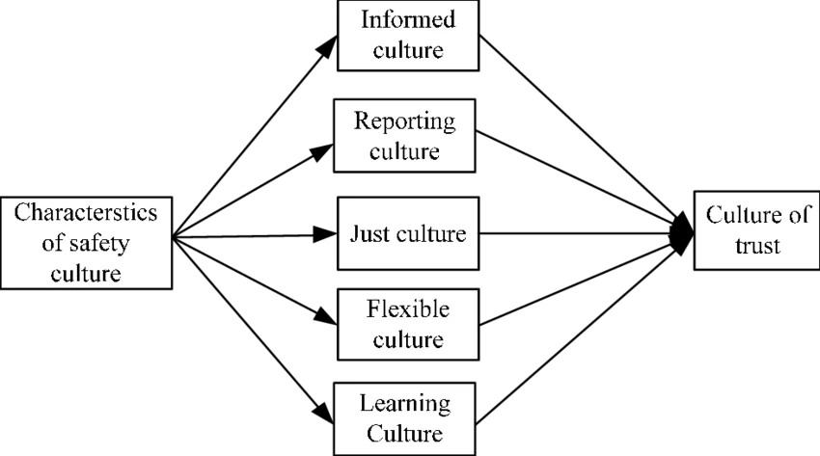
Figure 6: Safety Culture Theory
(Source: Jilcha and Kitaw, 2016)
With a positive safety culture, clear communication and encouragement of incident reporting will be facilitated by the absence of fear of blame and punishment (Glarcher and Vaismoradi, 2025). This will help organisations to discover the root causes of errors and make desirable changes. Conversely, a blame-based culture can dishearten reporting, which results in latent risks and errors.
The healthcare managers are essential in influencing the safety culture by building trust, encouraging employees, and facilitating collaborative working conditions (Hoxha et al., 2024). Organisations can also improve medication safety and quality of healthcare by incorporating safety-oriented values and behaviours.
Transformational Leadership Theory
Transformational Leadership Theory focuses on the leadership capability of inspiring, motivating, and influencing employees to reach greater performance and organisational change. See Figure 7given below for further elaboration. Presence of this kind of leaders in the healthcare setting will also help develop the culture of innovation, shared vision, and continuous improvement that will be another significant step towards improving patient safety and medication errors (Ghasemi et al., 2025).
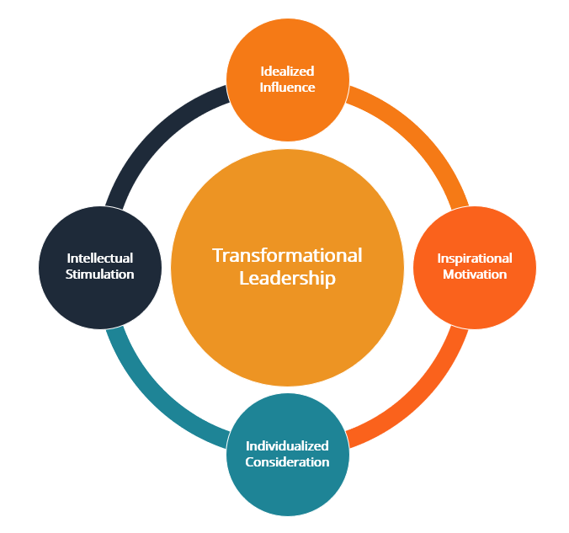
Figure 7: Transformational Leadership Theory
(Source: CFI, 2023)
This kind of leadership style has four major components which consist of idealised influence, inspirational motivation, intellectual stimulation as well as individualised consideration. According to Ranasinghe et al. (2022), role models Leaders provide some sense of direction to their employees, encourage critical thinking and provide personalised attention to their employees. Healthcare managers who use transformational leadership style within the NHS setting, where a positive safety culture is encouraged, staff engagement is enhanced, and communication between multidisciplinary teams is improved. This helps the successful implementation of medication safety practices (Mistri et al., 2023). Transformational leadership can be used to reduce the number of errors and improve the overall healthcare outcomes due to empowering the staff and improving their responsibility.

2.2.8 Conceptual Framework
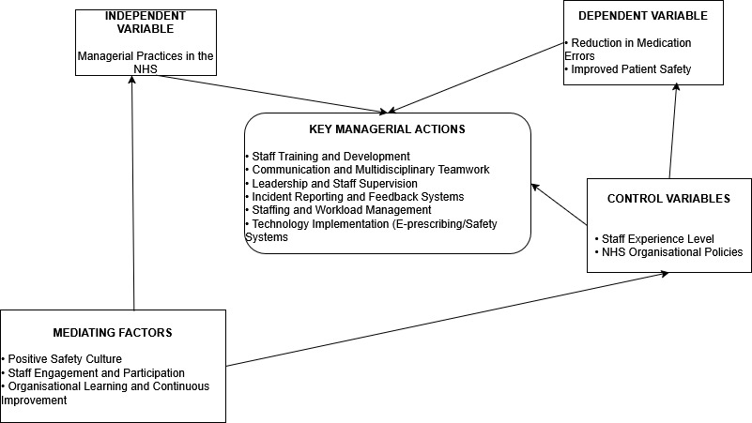
Figure 8: Conceptual Framework
(Source: Self-generated)
In the conceptual framework, it is illustrated in figure 8 how management leadership practices, communication in the organization, staffing support, safety culture and technological systems can all contribute to minimizing medication errors in the NHS (see Figure 8). The framework also emphasizes the obstacles and opportunities to improving medication safety. These theories namely Safety Culture Theory, Transformational Leadership Theory, and Systems Theory, provide a support to the framework by providing the understanding of the impact of managerial behaviours on the organisational safety outcomes and on patient care quality.
What does the manager do to improve medication safety?
By collaborating closely with healthcare teams, healthcare managers can help to reinforce safe medication practices in NHS organisations, thereby enhancing medication safety. Managers conduct regular training for staff, oversee medication-related procedures, promote good communication between multidisciplinary teams and assist in incident reporting systems which aim to identify and learn from errors (Ranasinghe et al., 2022). They also handle staffing levels and workload pressures, minimising stress and fatigue of healthcare professionals. Managers also promote staff engagement in safety programs and implement technology-driven approaches including E-Prescribing and safety monitoring systems. These actions help to contribute to a positive safety culture and support continuous learning, minimize medication errors and enhance patient safety outcomes.

2.2.9 Literature Gap
Table 1: Literature Gap
Research Gap | Description
Limited managerial focus | Most studies focus on clinical staff rather than healthcare managers
Lack of qualitative synthesis | Few studies systematically combine managerial perspectives
Limited theoretical integration | Leadership and organisational theories are insufficiently applied
Insufficient focus on barriers/facilitators | Limited evidence on organisational barriers affecting medication safety
Although there is a significant amount of literature about medication errors that addresses the clinical professionals' viewpoints (nurses, pharmacists, physicians), there has been little work that involves healthcare managers as part of the medication errors. There is limited literature on how healthcare managers fit into medication safety improvement. While several studies mention organizational safety measures, there is a lack of qualitative synthesis of how managerial leadership, communication strategies and organizational decision-making impact upon the reduction of medication errors. In addition, there are only few studies that have explored barriers and facilitators to medication safety from a managerial viewpoint in NHS contexts. Moreover, leadership and organisational theories were not well integrated to discuss the role of healthcare managers in improving medication safety. This study is therefore intended to fill these research gaps within a qualitative systematic literature review on managerial perspectives in the NHS.

2.3 Chapter Summary
This chapter was a critical review of the available literature on the topic of medication errors and their relevance as a societal health concern to the NHS. It has investigated the important concepts, causes and organisational determinants that affect medication safety and the significant role of the healthcare managers in minimising errors. Suitable theories, such as Safety Culture Theory and Transformational Leadership Theory, were discussed to learn about managerial influence. The chapter determined the main challenges and strategies regarding medication safety and the gaps in the research, such as a lack of emphasis on managerial viewpoints.

CHAPTER 3: METHODOLOGY

3.1 Introduction to the chapter
This chapter describes the methodology used to investigate the views of the healthcare managers in the NHS about their role in mitigating medication errors. Research methodology is the general approach and way of systematic arrangement of research to help plan, implement and interpret a study. It outlines the methodology and approach that should be adopted in this research. In this section, the research design, the study setting, sampling method, the data collection process, and the thematic analysis will also be discussed. Apart from that, credibility and trustworthiness, as well as the data management issues, are also explored to prove the rigour and credibility of the research process.An effectively stated methodology pre-eminent increases the truthfulness and logicality of results and facilitates replication and a critical assessment.

3.2 Systematic Literature Review (SLR)
This study is based on a systematic literature review (SLR) methodology that will be used to examine available literature on the topic of international business strategy and consumer behaviour.
A Systematic Literature Review (SLR) is a strong and transparent process which identifies, modifies, and combines prior studies which are pertinent to a particular research question (Azarian et al., 2023). In contrast to the traditional narrative review, an SLR has a systematic and repeatable procedure, specifying search strategies, selection and exclusion criteria, and screening of studies systematically (Paul and Barari, 2022). This should minimise bias and increase the dependability of results.
This research uses an SLR to compile this qualitative information on the views about medication error reduction among NHS managers. The technique is suitable, as it allows full understanding of the qualitative studies of relevance and consistency in the selection and appraisal of the studies (Drolet et al., 2023). The SLR offers a strong evidence base to address the development of leadership practice and approaches to patient safety enhancement by integrating the results of several sources.
Research methods are defined as techniques and procedures that are followed in gathering, analysing and interpreting data to answer the research question. These offer a feasible way of choosing the adopted methodology and to make sure that evidence is collected in a methodical and suitable way. In that case, for selecting credible and significant findings, it is important to choose appropriate research methods (Aguinis, 2023). Qualitative research is related to exploring and comprehending the experiences, perceptions, and meanings of people in the context of social and organisational settings (Lim, 2025). The qualitative methods do not require a numerical measurement of any variables but instead aim at coming up with rich and descriptive findings that can put in place the complexity involved in human behaviour and decision making. The qualitative approach is specifically applicable in this research since the aim of the study is to measure the perspectives of NHS managers towards their role in the elimination of medication errors based on the readily available qualitative data.
The rationale behind the choice of this approach is the opportunity to deeply investigate the leadership practice, organisational culture, and perceived challenges and facilitators that affect medication safety. The major advantage of qualitative research is that they offer extensive and context-related insight, which can be critical to influence policy and practice (Cash et al., 2022). However, limitations isthe researcher's interpretation, which can be biased, and the limited generalisability of results may be found using interpretation synthesis as opposed to the use of statistical representation.

3.3 Search Strategy
3.3.1 PICO Framework
The PICO framework directed the search strategy to have a systematic and focused identification of the relevant literature (Mishra and Alok, 2022). This model improved consistency and transparency in searching the database and selecting the studies (Nishikawa-Pacher, 2022). The PICO framework was chosen as it is common in healthcare studies in order to make straightforward and concentrated searches, especially in studies that involve clinical or organisational intervention.
Another approach that is generally applied in qualitative studies is PEO (Population, Exposure, Outcome). PEO was however not chosen in this research due to the fact that research is based on managerial strategies and interventions to minimize medication errors as opposed to exposure-based phenomena. The format of PICO enabled more precise determination of useful literature that was related to NHS managers, medication safety interventions, and patient safety outcomes. The elements of the PICO framework that will be employed in this research are listed in the following table.

3.4 Search Terms
The search terms were created using the PICO model and narrowed down to reflect major concepts regarding the topics of medication errors, managerial position, and the NHS setting. See Table 1 for further elaboration.
Table 2: PICO Model
PICO Element | Definition | Application in This Study
Population (P) | Group of interest | Healthcare leaders and managers in the NHS (UK).
Intervention (I) | Phenomenon of interest | Managerial practices and strategies in medication errors reduction.
Comparison (C) | Alternative approach | Not applicable (qualitative synthesis)
Outcome (O) | Expected outcome | Fewer medication errors and improved safety.
Relevant qualitative studies were maximised by using a combination of free-text keywords and subject headings to increase the retrieval (Irvine, 2024). Three principals were used to create keywords using Boolean operators (AND/OR) in the selected databases based on the given PICO. This methodological procedure guaranteed that the topical qualitative research undertaking the managerial outlook of medication security was identified entirely.
The inclusive approach resulted in a proper, methodical search of the pertinent databases and increased the chances of finding evidence of relevance in terms of qualitative data (Cheong et al., 2023). See table 2 for further elaboration.
Table 3: Search Terms
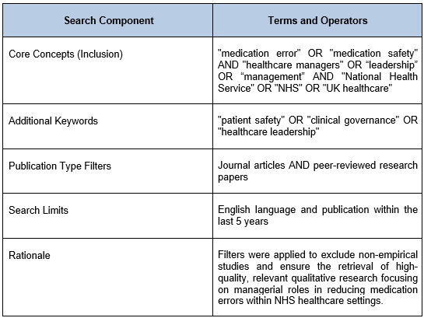

3.5 Keywords
The main search keywords were “medication error”, “medication safety”, “patient safety”, “healthcare managers”, “leadership”, “management”, “NHS”, “United Kingdom” and “qualitative research”. Other related terms that were added to this list include “drug errors”, “clinical governance”, “organisational culture” and “safety management”. The use of Boolean operators (AND/OR) to combine terms was used, such as medication error AND healthcare managers and qualitative.

3.6 Databases
Qualitative studies that were relevant to this systematic literature review were found in a number of authoritative electronic databases. They were PubMed, ScienceDirect, SAGE Journals, and Google Scholar because they have considerable coverage of the research on healthcare, patient safety, leadership, and management. These databases were chosen based on the need to have peer-reviewed and good-quality academic literature pertaining to medication errors and managerial attitudes in the NHS. The benefit of searching multiple databases was that it expanded the scope of studies found and minimised the chances of publication bias. All the searches were restricted to English-language publications and research that were published in the past five years to be contemporary. See table 3 for further elaboration.
Table 4: Databases
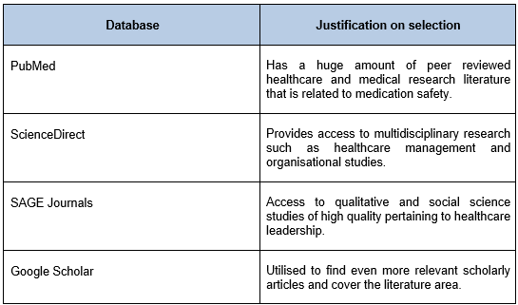

3.7Inclusion/Exclusion Criteria
The inclusion and exclusion criteria were clearly stated such that only pertinent and high-quality research was included in the systematic literature review. These were the criteria that were used to screen titles, abstracts, and full-text articles. See table 4 for further elaboration.
Table 5: Inclusion/Exclusion Criteria
Criteria | Inclusion | Exclusion
Study focus | Medication errors or medication safety | Studies not related to medication safety
Population | Healthcare managers or leaders | Studies focusing only on clinical staff
Setting | NHS or UK healthcare context | Non-UK healthcare settings
Study design | Qualitative or mixed methods with qualitative data | Studies that are not fully qualitative
Publication type | Peer-reviewed journal articles | Conference papers, editorials, dissertations
Language | English | Non-English publications
Timeframe | Published within the last 5 years | Published before the last 5 years
The use of these criteria helped in consistency and transparency in the selection of the study (Anas and Ishaq, 2022). Studies that specifically covered the managerial or leadership views regarding medication error reduction in the NHS were also used, which reinforced the usefulness and validity of the synthesis.

3.7.1 Data Evaluation through CASP Tool
Data evaluation is the evaluation of the quality, relevance and methodological rigour of the studies that have been included in a systematic review. In this research, all the chosen articles underwent critical appraisal in the process of ensuring that they fulfilled the inclusion criteria and reflected proper qualitative research standards. The methodological quality of studies involved in this systematic literature review was evaluated by use of the Critical Appraisal Skills Programme (CASP) qualitative checklist. CASP tool offers a systematic approach to assessing the main points like the clarity of research objectives, the adequacy of the methodology, research design, data gathering, research ethics, and data analysis rigour (Smith et al., 2025).
This tool was chosen as it gives a clear and systematic framework with which a qualitative research study is specifically to be evaluated. The instrument evaluates such methodological areas as design of research, research sampling, data collection procedures, ethical issues, and data analysis rigour. Other appraisal methods like the Joanna Briggs Institute (JBI) checklist and Newcastle-Ottawa Scale were also taken into account. However, the Newcastle-Ottawa Scale is mostly based on observational research and the JBI tool is wider and is mostly found in mixed-method reviews.
In the Quality Appraisal process, several other appraisal tolls were ignored in the process of selecting the CASP Tool. The justification for not selecting these tools have been mentioned below. See table 5 for further elaboration.
Table 6: Reasons for not selecting other tools
Appraisal Tool | Research Type | Key Features | Reason for Selection / Rejection
CASP (Critical Appraisal Skills Programme) | Qualitative research | Evaluates research design, sampling, data collection, ethics, and analysis rigour | Chosen as it is particularly designed for qualitative studies and associates with the methodology of this SLR
JBI Checklist | Qualitative and mixed methods | Wider appraisal tool involving several research designs | Not used because it is less focused in comparison to CASP for purely qualitative synthesis
Newcastle-Ottawa Scale (NOS) | Observational studies | Considers bias, comparability, and outcomes in cohort/case-control studies | Not selected as it is not appropriate for qualitative research

3.8 Search Results
In order to ensure transparency and rigour in the search and selection process, it was done in accordance with Preferred Reporting Items on Systematic Reviews and Meta-Analyses (PRISMA) (Marzi et al., 2025). The initial search in PubMed, ScienceDirect, SAGE Journals, and Google Scholar databases found 412 records. The title and abstract screening were performed on 316 records that had been left after the process of elimination of duplicates. Out of these, 257 articles were eliminated since they were not in line with the inclusion criteria, mostly because the focus was not relevant or the setting was not in the UK, or because they lacked managerial insights.
The remaining 59 full-text articles were evaluated as regards eligibility. After extensive screening, 28 articles were eliminated due to not being retrieved. In the end, 12 qualitative studies, which had passed all the inclusion criteria, were considered for the final synthesis. This process of selection is illustrated in the figure 9, PRISMA flow diagram for further elaboration.

3.8.1 PRISMA flow diagram
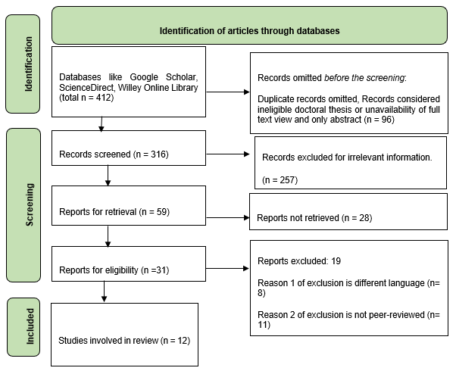
Figure 9: PRISMA flow diagram
(Source: Self-developed)
All the studies used were assessed to fit the CASP criteria to establish their credibility, relevance, and input to the review. This tool assisted in making sure that only high-quality qualitative evidence of high quality was used in the synthesis, thus enhancing the reliability and validity of the study findings. Some of the important points were the ability to understand the objective of the research, the suitability of the study design, sampling, methods of data collection, and data analysis transparency. Credibility and trustworthiness of findings were also analysed with reference to the way authors dealt with reflexivity and ethical issues (Okoli, 2023). The assessment of studies assisted in determining possible biases and limitations in separate papers. This process made sure that only reliable and applicable qualitative evidence had been used in the synthesis, hence improving the reliability and validity of the overall results.
3.8.2 Data analysis technique
Data analysis can be defined as a logical method of organising, analysing, and interpreting data to help identify meaningful trends and produce results correlated to the research question. In qualitative systematic reviews, evidence synthesising through the use of data is vital to convert the individual findings into observable themes. In this case, data analysis is especially essential since it will allow comparing and uniting managerial views on medication error reduction among various qualitative sources. The intensive analytical procedure will help make sure that the interpretations will be based on the evidence and that the results will be applied to the study objectives, adding more credibility and utility to the results in terms of informing leadership practice and patient safety enhancement.
Thematic Analysis
Thematic analysis is a qualitative approach to data analysis technique employed to recognise, analyse and interpret patterns or themes in the textual data (Braun and Clarke, 2022). It is widely applicable in the exploration of experiences, perceptions, and meaning among qualitative datasets and is advisable in qualitative research because it is flexible and systematic. It is specifically thematic analysis that is appropriate to summarise the findings in qualitative systematic reviews, as it allows comparing themes among various studies (Braun and Clarke, 2024).
Other techniques of qualitative analysis consist of content analysis, grounded theory, and narrative analysis. The content analysis is mainly interested in counting or categorising the text, and the goal of grounded theory is to derive new theories out of primary data gathering. Personal and chronological individual experiences are examined through a narrative analysis. These methods, however, are not so appropriate in the systematic literature review, which entails the synthesis of the findings of findings on multiple studies. Consequently, thematic analysis and especially the model by Braun and Clarke (2006) was chosen due to its flexibility and the fact that it is useful to discover the recurring patterns among the qualitative research studies in a systematic review.
This paper has used the six-step thematic analysis model introduced by Braun and Clarke (2006). The structure involves: (1) introduction to the data, via repetitive reading of the extracted information; (1) the establishment of initial codes concerning managerial duties, leadership behaviours, and medication safety; (2) the theme search, consisting in the categorisation of similar codes, (3) reviewing the theme, to verify its legitimacy and interest; (4) the identification and labelling of the theme; and (5) the final report writing. The stages have been utilised in a systematic manner so that synthesis of the qualitative evidence can be rigorous and transparent (Naeem et al., 2023).

3.9 Ethical Considerations
It is necessary to consider the ethical considerations to conduct the research in a responsible and ethical way. The research is found on a secondary examination of peer-reviewed writings that are publicly available, and thus, no direct interaction with human subjects was conducted. Ethical clearance was obtained from the University before the study was started. Respect for intellectual property, proper representation of findings, and plagiarism were some of the ethical principles that were followed to the letter (Taquette and Borges da Matta Souza, 2022). Every reference that was included was referenced accordingly using the Harvard style. Information was handled in compliance with the Research Data Management Policy of the University and the UK General Data Protection Regulation (GDPR). The passwords on the devices and cloud storage could only be accessed by the researcher, as electronic files were stored safely. These conditions provided confidentiality, transparency and adherence to institutional ethical guidelines.
Trustworthiness is a concept that describes the rigour of qualitative research and how likely and dependable the results are. This paper uses the four criteria introduced by Lincoln and Guba, which are credibility, dependability, confirmability and transferability. Systematic searching, precise inclusion criteria and practical synthesis of the findings helped in improving credibility. Reliability was also achieved by recording every level of the review process. Transparent reporting and direct use of evidence included in studies played the role of confirmability (Aguinis and Der Foo, 2024). These characteristics and descriptions of the contexts of the studies were used to provide support for transferability.

3.10 Chapter Summary
The chapter has described the research paradigm, methodology and the qualitative systematic review methodology assumed to be used in the study. It has presented the research design, sampling, data collection and the thematic analysis procedure, and how trustworthiness and ethical standards are going to be achieved.

CHAPTER 4: DATA EXTRACTION AND EVALUATION

4.1 Introductionto the Chapter
The chapter introduces the results of a systematic literature review of studies on healthcare managers' views on the process of reducing medication errors in the NHS. The included articles and journals are initially presented in an evidence table to highlight key aspects of the studies, including objectives, methods used, and key findings, to facilitate comparison. In order to present the overview of the key insights made throughout the literature, a summary table is also presented.

4.2 Data Extraction
Data extraction is the systematic process of gathering and sorting out the required information in the studies used in a systematic review (Afifi et al.,2023). It involves defining important features of individual studies and listing them in a systematic way to achieve uniformity and openness. Data extraction in this study focused on key information regarding the study objectives, research design, study setting, study participants, data collection procedures, and the study's important findings on the role of managers in mitigating medication errors. This systematic extraction made it easier to compare the studies and facilitated the subsequent thematic synthesis of qualitative data (Shaheen et al., 2023). The information obtained was summarised in an evidence table to provide a coherent presentation of the studies (see Appendix A).

4.3 Brief introduction to critical appraisal and paper quality assessment
The methodological quality, reliability, and relevance of the studies included in the review are the key elements of the process of the systematic literature review, as the critical appraisal is used to determine them. It assists in verifying that the evidence that is used in the research is believable and can help answer the research question. The systematic review of every study will allow the researcher to extract the possible biases, strengths, and limitations, enhancing the findings of the general results. The Critical Appraisal Skills Programme (CASP) qualitative checklist was applied in this study to improve the quality of the chosen studies. According to CASP, ten structured questions can assess some of the most important elements of qualitative research, including research goals, methodology, sampling plan, data collection, ethical issues, and rigour of data analysis (Smith et al., 2025). The use of this tool guaranteed the inclusion of only the most appropriate and quality qualitative research studies in the review and thus improved the validity and credibility of the study results.

4.4 Critical Appraisal Tools
One of the operations involved in a systematic literature review is critical appraisal since it determines the methodological, credibility, and relevance of the studies included in the review (Azarian et al., 2023). It makes sure that the evidence employed to present the findings of the research is both legitimate and authentic, based on evidence capable of responding to the research question. As part of this research, the quality of the chosen studies is measured with the help of the Critical Appraisal Skills Programme (CASP) checklist. The CASP qualitative tool offers a systematic guide that contains 10 questions that assess the key issues related to a qualitative study, such as the clarity of research purpose, the appropriate research design, recruitment approach, methods of data collection, ethical concerns, and rigour of data analysis and interpretation (Smith et al., 2025). This framework helped the researcher to critically consider each of the studies and establish their acceptability to acceptable academic standards. The critical appraisal and utilisation of all the chosen studies employed the CASP criteria in order to provide the evidence on the chosen studies that was relevant, credible, and methodologically appropriate to be included in the review. The qualitative appraisal process assisted in determining the strengths and possible weaknesses of the individual studies that allowed the findings to be balanced.

4.5 Evaluation of Qualitative Studies using any appropriate tool
Qualitative studies need to be evaluated to determine their credibility, methodological rigour and their relevance to the research topic. The tools like CASP qualitative checklist are habitually utilised in assessing research purposes, study plan, sampling, data gathering, ethical aspects, and data evaluation, such that only credible and qualitative studies are incorporated in the review.
Table 7: Data Extraction Table
Author, Year | Relevance to this Study | Geographic Focus | Geographic Focus | Key Findings
Rostami et al., 2019 | The study is relevant because it examines the use of medication safety data in NHS hospitals to assist in quality improvement efforts. | Three hospital trusts in the United Kingdom healthcare system of the Northwest of England. | The study employed a qualitative case study approach, integrating the interpretation of routine data from the Medication Safety Thermometer with interviews with healthcare professionals responsible for medication safety programs. | The research concluded that despite the routine collection of medication safety data, the organisations did not always use the data to learn and improve. The most common improvement was at the ward level and was more than likely initiated by clinical leaders as opposed to a formal managerial process. Among the significant obstacles which could prevent the successful use of medication safety information, the following consequences were found: poor communication, a lack of ownership of safety data, and a lack of feedback mechanisms. The results emphasise the fact that data collection cannot make drug safety better. The safety data needs effective leadership, and co-ordinated management participation, and organised organisational processes to transform the data into valuable improvements in healthcare systems.
Rostami et al., 2018 | This research is significant to the existing body of knowledge on managerial and organisational measures of medication safety improvement in healthcare facilities. | England, specifically the NHS | The data were gathered by conducting fifteen qualitative semi-structured interviews with professionals who are involved in medication safety activities. | The results have shown that the healthcare personnel tend to be aware of the importance of medication safety measurement. However, the application of the Medication Safety Thermometer tool was unevenly distributed throughout the organisations. Certain participants expressed a strong interest in safety data, whereas others had low knowledge of the purpose of safety data. Adequacy of organisational resources, absence of managerial support and adequate communication emerged as some of the challenges to the success of implementation. In other cases, local level improvements were achieved without being realised throughout the organisation. The paper states that the commitment of leaders, definite organisational procedures, and efficient communication networks are vital in making sure that medication safety data lead to beneficial quality improvements.
Nicol et al., 2014 | The research has significance in the perception of the wider scope of leadership in the healthcare system of the NHS. | UK, including the NHS health care system. | The research approach was a qualitative research design through semi-structured interviews with twenty senior healthcare leaders, including NHS executives, medical directors, and senior policymakers. | The results showed that, despite the prevalent awareness about the importance of clinical leadership in enhancing the quality and safety of healthcare provision, confusion has been experienced about the definition and roles that come with the concept. The participants viewed leadership as a more clinical role of persuading others, and a part of the group felt the need to highlight the significance of collective leadership that involved both clinicians and managers. The paper has also shown the existence of cultural barriers in the NHS that could cause restriction of leadership involvement in organisational improvement. Respondents recommended that managerial and clinical leaders should work together with greater intensity in assisting the healthcare system to improve and achieve improved patient safety outcomes.
Keers et al., 2018 | This research is pertinent as it evaluates the root causes of medication administration errors in an environment of an NHS hospital environment. | This research is pertinent as it evaluates the root causes of medication administration errors in an environment of an NHS hospital environment. | The design method employed in the study was qualitative and semi-structured interviews with twenty nursing personnel in an inpatient psychiatric ward. | The findings showed that other factors, such as poor staffing, work pressure, distracting incidents during the medication rounds, and inefficient communication among healthcare teams, contributed to medication administration errors. The organisational circumstances, such as poor management support and malaise in the healthcare system, also contributed to the errors. As the paper notes, these problems can hardly be attributed to the mistakes made by an individual person but are often connected to the larger system deficiencies that precondition the appearance of the medication errors. Therefore, to ensure that medication errors are minimised, the organisational interventions must be employed, the communication patterns should be enhanced, and the managerial leadership of healthcare systems should be empowered. Further reinforcement of safety culture, as well as offering sufficient training to the healthcare personnel and provision of transparent guidelines in medication management, which can also help in preventing medication-related incidents, can also contribute to this.
Sujan, 2015 | The article is appropriate as it seeks to understand the impact of organisational learning and incident reporting on enhancing patient safety in the NHS healthcare organisations. | Two National Health Service organisations in the United Kingdom. | The study involved semi-structured interviews of thirty-five healthcare professionals across various clinical positions, and thematic analysis was used to provide data analysis. | The results of the research revealed that staff members are inclined to consider incident reporting systems as bureaucratic and ineffective in bringing substantial change to the organisation. According to many respondents, there was not a lot of feedback on reporting systems and that incident lessons would seldom be transformed into practice. Open reporting was also not encouraged by a culture of blame and fear of consequences. The research indicates that successful learning needs to possess greater managerial ownership, enhanced channelling of safety information, and the creation of local initiatives and drives that prompt ongoing organisational learning.
Hall et al., 2022 | This research provides valuable information on the organisational and behavioural factors in the reporting of medication safety in primary care. | Primary care organisations in the United Kingdom healthcare system in Northeast England. | Twenty-five participants in qualitative semi-structured interviews will conduct the study. These interviews were analysed with the help of the COM-B behavioural model. | The results showed that quite a number of factors, which are based on the capability, opportunity, and motivation, can have an influence on the prescribing error reporting in primary care. The respondents indicated variations in reporting within organisations, a lack of definition of prescribing errors, and complicated reporting mechanisms. Reporting effectiveness was further curbed by workload pressures and poor communication between healthcare organisations. The research draws a conclusion that better medication safety reporting needs a more distinct governance framework, greater cooperation among clinicians, and better managerial coordination to facilitate uniform learning and improvement of the same in the primary care environments.
Savva et al., 2022 | The research has relevance since it investigates causes of medication errors and highlights organisational and leadership factors predicting medication safety. | This study was carried out in a specialist hospital within the state of Cyprus. | The research used a focus group discussion on nurses operating in the medical wards and thematic analysis to determine the factors that affect medication administration errors. | The results established various problems associated with the professional practice setting, the personal staff variables, medication-related variables, and the healthcare procedures. Nurses mentioned that the lack of adequate staffing and high rates of disruptions during administration of medication, system malfunctions and lack of leadership practices contributed greatly to increasing the risk of medication error. The respondents also emphasised pressures of patient complexity and workload pressures as factors affecting safe medication practices. The paper stresses that to enhance medication safety, an organisation needs to make changes, which should be based on the challenges on a system level but not the responsibility on the individual level. One of the key approaches towards the reduction of medication errors was reported to be the enhancement of leadership support, the most appropriate level of staffing and the creation of more specific medication administration processes.
Tabrizi and Masri, 2021 | The paper is relevant because it explores organisational learning based on medical errors and the value of managerial participation in enhancing patient safety. | UK health care system hospital organisations. | The research design was a qualitative comparative case study design conducted on forty interviews with clinicians who had to work in high-performing and low-performing hospitals. | The results suggest that learning about medical errors in organisations is usually hampered because of the deficiency in the implementation phase of the safety improvement mechanisms. GH reporting systems were operational in hospitals, but a large number of organisations failed to convert errors reported in clinical practice to successful clinical practice improvement. Although key impediments identified included failure by local managers to take a proactive role in ensuring safety improvement is incorporated into the normal healthcare practices. Respondents emphasised that learning through mistakes would involve joint efforts at the frontline and the managerial level of leadership to learn something. The research concludes that building a favourable organisational culture, the enhancement of leadership involvement and improving communication between staff and management are critical in making sure that the lessons learnt after the mistakes result in valuable changes in patient safety.
Fahrni et al., 2014 | This paper identifies governance and leadership issues that affect medication safety in healthcare systems. | UK care establishments. | The research methodology is a narrative literature review, which analysed published research and policy literature on medication safety in UK care homes. | The paper outlines a variety of organisational and governance issues with medication safety in UK care, evidence-based facilities. The elderly frequently have complicated health issues and several medications, making them as few targets as possible for medication effects. The results highlight that medicine error is often caused by disjointed healthcare duties, poor interaction among care home providers and NHS care, and a managerial vacuum in regulating medication practices. Moreover, poor accountability frameworks and a lack of regulatory control also led to poor medication safety practices. The authors note that the enhancement of medication safety in care homes involves the need to have a stronger national leadership, a clearer system of governance, and the ability of different healthcare organisations to provide medication-related services to co-ordinate their efforts towards the shared goal.
Ayre et al.,2024 | The aim of this research was to identify factors that provide a degree of safety when taking medication for patients suffering from mental health issues who are in primary care environments, as well as to identify high-priority areas that could use intervention. | UK, particularly the city of Manchester, and also included primary care service settings in other areas of the UK. | All three focus groups conducted (n=13) and two nominal group consensus workshops (including both patients, carers and healthcare professionals) used a multimethodological approach to gathering data. | Overall, participants reported feeling unsafe with their medications because they did not receive adequate communication about their medications and the decisions involved with taking them, limited input into the decision-making process for treatment, lack of continuity of care and inadequate knowledge on behalf of healthcare professionals regarding mental health medications. Common issues raised included delayed access to medications; inconsistent information and advice regarding medications provided by healthcare professionals; experiencing stigma attributed to having a mental illness; and receiving little or no follow-up support after being prescribed medications. Both the patients/carers and healthcare professionals involved in this study agreed that much work needs to be done in order to improve medication safety through effective communication between all involved services, implementing shared decision-making, providing respectful care, and providing comprehensive and ongoing training for all healthcare professionals regarding mental disorders and the medications used to treat these disorders; and that timely access to holistic, patient-centred care must be a priority when improving systems of support for individuals experiencing mental health issues.
Hult et al.,2023 | This research's purpose was to evaluate and examine the link between nursing leadership style and its impact on the organization, employee or nurse and their patients. | The countries that were included in the research were Canada, the United States of America, Saudi Arabia, United Kingdom and Finland. | A systematic review of the literature was conducted using the PRISMA approach and the data were collected from 9 electronic databases. Including a total of 12 literature reviews comprising 365 original studies. | The results of this research confirm that relational (transformational) leadership has a positive effect on the organizational culture, nurse job satisfaction, staff turnover, team work, employee and patient well-being, patient safety and quality of care. Conversely, the results of this research also show that a passive or destructive nursing leadership style creates poor outcomes such as employee burnout (stress), low job satisfaction and employee turnover. Therefore, this review of the literature clearly illustrates how supportive nursing leadership can positively affect healthcare outcomes.

4.6 Chapter Summary
In this chapter, the findings of the systematic literature review focusing on the managerial views on how to reduce the number of medication errors within the NHS are provided. The chapter started with the data extraction and critical appraisal of the chosen works with the help of the CASP tool. Different literatures were included among them, which were leadership influence, communication and reporting systems, workload and staffing pressures, organisational learning, and technological factors influencing medication safety. This chapter has provided an insight into the organisational and managerial aspects that determine the reduction of the nature of medication errors in a healthcare system.

CHAPTER 5: DATA ANALYSIS AND SYNTHESIS

5.1 Introduction to Chapter
This chapter gives the analysis and synthesis of the results obtained due to the systematic literature review. In that case, thematic analysis will be used to generalise the qualitative data and to extract common themes related to managerial roles, strategies, and issues in enhancing medication safety. The themes extracted because of the thematic analysis are further discussed as to their meaning in connection with managerial roles in minimising medication errors in the NHS. In the chapter, the evidence from the chosen studies has been unified and then critically analysed to identify key patterns, relationships, and implications for enhancing medication safety practices.

5.2 Thematic Analysis
Thematic analysis is a qualitative technique that is employed to detect, study and make sense of themes in information. It is usually used in the interpretation of common ideas within research studies. This process may also be known as thematic synthesis when applied to the syntheses of secondary data in a systematic literature review. The strategy is generally used in qualitative research by extracting the patterns in the reported findings and results.

5.3 Data Analysis Tool
The thematic analysis framework presented by Braun and Clarke (2006) was used in the data analysis of the study. The framework offers a methodical method of recognising, examining, and reporting findings in qualitative data. It has six major processes that consist of familiarisation with data, creation of the first codes, theme search, review of themes, definition of themes and report creation (Braun and Clarke, 2022). The framework is common among researchers as it provides flexibility and a structured and transparent process of finding and synthesising the findings of multiple research studies.

5.4 Characteristics of the Identified Studies
The research papers that were included in this systematic literature review were done on several countries and healthcare settings. Among the 12 articles examined, most of them were done in the United Kingdom, which served as the centre of the research in the National Health Service (NHS). Six research studies were carried out in the UK (Nicol et al., 2014; Sujan, 2015; Garfield et al., 2016; Keers et al., 2018; Rostami et al., 2018; Rostami et al., 2019). One of the studies was carried out in Cyprus (Savva et al., 2022), and the other investigated prescribing mistakes in the hospital environment based on qualitative interviews of multidisciplinary prescribers by Yusof et al.(2024). Moreover, another investigation investigated the learning in organisations related to healthcare safety (Tabrizi and Masri, 2021). The other research addressed the issue of governance and medication safety at care homes in the UK (Fahrni et al., 2014). Apart from that, a study mixed leadership and workforce variables that affected the outcomes of patients in NHS hospital trusts (Rostami et al., 2018). All these studies provide an in-depth understanding of the issue of medication safety and the influence of managers in the healthcare systems.

5.5 Emerging Themes from Included Studies

5.5.1 Themes identified through thematic analysis
This study used thematic analysis in accordance with the six-phase model by Braun and Clarke. At the initial stage, the study became familiar with data through examining the extracted findings of all of the selected studies. After that, the first codes were obtained through determining recurring concepts of medication safety, leadership, organisational processes and system challenges, then the codes were placed together to develop possible themes. Moreover, the themes were discussed to concur with the relevance and consistency of the studies included. Apart from that, all the themes were clearly named and defined based on their conceptual interpretation. At the end, the themes were consolidated and put forward to describe trends in the literature about the roles of managers in minimising medication errors in NHS healthcare practices. The image below shows the process of theme development.
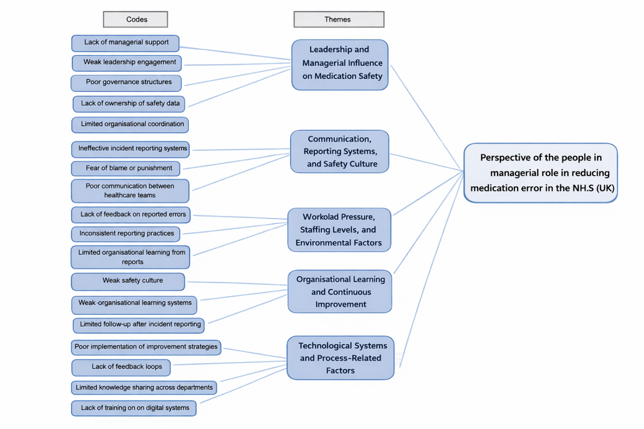
Figure 10: Theme Development
(Source: Self-developed)

5.5.2 Theme 1: Leadership and Managerial Influence on Medication Safety
The theme of leadership and managerial involvement became a major one that impacted medication safety practice in health care organisations. Studies included in the systematic review highlighted that managerial leadership is an important factor in setting up safe medication practices and quality improvement efforts (Rostami et al., 2019; Nicol et al., 2014). Strong leadership will help in building effective governance, organisational co-ordination and strategic decision making that will aid medication safety in the NHS.
Table 8: Theme Development Process - Theme 1
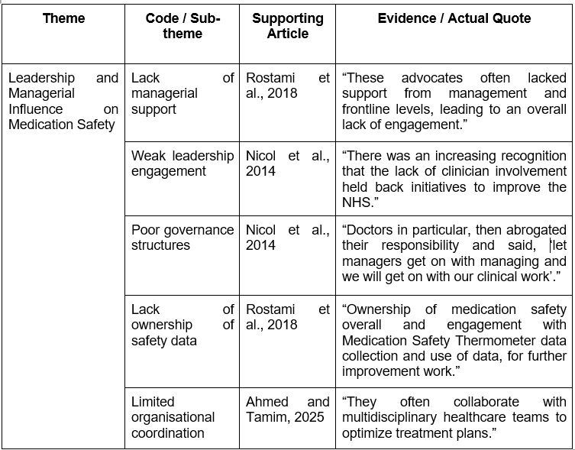
The synthesis of reviewed research suggests that the intervention of leadership and management is significant in the development of medication safety practices in healthcare organisations. Managers have the role of establishing governance frameworks, safety policies, and the coordination of operations of the healthcare professionals engaged in medication management (Ahmed and Tamim, 2025). Leadership can serve to ensure that medication safety programs are incorporated in the routine clinical practice and are supported with proper organisational resources. Investigations have shown that healthcare managers have a responsibility to ensure that the policy of medication safety, reporting systems, and strategies of quality improvement are properly introduced into the clinical settings (Falade et al., 2024).
The studies analysed imply that the involvement of the manager can affect employee involvement in safety measures such as incident reporting and quality improvement initiatives. Conductive support of the medication safety programmes by the healthcare managers significantly increases the likelihood of adherence to the safety procedures by the healthcare professionals, as well as their role in risk identification of possible medication risks (Xu et al., 2025; Bourne et al., 2022). On the other hand, a low level of managerial participation can make the safety efforts ineffective and lower the responsibility for the medication safety results. It has been noted in the literature that effective leadership will promote transparency, shared responsibility, and cooperation among healthcare professionals. Empowerment of managerial leadership and governance systems can thus increase organisational ability to reduce the number of medication errors and improve patient safety in the healthcare systems (Umeano, 2024). Leadership support also promotes the establishment of communication systems and monitoring procedures through which organisations can monitor the performance and safety of medication.
Nevertheless, Rostami et al. (2018) found that leadership engagement had weaknesses as an impediment to medication safety improvement. Medication safety data were collected systematically in most instances, but the data were not adequately reviewed and used by the management to lead improvement efforts. Absence of ownership of safety information, lack of coordination among the departments and less managerial control in organisations have been reported as contributing factors to the inability of the organisations to convert the safety information into applications.
Moreover, leadership has an impact on the creation of organisational safety culture (Fahrni et al., 2014). The active involvement of managers in safety efforts and the encouragement of open communication are the factors that contribute to the fact that healthcare professionals may report their medication errors and engage in safety enhancement efforts. On the other hand, minimal involvement by leadership may lead to disjointed safety practices and less responsibility towards medication safety management (Hult et al., 2023). In that case, active administrative attention, good governance mechanisms, and tactical integration are essential to achieve the successful implementation and maintenance of medication safety programs in healthcare settings in the form of strategic coordination. This theme directly addresses the research objective relating to managerial strategies used to reduce medication errors. The findings demonstrate that healthcare managers perceive leadership, governance, and staff engagement as important mechanisms for improving medication safety and reducing risks within healthcare organisations.

5.5.3 Theme 2: Communication, Reporting Systems, and Safety Culture
Managerial engagement and leadership became a significant theme that affected medication safety practice in healthcare organisations. The results highlighted the fact that managerial leadership plays a very significant role in determining effective medication safety systems as well as the provision of quality improvement initiatives (Keers et al., 2018). The literature review synthesis shows that communication practices and reporting systems play a crucial role in the sphere of medication safety in healthcare organisations. The communication among medical practitioners plays a crucial role in the transfer of correct medication information in the prescription, dispensing, and administration processes (Tabrizi and Masri, 2021).
Table 9: Theme Development Process - Theme 2
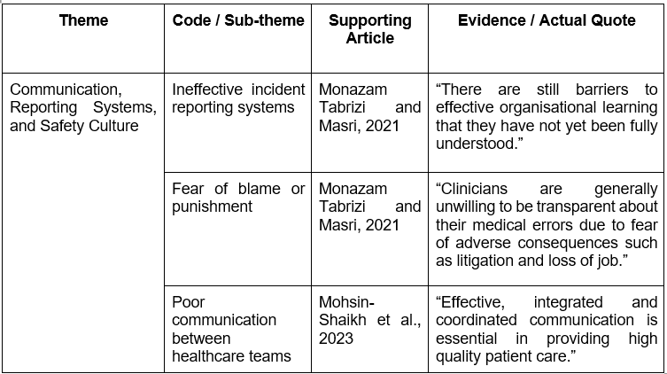
With effective and constant communication, the work of healthcare teams can be better organised and minimise the risk of harming patients due to medication errors. Studies by Mohsin-Shaikh et al. (2023) noted that there is always a possibility of communication breakdown between professional teams like doctors, nurses, and pharmacists. Such gaps can lead to misinterpretations on how to take the medication or failure to record patient data. These obstacles have the potential to lead to certain underperformance in medication errors and time lag in responding to possible safety issues. In the NHS, healthcare managers have a duty to come up with governance structures, to coordinate safety policies, and to make sure that medication safety processes are integrated uniformly in healthcare environments.
The articles reviewed have indicated that effective managerial leadership plays a role in the effective implementation of medication safety initiatives (Umeano, 2024). Managers can shape the ways in which the safety policies are being disseminated, the distribution of resources and the way in which the healthcare teams are cooperative in running the medication processes. Monitoring and evaluation of medication safety data is also obtained with the help of effective leadership, as it will enable organisations to create a strategy by detecting safety threats and identifying methods on how to minimise medication errors (Alqahtani et al., 2026). Employees in organisations that value high leadership engagement have high chances of taking part in safety efforts and reporting incidents related to medication. Nevertheless, a number of studies also report the limitations of weaknesses in leadership engagement as an obstacle to the improvement of medication safety. In some health organisations, medication safety information was obtained regularly, but it was not properly analysed and utilised by the management to make decisions (Awad et al., 2023). It was reported that the lack of ownership of safety information, poor governance structures and poor coordination between departments were impediments to the effectiveness of the safety improvement efforts. Incident reporting systems were also listed as useful mechanisms for identifying medication safety issues. These systems enable the medical organisations to obtain data regarding any medication errors and near misses.
However, according to Dawe et al. (2025), the reporting systems might not be actively used if healthcare professionals consider the reporting systems as time-consuming or complex. The medication safety practices can thus be improved by developing a supportive safety culture and by improving the communication channels. Moreover, the effect of managerial leadership on the safety culture of an organisation is huge. The managers who bring in transparency, accountability, and open communications lead to encouraging healthcare professionals to report mistakes and participate in safety enhancement activities. Conversely, relatively low leadership engagement can lead to disjointed safety practices and learning in organisations (Scott et al., 2022). Thus, the results show that excellent managerial leadership and good governance are necessary factors in enhancing medication safety and minimisation of medication errors in the NHS healthcare system. The findings of this theme contribute towards understanding how healthcare managers perceive communication systems, reporting mechanisms, and organisational safety culture as essential facilitators in reducing medication errors and improving medication safety outcomes.

5.5.4 Theme 3: Workload Pressure, Staffing Levels, and Environmental Factors
The interpolation of the studied works presupposes that workload pressure is a significant influence on medication safety in healthcare settings, which is affected by staffing. Healthcare workers often work in hectic clinical environments where patients, time, and staffing decisions influence their capacity to execute their medicine-related activities with high effectiveness (Yalçin et al., 2022). In cases where healthcare personnel must attend to many patients, the time taken to review the prescription and check the medication details might be increased. The workload pressure, staffing, and environmental conditions were found to be important influencing factors in medication safety in healthcare organisations.
Table 10: Theme Development Process - Theme 3
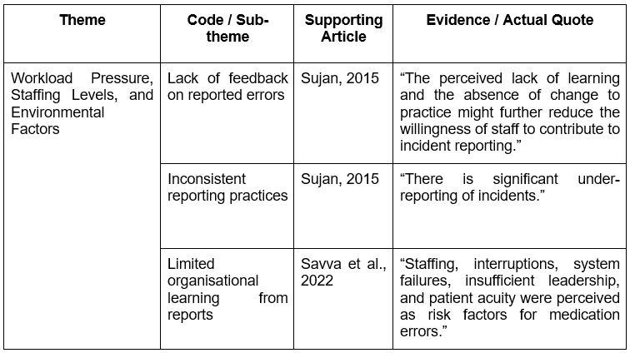
Studies in the systematic review have found that healthcare professionals frequently operate in heavy clinical stress conditions where there is a high workload and insufficient staffing to alleviate the workload (Sujan, 2015; Savva et al., 2022). These aspects influence the capabilities of the hospital employees to fulfil medication-related duties attentively and consistently.
Some research suggests that large patient-staff ratios are likely to cause medication errors. Healthcare workers can be fatigued and stressed to handle several of their responsibilities at the same time. Such pressures could also cause a lack of concentration when administering medication or during the prescription process, thereby increasing the possibility of an error (Booker et al., 2024; Garnett et al., 2023). It has been discovered that time pressure may be burdened during the process of medication administration and prescription due to the lack of personnel and excessive workload. To a large extent, healthcare professionals have to cope with several tasks at the same time, which may lead to less focus on medication safety procedures (Sutherland et al., 2025). Poor staffing can result in more stress and fatigue on the part of the nurse, pharmacists and prescribers, which can have negative effects on their concentration and decision-making capacity in medication handling. The disruptive situations during the medicinal administration were also generally cited as a causative factor of medication error (Atingaet al., 2024). These interruptions raise the chances of errors arising during medication-related duties.
Medication safety issues are also caused by environmental factors in the healthcare setting. Clinical duties related to medications may be interrupted by busy wards, high rates of interruptions, and collaborating clinical needs. These disruptions may affect focus and quality in the process of assembling or giving medications. Ensuring that there are adequate staff and enhancing the conditions under which they work might thus help to make medication management practice in healthcare organisations safer (Andersson et al., 2022).Moreover, another environmental issue that affects medication safety was found to be complex patient care requirements. Patients with various medical needs tend to have a number of treatments and drugs, making the process of prescribing and monitoring treatment more complex. These complex medication regimens entail close coordination of health care providers to manage them.Healthcare providers in a pressurised setting can choose to achieve outcomes rather than focus on detailed steps of medication safety (Bourne et al., 2023). Therefore, it can be argued that staffing deficit, the workload under pressure, and better conditions of work are the core recommendations of medication error reduction and improvement of medication safety in healthcare organisations. This theme addresses the research objective associated with identifying barriers influencing medication safety. The findings indicate that workload pressures, staffing shortages, and environmental interruptions are major organisational barriers affecting safe medication management practices in healthcare settings.

5.5.5 Theme 4: Organisational Learning and Continuous Improvement
Medication safety issues are also caused by environmental factors in the healthcare setting. Clinical duties related to medications may be interrupted by busy wards, high rates of interruptions, and collaborating clinical needs. These disruptions may affect focus and quality in the process of assembling or giving medications (Garfield et al., 2016).
Table 11: Theme Development Process - Theme 4
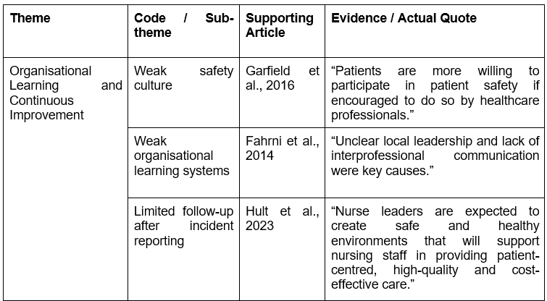
Ensuring that there are adequate staff and enhancing the conditions under which they work might thus help to make medication management practice in healthcare organisations safer. Continuous improvement and organisational learning became a significant theme that affects medication safety in healthcare organisations. Some research studies that were included in the systematic review point out that healthcare organisations should be capable of learning from medication errors and safety incidents in an effort to improve patient safety (Hult et al., 2023; Fahrni et al., 2014). Organisational learning is associated with performing an analysis of the reported incidents, the identified root causes of an error, and taking corrective measures to make sure that similar incidents do not happen in the future.
Nevertheless, studies by Palesy and Crowley (2025) suggest that the process of organisational learning is not necessarily developed completely in the healthcare systems. Although medication mistakes can be reported by using an incident reporting system, the results of these reports are not necessarily converted into beneficial changes. In other instances, the healthcare organisations gather safety information but do not have formal processes for examining and implementing such insights in clinical practice. The articles by Hall et al. (2022) suggest that incident reporting systems are a common practice in the healthcare environment to report medication errors and near misses. These systems give useful information which can be used by organisations to determine the patterns of medication-associated risks and can also determine aspects that need improvement (Alrowilyet al., 2025). However, the results indicate that healthcare organisations tend to have issues implementing reported incidents into meaningful changes. The reported safety incidents are, in most instances, not analysed effectively and readied with improvement measures (Jones et al., 2024). The research by Haraldseid-Driftlandet al. (2022) also highlights the need to have the cooperation of the healthcare professionals and managerial teams to enhance organisational learning. The exchange of lessons about safety incidents between departments can assist organisations to identify systemic problems and come up with prevention measures. Thus, establishing effective feedback systems can also motivate medical staff to take part in long-term safety enhancement practices.
The findings emphasise that ineffective feedback systems reduce the efficiency with which organisational learning is conducted. Medication errors are regularly reported by healthcare professionals who are not provided with feedback on the use of the information to help practice safety. Such a deficiency in communication makes staff less motivated to engage in reporting systems, and organisational learning is poor. Moreover, the lack of organised systems to analyse safety events can deny the health institutions the opportunity to detect the problems associated with medication safety on a system-wide level (Despott et al., 2025). Unless adequate assessment and subsequent measures are taken, organisations can keep falling prey to medication errors in the future. The analyses underline the fact that healthcare organisations should have well-defined procedures for evaluating the safety incidents, exchanging learning, and applying an improvement program. The analysis shows that to improve medication safety; it is important to strengthen organisational learning systems and encourage optimal improvement. Healthcare organisations should devise effective feedback and make sure that the lessons of medication errors are captured and put into practical lessons of safety enhancement (Guntschniget al., 2025). The theme also supports the research objective concerning facilitators of medication safety improvement. Organisational learning, continuous feedback systems, and collaborative safety practices were identified as important facilitators supporting long-term medication safety enhancement in the NHS.

5.5.6 Theme 5: Technological Systems and Process-Related Factors
The synthesis of the reviewed works suggests that technological systems and medication management processes play a large role in medication safety in healthcare organisations. Digital technologies that include electronic prescribing systems, medication tracking devices, and a lot more are being introduced in many healthcare institutions to enhance the accuracy and efficiency in the management of medications (Vejdaniet al., 2022; Osmani et al., 2023). These systems aim at facilitating clinical decision-making and minimising the errors that are linked to manual documentation.
Table 12: Theme Development Process - Theme 5
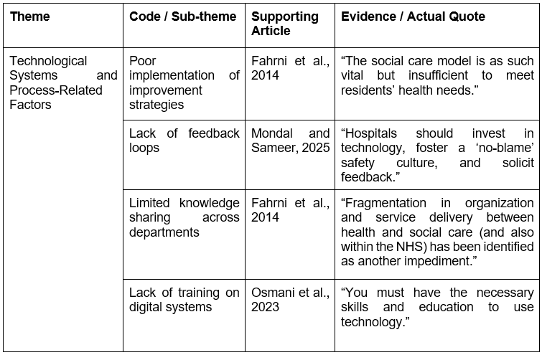
Studies also emphasised that digital technologies, electronic prescribing systems and medication data collection tools are becoming important to healthcare organisations as a means of enhancing the safety and efficiency of medication practices (Hult et al., 2023; Fahrni et al., 2014). The systems are meant to minimise the number of manual errors, enhance the quality of documentation, and offer clinical decision support to the health professionals in the process of prescribing and administering medication. Nevertheless, the research also proves that technological systems can create some new issues that can lead to the occurrence of medication errors (Mondal and Sameer, 2025). Specifically, research indicated that e-prescribing systems, in certain cases, provide chances of making mistakes as a result of system design flaws. The inaccurate selection of drugs via the electronic lists, the default automatic populating of the dosage of medications, and complicated electronic interfaces can boost the chances of prescription errors. Professionals in the healthcare sector also complained of alert fatigue, whereby staff find themselves receiving excessive warning signals regardless of the electronic systems. As a result of overreacting, they might start ignoring some valuable safety alerts (Ahsani-Estahbanatiet al., 2022). Although these are the advantages, the analysed articles imply that technological systems can also create new challenges. Certain medical care providers complain that system interfaces create some challenges, resulting in incorrect medication choices or dose entry. Moreover, the regular automated notifications of electronic systems can lead to the phenomenon of alert fatigue since relevant safety announcements are ignored because of the large number of notifications.
Moreover, inexperienced healthcare professionals are prone to commit mistakes when entering or reading the prescriptions out of their ignorance of the work with the system. Thus, the obtained results suggest that the enhancement of the system design, sufficient training, and the clarity of the medication management processes are the key elements of decreasing medication errors and improving medication safety in healthcare organisations (Adeyemi et al., 2024; Sharma et al., 2024). The coordination of the processes in the prescription, dispensing, and administration of medicines also influences medication safety (Huebner and Flessa, 2022). Such processes might be disrupted by poor communication or a lack of clarity among the healthcare staff. Providing sufficient training, enhancing the usability of systems and reinforcing the coordination between healthcare teams are therefore relevant towards medication safety. Furthermore, the findings within this theme demonstrate the relevance of systems-based and safety-oriented theoretical perspectives in understanding how healthcare managers approach medication safety improvement. Technological systems, process coordination, and structured medication management practices were identified as important components supporting safer healthcare delivery.

5.6 Chapter Summary
The thematic analysis framework, developed by Braun and Clarke, was then used to synthesise key findings of the studies. Five themes were included among them, which were leadership influence, communication and reporting systems, workload and staffing pressures, organisational learning, and technological factors influencing medication safety. The themes provide an insight into the organisational and managerial aspects that determine the reduction of the nature of medication errors in a healthcare system. Thus, enhancing the usability of the system, reinforcing coordination of the processes, and aiding the staff training are key to the utilisation of tech solutions in medication safety management effectively.

Chapter 6: DISCUSSION

6.1 Introduction to the Chapter
In this chapter, an analysis of the results obtained in Chapter 5 by thematic analysis is critically discussed, connecting them with the research objectives, the current literature, and theoretical perspectives. It demonstrates the impact of healthcare managers on medication safety in the NHS and the role they play in addressing the practice of leadership, organisational approaches, and decision-making. Key theories, such as the Safety Culture Theory and Transformational Leadership Theory, are incorporated in the discussion to offer a more detailed insight into the findings. In addition, it assesses how communication, staffing, organisational learning, and technological systems contribute to the development of the medication safety outcome in the context of complex healthcare settings.

6.2 Discussion of Key Findings

6.2.1 Discussion based on Objective 1
The results of this research demonstrated that the role of leadership and managerialinfluence is a key factor in medication safety in the NHS. This aligns with wider data in healthcare management that highlights how leadership impacts the organisational priorities, employee behaviour, and effective execution of safety programs. According to Rostami et al. (2019), the findings indicate that managers who take an active part in the governance and policy formulation, along with safety surveillance, play an important role in minimising medication errors.
As stated by Rostami et al. (2018), the results are consistent with known theories of leadership, such as transformational leadership, which emphasises motivation and empowerment of employees. Managers who stimulate cooperation, responsibility and collective responsibility promote compliance with safety practices and engagement in the quality improvement efforts among healthcare professionals (Hejazi et al., 2026). This is based on current research that the Leadership style has a direct impact on staff engagement and patient safety outcomes.
However, inconsistencies in the effectiveness of leadership are found in the results. Though leadership is identified as key, there is some evidence that there are managers who failed to effectively utilise the available safety data. These results invalidate current beliefs that the existence of leadership results in safety improvement. The study brings out the fact that successful leadership means that it is data-driven and participatory in the safety processes.
A critical reflection of the research method implies that the secondary qualitative data cannot be sufficient to manage the differences in leadership styles in various settings within the NHS. In addition, leadership is both a complex and situational process, and its impacts may vary, based on organisational culture and resources (Enahoro et al., 2024). All these differences in the outcome of various studies might point towards the fact that leadership effectiveness is affected by the outside components such as policy constraints and institutional pressures.Based on Nicol et al. (2014), the results emphasise the need to have coordination in various phases of the medication procedure. The mistakes can be managed in various stages, such as prescribing, dispensing and administration. It supports available literature that medication safety must be a holistic process and not an isolated intervention.
The importance of organisational learning and safety culture was established as one of the crucial elements of enhancing medication safety. According to Tabrizi and Masri (2021), the results indicate that in most healthcare organisations, there exist mechanisms for reporting errors. However, a gap exists with regard to effective strategies for transforming the errors reported into constructive improvements. This aligns with the available evidence that attests to the disconnect between reporting on errors and organisational learning.
Fahrni et al. (2014) upholds the idea of a good safety culture promoting openness, responsibility, and growth. The organisations that allow open communication and non-punitive reaction to the mistake have more chances to realise the issues and provide preventive actions. This is in accord with the existing safety culture models that the focus of the scheme is on learning from errors as opposed to blame.
Compared to the available literature, the results highlight the role of involvement of the managers in promoting a robust safety culture. The leaders play a key role in the organisational setting of values and behaviours, and its safety interest is a significant aspect influencing the attitudes of employees to reporting and learning. Conversely, Miziara and Miziara(2022) explains that technology can bring about new risks in these areas as they can be designed to cause defects within the system, burnout due to constant alerts and human mistakes. The discovery is remarkable because it dispels the belief that technology is a panacea for medication errors. It implies that technological interventions must be cautiously instituted and constantly monitored. These findings directly address the research objective relating to managerial strategies used to reduce medication errors. The discussion demonstrates that healthcare managers perceive leadership involvement, governance, and staff engagement as essential mechanisms for improving medication safety within NHS organisations.

6.2.2 Discussion based on Objective 2
This paper demonstrates that effective communication among multidisciplinary teams is critical and should be structured and clear to support the proper medication procedures. This complements the existing processes, which encourage standardised communication tools and protocols in healthcare facilities (Miziara and Miziara, 2022). Moreover, the significance of incident reporting systems can be aligned with the existing patient safety models that place the learning-based on error.
However,Keers et al. (2018) stated that, the results highlight the shortcomings of the effectiveness of the reporting systems. These systems are viewed by many healthcare professionals as complicated, time-consuming and unproductive in terms of providing meaningful feedback. This observation is especially important since it defies the expectation that the availability of reporting systems can result in better safety outcomes.
Compared to the current literature, Sujan, (2015) stated that, the research supports the concept of organisational culture as a key determinant of effective communication. As there is a culture of not reporting because of fear of being blamed, this can be a major setback to safety efforts (Nawathe and Herrington, 2024). This is aligned with overall evidence that non-punitive settings are critical towards fostering transparency and learning.
In that case, communication structures are highly advocated; there seems to be no uniformity in their application. Moreover, Hall et al. (2022) stated that, the systematic literature review restricts the possibilities to investigate the dynamics of real-time communication, which can allow gaining more knowledge about the way in which the failures of communication take place in practice. The conclusion of the research compares with the available literature that the use of technology ought to be in the context of a wider socio-technical framework. Digital tools are dependent on variables like training of the users, the usability of the system and the organisational support (Rahman and Jyoti, 2022). The findings also contribute towards answering the research question by demonstrating that healthcare managers consider communication systems, reporting structures, and organisational safety culture as critical facilitators supporting medication safety improvement and error reduction.

6.2.3 Discussion based on Objective 3
The results are strong, showing that staffing pressures and workload are significant contributors to medication errors. The large numbers of patients, shortage of staff and time minimise the capacity of medical practitioners to adhere to safety protocols (Ramadhan et al., 2025). This aligns with a considerable amount of literature that indicates a connection between workforce concerns and patient safety risks.
The findings justify the perception that medication errors can usually be systemic but not individual. Well-trained professionals find it more challenging to make mistakes in an atmosphere of high workload. This complements the well-known theories that underscore the significance of organisational factors in human performance development.
One of the lessons was developed based on the findings, and this is the role of environmental variables, such as interruptions and distractions in the rise in error rates. This provides a dimension to the available research by placing importance on the role of knowing how the physical and operational environment determines medication safety (Satterwhite et al., 2024). It indicates that efforts are required besides the staffing levels to reduce errors through bettering working conditions.
The research methodology can reduce the capacity to measure the level of risks associated with workloads since qualitative data is based on perceptions.According to Savva et al. (2022), the results are context-specific to the NHS, which can restrict their applicability to other healthcare systems that have varying resource-organisation. The inconsistency of results of various studies could be a measure of different organisational policies and practices of managing the workforce. The results demonstrate the duality of technology in terms of medication safety. On the one hand, technological systems like electronic prescribing increase the level of accuracy, minimise the number of manual errors, and become more efficient (Adeyemi et al., 2024). This is aligned with the available evidence that favours the use of digital tools in healthcare.
Besides technological difficulties, healthcare organisations' medication processes were cited as the cause of medication errors. There are various phases of medication management with prescription, dispensing, administration, and monitoring in that order, and there is a need to coordinate the activities of different healthcare professionals. In case of poor communication among these professionals or a lack of clearly defined procedures, the chances of medication errors are higher. The articles by Bethune et al. (2023) also highlight that substandard training in the implementation of digital prescribing systems can influence the capacity of the staff to safely handle medications.
However, Keers et al. (2018) the results highlight that the safety culture is not always realised completely. The performance of organisational learning is diminished by weak feedback systems and the dissemination of lessons learned (Do and Mai, 2022). This idea can be based on reporting systems that automatically result in improvement and point out the value of structured procedures to analyse and act on safety data.
Overall, these results emphasise the significance of proper staffing rates and the distribution of resources in healthcare facilities in comparison with the existing evidence. Safe staffing is known to be a lot to ensure quality care and minimise errors (Ferguson et al., 2024). The study evidence that balancing cost-effectiveness with patient safety is still a challenge, particularly in system-resource-constrained ones, like the NHS. This discussion strongly aligns with the research objective examining barriers affecting medication safety improvement. Workload pressures, staffing shortages, environmental interruptions, and operational stress were identified as major organisational barriers influencing safe medication management within healthcare settings.

6.3 Strengths and Limitations
This work has several strengths which make it more academically rigorous and relevant. On the one hand, the SLR was used to provide a transparent and well-organised pattern of data collection and analysis, minimising the selection bias and enhancing reliability. The emphasis on managerial views bridges a major gap in the current body of research, where much of the focus in the research is generally on frontline clinical staff. Moreover, the usage of thematic analysis made it possible to recognise the common trends in several studies and aligned with an in-depth overview of organisational and leadership drivers of medication safety. The combination of theoretical frameworks enhances the depth of analysis of the study.
However, the study has significant weaknesses as well. The use of secondary qualitative data limits the capacity to observe live managerial experiences, which can bias interpretation. The results can be limited to the context of the NHS and UK, meaning that they cannot be generalised to other health care systems. Moreover, it is possible that the scope of perspectives could be narrowed by the volume of relatively limited literature included. Other factors that can affect consistency include variations in the quality and design of studies included in their selection.

6.4 Chapter Summary
The chapter critically reflected on the most important study findings in relation to existing literature, theoretical frameworks, and research objectives. It was explored in the discussion that organisational and systemic factors such as leadership, communication, workload, the safety culture and technology are the main determinants of medication errors. The results were mostly in line with the existing studies, with some issues in policy and practice in the leadership engagement and organisational learning. Research strengths and limitations were considered, the methodological limitations, and contextual boundaries were realised. The chapter has highlighted the importance of healthcare managers to influence safe practice and enhance medication safety in the NHS.

Chapter 7: RECOMMENDATIONS AND CONCLUSION

7.1 Introduction to the Chapter
The chapter provides the main conclusions and recommendations based on the research concerning the views of healthcare managers when it comes to minimising medication errors in the NHS. It summarises the general conclusions of the study and its importance to healthcare management and patient safety. The chapter provides practical and theoretical implications of the research and then provides elaborate recommendations on the ways of advising organisational practices and leadership strategies. Moreover, it provides future research recommendations to fill the gaps in the literature.

7.2 Linking with objectives
Research Objective | Related Findings/Themes | Key Findings/Conclusion | How this was Achieved
Objective 1: To explore NHS managers’ understanding of medication errors and their causes. | Leadership influence, communication failures, workload pressures, technological factors | NHS managers recognised that medication errors are mainly caused by organisational, communication, staffing, and system-related failures rather than individual mistakes. Leadership and safety culture were viewed as important in reducing risks. | Achieved through systematic review and thematic analysis of qualitative studies examining managerial perceptions and organisational causes of medication errors in NHS healthcare settings.
Objective 2: To identify managerial strategies used to reduce medication errors. | Leadership strategies, reporting systems, organisational learning, staff training | Managers identified safety governance, incident reporting systems, staff engagement, communication improvement, and continuous training as important strategies for improving medication safety. | Achieved through analysis of qualitative evidence exploring managerial practices, safety initiatives, and organisational approaches used within healthcare organisations.
Objective 3: To examine perceived barriers and facilitators to improve medication safety and theoretical framework used by managers. | Staffing pressures, safety culture, organisational learning, Systems Theory, Safety Culture Theory | Staffing shortages, workload, and weak communication acted as barriers, while leadership support, learning culture, and technological systems acted as facilitators supporting medication safety improvement. | Achieved through thematic synthesis of studies discussing organisational barriers, facilitators, and theoretical approaches influencing medication safety management in the NHS.

7.3 Recommendations for Practice
According to the findings, there are several recommendations to make, which will enhance medication safety practices in the NHS. In that case, promoting the transformation of leadership practices should be fostered within healthcare organisations through leadership and governance. Managers can be educated to participate in safety efforts positively, effectively use safety data, and invest in the importance of accountability and improvement. Communication systems need to be enhanced by adopting standard protocols and simple reporting systems. The timely feedback on reported incidents will motivate the staff to participate and improve organisational learning. That leads to a need to overcome the issues of workload pressure and staffing. To reduce the number of errors caused by fatigue, healthcare organisations must orient towards a favourable staff-patient ratio and offer favourable working conditions. The technological systems ought to be optimised, through proper staff training, system design enhancement and repetitive assessment of the effectiveness of the systems. Organisational processes should be adopted to use technology and facilitate instead of working against medication safety. Furthermore, the measures will be capable of enhancing patient safety and reducing the medication error.

7.4 Recommendation Summary Table
Recommendation | Target Level | Expected Impact
Developing healthcare management excellence through a focus on patient safety leadership and developing accountability in healthcare professionals. | Organisational | Facilitated development of a stronger safety culture, through improved decision-making and the increased accountability of healthcare managers in relation to reducing medication errors.
Establishment of standardised communication/incident reporting and use of real time feedback systems. | Practice/Organisation | Increased transparency; increased levels of error reporting; increased levels of organisational learning and reduced repeat errors.
Support to encourage a no-blame reporting culture in NHS organisations. | Organisational | Encourages openness in reporting staff perceive less risk; continuously improving and learning from mistakes.
Maximising the staff levels available to meet workload and use of workload distribution strategies. | Organisational | Minimises staff fatigue and burnout and improves level of attention; reduces the risk of making errors in medication.
Consistent provision of education for healthcare personnel about safe handling of medications and using their systems effectively. | Education/Practice Based | Improvement in proficiency of personnel, decreased number of mistakes through less total of administration and calculating errors, increase the ability to follow through on safety procedure adherence.
Integrate with proper education/usage training technologies related to healthcare such as the electronic prescribing system | Practice/Organisational | Decrease human error and improve the accuracy in administering the prescription; reduce risk related to the usage of the system.
Improving organisational learning with formal auditing and feedback systems. | Organisational | Advancement of long-term continuous improvement, identification of systemic weaknesses, evidence based decision making.
Increasing staff engagement and safety participation using supportive leadership development practices. | Organisational | Facilitation of staff trust, morale, compliance with safety procedures and other measures.
Ongoing evaluation and monitoring of medication safety systems/policies/protocols. | Organisational | Provides assessment of effectiveness of safety measures, allows for timely corrective actions to eradicate any long-term challenges.

7.5 Recommendations for Future Research
This research determines some potential areas where research should be conducted in the future to further understand medication safety in health care. In that case, primary data collection methods such as interviews or questionnaires with the healthcare managers need to be used in future investigations to obtain more information on the practical experience and decision-making processes. This will overcome the drawbacks of secondary data. Secondly, amixed research approach is advisable with the application of the statistical correlation between managerial practices and the reduction in medication errors. This will enhance the overall generalisability of results and manage stronger evidence. Cross-national research would provide an opportunity to compare the best practices and contextual variations in medication safety control against other healthcare systems and countries. Moreover, the effect of emerging technology, which includes AI and digital health systems, on medication safety can be investigated in the future. More research on the organisational culture and leadership styles will develop a more in-depth insight into how the two and their impact on patient safety outcomes.

7.6 Conclusion
The aim of this research was to discover the views of NHS healthcare managers on their role to play in medical error prevention. The study addressed the research question by examining the attitudes of healthcare managers working in the NHS (UK) towards their responsibility in minimising medication errors.The qualitative systematic literature review allowed the research to review available evidence to determine the major themes associated with leadership, organisational practices, and patient safety.
The study results prove that medication errors are multifactorial and complex problems as they are mainly caused by organisational and systemic factors, rather than personal error. Some of the themes identified include leadership and involvement of the managers, communication and reporting systems, workload and staffing pressures, organisational learning and technological systems. Among them, leadership has become a crucial issue, and managerial engagement in the field of encouraging safety practices and enhancing employee involvement and policy implementation has become an important factor.
It was also discovered that the communication breakdown and poor reporting systems are elements leading to the occurrence of medication errors despite the structured frameworks. Moreover, workload pressures and staffing shortages were also identified as significant issues that affect the capacity of healthcare providers to adhere to safe practices. Weak feedback mechanisms were found to keep the issue of organisational learning limited, and technological systems, despite being helpful, can lead to new risks that should not be neglected.
These findings are important because of their role in informing management about the field of medication safety, which has been partially covered in the literature. The research highlights the significance of taking a systems-based approach to patient safety through which the leadership, organisational culture and operational processes are coordinated to reduce risks.
A multi-level approach that will enable the solution with a lot of complexity and will go beyond personal responsibility will be essential to achieve a considerable reduction in the number of medication errors in the NHS. The healthcare managers play an important role in ensuring safe environments by providing resources properly through adequate leadership, management and communication. By helping the organisation to resolve organisational problems and advocate the use of safety systems, healthcare organisations can improve patient outcomes and the overall quality of care.

Reference List
Adeyemi, C., Adegoke, B.O. and Odugbose, T., (2024). The impact of healthcare information technology on reducing medication errors: A review of recent advances. Int J Front Med Surg Res [online], 5(2), pp.020-029. https://www.researchgate.net/profile/Bisola-Adegoke/publication/386415037_The_impact_of_healthcare_information_technology_on_reducing_medication_errors_A_review_of_recent_advances/links/67504c56a7fbc259f1ac81b7/The-impact-of-healthcare-information-technology-on-reducing-medication-errors-A-review-of-recent-advances.pdf
Afifi, M., Stryhn, H. and Sanchez, J., (2023). Data extraction and comparison for complex systematic reviews: a step-by-step guideline and an implementation example using open-source software. Systematic reviews, 12(1), p.226. https://link.springer.com/article/10.1186/s13643-023-02322-1
Aguinis, H., (2023). Research methodology: Best practices for rigorous, credible, and impactful research. SAGE Publications.
Aguinis, H., Li, Z.A. and Der Foo, M., (2024). The research transparency index. The Leadership Quarterly, 35(4), p.101809. https://www.sciencedirect.com/science/article/pii/S1048984324000389
Ahmed, R. and Tamim, T.R., (2025). Enhancing medication safety: the role of community and hospital pharmacists in modern healthcare systems. Radinka Journal of Health Science, 2(3), pp.328-355. https://rjupublisher.com/ojs/index.php/RJHS/article/view/418
Ahsani-Estahbanati, E., Sergeevich Gordeev, V. and Doshmangir, L., (2022). Interventions to reduce the incidence of medical error and its financial burden in health care systems: A systematic review of systematic reviews. Frontiers in medicine, 9, p.875426. https://www.frontiersin.org/journals/medicine/articles/10.3389/fmed.2022.875426/full
Alqahtani, J., Almatouq, S., Ghanim, A.A. and Alshagrawi, S., (2026). Perspectives of healthcare professionals in quality improvement initiatives on reducing medication errors in Aseer hospitals, Saudi Arabia. Future Journal of Pharmaceutical Sciences, 12(1), p.29. https://link.springer.com/article/10.1186/s43094-026-00950-7
Alrowily, A., Alfaraidy, K., Almutairi, S., Alamri, A., Alrowily, W., Abutaleb, M., Zaitoun, M., Sarawi, W. and Aljead, M., (2025). High-risk medication errors: Insight from the UK National Reporting and learning system. Exploratory Research in Clinical and Social Pharmacy, 17, p.100531. https://www.sciencedirect.com/science/article/pii/S2667276624001288
Alrshah, Y.M.S., Alqufayli, M.S.S., Aalalhareth, H.S.M., Alaiajam, M.H., Alnasib, F.M.S. and Almsfooh, N.S.M., (2024). Optimizing Infection Control Through Interprofessional Collaboration: An Integrative Review Of Roles, Responsibilities, And Evidence Across All Healthcare Departments. The Review of Diabetic Studies, pp.153-165. https://diabeticstudies.org/index.php/RDS/article/view/1146
Anas, N.A.S.I.R.U. and Ishaq, K.A.M.I.L.U., (2022). Qualitative research method in social and behavioural science research. International journal of management, social sciences, peace and conflict studies, 5(1), pp.89-93. https://www.researchgate.net/profile/Nasiru-Anas/publication/361174520_Qualitative_Research_Paper/links/62a0d31955273755ebdd5ef0/Qualitative-Research-Paper.pdf
Andersson, U., Andersson Hagiwara, M., Wireklint Sundström, B., Andersson, H. and Maurin Söderholm, H., (2022). Clinical reasoning among registered nurses in emergency medical services: a case study. Journal of Cognitive Engineering and Decision Making, 16(3), pp.123-156. https://journals.sagepub.com/doi/abs/10.1177/15553434221097788
Armstrong, M. (2026). Infographic: Why people are dissatisfied with the NHS. [online] Statista Daily Data. Available at: https://www.statista.com/chart/17311/why-people-are-dissatisfied-with-the-nhs/?srsltid=AfmBOoqxety-T1rE_-YZgVftbxOCF9026wyyr_7AumaKU6b6o_o12rbr [Accessed 8 Apr. 2026].
Asamoah, D., (2025). The role of health services regulation in healthcare delivery. Electr J Med Dent Stud, 14(1). https://www.ejmds.com/download/the-role-of-health-services-regulation-in-healthcare-delivery-16003.pdf
Atinga, R.A., Gmaligan, M.N., Ayawine, A. and Yambah, J.K., (2024). “It's the patient that suffers from poor communication”: Analyzing communication gaps and associated consequences in handover events from nurses’ experiences. SSM-Qualitative Research in Health, 6, p.100482. https://www.sciencedirect.com/science/article/pii/S266732152400091X
Awad, S., Amon, K., Baillie, A., Loveday, T. and Baysari, M.T., (2023). Human factors and safety analysis methods used in the design and redesign of electronic medication management systems: A systematic review. International Journal of Medical Informatics, 172, p.105017. https://www.sciencedirect.com/science/article/pii/S1386505623000345
Ayre, M.J., Lewis, P.J., Phipps, D.L., Morgan, K.M. and Keers, R.N., (2024). Towards understanding and improving medication safety for patients with mental illness in primary care: A multimethod study. Health Expectations, 27(3), p.e14095. https://onlinelibrary.wiley.com/doi/abs/10.1111/hex.14095
Azarian, M., Yu, H., Shiferaw, A.T. and Stevik, T.K., (2023). Do we perform systematic literature review right? A scientific mapping and methodological assessment. Logistics, 7(4), p.89. https://www.mdpi.com/2305-6290/7/4/89
Bethune, R.M., Ball, S., Doran, N., Harris, M., Medina-Lara, A., Fornasiero, M., Hill, M., Lang, I., McGregor-Harper, J. and Sheaff, R., (2023). How safety culture surveys influence the quality and safety of healthcare organisations. Cureus, 15(9). https://www.cureus.com/articles/156710-how-safety-culture-surveys-influence-the-quality-and-safety-of-healthcare-organisations.pdf
Bolous, N.S., Graetz, D.E., Ashrafian, H., Barlow, J., Bhakta, N., Sounderajah, V. and Dowdeswell, B., (2023). Harnessing a clinician-led governance model to overcome healthcare tribalism and drive innovation: a case study of Northumbria NHS Foundation Trust. Journal of Health Organization and Management, 37(9), pp.1-16. https://www.emerald.com/jhom/article/37/9/1/224283
Booker, L.A., Fitzgerald, J., Mills, J., Bish, M., Spong, J., Deacon‐Crouch, M. and Skinner, T.C., (2024). Sleep and fatigue management strategies: How nurses, midwives and paramedics cope with their shift work schedules—a qualitative study. Nursing open, 11(1), p.e2099. https://onlinelibrary.wiley.com/doi/abs/10.1002/nop2.2099
Bourne, R.S., Jeffries, M., Phipps, D.L., Jennings, J.K., Boxall, E., Wilson, F., March, H. and Ashcroft, D.M., (2023). Understanding medication safety involving patient transfer from intensive care to hospital ward: a qualitative sociotechnical factor study. BMJ open, 13(5), p.e066757. https://bmjopen.bmj.com/content/13/5/e066757.abstract
Braun, V. and Clarke, V., (2024). A critical review of the reporting of reflexive thematic analysis in Health Promotion International. Health Promotion International, 39(3), p.daae049. https://academic.oup.com/heapro/article-pdf/doi/10.1093/heapro/daae049/57953479/daae049.pdf
Braun, V., and Clarke, V. (2022). Conceptual and design thinking for thematic analysis. Qualitative psychology, 9(1), p.3. https://psycnet.apa.org/journals/qua/9/1/3/
Carvalho, R.E.F.L.D., Bates, D.W., Syrowatka, A., Almeida, I., Sousa, L., Goncalves, J., Oliveira, N., Gama, M. and Alencar, A.P., (2023). Factors determining safety culture in hospitals: a scoping review. BMJ Open Quality, 12(4), p.e002310. https://bmjopenquality.bmj.com/content/12/4/e002310
Cash, P., Isaksson, O., Maier, A. and Summers, J., (2022). Sampling in design research: Eight key considerations. Design studies, 78, p.101077. https://www.sciencedirect.com/science/article/pii/S0142694X21000880
CFI (2023). Transformational Leadership. [online] Corporate Finance Institute. Available at: https://corporatefinanceinstitute.com/resources/management/transformational-leadership/ [Accessed 8 Apr. 2026].
Cheong, H.I., Lyons, A., Houghton, R. and Majumdar, A., (2023). Secondary qualitative research methodology using online data within the context of social sciences. International Journal of Qualitative Methods, 22, p.16094069231180160. https://journals.sagepub.com/doi/abs/10.1177/16094069231180160
Damiani, G., Altamura, G., Zedda, M., Nurchis, M.C., Aulino, G., Heidar Alizadeh, A., Cazzato, F., Della Morte, G., Caputo, M., Grassi, S. and Oliva, A., (2023). Potentiality of algorithms and artificial intelligence adoption to improve medication management in primary care: a systematic review. BMJ open, 13(3), p.e065301. https://bmjopen.bmj.com/content/13/3/e065301.abstract
Dawe, A., Hosking, J. and Kerr, D., (2025). Interprofessional communication by junior nurses and junior doctors in the acute regional hospital setting: A qualitative descriptive study. Journal of Interprofessional Care, 39(3), pp.459-468. https://www.tandfonline.com/doi/abs/10.1080/13561820.2025.2469324
Despott, R.A., Vella Bonanno, P. and Gauci, C., (2025). Risk management of medication errors: improving the quality of pharmacotherapeutic practice. Pharmacology Research & Perspectives, 13(3), p.e70093. https://bpspubs.onlinelibrary.wiley.com/doi/abs/10.1002/prp2.70093
Do, T.T. and Mai, N.K., (2022). Organizational learning and firm performance: a systematic review. International Journal of Productivity and Performance Management, 71(4), pp.1230-1253. https://www.emerald.com/ijppm/article/71/4/1230/390193
Drolet, M.J., Rose-Derouin, E., Leblanc, J.C., Ruest, M. and Williams-Jones, B., (2023). Ethical issues in research: Perceptions of researchers, research ethics board members and research ethics experts. Journal of Academic Ethics, 21(2), pp.269-292. https://indianapublications.com/articles/IJHSS_3(1)_14-20_61f38990115064.95135470.pdf
Duffin, E. (2026). Medication error reporting market revenue worldwide 2016-2026| Statista. [online] Statista. Available at: https://www.statista.com/statistics/1042228/medication-error-reporting-market-size-worldwide/?srsltid=AfmBOopeXHRgohdqHk_IauR6XjrJZImLWn9IPNguQTEyVERkXqCgHQqx [Accessed 8 Apr. 2026].
Enahoro, A., Osunlaja, O., Maha, C.C., Kolawole, T.O. and Abdul, S., (2024). Reviewing healthcare quality improvement initiatives: Best practices in management and leadership. International Journal of Management & Entrepreneurship Research, 6(6), pp.1869-1884. https://www.researchgate.net/profile/Chukwudi-Maha/publication/381194080_Reviewing_healthcare_quality_improvement_initiatives_Best_practices_in_management_and_leadership/links/66616b9b85a4ee7261a8f911/Reviewing-healthcare-quality-improvement-initiatives-Best-practices-in-management-and-leadership.pdf
Fahrni, M.L., Franklin, B.D., Rawaf, S. and Majeed, A., (2014). Improving medication safety in UK care homes: challenges and current perspective. JRSM open, 5(2), p.2042533313515475. https://journals.sagepub.com/doi/abs/10.1177/2042533313515475
Falade, I.M., Gyampoh, G.K.S., Akpamgbo, E.O., Chika, O.C., Obodo, O.R., Okobi, O.E., Aguguo, J.C. and Chukwu, V.U., (2024). A comprehensive review of effective patient safety and quality improvement programs in healthcare facilities. Medical Research Archives, 12(7). https://www.researchgate.net/profile/Gideon-Gyampoh/publication/382821234_A_Comprehensive_Review_of_Effective_Patient_Safety_and_Quality_Improvement_Programs_in_Healthcare_Facilities/links/66c686a597265406eaa0606d/A-Comprehensive-Review-of-Effective-Patient-Safety-and-Quality-Improvement-Programs-in-Healthcare-Facilities.pdf
Ferguson, J., Stringer, G., Walshe, K., Allen, T., Grigoroglou, C., Ashcroft, D.M. and Kontopantelis, E., (2024). Locum doctor working and quality and safety: a qualitative study in English primary and secondary care. BMJ Quality & Safety, 33(6), pp.354-362. https://qualitysafety.bmj.com/content/33/6/354.abstract
Fleck, A. (2022). Infographic: The NHS’s Most Serious (and Avoidable) Errors of 2021. [online] Statista Daily Data. Available at: https://www.statista.com/chart/27444/nhs-never-events/?srsltid=AfmBOoo5Rnw41Comaf0ZpXiROJCy1h7K7n06Ok5r5ryEIlNW11lD7h7O [Accessed 8 Apr. 2026].
Garfield, S., Jheeta, S., Husson, F., Lloyd, J., Taylor, A., Boucher, C., Jacklin, A., Bischler, A., Norton, C., Hayles, R. and Dean Franklin, B., (2016). The role of hospital inpatients in supporting medication safety: a qualitative study. PloS one, 11(4), p.e0153721. https://journals.plos.org/plosone/article?id=10.1371/journal.pone.0153721
Garnett, A., Hui, L., Oleynikov, C. and Boamah, S., (2023). Compassion fatigue in healthcare providers: a scoping review. BMC health services research, 23(1), p.1336. https://link.springer.com/article/10.1186/s12913-023-10356-3
Ghasemi, F., Mahdinia, M. and Doosti-Irani, A., (2025). Safety-specific transformational leadership and safety outcomes at workplaces: a scoping review study. BMC Public Health, 25(1), p.2723. https://link.springer.com/article/10.1186/s12889-025-24044-w
Glarcher, M. and Vaismoradi, M., (2025). Promoting just culture in nursing education: A systematic integrative review on enhancing patient safety. Nurse education today, 152, p.106776. https://www.sciencedirect.com/science/article/pii/S0260691725002126
Guntschnig, S., Barbosa, R., Jenzer, H., Greening, M., Hayde, J., Heery, H., Serrano, M.C.I., Lajtmanová, K., Rossin, E., Tentova-Peceva, S. and Kohl, S., (2025). Tackling medication errors: how a systems approach improves patient safety. European Journal of Hospital Pharmacy. https://ejhp.bmj.com/content/early/2025/04/30/ejhpharm-2025-004533?versioned=true
Hall, N., Bullen, K., Sherwood, J., Wake, N., Wilkes, S. and Donovan, G., (2022). Exploration of prescribing error reporting across primary care: a qualitative study. BMJ open, 12(1), p.e050283. https://bmjopen.bmj.com/content/12/1/e050283.abstract
Haraldseid-Driftland, C., Billett, S., Guise, V., Schibevaag, L., Alsvik, J.G., Fagerdal, B., Lyng, H.B. and Wiig, S., (2022). The role of collaborative learning in resilience in healthcare—a thematic qualitative meta-synthesis of resilience narratives. BMC Health Services Research, 22(1), p.1091. https://link.springer.com/article/10.1186/s12913-022-08451-y
Hejazi, M.E., Alizadeh-Dizaj, G., Khoshsirat, S., Raoofi, S. and Javan Biparva, A., (2026). Exploring collaborative strategies to improve patient safety in healthcare organizations: A qualitative study. PloS one, 21(1), p.e0341022. https://journals.plos.org/plosone/article?id= 10.1371/journal.pone.0341022
Howick, J., Bennett-Weston, A., Solomon, J., Nockels, K., Bostock, J. and Keshtkar, L., (2024). How does communication affect patient safety? Protocol for a systematic review and logic model. BMJ open, 14(5), p.e085312. https://bmjopen.bmj.com/content/14/5/e085312.abstract
Hoxha, G., Simeli, I., Theocharis, D., Vasileiou, A. and Tsekouropoulos, G., (2024). Sustainable healthcare quality and job satisfaction through organizational culture: Approaches and outcomes. Sustainability, 16(9), p.3603. https://www.mdpi.com/2071-1050/16/9/3603
Huebner, C. and Flessa, S., (2022). Strategic management in healthcare: a call for long-term and systems-thinking in an uncertain system. International journal of environmental research and public health, 19(14), p.8617. https://www.mdpi.com/1660-4601/19/14/8617
Hult, M., Terkamo‐Moisio, A., Kaakinen, P., Karki, S., Nurmeksela, A., Palonen, M., Peltonen, L.M. and Häggman‐Laitila, A., (2023). Relationships between nursing leadership and organizational, staff and patient outcomes: A systematic review of reviews. Nursing open, 10(9), pp.5920-5936. https://onlinelibrary.wiley.com/doi/abs/10.1002/nop2.1876
Irvine, A., (2024). First steps in qualitative secondary analysis: experiences of engaging with the primary research team. International Journal of Social Research Methodology, 27(6), pp.721-733. https://www.tandfonline.com/doi/abs/10.1080/13645579.2023.2267836
Jilcha, K. and Kitaw, D., (2016). A literature review on global occupational safety and health practice & accidents severity. International Journal for Quality Research, 10(2). https://www.researchgate.net/profile/Kassu-Jilcha-2/publication/304379574_A_literature_review_on_global_occupational_safety_and_health_practice_accidents_severity/links/576d632908ae62194742437f/A-literature-review-on-global-occupational-safety-and-health-practice-accidents-severity.pdf
Jones, M.D., Liu, S., Powell, F., Samsor, A., Ting, F.C.R., Veliotis, N., Wong, Y.M., Franklin, B.D. and Garfield, S., (2024). Exploring the role of guidelines in contributing to medication errors: a descriptive analysis of national patient safety incident data. Drug Safety, 47(4), pp.389-400. https://link.springer.com/article/10.1007/s40264-024-01396-7
Keers, R.N., Plácido, M., Bennett, K., Clayton, K., Brown, P. and Ashcroft, D.M., (2018). What causes medication administration errors in a mental health hospital? A qualitative study with nursing staff. PloS one, 13(10), p.e0206233. https://journals.plos.org/plosone/article?id=10.1371/journal.pone.0206233
Kirk, K., Cohen, L., Timmons, S. and Edgley, A., (2023). “Zero to hero”: conceptualising time as a moderator of nurses’ emotional labour on the front line. Journal of Nursing Management, 2023(1), p.9383167. https://onlinelibrary.wiley.com/doi/abs/10.1155/2023/9383167
Lennox, L., Barber, S., Stillman, N., Spitters, S., Ward, E., Marvin, V. and Reed, J.E., (2022). Conceptualising interventions to enhance spread in complex systems: a multisite comprehensive medication review case study. BMJ Quality & Safety, 31(1), pp.31-44. https://qualitysafety.bmj.com/content/31/1/31.abstract
Lim, W.M., (2025). What is qualitative research? An overview and guidelines. Australasian Marketing Journal, 33(2), pp.199-229. https://journals.sagepub.com/doi/abs/10.1177/14413582241264619
Mahat, S., Rafferty, A.M., Vehviläinen-Julkunen, K. and Härkänen, M., (2022). Negative emotions experienced by healthcare staff following medication administration errors: a descriptive study using text-mining and content analysis of incident data. BMC health services research, 22(1), p.1474. https://link.springer.com/article/10.1186/s12913-022-08818-1
Marzi, G., Balzano, M., Caputo, A. and Pellegrini, M.M., (2025). Guidelines for bibliometric‐systematic literature reviews: 10 steps to combine analysis, synthesis and theory development. International Journal of Management Reviews, 27(1), pp.81-103. https://onlinelibrary.wiley.com/doi/abs/10.1111/ijmr.12381
Mishra, S.B. and Alok, S., (2022). Handbook of research methodology. Educreation publishing. http://74.208.36.141:8080/jspui/bitstream/123456789/1319/1/BookResearchMethodology.pdf
Mistri, I.U., Badge, A. and Shahu, S., (2023). Enhancing patient safety culture in hospitals. Cureus, 15(12), p.e51159. https://www.cureus.com/articles/199967
Miziara, I.D. and Miziara, C.S.M.G., (2022). Medical errors, medical negligence and defensive medicine: A narrative review. Clinics, 77, p.100053. https://www.scielo.br/j/clin/a/4BPSY9FHSsKLkKBH5WjXYYb/?format=html&lang=en
Mohsin-Shaikh, S., Blandford, A. and Franklin, B.D., (2023). Hospital pharmacists’, doctors’ and nurses’ perceptions of intra-and inter-professional communication in the context of electronic prescribing and medication administration systems: A qualitative study. Plos one, 18(11), p.e0294714. https://journals.plos.org/plosone/article?id=10.1371/journal.pone.0294714
Mondal, R. and Sameer, M., (2025). Connected healthcare system technology interventions to improve patient safety by reducing medical errors: a systematic review. Global Journal on Quality and Safety in Healthcare, 8(1), pp.43-49. https://innovationsjournals-jqsh.kglmeridian.com/view/journals/jqsh/8/1/article-p43.xml
Naeem, M., Ozuem, W., Howell, K. and Ranfagni, S., (2023). A step-by-step process of thematic analysis to develop a conceptual model in qualitative research. International journal of qualitative methods, 22, p.16094069231205789. https://journals.sagepub.com/doi/abs/10.1177/16094069231205789
Naseralallah, L., Stewart, D., Azfar Ali, R. and Paudyal, V., (2022). An umbrella review of systematic reviews on contributory factors to medication errors in health-care settings. Expert opinion on drug safety, 21(11), pp.1379-1399. https://www.tandfonline.com/doi/abs/10.1080/14740338.2022.2147921
Nawathe, P.A. and Herrington, A., (2024). Enhancing healthcare communication education: Standardised patient programmes. Indian Journal of Anaesthesia, 68(1), pp.65-70. https://journals.lww.com/ijaweb/fulltext/2024/01000/enhancing_healthcare_communication_education_.13.aspx
Ng, S.M., (2022). A qualitative study on relationships and perceptions between managers and clinicians and its effect on value-based healthcare within the national health service in the UK. Health Services Management Research, 35(4), pp.251-258. https://journals.sagepub.com/doi/abs/10.1177/09514848211068624
Nicol, E.D., Mohanna, K. and Cowpe, J., (2014). Perspectives on clinical leadership: a qualitative study exploring the views of senior healthcare leaders in the UK. Journal of the Royal Society of Medicine, 107(7), pp.277-286.https://pmc.ncbi.nlm.nih.gov/articles/PMC4093754/
Nishikawa-Pacher, A., (2022). Research questions with PICO: a universal mnemonic. Publications, 10(3), p.21. https://www.mdpi.com/2304-6775/10/3/21
Okoli, C., (2023). Inductive, abductive and deductive theorising. International Journal of Management Concepts and Philosophy, 16(3), pp.302-316. https://www.inderscienceonline.com/doi/abs/10.1504/IJMCP.2023.131769
Ominyi, J., Nwedu, A., Agom, D. and Eze, U., (2025). Leading evidence-based practice: nurse managers’ strategies for knowledge utilisation in acute care settings. BMC nursing, 24(1), p.252. https://link.springer.com/article/10.1186/s12912-025-02912-5
Osmani, F., Arab-Zozani, M., Shahali, Z. and Lotfi, F., (2023, May). Evaluation of the effectiveness of electronic prescription in reducing medical and medical errors (systematic review study). In Annales PharmaceutiquesFrançaises (Vol. 81, No. 3, pp. 433-445). Elsevier Masson. https://www.sciencedirect.com/science/article/pii/S0003450922001602
Palesy, D. and Crowley, M.E., (2025). Organisational learning approaches in healthcare organisations: A scoping review. Health Education in Practice: Journal of Research for Professional Learning, 8(1), pp.1-32. https://search.informit.org/doi/abs/10.3316/informit.T2025091100017392095136001
Paul, J. and Barari, M., (2022). Meta‐analysis and traditional systematic literature reviews—What, why, when, where, and how?.Psychology & Marketing, 39(6), pp.1099-1115. https://onlinelibrary.wiley.com/doi/pdf/10.1002/mar.21657
Phillips, R.L., Fisher, R., Jackson, C., Martin, D., Olde Hartman, T. and GOODYEAR‐SMITH, F.E.L.I.C.I.T.Y., (2026). Sufficient and efficient spending on primary care benefits national health and health systems. The Milbank Quarterly. https://onlinelibrary.wiley.com/doi/abs/10.1111/1468-0009.70075
Rahman, M.A. and Jyoti, S.N., (2022). A Systematic Literature Review of User-Centric Design In Digital Business Systems: Enhancing Accessibility, Adoption, And Organizational Impact. Review of Applied Science and Technology, 1(04), pp.01-25. https://rast-journal.org/index.php/RAST/article/view/17
Ramadhan, G.A., Mustakim, D. and Zulfikar, A.J., (2025). The influence of organizational culture on the emergence of a blaming culture and its implications for workplace safety: A review article. TEKNOSAINS: Jurnal Sains, Teknologi dan Informatika, 12(2), pp.322-328. http://jurnal.sttmcileungsi.ac.id/index.php/tekno/article/view/1596
Ranasinghe, K., Sabatini, R., Gardi, A., Bijjahalli, S., Kapoor, R., Fahey, T. and Thangavel, K., (2022). Advances in Integrated System Health Management for mission-essential and safety-critical aerospace applications. Progress in Aerospace Sciences, 128, p.100758. https://www.sciencedirect.com/science/article/pii/S0376042121000622
Rostami, P., Ashcroft, D.M. and Tully, M.P., (2018). A formative evaluation of the implementation of a medication safety data collection tool in English healthcare settings: A qualitative interview study using normalisation process theory. PLoS One, 13(2), p.e0192224. https://journals.plos.org/plosone/article?id=10.1371/journal.pone.0192224
Sardi, A., Sorano, E., Tradori, V. and Ceruzzi, P., (2024). Performance measurement and critical success factors: a case study of a national health service. International Journal of Productivity and Performance Management, 73(11), pp.270-293. https://www.emerald.com/ijppm/article/73/11/270/1226411
Satterwhite, S., Nguyen, M.L.T., Honcharov, V., McDermott, A.M. and Sarkar, U., (2024). “Good care is slow enough to be able to pay attention”: primary care time scarcity and patient safety. Journal of General Internal Medicine, 39(9), p.1575. https://pmc.ncbi.nlm.nih.gov/articles/PMC11255151/
Savva, G., Papastavrou, E., Charalambous, A., Vryonides, S. and Merkouris, A., (2022). Exploring nurses’ perceptions of medication error risk factors: findings from a sequential qualitative study. Global qualitative nursing research, 9, p.23333936221094857. https://journals.sagepub.com/doi/abs/10.1177/23333936221094857
Scott, G., Hogden, A., Taylor, R. and Mauldon, E., (2022). Exploring the impact of employee engagement and patient safety. International Journal for Quality in Health Care, 34(3), p.mzac059. https://academic.oup.com/intqhc/article-abstract/34/3/mzac059/6650746
Shaheen, N., Shaheen, A., Ramadan, A., Hefnawy, M.T., Ramadan, A., Ibrahim, I.A., Hassanein, M.E., Ashour, M.E. and Flouty, O., (2023). Appraising systematic reviews: a comprehensive guide to ensuring validity and reliability. Frontiers in research metrics and analytics, 8, p.1268045. https://www.frontiersin.org/journals/research-metrics-and-analytics/articles/10.3389/frma.2023.1268045/full
Sharma, L., Prakash, A. and Medhi, B., (2024). Ensuring medication and patient safety for better quality healthcare. Indian Journal of Pharmacology, 56(6), pp.375-378. https://journals.lww.com/iphr/fulltext/2024/11000/ensuring_medication_and_patient_safety_for_better.1.aspx?context=latestarticles
Smith, V., Smith, A. and Carroll, L., (2025). Quality appraisal tools used in qualitative evidence syntheses of maternity care research: A scoping review. Midwifery, p.104479. https://www.sciencedirect.com/science/article/pii/S0266613825001974
Statista, (2023). NHS England: number of clinical negligence claims by specialty 2019-2023| Statista. [online] Available at: https://www.statista.com/statistics/1416321/nhs-england-number-of-clinical-negligence-claims-by-specialty/ [Accessed 8 Apr. 2026].
Sujan, M., (2015). An organisation without a memory: a qualitative study of hospital staff perceptions on reporting and organisational learning for patient safety. Reliability engineering & system safety, 144, pp.45-52. https://www.sciencedirect.com/science/article/pii/S095183201500201X
Sutherland, A.B., Phipps, D.L., Grant, S., Hughes, J., Tomlin, S. and Ashcroft, D.M., (2025). Understanding the informal aspects of medication processes to maintain patient safety in hospitals: a sociotechnical ethnographic study in paediatric units. Ergonomics, 68(3), pp.444-458. https://www.tandfonline.com/doi/abs/10.1080/00140139.2024.2333396
Tabrizi, N.M. and Masri, F., (2021). Towards safer healthcare: qualitative insights from a process view of organisational learning from failure. BMJ open, 11(8), p.e048036. https://bmjopen.bmj.com/content/11/8/e048036.abstract
Tamata, A.T. and Mohammadnezhad, M., (2023). A systematic review study on the factors affecting shortage of nursing workforce in the hospitals. Nursing open, 10(3), pp.1247-1257. https://onlinelibrary.wiley.com/doi/abs/10.1002/nop2.1434
Taquette, S.R. and Borges da Matta Souza, L.M., (2022). Ethical dilemmas in qualitative research: A critical literature review. International Journal of Qualitative Methods, 21, p.16094069221078731. https://journals.sagepub.com/doi/abs/10.1177/16094069221078731
Umeano, A., (2024). Nursing leadership strategies for fostering interprofessional collaboration with pharmacists to improve medication safety and patient-centered healthcare outcomes. https://www.researchgate.net/profile/Adanna-Umeano-2/publication/396400115_Nursing_leadership_strategies_for_fostering_interprofessional_collaboration_with_pharmacists_to_improve_medication_safety_and_patient-centered_healthcare_outcomes/links/68e93c517d9a4d4e870895f2/Nursing-leadership-strategies-for-fostering-interprofessional-collaboration-with-pharmacists-to-improve-medication-safety-and-patient-centered-healthcare-outcomes.pdf
Umeano, A., (2024). Nursing leadership strategies for fostering interprofessional collaboration with pharmacists to improve medication safety and patient-centered healthcare outcomes. https://www.researchgate.net/profile/Adanna-Umeano-2/publication/396400115_Nursing_leadership_strategies_for_fostering_interprofessional_collaboration_with_pharmacists_to_improve_medication_safety_and_patient-centered_healthcare_outcomes/links/68e93c517d9a4d4e870895f2/Nursing-leadership-strategies-for-fostering-interprofessional-collaboration-with-pharmacists-to-improve-medication-safety-and-patient-centered-healthcare-outcomes.pdf
Vejdani, M., Varmaghani, M., Meraji, M., Jamali, J., Hooshmand, E. and Vafaee-Najar, A., (2022). Electronic prescription system requirements: a scoping review. BMC medical informatics and decision making, 22(1), p.231. https://link.springer.com/article/10.1186/s12911-022-01948-w
Xu, W., Lin, X., Lai, H., Ren, Y., Peng, S. and Lin, T., (2025). Development and evaluation of a comprehensive Patient for Medication Safety (PFMS) intervention programme to improve participation in medication safety behaviours among older adults with chronic disease during hospital-to-home transition: a pilot randomized controlled trial. BMC geriatrics, 25(1), p.861. https://link.springer.com/article/10.1186/s12877-025-06563-8
Yalçin, M., Mundorf, A., Thiel, F., Amatriain-Fernández, S., Kalthoff, I.S., Beucke, J.C., Budde, H., Garthus-Niegel, S., Peterburs, J. and Relógio, A., (2022). It’s about time: the circadian network as time-keeper for cognitive functioning, locomotor activity and mental health. Frontiers in physiology, 13, p.873237. https://www.frontiersin.org/journals/physiology/articles/10.3389/fphys.2022.873237/full
Yusof, M.M., Takeda, T., Shimai, Y., Mihara, N. and Matsumura, Y., (2024). Evaluating health information systems-related errors using the human, organization, process, technology-fit (HOPT-fit) framework. Health Informatics Journal, 30(2), p.14604582241252763. https://journals.sagepub.com/doi/abs/10.1177/14604582241252763

Appendices

Appendix 1: CASP Assessment
Article name | Did the review address a clearly focused question? | Did the authors look for the right type of papers? | Do you think all the important, relevant studies were included? | Did the review’s authors do enough to assess the quality of the included studies? | If the results of the review have been combined, was it reasonable to do so? | What are the overall results of the review? | How precise are the results? | Can the results be applied to the local population? | Were all important outcomes considered? | Are the benefits worth the harms and costs?
Rostami et al., 2019 | Yes | Yes | Yes | Yes | Yes | Yes | Yes | No | Yes | Yes
Rostami et al., 2018 | No | Yes | Yes | Yes | Yes | Yes | Yes | Yes | Yes | No
Nicol et al., 2014 | Yes | No | Yes | Yes | Yes | Yes | Yes | Yes | No | Yes
Keers et al., 2018 | No | Yes | Yes | Yes | Yes | No | Yes | Yes | Yes | Yes
Sujan, 2015 | Yes | No | Yes | Yes | Yes | No | Yes | Yes | Yes | No
Hall et al., 2022 | No | No | Yes | Yes | Yes | Yes | Yes | Yes | Yes | No
Tabrizi and Masri, 2021 | Yes | Yes | Yes | Yes | Yes | Yes | No | No | Yes | Yes
Savva et al., 2022 | Yes | No | Yes | Yes | Yes | Yes | Yes | No | Yes | Yes
Fahrni et al., 2014 | No | Yes | Yes | Yes | Yes | Yes | No | Yes | No | Yes
Garfield et al., 2016 | No | Yes | Yes | Yes | Yes | Yes | Yes | Yes | Yes | No
Ayre et al., 2024 | No | Yes | Yes | No | Yes | Yes | Yes | Yes | Yes | Yes
Hult et al., 2023 | Yes | No | Yes | Yes | Yes | No | Yes | Yes | Yes | No

Appendix 2: Theme Development

